Lab 03

Danah Milyani

2-5-23

# Packages

library(tidyverse)  
library(sf)

# Data

fl_votes <- st_read("data/fl_votes.shp", quiet = TRUE)  
fl_votes %>%  
 slice(1:6)

## Simple feature collection with 6 features and 5 fields  
## Geometry type: MULTIPOLYGON  
## Dimension: XY  
## Bounding box: xmin: -85.99989 ymin: 25.95675 xmax: -80.01528 ymax: 30.58427  
## Geodetic CRS: NAD83  
## county rep16 dem16 rep20 dem20 geometry  
## 1 Alachua 46834 75820 50972 89704 MULTIPOLYGON (((-82.37389 2...  
## 2 Baker 10294 2112 11911 2037 MULTIPOLYGON (((-82.10107 3...  
## 3 Bay 62194 21797 66097 25614 MULTIPOLYGON (((-85.65968 3...  
## 4 Bradford 8913 2924 10334 3160 MULTIPOLYGON (((-82.274 29....  
## 5 Brevard 181848 119679 207883 148549 MULTIPOLYGON (((-80.49977 2...  
## 6 Broward 260951 553320 333409 618752 MULTIPOLYGON (((-80.29693 2...

# Exercise 1

fl_votes <- fl_votes %>% mutate(winner20 =   
 if_else(rep20 > dem20,'Donald Trump', 'Joe Biden'))

# Exercise 2

ggplot(fl_votes) +   
 geom_sf(aes(fill=winner20)) +   
 scale_fill_manual(values=c ('#DE0100', '#0015BC')) +  
 labs(title="Election winners 2020", fill="winner") +  
 theme_bw()

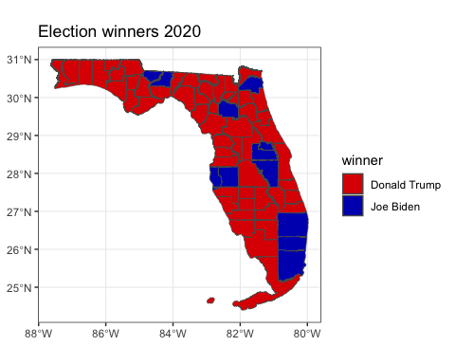

# Exercise #3

fl_votes <- fl_votes %>% mutate(prop_rep16 =rep16/(rep16+dem16))  
fl_votes <- fl_votes %>% mutate(prop_rep20 =rep20/(rep20+dem20))

# Exercise 4

ggplot(fl_votes) +   
 geom_sf(aes(fill=prop_rep20)) +   
 scale_fill_gradient(low='#0015BC', high= '#DE0100') +  
 labs(title="Election 2020 results", fill="Republican share of votes") +  
 theme_bw()

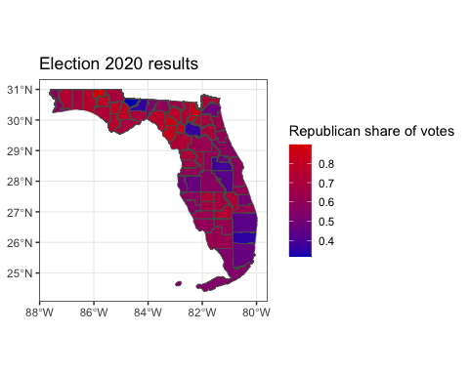

# Exercise 5

fl_votes <- fl_votes %>% mutate(diff_rep = prop_rep20 - prop_rep16)

# Exercise 6

ggplot(fl_votes) +   
 geom_sf(aes(fill=diff_rep)) +   
 scale_fill_gradient2(low='#0015BC', midpoint=0, high= '#DE0100') +  
 labs(title="Election 2020 results", fill="Change in Republican share") +  
 theme_bw()

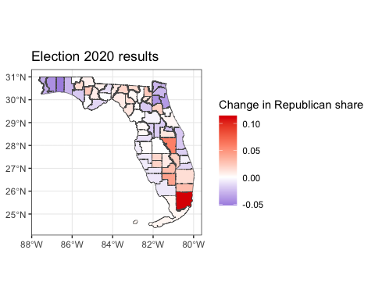

# Exercise 7

1. What do the visualizations you developed tell you about the 2016 and 2020 Presidential election in Florida? What are limitations of these visualizations?

A. The visualizations i developed tells me that the 2016 and 2020 Presidential election in Florida was mostly leaning towards republican votes, except in certain areas which show a heavy democratic votes, and we could see that compared to the 2016 election the 2020 election showed that the democratic votes have increased in most cities. The limitations of these visualizations is that for fl-plot-1 the visual of the graph wasnt very clear