QuickLoan Mobile
Data Governance & Integrity Review
A review of data quality, legal compliance under Ghana's DPA, and AI bias risk in the QuickLoan Mobile lending pipeline.

1. Overview
QuickLoan Mobile is a mobile lending app. It collects customer data such as income, national ID, credit history and phone number, then runs that data through a machine learning model that automatically approves or rejects loan applications.
This review looks at the QuickLoan data pipeline through two core data governance lenses: the data lifecycle, and data classification. The goal is to flag where things can go wrong on data quality, legal compliance and fairness, and to suggest fixes for each.
NOTE: the original project brief and diagram for QuickLoan weren't available for this review, so the review below is a reasonable reconstruction based on how a typical mobile lending app works, and that's the scenario used throughout the rest of this analysis.

Data Flow Pipeline
The pipeline is assumed to run through ten stages.
First, the user submits data through the app: name, phone number, ID, income, employment status and credit history. That data is transmitted to QuickLoan's backend server and stored in a central database. It then gets preprocessed (cleaned, formatted, normalized) and passed through feature engineering so the model can actually use it. The model scores the applicant's credit risk, and the system generates an automatic approve or reject decision. That decision is sent back to the user through the app or SMS, then logged and archived. Finally, data or insights get shared with third parties like credit bureaus or analytics partners.

2. Data Quality Risk
One of the clearest problems shows up with income data. Informally employed applicants (traders, gig workers, boda riders, market vendors) don't have a fixed salary, so this field often ends up blank, guessed at, or filled in inconsistently. Since the model treats income as a key risk signal, unreliable values throw off the risk score in both directions: creditworthy informal workers get rejected unfairly, while inflated self-reports let riskier applicants through. This is really an accuracy problem at the core of data integrity. A fix here could be to replace free-text income entry with structured bands (say, GHS 0-500, 500-1500, 1500+ monthly-equivalent), ask for supporting evidence where possible such as mobile money statements, and flag incomplete submissions for manual review instead of quietly accepting them.
Phone number formatting is another one. Right now there doesn't seem to be an enforced format at entry, so numbers show up as 0244123456, +233244123456, or with random spaces and dashes thrown in. That inconsistency breaks OTP and SMS delivery for loan notifications, makes duplicate-user detection unreliable, and messes up any analysis grouped by phone prefix or region. The fix is fairly standard: enforce input masking and regex validation on the form itself, auto-normalize everything to E.164 format before it's stored, and reject malformed entries right at submission rather than downstream.
ID numbers raise a similar concern. There's no real-time check against a national ID system when someone enters their ID, which opens the door to identity fraud and to the same person submitting multiple loan applications under slightly different spellings of their name. It also quietly poisons future training data with fraudulent approved cases. Adding ID checksum or format validation at entry, and ideally a lookup against Ghana Card standards before the record is stored, would close most of this gap.
There's also the question of stale data. If income or employment status isn't re-verified periodically, a decision could end up being made on financial circumstances that are months out of date, someone who lost their job three months ago might still be scored as employed today. Attaching a last-verified timestamp to sensitive fields and forcing re-verification after something like a 90-day window would address this.
Finally, there doesn't seem to be schema or type enforcement across the different channels the app uses (mobile, USSD, web). The same field, income for example, could come in as text through one channel and as a number through another, which breaks preprocessing and quietly produces garbage features for the model. A single shared data schema, validated server-side regardless of entry point, would fix this.
All five of these sit right at the front of the pipeline, in collection and preprocessing, and they map onto the same four data quality dimensions that show up in most governance frameworks: accuracy, completeness, consistency and timeliness. Because QuickLoan's decision-making is fully automated downstream, any weakness here doesn't stay small, it turns into biased or wrong loan outcomes at scale.

3. Legal & Compliance Risk
The most obvious gap is consent. There's no explicit, informed consent step before QuickLoan collects sensitive personal and financial data, no clear explanation of what's being collected, why, or how it will be used. That's a direct problem under Ghana's Data Protection Act, 2012 (Act 843), which requires informed consent before personal data is processed, and it exposes QuickLoan to fines, sanctions from the Data Protection Commission, and a real hit to user trust. A mandatory consent screen with plain-language explanations, opt-in checkboxes that aren't pre-ticked, and a timestamped consent log would address this directly.
Related to that is over-collection. The app may be gathering more than it needs, things like a full contact list or location history that go beyond income, ID and credit history. That runs against the data minimization principle in Act 843, since only data necessary for the stated purpose should be collected, and it increases how much damage a breach could do. The fix is really an audit: go through every field collected, check it against the actual purpose of a loan decision, and drop anything that isn't essential.
Data classification is also missing. Sensitive information like financial records and national ID numbers appears to be stored the same way as low-risk data such as app usage logs. Without classification, sensitive data doesn't get the stronger protections it legally needs, which raises the severity of any breach and the odds of non-compliance. Classifying fields as Public, Internal or Sensitive at the storage stage, then applying encryption at rest and role-based access control to the Sensitive tier, solves most of this.
There's also no clear retention period. Data seems to be kept indefinitely with no deletion policy, which conflicts with Act 843's requirement that data not be held longer than necessary. A defined retention schedule (for instance, deleting or anonymizing data after loan closure or a period of account inactivity), enforced automatically rather than manually, would fix this.
Third-party sharing is another weak spot. Data appears to be shared with credit bureaus or analytics partners without a clear legal basis or any anonymization first. Sharing personal data like this, without consent or documentation, is a further Act 843 violation, and it creates the risk that partners misuse the data downstream. Requiring data processing agreements with every third party, masking PII before sharing where individual identity isn't actually needed, and disclosing this sharing in the consent notice would close the gap.
Last, there's no visible audit trail for who accessed sensitive data or why an automated decision came out the way it did. That makes it hard to demonstrate accountability or respond if a user asks for an explanation, something Act 843's accountability principle expects. Logging access to sensitive records, plus logging the key factors behind each decision, would fix this.
Together, these six issues map onto the accountability side of data governance: lawfulness, purpose limitation, data minimization, storage limitation and accountability itself. Because QuickLoan is handling data that should be classified as Sensitive, missing consent, classification, retention limits and audit trails isn't a minor gap, it's a structural governance failure that puts both user trust and legal compliance under Act 843 at risk.

4. Bias & Fairness Risk
The starting point for bias is usually the training data itself. If QuickLoan's model was trained on past loan decisions, and those past decisions leaned toward approving formally employed, urban or higher-income applicants, the model inherits that pattern. Worse, it doesn't just repeat the bias, it scales it automatically, so informal, rural, younger or female applicants could end up scored as higher-risk regardless of whether they're actually creditworthy. Auditing the historical training data for demographic imbalance, applying fairness-aware training methods like re-weighting or balanced sampling, and retraining periodically would help catch this early.
A subtler issue is proxy variables. Fields like location, phone prefix or device type can end up standing in for gender, region or class, even when the model is never explicitly told someone's gender or ethnicity. This lets discrimination creep in indirectly, which is a well-documented way ML bias hides. Testing model outputs for correlation with these proxy variables, and removing or de-weighting the ones that correlate strongly, is the main way to catch this.
There's also no ongoing demographic monitoring, nothing tracking whether approval or rejection rates differ meaningfully across groups over time. Without that, bias can quietly get worse through a feedback loop, where the model keeps retraining on its own biased outputs, until it becomes a serious fairness or legal problem. Setting up ongoing monitoring of approval rate by group (age, gender, region, employment type) as a standing governance metric would catch this before it compounds.
Fully automated decisions with no human review for borderline or rejected cases is another gap. That removes any safety net for catching algorithmic bias before it affects a real applicant, and it weakens a user's ability to contest a decision they think is wrong. Adding human-in-the-loop review for borderline scores, plus a formal appeal process, addresses this.
Class imbalance in the training data is worth checking too. If there are far more approved than rejected cases for certain groups (or the reverse), the model becomes overconfident about the majority group and less accurate for underrepresented ones, which compounds the unfairness. Resampling techniques, oversampling, undersampling, or synthetic data generation like SMOTE, can help balance this before retraining.
Explainability is a related concern. If the model works as a black box, even QuickLoan's own team might not know why a specific applicant was rejected. Without that visibility, it's nearly impossible to spot which factors are driving unfair outcomes, and rejected users can't be given a real reason, which undermines both fairness and legal accountability. Explainable AI techniques such as SHAP values or feature importance reports would let QuickLoan show which factors influenced each decision.
Last, there's no documented fairness standard at all, nothing defining what fair actually means for QuickLoan. Without that, different teams can disagree on whether a gap between groups is acceptable, and bias mitigation work has no clear target. Defining a specific fairness criterion, such as demographic parity or equal opportunity, as organizational policy, and checking the model against it before and after every retraining cycle, gives the team something concrete to work toward.
Taken together, these seven points show that bias isn't a single bug to patch, it spans the data, the model design, and the process around it. Since the root cause is historical data reflecting real socioeconomic inequality, fixing it needs governance controls (monitoring, human oversight, documented standards) layered on top of any technical fix, echoing the same accountability principles from the legal and compliance section.

5. Storytelling / Reporting Recommendation

Metric 1- Approval Rate by Demographic Group
This metric tracks the percentage of applications approved, split by group such as employment type or region. It's a direct way to expose the bias risk described above: a large gap between groups is a visible red flag. A grouped bar chart works best here because it lets you compare a metric across discrete categories side by side. A pie chart wouldn't fit a comparison across independent groups, and a line chart would imply a trend over time rather than a snapshot.
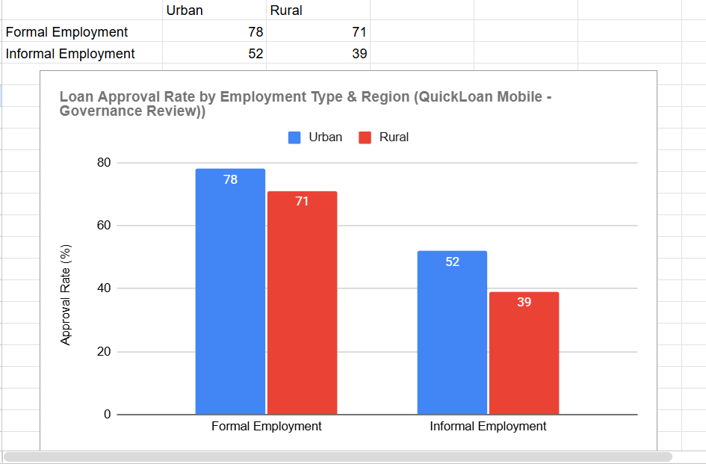

Metric 2- Approval Rate Over Time
This one tracks how the approval rate for a specific group changes month to month after governance fixes go in, which shows whether the fairness interventions are actually working rather than just sounding good on paper. A line chart is the natural choice for this kind of trend over a continuous variable like time.
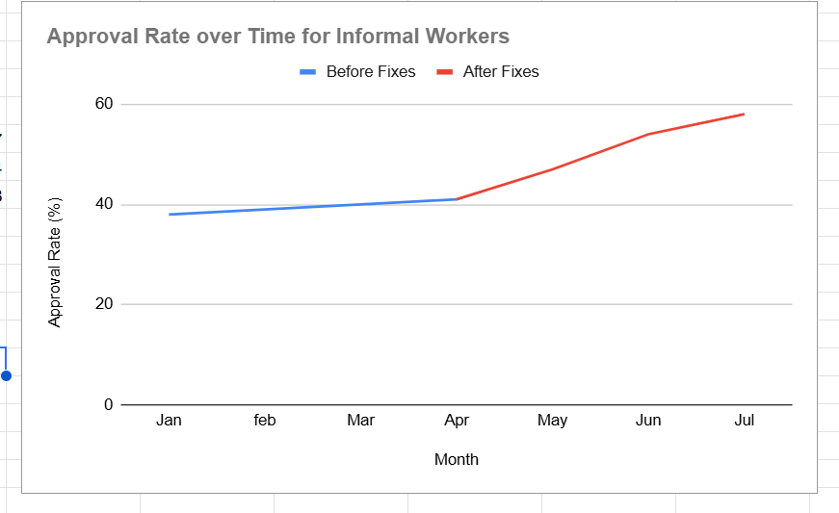

Metric 3- Data Quality Issues by Type
This tracks how many records are affected by each type of data quality issue identified earlier, which helps prioritize where to focus remediation effort. A Pareto chart (a bar chart sorted by frequency with a cumulative percentage line layered on top) fits well here because it highlights the small number of issues causing most of the damage, which is exactly what you want when deciding what to fix first.
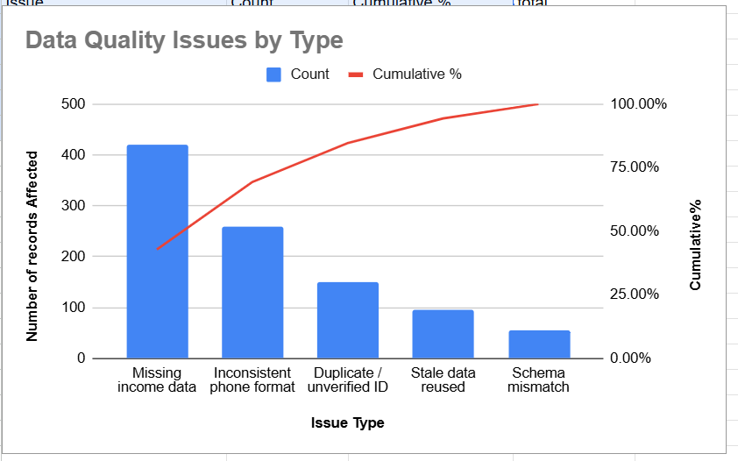
Figure 3: Illustrative data quality issues by type, with cumulative percentage.
Chart choice matters more than it might seem. Picking the right visualization is part of transparency and accountability in governance reporting. A grouped bar chart makes disparities obvious to a non-technical stakeholder, a regulator or board member, for example, which supports real oversight instead of burying the issue in a data table nobody reads closely.

6. Annotated Corrected Data Flow
Going back through the assumed ten-step pipeline, here's what fix applies at each stage and why.
Step 1, Data Collection: limit the fields collected to only what's essential, income band, ID, credit history, and drop anything non-essential. This satisfies the data minimization principle.
Steps 1 to 2, Collection into Transmission: add a mandatory consent checkpoint, plain-language and timestamped, before any data leaves the device. This covers lawful basis and informed consent.
Step 2, Transmission: enforce input validation and standardization right at entry, covering phone format, income bands and ID checksum. This is a data quality fix, aimed at accuracy and consistency.
Step 3, Storage: classify data as Sensitive, apply encryption at rest and role-based access control, and set a retention period with automatic deletion. This addresses data classification, storage limitation and security together.
Step 4, Preprocessing: add automated cleaning, validation and normalization before the data reaches the model. This is straightforward data integrity work.
Step 5, Feature Engineering: test engineered features like location or phone prefix for correlation with protected attributes. This catches indirect discrimination before it reaches the model.
Step 6, Model Scoring: apply fairness-aware training and monitor the model's outputs for demographic skew. This is bias mitigation at the model level.
Step 7, Decision: add decision logging with explanation metadata, and route borderline or rejected cases to human review. This supports transparency, accountability and explainability.
Step 8, Notification: give the user a clear reason for the decision, along with a way to appeal it. This is the right-to-explanation piece.
Step 9, Logging and Archiving: log who accessed sensitive records, and when. This is accountability and auditability.
Step 10, Data Sharing: mask or anonymize PII before it's shared with third parties, and require data processing agreements. This covers purpose limitation and third-party safeguards.

7. Summary of Review Process
This review worked through the QuickLoan Mobile lending pipeline using three lenses: data quality, legal compliance, and algorithmic fairness, following the data lifecycle from collection all the way to third-party sharing. Going stage by stage surfaced governance gaps that, if left alone, would undermine both the reliability of the ML-driven loan decisions and QuickLoan's legal standing under Ghana's Data Protection Act, 2012 (Act 843).
At collection and preprocessing, inconsistent formats and missing fields, especially around informal income and phone numbers, threaten data integrity directly by feeding unreliable inputs into a system that makes decisions automatically. On the legal side, the missing consent, classification and retention limits point to a structural gap against Act 843's core principles of lawful processing, data minimization and accountability. Classifying customer data as Sensitive made it clear that stronger safeguards, encryption, access control, third-party masking, are genuinely needed, not optional.
The bias and fairness analysis traced a further risk back to the historical data used to train the model, where existing gaps between formally and informally employed applicants, and between urban and rural regions, could get inherited and scaled rather than corrected. Without demographic monitoring or human oversight of automated decisions, that risk could quietly get worse over time without anyone noticing.
To make these risks visible and something people can actually act on, this review recommends approval rate by demographic group as a core governance metric, tracked with a grouped bar chart so stakeholders can spot disparities quickly, backed by a trend view over time to confirm whether fairness fixes are actually working, and a Pareto chart to prioritize whichever data quality issues are causing the most harm. Put together, these fixes across all ten stages of the pipeline move QuickLoan Mobile from a system that just functions to one that's transparent, compliant and fair by design.

