AIntern UAT Plan and User Manual
Professional pilot testing guide for intern daily logs, supervisor review, official logbook, Weekly/Monthly reports, Final Report Studio, PDF/Word export, QR verification, and offline behavior.
Document owner | Effort Studio / AIntern
Prepared date | 28 July 2026
Application | AIntern PWA
Primary test URL | https://a-intern.vercel.app
Local test URL | http://localhost:4900
Supabase project | wdhdjhvvngssnszqgiyk
Test account | Use the provided pilot account. Do not publish passwords in UAT evidence.

Purpose
This document gives testers one clear place to understand the product, run UAT, record evidence, and learn the AIntern user workflow. It is written for pilot users, internal testers, supervisors, and institution reviewers.

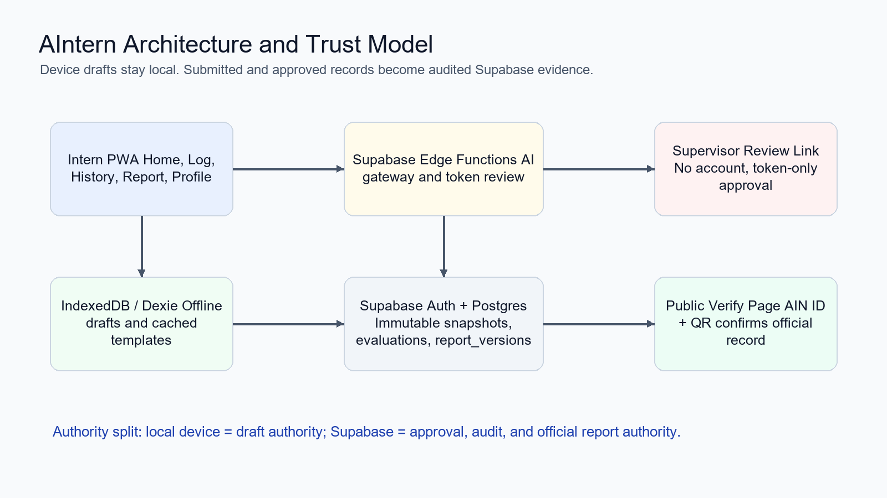

Table of Contents
AIntern UAT Plan and User Manual 1
1. Product Architecture Summary 4
2. Current Release Status 5
3. UAT Scope and Entry Criteria 6
3.1 Roles 6
3.2 Required Test Material 6
3.3 Entry Criteria 6
3.4 Exit Criteria 6
4. UAT Test Cases 8
UAT-01 - Login and first screen 8
UAT-02 - Profile and internship data 8
UAT-03 - Daily log autosave 8
UAT-04 - AI polish daily note 9
UAT-05 - Offline daily log 9
UAT-06 - Submit for review 9
UAT-07 - Supervisor approve 10
UAT-08 - Supervisor reject and resubmit 10
UAT-09 - Supervisor evaluation 10
UAT-10 - Official logbook Ready Check 11
UAT-11 - Verified official logbook 11
UAT-12 - QR phone verification 12
UAT-13 - Word edit does not alter official record 12
UAT-14 - Negative verify ID 12
UAT-15 - Report Center Settings 13
UAT-16 - Weekly default narrative 13
UAT-17 - Weekly default table 13
UAT-18 - Weekly sample extraction 14
UAT-19 - Monthly combined default 14
UAT-20 - Monthly sample extraction 14
UAT-21 - Daily log Template Studio 15
UAT-22 - Final report structure extraction 15
UAT-23 - Final report authoring and export 15
UAT-24 - Access and privacy spot check 16
5. User Manual 17
5.1 Navigation 17
5.2 Daily Logging 17
5.3 AI Polish 17
5.4 Submit to Supervisor 17
5.5 Supervisor Review 17
5.6 Official Logbook 18
5.7 Weekly and Monthly Reports 18
5.8 Final Report Studio 18
5.9 Public Verification 18
6. Troubleshooting Guide 19
7. Acceptance and Sign-off 19

1. Product Architecture Summary
AIntern is a mobile-first internship logbook platform. The intern owns the account and draft workflow. Supervisors approve through audited no-account review links. Official records are stored as immutable Supabase snapshots and exported as PDF or Word reports with public verification IDs.
Core trust model
Device and IndexedDB are the draft authority. Supabase is the approval, audit, and official report authority. Approved snapshots, evaluations, and report versions must not be edited after creation.

- React/Vite PWA provides Home, Log, History, Report, and Profile navigation on mobile and desktop.
- Dexie/IndexedDB stores local drafts and cached templates for offline daily logging.
- Supabase Auth identifies interns; owner-based RLS restricts intern data.
- Supabase Edge Functions handle AI gateway actions and supervisor token review.
- Postgres report_versions freezes official content and template metadata for exports.
- Public /verify confirms AIN Verification IDs without exposing private report content.
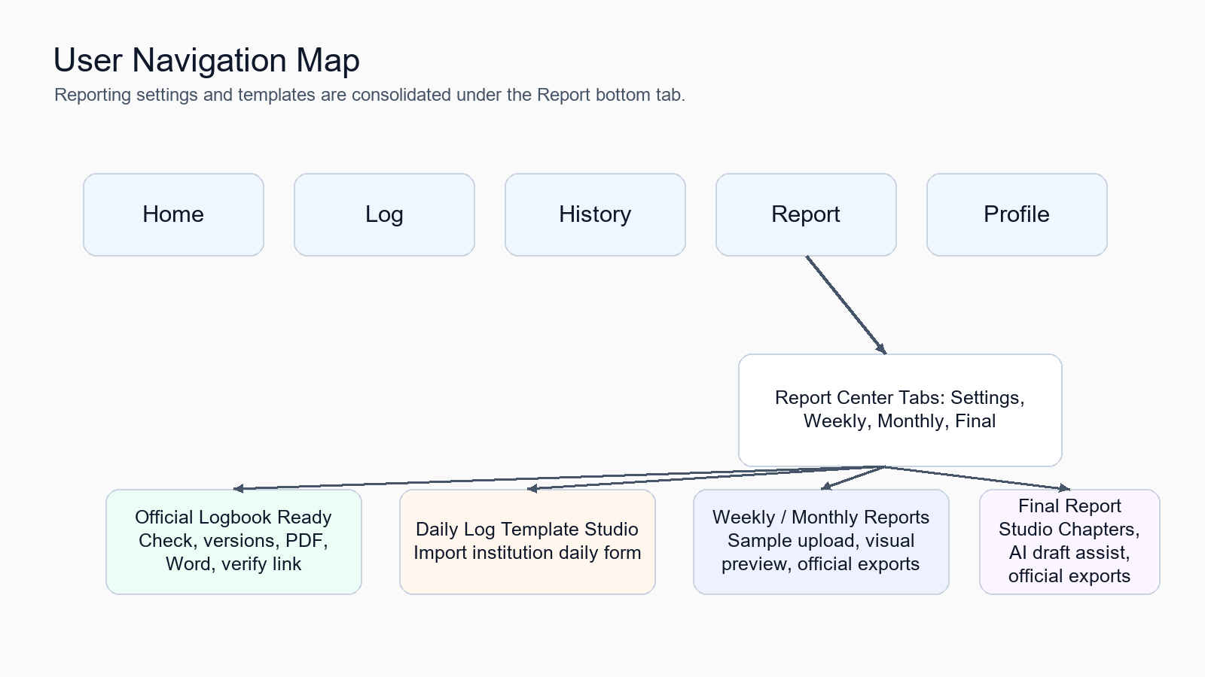

2. Current Release Status
Area | Status | Notes
Daily logging | Built | Autosave, offline drafts, AI polish, History, submit flow.
Supervisor approval | Built | Token-only review links, approve/reject, comments, signatures, evaluations.
Official logbook | Built and verified | Ready Check, official versions, PDF/Word, QR, public verify page.
Report Center | Built; awaiting real-sample UAT | Settings, Weekly, Monthly, Final tabs with breadcrumbs.
Weekly report | Built; awaiting sample UAT | Narrative or Table default templates, upload sample, visual preview, official export.
Monthly report | Built; awaiting sample UAT | Combined tables and narrative reflection, upload sample, visual preview, official export.
Final report | Built; awaiting sample UAT | Chapter extraction, narrative authoring, AI draft assist, official export.
Monetization | Built; awaiting pilot | Trial/pass gating for official report creation and export.

Known pilot note
The AI narrative quality check is advisory. Deterministic Ready Check and server-side snapshot rules remain the authority for Verified or Unverified status.

3. UAT Scope and Entry Criteria

3.1 Roles
Role | What to test
Intern | Login, onboarding/profile, daily logs, History, Report Center, official exports, offline behavior.
Supervisor | Open review link without account, approve/reject entries, complete evaluation, sign, submit.
Verifier | Open /verify or scan QR and confirm only public-safe verification information appears.

3.2 Required Test Material
- At least one real Weekly institution sample report in PDF or image format.
- At least one real Monthly institution sample report in PDF or image format.
- One Final report sample or table of contents from an institution.
- A mobile phone with camera or QR scanning capability.
- Microsoft Word for opening and editing DOCX exports.
- Browser DevTools for offline simulation.

3.3 Entry Criteria
- Tester can access https://a-intern.vercel.app or local http://localhost:4900.
- Intern has completed basic profile and internship setup.
- At least one daily log can be submitted and approved.
- AI provider key or bundled AI access is available for sample extraction tests.
- Supervisor review link can be opened, or copied manually if email delivery hangs.

3.4 Exit Criteria
- All Critical and High UAT cases pass or have accepted defects.
- Verified official version produces an AIN ID and a PDF with QR on the verification appendix.
- /verify succeeds for a real ID and shows a red warning for a fake ID.
- Weekly, Monthly, and Final report flows can create official versions and export PDF/Word.
- Offline daily log reload and autosave behavior passes.
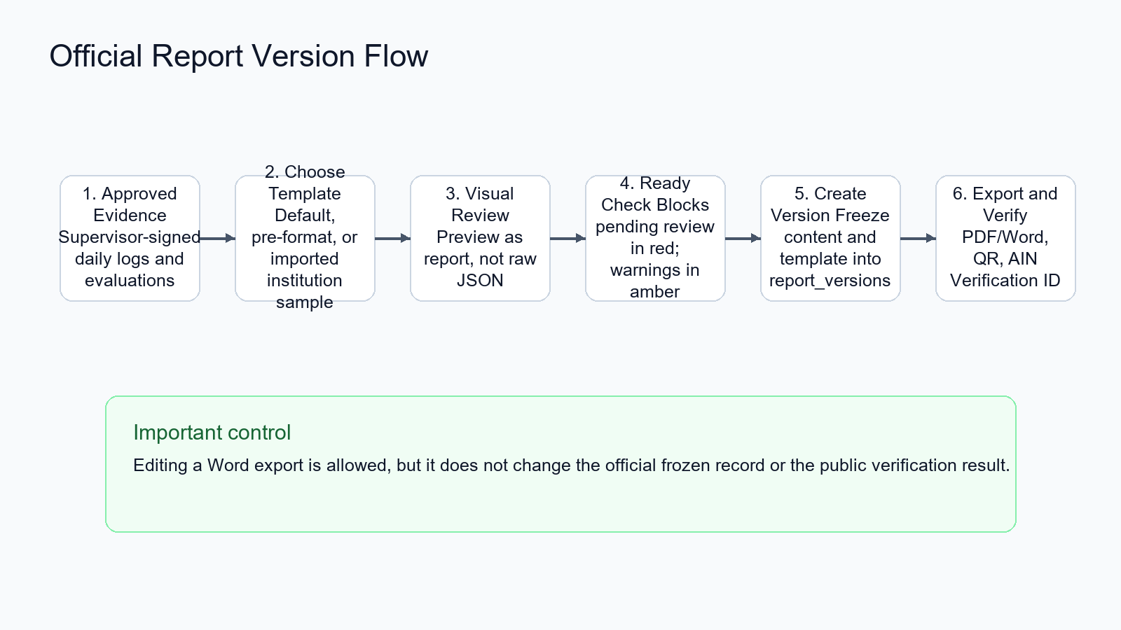

4. UAT Test Cases
How to record results
For each case, mark Pass, Fail, or Blocked. Attach screenshots, exported files, or notes. Do not paste passwords, API keys, tokens, or private supervisor links into shared evidence.

UAT-01 - Login and first screen
Field | Detail
Priority | Critical
Precondition | Intern account exists
Steps | Open app, login, confirm bottom navigation is visible.
Expected result | Home loads with Home, Log, History, Report, Profile navigation.
Actual result
Status | Pass / Fail / Blocked
Evidence / notes

UAT-02 - Profile and internship data
Field | Detail
Priority | High
Precondition | Logged in as intern
Steps | Open Profile, confirm intern details, company, supervisor, cadence, AI assistant area.
Expected result | Profile settings are editable without report settings clutter.
Actual result
Status | Pass / Fail / Blocked
Evidence / notes

UAT-03 - Daily log autosave
Field | Detail
Priority | Critical
Precondition | Profile/internship complete
Steps | Open Log, type daily work notes, wait for Autosaved indicator, reload page.
Expected result | Draft remains after reload.
Actual result
Status | Pass / Fail / Blocked
Evidence / notes

UAT-04 - AI polish daily note
Field | Detail
Priority | High
Precondition | AI access available
Steps | In Log, type rough notes, click Polish with AI, review output.
Expected result | Text becomes formal, same facts/language retained, user can edit.
Actual result
Status | Pass / Fail / Blocked
Evidence / notes

UAT-05 - Offline daily log
Field | Detail
Priority | Critical
Precondition | Draft exists
Steps | DevTools Network Offline, reload /log, edit field, return online.
Expected result | Form loads from cache and edits continue saving locally.
Actual result
Status | Pass / Fail / Blocked
Evidence / notes

UAT-06 - Submit for review
Field | Detail
Priority | Critical
Precondition | Ready daily log exists
Steps | Open History, select/submit log, use email review or Copy review link fallback.
Expected result | Submission status becomes submitted/pending and review link is available.
Actual result
Status | Pass / Fail / Blocked
Evidence / notes

UAT-07 - Supervisor approve
Field | Detail
Priority | Critical
Precondition | Valid review link
Steps | Open review link in browser, approve one entry, sign, submit.
Expected result | Approved snapshot appears in intern Logbook/History after sync.
Actual result
Status | Pass / Fail / Blocked
Evidence / notes

UAT-08 - Supervisor reject and resubmit
Field | Detail
Priority | High
Precondition | Valid review link
Steps | Reject one entry with comment, revise it as intern, submit again, approve.
Expected result | Rejected comment appears, revised log can be resubmitted and later approved.
Actual result
Status | Pass / Fail / Blocked
Evidence / notes

UAT-09 - Supervisor evaluation
Field | Detail
Priority | High
Precondition | Evaluation is due
Steps | Open review link with evaluation section, enter scores/comments, sign, submit.
Expected result | Evaluation appears in Official logbook and exports.
Actual result
Status | Pass / Fail / Blocked
Evidence / notes

UAT-10 - Official logbook Ready Check
Field | Detail
Priority | Critical
Precondition | At least one approved log
Steps | Report > Settings > Official logbook, run Ready Check.
Expected result | Blocking issues show red; warnings show amber; clean state says Verified version can be created.
Actual result
Status | Pass / Fail / Blocked
Evidence / notes

UAT-11 - Verified official logbook
Field | Detail
Priority | Critical
Precondition | Ready Check clean
Steps | Create official version, download PDF and Word.
Expected result | Version has Verified chip, AIN ID, PDF/Word buttons work.
Actual result
Status | Pass / Fail / Blocked
Evidence / notes

UAT-12 - QR phone verification
Field | Detail
Priority | Critical
Precondition | Verified PDF downloaded
Steps | Open PDF on phone, scan last-page QR.
Expected result | Phone lands on /verify?id=AIN-... and confirms record.
Actual result
Status | Pass / Fail / Blocked
Evidence / notes

UAT-13 - Word edit does not alter official record
Field | Detail
Priority | Critical
Precondition | Verified DOCX downloaded
Steps | Open DOCX in Word, edit text, save locally, re-open /verify ID.
Expected result | Public verification remains unchanged; edited Word copy is not official source.
Actual result
Status | Pass / Fail / Blocked
Evidence / notes

UAT-14 - Negative verify ID
Field | Detail
Priority | Critical
Precondition | None
Steps | Open /verify, type AIN-FAKE-0000 or another fake ID, click Verify.
Expected result | Red no-record card appears.
Actual result
Status | Pass / Fail / Blocked
Evidence / notes

UAT-15 - Report Center Settings
Field | Detail
Priority | High
Precondition | Logged in
Steps | Bottom nav Report, Settings tab.
Expected result | Breadcrumb shows Report / Settings; Official logbook and Daily log Template Studio links work.
Actual result
Status | Pass / Fail / Blocked
Evidence / notes

UAT-16 - Weekly default narrative
Field | Detail
Priority | High
Precondition | Approved entries exist
Steps | Report > Weekly, choose Narrative, preview current template, set dates, create official version, export PDF/Word.
Expected result | Narrative style report is created and exports from frozen version.
Actual result
Status | Pass / Fail / Blocked
Evidence / notes

UAT-17 - Weekly default table
Field | Detail
Priority | High
Precondition | Approved entries exist
Steps | Report > Weekly, choose Table, create official version, export PDF/Word.
Expected result | Table report uses approved activity rows and supervisor verification.
Actual result
Status | Pass / Fail / Blocked
Evidence / notes

UAT-18 - Weekly sample extraction
Field | Detail
Priority | Critical
Precondition | Weekly sample file ready
Steps | Report > Weekly, upload PDF/photo, select provider, Extract sample template, review visual modal, Apply.
Expected result | Preview is understandable visually; custom template chip appears; official export uses custom structure.
Actual result
Status | Pass / Fail / Blocked
Evidence / notes

UAT-19 - Monthly combined default
Field | Detail
Priority | High
Precondition | Approved entries exist
Steps | Report > Monthly, preview combined template, set dates, create official version, export PDF/Word.
Expected result | Monthly report combines data tables and narrative/reflection sections.
Actual result
Status | Pass / Fail / Blocked
Evidence / notes

UAT-20 - Monthly sample extraction
Field | Detail
Priority | Critical
Precondition | Monthly sample file ready
Steps | Report > Monthly, upload PDF/photo, Extract, preview, Apply, create/export.
Expected result | Custom monthly template is visually reviewed and used in frozen official export.
Actual result
Status | Pass / Fail / Blocked
Evidence / notes

UAT-21 - Daily log Template Studio
Field | Detail
Priority | High
Precondition | Institution daily form sample ready
Steps | Report > Settings > Daily log Template Studio, upload daily form, extract, review fields, apply.
Expected result | New logs use imported daily form; approved old entries stay unchanged.
Actual result
Status | Pass / Fail / Blocked
Evidence / notes

UAT-22 - Final report structure extraction
Field | Detail
Priority | Critical
Precondition | Final report/TOC sample ready
Steps | Report > Final > Continue final report workflow, upload sample, extract, preview, use structure.
Expected result | Chapter list visually matches institution format before applying.
Actual result
Status | Pass / Fail / Blocked
Evidence / notes

UAT-23 - Final report authoring and export
Field | Detail
Priority | Critical
Precondition | Approved entries exist
Steps | Write narrative chapters, optionally draft from evidence, create official final version, export PDF/Word.
Expected result | Final version freezes title, chapters, narrative draft, evidence appendices, QR if Verified.
Actual result
Status | Pass / Fail / Blocked
Evidence / notes

UAT-24 - Access and privacy spot check
Field | Detail
Priority | Critical
Precondition | Two users or incognito available
Steps | Confirm intern sees only own data; supervisor link opens only review page; verify page exposes public-safe fields only.
Expected result | No cross-user data exposure; no report content displayed publicly.
Actual result
Status | Pass / Fail / Blocked
Evidence / notes

5. User Manual

5.1 Navigation
Area | Purpose
Home | Start or continue today's log and access major workflows.
Log | Fill the daily log. Drafts autosave locally and work offline.
History | Review daily log statuses, submit logs, resend or copy review links.
Report | Central place for reporting settings, Weekly, Monthly, and Final reports.
Profile | Personal details, internship pass, supervisor review settings, and AI keys.

5.2 Daily Logging
- Open Log from the bottom navigation or Home.
- Fill the work summary, outcomes, learning, blockers, attendance, and any enabled custom fields.
- Wait for the Autosaved indicator before closing the page.
- Click Save log when the day is ready for submission.
- Approved or submitted logs become read-only until the supervisor outcome allows revision.

5.3 AI Polish
- Use Polish with AI on rough notes when online.
- Review the rewritten text before saving; the intern remains responsible for accuracy.
- If offline or AI is unavailable, continue writing manually and polish later.
- Do not enter confidential API keys into report text or UAT notes.

5.4 Submit to Supervisor
- Open History and confirm the log is ready.
- Submit the selected log or batch for supervisor review.
- Use Email supervisor if delivery is configured. Use Copy review link if email delivery hangs or the provider is slow.
- The supervisor opens the token link without creating an account.
- After approval or rejection, return to History or Official logbook and refresh/sync status.

5.5 Supervisor Review
- Open the review link received from the intern.
- Read each submitted entry.
- Approve valid entries or mark Needs revision with a clear comment.
- Complete evaluation scores and comments when the evaluation section appears.
- Sign on screen and submit.

5.6 Official Logbook
- Go to Report > Settings > Official logbook.
- Run Ready Check before creating an official version.
- Fix red blocking items first. Amber warnings can still allow creation, but should be reviewed.
- Create an official version. Verified versions receive an AIN Verification ID.
- Use PDF for official submission. Use Word for editable working copies.

5.7 Weekly and Monthly Reports
- Go to Report > Weekly or Report > Monthly.
- Weekly supports Narrative and Table default formats. Monthly uses a combined table plus narrative format.
- To match an institution sample, upload PDF/photo, choose provider, extract, and review the visual preview.
- Apply only when the preview looks correct. Technical JSON is for debugging only.
- Set the date period, create official version, and download PDF/Word.

5.8 Final Report Studio
- Go to Report > Final > Continue final report workflow.
- Use the default chapter structure or upload an institution final report/TOC sample.
- Review the visual table-of-contents preview before applying.
- Write narrative chapters. Auto logbook and evaluation chapters come from approved records and cannot be edited inside the studio.
- Create the official final version and export PDF/Word.

5.9 Public Verification
- Open /verify or scan the QR in a verified PDF.
- Enter the AIN Verification ID if it is not already in the URL.
- Green card means the record exists and was generated from official verified data.
- Red card means no verified record was found for that ID.
- The verification page does not expose private report content.

6. Troubleshooting Guide
Issue | Likely cause | Action
Email review button hangs | Email provider delivery not configured, slow, or restricted. | Use Copy review link and send it manually.
AI extraction fails | Provider key/model unavailable or file scan is unclear. | Try Gemini or Claude for image/scanned PDF; use clearer sample; check BYOK model.
No Verified status | Pending review, no approved entries, gaps, or rejected unrevised logs. | Run Ready Check and resolve red blocking items.
PDF has no QR | Version is Unverified or export is working preview. | Create a Verified official version, then download its official PDF.
Word edits not reflected online | DOCX is an editable copy only. | This is expected; official records are frozen in AIntern.
Offline log missing on another device | Drafts are local until submitted/approved. | Use same device for drafts; approved/submitted records restore through server sync.
Settings scattered | Older deployment/cache or wrong path. | Open bottom nav Report; hard refresh if the old Profile report settings still appear.

7. Acceptance and Sign-off
Role | Name | Decision | Date | Signature / Notes
Product owner |  | Accepted / Rejected / Conditional
UAT tester |  | Accepted / Rejected / Conditional
Technical lead |  | Accepted / Rejected / Conditional
Pilot institution reviewer |  | Accepted / Rejected / Conditional

Recommended release decision
Approve pilot release only after Critical UAT cases pass on the live Vercel app and at least one real Weekly, Monthly, and Final institution sample has been tested end to end.

