Modify FPGA Bootloader Address

The bootloader is the first program get executed when the FPGA board power on. For the Sapphire SoC, the bootloader will load the program at designated location as specify on embedded_sw/<soc>/bsp/efinix/EfxSapphireSoc/app/bootloaderConfig.h. By default, the bootloader will load user software binary from address 0x00380000 in flash memory. Then it will copy the user software binary to RAM at address 0x00001000.

Here is the default configuration of bootloaderConfig.h for Efinix SapphireSoc.

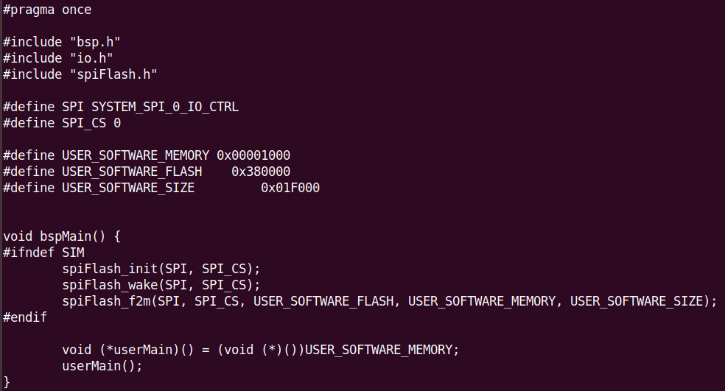

Steps to modify bootloader code to load user software at different address

Modify the bootloaderConfig.h to load different program at specific address require to recompile the bootloader and FPGA bitstream. This step shows how to modify the bootloader to load OpenSBI and U-Boot for Linux bootstrapping process.

Make sure to install Efinix SDK by referring to Sapphire RISC-V SoC Hardware and Software User Guide on Efinix support page document.

Steps
- Update the desire address on bootloaderConfig.h. For example, update address of SPI flash to load OpenSBI and U-Boot as shown in the table below.

Binary | Flash Address | RAM Address
OpenSBI | 0x00400000 | 0x01000000
U-Boot | 0x00480000 | 0x01040000

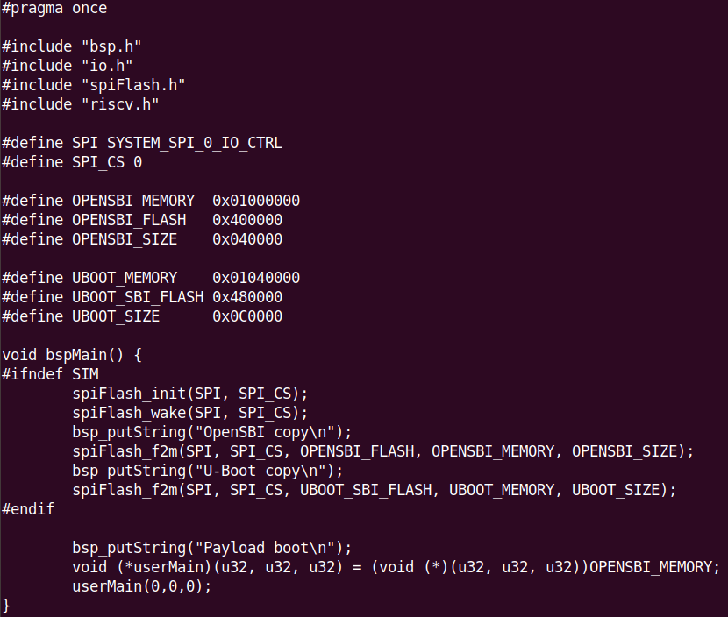

- Recompile the bootloader program. Bootloader program located in <efinity_project>/embedded_sw/<soc>/software/standalone/bootloader
  - Using Eclipse
$ cd /path/to/SDK_Ubuntu
$ ./setup.sh
$ ./run_eclipse.sh
Then select 1 to use SapphireSoC configuration to launch Eclipse

Select Import Existing Code
Select Browse to find the bootloader in <efinity_project>/embedded_sw/<soc>/software/standalone/bootloader

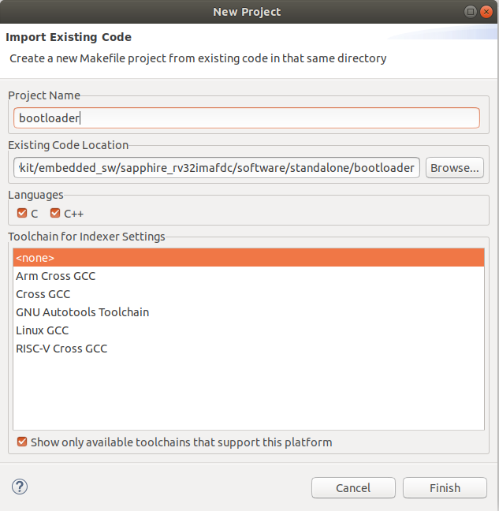
Then click Finish
Right click on bootloader then select Build Project
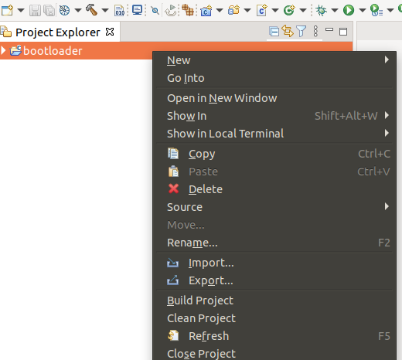

  - Using command line
$ export PATH=</path/to>/SDK_Ubuntu/riscv-xpack-toolchain_8.3.0-2.3_linux/bin:$PATH
$ cd <efinity_project>/embedded_sw/<soc>/software/standalone/bootloader
$ BSP_PATH=<efinity_project>/embedded_sw/<soc>/bsp/efinix/EfxSapphireSoc make

- Generate memory initialization bin file called "EfxSapphireSoc.v_toplevel_system_ramA_logic_ram_symbol*.bin". These files generated when compiling efinity project. To update these files, use bitGen.py in <efinity_project>/embedded_sw/<soc>/tool/binGen.py

$ python3 bitGen.py -f 0 -s 4096 -b <path/to/bootloader.bin>.
where,
-f, fpu. If enable set to 1. else set to 0
-s, On-Chip RAM size. See the IP manager configuration of cache/memory as shown on the image below

You can check the On-Chip RAM size on the IP Manager
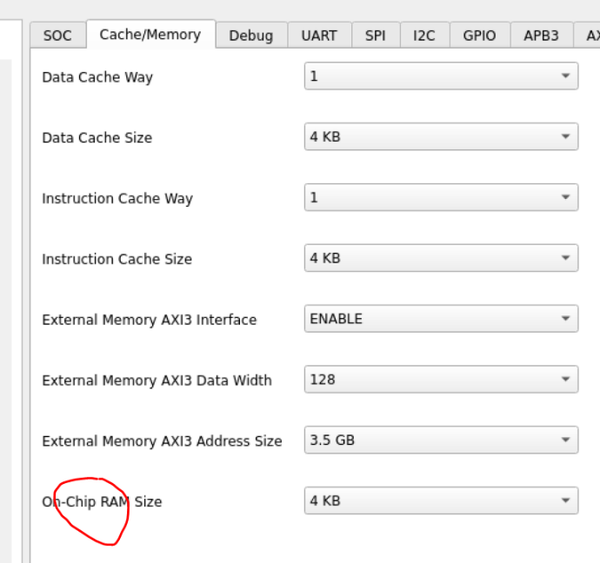

- Copy the generated memory initialization bin files in rom folder to <efinity_project>
$ cp -r <efinity_project>/embedded_sw/<soc>/tool/rom/*.bin <efinity_project>
- Recompile the Efinity project by clicking the icon 
- Bitstream or flash the Efinity project file in <efinity_project/outflow/soc.hex to FPGA board. Make sure the serial UART cable is connected. Please refer to document setup_the _development_board.rtf in this repository.

