Setup the Development board
This guide show on how to setup Trion T120F324 board. Make sure you enable the SD card module on the Sapphire SoC. Refer to enable_SD_card_module.rtf document in this repository before you proceed with this setup.
Prerequisite
- PMOD MicroSD module
- MicroSD card 16GB
- USB UART module
- Trion T120 BGA324
- 3x male to female jumper cable
- MIPI and LVDS expansion daughter card
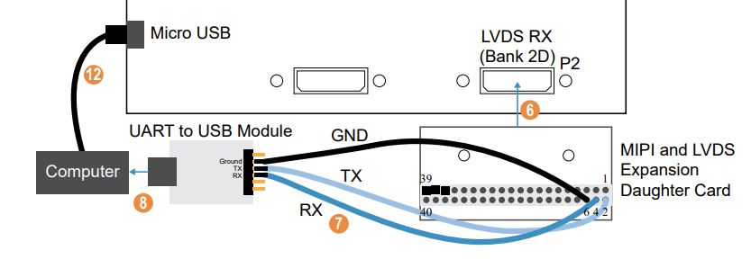
Set Up the UART Module
6. Connect the MIPI and LVDS Expansion Daughter Card to the board at:
- P2 for Trion® T120 BGA324 Development Board
- P3 for Trion® T120 BGA576 Development Board
7. Connect jumper wires to the daughter card and UART module:
- RX to pin 4
- TX to pin 2
- GND to pin 6
8. Connect the UART module to your computer. Connect Cables and Jumpers
12. Connect a USB cable to the board and to your computer.

