Enable SD card module on Efinix Trion T120 and Ti60 boards with Sapphire SoC

The default Sapphire SoC does not enable SD card thru SPI. Efinix FPGA board such as Trion T120 does not have SD Card module. You might need to purchase an external SD card module such as PMOD microsd module and attach it to the T120 board. Connect the external SD card module to J12.

In this tutorial, we are going to enable SD card (SPI 1) on Efinix FPGA board with Sapphire SoC by modifying the top level verilog code top_soc.v and pin out of the board.

Efinity version: 2021.2.323

Make sure to download the Efinity Software from Efinix Support page and install it.
To install Efinity Software please refer to Efinity Software Installation User Guide on Efinix Support page documentation.

- Launch Efinity
- Create reference design of Sapphire SoC using IP manager.

  - Click Open IP Catelog icon then click Installed IP > Efinix > Processor and Peripherals > Sapphire SoC
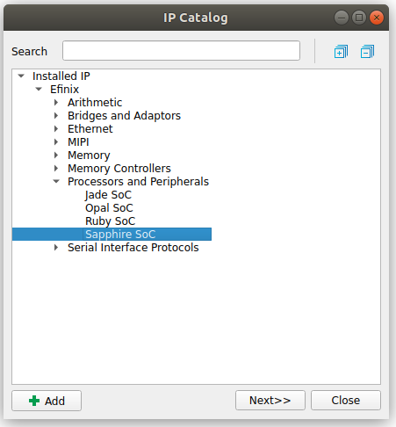
  - Then click Next
  - Give the Module Name on IP Configuration window
  - On SOC tab,
    - Enable the Linux Memory Management Unit
    - Enable the Floating-point Unit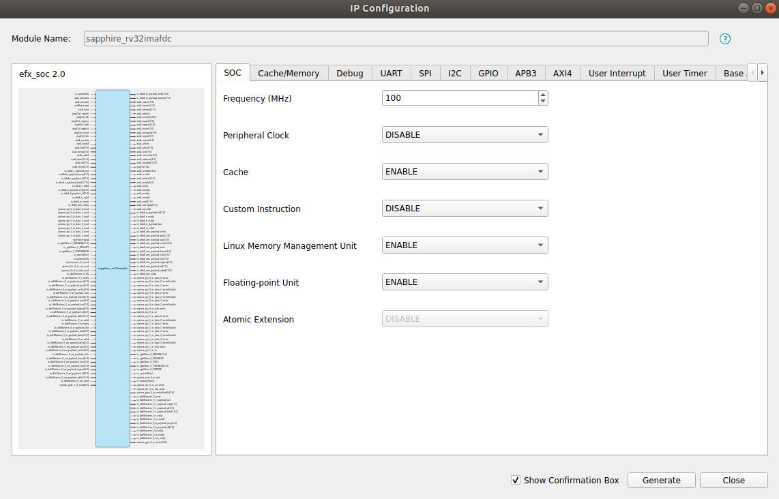

  - On SPI tab, Enable the SPI 1

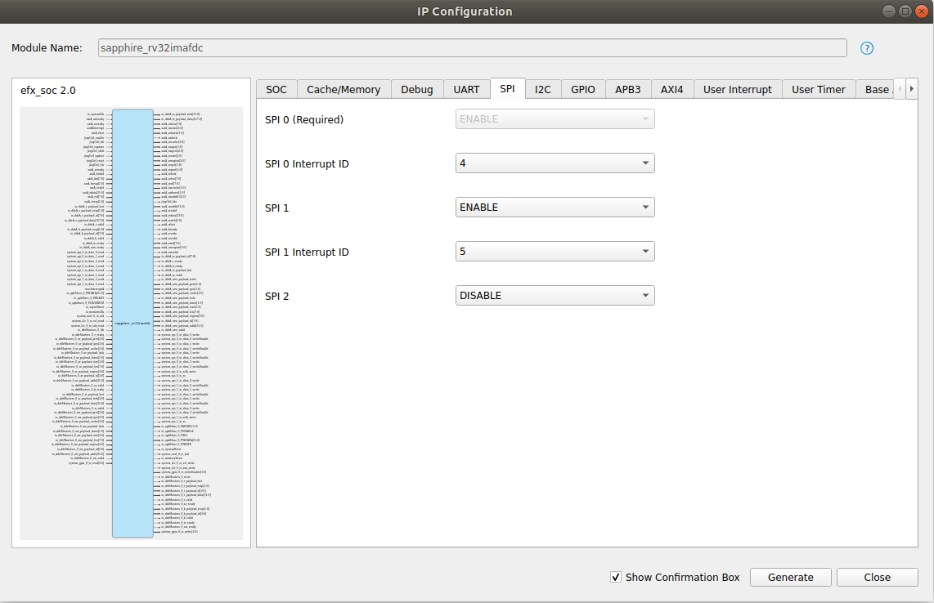

  - Click Generate button on the bottom to generate the design

- Open the generated project in ip folder and load the soc.xml file
- Open Efinity Interface Designer icon and add some blocks under GPIO. Use table below for each board. Click Create Block icon on Efinity Interface Designer to add block.
- Pin name and pinout for each IO
Board | Instance Name | Pin | Mode | I/O standard | Clock signal
T120F324 | system_spi_1_io_data_0  system_spi_1_io_data_1  system_spi_1_io_sclk_write  system_spi_1_io_ss  system_uart_0_io_rxd  system_uart_0_io_txd | GPIOT_RXP21  GPIOT_RXP22  GPIOT_RXP23  GPIOT_RXP20  GPIOT_RXP07  GPIOT_RXN07 | inout  inout  output  output  input  output | 3.3 V LVCMOS | io_systemClk
Ti60F225 | system_spi_1_io_data_0  system_spi_1_io_data_1  system_spi_1_io_sclk_write  system_spi_1_io_ss | GPIOR_16  GPIOR_18  GPIOR_15  GPIOR_13 | inout  inout  output  output |  | io_systemClk

Board | Instance Name | Pin name | Mode | Register option
T120F324 | system_spi_1_io_data_0  system_spi_1_io_data_1  system_spi_1_io_sclk_write  system_spi_1_io_ss  system_uart_0_io_rxd  system_uart_0_io_txd | system_spi_1_io_data_0_read  system_spi_1_io_data_0_write  system_spi_1_io_data_0_writeEnable  system_spi_1_io_data_1_read  system_spi_1_io_data_1_write  system_spi_1_io_data_1_writeEnable  system_spi_1_io_sclk_write  system_spi_1_io_ss | inout  inout  output  output  output  input  output | register
Ti60F225 | system_spi_1_io_data_0  system_spi_1_io_data_1  system_spi_1_io_sclk_write  system_spi_1_io_ss | system_spi_1_io_data_0_read  system_spi_1_io_data_0_write  system_spi_1_io_data_0_writeEnable  system_spi_1_io_data_1_read  system_spi_1_io_data_1_write  system_spi_1_io_data_1_writeEnable  system_spi_1_io_sclk_write  system_spi_1_io_ss | inout  inout  output  output  output | register

- Assign the pin to resource
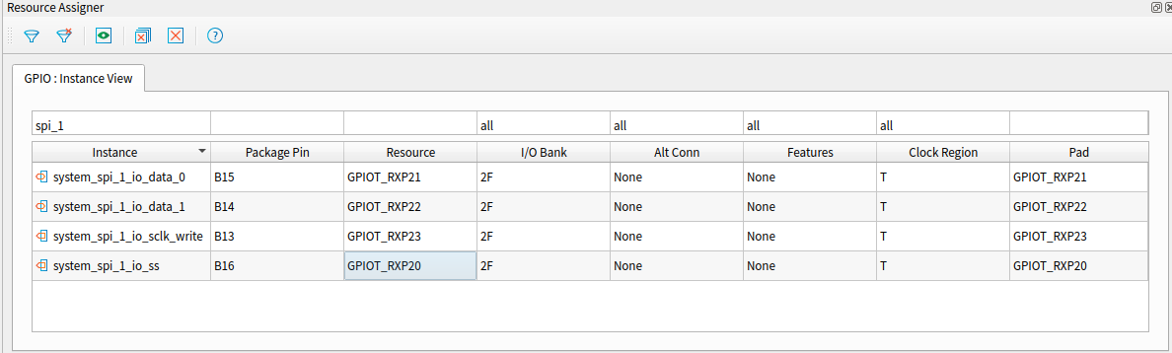
- Click Generate Efinity Constrain Files icon
- Open top_soc.v and edit it in the following section
- Modify in top_soc() by adding the following code
```
module top_soc (
…
output system_spi_1_io_sclk_write,
output system_spi_1_io_data_0_writeEnable,
input system_spi_1_io_data_0_read,
output system_spi_1_io_data_0_write,
output system_spi_1_io_data_1_writeEnable,
input system_spi_1_io_data_1_read,
output system_spi_1_io_data_1_write,
output system_spi_1_io_ss,
…
)
```
- And modify in soc_inst() by adding pin name in parenthesis ()
```
sapphire_rv32imafd soc_inst (
…
.system_spi_1_io_sclk_write(system_spi_1_io_sclk_write),
.system_spi_1_io_data_0_writeEnable(system_spi_1_io_data_0_writeEnable),
.system_spi_1_io_data_0_read(system_spi_1_io_data_0_read),
.system_spi_1_io_data_0_write(system_spi_1_io_data_0_write),
.system_spi_1_io_data_1_writeEnable(system_spi_1_io_data_1_writeEnable),
.system_spi_1_io_data_1_read(system_spi_1_io_data_1_read),
.system_spi_1_io_data_1_write(system_spi_1_io_data_1_write),
.system_spi_1_io_data_2_writeEnable(),
.system_spi_1_io_data_2_read(),
.system_spi_1_io_data_2_write(),
.system_spi_1_io_data_3_writeEnable(),
.system_spi_1_io_data_3_read(),
.system_spi_1_io_data_3_write(),
.system_spi_1_io_ss(system_spi_1_io_ss),
…
```
- Modify the bootloader address to enable OpenSBI, U-Boot and Linux to boot on the target board. Please refer to Modify FPGA Bootloader Address document in this repository.
- Compile Efinity project by clicking this icon 

