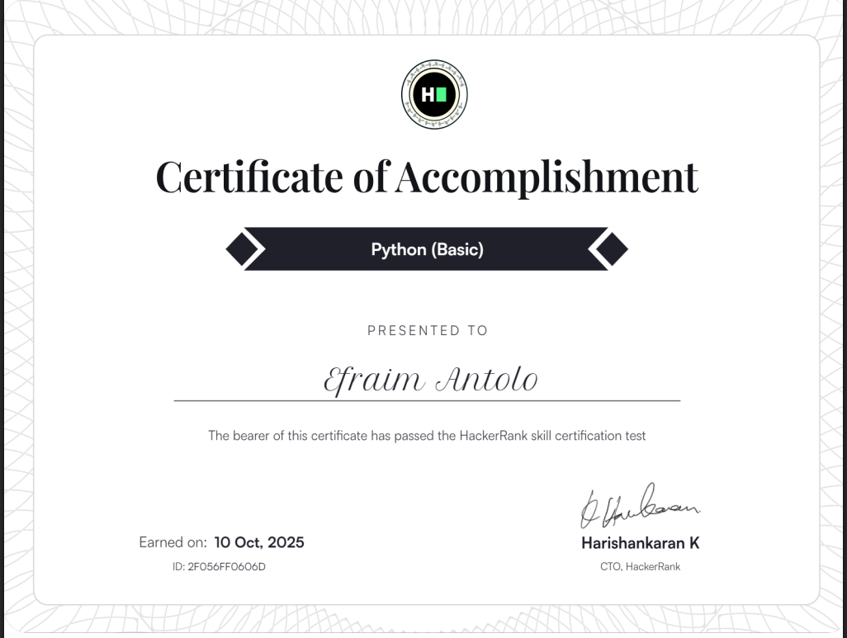

**Link:** [**https://www.hackerrank.com/certificates/iframe/2f056ff0606d**](https://www.hackerrank.com/certificates/iframe/2f056ff0606d)