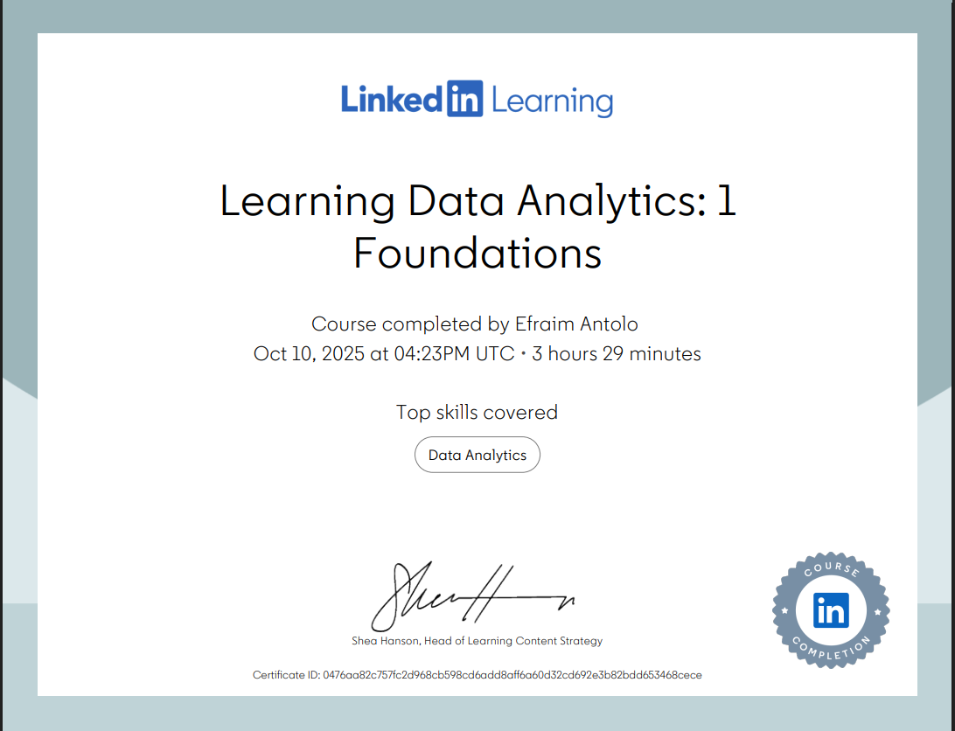

**Link:**<https://www.linkedin.com/learning/certificates/0476aa82c757fc2d968cb598cd6add8aff6a60d32cd692e3b82bdd653468cece?trk=share_certificate%20#dataanalytics>.