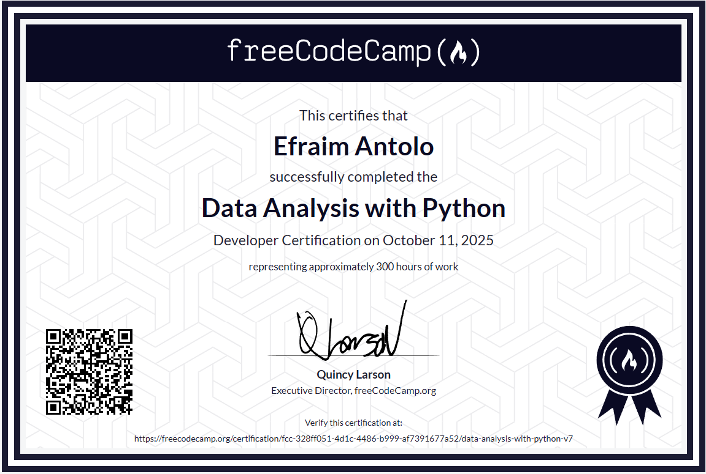

**Link:** [**https://www.freecodecamp.org/certification/fcc-328ff051-4d1c-4486-b999-af7391677a52/data-analysis-with-python-v7**](https://www.freecodecamp.org/certification/fcc-328ff051-4d1c-4486-b999-af7391677a52/data-analysis-with-python-v7)