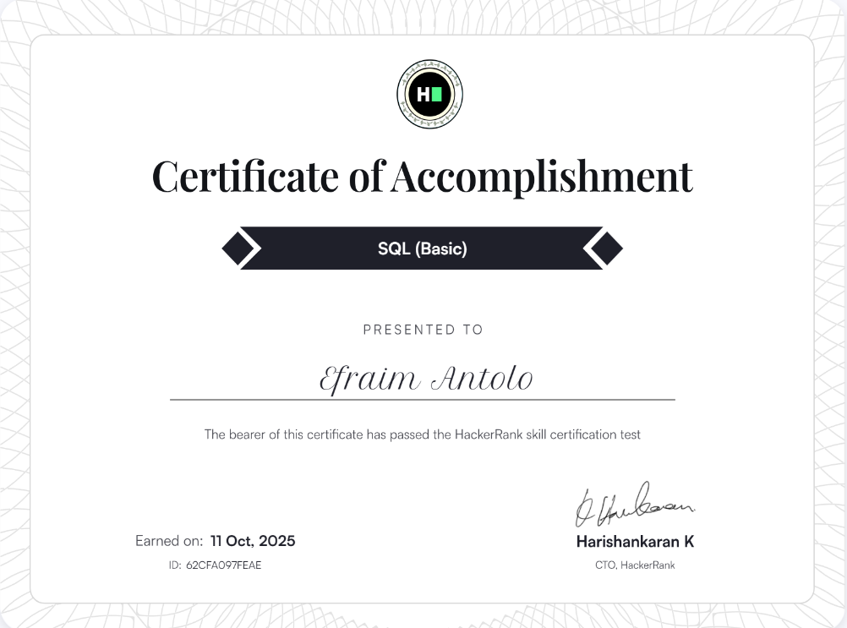

**Link:** <https://www.hackerrank.com/certificates/iframe/62cfa097feae>