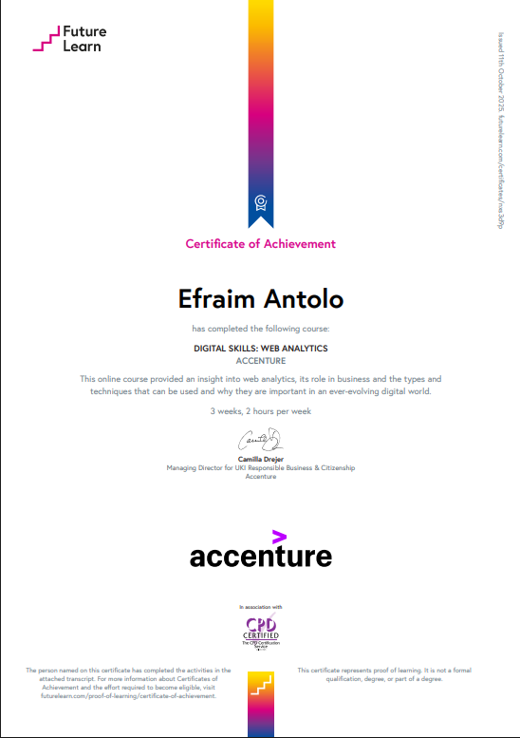

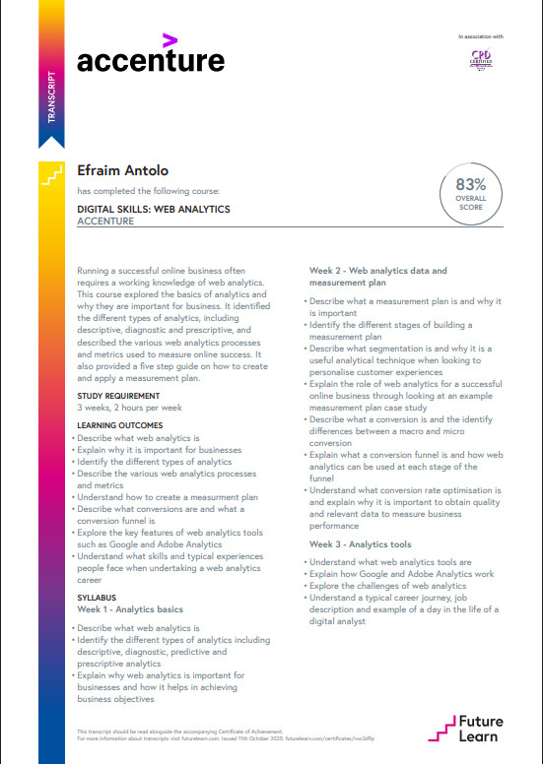

**Link:** [**https://www.futurelearn.com/certificates/nxs3d9p**](https://www.futurelearn.com/certificates/nxs3d9p)