THE KTM SYSTEM

|  |  |
| --- | --- |
| The KTM System, is a series of Excel Workbooks behind a python interface. The Excel can always be accessed, maintained and changed through MSExcel.  This system is specifically for keeping track of checks, images of checks and deposits. We do not do the accounting. We are only concerned with showing the user a picture of the check. This system is used instead of a “paper trail”.  FILE DIRECTORIES  There are two main directories: |  |

One for the code (base-directory/msutils/) and one for the data, or Excel spread sheets (base-directory/msutils/BOOKS/DATA).

THE DATA FILES

Here, we keep records of all checks that come in. In order to enhance our reliability, we also keep images of the checks. The other data we keep is person’s name, date check came in, date on the check, and amount. This is all kept in a series of Excel workbooks.

|  |  |
| --- | --- |
| Workbook DATA/DailyLog.xlxs:  This workbook is made up of a series of worksheets for the |  |

current month. Each worksheet is named according to the day it reports, the month name followed by a two-digit date. For example, in September the workbook may have worksheets September05, September08, September09 and so on.

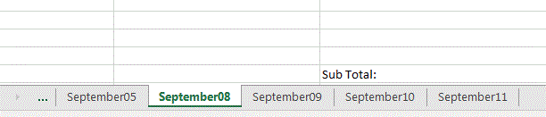

At the end of the month, the entire month will be moved to a new workbook, named after the month, and older workbooks will be moved into the DATA/Backup directory.

In the DATA/Checks directory, are the images of the checks for the day. I normally name them “ChecksMonthDayYearDesignation”. For example, in the picture I have

|  |  |
| --- | --- |
|  | Checks09102019, and Checks09092019, and Checks09092019b. These file names are listed in the excel file as I scan them in.  In summary, there is an excel workbook, that has one spreadsheet for each day (tabs at the bottom of the workbook). Each one of these spreadsheets has titles, and data about each check. This data is |

input manually.

THE CHECKS COME IN – STEP BY STEP THROUGH THE PROCEDURE

The checks have been retrieved from the mailbox and opened. First click on the Tree Icon on the desktop. This opens the application panel. Let’s say you have three checks:

Schwartz 4933 In memory of mother $18.00  
Berkowitz 809 Kiddush Donation $180.00  
Bronfman 101 Donation $18000.00

|  |  |
| --- | --- |
| Open the application, and click on the button ‘Enter Checks/Cash’. This opens a data entry screen.  The name of the deposit can be anything, but the screen prompts you to continue your last deposit (if it has not been deposited).  Now you can enter the data, one check at a time, and press ‘save’ each time.  When you have finished, close the screen, and scan the checks. I usually scan as many as possible in one image, so I would scan all three into one image. |  |

My scanner is set to move the scans into a specific directory. This directory is listed in my profile. If this is set up properly, I can simply click the “Move Chk” button. The images are moved into the proper ‘’checks’ directory, and the excel spreadsheet is updated.

Click on the button that says “Check View”, and a new panel opens up. This panel allows you to view information by day (the drop down list) or by deposit (the list in yellow on the left).

|  |  |  |  |  |  |  |
| --- | --- | --- | --- | --- | --- | --- |
| |  |  | | --- | --- | | If you click on the day in the dropdown list, a list of entries for that day is presented. If you click on the deposits in yellow, a list of transactions is presented for that deposit. | | | |  |  | | --- | --- | |  | On this list you can either click on the name, to view every transaction under that name, or on “view” and see the check image. | | |  |

Please notice, there are two sections of the page. The top is for cash, and the bottom is for checks.

Each new page must be associated with the deposit you are currently working on. For example, I am creating a deposit called “FirstWeek”, so I should enter “FirstWeek” into the box under the box that says “Deposit:” (Column G; Row 2).

Multiple spreadsheets can be associated with the same deposit.

Enter the check number, name, memo, data on the check, and amount.

Get the physical checks, stamp the backs, and place them on the copier to scan them in. This scan will then be renamed to “ChecksMMDDYYYY” e.g. Checks08281960.

The name you use is entered into the spread sheet under “Image”. Save. Close. Close the KTMSystem.

THE CHECKS: What do you have?

Now you have all the data at your fingertips!

Click on the Tree => click on “Check View”. You see a panel with two buttons, a dropdown box, and a list of deposits. The drop down list is a series of dates – one for each worksheet you entered. Open todays!

The “Print” button allows you to print the Excel spread sheet.

The “View” button allows you to look at the image of the actual check. In order to print the checks, you have to view them, then print from adobe viewer.

If you click on a deposit name, you see all the details of that deposit. From the deposit, you can click on a person’s name and see all of their checks.

THE CHECKS: The “SHIFT” button

Now you have all the data at your fingertips!

When the data becomes a bit unwieldy, click the ‘shift’ button. That will move all the older data into the backup folders and allow you to focus on the current data.

If you want to see ALL the data you have, open the “Check View (All)” button. It is exactly the same – but it reads all the data you have.

WHAT ELSE DO YOU HAVE?

Button: Build Monthly Yahrzeit List

In ShulCloud, there is a spreadsheet of yahrzeits you can download. It looks something like this:

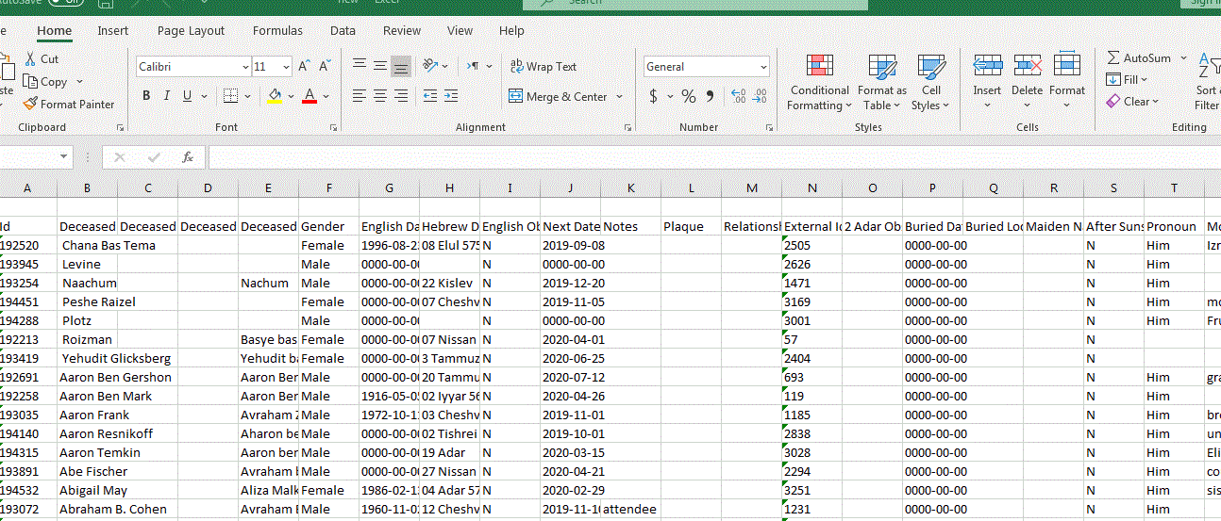

If you put that into your Downloads folder, and then move the file into position using the ‘FIX’ button when necessary (remember this file needs to be updated to reflect current information in shulcloud; we will prompt you when it needs to be downloaded again). The button to the write will reformat the file so we can use it. This will open

|  |  |
| --- | --- |
| excel for you, and you can print the worksheets.  After you print them, just close the excel file. |  |

Button: Yahrzeit Names for Bulletin

At KTM we publish a weekly bulletin. In this bulletin we list all the yahrzeits for the week – including Shabbos on both sides of the week. This button opens a word document with those names.

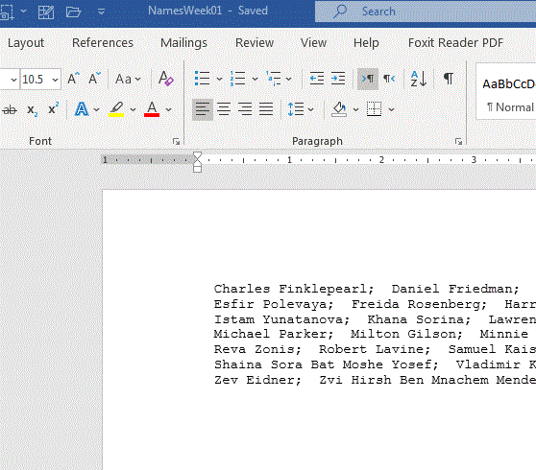

AND THE FOURTH BUTTON?

In ShulCloud, the organization collects donations and then packages them together as a ‘Deposit’. This ‘Deposit’ should reflect the actual money taken to the bank. ShulCloud generates a report with all the transactions. We take this report, scan it, and store the scan in the ‘deposits’ directory.

In the check entry system, we have input all the cash and checks and labeled those transactions under a deposit name. In shulcloud, we have the deposit. Here, we track the deposits and we can compare them to the deposits listed in the check entry system.

If you want to go directly to the excel spread sheet and not deal with the viewer application, just click on the “FILE” button.

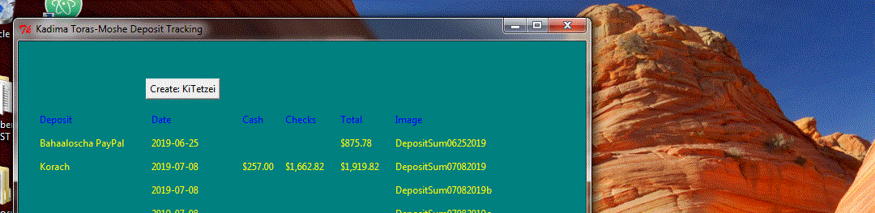

Clicking the ‘Create Deposit-name’ button creates a new deposit from the check entry system. This should match the deposit from ShulCloud. You can also see the scan of the deposit by clicking on the image name.

THE LAST TWO BUTTONS:

The next button is “Send EMAIL for Aliyas”. If someone pledges an Aliyah, we log it in the shulcloud database as a $0 payment categorized as “Aliyah”.

This button tells our KTMSystem to read the transaction file for every occurrence of a $0 payment for an Aliyah and send email to the oleh. I click this button once each month.

Finally, there is the “Send EMAIL for Mishberech” button.

We keep a “Mishberech” spreadsheet on shulcloud under “Files”. This application knows where the file is, downloads it, and sends email to everyone who has had someone on the list for longer than 30 days. The email says I am going to take the person off the list unless they email back and ask me to keep them.

I then update the list based on the return emails, deleting the name if there is no response. This helps us to keep our mishberech list from growing exponentially.

If you click on the “File” button, next to the “Mishberech” button, you will open the Excel spreadsheet. Please notice, this workbook has two worksheets. The first, “Updates” is for you to update. You can add and subtract data.

The second worksheet, called “Print” is for printing. This one has formulas that copy the data from the first worksheet. It also has hidden rows so that it all prints together.

If you enter data into Updates, and it does not show up, make sure the row is not hidden (and hide the empty rows)!