**CSC3119 User Interface Design**

**FIGMA ASSIGNMENT REPORT**

**YEAR 3 BSSE**

**NAME: EFRATA ARON**

**REG NUMBER: 22/X/5249/PS**

**STUDENT NUMBER: 2200705249**

**MUSIC APP: MUSICEL**

**Github Link;**

**<https://github.com/EfrataAron/FIGMA_UI.git>**

**Design;**

<https://www.figma.com/design/N2VdbTW8wJKfMxomI786Dy/Musicel?node-id=0-1&t=WWF9QzsULblUxJuB-1>

**Prototype;**

**<https://www.figma.com/proto/N2VdbTW8wJKfMxomI786Dy/Musicel?node-id=4-3&node-type=canvas&t=Ps8Lg6BwIWJstPqo-1&scaling=scale-down&content-scaling=fixed&page-id=0%3A1&starting-point-node-id=4%3A3&share=1>**

1. **Introduction**

**MUSICEL** is a mobile app that focuses on music listening. It is a user-friendly, intuitive and visually appealing app that has been designed using **Figma.** The app provides music streaming, personalized playlists and recommendations.

1. **Target Audience**

The App is intended for music lovers and music enthusiasts to access their favorite songs, playlists from various artists online.

1. **Goals**

It is designed for simplicity of users access to music and listening activity.

* **Improve User Experience:** Design a clear and simple navigation structure that allows users to easily find and access their desired music.
* **Personalized Experience:** Implement features that personalize the user experience, such as customized recommendations and saved playlists.
* **Seamless Playback:** Ensure smooth and uninterrupted playback of music, with minimal buffering and loading times.

1. **User Personas:**

Music Lovers; Uses the app occasionally for mood-based playlists.

"Music Enthusiast" – Regularly explores new releases and curates playlists.

1. **Initial wireframe / Lowfi**

The lowfi shows the basic layout of the app, showing where elements are placed and where images will be. The high fi is created based on this lowfi design. The Low fi for the Musicel Music app is shown below. The text has been represented using lines.

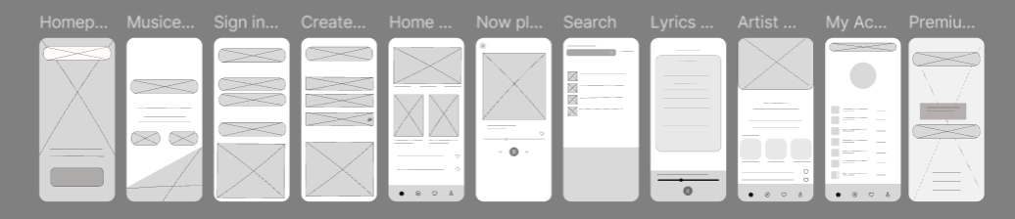

**High-Fi**

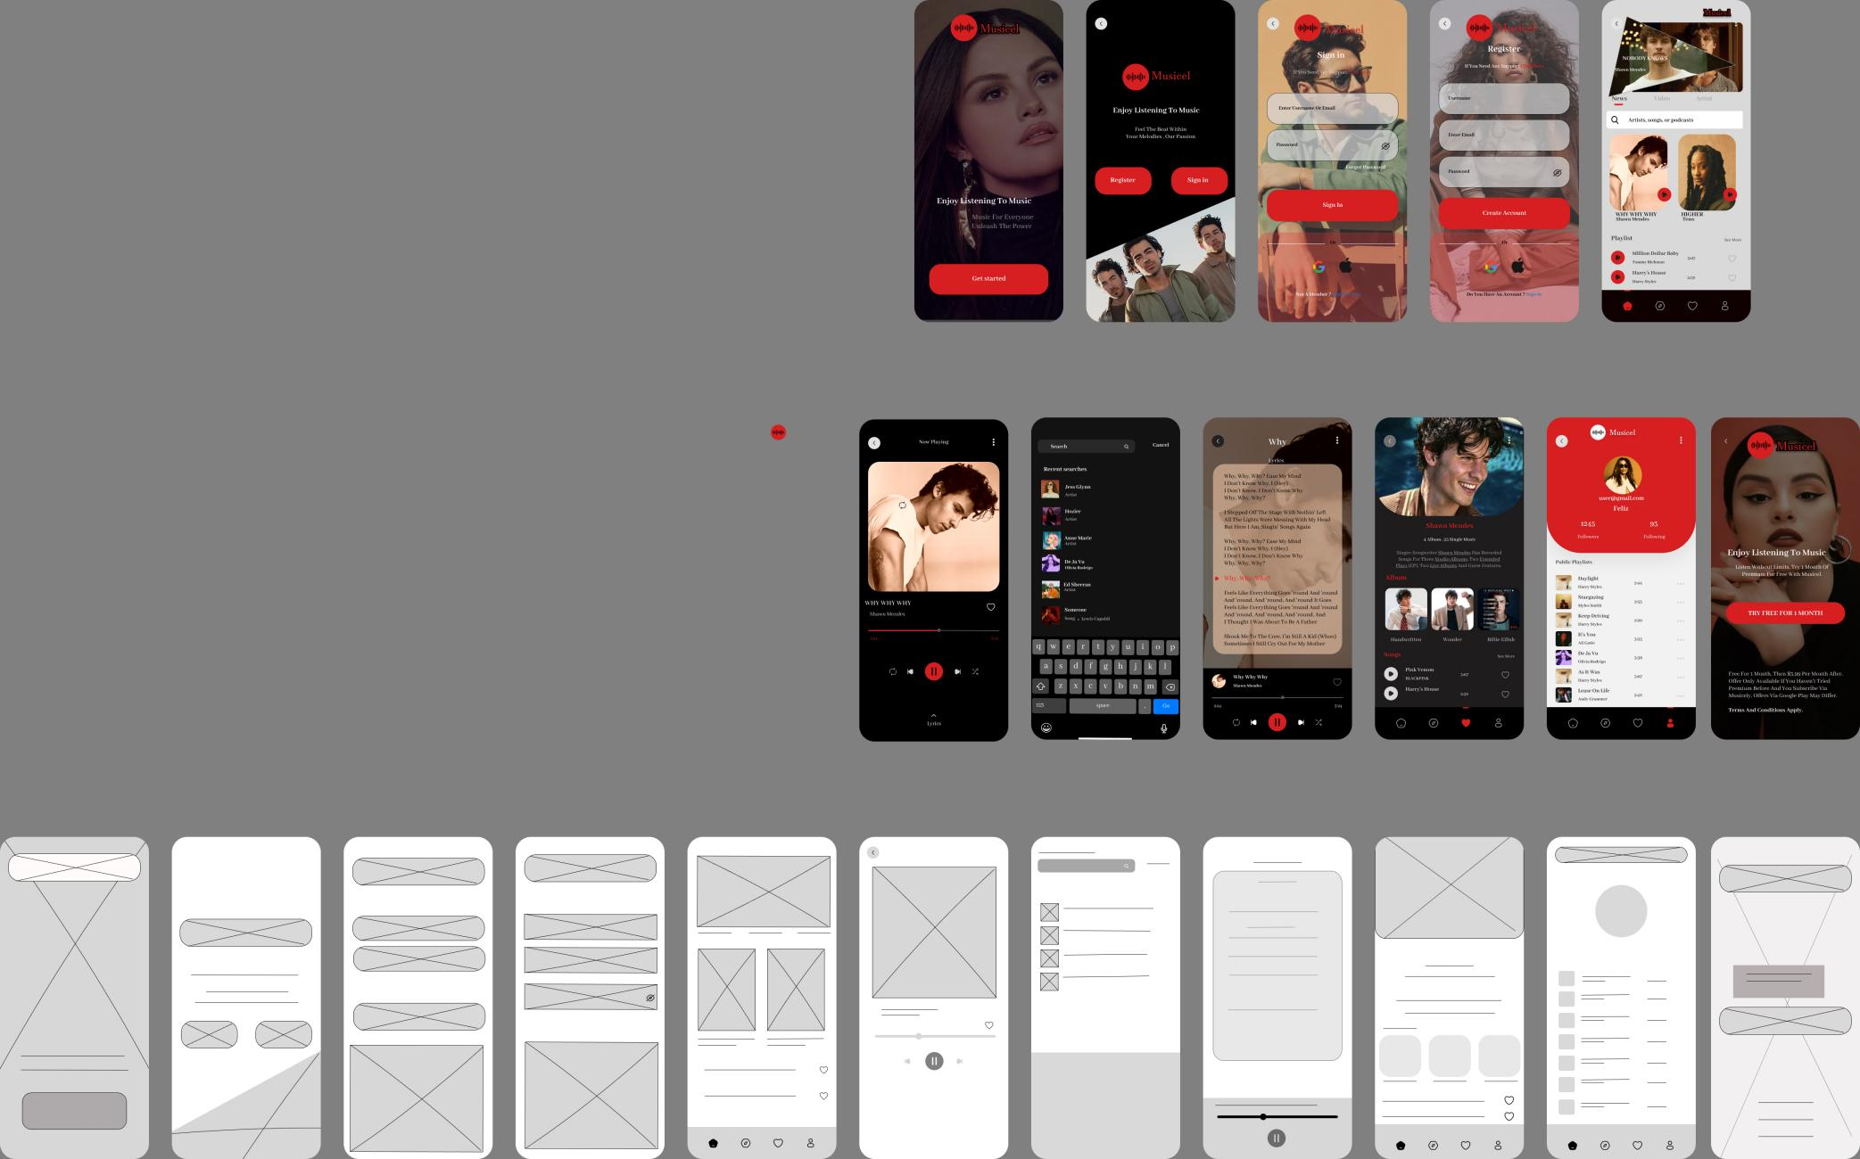

The highfi as shown above is derived from the lowfi. It shows different pages including landing page, home, register, signup, lyrics page, search, artist page, now playing page, account page, Premium page.

**PAGES**

**Home Page:** Displays featured playlists, recently played songs, and personalized recommendations.

**Register Page:** A form for new users to create an account by entering details like email, username, and password.

**Sign-In Page:** Allows existing users to log in with email or social accounts like Google or Apple.

**Lyrics Page:** Displays song lyrics while the music is playing for an immersive experience.

**Search Page:** A search bar for exploring songs, artists, or playlists, with recent searches shown below.

**Artist Page:** Highlights an artist’s profile, albums and popular songs.

**Now Playing Page:** Shows the currently playing song, album art, playback controls, and options like adding to favorites.

**Account Page:** Displays user profile details, playlists, following and followers.

**USER INTERFACE**

1. **Shapes**.Using shapes to create buttons and create backgrounds and a visually appealing interface. For example using rectangles and adjusting the radius to form nice shapes.
2. **Designing pages on frames.** Creating frames and choosing the devices for which the app is being designed for. For example android, iphone.
3. **Prototyping** pages by linking components of the page to another page for example a button or link so that when tapped then proceeds to the next page. Also animations and effects for the arrow actions can be chosen.
4. **Colours**. Choosing colors that will be used in app creation. For Musicel, three colors were used . Red, shades of black and white.
5. **Images and Icons**. High resolution images and icons were used to make the application visually appealing and aesthetic. Icons are used to represent functionality in the app for example the home, search, settings and accounts icons.
6. **Typography**. Choosing readable fonts and font sizes. This also involves making necessary adjustments and adding desired text effects.

In Conclusion, Musicel is a sleek and user-friendly music streaming app that offers personalized playlists, song lyrics, artist profiles, and seamless account management, delivering an engaging and enjoyable listening experience.