SciTech2023-**[Paper ID]**

Title of the paper style *Title 0*

Name Surname1[1], Name Surname2[2], Name Surname3[3], Name Surname4[4]

**Abstract.** Style *Main 0*.

**Keywords**: Style *Main 0*.

1. Title of the first level

Use the style *Title 1*. The title is separated from the previous and subsequent text by empty line of the style *Main 0*.

Main text is typed by the style *Main 1*. Do not use tabulation and other ways for indent in the 1st line. If the indent is not required, for example if a equation is inside a text, use the style *Main 0*.

1.1. Title of second level

Use the style *Title 2*. The title is separated from the previous and subsequent text by empty line of the style *Main 0*.

Table is centered. The title of the table is before it and separated from the previous text by empty line (here and after empty line means empty line of *Main 0* style).

The style of the table title is *Tab Cap*. There is no full stop at the end of the table title.

The title of the table is not separated by empty line from the table.

Tab. 1. Title of the table

|  |  |
| --- | --- |
| Title of each column is centered |  |
| Table Font: Times New Roman from 10 to 12 pt. |  |

The table is separated from the following text by empty line.

1.2. Figures

Figure is centered and separated from the previous text by empty line. The style of figure is Figure.

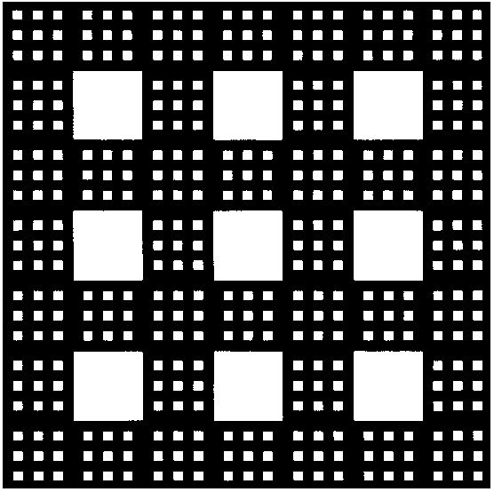

Fig. 1. Serpinsky carpet, the second step of construction

The picture caption is under the picture, style *Fig Cap*. The caption is separated from the following text by empty line. There is no full stop at the end of caption.

1.3. Equations

Equations are typed in the MS Word editor (2007 or higher) are placed in two column table and numbered. In the left column formulas should be put center aligned. All equations are numbered in the right column with right alignment. The bounds of the table are invisible. Equations are separated from previous and following texts by empty line.

Example 1

|  |  |
| --- | --- |
| $${\left(x+a\right)}^{n}=\sum_{k=0}^{n}{\left({n \atop k}\right)x^{k}a^{n-k}}$$ | (1) |

Example 2

|  |  |
| --- | --- |
|  | (2) |

2. Acknowledgements

Style *Main 0*

3. References

Use style *Ref.*

1. Andreev, Y.N. Control of finite-dimensional linear objects. М.: Nauka, 1976.(in Russian)
2. Nordstrom, K., and Norlander, H. On the Multi Input Pole Placement Control Problem. Proc. of the 36th IEEE Conference on Decision and Control, vol. 5, p. 4288-4293, 1998. DOI: 10.1109/CDC.1997.649511.

1. Affiliated organization name, organization address, author email
2. Affiliated organization name, organization address, author email
3. Affiliated organization name, organization address, author email
4. Affiliated organization name, organization address, author email