touchLockWEH

Tool to lock the touch screen of a Windows Embedded Handheld 6.5.3 device.

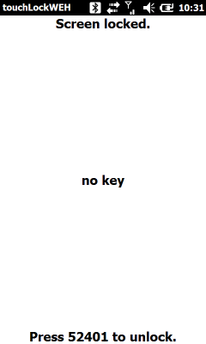

To unlock the touch screen press 52401 within a short time. If the entered number is wrong, the input can be started again after a short timeout.

The entered digits are printed in the mid of the screen. If the key is wrong or input has timed out, the input is cleared.

## Installation

Just copy the touchLockWEH.exe to the device and start it when needed. In the following touchLockWEH has been copied to "\Flash File Store\touchLockWEH.exe” on the device.

## Integrate with Intermec Launcher

In the following configuration touchLockWEH is installed as third application and assigned to the APP 1 hardware key:

<?xml version="1.0" encoding="UTF-8" ?>   
<DevInfo Action="Set" Persist="true">  
 <Subsystem Name="Intermec Launcher">  
 <Group Name="Application Launch Buttons">  
 <Group Name="Application Button 3">  
 <Field Name="Executable Path:">\Flash File Store\touchLockWEH.exe</Field>   
 <Field Name="Caption:">LOCK screen</Field>   
 </Group>  
 </Group>  
 <Group Name="Keypad Options">  
 <Group Name="Application Shortcut Keys">  
 <Field Name="Application Key 1 Path:">\Flash File Store\touchLockWEH.exe</Field>   
 </Group>  
 </Group>  
 </Subsystem>  
</DevInfo>  
Copy this content as xml file to \SmartSystems\SSConfigDir on the device to use touchLockWEH as third application and assign APP1 button to touchLockWEH.

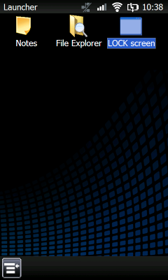

## Assign to Intermec Launcher hardware key

To assign a hardware key as APP 1 key use the Intermec Keyboard Remapper Utility (see Intermec Device Resource Kit). In the following, the “Star” key has been assigned as APP 1 button and will launch touchLockWEH (and Intermec Launcher with the above configuration).

