Ministry of Education and Research of the Republic of Moldova
Technical University of Moldova
Faculty of Computers, Informatics and Microelectronics
Department of Software Engineering and Automatics
REPORT
on Laboratory Work No. 5
Course: Operating Systems
Topic: The File System with Your Own Hands
Track A: warm-up on Linux
Done by: st. gr. FAF-242, Eftode Andrei
Checked by: univ. assist. Reițman Patricia
Chișinău, 2026
Contents
Laboratory Work No. 5. The File System with Your Own Hands 3
Preparation 3
Part 1. The tree and the file types 3
Part 2. Inodes and links 4
Part 3. Permissions 6
Part 4. Disks and the kernel as files 8
Part 5. Stretch: all four 9
Deliverables and conclusions 11

Laboratory Work No. 5. The File System with Your Own Hands
Purpose: to check on a real Linux system the ideas of the lecture: the directory tree and the file types, inodes behind the names, hard and symbolic links, permissions, and the disks underneath, using only commands.
Environment: Ubuntu 26.04.1 LTS in a VirtualBox virtual machine (8 processors, 6.4 GB of RAM, a 50 GB virtual disk), user vboxuser, not root. The CPU, RAM and disk answers describe this virtual machine.

Preparation
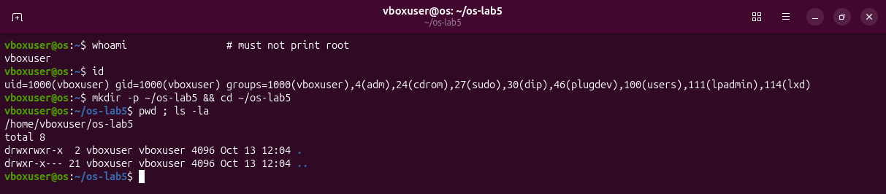
Figure 0.1 – whoami is not root; the folder ~/os-lab5 is created.

Part 1. The tree and the file types
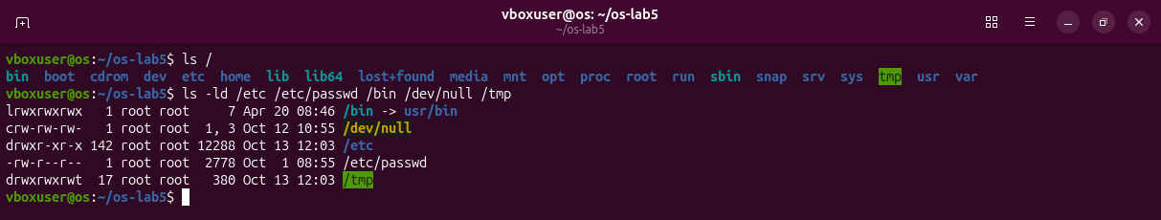
Figure 1.1 – The root directory and the five paths of the sheet.
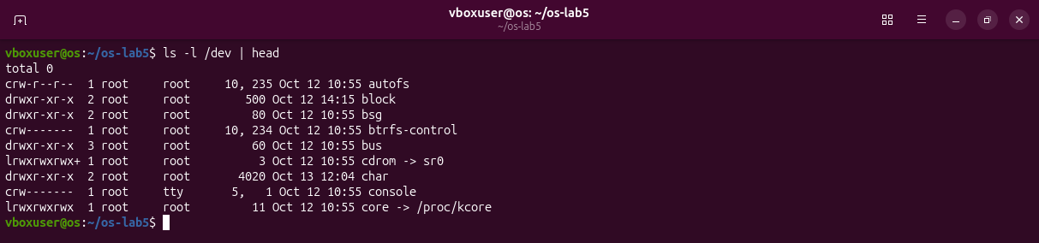
Figure 1.2 – The first entries of /dev.
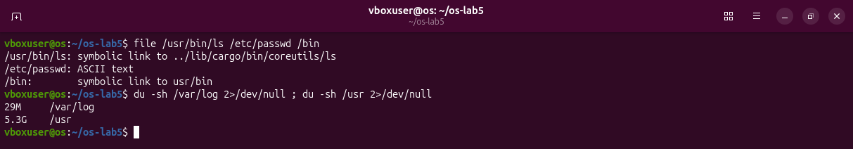
Figure 1.3 – file and du.
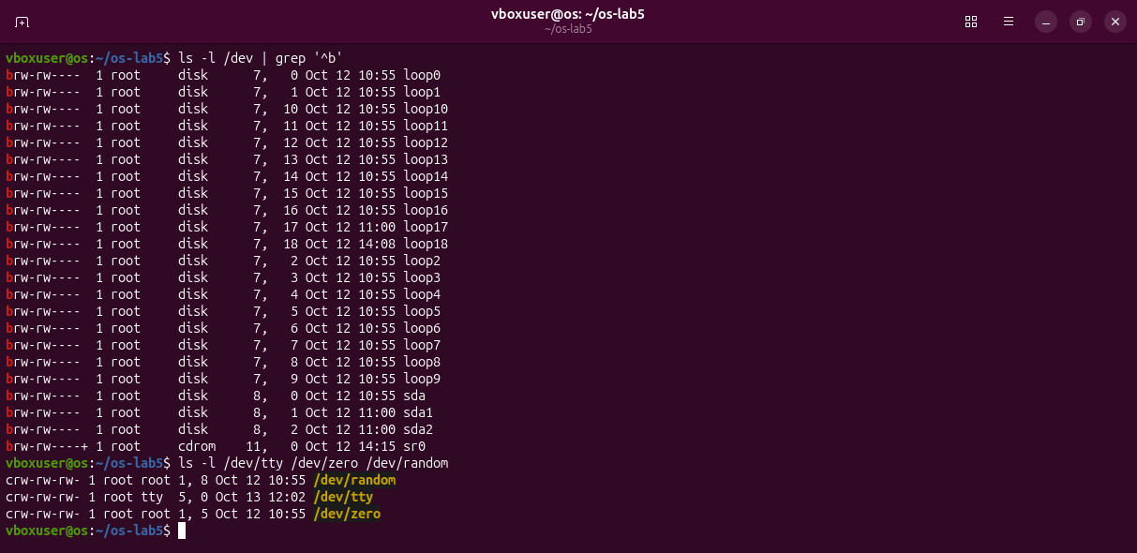
Figure 1.4 – All block devices, and three character devices.
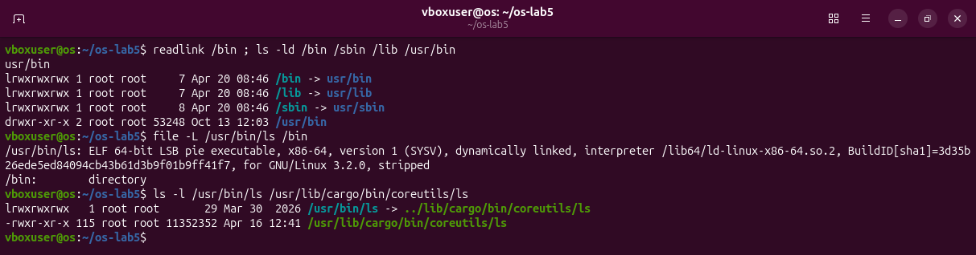
Figure 1.5 – /bin is a link; /usr/bin/ls is a link to the Rust coreutils program.
Observations
(1) Types: /etc is d, a directory; /etc/passwd is -, a regular file; /bin is l, a symbolic link; /dev/null is c, a character device; /tmp is d, a directory (with the sticky bit t).
(2) /bin: a symbolic link to usr/bin, that is /usr/bin. /sbin and /lib are links in the same way.
(3) Devices: character device /dev/null (major 1, minor 3); block device /dev/sda (major 8, minor 0), the disk, with the partitions sda1 and sda2.
(4) Sizes: /usr has 5.3G and /var/log 29M, so /usr is bigger by about 5.3 GB, roughly 190 times.

Part 2. Inodes and links
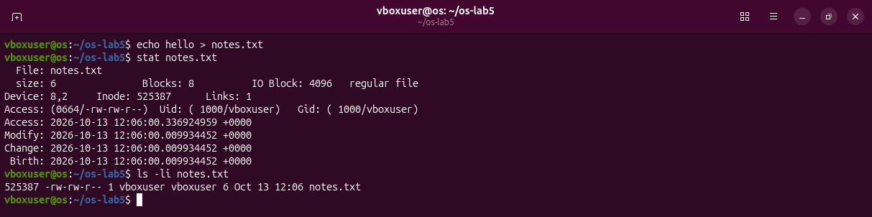
Figure 2.1 – An inode: stat and ls -li.
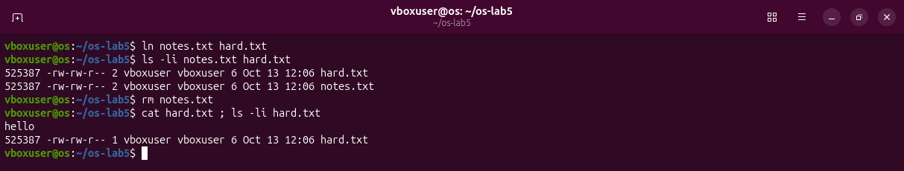
Figure 2.2 – A hard link, then rm of the "original".
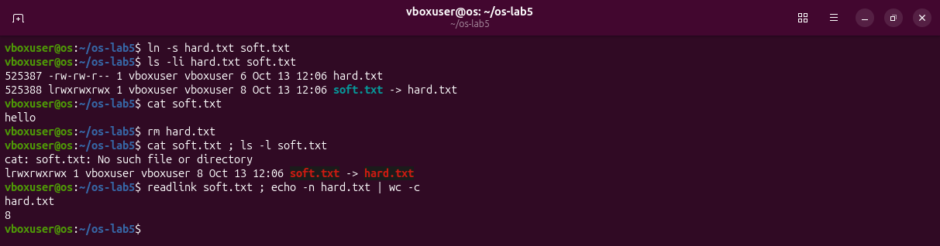
Figure 2.3 – A symbolic link, then rm of its target.
Prediction for the next step: a new directory has 2 links, and 4 after two subdirectories.
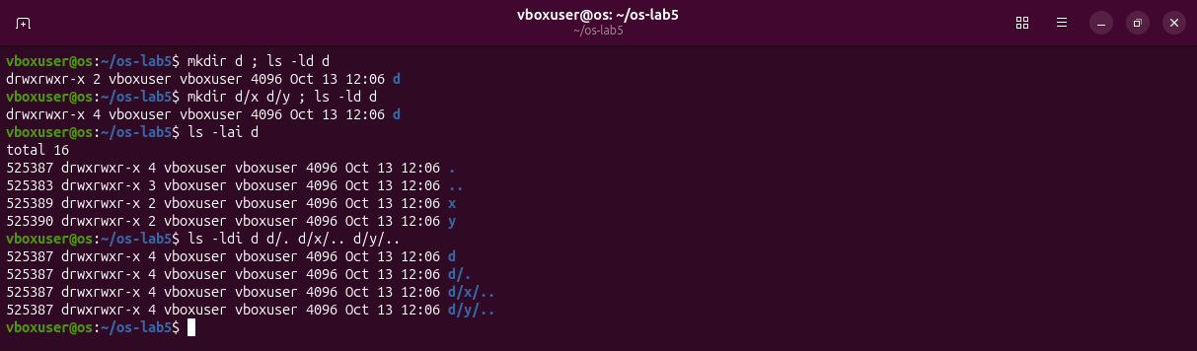
Figure 2.4 – Links of a directory; the four names of inode 525387.
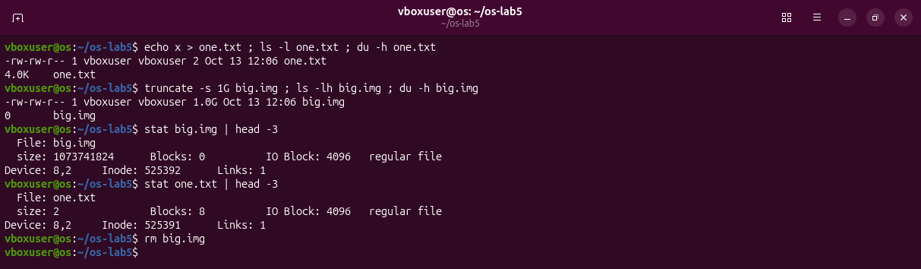
Figure 2.5 – Size is not space: a 2-byte file and a 1 GB sparse file.
Observations
(1) Inode: 525387 is the inode number; Links: 1 is how many names the file has.
(2) ln gave the same inode a second name (links 2). rm removes a name, not the file: it deletes the directory entry and lowers the count to 1. The data is freed only when no name and no open descriptor is left.
(3) soft.txt is a separate inode that holds only the path hard.txt; that name no longer exists, so following it fails. Its size is 8 bytes, the length of the text hard.txt.
(4) The prediction was right. The links are the name d in its parent, the entry . inside d, and the entry .. inside each of x and y: all four point to inode 525387 (Figure 2.4).
(5) Space is given in whole 4 KiB blocks, so 2 bytes take 4.0K (Blocks: 8 of 512 bytes). truncate only sets the size and allocates no block (Blocks: 0), so the 1 GB file uses 0.

Part 3. Permissions
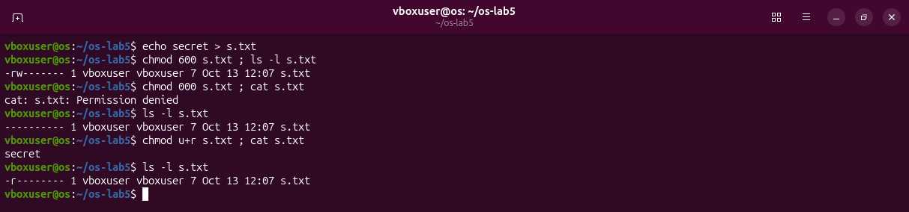
Figure 3.1 – Modes 600, 000 and u+r on s.txt.
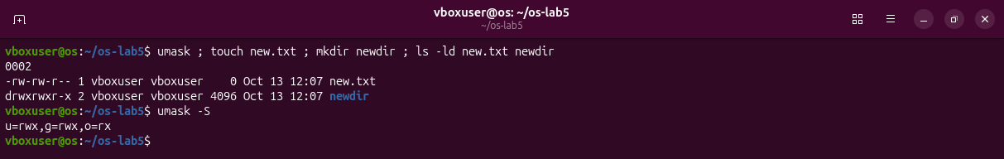
Figure 3.2 – The umask and the modes of a new file and a new directory.
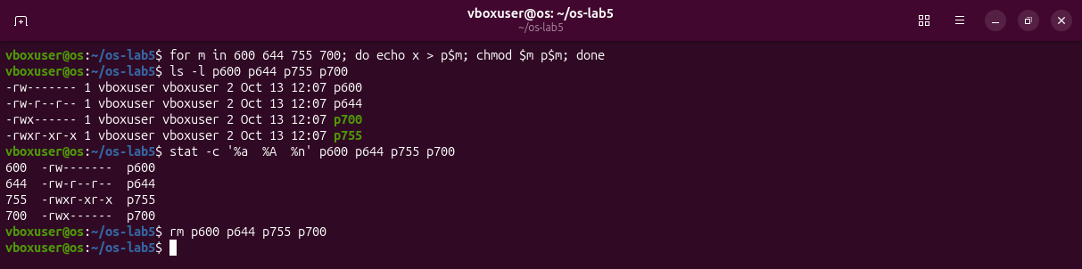
Figure 3.3 – The four modes of Observe (1), as numbers and as rwx.
Prediction for the box: with r only, ls works and cat fails; with x only, ls fails and cat works.
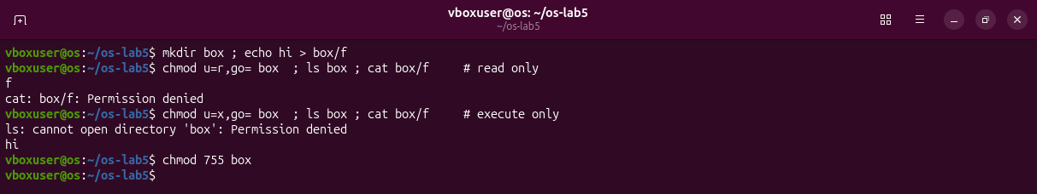
Figure 3.4 – The box experiment, exactly as on the sheet.
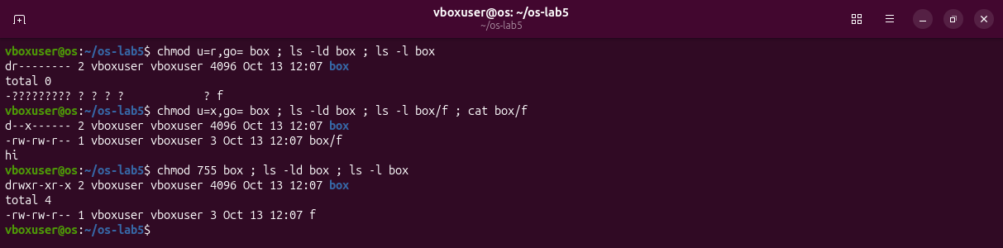
Figure 3.5 – The same with ls -l: names without details, details without names.
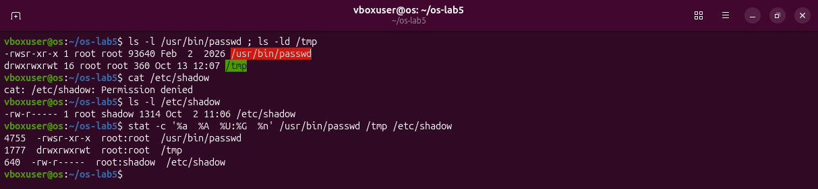
Figure 3.6 – Special bits, and a file I may not read.
Observations
(1) 600 = rw------- (a private key), 644 = rw-r--r-- (/etc/passwd), 755 = rwxr-xr-x (programs, /usr/bin/ls), 700 = rwx------ (a private folder, ~/.ssh).
(2) The kernel uses only the owner bits for the owner, and they are ---. Owning the file gives no access, only the right to change the mode, which chmod u+r did.
(3) The umask is 0002: it removes write for others. Files start from 666, so rw-rw-r-- (664); directories from 777, so rwxrwxr-x (775).
(4) The prediction was right. r on a directory allows reading the list of names; x allows going through it to a name you already know.
(5) s is the setuid bit: passwd runs as its owner, root, so it can write /etc/shadow, which only root may write. t is the sticky bit: in /tmp everyone may create files, but only the owner may delete them.

Part 4. Disks and the kernel as files
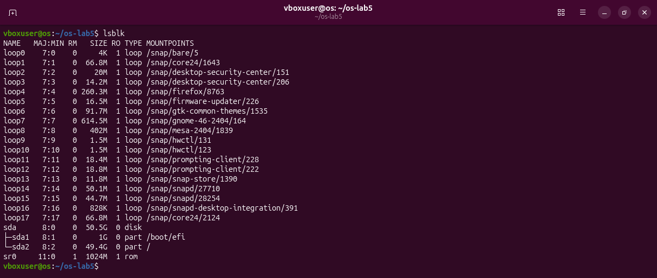
Figure 4.1 – lsblk: the disk, its partitions, and the snap images.
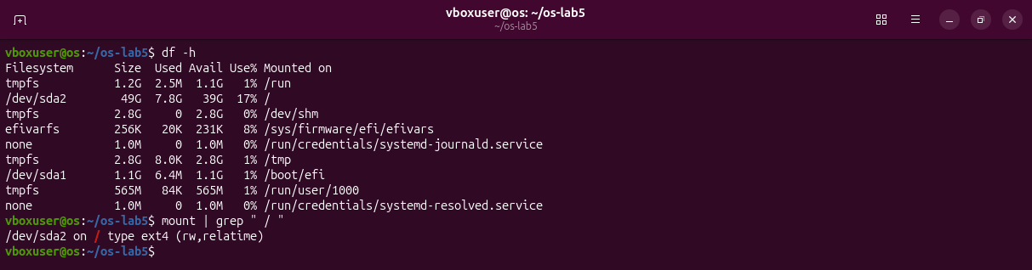
Figure 4.2 – df -h and the root mount.
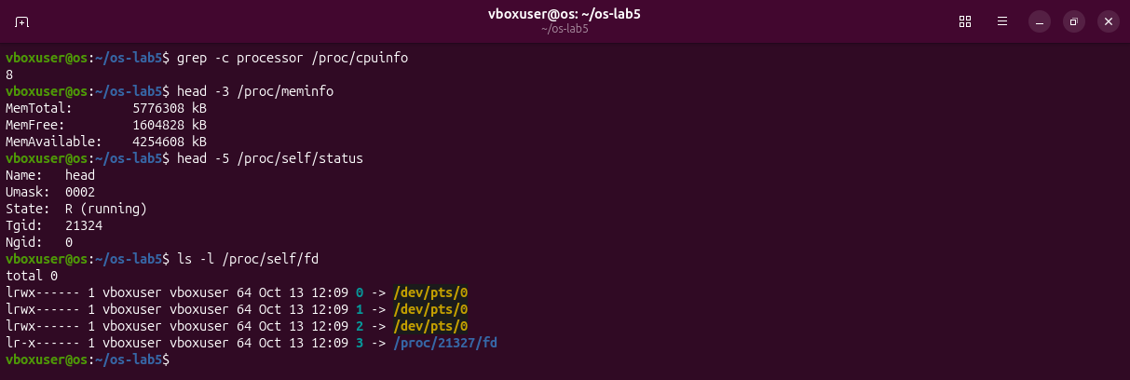
Figure 4.3 – Cores, RAM and the process itself, read from /proc.
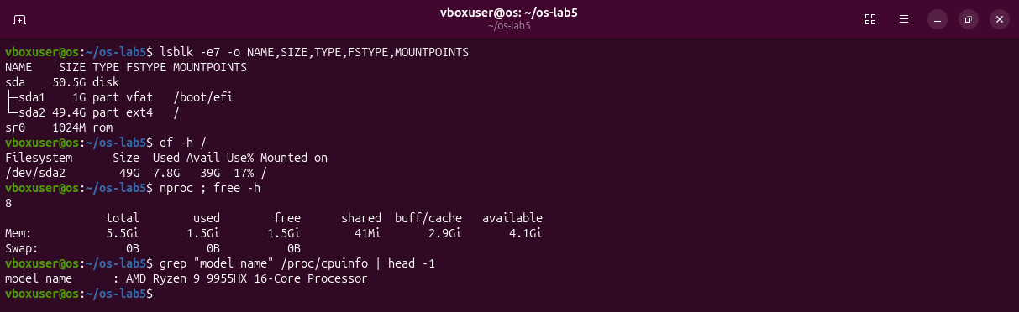
Figure 4.4 – The disk without the loop devices, the root use, and the processor model.
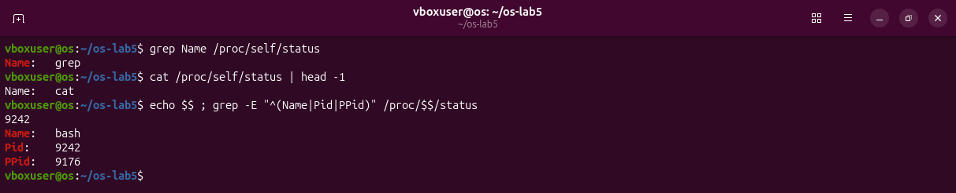
Figure 4.5 – /proc/self names whoever reads it.
Observations
(1) My disk:
sda 50.5G (virtual disk)
|- sda1 1G vfat mounted at /boot/efi
`- sda2 49.4G ext4 mounted at /
(2) The root file system is 17% full: 7.8G used of 49G, 39G free.
(3) 8 cores; MemTotal 5776308 kB, about 5.5 GiB of RAM (the virtual machine was given 6.4 GB; the real laptop has an AMD Ryzen 9 9955HX with 16 cores).
(4) head: /proc/self always means the process that reads it, and that process was head itself (grep and cat see their own names, Figure 4.5).

Part 5. Stretch: all four
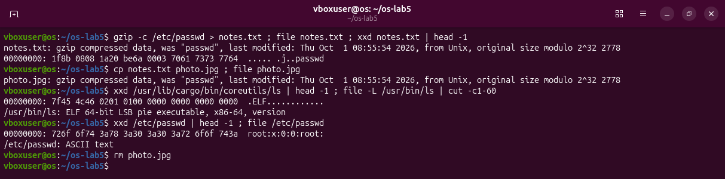
Figure 5.1 – (a) Magic numbers: file reads the first bytes, not the name.
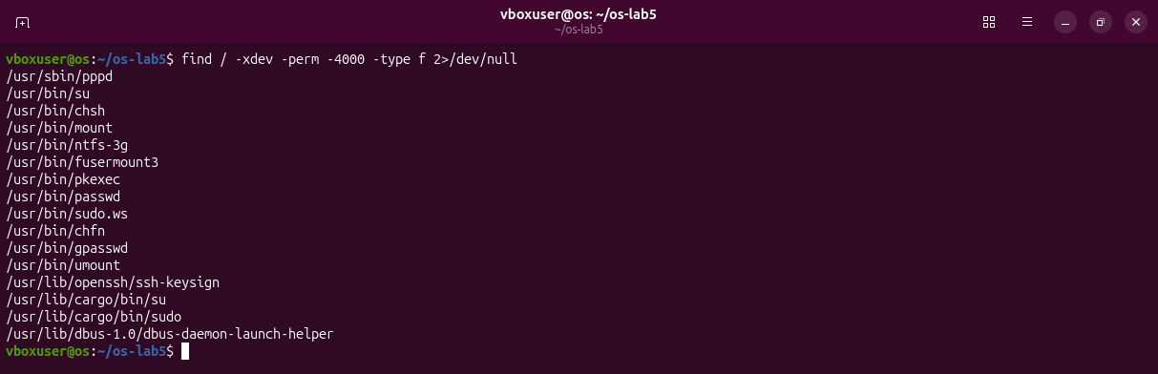
Figure 5.2 – (b) The setuid programs of this system.
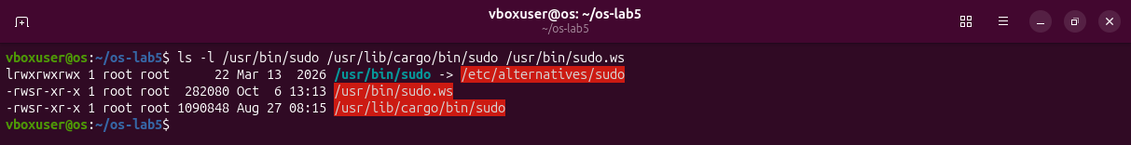
Figure 5.3 – (b) Two versions of sudo.
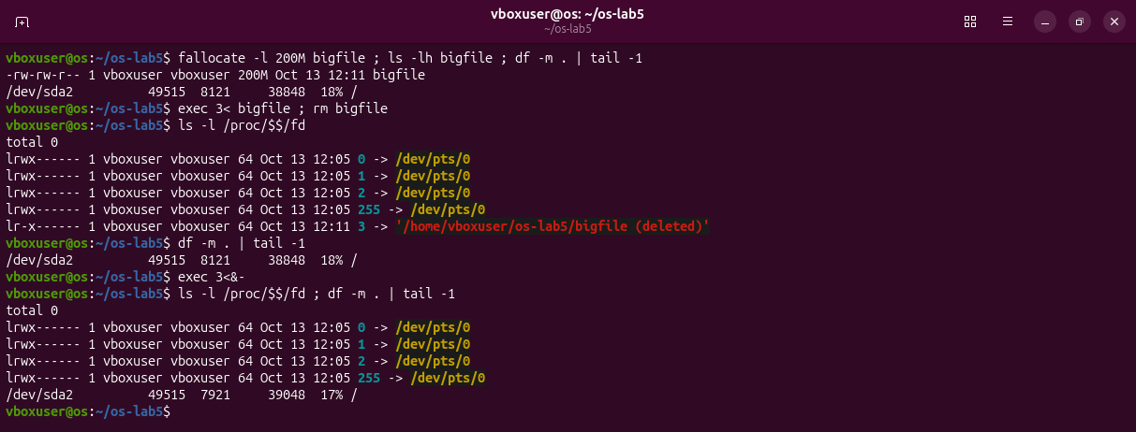
Figure 5.4 – (c) A deleted file that is still open.
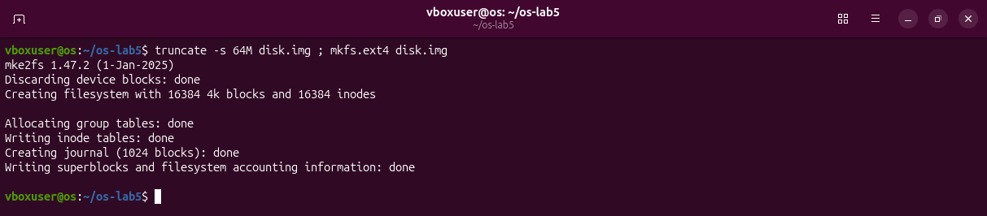
Figure 5.5 – (d) mkfs.ext4 on a 64 MB file.
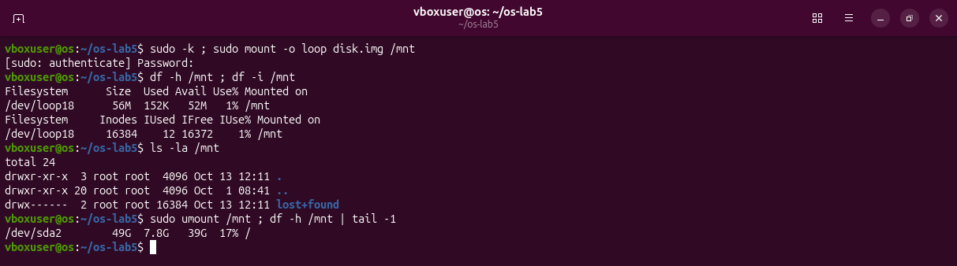
Figure 5.6 – (d) The new file system, mounted through a loop device.
Observations
(a) 1f 8b is the gzip magic number; a program starts with 7f 45 4c 46 (.ELF). A copy named photo.jpg is still gzip for file.
(b) 16 programs. Besides passwd, su, sudo, mount, umount, chsh, chfn and gpasswd, this Ubuntu has the Rust sudo and su in /usr/lib/cargo/bin (the default sudo) next to the classic sudo.ws, and pppd, ntfs-3g, fusermount3, pkexec, ssh-keysign, dbus-daemon-launch-helper.
(c) The link says bigfile (deleted). The 200 MB stayed used after rm (8121 MB) and were freed only when exec 3<&- closed the last descriptor (7921 MB).
(d) mkfs created 16384 inodes, one per 4 KiB block; df -i shows 12 of them used.

Deliverables and conclusions
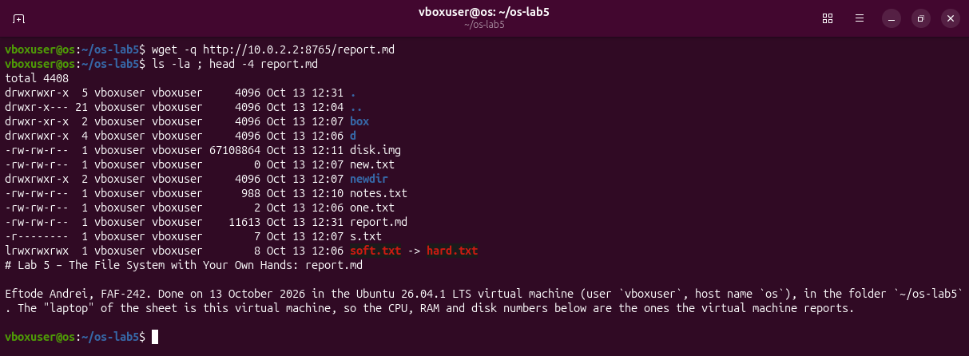
Figure 6.1 – The lab folder at the end, with report.md.
A name is not a file. The file is the inode, and a directory is a table of names that point to inode numbers. Hard links are extra names for one inode, a symbolic link is a small file that holds a path, and the data is freed only when no name and no open descriptor is left. The same rwx bits mean different things on files and on directories, and the disks, the devices and the processes can all be read as files.
Files in the folder lab5/ of the repository: this report, report.md with the answers, and the screenshots.

