Ministry of Education and Research of the Republic of Moldova
Technical University of Moldova
Faculty of Computers, Informatics and Microelectronics
Department of Software Engineering and Automatics
REPORT
on Laboratory Work No. 7
Course: Operating Systems
Topic: Three Small Programs: Processes, Redirection, a Pipe
Track A: the real OS, from the outside (Linux)
Done by: st. gr. FAF-242, Eftode Andrei
Checked by: univ. assist. Reițman Patricia
Chișinău, 2026
Contents
Laboratory Work No. 7. Three Small Programs 3
Preparation 3
Part 1. fork + exec + wait 3
Part 2. A zombie, on purpose 5
Part 3. Redirection: ls -l > out.txt 6
Part 4. A pipe: ls /etc | wc -l 7
Optional: three stages 8
Deliverables and conclusions 10

Laboratory Work No. 7. Three Small Programs
Purpose: to run in C the three steps the shell uses for every command (fork, exec, wait), to make a zombie on purpose, and to build ls -l > out.txt and ls /etc | wc -l by hand with close, open, dup and pipe.
Environment: Ubuntu 26.04.1 LTS virtual machine, kernel 7.0.0-38-generic, gcc 15.2.0, working folder ~/os-lab7.

Preparation
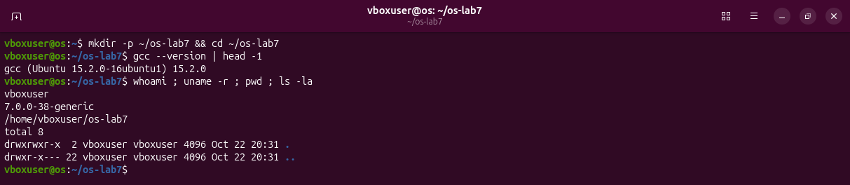
Figure 0.1 – The working folder and the compiler.

Part 1. fork + exec + wait
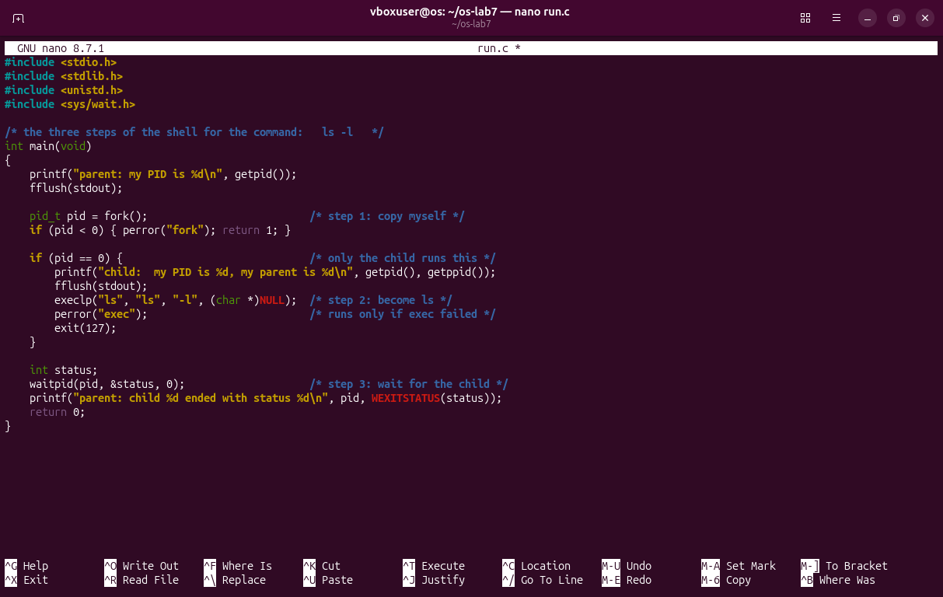
Figure 1.1 – run.c written in nano, exactly as on the sheet.
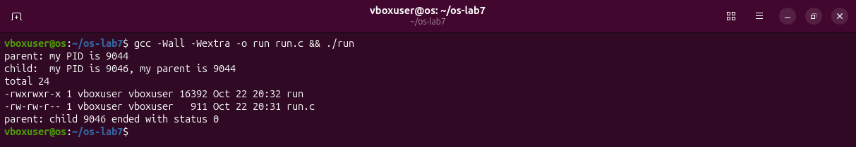
Figure 1.2 – The parent, the child, the listing of ls -l, and the status.
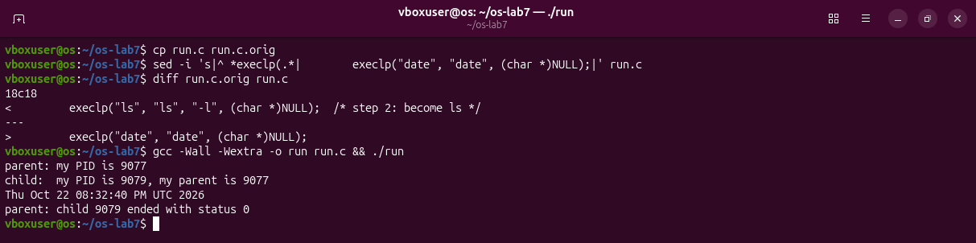
Figure 1.3 – The child runs date instead of ls.
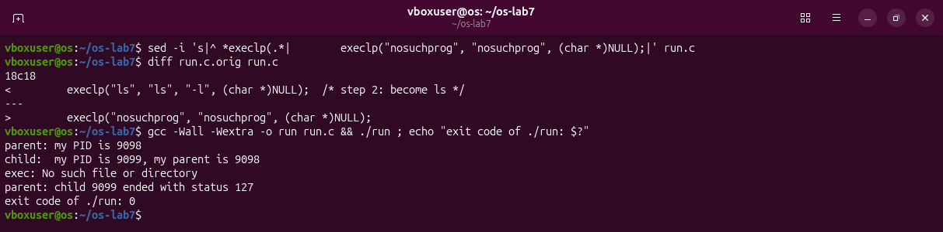
Figure 1.4 – The child asks for nosuchprog.
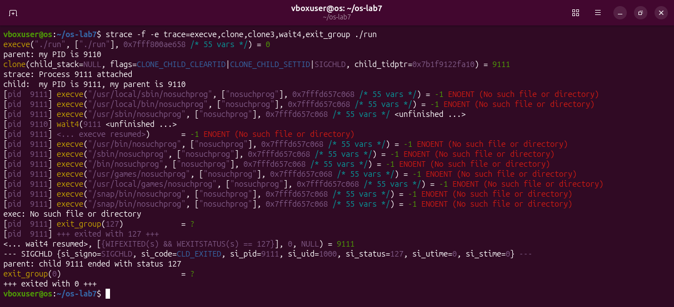
Figure 1.5 – strace: every execve in PATH fails, then perror and exit(127).
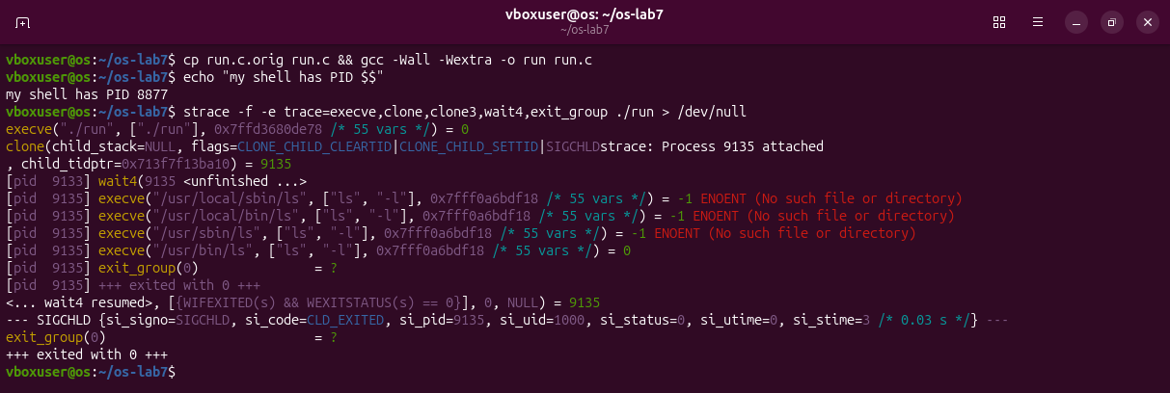
Figure 1.6 – strace with ls: clone (the fork), the fourth execve works, wait4 gets status 0.
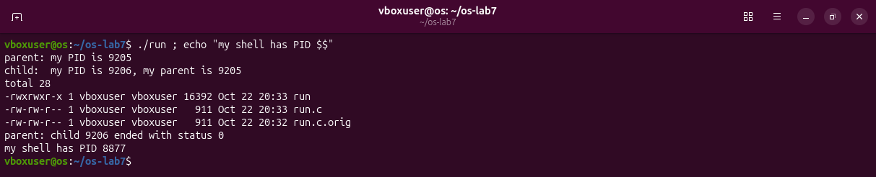
Figure 1.7 – The PID the child calls "my parent", and the PID of my shell.
Observations
(1) execlp comes back only when it fails. When it works, the child's program is replaced by ls, so perror and exit(127) no longer exist. With nosuchprog every execve ended with ENOENT (Figure 1.5), so perror ran.
(2) The child prints 9044, the PID of the ./run process itself (its first line). It is not the shell, which is 8877 (Figure 1.7).
(3) Status 0 with ls. Status 127 with nosuchprog: the number the child gave to exit(127).

Part 2. A zombie, on purpose
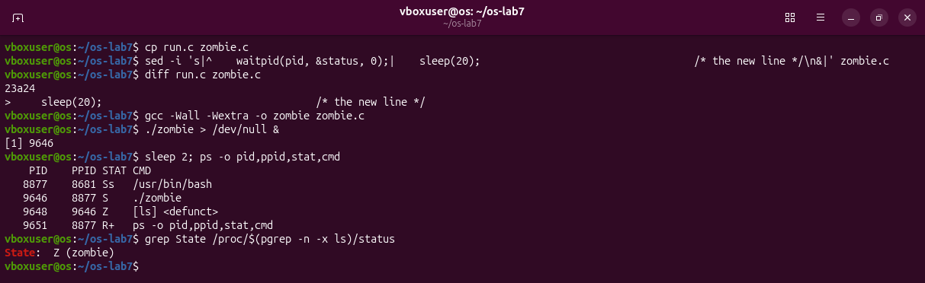
Figure 2.1 – zombie.c = run.c plus sleep(20); before waitpid. While the parent sleeps, ls is a zombie.
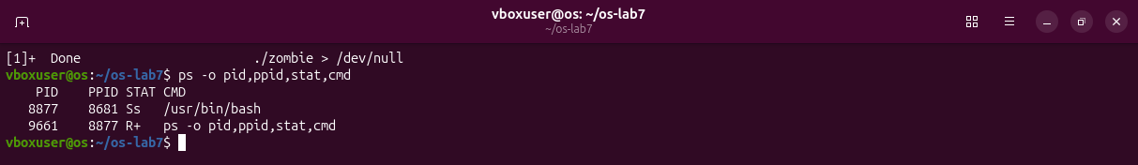
Figure 2.2 – Twenty seconds later the zombie is gone.
Observations
(1) Z, a zombie (<defunct>): ls has ended, but its exit status is still kept for the parent. /proc says the same: State: Z (zombie).
(2) The line is gone. waitpid(pid, &status, 0); collected the status, and the kernel removed the entry.

Part 3. Redirection: ls -l > out.txt
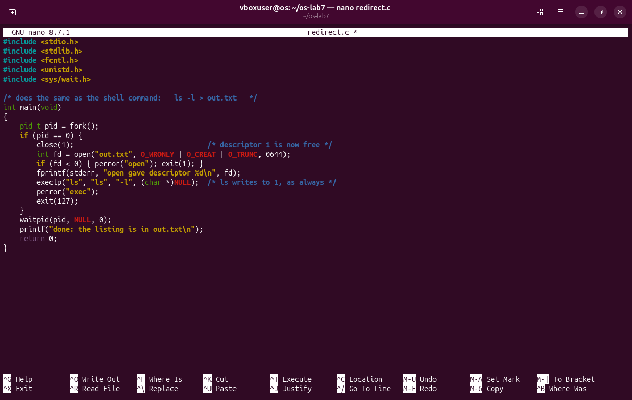
Figure 3.1 – redirect.c in nano.
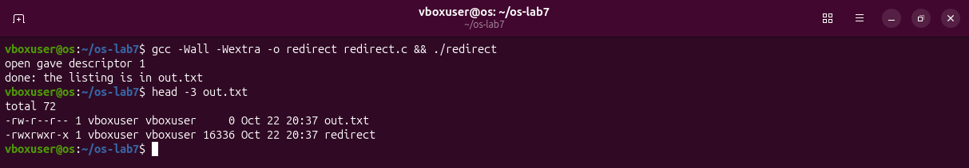
Figure 3.2 – open gives descriptor 1 and the listing goes into out.txt.
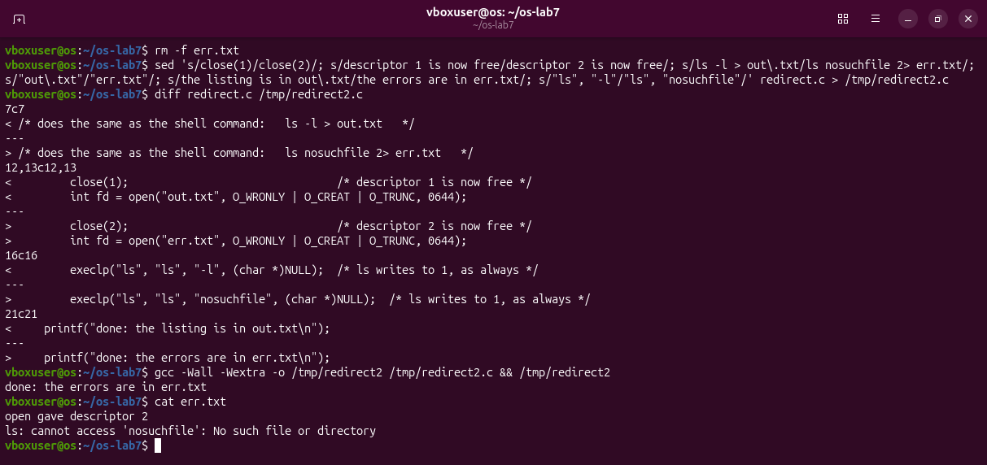
Figure 3.3 – Extra: the same with close(2). The error of ls lands in err.txt.
Observations
(1) 1. The kernel always gives the smallest free descriptor: 0 was open, 1 had just been closed.
(2) ls writes to descriptor 1 as always, and in this child 1 is the file out.txt. exec keeps the open descriptors.
(3) Descriptor 2 (Figure 3.3).

Part 4. A pipe: ls /etc | wc -l
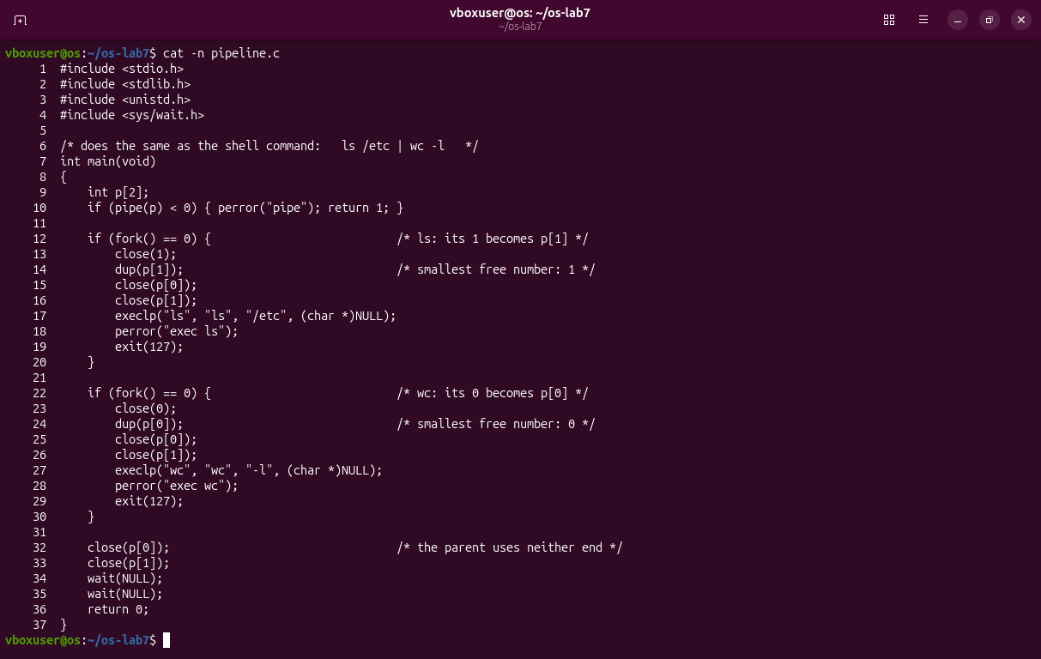
Figure 4.1 – pipeline.c: one pipe, two forks.
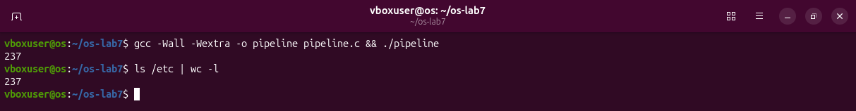
Figure 4.2 – My program and the shell give the same number.
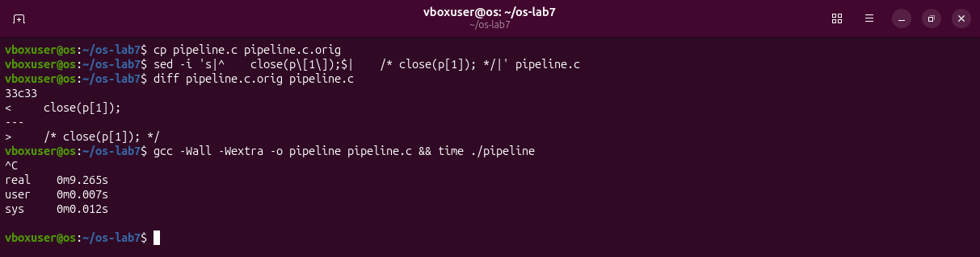
Figure 4.3 – With close(p[1]) commented out in the parent, nothing is printed; stopped with Ctrl-C after 9 s.
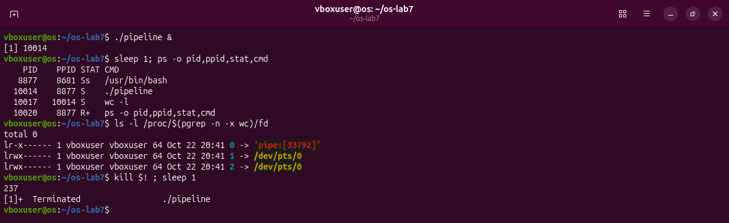
Figure 4.4 – Who waits: wc -l, reading from a pipe. When only the parent is killed, wc prints 237.
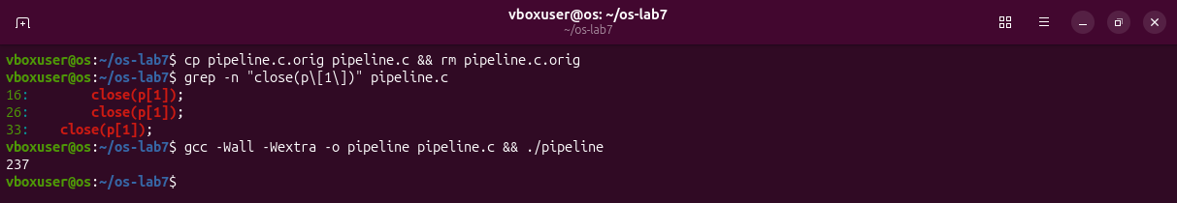
Figure 4.5 – pipeline.c put back as it was.
Observations
(1) Yes: 237 and 237.
(2) wc never ends. ls has finished, and only ./pipeline and wc -l are left (Figure 4.4).
(3) wc waits for end of file, and a pipe gives it only when every write end is closed; the parent still had p[1] open.

Optional: three stages
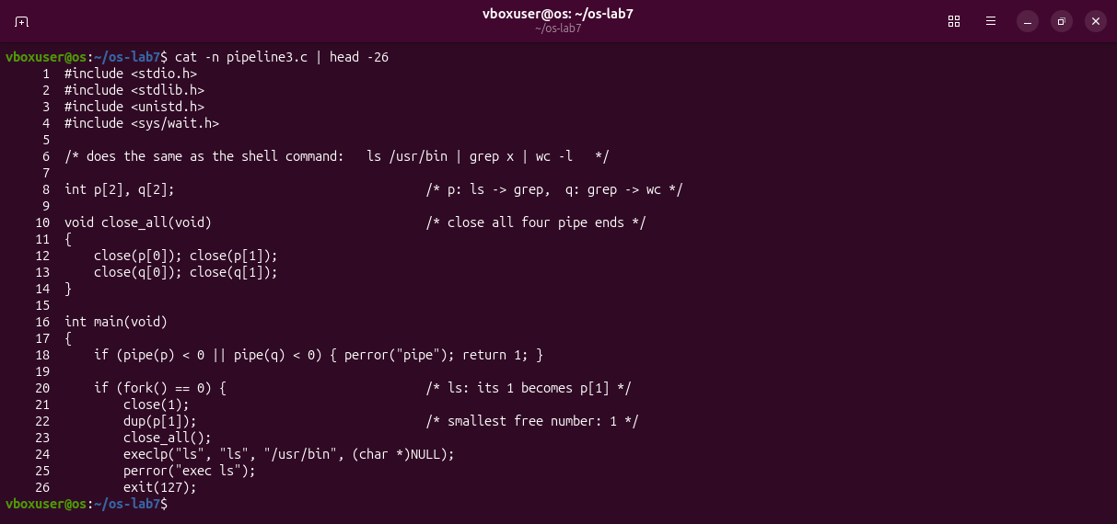
Figure 5.1 – pipeline3.c, first half: two pipes and the ls child.
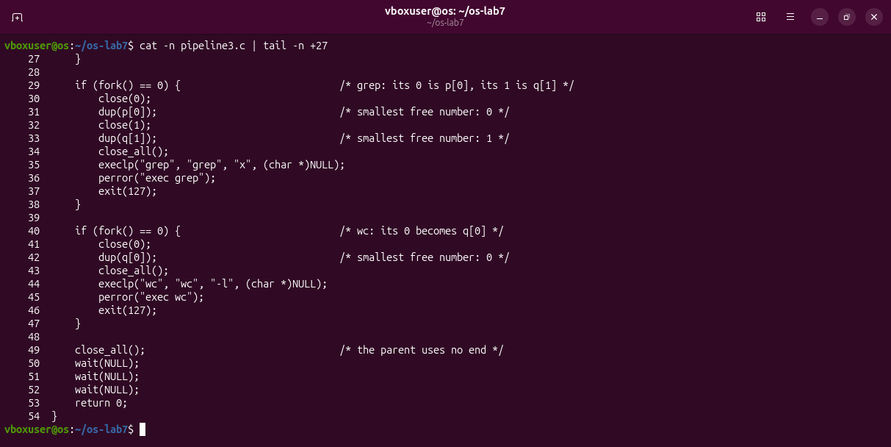
Figure 5.2 – pipeline3.c, second half: grep, wc, and the parent.
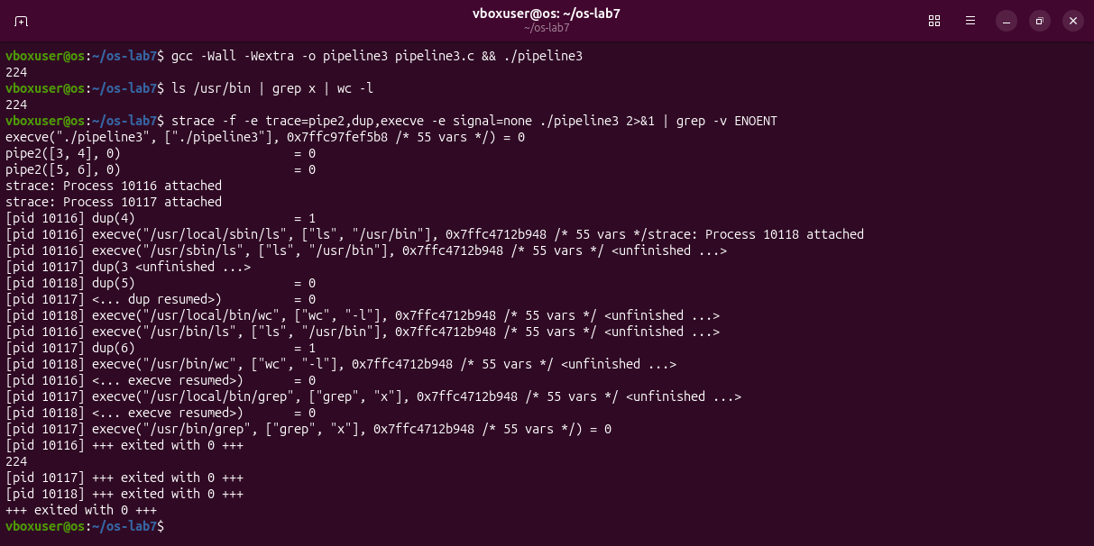
Figure 5.3 – The same number as the shell, and the pipe ends seen by strace.
Every child closes all four pipe ends after its dup, and so does the parent; otherwise grep or wc would never get end of file. Both print 224.

Deliverables and conclusions
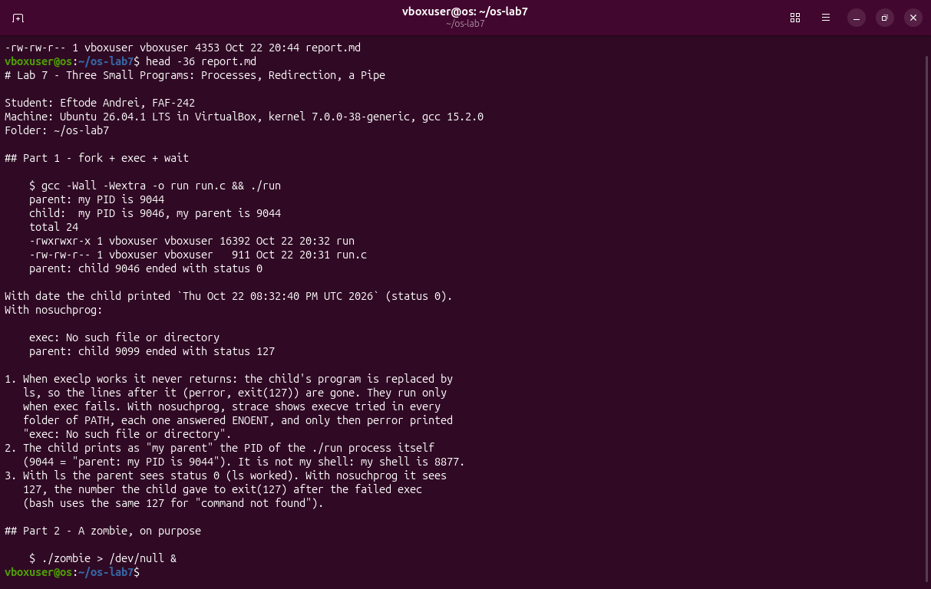
Figure 6.1 – The beginning of report.md.
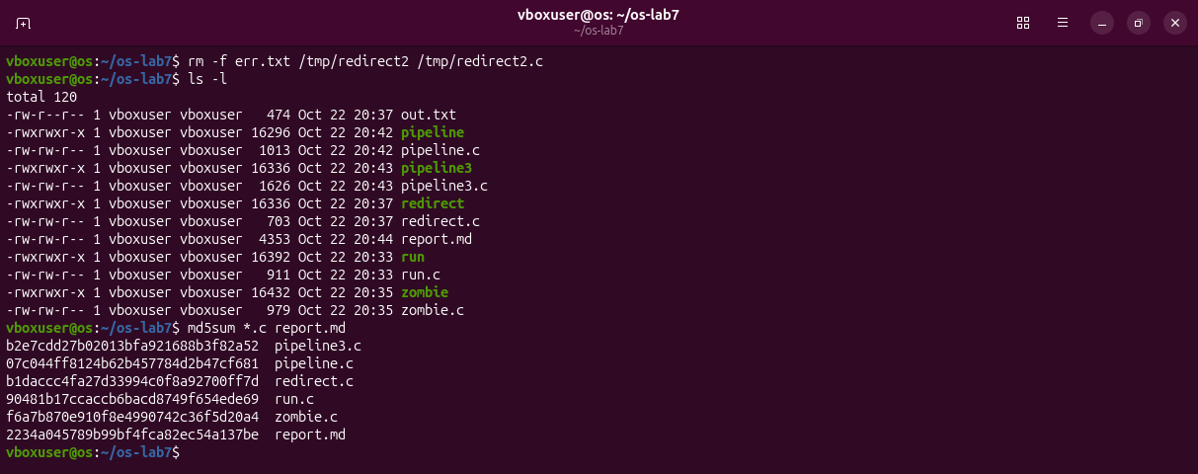
Figure 6.2 – The folder at the end of the lab.
The shell runs a command with three system calls: fork makes a copy, exec turns it into the program, wait collects the exit status; a child nobody waits for stays a zombie. Redirection and pipes need no change in the program: the child puts a file or a pipe end on descriptor 0 or 1 before exec, because open and dup take the smallest free number.
Files in the folder lab7/ of the repository: this report, run.c, zombie.c, redirect.c, pipeline.c, pipeline3.c, report.md and the screenshots.

