Ministry of Education and Research of the Republic of Moldova
Technical University of Moldova
Faculty of Computers, Informatics and Microelectronics
Department of Software Engineering and Automatics
REPORT
on Laboratory Work No. 8
Course: Operating Systems
Topic: The Same Calls, Inside Your Own OS
Track B: build your own small OS (xv6)
Done by: st. gr. FAF-242, Eftode Andrei
Checked by: univ. assist. Reițman Patricia
Chișinău, 2026
Contents
Laboratory Work No. 8. The Same Calls, Inside Your Own OS 3
Preparation 3
Part 1. run, inside xv6 4
Part 2. pingpong 8
Optional: primes 9
Deliverables and conclusions 10

Laboratory Work No. 8. The Same Calls, Inside Your Own OS
Purpose: to run the program of Lab 7 (fork, exec, wait) inside xv6 and see that the calls are the same, then to make two processes talk through two pipes (pingpong).
Environment: Ubuntu 26.04.1 LTS virtual machine, riscv64-linux-gnu-gcc 15.2.0, QEMU 10.2.1, xv6 revision 06aad25 in ~/xv6-riscv on branch lab, which already has the programs of Labs 4 and 6.

Preparation
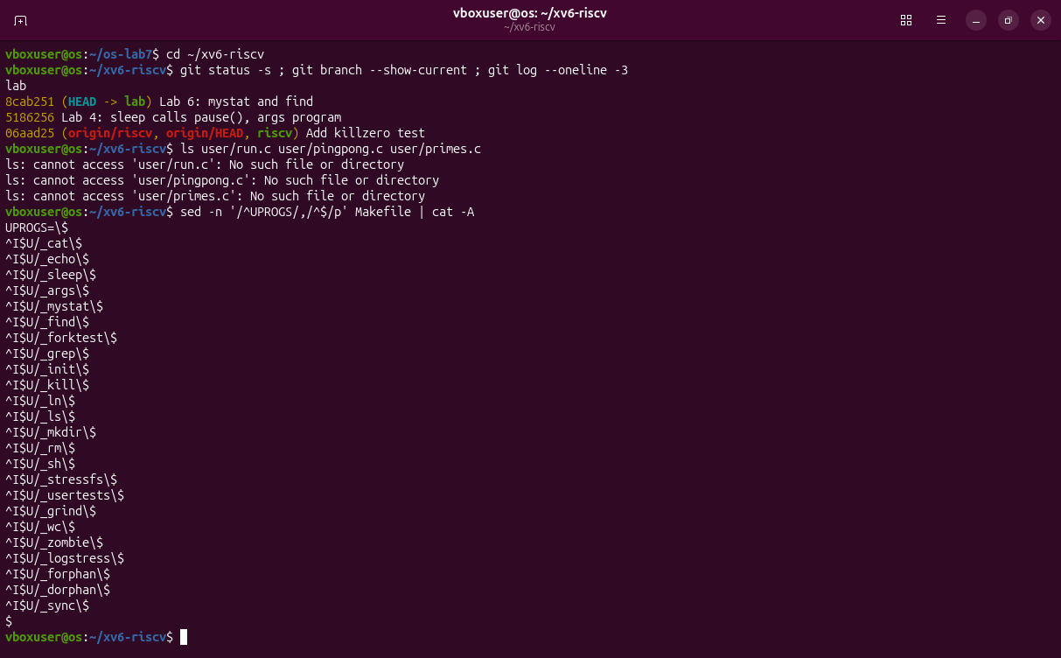
Figure 0.1 – The xv6 tree before the lab: branch lab, no Lab 8 files yet, and the UPROGS list.

Part 1. run, inside xv6
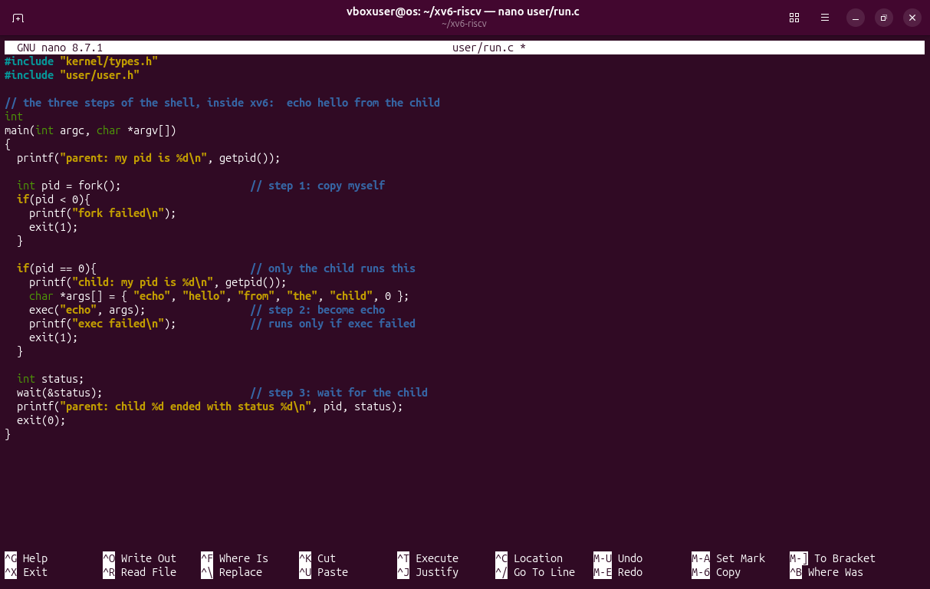
Figure 1.1 – user/run.c written in nano, exactly as on the sheet.
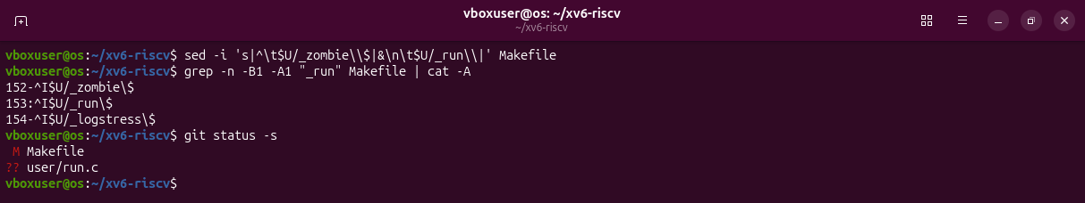
Figure 1.2 – The line $U/_run\ added to UPROGS after $U/_zombie\: a TAB at the start, nothing after the backslash.
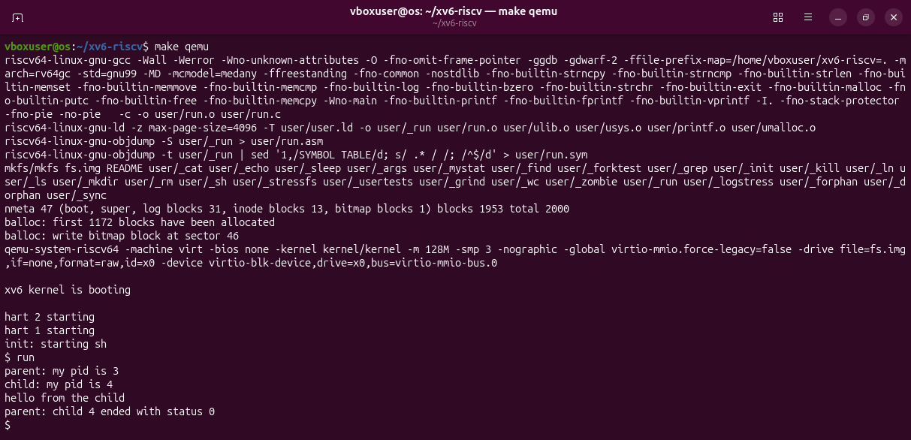
Figure 1.3 – make qemu compiles run, puts it on the disk, and xv6 runs it.
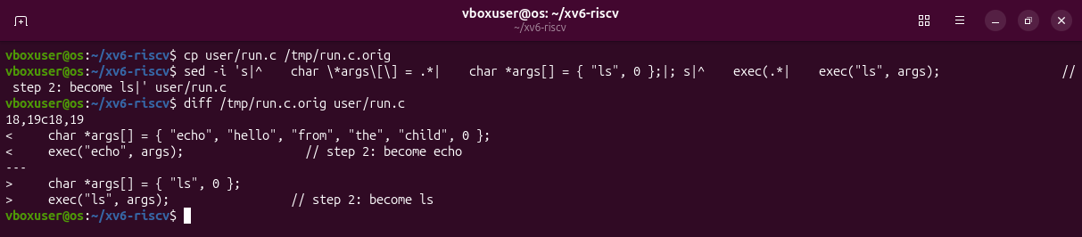
Figure 1.4 – The child is changed to run ls.
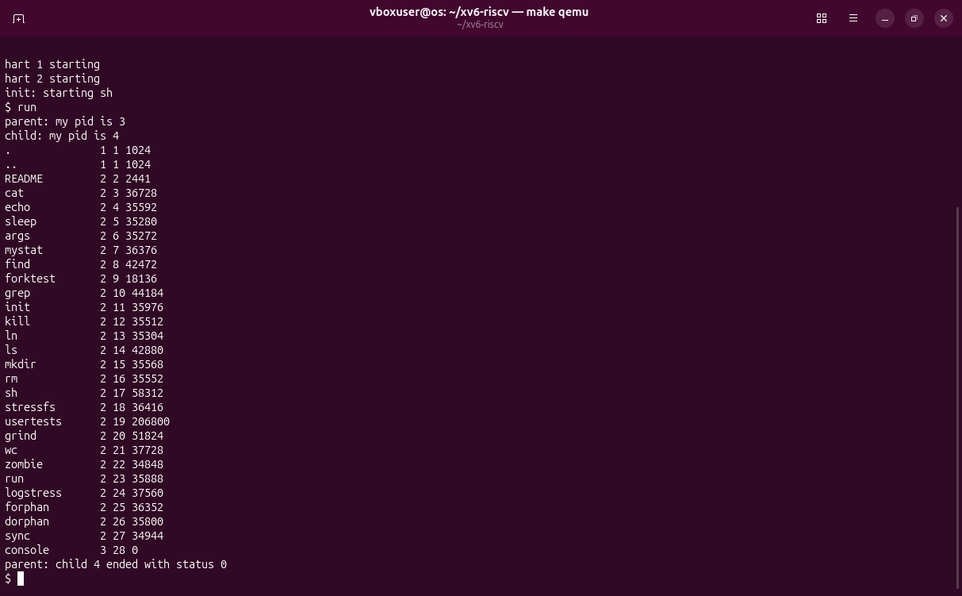
Figure 1.5 – The child became ls and listed the root directory.
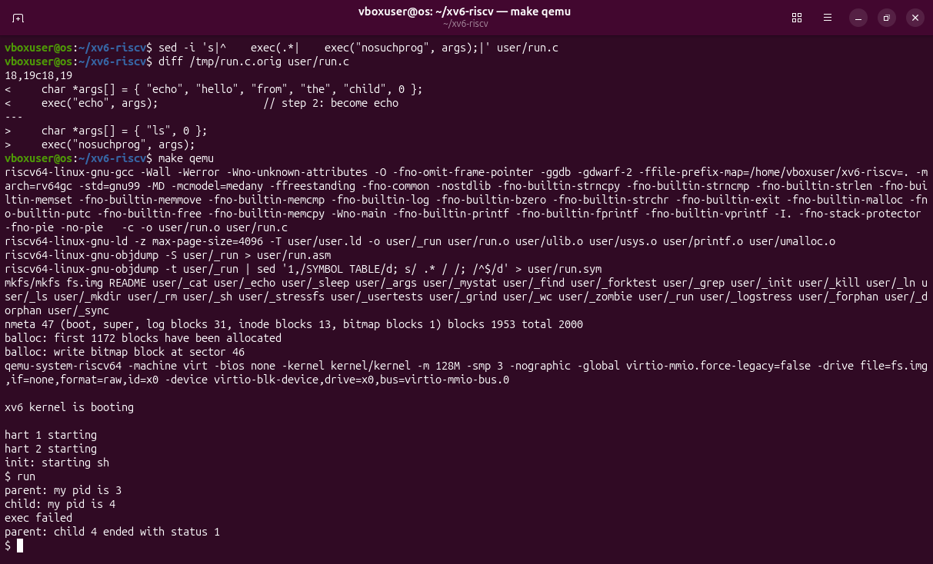
Figure 1.6 – A program that does not exist: exec failed, status 1.
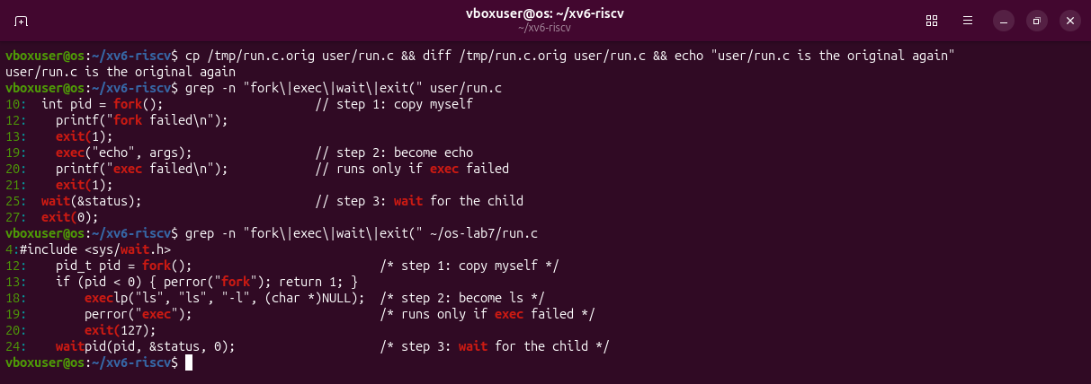
Figure 1.7 – run.c put back as it was, and the same three calls in the xv6 and the Linux version.
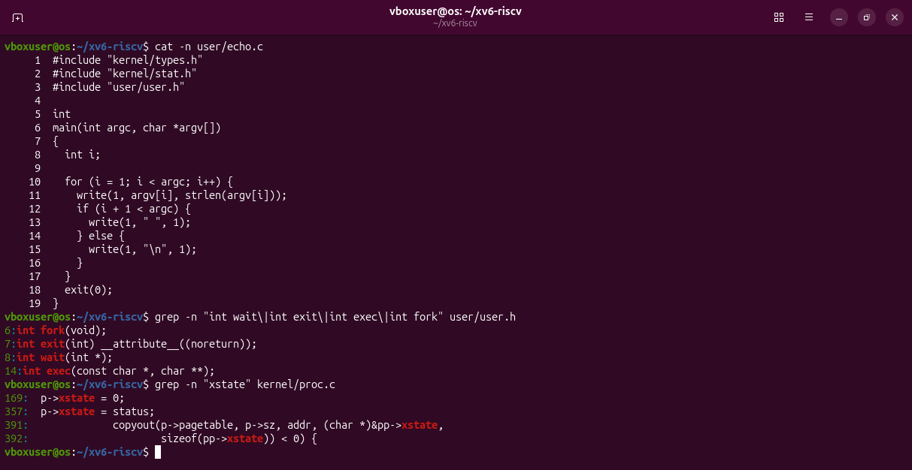
Figure 1.8 – user/echo.c, the calls in user/user.h, and where the kernel keeps the exit status.
Observations
(1) xv6: fork(), exec("echo", args), wait(&status). Linux: fork(), execlp(...), waitpid(pid, &status, 0). The same three steps in the same order; only the library differs (execlp searches PATH, waitpid waits for one given child).
(2) echo prints it. After exec the child is the program user/echo.c, which writes its arguments.
(3) The status is the number the child gives to exit: exit(1) after exec here, exit(127) in Lab 7. xv6 wait returns it as it is (p->xstate).

Part 2. pingpong
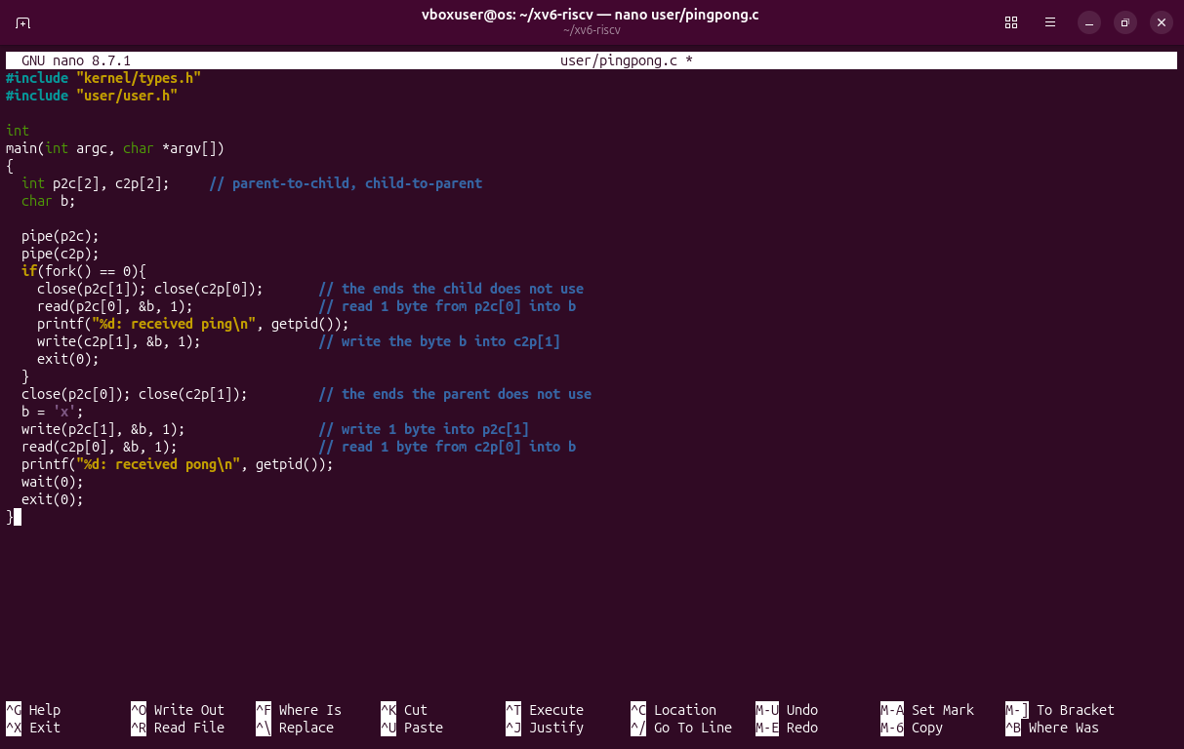
Figure 2.1 – user/pingpong.c with the TODO lines written.
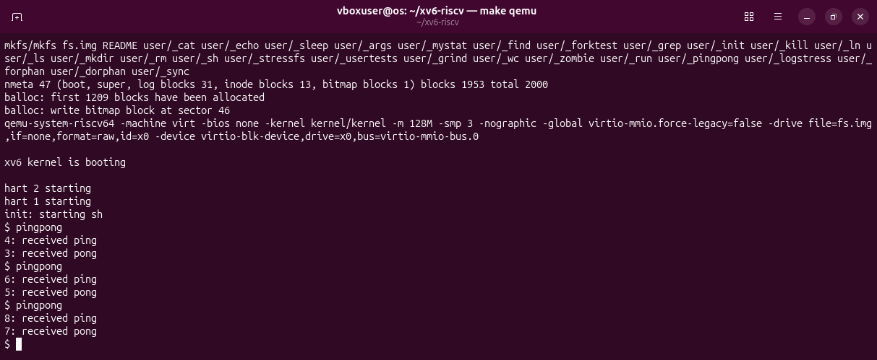
Figure 2.2 – make qemu and three runs: "ping" always comes first, from the child.
Observations
(1) A pipe goes one way only and does not know who reads it. With one pipe the parent could read back its own ping before the child takes it; with two, each direction has its own pipe.
(2) read(c2p[0], &b, 1): a read on an empty pipe blocks until the child writes the pong.

Optional: primes
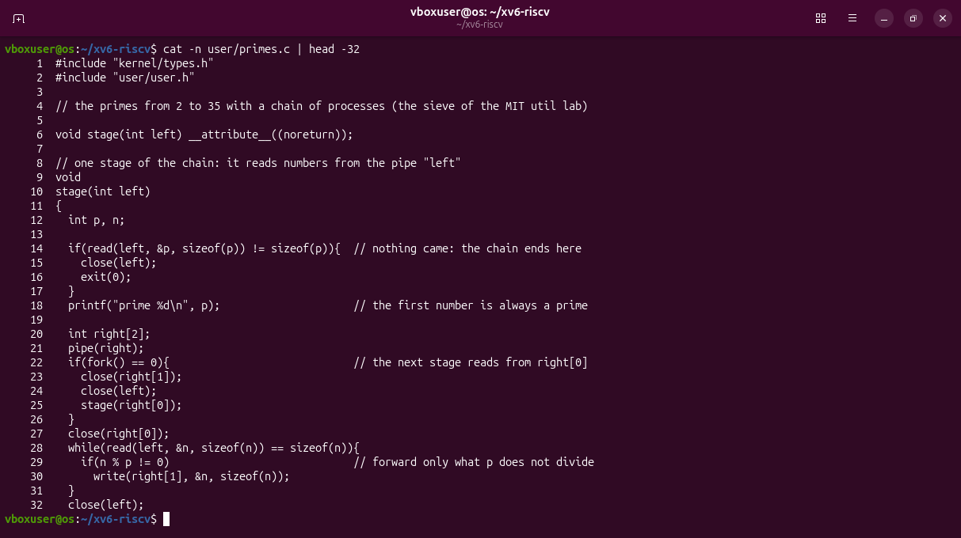
Figure 3.1 – user/primes.c, first half: one stage of the chain.
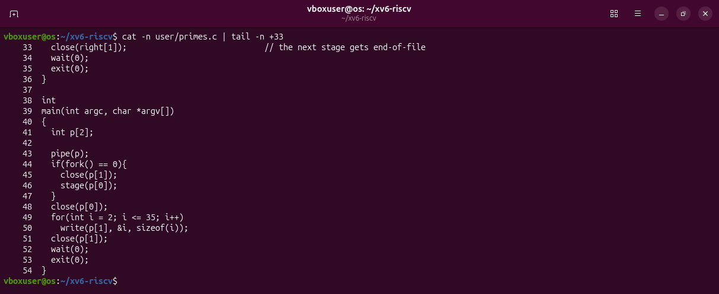
Figure 3.2 – user/primes.c, second half: main sends 2 to 35.
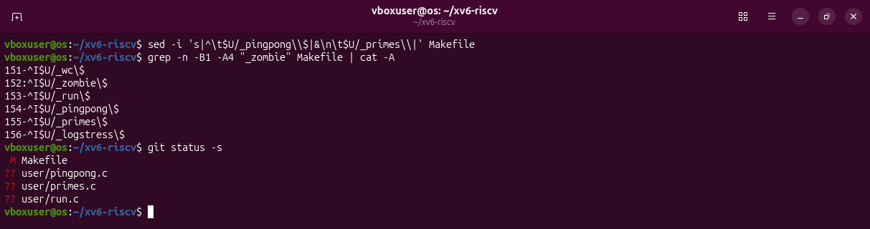
Figure 3.3 – My three lines in UPROGS and the new files.
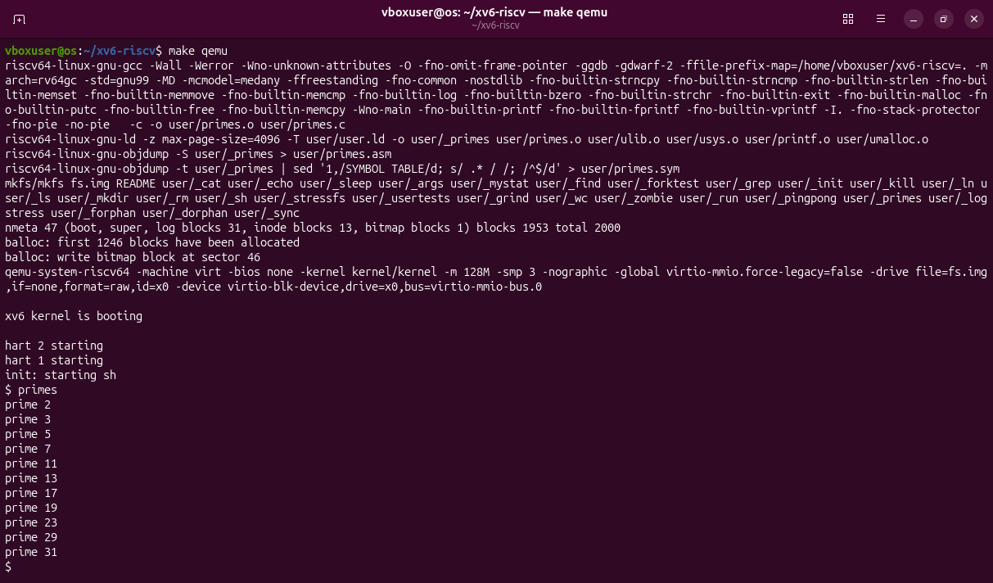
Figure 3.4 – The primes from 2 to 35, each printed by a different process.
Each stage reads its first number p (always a prime), prints it, makes a pipe and the next stage, and forwards only the numbers p does not divide. Every process closes the pipe ends it does not use.

Deliverables and conclusions
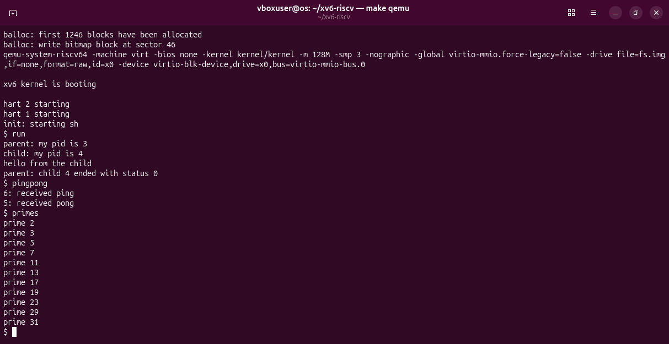
Figure 4.1 – A clean build (make clean ; make qemu) and the three programs.
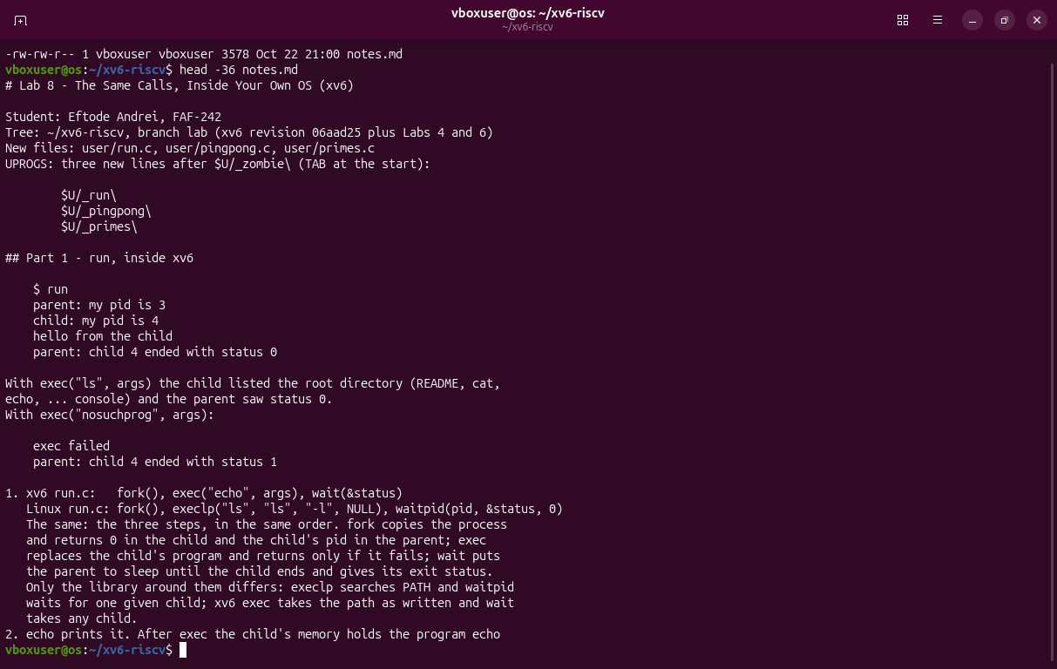
Figure 4.2 – The beginning of notes.md.
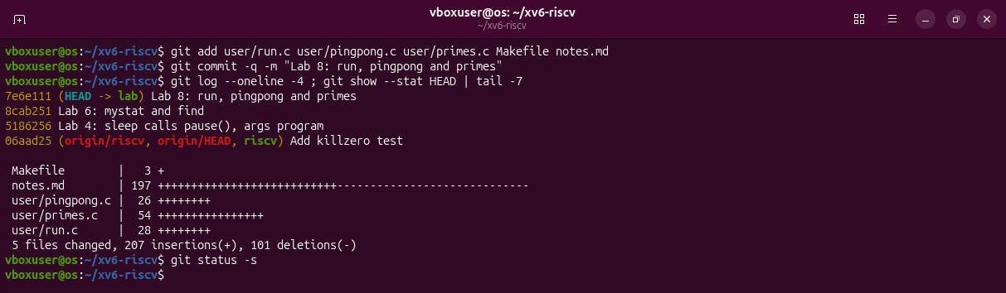
Figure 4.3 – The Lab 8 commit on branch lab.
The calls of Lab 7 are the same in xv6: fork, exec, wait, pipe, read, write, close. A pipe is a one-way buffer, and a read on an empty pipe blocks; that alone keeps the two processes of pingpong in step.
Files in the folder lab8/ of the repository: this report, run.c, pingpong.c, primes.c, the Makefile, notes.md and the screenshots.

