Ministry of Education and Research of the Republic of Moldova
Technical University of Moldova
Faculty of Computers, Informatics and Microelectronics
Department of Software Engineering and Automatics
REPORT
on Laboratory Work No. 1
Course: Operating Systems
Topic: The OS as a Resource Manager
Track A: the real OS, from the outside (Linux)
Done by: st. gr. FAF-242, Eftode Andrei
Checked by: univ. assist. Reițman Patricia
Chișinău, 2026
Contents
Laboratory Work No. 1. The OS as a Resource Manager 3
Preparation 3
Part 1. Files and directories 4
Part 2. Processes 5
Part 3. Memory 8
Part 4. Devices and storage 9
Optional: htop and strace 10
Deliverables and conclusions 11

Laboratory Work No. 1. The OS as a Resource Manager
Purpose: to watch the operating system manage its four resources (files, processes, memory and devices) from the terminal of a Linux machine, and to write down what it shows.
Environment: Ubuntu 26.04.1 LTS in VirtualBox, kernel Linux 7.0.0-34-generic, user vboxuser on host os, working folder ~/os-lab1.

Preparation
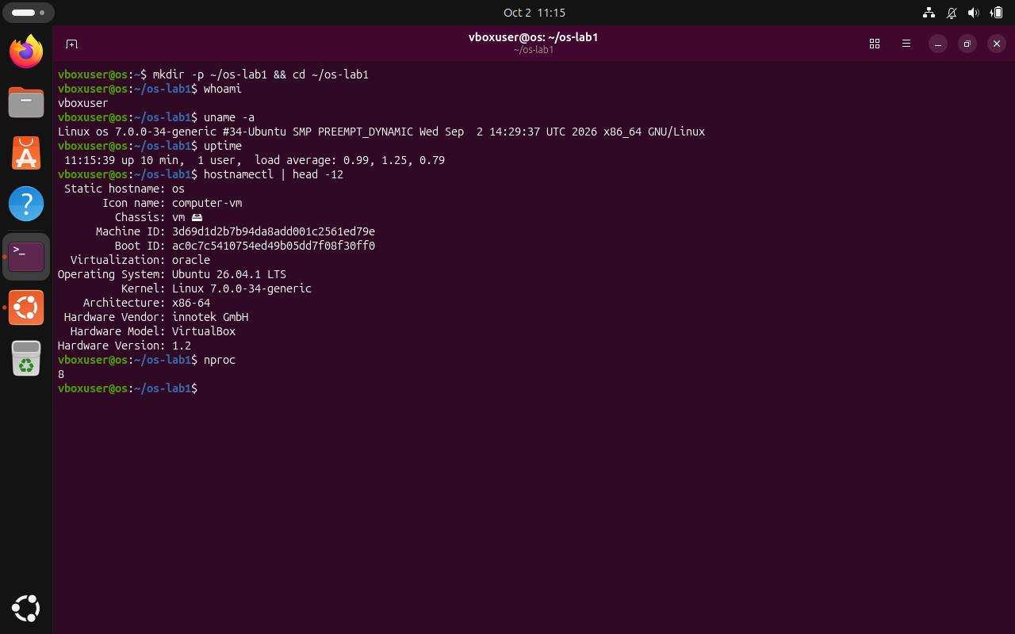
Figure 0.1 – Setup: whoami, uname -a, uptime.

Part 1. Files and directories
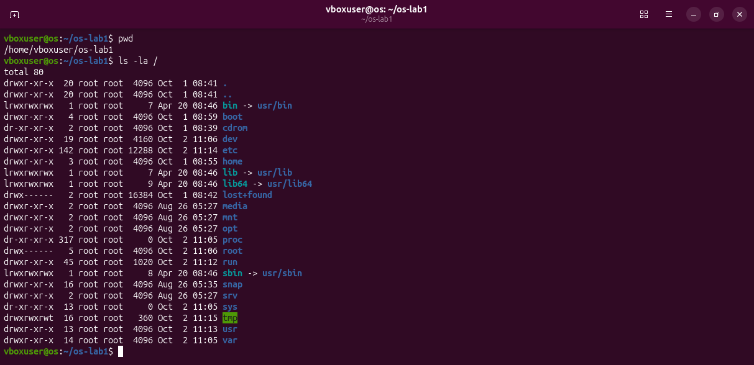
Figure 1.1 – pwd and the root of the tree, ls -la /.
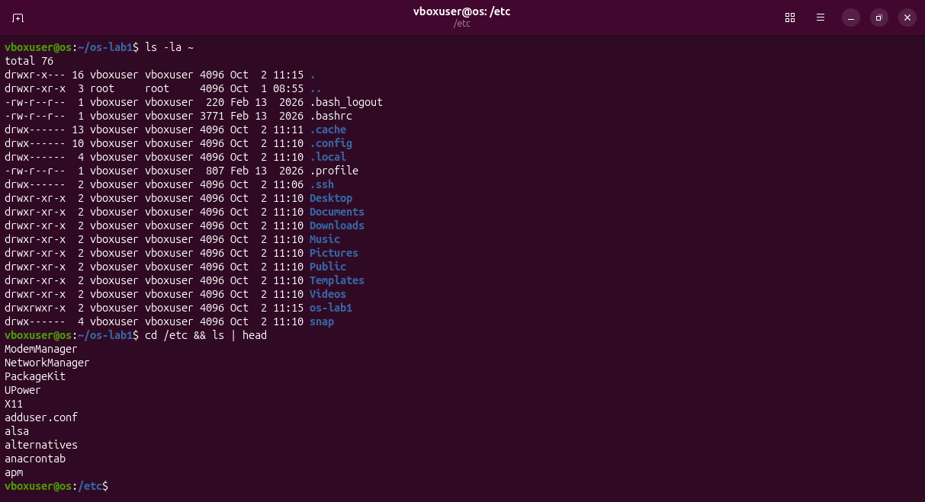
Figure 1.2 – The home directory and the first entries of /etc.
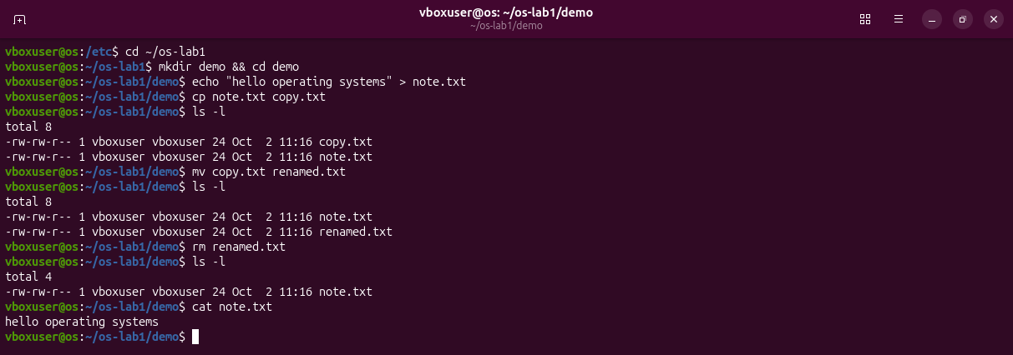
Figure 1.3 – Creating, copying, renaming and removing files.
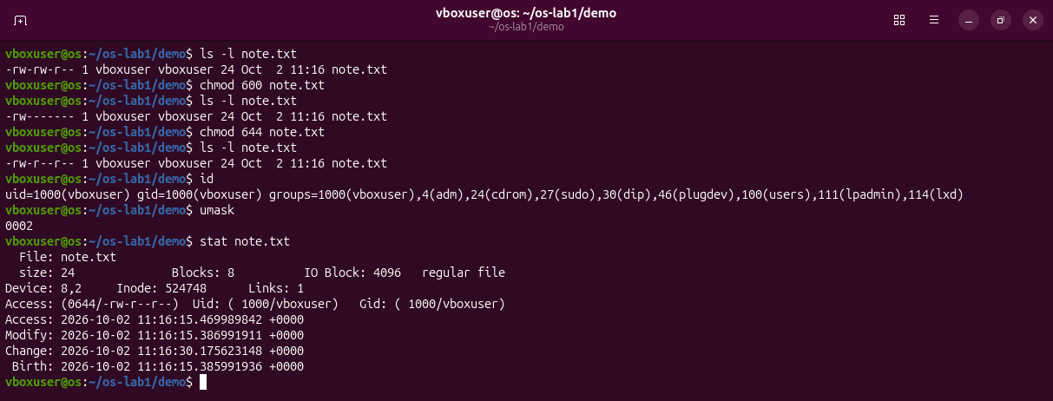
Figure 1.4 – Permissions of note.txt after chmod 600 and chmod 644.
Observations
(1) Owner and group: user vboxuser, group vboxuser (uid 1000, gid 1000).
(2) After chmod 600 the ten characters are -rw-------: - a regular file, rw- the owner may read and write, --- the group has no rights, --- the others have no rights.
(3) /etc holds the system configuration files; /home holds the personal folders of the users.

Part 2. Processes
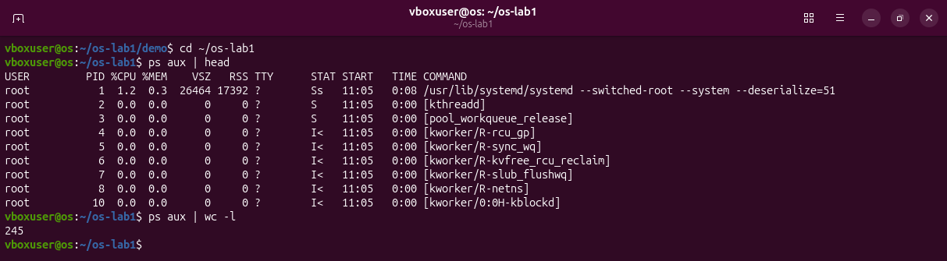
Figure 2.1 – ps aux | head and the number of processes.
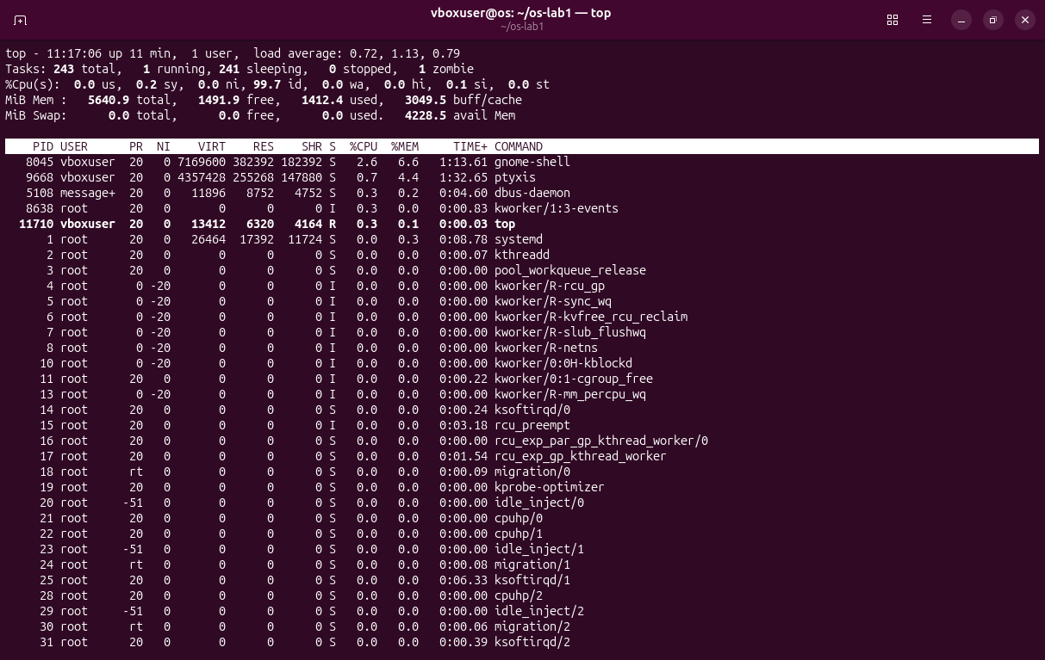
Figure 2.2 – The live view of top.
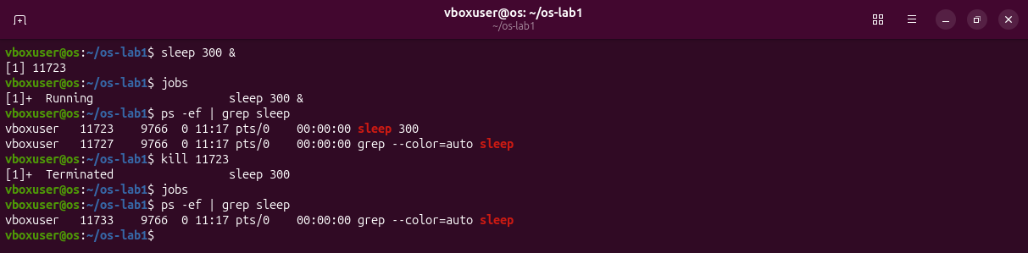
Figure 2.3 – A background sleep is started, found with ps -ef | grep and stopped with kill.
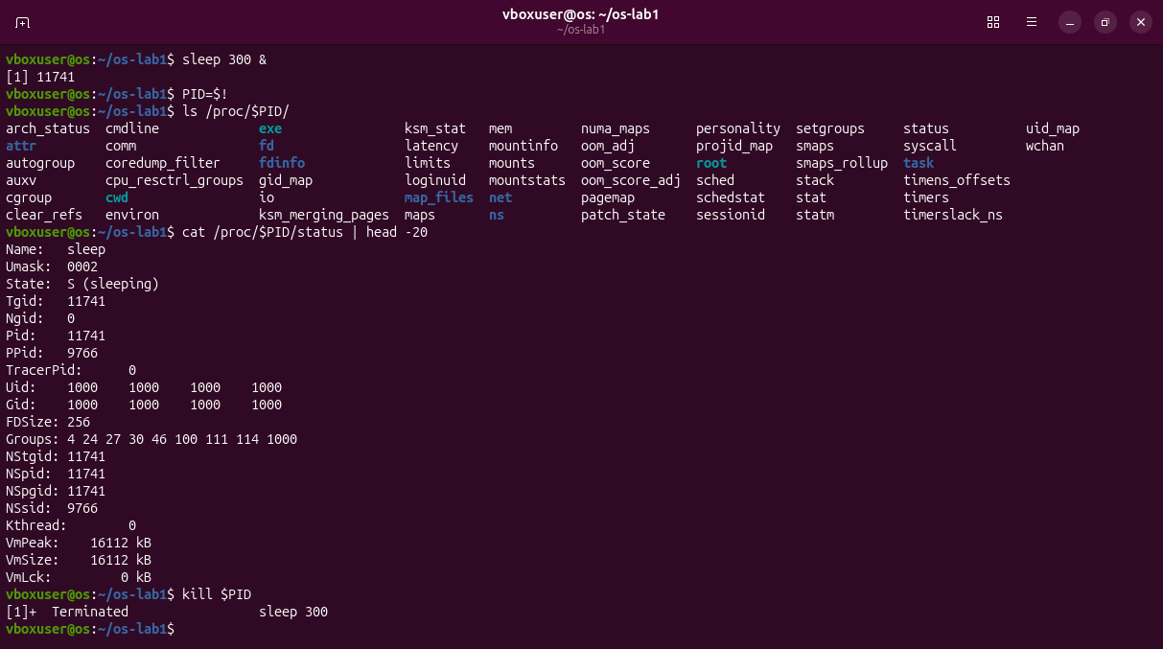
Figure 2.4 – The process seen through /proc/<pid>/.
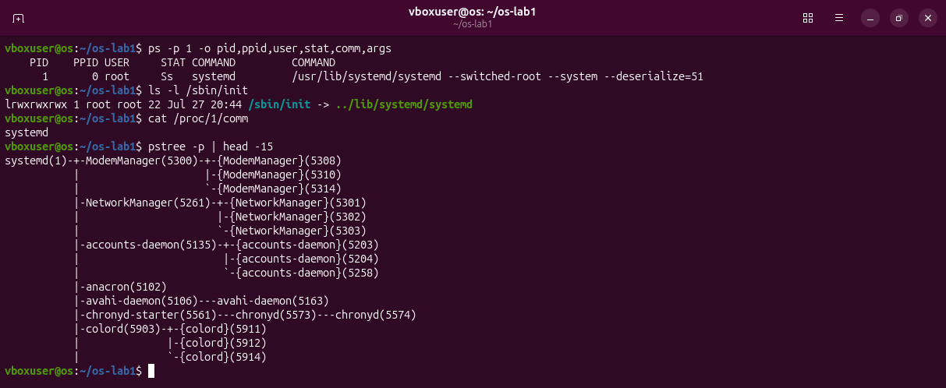
Figure 2.5 – Process number 1.
Observations
(1) PID 1 is systemd, the first user-space process started by the kernel; it starts the services and is the ancestor of all other processes (Figure 2.5).
(2) About 244: ps aux | wc -l printed 245 with the header line; top showed 243 tasks.
(3) State: S (sleeping): the process waits for its timer and uses no CPU (Figure 2.4).

Part 3. Memory
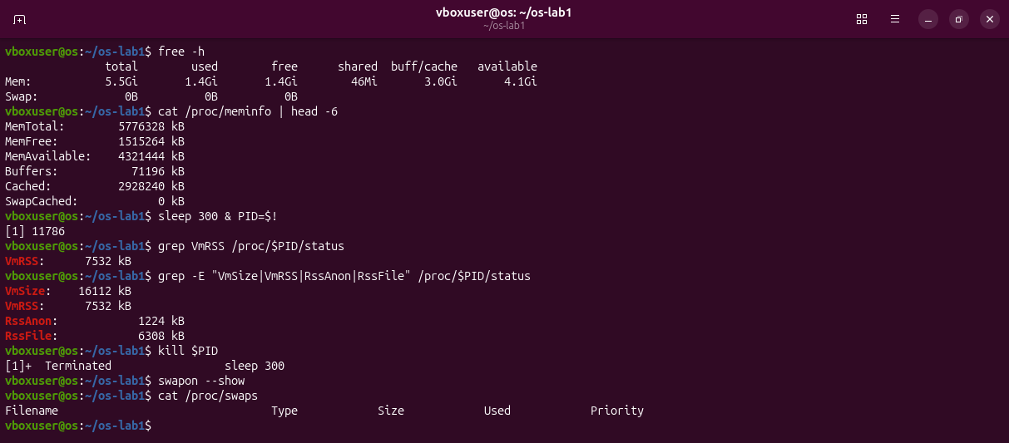
Figure 3.1 – free -h, /proc/meminfo, the memory of one sleep process and the swap list.
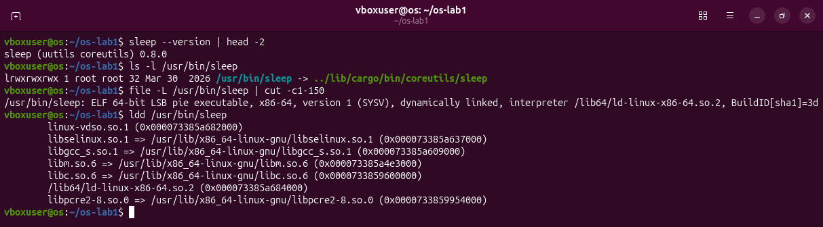
Figure 3.2 – Which program sleep is on this system and the libraries it loads.
Observations
(1) 5.5 GiB of RAM in total, 1.4 GiB free and 4.1 GiB available (the rest is cache the kernel can give back).
(2) Swap is disk space where the kernel moves memory pages that are not in use. None is configured here: Swap: 0B, and swapon --show prints nothing.
(3) VmRSS of sleep: 7532 kB. It surprised me for a program that only waits, but 6308 kB of it are shared library pages (RssFile) and only 1224 kB are its own (RssAnon).

Part 4. Devices and storage
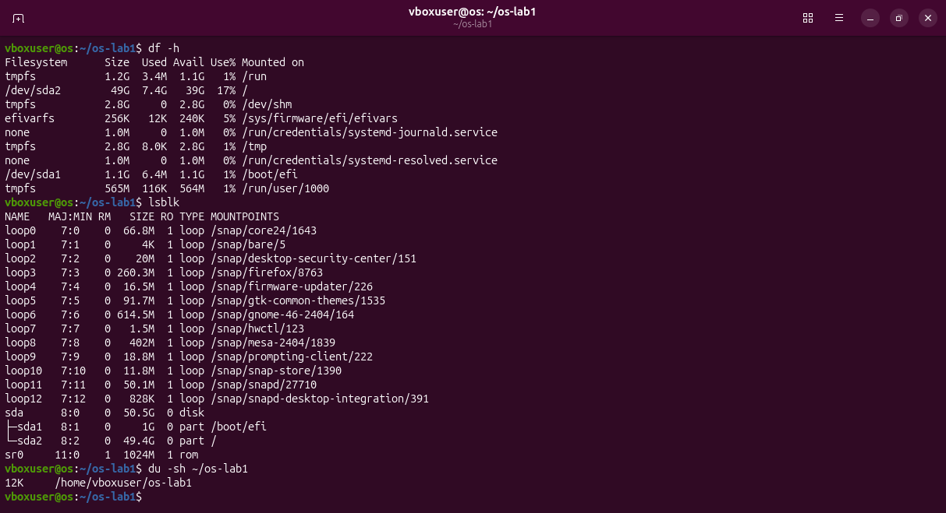
Figure 4.1 – df -h, lsblk and du -sh ~/os-lab1.
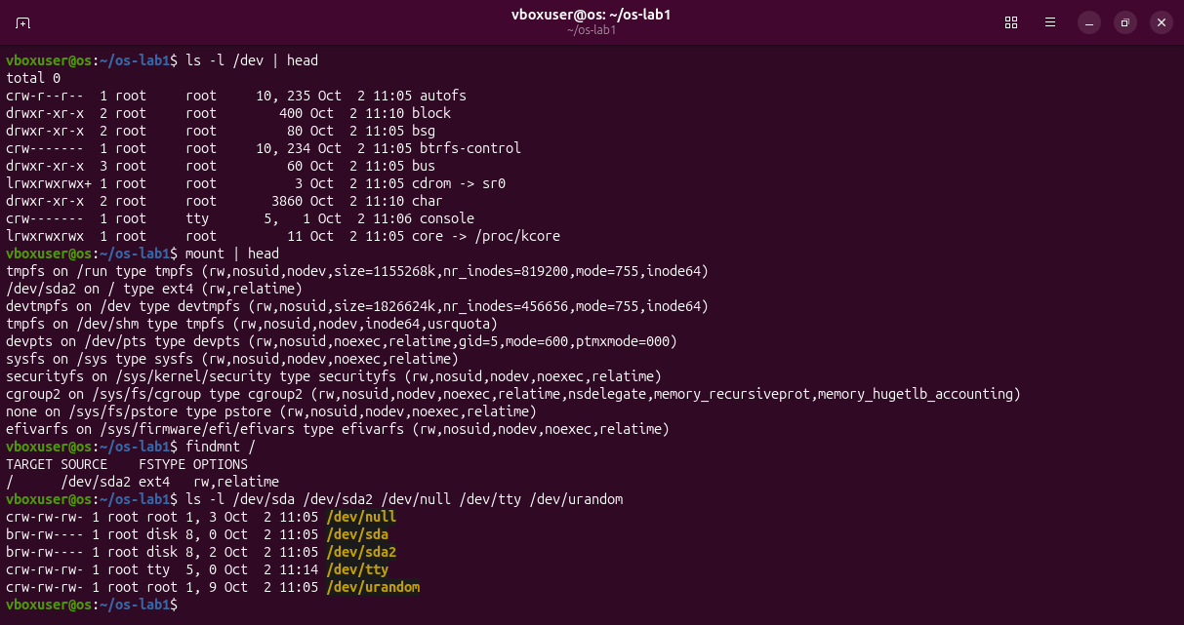
Figure 4.2 – Devices as files in /dev, mount and the source of /.
Observations
(1) / is mounted from /dev/sda2, an ext4 file system (findmnt /).
(2) /dev/sda is the whole hard disk of the machine (block device 8, 0); /dev/null throws away everything written to it.
(3) Disks, terminals and even the kernel's data about processes are names in one directory tree, used with the same open, read and write calls as ordinary files.

Optional: htop and strace
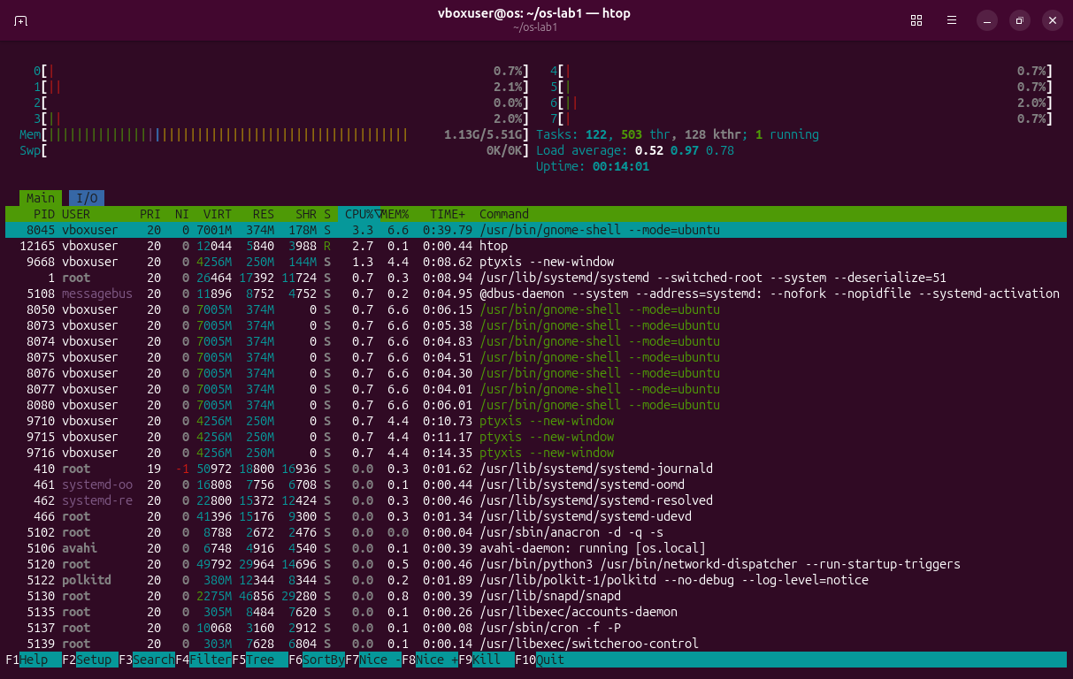
Figure 5.1 – htop in place of top.
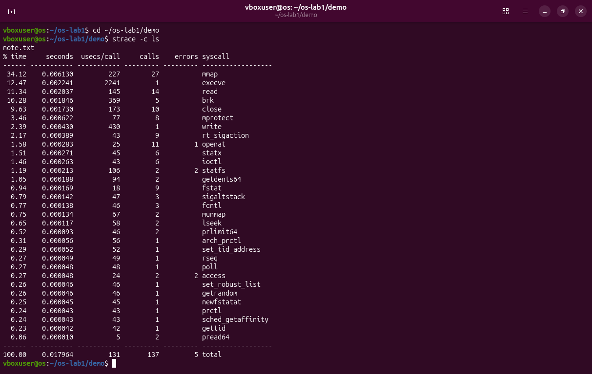
Figure 5.2 – strace -c ls: 137 system calls of 31 kinds to list a folder with one file.

Deliverables and conclusions
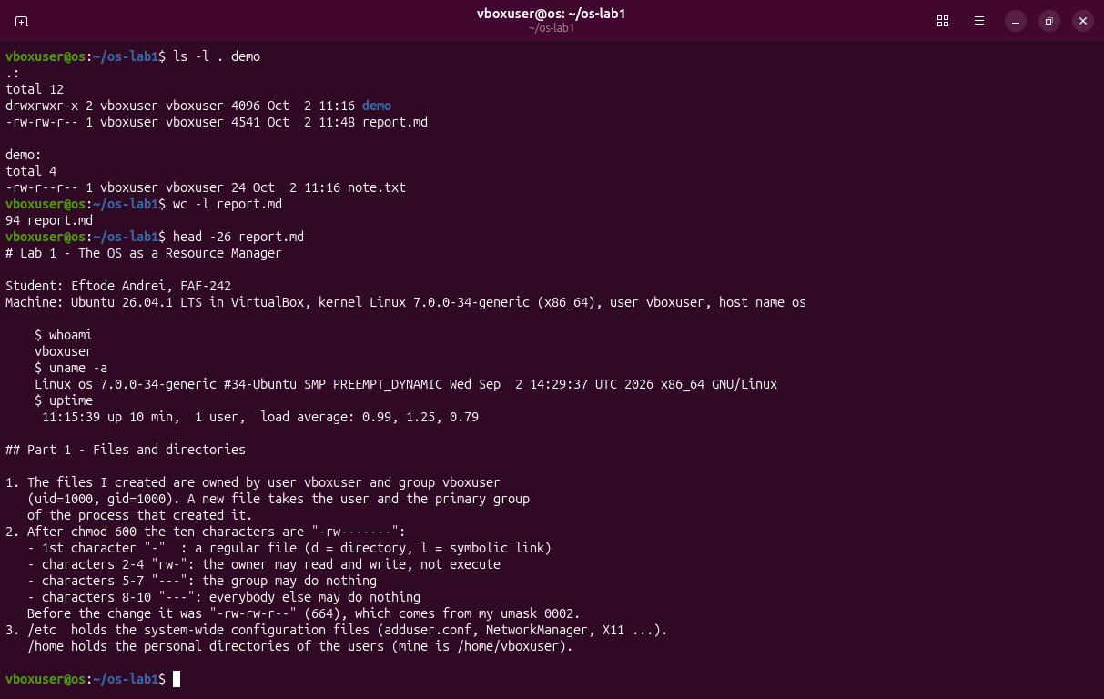
Figure 6.1 – The work folder and the beginning of report.md.
The OS manages four resources: files, processes, memory and devices. I saw the files with ls -l, the processes with ps aux, the memory with free -h and the devices with lsblk. In every case the program only asked, and the kernel decided.
Files in the folder lab1/ of the repository: this report, report.md with the answers, and the screenshots.

