Ministry of Education and Research of the Republic of Moldova
Technical University of Moldova
Faculty of Computers, Informatics and Microelectronics
Department of Software Engineering and Automatics
REPORT
on Laboratory Work No. 2
Course: Operating Systems
Topic: Meet the OS You Will Build
Track B: build your own small OS (xv6)
Done by: st. gr. FAF-242, Eftode Andrei
Checked by: univ. assist. Reițman Patricia
Chișinău, 2026
Contents
Laboratory Work No. 2. Meet the OS You Will Build 3
Preparation 3
Part 1. Build it and boot it 4
Part 2. Use xv6 as the Unix it is 4
Part 3. Read the source 6
Part 4. Write your first xv6 program 8
Optional: pingpong 11
Deliverables and conclusions 12

Laboratory Work No. 2. Meet the OS You Will Build
Purpose: to build xv6 from source, boot it in QEMU, use it as a small Unix, read how its source is split between kernel/ and user/, and add a first program, sleep, that makes a system call.
Environment: Ubuntu 26.04.1 LTS in VirtualBox, riscv64-linux-gnu-gcc 15.2.0, QEMU 10.2.1, a fresh clone of the current xv6 (revision f780d78) in ~/xv6-lab2.
Note: I first did this lab in September on the last xv6 revision before sleep() was renamed to pause(). I did it again here, on the current xv6, so that my sleep.c builds on the xv6 that is used now.

Preparation
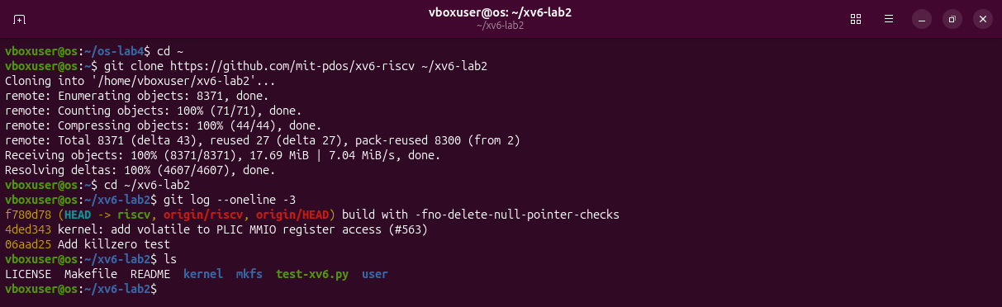
Figure 0.1 – A fresh clone of the current xv6.
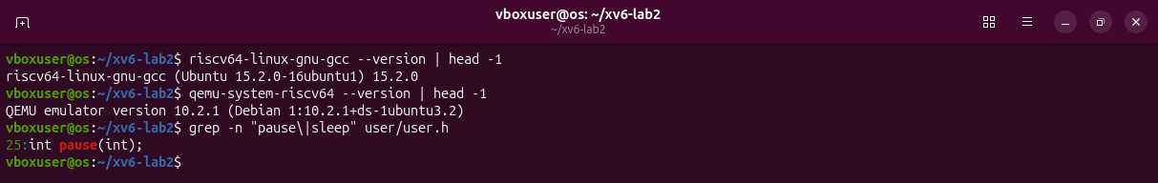
Figure 0.2 – The cross-compiler, QEMU, and the system call pause in user/user.h.
In the current xv6 the system call that waits for clock ticks is called pause(); there is no sleep() in user/user.h any more (it was renamed upstream in August 2025). Part 4 shows what this means for the sheet's code.

Part 1. Build it and boot it
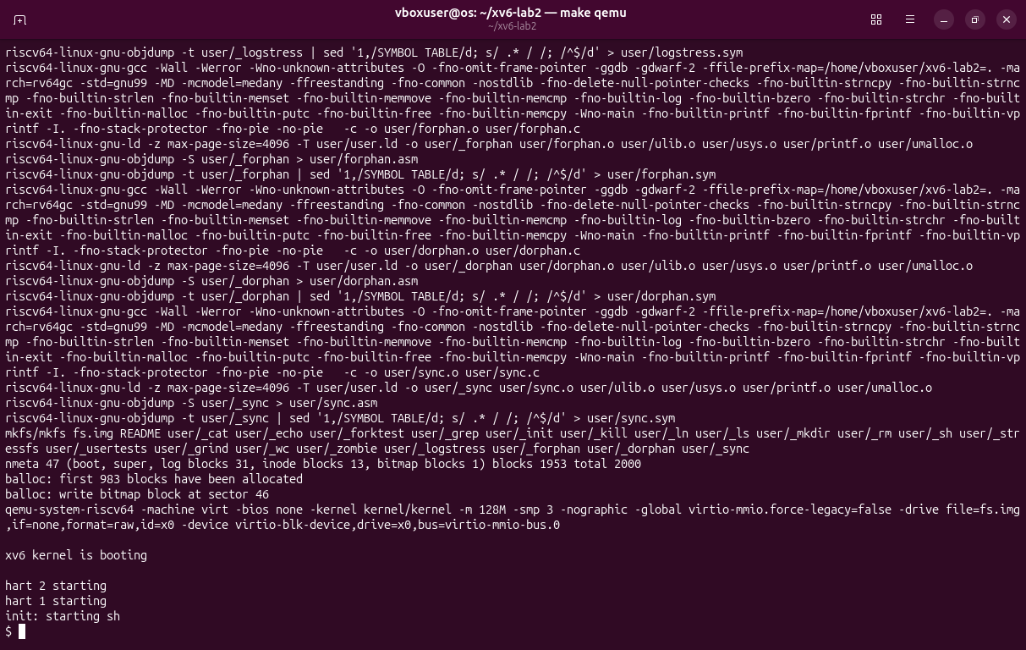
Figure 1.1 – make qemu: the last build steps, mkfs makes the disk, the kernel boots and init starts the shell.

Part 2. Use xv6 as the Unix it is
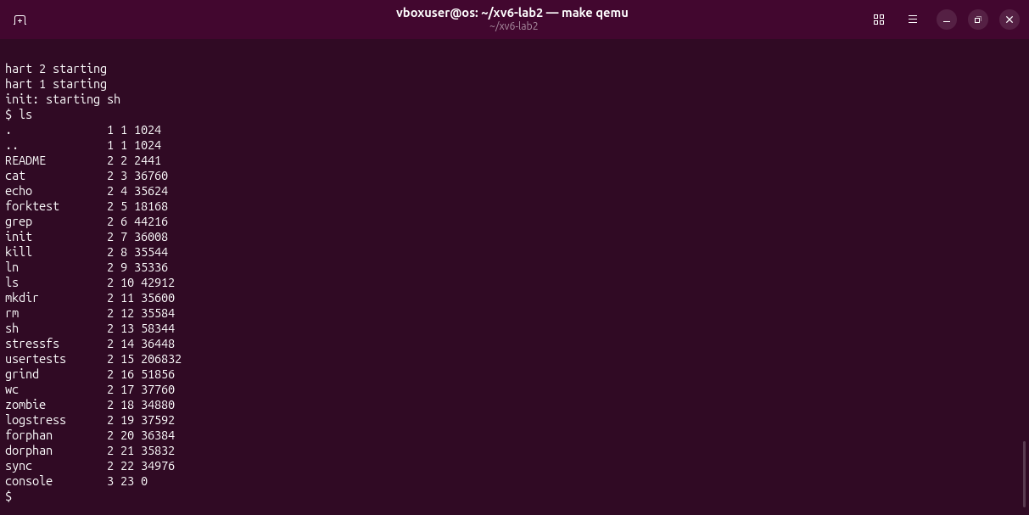
Figure 2.1 – ls inside xv6: the programs on the disk.
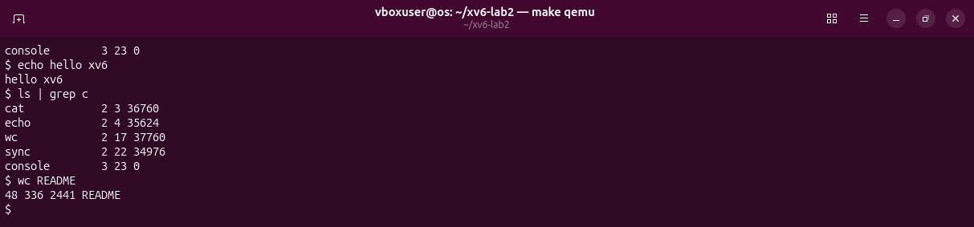
Figure 2.2 – echo, a pipe (ls | grep c) and wc.
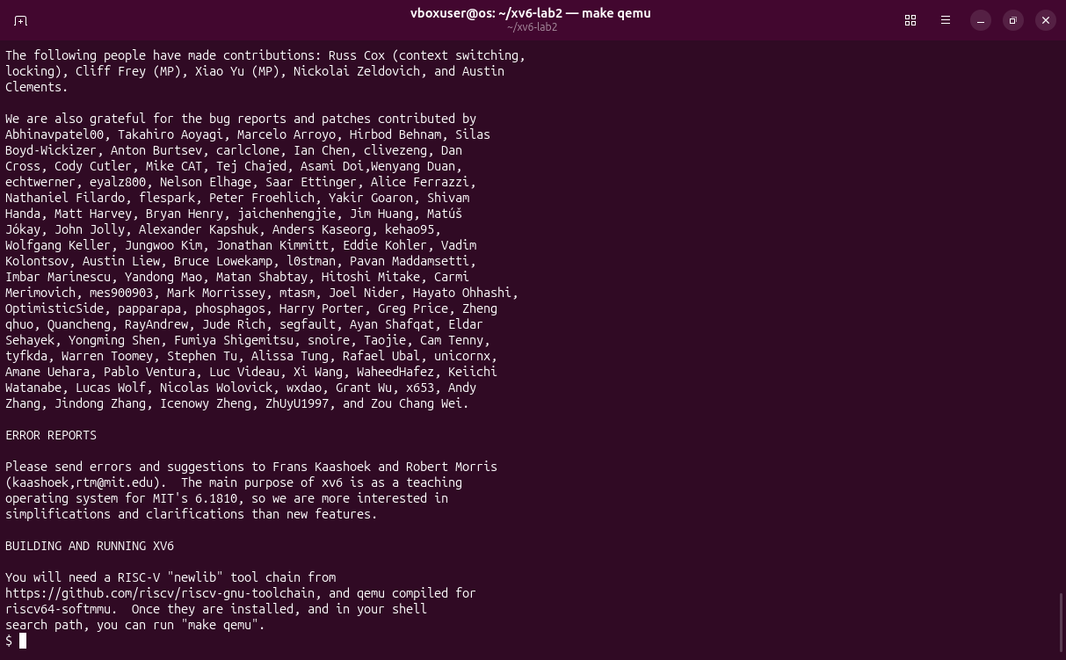
Figure 2.3 – The end of cat README.
Observations
(1) Three programs: ls, cat, echo (also grep, wc, mkdir, rm, sh ...).
(2) Processes and communication between them: the shell runs ls and grep as two processes, and the kernel pipe (a buffer with a write end and a read end) carries the output of one into the input of the other.
(3) The same idea of commands, pipes and redirection as bash, but much smaller: the prompt is only $, with no history, completion, variables or job control.

Part 3. Read the source
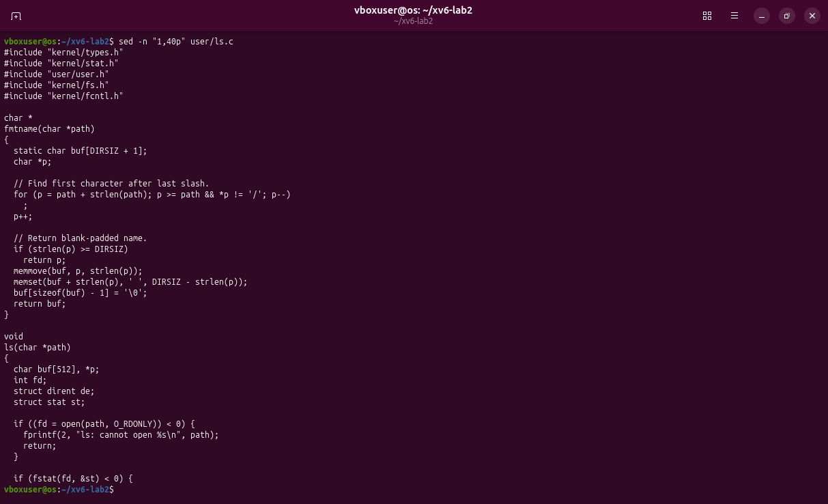
Figure 3.1 – The first 40 lines of user/ls.c.
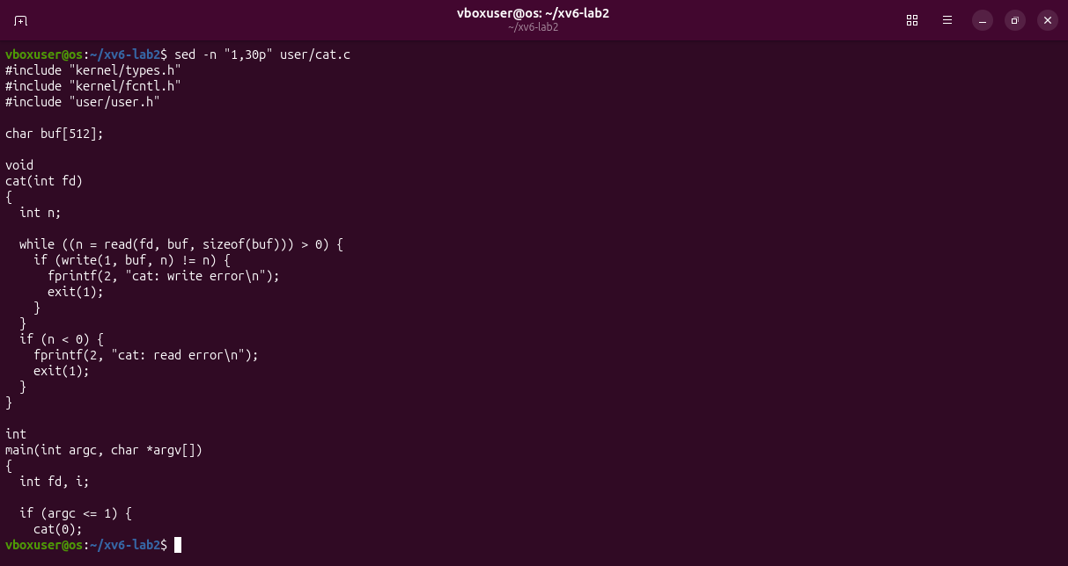
Figure 3.2 – The first 30 lines of user/cat.c.
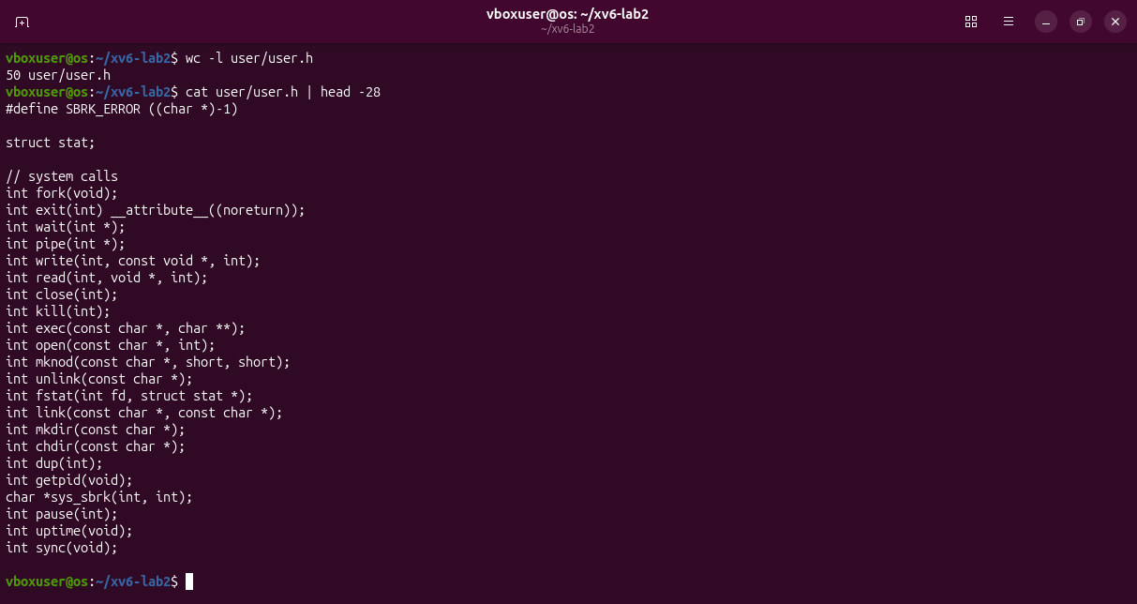
Figure 3.3 – user/user.h: the system calls.
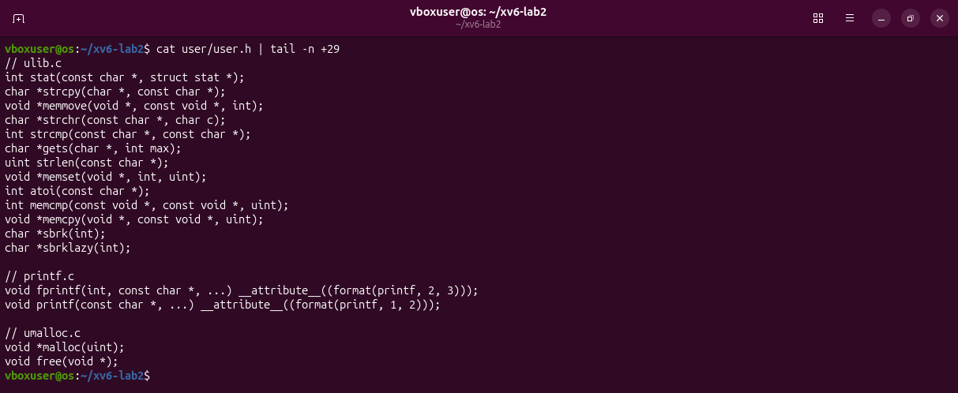
Figure 3.4 – user/user.h: the library functions.
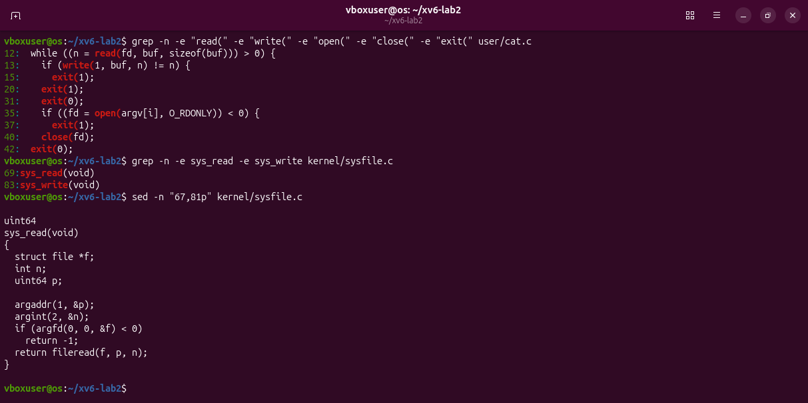
Figure 3.5 – The calls in cat.c, and sys_read / sys_write in kernel/sysfile.c.
Observations
(1) read copies bytes from an open file into a buffer, write sends bytes to a file descriptor (1 is the console), open turns a file name into a descriptor, close gives the descriptor back, exit ends the process.
(2) kernel/sysfile.c, line 69 (sys_read); sys_write is at line 83.
(3) kernel/ is the operating system itself and runs privileged; user/ holds ordinary programs that can only ask the kernel for things through system calls.

Part 4. Write your first xv6 program
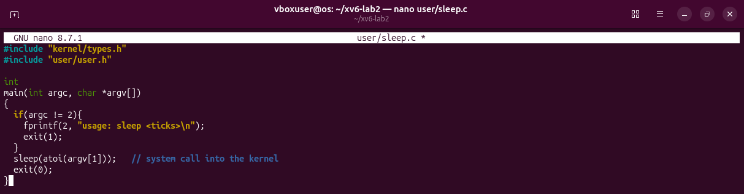
Figure 4.1 – user/sleep.c typed in nano, exactly as on the sheet.
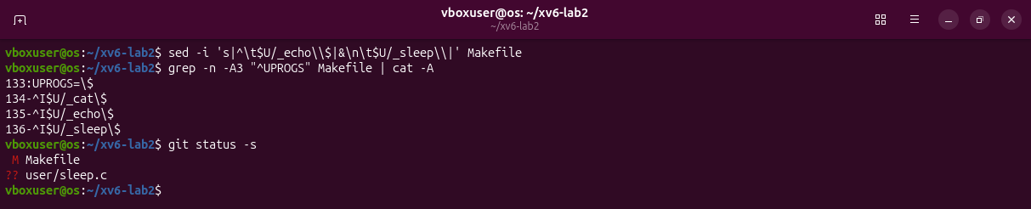
Figure 4.2 – The line $U/_sleep\ added to UPROGS (^I is the TAB, $ the end of the line).
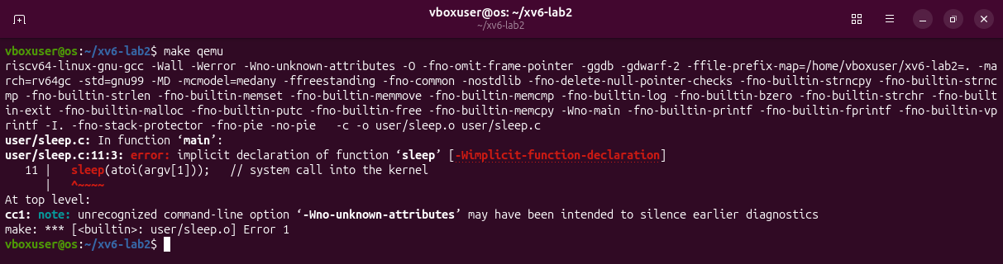
Figure 4.3 – The sheet's version does not compile on the current xv6: there is no sleep().
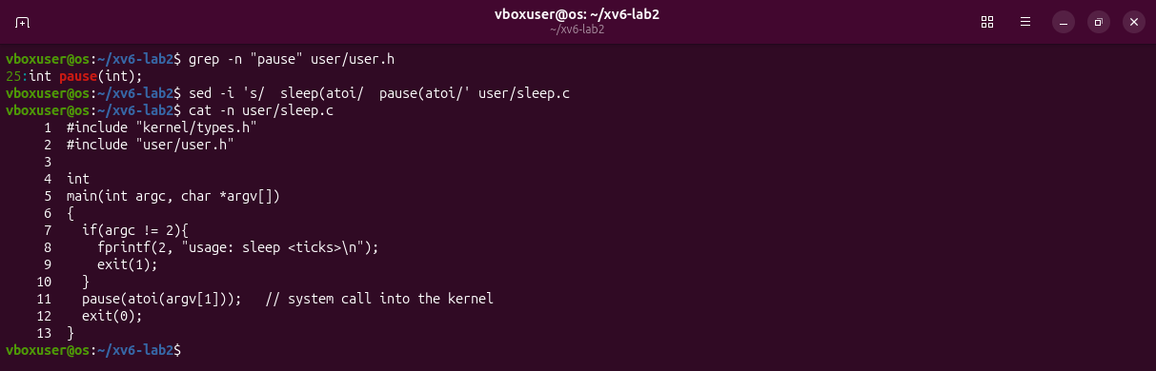
Figure 4.4 – The fix: pause(), the name the current xv6 gives to the same system call.
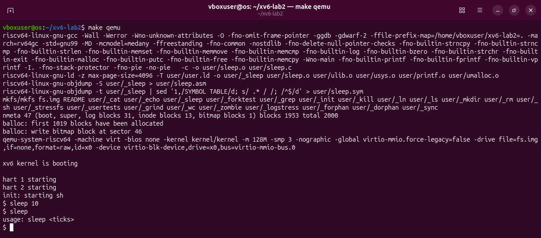
Figure 4.5 – sleep 10 pauses and returns; sleep alone prints the usage message.
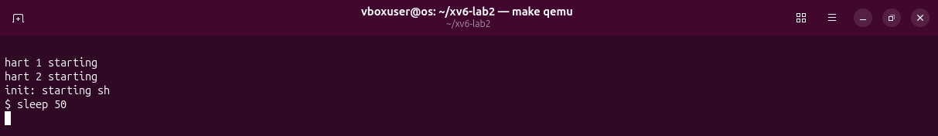
Figure 4.6 – sleep 50, two seconds after Enter: still sleeping, no prompt.
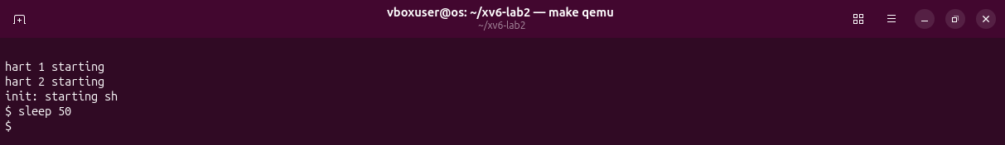
Figure 4.7 – A few seconds later the prompt is back.
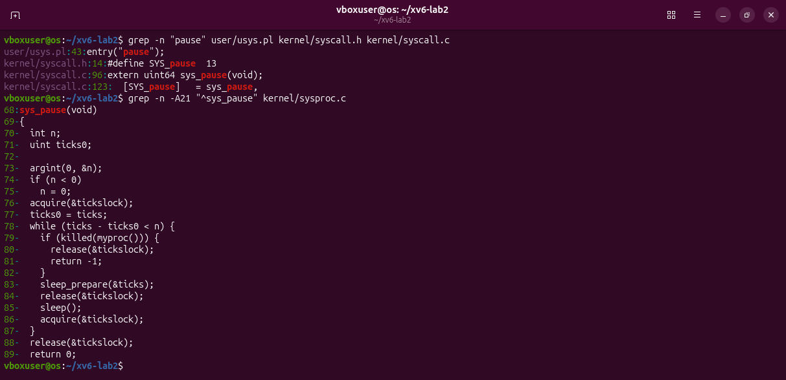
Figure 4.8 – The kernel side: system call 13 and sys_pause in kernel/sysproc.c.
pause() enters the kernel as system call 13 and runs sys_pause (kernel/sysproc.c, line 68), which waits until the tick counter has advanced by n; one tick is about a tenth of a second, so sleep 50 takes about five seconds.

Optional: pingpong
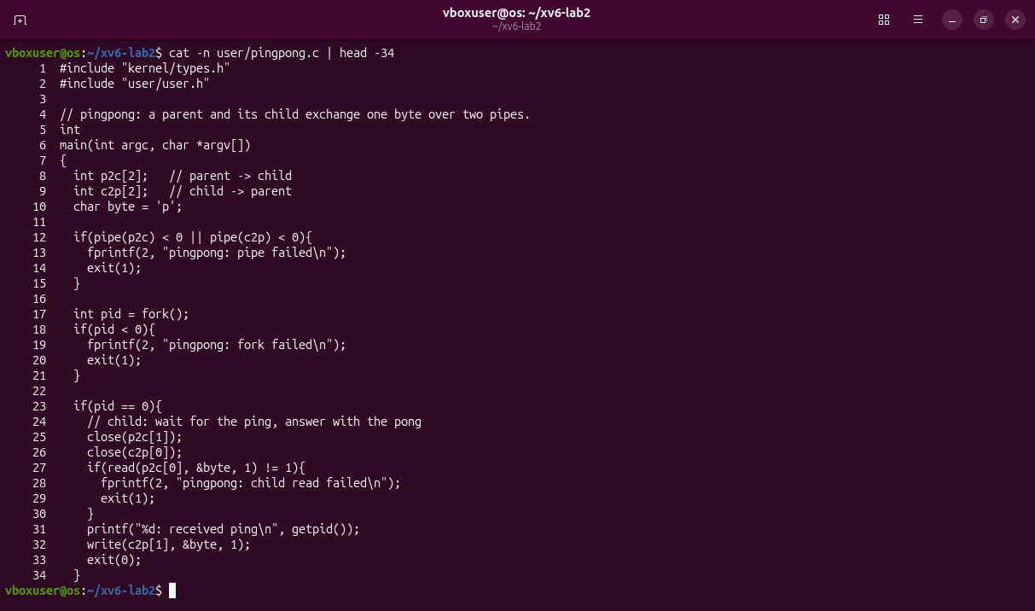
Figure 5.1 – user/pingpong.c, first half: two pipes, a fork(), and the child.
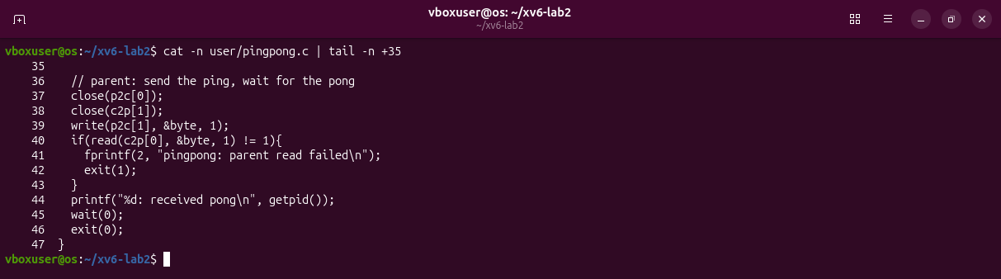
Figure 5.2 – user/pingpong.c, second half: the parent.
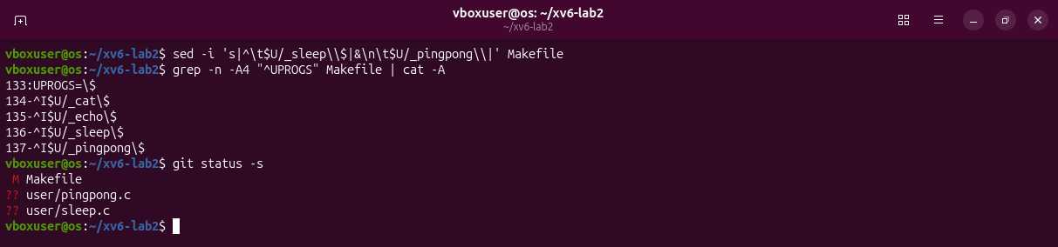
Figure 5.3 – $U/_pingpong\ added to UPROGS.
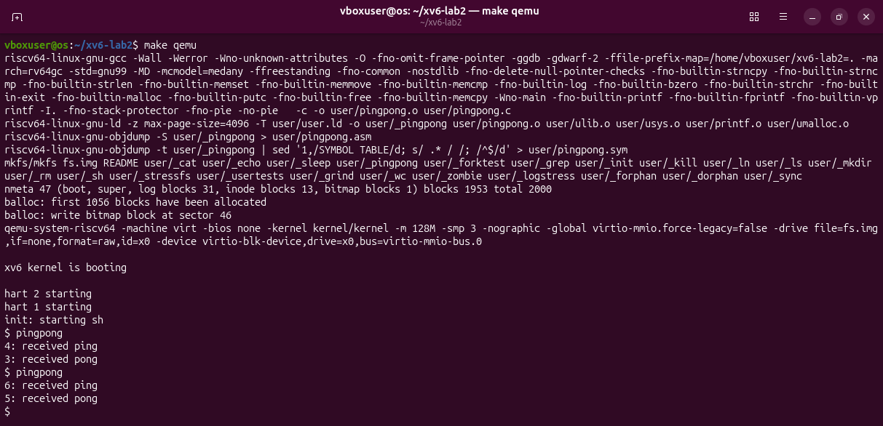
Figure 5.4 – The child receives the ping, then the parent receives the pong.

Deliverables and conclusions
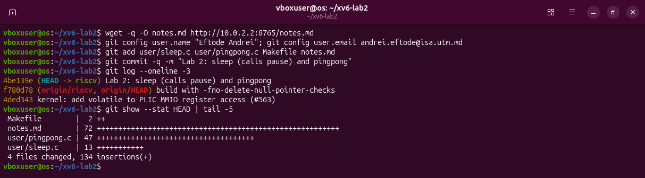
Figure 6.1 – My changes, committed in ~/xv6-lab2.
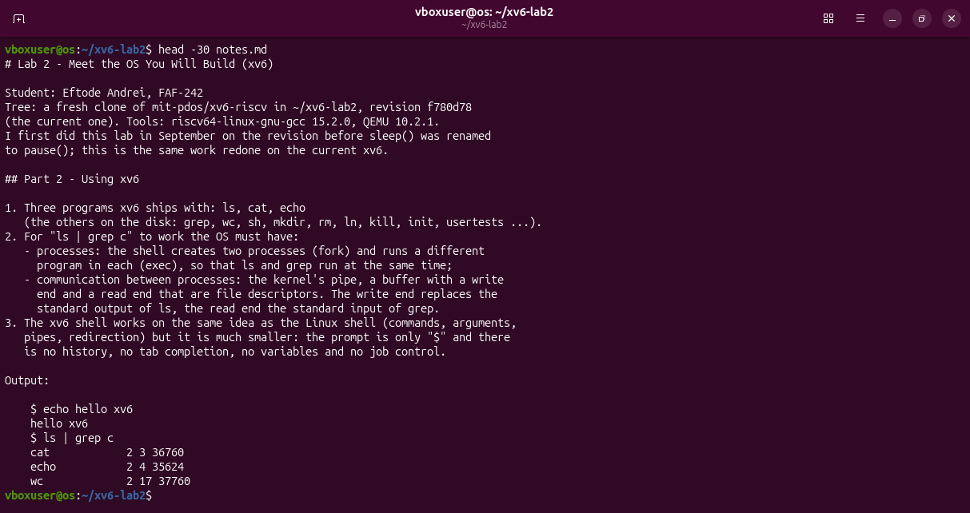
Figure 6.2 – The beginning of notes.md.
I built a real operating system from source, booted it and followed a system call from the program that asks (user/) to the kernel code that answers (kernel/). My sleep is a few lines of C; the waiting is done by the kernel. The sheet's sleep() no longer exists in the current xv6, so the program calls pause().
Files in the folder lab2/ of the repository: this report, sleep.c, pingpong.c, the Makefile, notes.md and the screenshots.

