Ministry of Education and Research of the Republic of Moldova
Technical University of Moldova
Faculty of Computers, Informatics and Microelectronics
Department of Software Engineering and Automatics
REPORT
on Laboratory Work No. 6
Course: Operating Systems
Topic: Inside the xv6 File System
Track B: build your own small OS (xv6)
Done by: st. gr. FAF-242, Eftode Andrei
Checked by: univ. assist. Reițman Patricia
Chișinău, 2026
Contents
Laboratory Work No. 6. Inside the xv6 File System 3
Preparation 3
Part 1. Read what xv6 shows you 4
Part 2. Write mystat 6
Part 3. Measure the limits 9
Part 4. Write find 10
Deliverables and conclusions 13

Laboratory Work No. 6. Inside the xv6 File System
Purpose: to read what the xv6 file system shows, to write a stat program and watch hard links with it, to measure the limits written in kernel/fs.h, and to write find, which walks the directory tree recursively.
Environment: Ubuntu 26.04.1 LTS virtual machine, riscv64-linux-gnu-gcc 15.2.0, QEMU 10.2.1, xv6 revision 06aad25 in ~/xv6-riscv on branch lab, which already has sleep and args from Lab 4.

Preparation
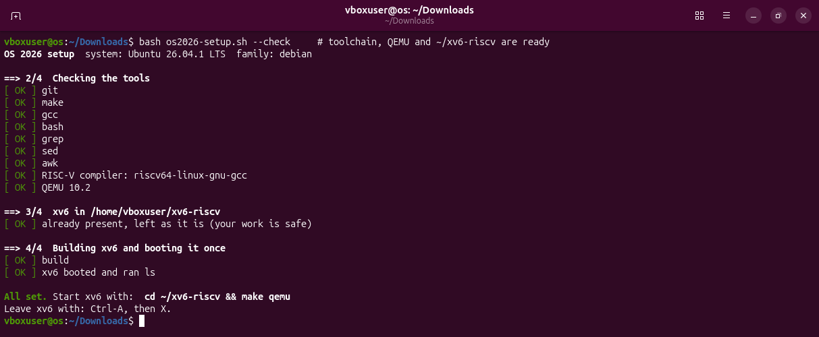
Figure 0.1 – bash os2026-setup.sh --check: the tools are there, xv6 builds and boots.
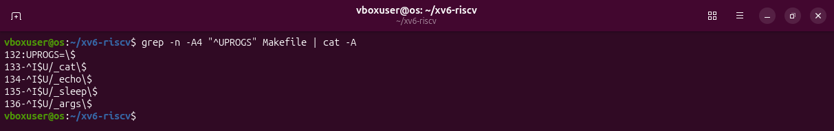
Figure 0.2 – The UPROGS list before this lab, with the two lines from Lab 4.

Part 1. Read what xv6 shows you
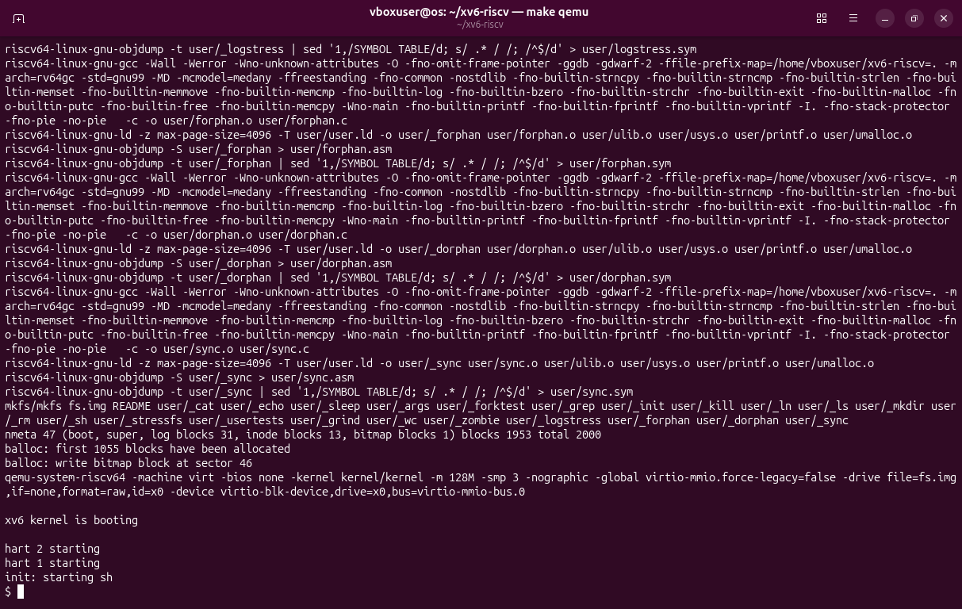
Figure 1.1 – make clean ; make qemu: a fresh disk is built and xv6 boots.
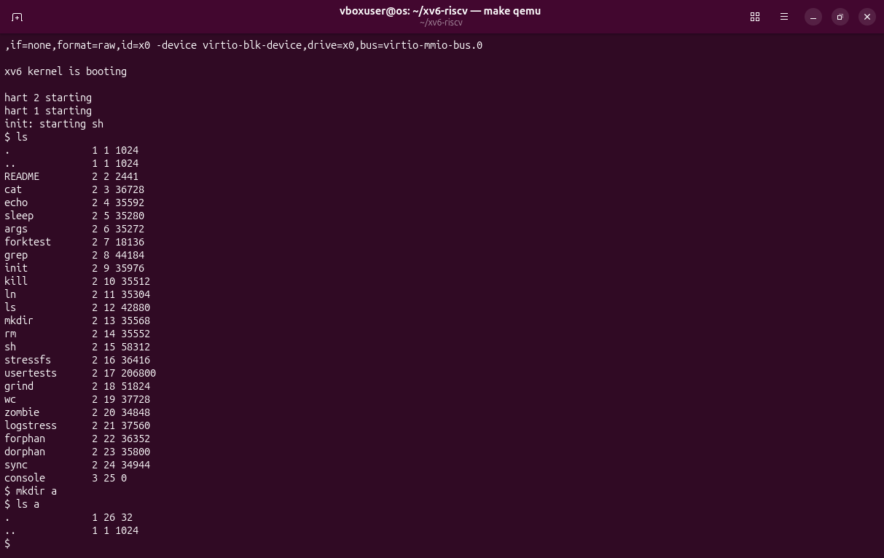
Figure 1.2 – ls, mkdir a and ls a in xv6.
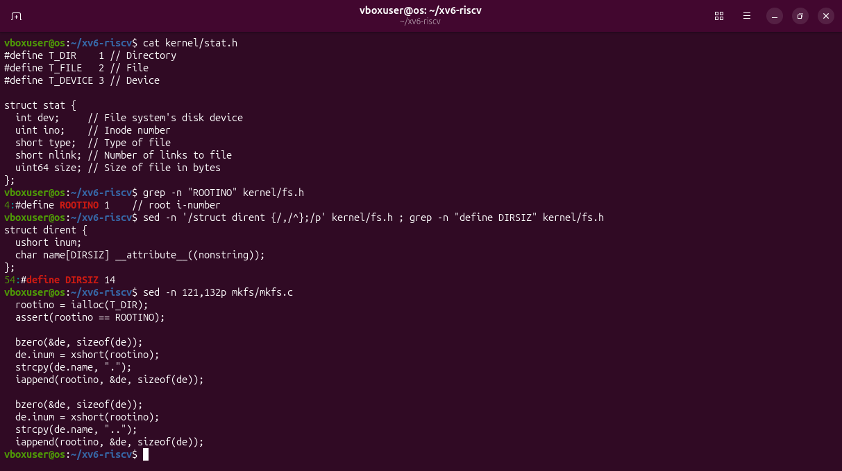
Figure 1.3 – The types in kernel/stat.h, the root inode, a directory entry, and how mkfs makes the root.
Observations
(1) T_DIR 1 is a directory, T_FILE 2 a regular file, T_DEVICE 3 a device (console).
(2) The root is inode 1 (ROOTINO). It has no parent, so mkfs writes both . and .. with the root's own number: going up from / stays in /.
(3) One entry is 16 bytes: ushort inum (2) plus char name[DIRSIZ] (14). The 32 bytes of a are two entries: . (inode 26, a itself) and .. (inode 1, the root).

Part 2. Write mystat
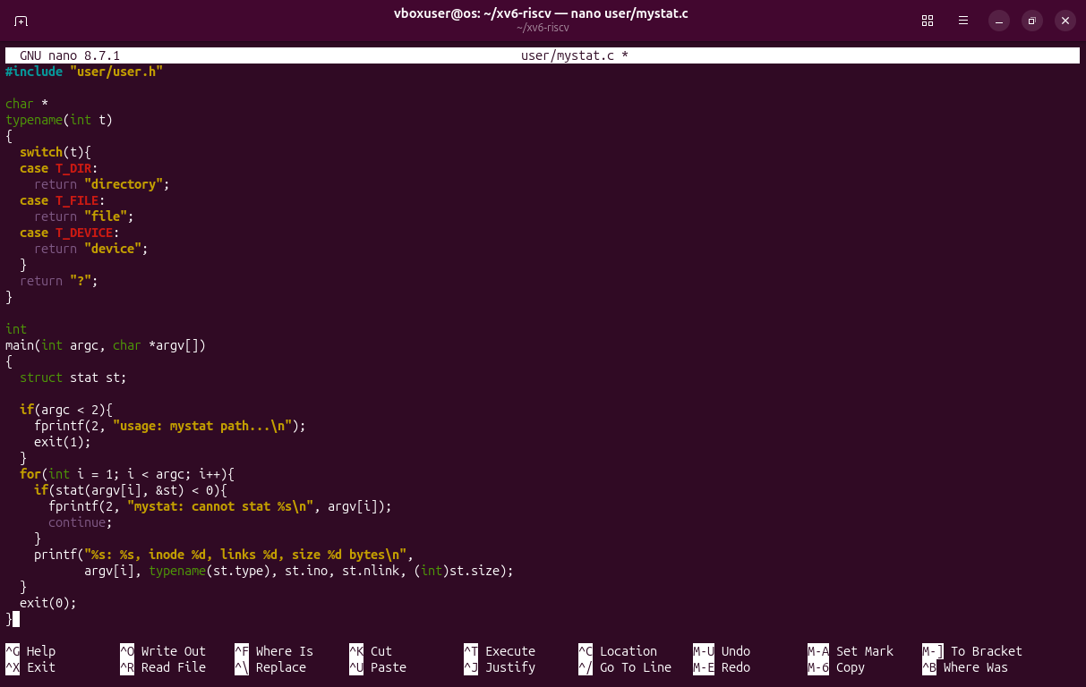
Figure 2.1 – Writing user/mystat.c in nano.
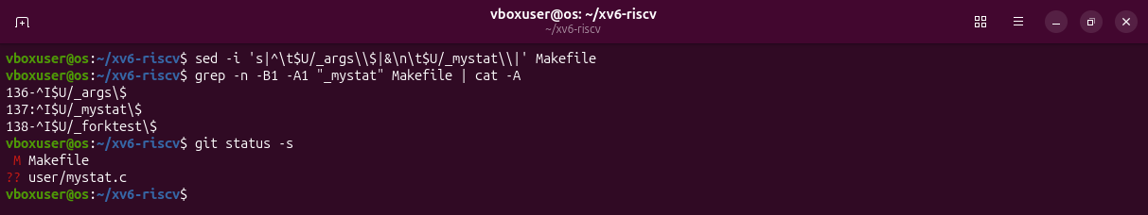
Figure 2.2 – The line $U/_mystat\ added to UPROGS.
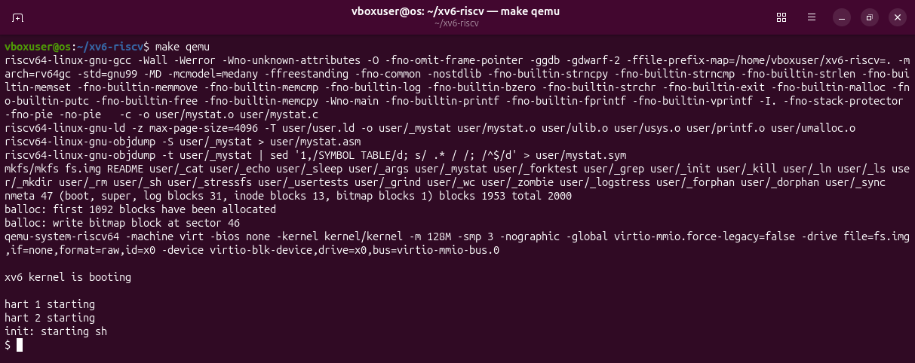
Figure 2.3 – make qemu compiles mystat and puts it on a new disk.
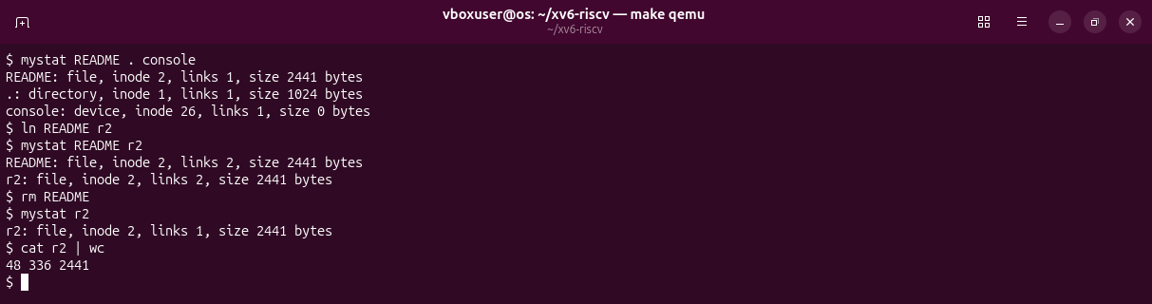
Figure 2.4 – Hard links at work: ln, then rm of the original name.
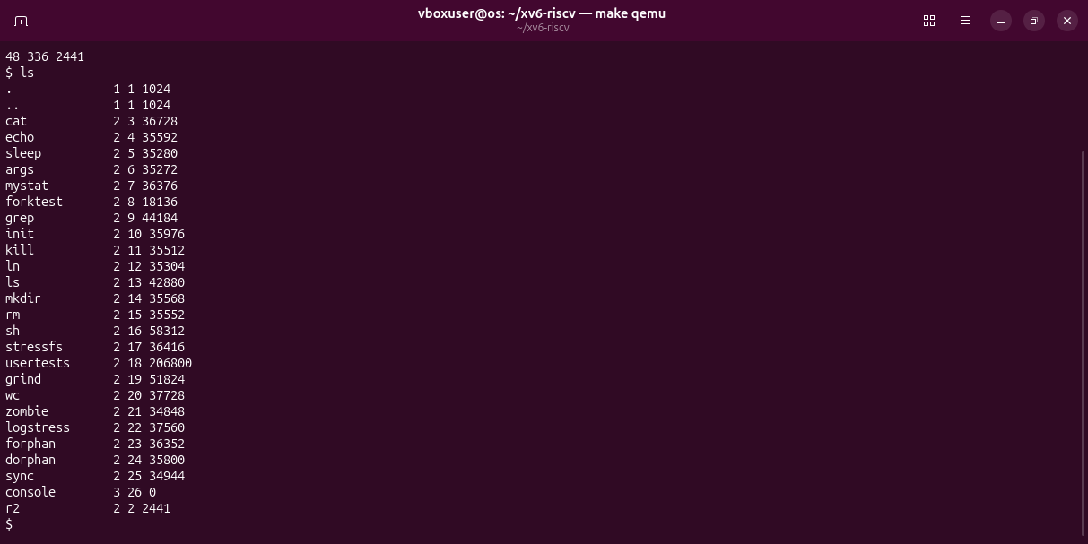
Figure 2.5 – The root after rm README: only r2 is left, with inode 2.
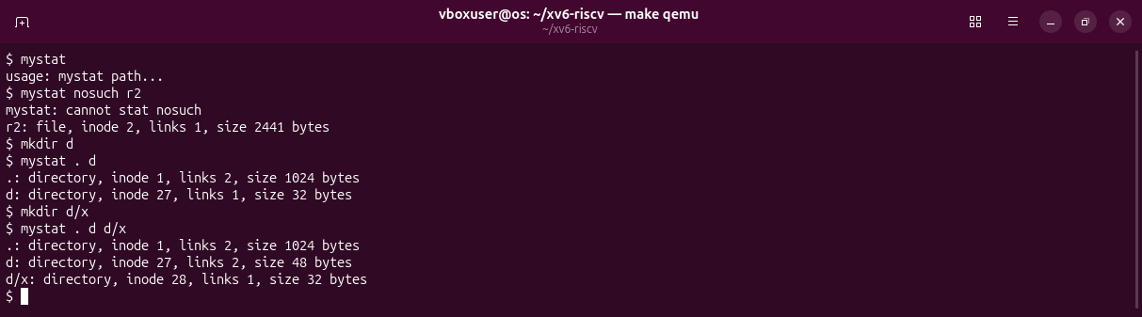
Figure 2.6 – Errors go to fd 2; links of xv6 directories.
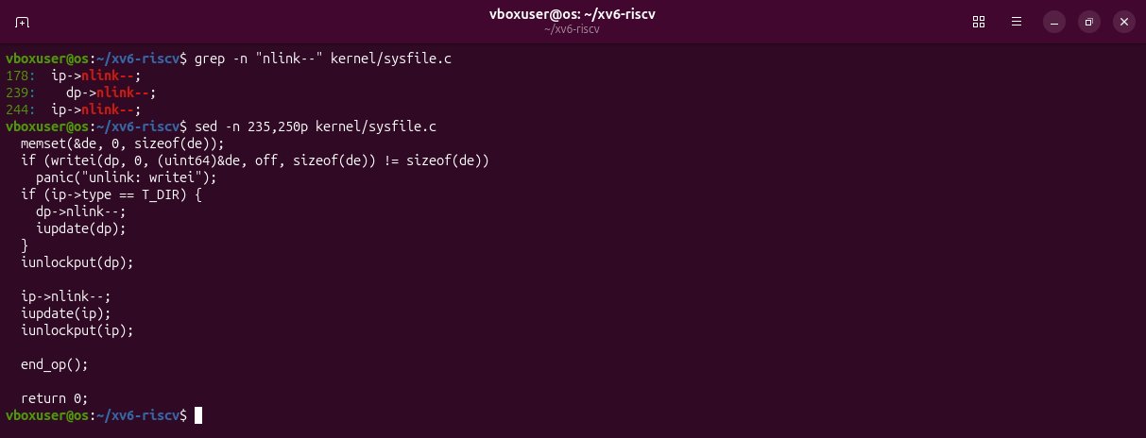
Figure 2.7 – The end of sys_unlink in kernel/sysfile.c.
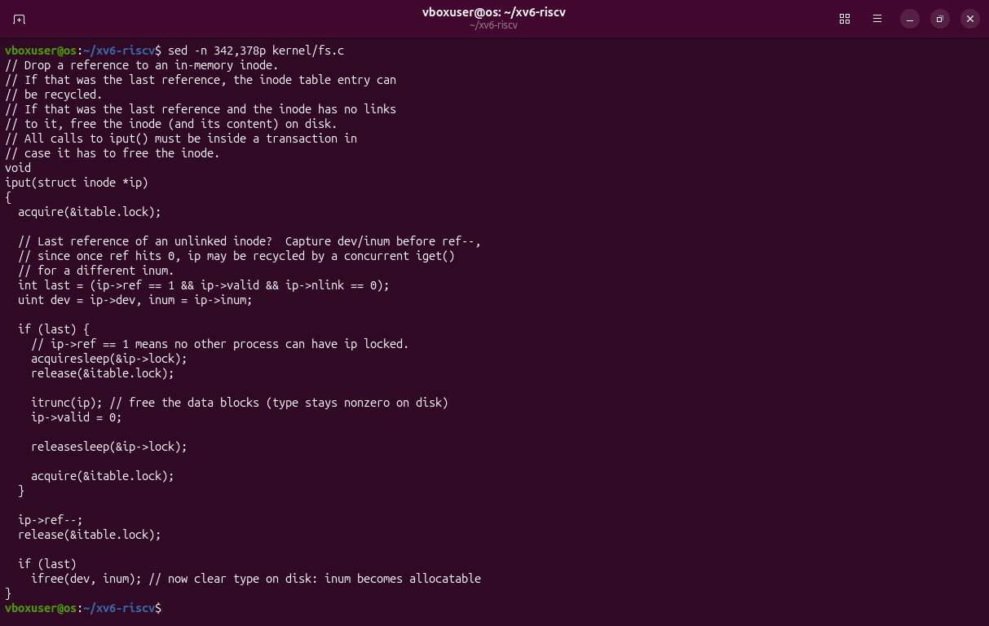
Figure 2.8 – iput in kernel/fs.c: where the data blocks are freed.
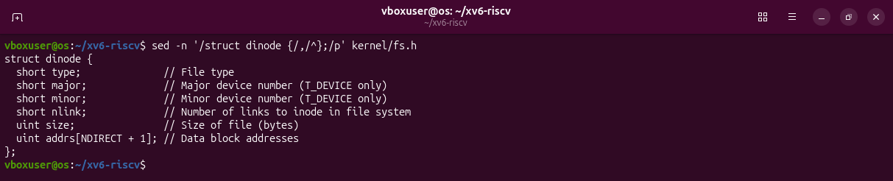
Figure 2.9 – The on-disk inode, struct dinode.
Observations
(1) After ln, README and r2 are both inode 2 with 2 links. After rm, r2 is inode 2 with 1 link, and all 2441 bytes are still there (wc). Only the link count and the names changed; the inode, the size and the data did not.
(2) Line 244 of kernel/sysfile.c: ip->nlink--;. The data blocks are freed later, in iput() (kernel/fs.c, line 365, itrunc(ip)), when the last reference to the inode is dropped and nlink is 0.
(3) type, major, minor, nlink, size and addrs[NDIRECT + 1]. No owner, no permissions, no times.
Extra: an xv6 directory starts with 1 link, not 2 as on Linux, because . is not counted; the parent gets +1 for the child's .. (Figure 2.6).

Part 3. Measure the limits
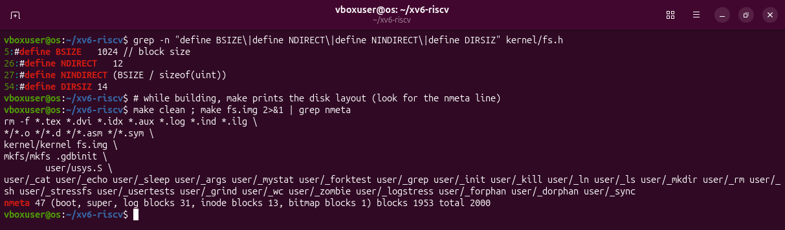
Figure 3.1 – The constants of kernel/fs.h and the nmeta line printed by mkfs.
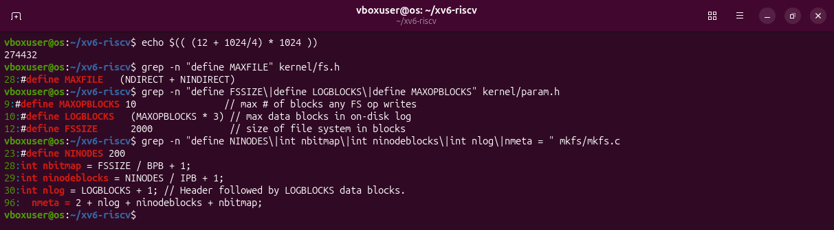
Figure 3.2 – The largest file, computed in bash, and where the disk layout comes from.
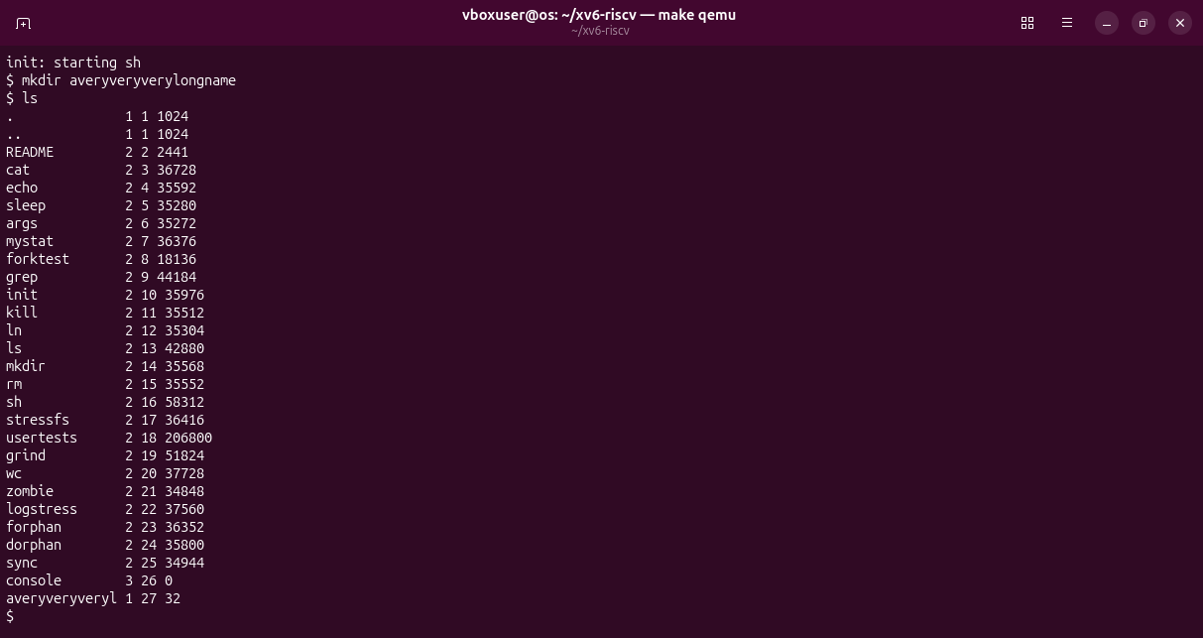
Figure 3.3 – mkdir averyveryverylongname and ls.
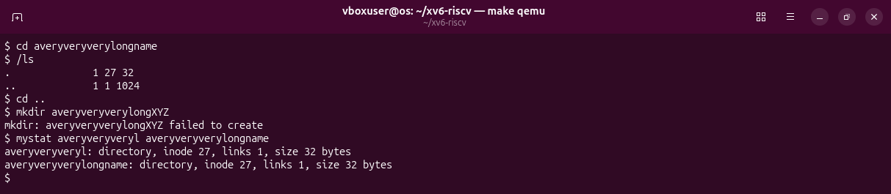
Figure 3.4 – The long name still works, because every lookup is cut to 14 characters too.
Observations
(1) ls shows averyveryveryl, the first 14 characters: DIRSIZ is 14.
(2) The largest file:
NINDIRECT = BSIZE / 4 = 1024 / 4 = 256
MAXFILE = 12 + 256 = 268 blocks
268 * 1024 = 274432 bytes = 268 KiB
(3) 2000 blocks in total: 47 for metadata (1 boot, 1 super, 31 log, 13 inode, 1 bitmap) and 1953 for data.

Part 4. Write find
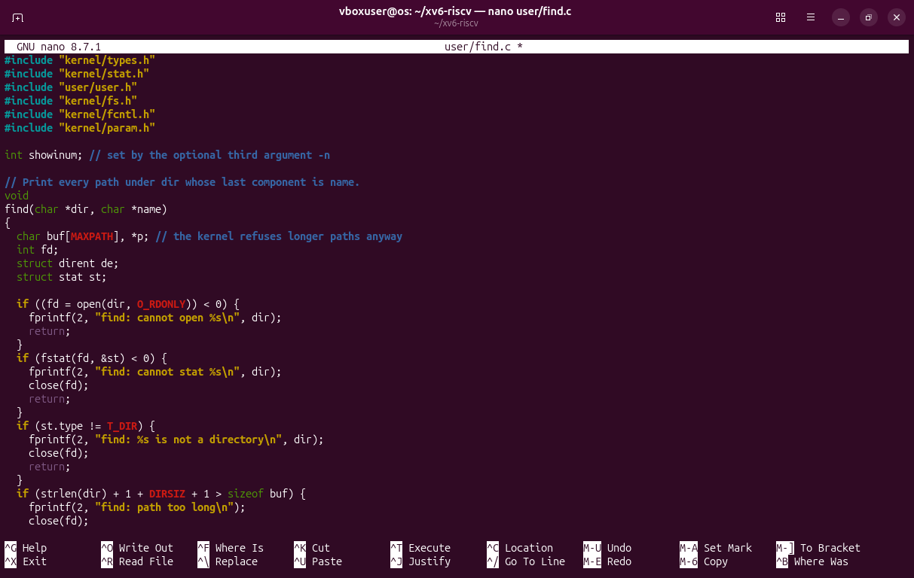
Figure 4.1 – user/find.c in nano, the first part.
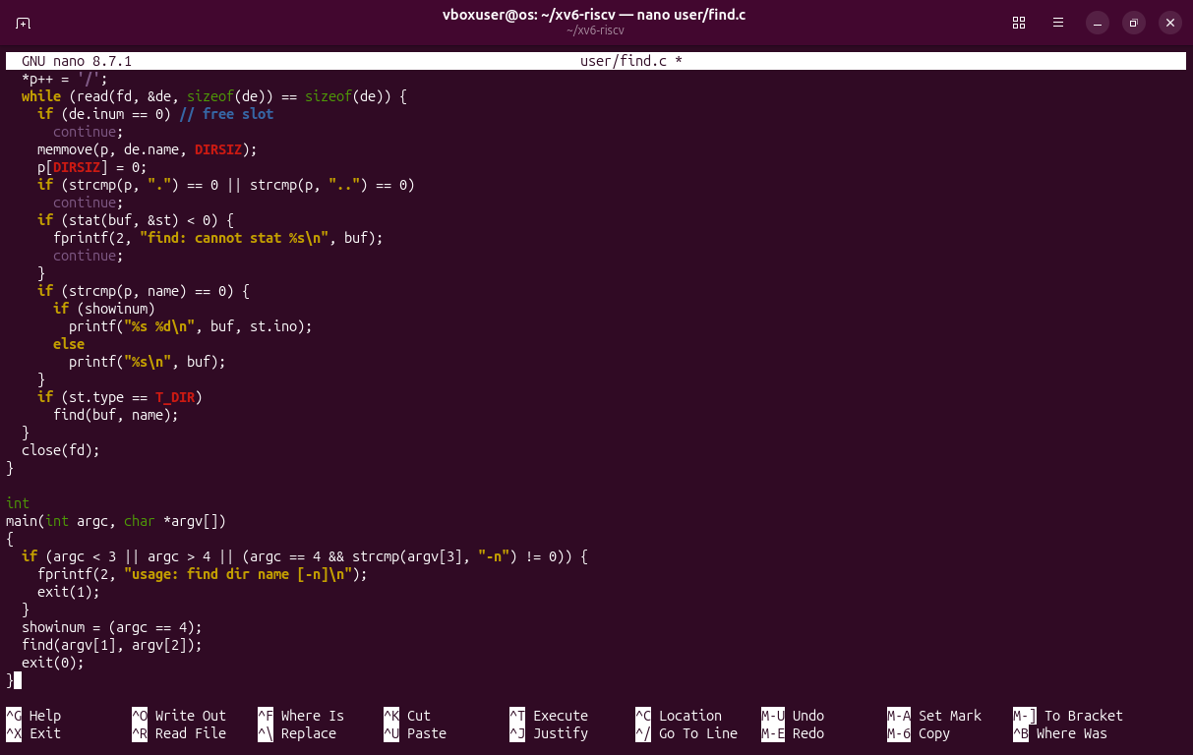
Figure 4.2 – user/find.c, the second part: the loop over the entries and main.
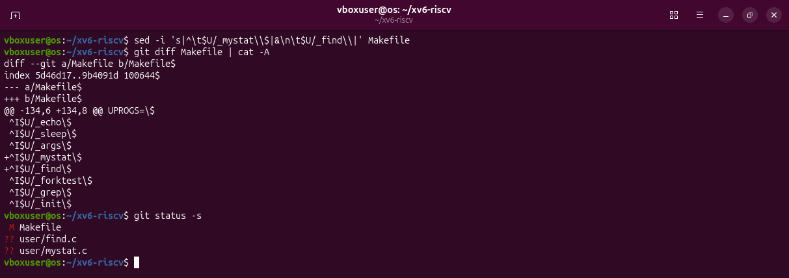
Figure 4.3 – My two lines in the Makefile, and the new files.
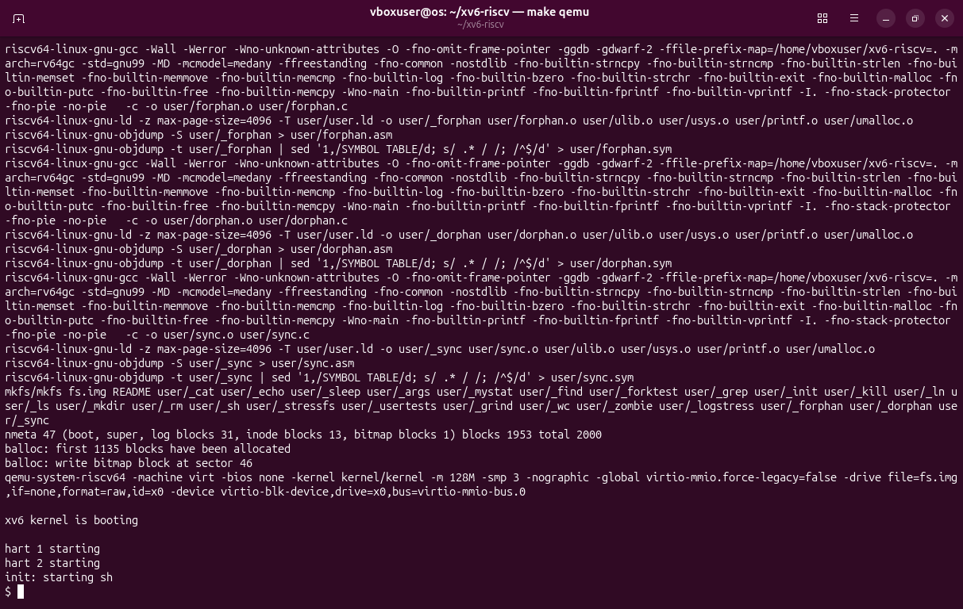
Figure 4.4 – make clean ; make qemu: a fresh disk with mystat and find.
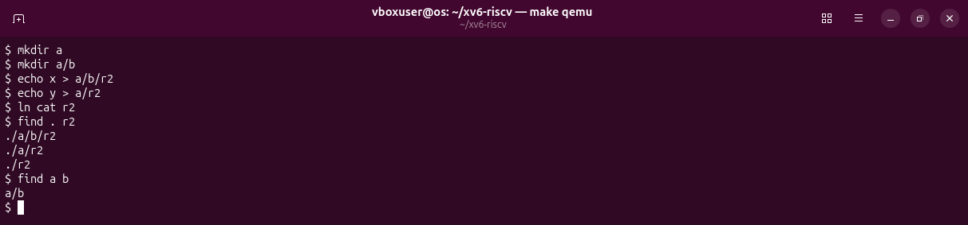
Figure 4.5 – The test of the sheet.
The order of the lines follows the order of the entries in each directory: in a, b comes before r2, and in the root a comes before r2, because they were created in that order.
Stretch: find . r2 -n
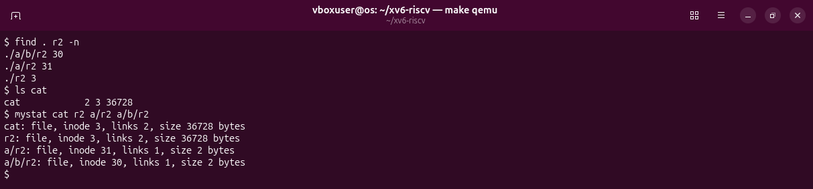
Figure 4.6 – The inode number next to each path.
./r2 has inode 3, the same as cat, because it was made with ln cat r2; both have 2 links. ./a/r2 (31) and ./a/b/r2 (30) are different files.
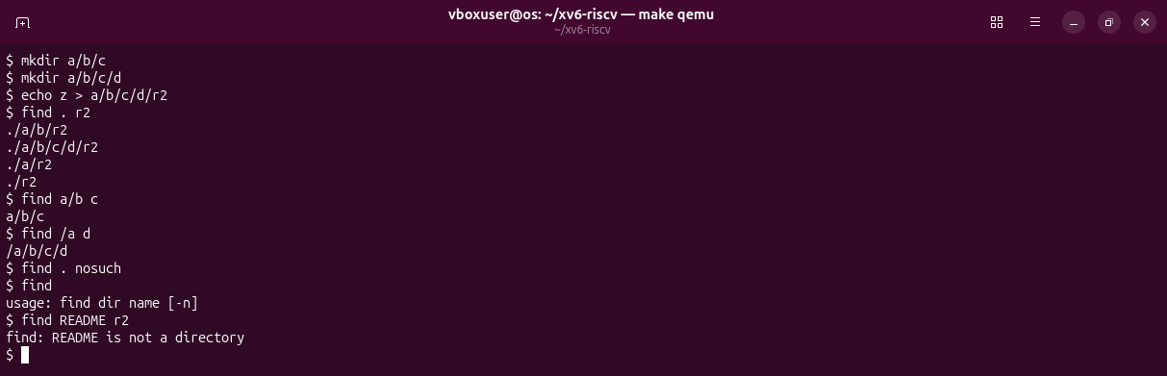
Figure 4.7 – More tests: a deeper tree, an absolute path, no match, wrong arguments.

Deliverables and conclusions
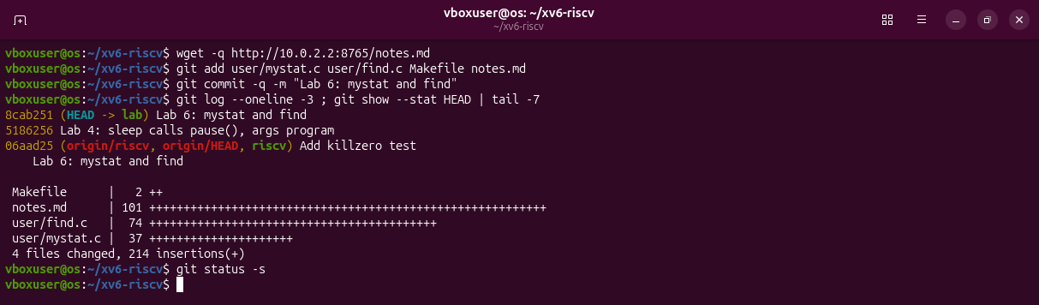
Figure 5.1 – The xv6 tree at the end: the Lab 6 commit on branch lab.
The xv6 file system has the same ideas as ext4 in a few hundred lines: an inode with a link count and a list of blocks, directories that are tables of 16-byte entries, and names that are only references, so the data lives until the last link and the last reference are gone. Its limits are plain constants: 14-character names, 268 KiB files and a 2000-block disk.
Files in the folder lab6/ of the repository: this report, mystat.c, find.c, the Makefile, notes.md and the screenshots.

