MINISTRY OF EDUCATION AND RESEARCH OF THE REPUBLIC OF MOLDOVA
Technical University of Moldova
Faculty of Computers, Informatics and Microelectronics
Department of Software Engineering and Automation

REPORT
Laboratory work No. 1
Discipline: Network Programming
Topic: Concurrency in Practice

Elaborated: st. gr. FAF-242, Eftode Andrei
Verified: Cristofor Fistic

Chișinău, 2026

1. Goal of the work
Measure how the number of threads, and the way the work is divided among them, change the running time and the memory of a real workload; decide from my own measurements when the work is CPU-bound and when it is I/O-bound; observe a race condition and the cost of fixing it; and find where parallel speed-up stops.
The workload: count how many of 50,000,000 integers are negative, positive and zero. All tasks are one console program; the task and its configuration are chosen with command-line parameters. The program was written twice: in C# (the main version) and in Java (the bonus: comparison of two languages).

1.1 Source code
Git repository: https://github.com/EftodeAndreiFAF242/RC_E_F — folder Lab1.
Path in the repository | Contents
Lab1/*.cs, Lab1/Lab1.csproj | C# program: Program.cs (command dispatch), Task1a.cs, Task1b.cs, Task1c.cs, Task2.cs, shared helpers
Lab1/java/src/lab1/*.java | Java program with the same commands, options and CSV output
Lab1/run_task1.ps1, Lab1/run_task2.ps1 | scripts that build both programs and run every configuration; run_task2.ps1 also ejects the USB drive and waits for it to be re-plugged before every run
Lab1/results/*.csv | every measurement used in this report
Lab1/report/ | the generator of this report (charts and document) from the CSV files
Lab1/README.md | how to build and run every task, and a full explanation of the lab

Build and run (from the Lab1 folder):
# C#: compile (optimised), create the data, run one configuration
dotnet build -c Release
..\artifacts\bin\Lab1\release\Lab1.exe gen
..\artifacts\bin\Lab1\release\Lab1.exe task1a --threads 8
# Java: compile and run the same configuration
javac -d java/out -encoding UTF-8 java/src/lab1/*.java
java --enable-native-access=ALL-UNNAMED -cp java/out lab1.Main task1a --threads 8
# every configuration of every task, both languages
powershell -ExecutionPolicy Bypass -File .\run_task1.ps1 -Lang both -Runs 5 -Extras
powershell -ExecutionPolicy Bypass -File .\run_task2.ps1 -Lang both -Warm

2. Hardware and software
Component | Value
CPU | AMD Ryzen 9 9955HX (Zen 5), base clock 2.5 GHz, 2 chiplets × 8 cores
Physical cores / logical processors | 16 / 32 (SMT: 2 hardware threads per core)
RAM | 32 GB DDR5-5600 (2 × 16 GB, Micron)
Disk | Micron MTFDKBA1T0QGN, 1 TB NVMe SSD
USB flash drive | "VendorCo ProductCode" (controller VID 048D / PID 1234, a no-name stick), reports 124 GB; 32 GB FAT32 partition used
USB version | USB 2.0 High-Speed (480 Mbit/s): the device descriptor says bcdUSB = 2.00 and the hub driver reports "High speed", although it was plugged into a USB 3 port. Measured: read 11.7 MB/s, write 4.5 MB/s
Operating system | Windows 11 Pro 64-bit (10.0.26200), power plan "Performance", on mains power
C# | C# 14, .NET SDK 10.0.401, runtime .NET 10.0.12 (x64), Release build, tiered compilation off
Java | Java 25: Eclipse Temurin 25.0.5+8 LTS, HotSpot 64-bit Server VM, default G1 garbage collector

The USB version was read from the USB hub driver (IOCTL_USB_GET_NODE_CONNECTION_INFORMATION_EX, the same data the USBView tool shows), the core counts from Win32_Processor.

3. Data and measurement method
The program's gen command writes numbers.txt: 50,000,000 random integers from −1,000,000 to 1,000,000, one per line (\n line endings, 352.3 MB), with a fixed random seed (12345) so the file is reproducible. At the same time it writes the 8 files of 6,250,000 numbers for Task 2 (the same numbers, in order, ~44 MB each) and the correct totals, which every run compares with its own result and prints CORRECT or WRONG.
Negative | Positive | Zero | Total
25,007,776 | 24,992,202 | 22 | 50,000,000

- Time is measured inside the program (C#: Stopwatch, Java: System.nanoTime) from just before the threads are created until the last thread has finished. Starting the process and, in Task 1b, loading the array are not measured.
- Peak memory is the peak working set of the process: the most physical RAM it used at any moment (Windows PeakWorkingSetSize; Java reads the same counter through its Foreign Function API). Every configuration runs in a new process, so peaks do not carry over between configurations.
- Task 1 reads numbers.txt from the Windows file cache (a warm-up run loads it first), so it measures the counting work, not the SSD. Every configuration was run 5 times; the tables and charts show the median.
- Task 2 reads the 8 files from the USB drive. Before every run the script ejected the drive and waited until it was unplugged and plugged back in, so no data came from the file cache. One run per configuration.
- All runs of all tasks gave the correct totals, except Task 1b version 1, which is wrong on purpose.

4. Task 1: one file

4.1 Task 1a: counting with threads
Implementation. The file (352 MB) is cut into N equal byte ranges, one per thread. Every thread opens the file itself and reads only its range with positional reads of 1 MB (RandomAccess.Read / FileChannel.read(buffer, position)), then parses the bytes directly (digits → number, '-' → negative, '\n' → line finished), without creating a string per line.
Boundaries. A cut usually falls in the middle of a line. Rule: a line belongs to the thread whose range contains the line's first byte. A thread that does not start at 0 looks at the byte just before its range: if it is not \n, the line began earlier and belongs to the previous thread, so it skips to the next \n. At the end, a thread keeps reading past its range until it finishes the line it started. Every line has exactly one first byte and the ranges do not overlap, so every line is counted exactly once; the totals were correct in every run.
Threads | C# time | C# speed-up | C# peak memory | Java time | Java speed-up | Java peak memory
1 | 398 ms | 1.00× | 26.2 MB | 583 ms | 1.00× | 58.2 MB
2 | 203 ms | 1.96× | 27.2 MB | 313 ms | 1.86× | 59.4 MB
4 | 110 ms | 3.63× | 29.8 MB | 181 ms | 3.23× | 61.4 MB
8 | 63.1 ms | 6.31× | 33.7 MB | 131 ms | 4.46× | 65.8 MB
16 | 39.0 ms | 10.2× | 42.1 MB | 159 ms | 3.67× | 77.3 MB
32 | 35.1 ms | 11.3× | 58.3 MB | 213 ms | 2.74× | 135.4 MB
64 | 38.8 ms | 10.3× | 90.4 MB | 224 ms | 2.61× | 187.4 MB
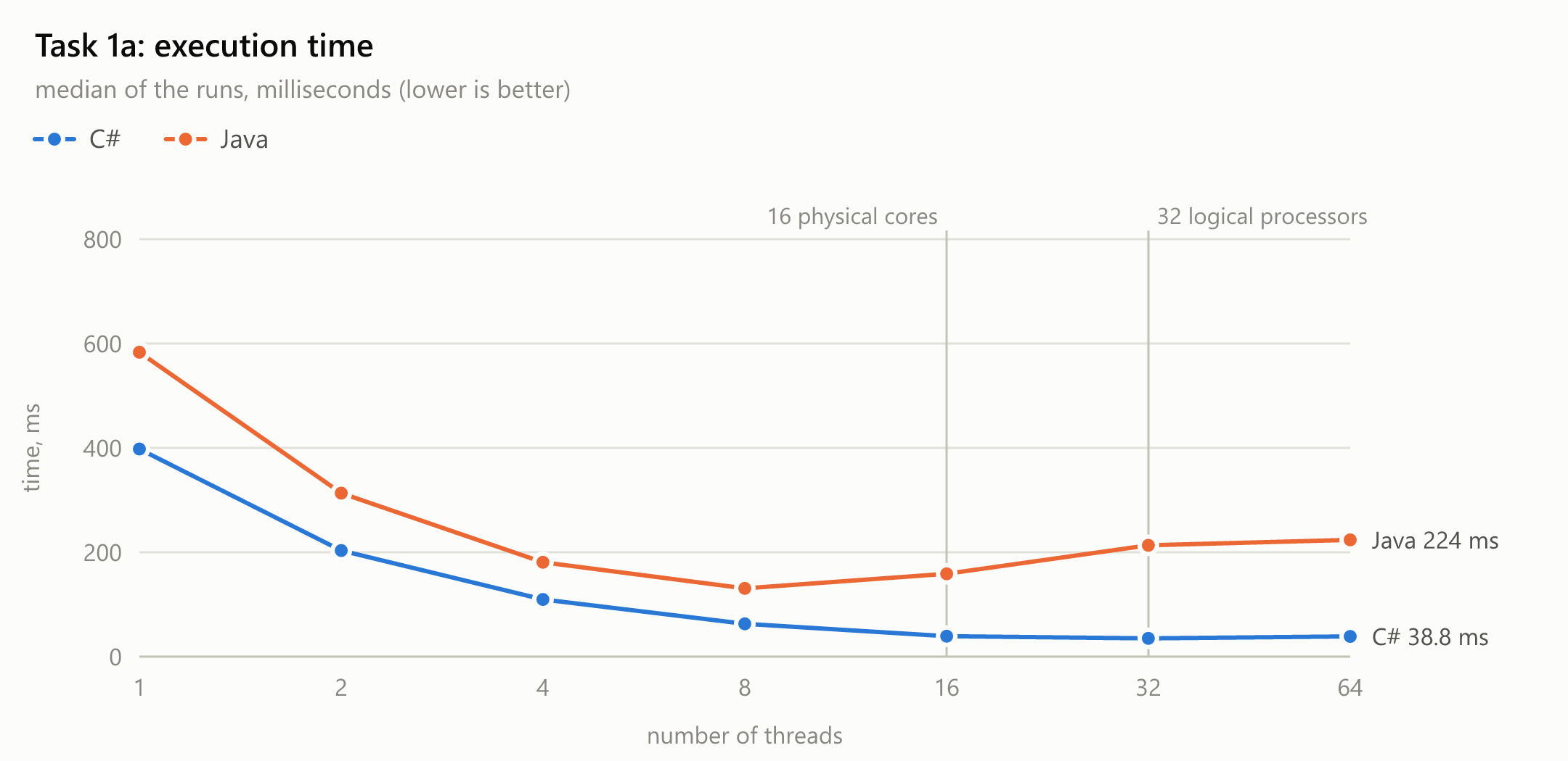
Figure 1. Task 1a: execution time
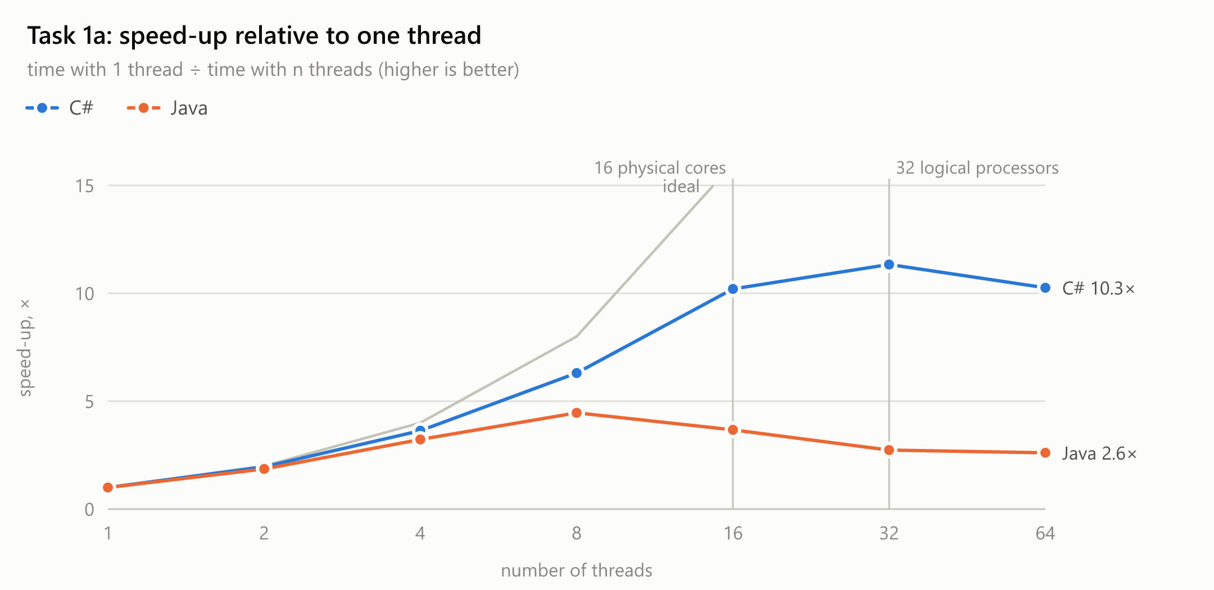
Figure 2. Task 1a: speed-up relative to one thread
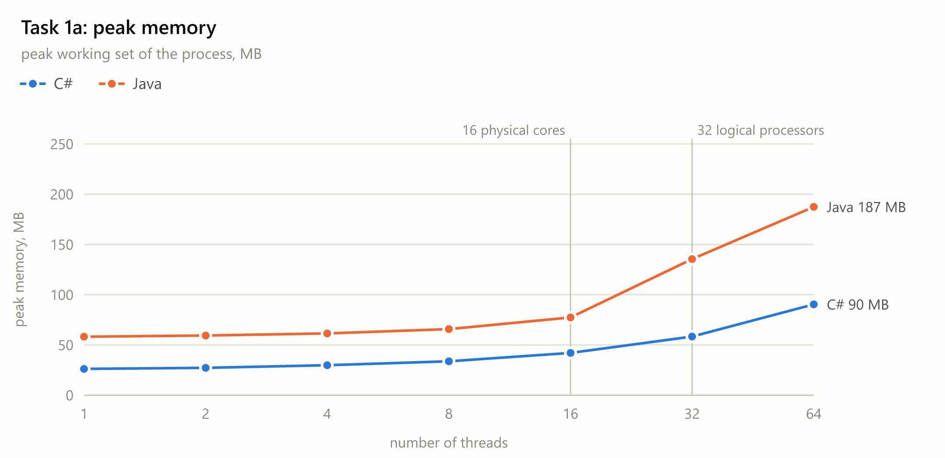
Figure 3. Task 1a: peak memory

4.2 Task 1b: three ways to count
Implementation. All 50,000,000 numbers are first loaded into an int[] (not measured). The array is split into 32 equal parts (one per logical processor) and counted in three ways: (1) all threads increment the same three shared counters without synchronisation; (2) the same, but every increment is inside lock (C#) / synchronized (Java); (3) every thread counts into its own local counters and the main thread adds the 32 results after Join. Version 1 was run three times, as required; the whole measurement was repeated 5 times.
Lang | Version | Time | Negative | Positive | Zero | Total | Check
C# | 1. no synchronisation (run 1) | 469 ms | 1,750,102 | 1,687,250 | 22 | 3,437,374 | WRONG
C# | 1. no synchronisation (run 2) | 235 ms | 2,682,905 | 2,690,778 | 22 | 5,373,705 | WRONG
C# | 1. no synchronisation (run 3) | 247 ms | 2,616,061 | 2,617,066 | 22 | 5,233,149 | WRONG
C# | 2. lock (median of 5) | 4,212 ms | 25,007,776 | 24,992,202 | 22 | 50,000,000 | correct
C# | 3. per-thread counters (median of 5) | 12.4 ms | 25,007,776 | 24,992,202 | 22 | 50,000,000 | correct
Java | 1. no synchronisation (run 1) | 316 ms | 2,027,963 | 1,895,305 | 22 | 3,923,290 | WRONG
Java | 1. no synchronisation (run 2) | 210 ms | 1,631,442 | 1,153,329 | 22 | 2,784,793 | WRONG
Java | 1. no synchronisation (run 3) | 164 ms | 1,125,536 | 1,670,380 | 22 | 2,795,938 | WRONG
Java | 2. lock (median of 5) | 2,055 ms | 25,007,776 | 24,992,202 | 22 | 50,000,000 | correct
Java | 3. per-thread counters (median of 5) | 107 ms | 25,007,776 | 24,992,202 | 22 | 50,000,000 | correct

Version 1 over all 15 C# runs: 235 ms – 477 ms, totals 3,360,264 – 5,820,694 instead of 50,000,000. Java (15 runs): totals 2,652,796 – 3,923,290. The peak memory of Task 1b (C# ≈ 425.6 MB, Java ≈ 547.8 MB) is dominated by loading the array and is the same for all versions, so it is not charted.
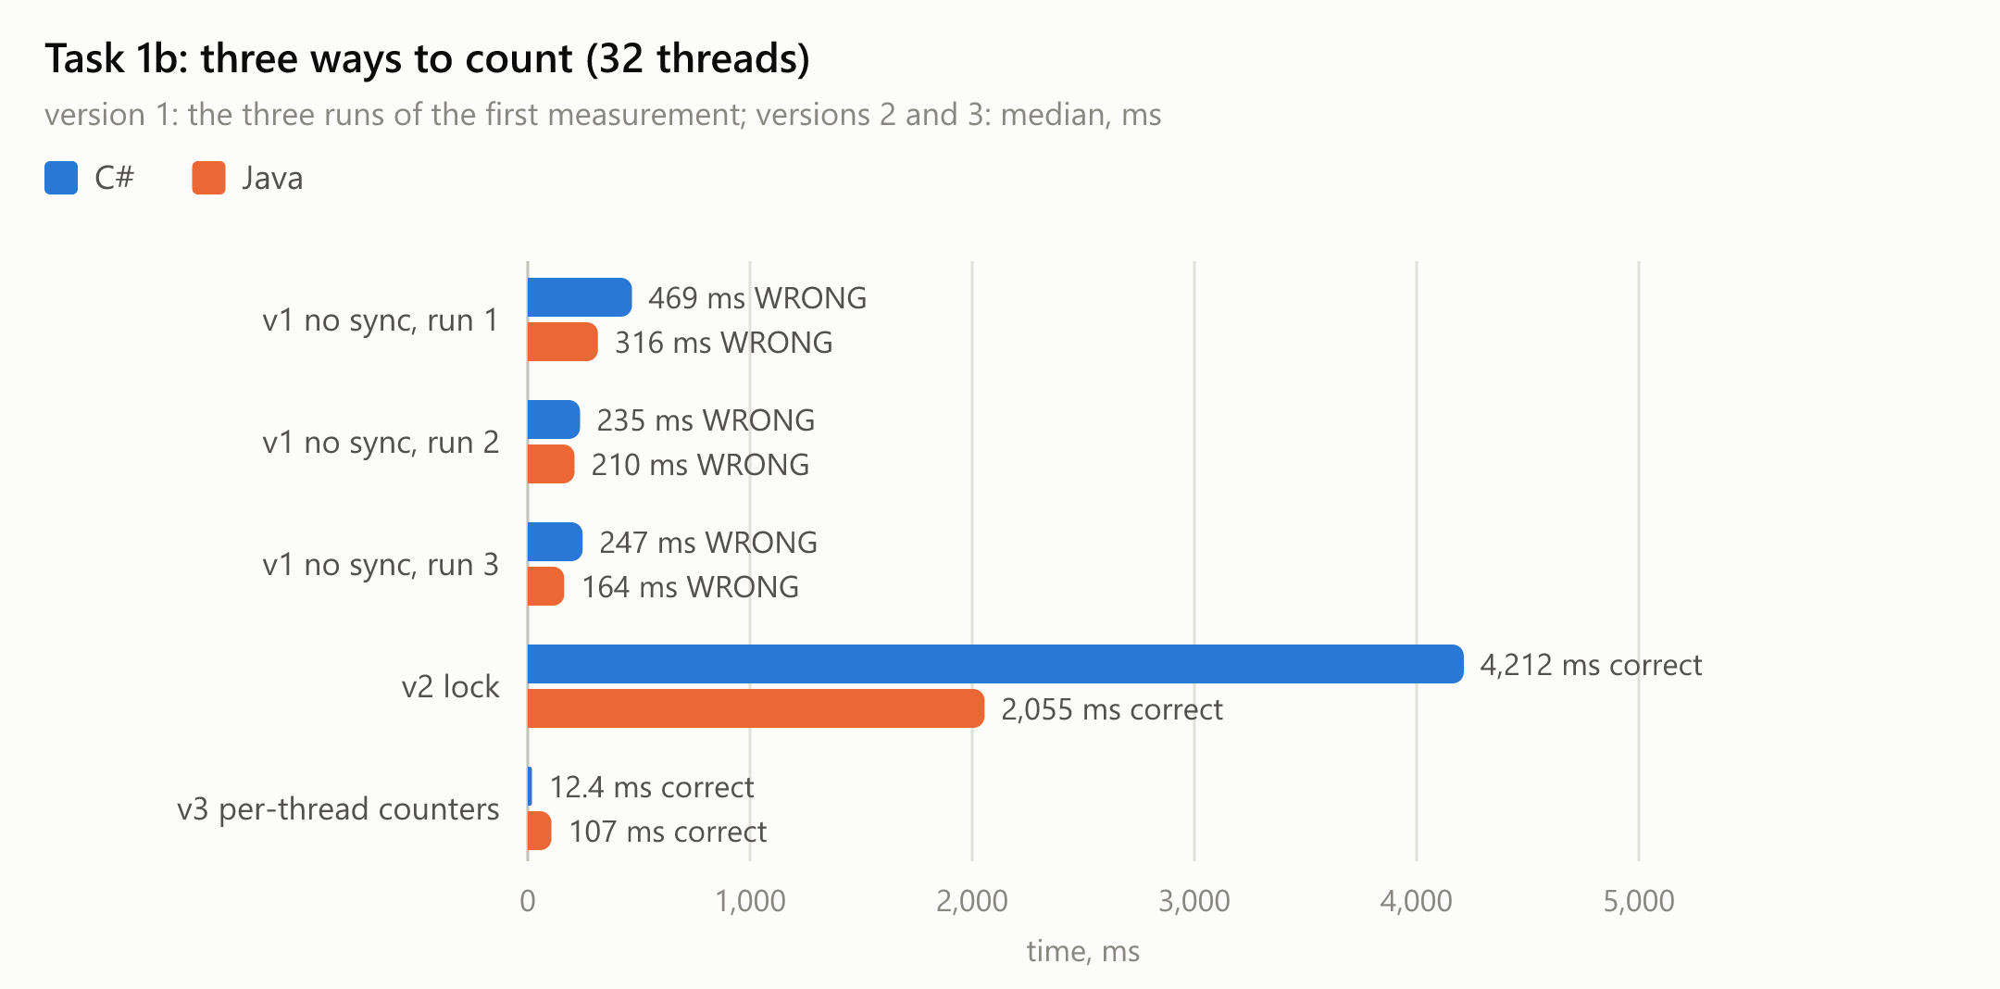
Figure 4. Task 1b: time of the three versions

4.3 Task 1c: producer and consumers
Implementation. One reader thread reads numbers.txt line by line and puts the lines, in batches of 10,000, into a blocking queue that holds at most 100 batches (C#: BlockingCollection<List<string>>(boundedCapacity: 100); Java: ArrayBlockingQueue<List<String>>(100)). The workers repeatedly take the next batch and parse its lines (int.Parse / Integer.parseInt) into their own counters. When the queue is full, Add/put blocks the reader; when it is empty, Take/take blocks the workers. At the end of the file the reader closes the queue: C# calls CompleteAdding(), and the workers' GetConsumingEnumerable() loop ends once the queue is empty; Java's queue has no "close", so the reader puts one special END batch (a "poison pill") per worker after the last real batch.
Workers | C# time | C# speed-up | C# peak memory | Java time | Java speed-up | Java peak memory
1 | 1,568 ms | 1.00× | 78.2 MB | 1,027 ms | 1.00× | 369.1 MB
2 | 1,021 ms | 1.54× | 44.5 MB | 1,023 ms | 1.00× | 369.7 MB
4 | 1,186 ms | 1.32× | 45.1 MB | 1,023 ms | 1.00× | 365.6 MB
8 | 1,265 ms | 1.24× | 54.9 MB | 1,035 ms | 0.99× | 377.9 MB
16 | 1,645 ms | 0.95× | 64.5 MB | 1,051 ms | 0.98× | 375.9 MB
32 | 2,127 ms | 0.74× | 82.1 MB | 1,050 ms | 0.98× | 367.6 MB
64 | 2,192 ms | 0.72× | 134.7 MB | 1,076 ms | 0.95× | 462.5 MB
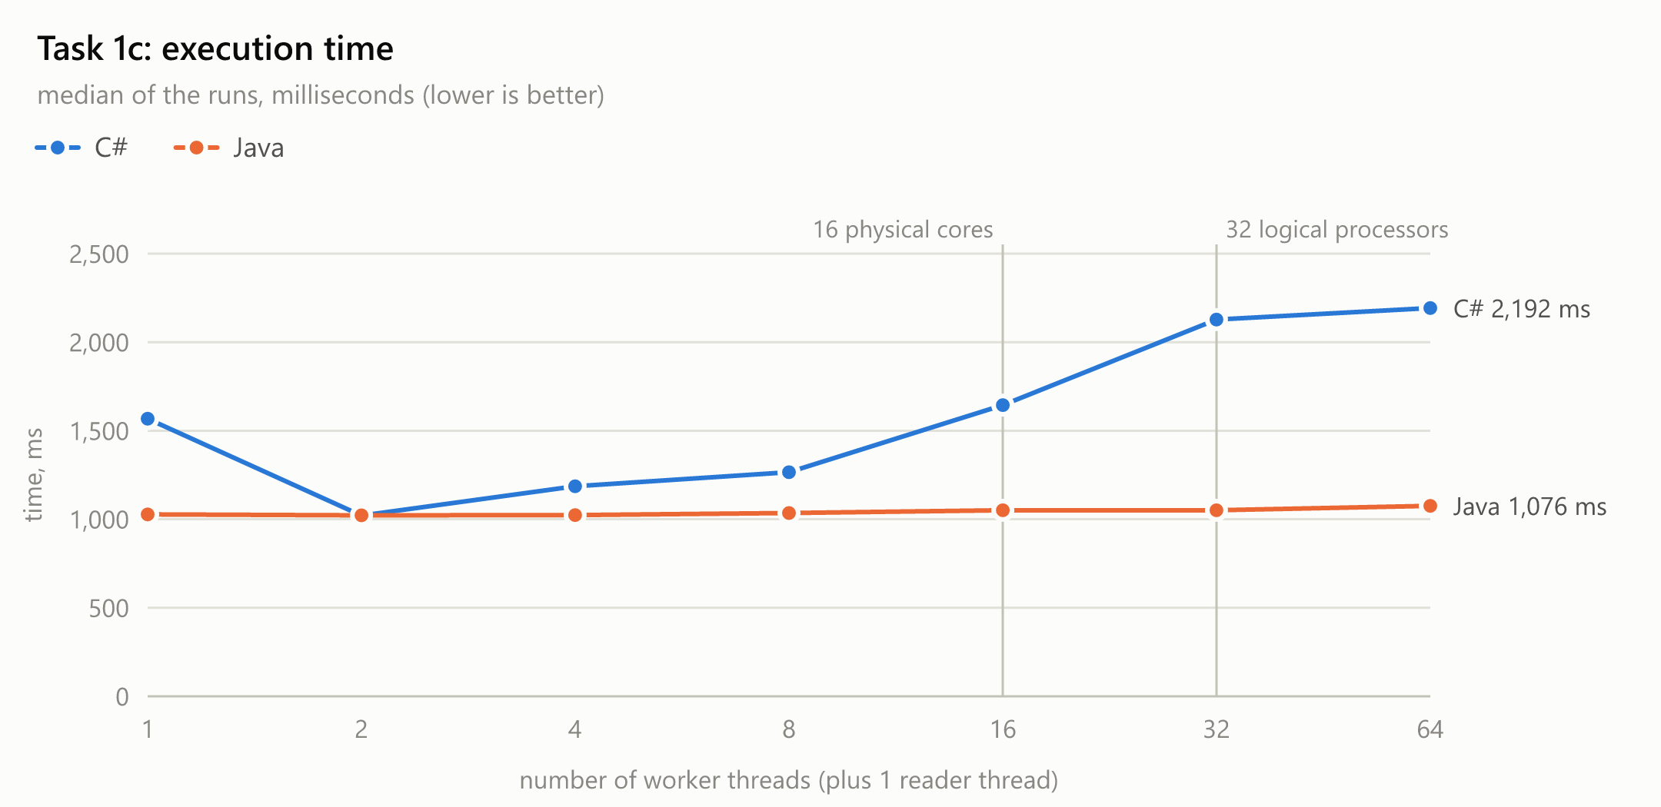
Figure 5. Task 1c: execution time (the x axis is the number of workers; plus 1 reader thread)
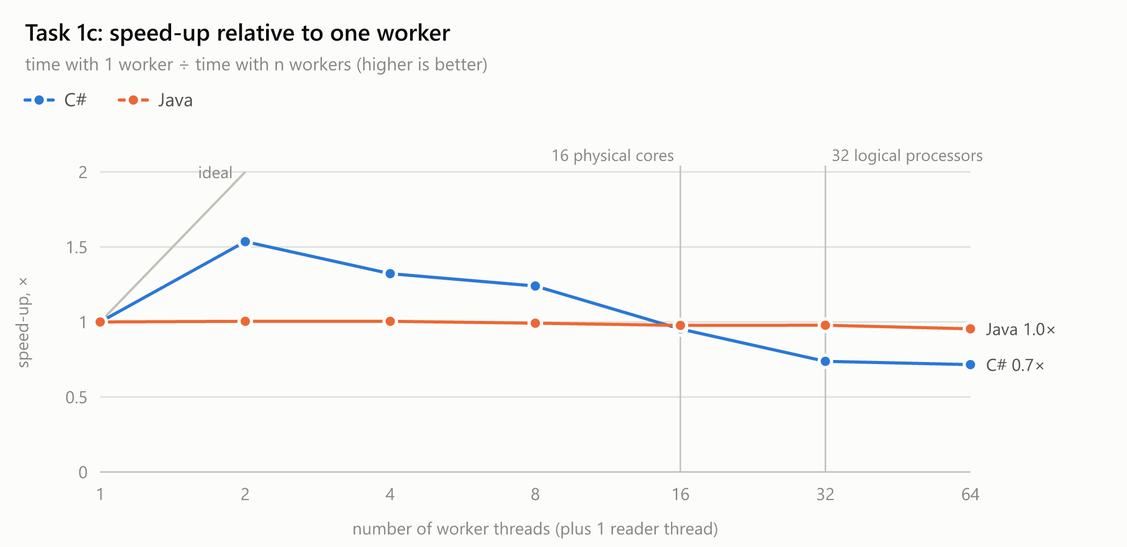
Figure 6. Task 1c: speed-up relative to one worker
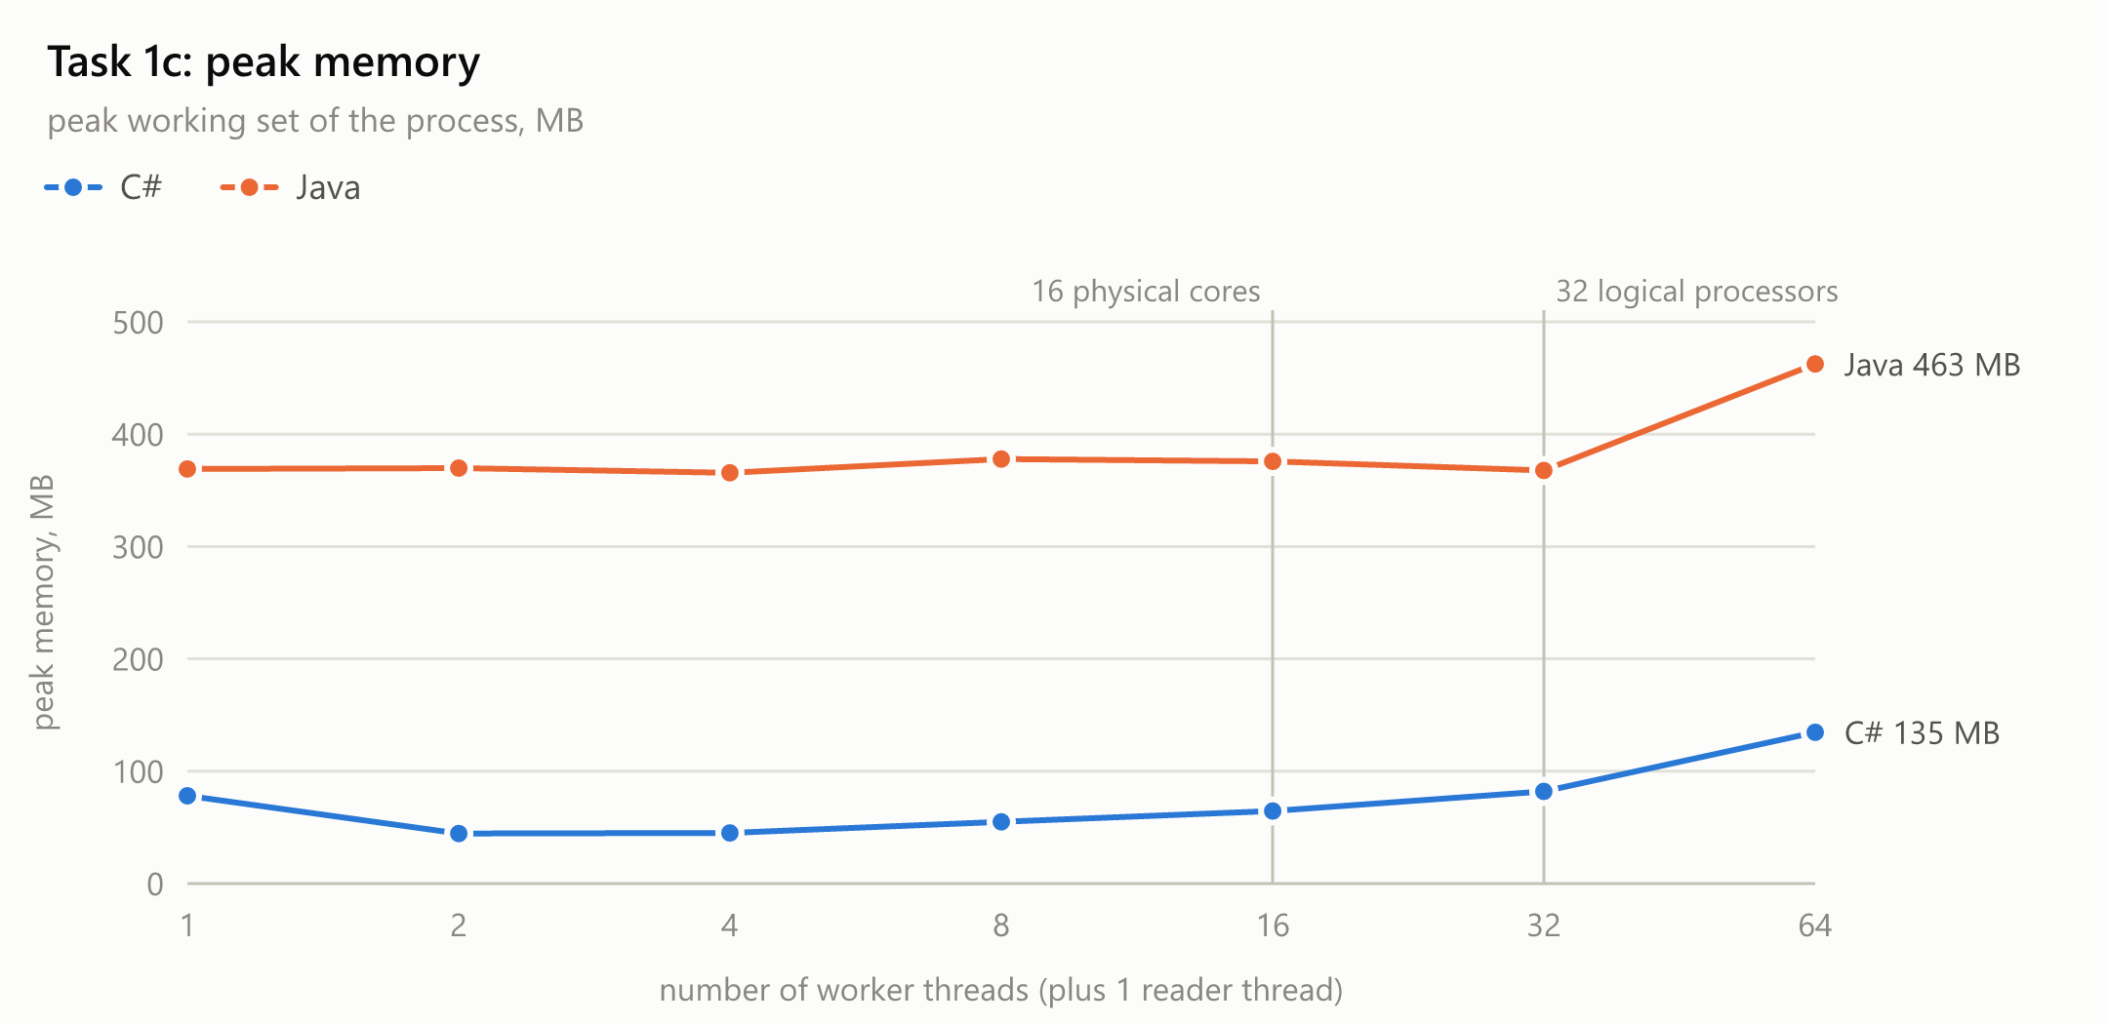
Figure 7. Task 1c: peak memory

Extra experiment for question 6
Lang | Configuration | Workers | Time | Peak memory | Max batches in queue
C# | normal: 10,000 lines per batch, at most 100 batches (median) | 1 | 1,568 ms | 78.2 MB | 44
C# | normal: 10,000 lines per batch, at most 100 batches (median) | 4 | 1,186 ms | 45.1 MB | 1
C# | 1 line per batch, at most 100 batches | 1 | 11,022 ms | 43.3 MB | 100
C# | 1 line per batch, at most 100 batches | 4 | 31,239 ms | 42.4 MB | 100
C# | 10,000 lines per batch, queue without a limit | 1 | 1,600 ms | 74.6 MB | 43
C# | 10,000 lines per batch, queue without a limit | 4 | 1,224 ms | 55.8 MB | 3
Java | normal: 10,000 lines per batch, at most 100 batches (median) | 1 | 1,027 ms | 369.1 MB | 4
Java | normal: 10,000 lines per batch, at most 100 batches (median) | 4 | 1,023 ms | 365.6 MB | 22
Java | 1 line per batch, at most 100 batches | 1 | 7,266 ms | 355.8 MB | 100
Java | 1 line per batch, at most 100 batches | 4 | 16,150 ms | 355.1 MB | 100
Java | 10,000 lines per batch, queue without a limit | 1 | 1,012 ms | 374.9 MB | 6
Java | 10,000 lines per batch, queue without a limit | 4 | 1,039 ms | 365.7 MB | 4

All runs in this table gave the correct totals. "Max batches in queue" is the largest number of batches that were waiting in the queue at any moment (measured by the reader right after each Add/put).

4.4 Answers to the questions of Task 1
1. At which number of threads does the speed-up stop growing? Relate it to your physical cores and logical processors.
C#: the speed-up is almost ideal up to 8 threads (1.96× with 2, 3.63× with 4, 6.31× with 8), still grows strongly up to 16 threads = the number of physical cores (10.2×), grows only a little more up to 32 threads = the number of logical processors (11.3×, 35.1 ms) and stops there: 64 threads are slower again (10.3×).
Why less than 16× with 16 threads: all threads copy their part of the file from the file cache in RAM at the same time and share the memory bandwidth; the processor lowers its clock when all 16 cores are busy (one busy core runs at a much higher boost clock); and every thread has a fixed cost (creation, opening the file, its 1 MB buffer). Why only a small gain from 16 to 32: the second logical processor of a core is SMT ("hyper-threading"): the two hardware threads share one core's execution units, so the second one only fills the moments when the first one waits (for example for memory) - the lecture estimates 15–30 %; here it was 11 %.
Java: the speed-up stops much earlier: the best time is with 8 threads (131 ms, 4.46×); with 16, 32 and 64 threads it is slower (159 ms, 213 ms, 224 ms). The reason is the Java runtime, not the hardware. The JVM starts every method in its interpreter, then compiles the hot loop in steps on separate compiler threads, and the final optimised code is built on assumptions from what the loop has done so far. The JVM's compilation log (-XX:+PrintCompilation) shows two things: the optimised loop was ready 54 ms after start with 8 threads but only after 103 ms with 32 threads, because the compiler threads had to compete with 32 busy workers for the 32 logical processors; and the optimised code was thrown away and rebuilt several times ("made not entrant: uncommon trap") whenever a thread took a path that had not happened before, for example reaching the end of its range. Meanwhile the threads run slower code. This warm-up does not get shorter with more threads (Amdahl's law), and in a run of only 100–200 ms it is a large part of the time. (The C# version is compiled to optimised code before its first run, because tiered compilation is turned off in its project file.)
2. Why do 32 and 64 threads not help? Are they slower, and why?
In C#, 32 threads still help a little because they use the second hardware thread of every core (39.0 ms → 35.1 ms), but 64 threads are slower than 32 (38.8 ms). There are only 32 logical processors, so 64 threads cannot all run at once: Windows has to switch between them (a context switch saves one thread's registers, loads another's and leaves the caches full of the other thread's data). Every extra thread also costs something - creating and starting it (tens of microseconds), its stack, its 1 MB buffer, its own file handle - while adding no hardware to do the work. With 64 threads each part is only 5.5 MB, so these fixed costs are a larger share of a run that takes only ~39 ms.
In Java, 32 and 64 threads are slower than 8 (213 ms and 224 ms vs 131 ms): to the costs above it adds the JIT warm-up described in question 1, which takes longer when the JVM's own compiler and garbage-collector threads find all the processors busy.
3. Does the peak memory depend on the number of threads? Why?
Yes, linearly. Task 1a in C#: 26.2 MB with 1 thread, 90.4 MB with 64, i.e. about 1.0 MB per extra thread - exactly the private 1 MB read buffer every thread allocates (plus a little for its stack and the runtime's per-thread data; a stack reserves 1 MB of address space, but only the few pages really used count in the working set). Java: 58.2 MB → 187.4 MB, ~2.1 MB per thread, because FileChannel.read into a normal array goes through a temporary native buffer of the same size, and the JVM itself starts bigger.
Task 1c: the memory is set mostly by how many batches exist at the same time - those waiting in the queue plus one being counted by every worker - so it also grows with the workers in C# (78.2 MB → 134.7 MB). In Java it stays around 365.6 MB: there the garbage collector's heap sizing dominates - the JVM lets the heap grow to hundreds of MB before collecting the 50 million short-lived strings. Task 1b uses the same ~426 MB (C#) for every version: the 200 MB array and the leftovers of loading it dominate, and its threads allocate nothing.
4. Rank the three versions of Task 1b by time. Which of them are correct? Explain each result.
Fastest to slowest: version 3 (per-thread counters) < version 1 (no synchronisation) < version 2 (lock). C#: 12.4 ms < 235 ms–477 ms < 4.2 s. Java: 107 ms < 162 ms–317 ms < 2.1 s. Versions 2 and 3 are correct; version 1 is wrong in every run and gives a different total each time.
Version 1 has a race condition. counter++ is three steps: read the value into a register, add 1, write it back. When two threads read the same old value, both write old + 1, and one of the two increments is lost. Here 88–93 % of the increments were lost in C# and 92–95 % in Java. It is also slow, although it never waits for a lock: the three counters sit in the same 64-byte cache line, and every write needs that line exclusively in the writing core's cache, so the line keeps moving between the 32 logical processors (cache-coherence traffic). Each increment then costs a trip between cores instead of one cycle.
Version 2 is correct because only one thread at a time can be inside the lock/synchronized block, so the read-add-write steps of two threads can no longer interleave. It is the slowest because it takes and releases the lock 50,000,000 times, with 32 threads fighting for it: almost all the time is spent waiting, and the counting is done one thread at a time - slower than a single thread without a lock. (Java's lock was about 2.0× faster than C#'s under this extreme contention, but both are far slower than versions 1 and 3.)
Version 3 is correct and fastest: every thread counts its part into its own local variables, which the compiler keeps in registers; nothing is shared during the loop, so there is no race and no waiting. The 32 partial results are added once, after Join guarantees that all threads have finished. In C# it reads the 200 MB array in 12.4 ms (≈ 16 GB/s): the memory bandwidth is the limit. Java's 107 ms is mostly the JIT warm-up described in question 1.
5. Compare Task 1c with Task 1a. Which one is faster, and why? At which number of workers does Task 1c stop getting faster?
Task 1a is much faster: best C# 35.1 ms vs 1,021 ms for Task 1c (29×); Java 131 ms vs 1,023 ms. In Task 1c one reader thread does a sequential job for the whole file: it decodes the bytes into characters, finds the line ends and creates 50,000,000 string objects and 5,000 lists. That part cannot be shared between threads, and it alone takes about one second, so it limits the whole task however many workers there are (Amdahl's law: the serial part sets the minimum time). In Task 1a every thread reads and parses its own part of the raw bytes, in parallel and without creating any strings.
Where Task 1c stops getting faster. C#: 1,568 ms with 1 worker, best with 2 workers (1,021 ms), and from 4 workers it gets slower again (1,265 ms with 8, 2,192 ms with 64). Java: about 1,027 ms already with 1 worker and the same with 64. The queue measurement shows why: with 1 C# worker the queue held up to 46 batches (the reader was sometimes ahead and waited for the worker), but from 2 workers on it never held more than 4 - the workers were waiting for the reader. In Java the queue held at most 5 batches even with 1 worker: one Java worker is already faster than the reader. (With 8 or more Java workers the queue sometimes filled up for a moment - in some runs to the limit, in others not at all - when the workers were stalled together, for example by a garbage-collection pause; the total time hardly changed.) Extra workers only add cost: they compete for the queue's lock, are woken up and put to sleep more often, and allocate from more threads, which makes the garbage collector's work more expensive.
6. What would happen with batches of a single line? And with a queue that has no size limit?
Batches of one line (measured): C# 11.0 s with 1 worker and 31.2 s with 4 workers; Java 7.3 s and 16.1 s, against 1.0 s–1.6 s with normal batches. Every batch costs one Add and one Take, each of which takes the queue's lock and may have to wake a sleeping thread through the operating system. With batches of 10,000 lines that cost is paid 5,000 times; with single lines it is paid 50,000,000 times, and it is far bigger than the work per line (parsing one number takes nanoseconds). More workers make it even slower, because they all fight for the same queue lock. Batching exists to spread the synchronisation cost over many items.
A queue without a size limit removes the back-pressure: the reader never waits. If the workers are slower than the reader, the batches pile up in memory - in the worst case the whole file as 50,000,000 strings, several gigabytes - and the program can run out of memory; the limit of 100 batches keeps at most ~1,000,000 lines in the queue. In this measurement the workers were nearly as fast as the reader, so the queue never even reached the old limit of 100 and removing it changed nothing: C# with 1 worker held up to 43 batches (74.6 MB), with 4 workers 3 (55.8 MB); Java with 1 worker 6 batches. The limit matters when the consumers are slower than the producer - for example when each item needs real processing or a network call.

5. Task 2: many files on slow storage
Setup. The 8 files (6,250,000 numbers each, 352 MB in total) were copied to the folder lab1_task2 on the USB drive; copying took 78 s (4.5 MB/s). The script run_task2.ps1 then, before every run: ejected the drive from code (CM_Request_Device_Eject, the same as "Safely Remove Hardware"), waited until it was pulled out, waited until it was plugged back in and had stayed connected for 8 seconds, and only then started the program. Ejecting and re-plugging dismounts the drive, so Windows forgets everything it had cached from it, and every measured run read all 352 MB from the flash memory.
Implementation. A file is the unit of work; the 8 files are divided among the threads in equal consecutive groups (1 thread: all 8; 2 threads: 4 each; 4 threads: 2 each). For each file a thread opens it, reads it with one read call into one byte buffer (C#: a reused byte[]; Java: a reused direct ByteBuffer), and parses the bytes with the same parser as Task 1a. Each thread also measures how long it spent opening and reading (I/O) and how long it spent parsing (CPU).
Lang | Threads | Time (USB, cold) | Speed-up | Peak memory | I/O, sum of threads | Parse, sum of threads | Same, from cache
C# | 1 | 30.3 s | 1.00× | 71.0 MB | 29.9 s | 323 ms | 348 ms
C# | 2 | 30.0 s | 1.01× | 115.5 MB | 55.8 s | 310 ms | 186 ms
C# | 4 | 29.9 s | 1.01× | 203.3 MB | 96.8 s | 317 ms | 116 ms
Java | 1 | 30.5 s | 1.00× | 96.0 MB | 30.0 s | 477 ms | 500 ms
Java | 2 | not completed* | – | – | – | – | –
Java | 4 | not completed* | – | – | – | – | –

All completed runs gave the correct totals. "Same, from cache" is an extra run started right after the measured one, without re-plugging: the files then come from the Windows file cache in RAM. About the drive: during the session Windows logged 1,341 read errors from this no-name stick (System log, source "disk", event 51); Windows repeats a failed read, so these only cost time, but five runs - all with 2 or more threads reading at once - failed with "A device which does not exist was specified" because the stick reset itself and disconnected. Such a run produced no result; it was repeated after a new re-plug. *The Java run with 2 threads failed this way in all four attempts, so the Java runs with 2 and 4 threads could not be completed with this stick. The required part of Task 2 (C#, 1, 2 and 4 threads) is complete.
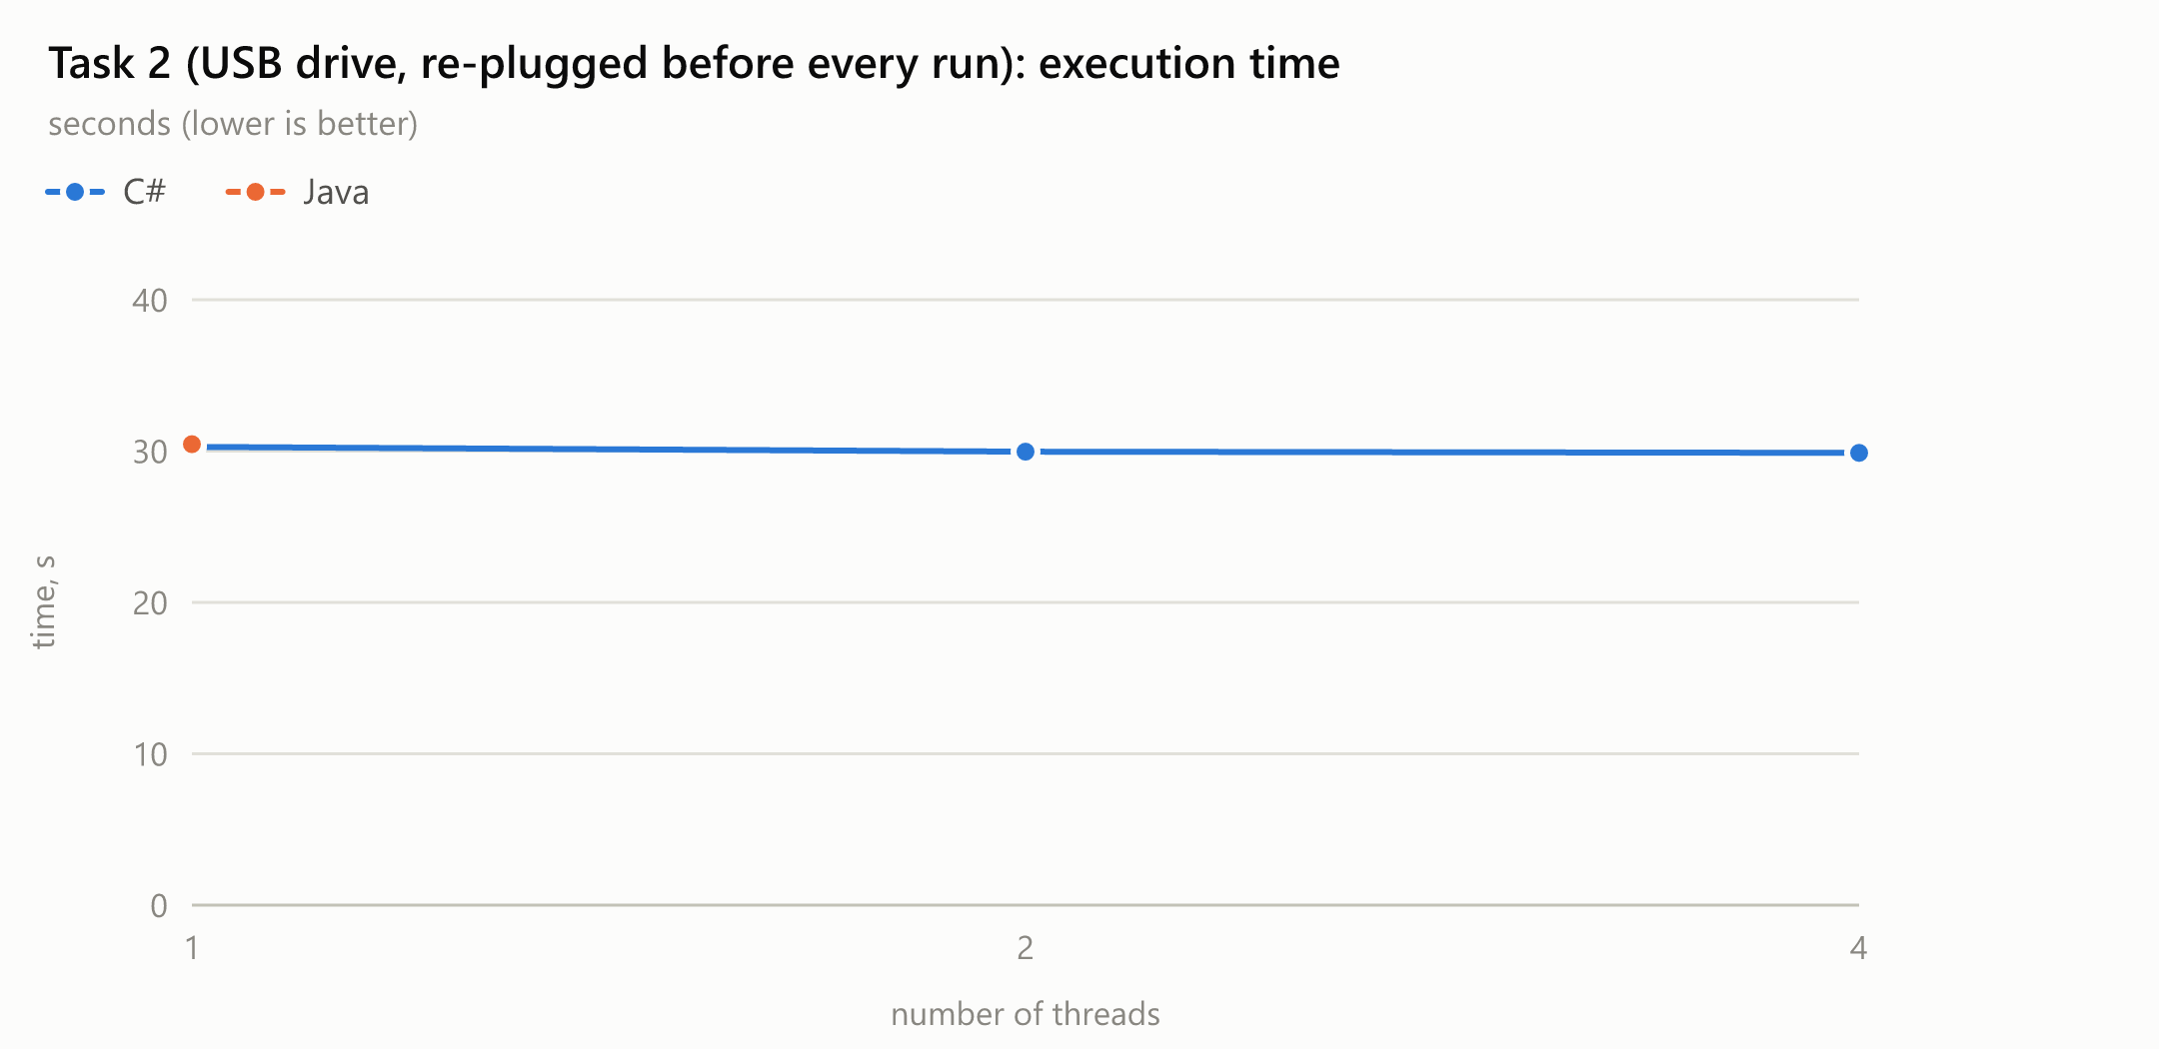
Figure 8. Task 2: execution time with the files on the USB drive
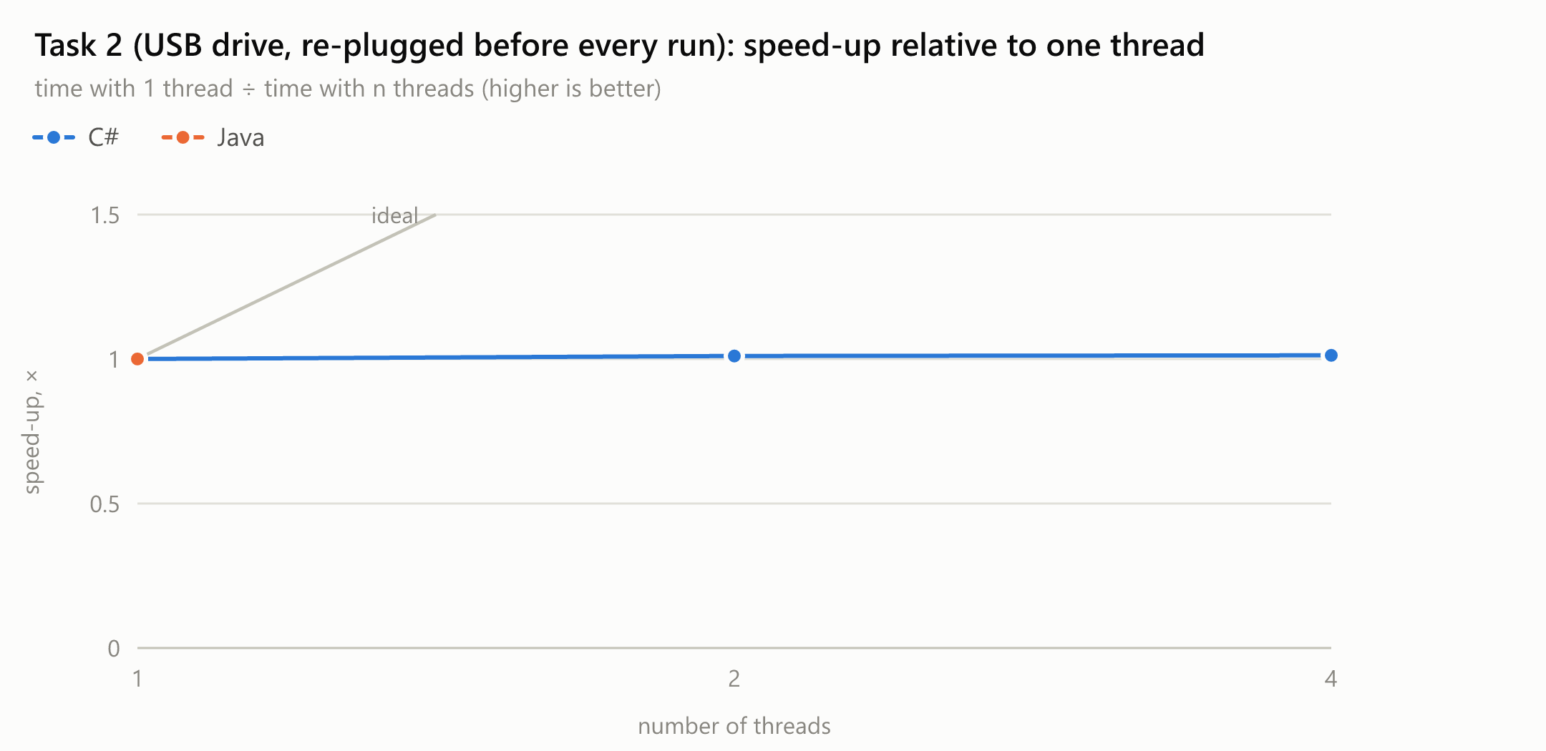
Figure 9. Task 2: speed-up relative to one thread
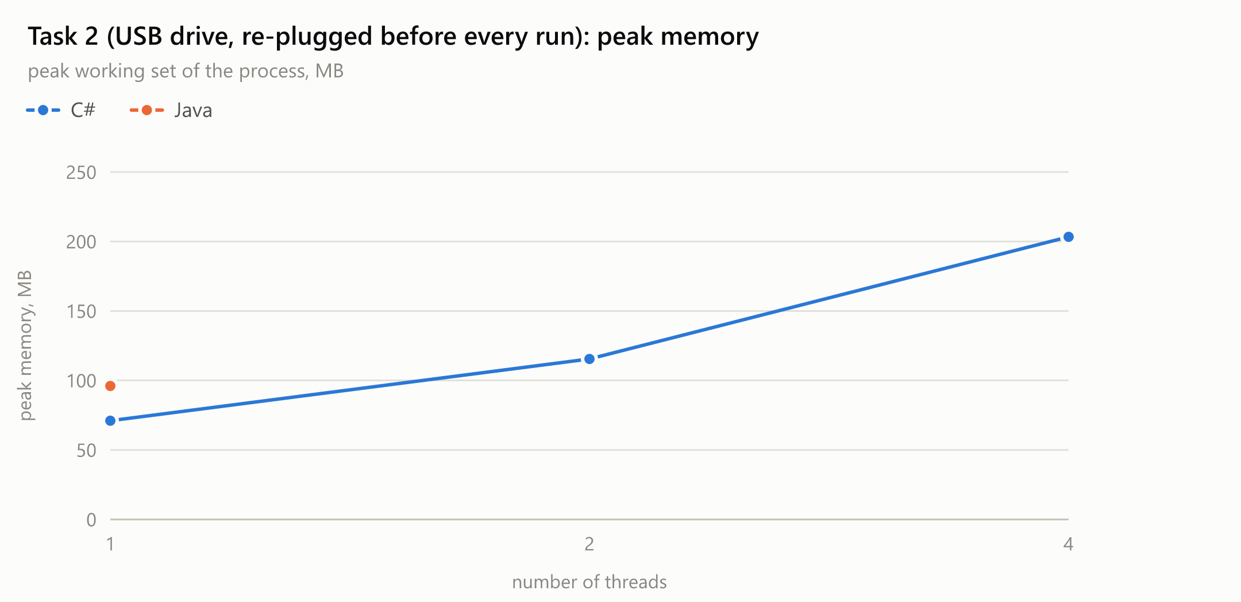
Figure 10. Task 2: peak memory
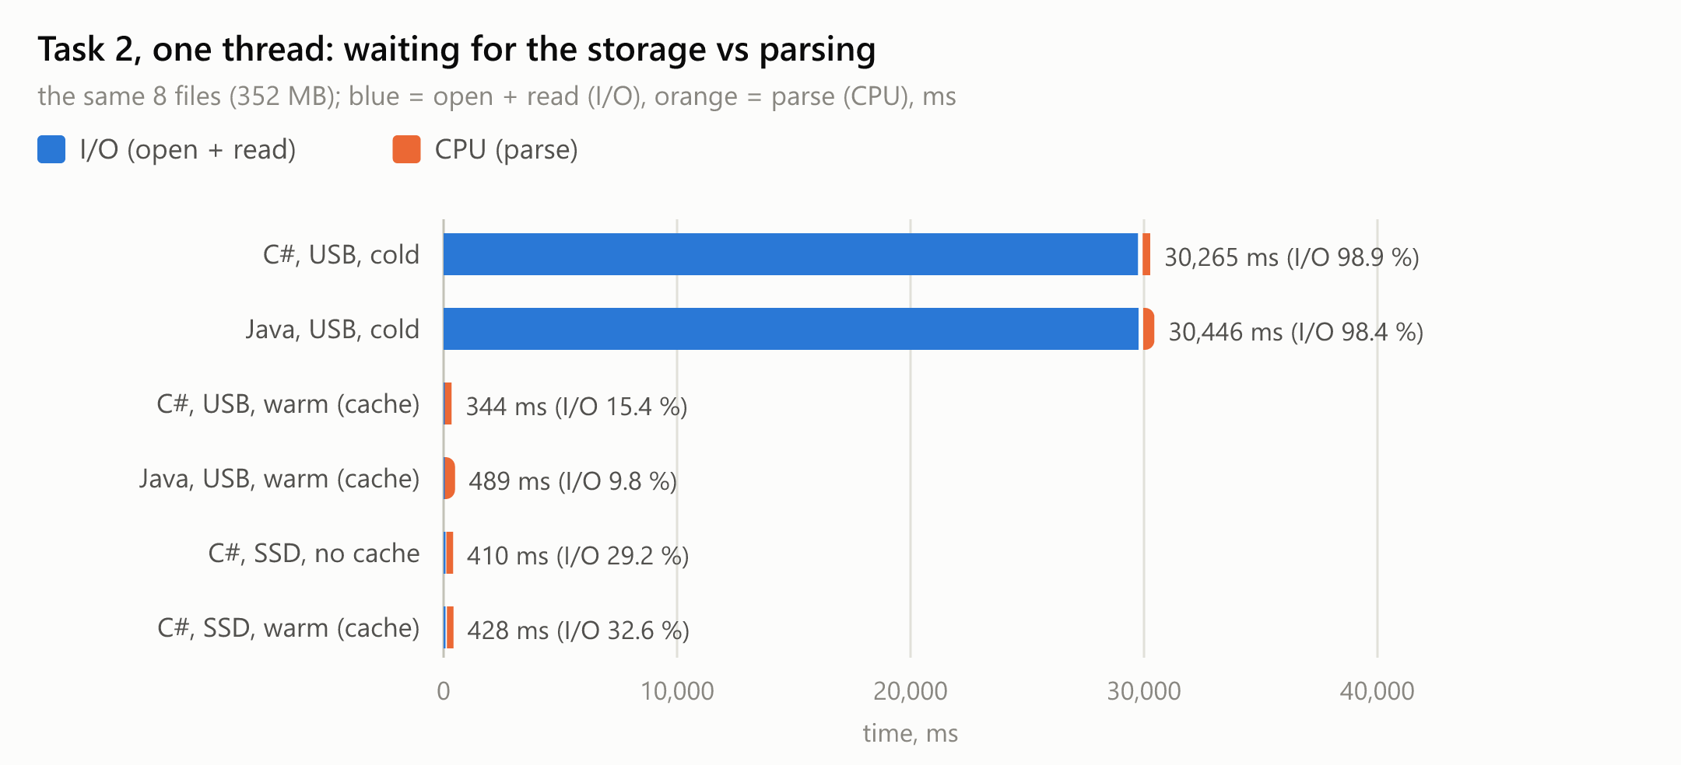
Figure 11. Task 2 with one thread: time spent waiting for the storage (I/O) and parsing (CPU)
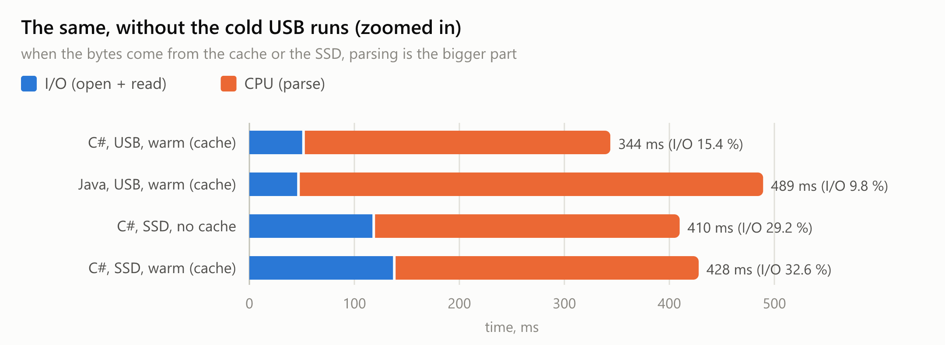
Figure 12. The same without the cold USB runs
Extra experiment: the same Task 2 code on the internal SSD. With the option --cache off the C# program opens the files with FILE_FLAG_NO_BUFFERING, which makes Windows read straight from the device instead of the file cache - a cold read without unplugging anything. On the NVMe SSD (median of 3 runs) one thread took 417 ms, of which only 120 ms was I/O; 2 threads: 244 ms, 4 threads: 170 ms, 8 threads: 139 ms. The speed-up is not ideal because there are only 8 files, and with 8 threads the SSD's bandwidth starts to matter, but more threads clearly help.
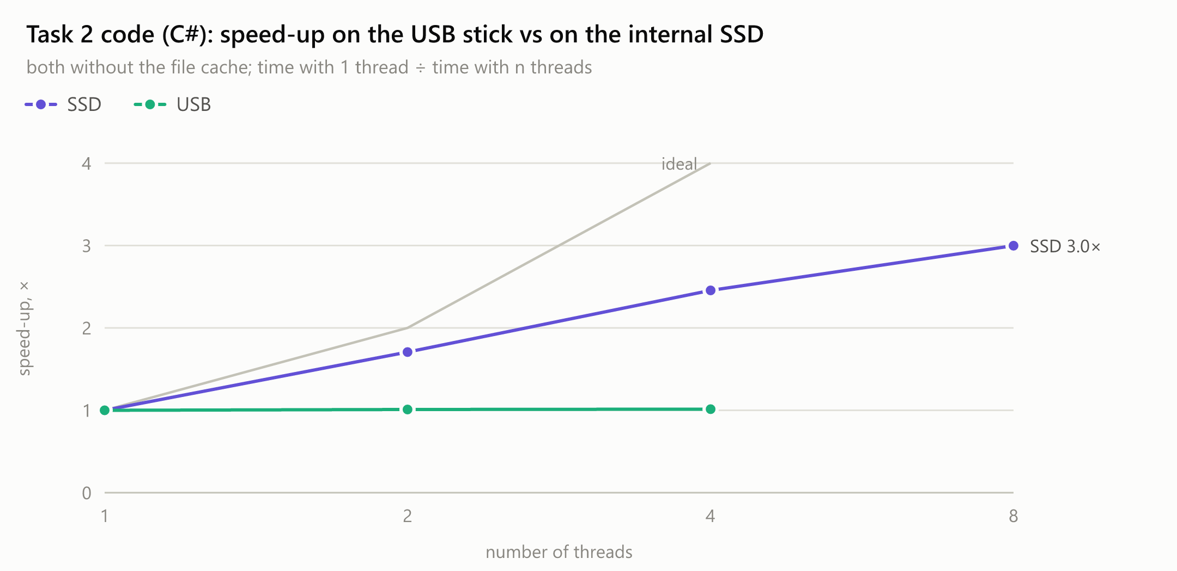
Figure 13. The same program and files: more threads help on the SSD, not on the USB drive

5.1 Answers to the questions of Task 2
1. Compare the time on one thread with Task 1a on one thread. On the USB drive, is the work CPU-bound or I/O-bound?
Task 1a with one thread parses all 50,000,000 numbers in 398 ms (C#). Task 2 with one thread parses the same numbers and needs 30.3 s, 76× longer. The thread's own measurement shows where the time goes: 29.9 s (98.9 %) waiting for the drive to deliver the bytes and only 323 ms parsing - the same amount of CPU work as in Task 1a. The drive delivered 11.6 MB/s, which is what a cheap USB 2.0 stick can do.
Two more measurements confirm it. Reading the same files again from the file cache took 348 ms instead of 30.3 s (87× faster) - removing the waiting removes almost all the time. And the language does not matter: Java parses more slowly (477 ms vs 323 ms) but needed the same 30.5 s, because both wait for the same drive. On the USB drive the work is I/O-bound.
2. On the USB drive, do more threads help? Why not, when lecture 1 showed that I/O-bound work benefits from concurrency?
No. C#: 1 thread: 30.3 s, 2 threads: 30.0 s, 4 threads: 29.9 s - the same time within 1–2 %, while the peak memory grew from 71.0 MB to 203.3 MB because every thread holds a ~44 MB buffer. The sum of the threads' I/O time grew to 55.8 s with 2 threads and 96.8 s with 4: the threads did not read faster, they only waited together.
Concurrency helps I/O-bound work when the waits are independent and can overlap - for example a server waiting for answers from many different machines: each remote machine works on its own request, so ten requests in parallel take about as long as one. Here every thread waits for the same single device. The drive has a fixed speed (~11.7 MB/s); a USB 2.0 stick handles one command at a time, so requests from 4 threads simply queue up behind each other, and 352 MB at 11.7 MB/s take ~30 s however the requests are split. In the lecture's words: more people do not make one pizza oven bake faster. Parallel requests could even be slower, because the drive then jumps between 4 files instead of reading one file from start to end.
On the internal SSD the same code does get faster with more threads (Figure 13): the SSD is so fast (2,943 MB/s for one thread) that parsing dominates, i.e. the same program is CPU-bound there.

6. Bonus: C# compared with Java
Both versions implement the same algorithms with the same data, options and output, so the differences below come from the languages and their runtimes.

6.1 How threads, locks and queues are written
 | C# (.NET 10) | Java 25
Create and wait for an OS thread | var t = new Thread(() => Work()); t.Start(); t.Join(); | Thread t = new Thread(() -> work()); t.start(); t.join();
Loop variable in a lambda | compiles, but all iterations share one for variable → copy it (int index = t;) | does not compile unless the variable is effectively final → the same copy is forced
Lock | lock (gate) { ... } with a System.Threading.Lock object | synchronized (gate) { ... } on any object (or ReentrantLock)
Bounded blocking queue | BlockingCollection<T>(boundedCapacity: 100); Add / GetConsumingEnumerable() | ArrayBlockingQueue<T>(100); put / take
Closing the queue | CompleteAdding(): consumers stop when it is empty | no "close": a poison-pill object, one per consumer
Per-thread result | struct SignCounts (value type, copied) | class SignCounts (reference type, one object per thread)
Read at a file offset | RandomAccess.Read(handle, span, offset) | FileChannel.read(buffer, position)
Peak memory | Process.GetCurrentProcess().PeakWorkingSet64 | no API: call K32GetProcessMemoryInfo from kernel32.dll with the Foreign Function API
Exceptions in threads | unhandled → the process stops | printed and the thread dies; the program must collect them itself

6.2 Do the threads really run in parallel?
Yes, in both languages. new Thread creates a real operating-system ("platform") thread in .NET and in Java, and neither runtime has a global lock like CPython's GIL, so the threads run on different cores at the same time. The measurements prove it: Task 1a runs 11.3× faster with 32 threads in C# and 4.46× faster with 8 threads in Java, which is impossible if only one thread runs at a time; and the lost updates of Task 1b version 1 (88–93 % in C#, 92–95 % in Java) need truly simultaneous increments. (Java 21+ also has virtual threads, which are not OS threads; they were not used, as the lab requires OS threads.)

6.3 Time and memory of the same tasks
Measurement | C# | Java
Task 1a, 1 thread | 398 ms, 26.2 MB | 583 ms, 58.2 MB
Task 1a, best | 35.1 ms with 32 threads (11.3×) | 131 ms with 8 threads (4.46×)
Task 1b v1 (no sync), lost updates | 88–93 % | 92–95 %
Task 1b v2 (lock) | 4.2 s | 2.1 s
Task 1b v3 (per-thread) | 12.4 ms | 107 ms
Task 1b peak memory | 425.6 MB | 547.8 MB
Task 1c, best | 1,021 ms with 2 workers | 1,023 ms with 2 workers
Task 1c peak memory (4 workers) | 45.1 MB | 365.6 MB
Task 2, USB, 1 thread | 30.3 s (parse 323 ms) | 30.5 s (parse 477 ms)
Task 2, USB, 1 thread, peak memory | 71.0 MB | 96.0 MB

6.4 What the comparison shows
- Start-up and warm-up: C# wins short runs. The C# build compiles every method to optimised machine code before its first call (tiered compilation off); the JVM starts in the interpreter and compiles hot code while the program runs. For runs of 10–200 ms this warm-up is a large part of the time (Task 1b v3: 12.4 ms vs 107 ms; Task 1a: 35.1 ms vs 131 ms), and because it does not shrink with more threads, Java stops scaling earlier.
- Memory: Java needs more. An empty JVM already uses more memory than the .NET runtime (Task 1a with 1 thread: 58.2 MB vs 26.2 MB), and its garbage collector lets the heap grow much more before collecting (Task 1c: ~366 MB vs ~45 MB).
- Strings and the producer–consumer task: Java is faster. Java stores text like "-42" with one byte per character (compact strings), .NET with two (UTF-16), so Java's reader creates less data and its Task 1c is faster and does not slow down with more workers.
- Heavy lock contention: Java's synchronized was 2.0× faster than C#'s lock with 32 threads fighting for one lock - but both are the wrong tool here; per-thread counters are hundreds of times faster in both languages.
- I/O-bound work: no difference. On the USB drive both languages take the same ~30 s, because both wait for the same device.

7. Conclusion
CPU-bound on my machine: Tasks 1a, 1b and 1c, whose input was already in RAM (file cache), and Task 2 when the files are on the internal NVMe SSD. I know because more threads made them faster - Task 1a up to 11.3× with 32 threads - and because, when Task 2 reads from the cache or the SSD, parsing takes most of the time. Their speed-up stopped where the hardware stops: almost linear up to the 16 physical cores, a small SMT gain up to the 32 logical processors, and a loss beyond that. Task 1c is a special case: it is limited by its single reader thread (a serial part), so it stops improving after 2 workers in C# and does not improve at all in Java.
I/O-bound on my machine: Task 2 with the files on the USB 2.0 flash drive. I know because 98.9 % of the time was spent waiting for the drive and only 323 ms parsing; because 1, 2 and 4 threads all took ~30 s; because the same files from the cache took 348 ms; and because C# and Java, which parse at different speeds, took the same time. More threads do not help I/O-bound work that waits for one single slow device; they only cost memory.
The other lessons: shared counters without synchronisation lose most of the updates; a lock makes them correct but serialises the threads and is the slowest option; giving every thread its own data and combining the results at the end is both correct and the fastest. The cost of synchronisation must be spread over enough work (batches), and a bounded queue protects memory when the producer is faster than the consumers.

