Ministry of Education and Research of the Republic of Moldova
Technical University of Moldova
Faculty of Computers, Informatics and Microelectronics
Department of Software Engineering and Automatics
REPORT
on Laboratory Work No. 3
Course: Operating Systems
Topic: The Command Line: Shell, Pipes and Text Filters
Track A: the real OS, from the outside (Linux)
Done by: st. gr. FAF-242, Eftode Andrei
Checked by: Reițman Patricia
Chișinău, 2026
Contents
Laboratory Work No. 3. The Command Line: Shell, Pipes and Text Filters 3
Preparation 3
Part 1. Move fast, find help 3
Part 2. What the shell does to your line 6
Part 3. Redirection, chaining and jobs 8
Part 4. Answer questions with one-liners 9
Part 5. Your first script 12
Conclusions 14

Laboratory Work No. 3. The Command Line: Shell, Pipes and Text Filters
Purpose: to move fast in bash, to predict what the shell does to a command line before it runs, to redirect input and output, and to answer questions about data with small filters joined by pipes.
Environment: Ubuntu 26.04.1 LTS in VirtualBox, bash, user vboxuser on host os, working folder ~/os-lab3.

Preparation
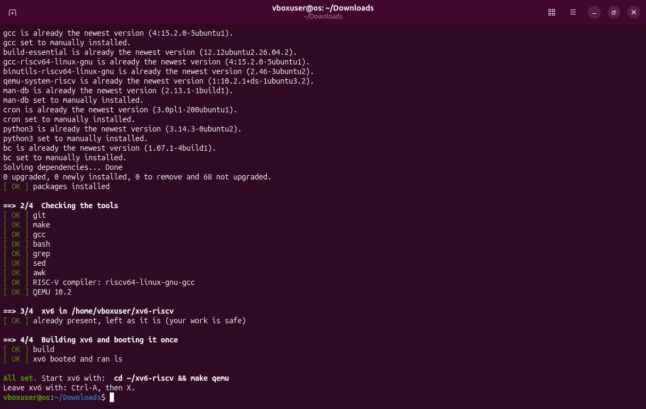
Figure 0.1 – The course script os2026-setup.sh ends with All set.
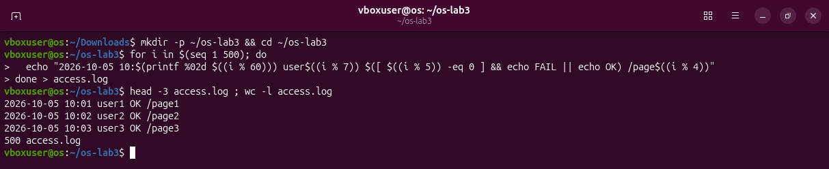
Figure 0.2 – Generating the data set access.log, 500 lines.

Part 1. Move fast, find help
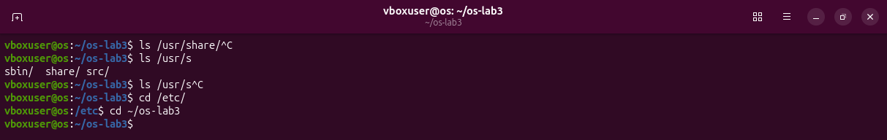
Figure 1.1 – Tab completion.
ls /usr/sh became ls /usr/share/ at the first Tab, because only one name matches, and the second Tab had nothing to add. With ls /usr/s two Tabs listed the three candidates. cd /et became cd /etc/ with one Tab.
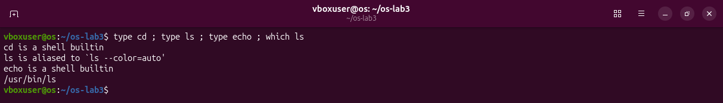
Figure 1.2 – Output of type and which.
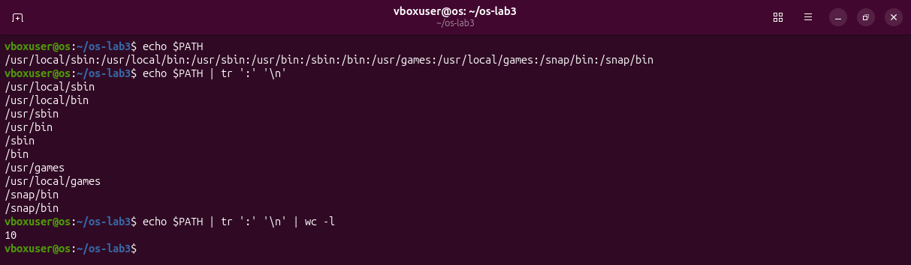
Figure 1.3 – The directories in PATH.
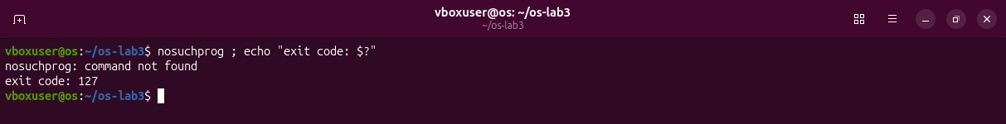
Figure 1.4 – Exit code of a missing command.
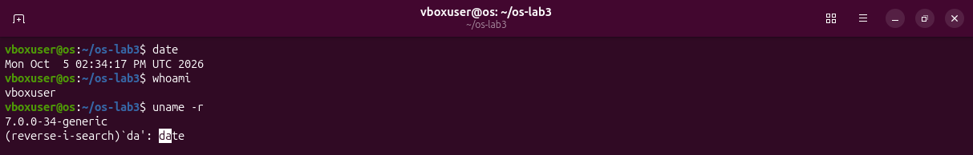
Figure 1.5 – Ctrl+R: the letters da bring back the command date from the history.
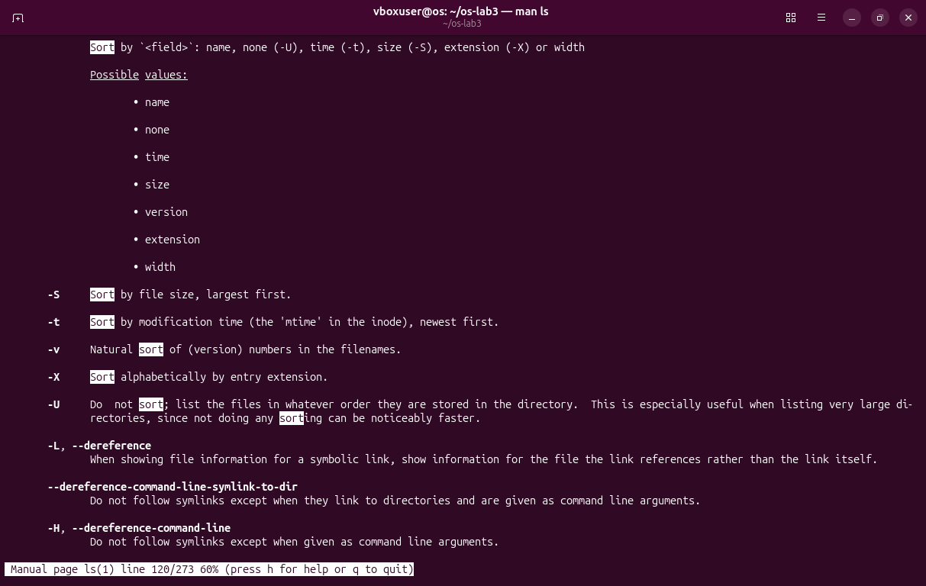
Figure 1.6 – man ls, searched with /sort and n: the option -t.
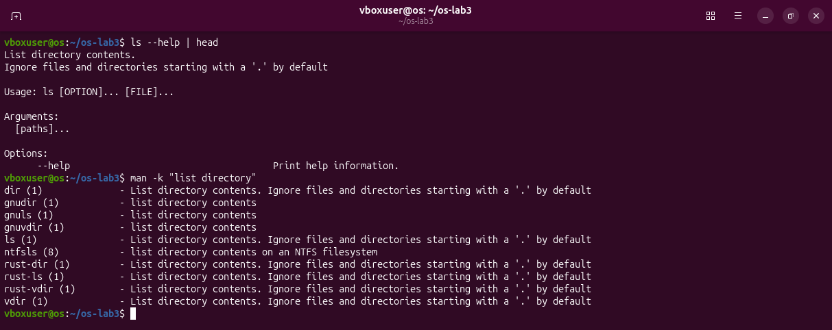
Figure 1.7 – ls --help | head and man -k "list directory".
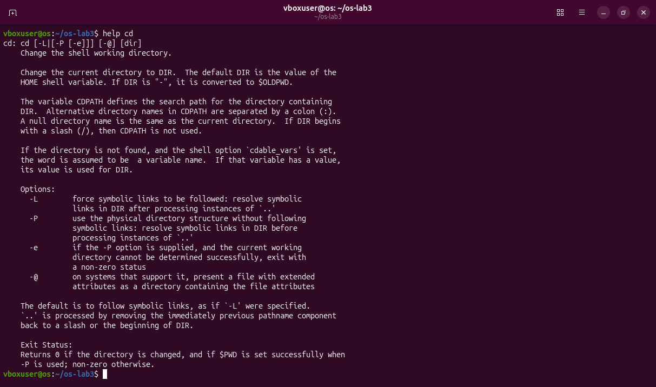
Figure 1.8 – help cd, the help of a built-in.
Observations
(1) Built-ins: cd and echo are shell built-ins; ls is an external program, /usr/bin/ls (here behind the alias ls --color=auto). cd must be a built-in because the working directory belongs to each process: an external cd would change only its own directory and exit, and the shell would stay where it was.
(2) PATH: 10 directories; ls is in /usr/bin.
(3) Exit code of a command that is not found: 127.
(4) Sorting by modification time: ls -t, newest first.

Part 2. What the shell does to your line
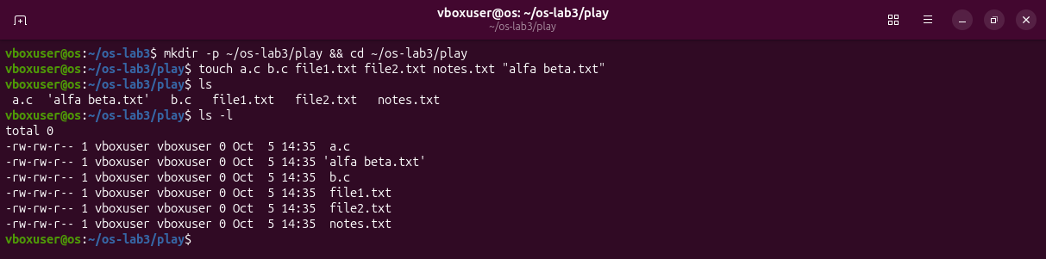
Figure 2.1 – Files created in the play directory.
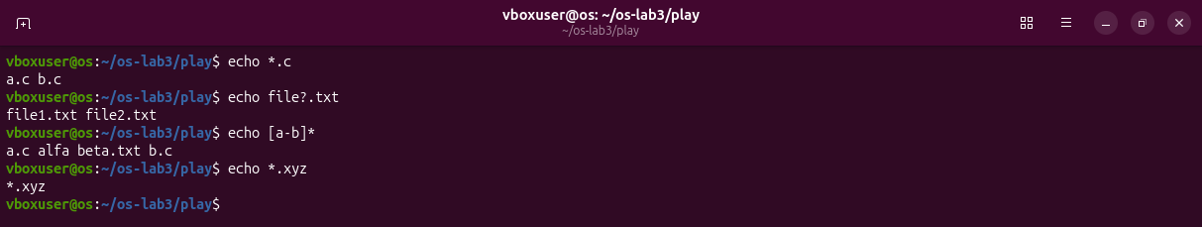
Figure 2.2 – Globbing results.
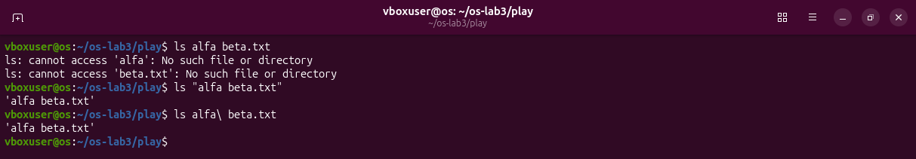
Figure 2.3 – The ls error on a name with a space, and the fix.
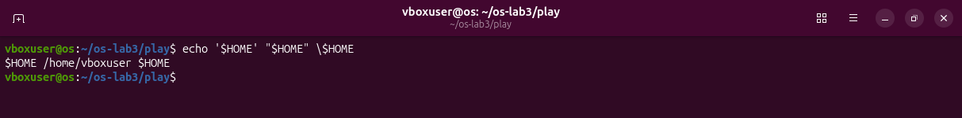
Figure 2.4 – Single quotes, double quotes and backslash.
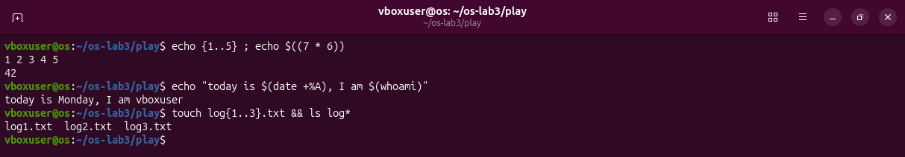
Figure 2.5 – Brace expansion, arithmetic and command substitution.
Observations
(1) Predictions and real outputs:
Command | My prediction | Real output | Explanation (if different)
echo *.c | a.c b.c | a.c b.c
echo file?.txt | file1.txt file2.txt | file1.txt file2.txt
echo [a-b]* | a.c b.c | a.c alfa beta.txt b.c | I forgot alfa beta.txt: the pattern asks only that the first letter is a or b.
echo *.xyz | an empty line | *.xyz | When nothing matches, bash leaves the pattern as it is and echo prints it.
ls alfa beta.txt | the file alfa beta.txt | two errors: cannot access alfa, cannot access beta.txt | The shell splits the line at the space, so ls gets two names.
ls "alfa beta.txt" | alfa beta.txt | 'alfa beta.txt' | ls itself adds quotes around a name that contains a space.
echo '$HOME' "$HOME" \$HOME | $HOME /home/vboxuser $HOME | $HOME /home/vboxuser $HOME
echo {1..5} ; echo $((7 * 6)) | 1 2 3 4 5 and 42 | 1 2 3 4 5 and 42
echo "today is $(date +%A), I am $(whoami)" | today is Monday, I am vboxuser | today is Monday, I am vboxuser
touch log{1..3}.txt && ls log* | log1.txt log2.txt log3.txt | log1.txt log2.txt log3.txt

(2) Who produced the file names: the shell. Bash replaced *.c with the matching names before it started echo; echo only printed the arguments it received.
(3) Why ls alfa beta.txt failed: the shell cut the line at the space, so ls looked for two files, alfa and beta.txt. Two fixes: quotes, ls "alfa beta.txt", or a backslash before the space, ls alfa\ beta.txt.
(4) Single and double quotes: inside single quotes nothing is expanded; inside double quotes $name and $(command) are still replaced, but spaces and * are not special.
Note: ls prints 'alfa beta.txt' in quotes to show that it is one name with a space inside, in a form that can be copied back into a command. The quotes are not part of the name.

Part 3. Redirection, chaining and jobs
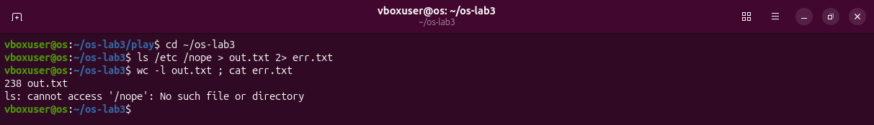
Figure 3.1 – stdout and stderr in separate files.
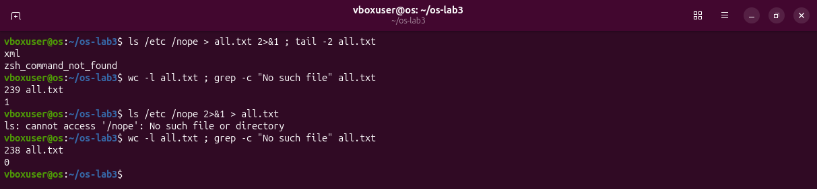
Figure 3.2 – Comparing the order of redirections.
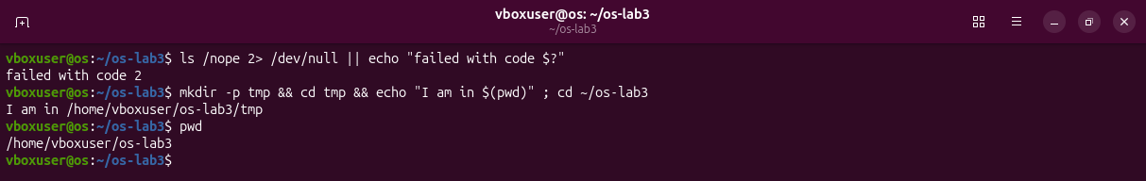
Figure 3.3 – The ; && || operators.
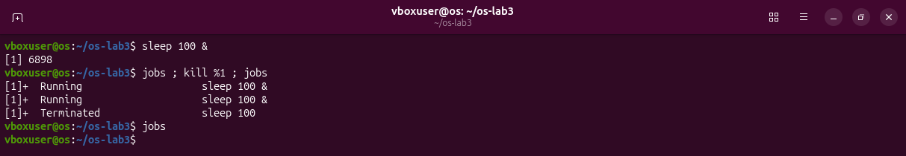
Figure 3.4 – Running a background job and stopping it.
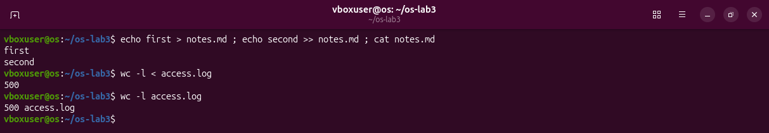
Figure 3.5 – Appending with >> and reading input with <.
Observations
(1) Which file got what: out.txt got the listing (238 lines) and err.txt got the error message.
(2) Order of redirections: they are applied from left to right. In > all.txt 2>&1 stdout goes to the file first, then stderr is sent to the same place, so the file holds both (239 lines). In 2>&1 > all.txt stderr is first sent to where stdout points at that moment, the terminal, and only then stdout goes to the file, so the error stays on the screen (238 lines).
(3) wc -l < access.log: the shell opens the file and gives it to wc as standard input, so wc never learns the name and prints only 500. In wc -l access.log the name is an argument and wc prints it.
(4) Operators: ; runs the next command in any case; && runs it only if the previous one succeeded; || runs it only if the previous one failed.

Part 4. Answer questions with one-liners
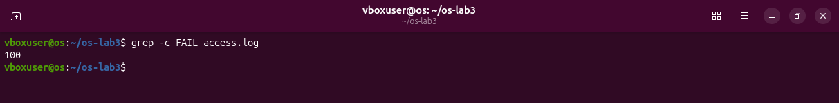
Figure 4.1 – Number of failed requests.
Q1: 100 requests failed.
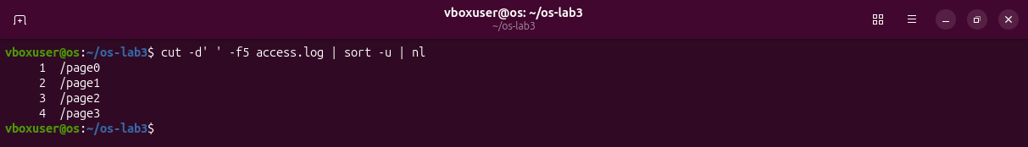
Figure 4.2 – The different pages.
Q2: 4 different pages: /page0, /page1, /page2, /page3.
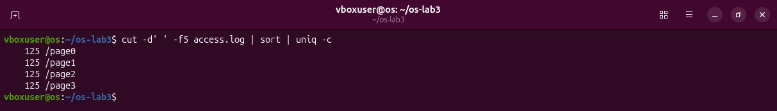
Figure 4.3 – Requests per page.
Q3: 125 requests for each page; 4 x 125 = 500, the size of the log.
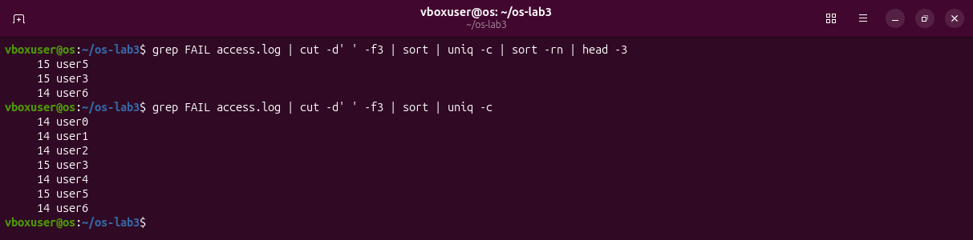
Figure 4.4 – Users with the most failed requests, and the full list as a check.
Q4: user3 and user5, with 15 failed requests each. The seven counts add up to 100, the answer of Q1.
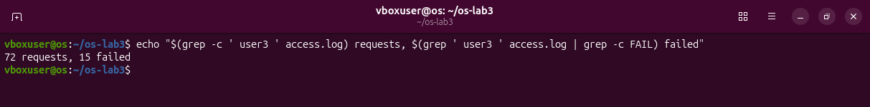
Figure 4.5 – Requests and failures of user3.
Q5: user3 made 72 requests and 15 of them failed.
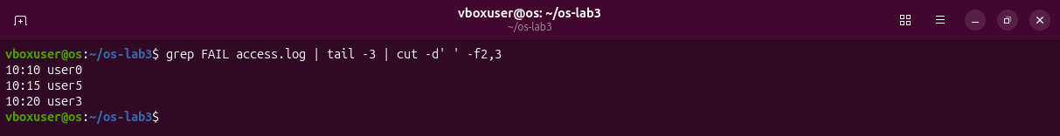
Figure 4.6 – The last three failed requests, time and user only.
Q6: 10:10 user0, 10:15 user5, 10:20 user3.
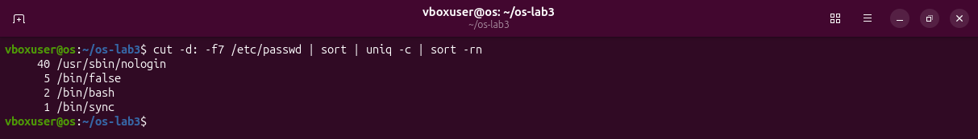
Figure 4.7 – Login shells in /etc/passwd.
Q7: /usr/sbin/nologin 40 accounts, /bin/false 5, /bin/bash 2, /bin/sync 1.
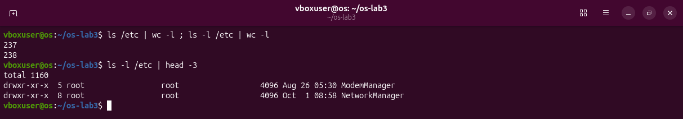
Figure 4.8 – ls /etc and ls -l /etc counted with wc -l.
Q8: I predicted the same number. The real counts are 237 and 238: ls -l prints one more line at the top, total 1160, before the entries.
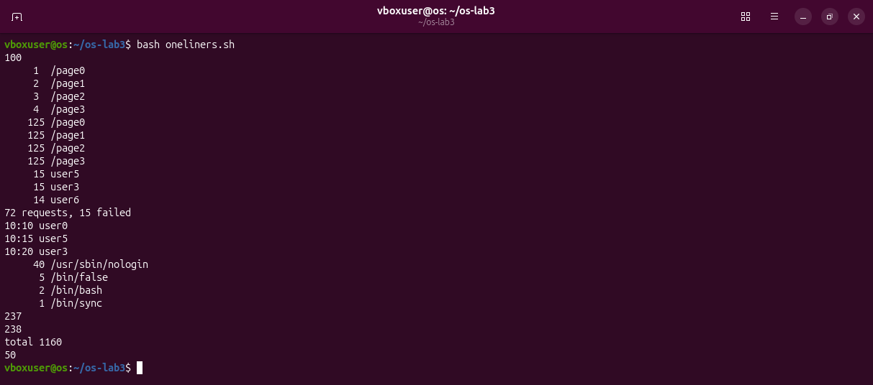
Figure 4.9 – Full run of oneliners.sh.
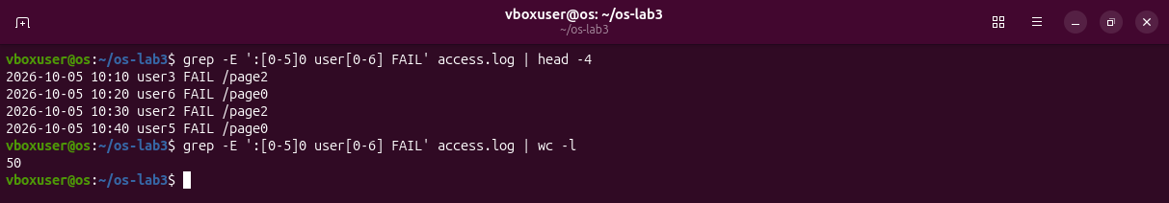
Figure 4.10 – Bonus: failed requests in a minute that ends in 0.
Bonus: 50 lines, found with grep -E ':[0-5]0 user[0-6] FAIL'.
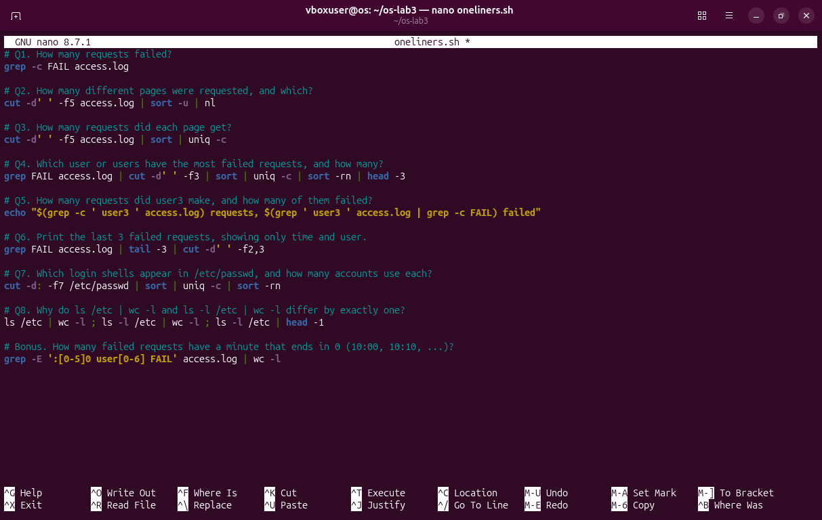
Figure 4.11 – oneliners.sh in the editor.
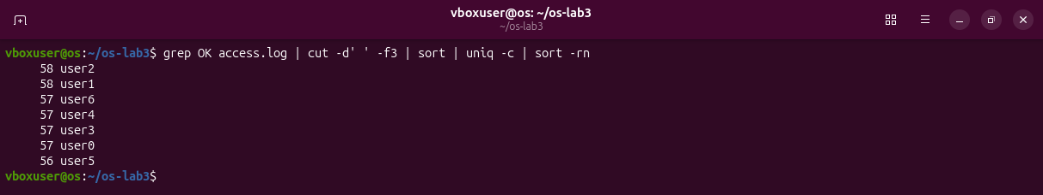
Figure 4.12 – The starting pattern from the lab sheet: successful requests per user.

Part 5. Your first script
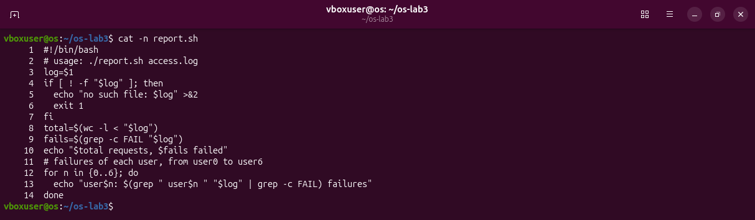
Figure 5.1 – Contents of report.sh.
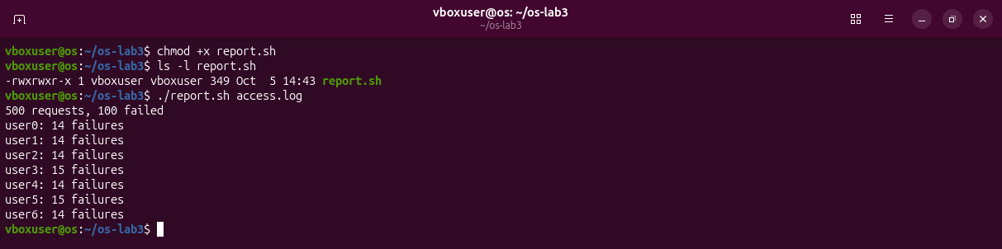
Figure 5.2 – Running the script on access.log.
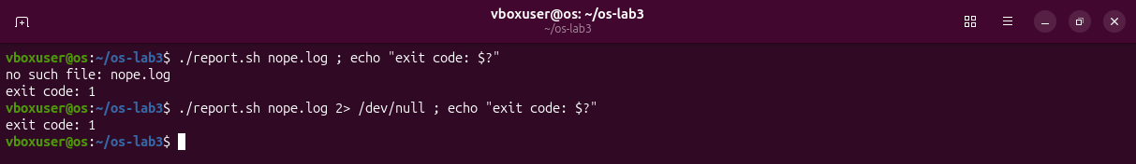
Figure 5.3 – Error handling for a missing file.
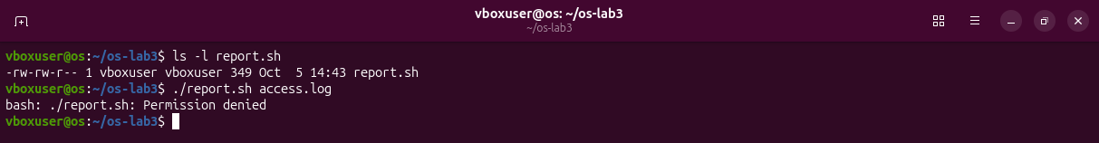
Figure 5.4 – Before chmod +x: Permission denied.
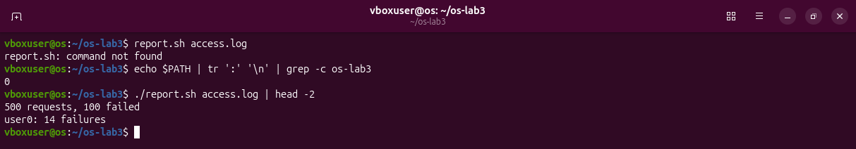
Figure 5.5 – Without ./ the shell does not find the script.
Observations
(1) #!/bin/bash: it tells the kernel which program must read and run the file. Before chmod +x the file has no execute permission and bash answers Permission denied.
(2) Why ./report.sh: the shell looks for a command only in the directories of PATH, and ~/os-lab3 is not one of them. ./ gives the path to the file directly.
(3) >&2 and exit 1: the message goes to stderr, so it does not mix with the normal output, and the exit code 1 tells the caller that the script failed.
Bonus: cron
* * * * * /home/vboxuser/os-lab3/report.sh /home/vboxuser/os-lab3/access.log >> /home/vboxuser/os-lab3/report.log 2>&1
The five stars mean every minute. Cron ran the script three times, at 14:49, 14:50 and 14:51, and each run added its eight lines to report.log. Then the line was removed with crontab -r.
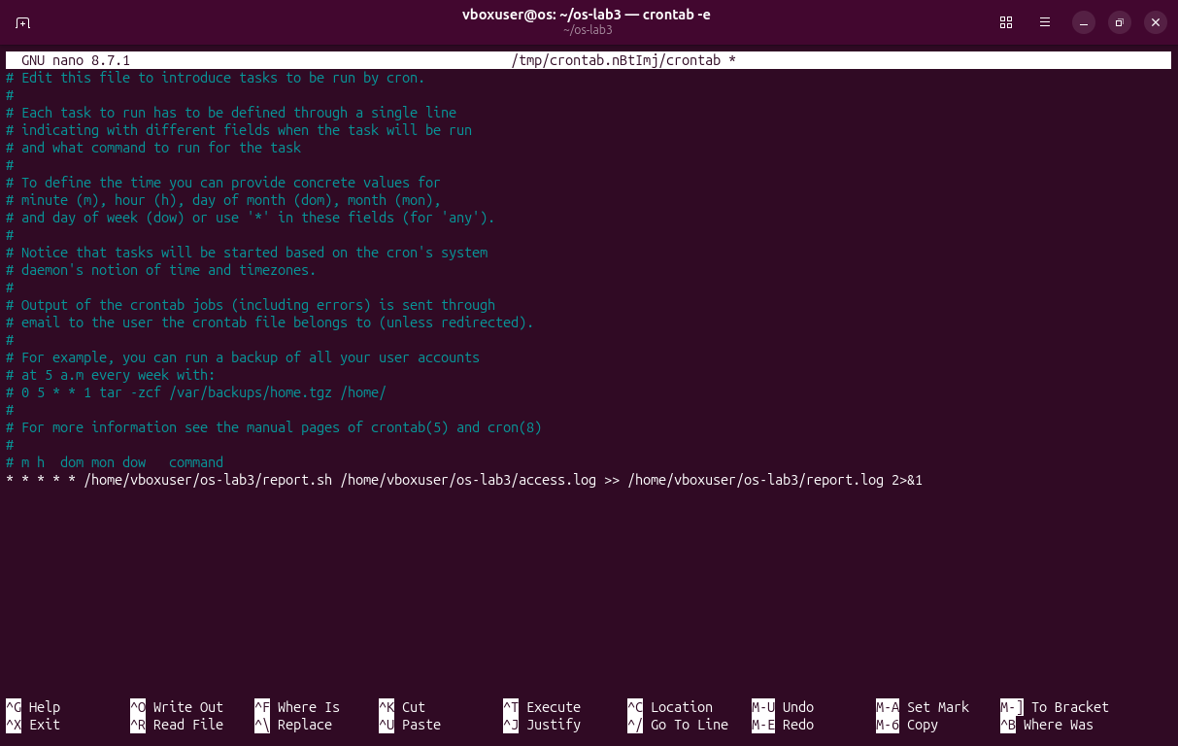
Figure 5.6 – The line added with crontab -e.
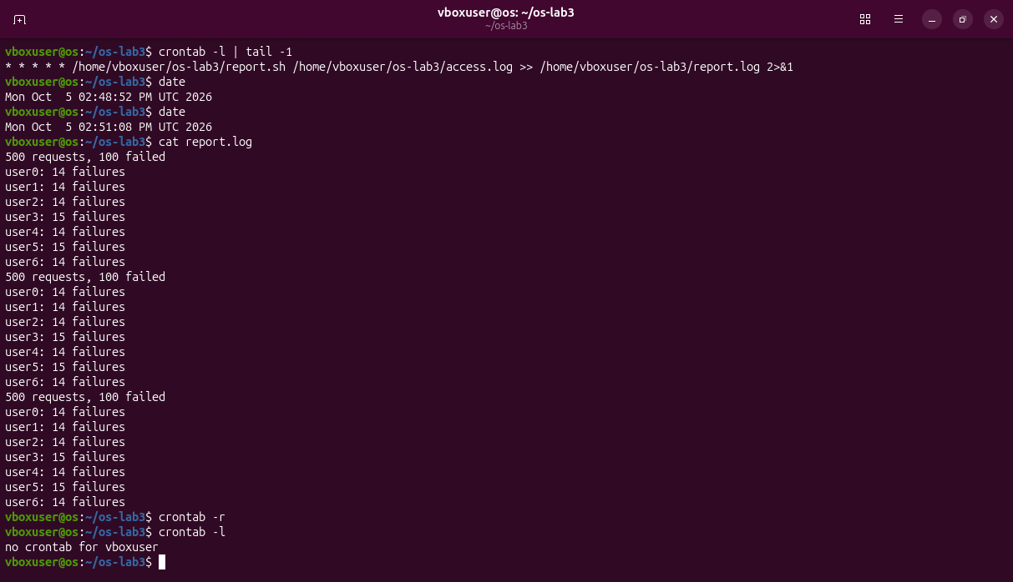
Figure 5.7 – report.log after three minutes, then the crontab is removed.

Conclusions
The shell rewrites my line before any program starts: it expands patterns, variables and quotes, prepares the redirections and only then runs the commands. Small filters such as grep, cut, sort, uniq and wc answer real questions when they are joined by pipes, and the same lines become a program when they are saved in a script. Exit codes and the separate error stream are what make &&, || and redirection reliable.
Files in the folder lab3/ of the repository: this report, report.sh and oneliners.sh.

