Ministry of Education and Research of the Republic of Moldova
Technical University of Moldova
Faculty of Computers, Informatics and Microelectronics
Department of Software Engineering and Automatics
REPORT
on Laboratory Work No. 9
Course: Operating Systems
Topic: Watching System Calls with strace
Track A: the real OS, from the outside (Linux)
Done by: st. gr. FAF-242, Eftode Andrei
Checked by: univ. assist. Reițman Patricia
Chișinău, 2026
Contents
Laboratory Work No. 9. Watching System Calls with strace 3
Preparation 3
Part 1. See the calls of a real command 3
Part 2. A program that calls the kernel directly 5
Part 3. Count one kind of call 6
Deliverables 8
Conclusions 9

Laboratory Work No. 9. Watching System Calls with strace
Purpose: to watch with strace the system calls of a real command and of my own program, which uses open, write, read and close directly, and to count one kind of call.
Environment: Ubuntu 26.04.1 LTS virtual machine, kernel 7.0.0-38-generic, gcc 15.2.0, strace 6.19, working folder ~/os-lab9.

Preparation
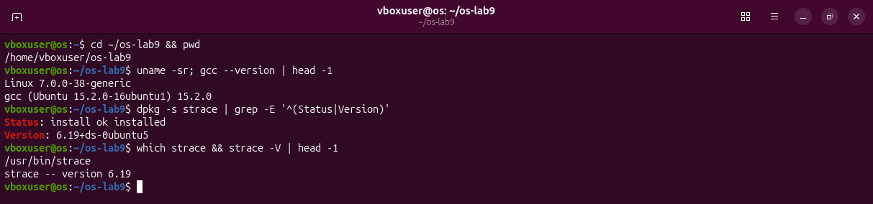
Figure 0.1 – The working folder, the compiler, and strace 6.19, already installed.

Part 1. See the calls of a real command
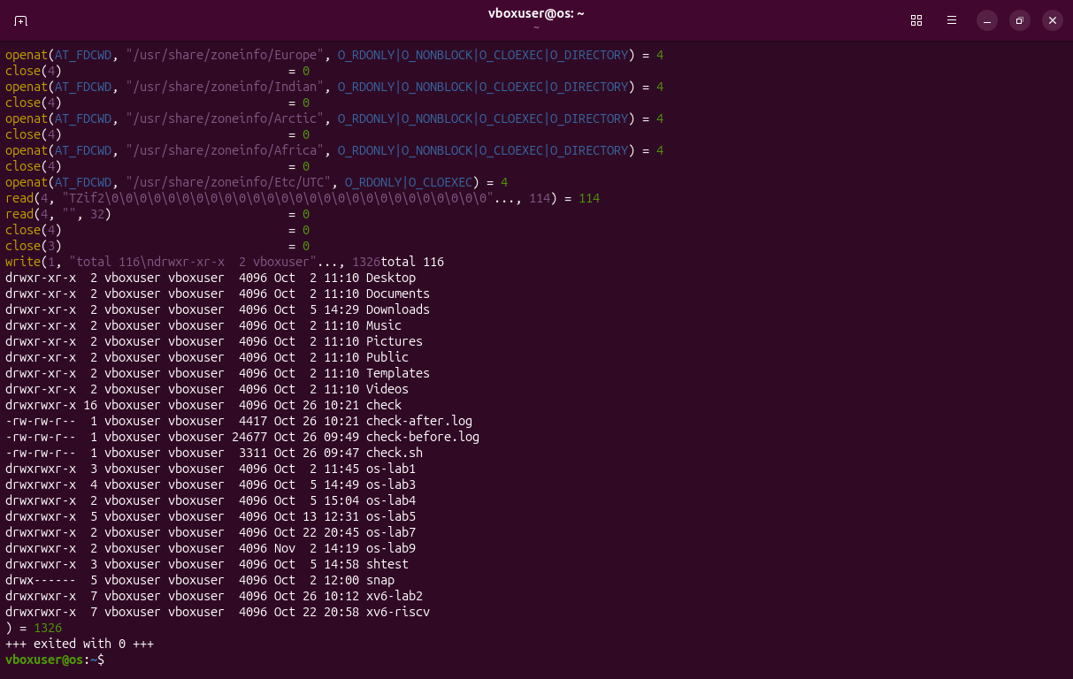
Figure 1.1 – strace -f -e trace=openat,read,write,close ls -l in my home folder, the end of the output: the whole listing is one write(1, ...) of 1326 bytes.
strace prints write(1, ... before the call ends, so the listing of ls appears in the middle of that line and ) = 1326 comes after it.
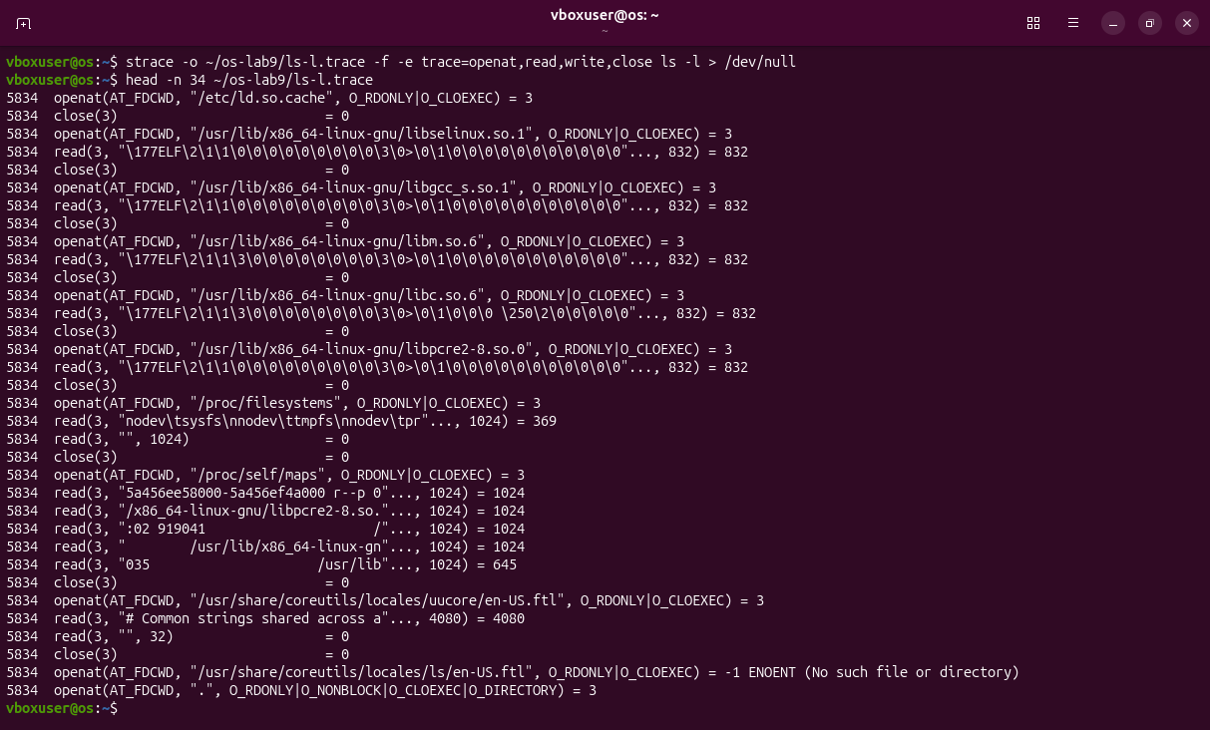
Figure 1.2 – The beginning of the same trace, saved with -o: five libraries, /proc/filesystems, /proc/self/maps, the message file of ls.
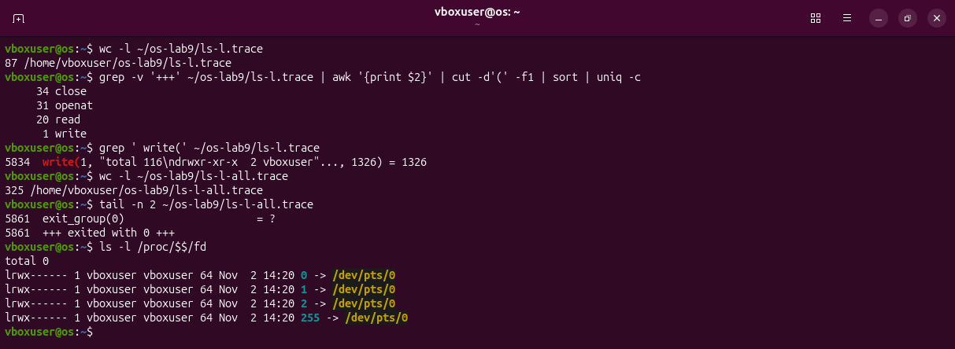
Figure 1.3 – Counting: 86 calls of the four kinds and only one write; 324 system calls of every kind. Descriptors 0, 1 and 2 of my shell are the terminal.
Observations
(1) ls prints with the system call write, to descriptor 1, the standard output, which is my terminal (/dev/pts/0). One ls -l makes 86 calls of these four kinds and about 320 in total; only one of them prints.

Part 2. A program that calls the kernel directly
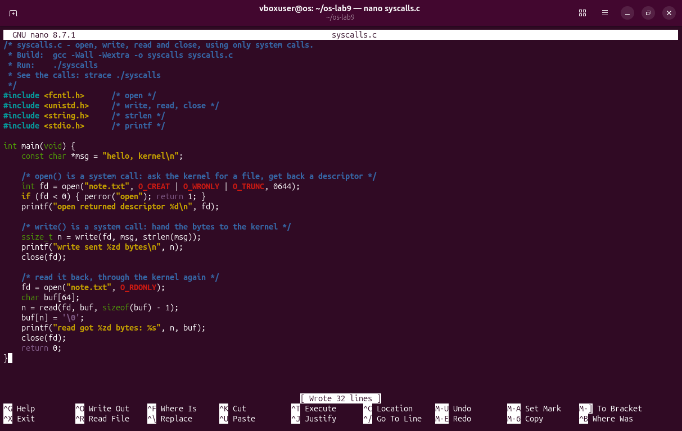
Figure 2.1 – syscalls.c written in nano, exactly as on the sheet.
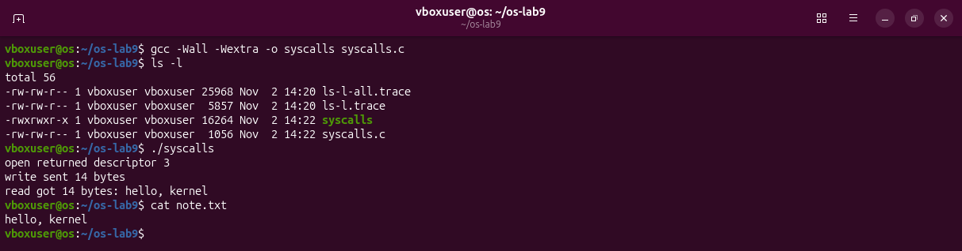
Figure 2.2 – Compiled with -Wall -Wextra without a warning; the expected output, and note.txt holds the line.
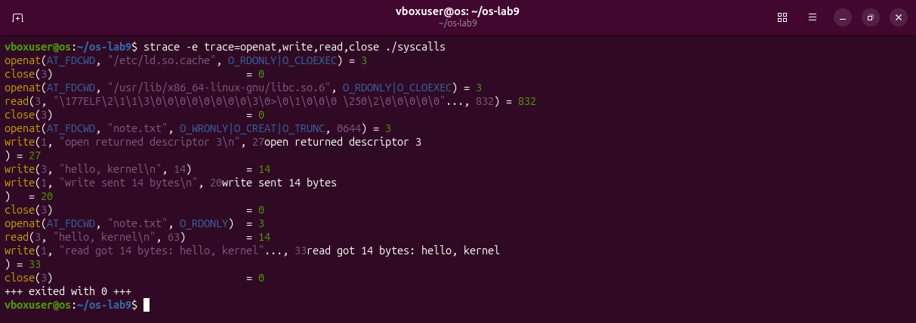
Figure 2.3 – strace -e trace=openat,write,read,close ./syscalls: after the loader's lines come my calls, with the output of printf mixed in.
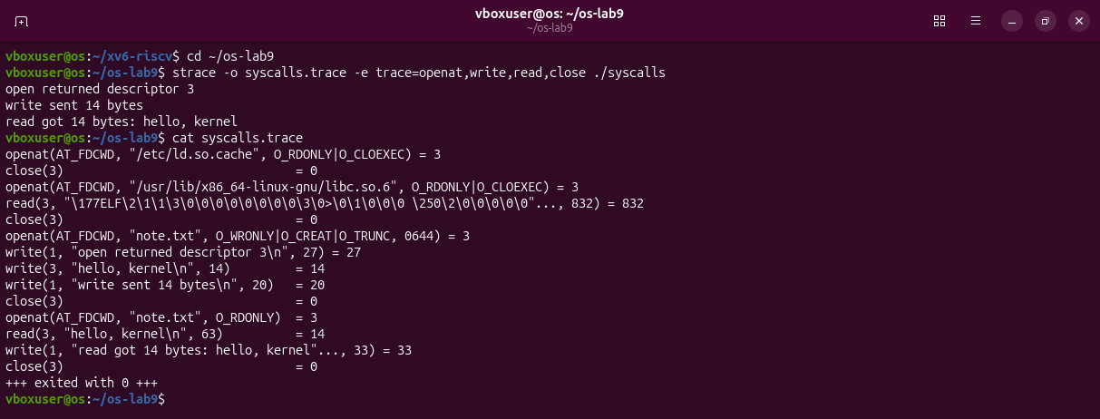
Figure 2.4 – The same trace saved with -o: the six calls of the sheet, and between them the three write(1, ...) of printf.
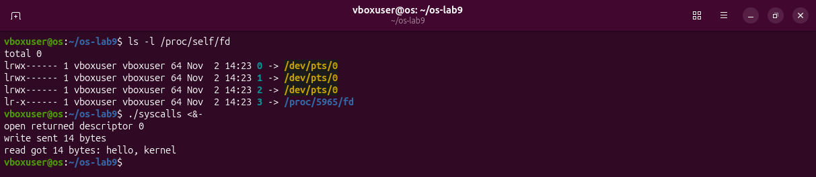
Figure 2.5 – Descriptors 0, 1, 2 are open on the terminal before the program starts. With standard input closed (<&-), open returns 0.
Observations
(1) 0, 1 and 2 are standard input, standard output and standard error. The shell opened them on the terminal, and the program inherits them through fork and exec. open always returns the smallest free descriptor, so 3. Figure 2.5 proves it: with 0 closed, open returns 0.

Part 3. Count one kind of call
The sheet gives only the title of this part, so I counted with strace -c, which prints a table with the number of calls of each kind instead of the calls themselves.
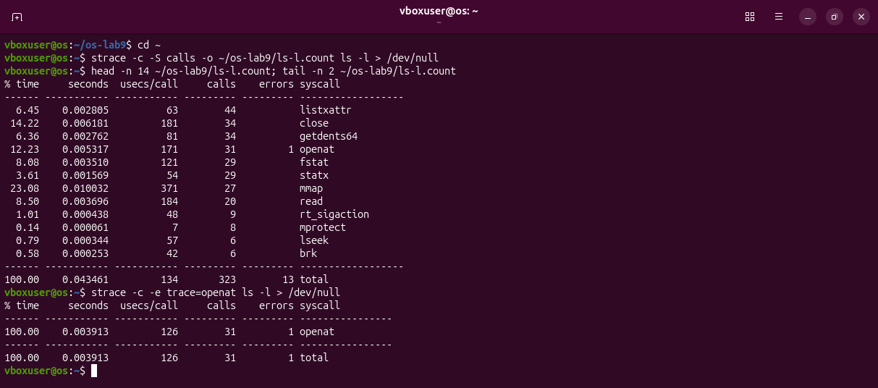
Figure 3.1 – strace -c on ls -l, sorted by count: 323 calls, most of them listxattr, close, getdents64, openat. With -e trace=openat only one kind is counted: 31.
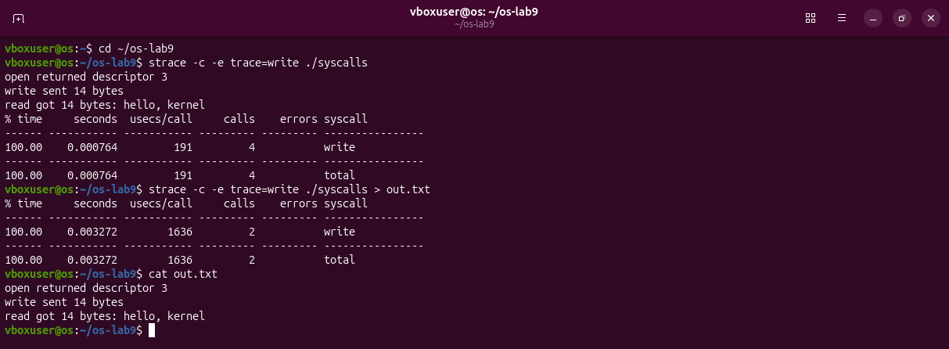
Figure 3.2 – Only write: ./syscalls makes 4 on the terminal, but only 2 when its output goes to a file.
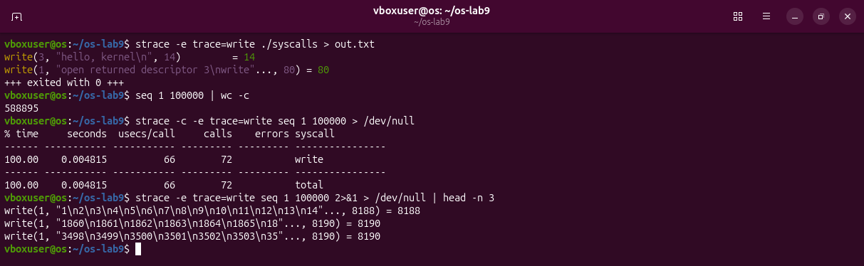
Figure 3.3 – Into a file the three printf lines leave in one write of 80 bytes. seq 1 100000 prints 588 895 bytes with only 72 writes.
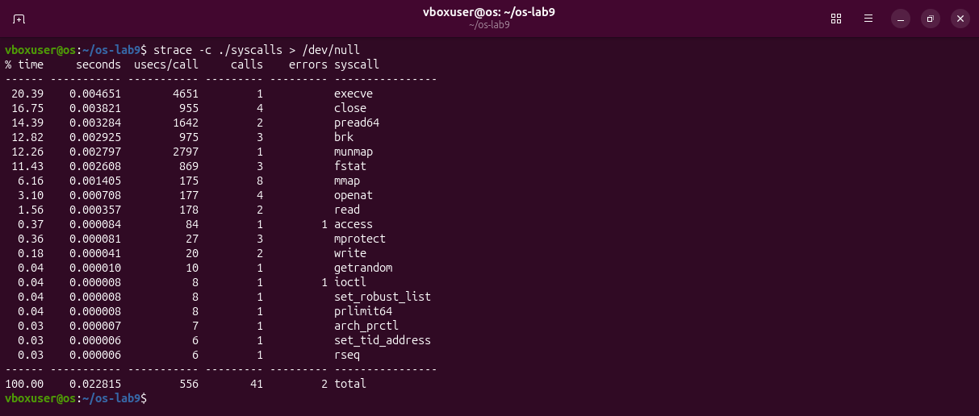
Figure 3.4 – Every call of ./syscalls: 41 calls of 19 kinds; only 6 of them are the calls I wrote.
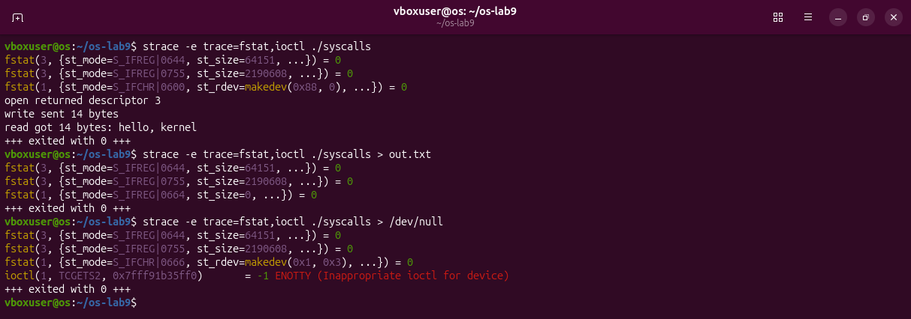
Figure 3.5 – How the C library chooses: fstat(1) shows a terminal (device 0x88) or a regular file; for /dev/null it also tries ioctl, which fails.
Observations
(1) ls -l spends its calls on collecting information (listxattr and statx for every entry, getdents64 to read folders) and on loading libraries. Printing is 1 call out of 323.
(2) printf is not a system call: it fills a buffer of the C library. On a terminal the buffer is sent at every new line (3 writes); into a file it is sent once, at the end (1 write). My own write to note.txt is always exactly one call.
(3) Every system call is a trip into the kernel, so programs collect their output and write it in large pieces: 72 writes of about 8 KB for 100 000 lines.

Deliverables
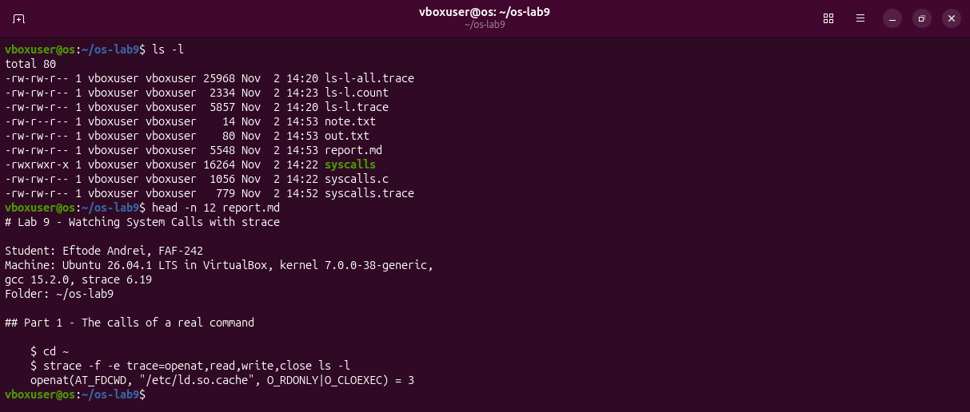
Figure 4.1 – The folder ~/os-lab9 and the beginning of report.md, with the answers.
Files in the folder lab9/ of the repository: this report, syscalls.c, report.md and the screenshots.

Conclusions
In this laboratory work I watched, with strace, the border between programs and the Linux kernel. A simple ls -l made about 320 system calls, but only one of them, a single write to descriptor 1, printed the listing; all the others loaded libraries and collected information about the files and their owners. In my own program the C functions open, write, read and close became the system calls openat, write, read and close, and the first file received descriptor 3, because 0, 1 and 2 are the terminal that every program inherits from the shell.
Counting the calls showed that printf is not a system call: the C library keeps the text in a buffer and decides when to call write, so the same program made 4 writes on a terminal and only 2 into a file. Since every system call is a trip into the kernel and back, programs collect their output and write it in large pieces. strace proved to be a simple way to see what a program really asks the operating system to do, and why it fails when it does.

