Ministry of Education and Research of the Republic of Moldova
Technical University of Moldova
Faculty of Computers, Informatics and Microelectronics
Department of Software Engineering and Automatics
REPORT
on Laboratory Work No. 4
Course: Operating Systems
Topic: The xv6 Shell from the Outside
Track B: build your own small OS (xv6)
Done by: st. gr. FAF-242, Eftode Andrei
Checked by: Reițman Patricia
Chișinău, 2026
Contents
Laboratory Work No. 4. The xv6 Shell from the Outside 3
Preparation 3
Part 1. Fix sleep for the current xv6 3
Part 2. bash versus the xv6 shell 5
Part 3. Who expands *? A program that prints its argv 8
Part 4. Read the shell 10
Deliverables and conclusions 11

Laboratory Work No. 4. The xv6 Shell from the Outside
Purpose: to use the xv6 shell side by side with bash, to find by experiment what a shell must do and what bash adds on top, and to see who expands * and removes quotes, with a program that prints its arguments.
Environment: the same Ubuntu 26.04.1 LTS virtual machine, riscv64-linux-gnu-gcc 15.2.0, QEMU 10.2.1, xv6 revision 06aad25 in ~/xv6-riscv on branch lab.

Preparation
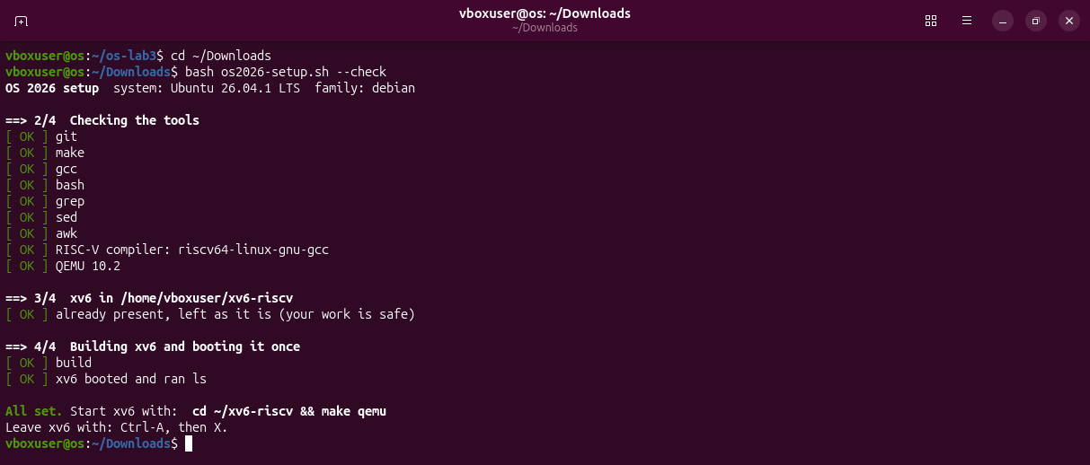
Figure 0.1 – bash os2026-setup.sh --check: xv6 builds and boots.

Part 1. Fix sleep for the current xv6
My tree from Lab 2 was fixed on the last commit before the rename, where user.h still declares sleep. I saved that work as a commit on branch lab2 and moved to revision 06aad25, the one the course script uses, on a new branch lab. There user.h declares pause.
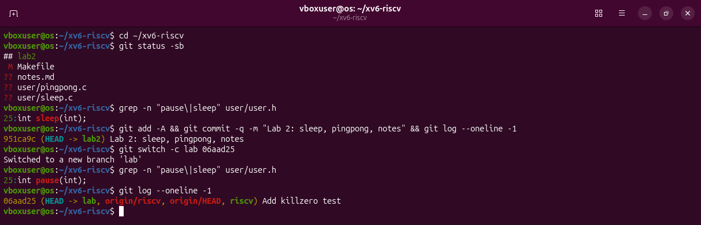
Figure 1.1 – The grep result in user.h, on the Lab 2 tree and on the current xv6.
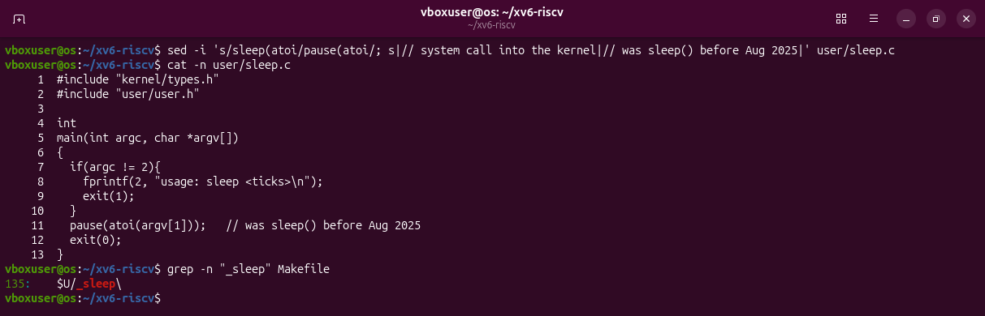
Figure 1.2 – The updated sleep.c: line 11 calls pause().
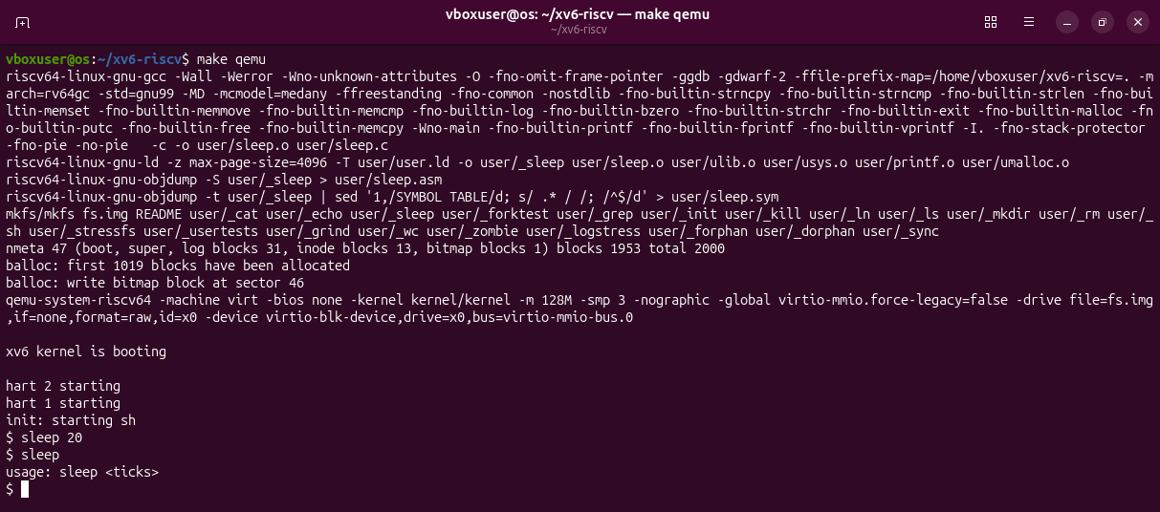
Figure 1.3 – sleep running in xv6, with and without an argument.
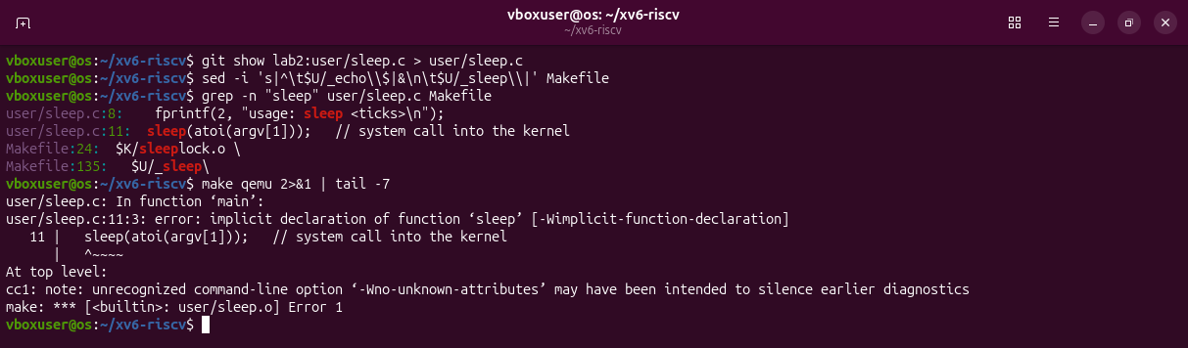
Figure 1.4 – Before the change: the sleep.c from Lab 2 does not build on the current xv6.
sleep 20 pauses for about two seconds and returns; sleep alone prints the usage message. The line $U/_sleep\ is in UPROGS, at line 135 of the Makefile.

Part 2. bash versus the xv6 shell
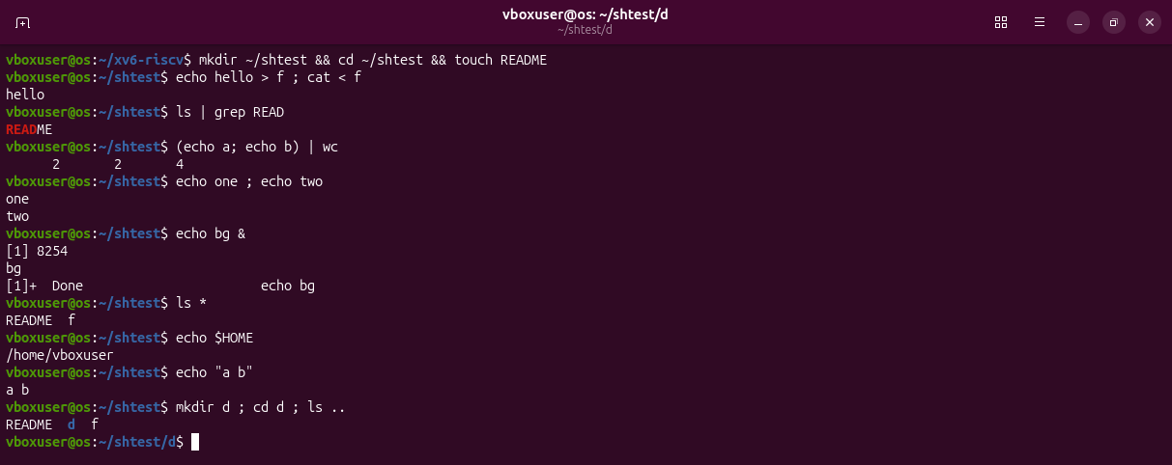
Figure 2.1 – The commands run in bash.
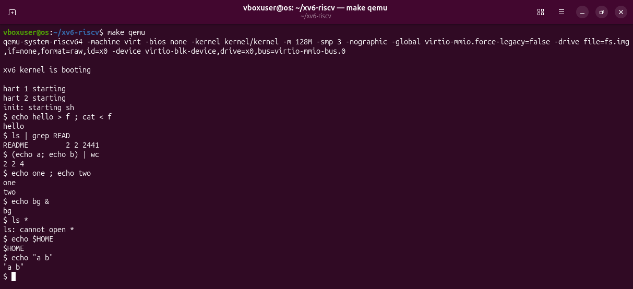
Figure 2.2 – The same commands run in xv6.
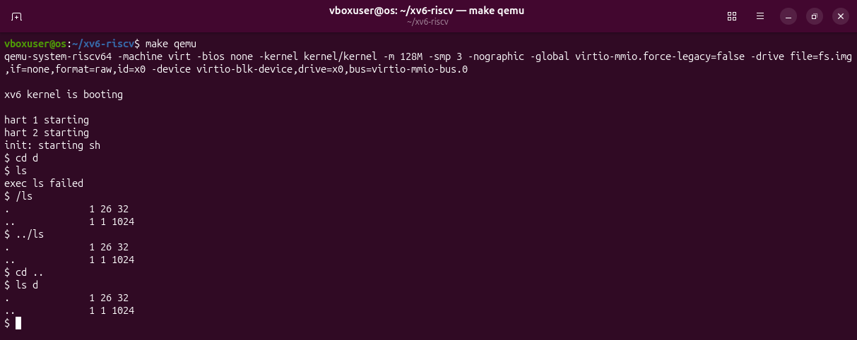
Figure 2.3 – ls failing after cd d, and the working alternative.
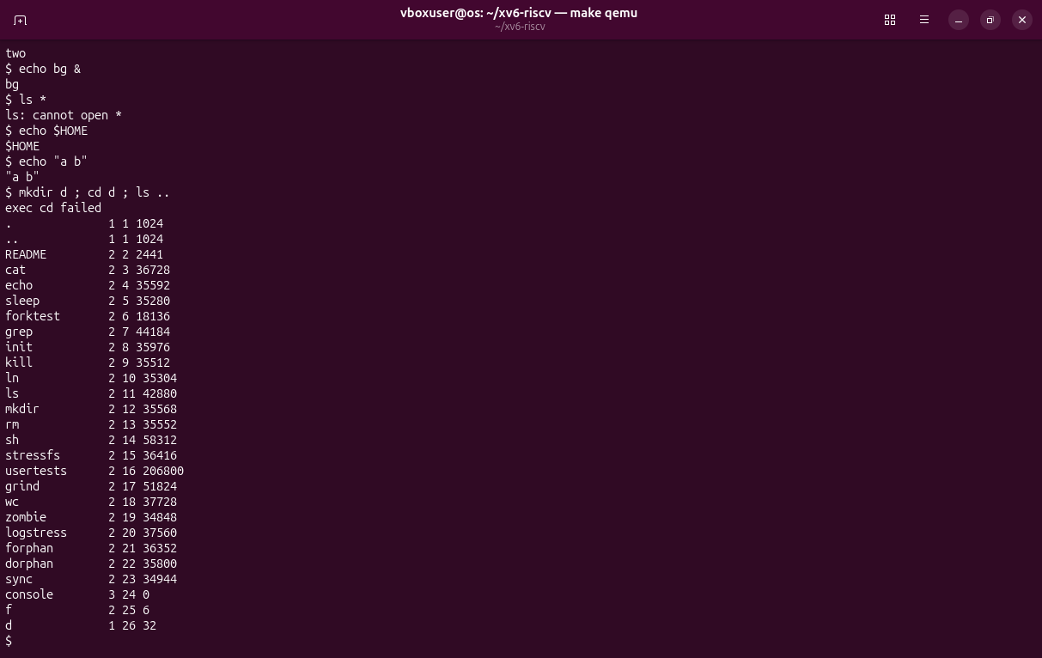
Figure 2.4 – The row mkdir d ; cd d ; ls .. in xv6.
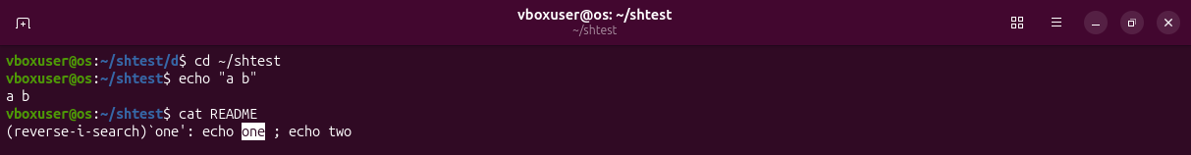
Figure 2.5 – History, completion and Ctrl+R in bash.
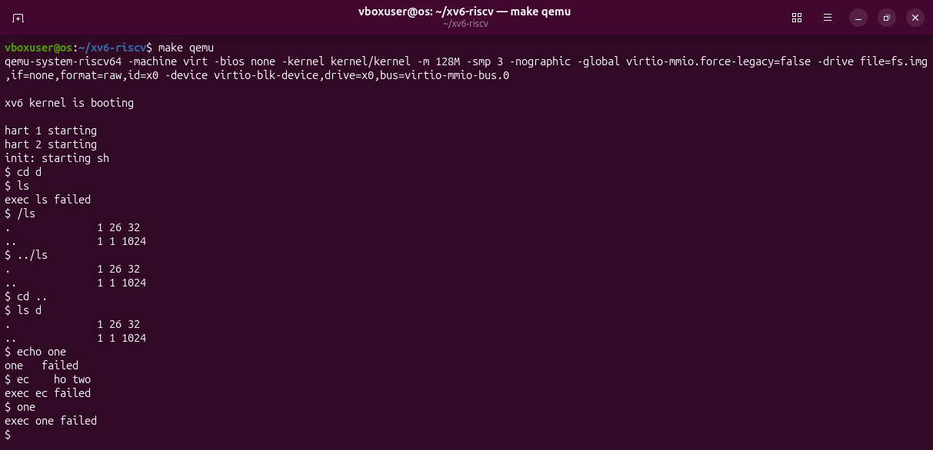
Figure 2.6 – Arrow up, Tab and Ctrl+R in xv6.
The comparison table
Command | Tests | bash | xv6
echo hello > f ; cat < f | redirection | hello. Both > and < work. | hello. Both work.
ls | grep READ | pipe | README | README 2 2 2441. The pipe works; the xv6 ls also prints type, inode and size.
(echo a; echo b) | wc | grouping, list | 2 2 4 | 2 2 4. Parentheses and ; work.
echo one ; echo two | sequence | one then two | one then two
echo bg & | background | [1] 8254, bg, then [1]+ Done. Bash numbers the job and reports its end. | bg. It runs in the background, but there are no job numbers.
ls * | globbing | README f. Bash replaced * with the file names. | ls: cannot open *. The star reached ls unchanged.
echo $HOME | variables | /home/vboxuser | $HOME. There are no variables.
echo "a b" | quotes | a b. Bash removed the quotes. | "a b". The quotes are ordinary characters.
mkdir d ; cd d ; ls .. | PATH | README d f. cd is a built-in and ls is found through PATH. | exec cd failed, then the listing of /. Inside a list cd is run as a program, and there is none.
arrow up, Tab, Ctrl+R | history, completion | The last command returns, cat RE becomes cat README, Ctrl+R searches. | Nothing useful: the keys become characters of the command, which then fails.

Observations
(1) Features: both shells run programs with arguments and have redirection (<, >), pipes, lists with ;, grouping with parentheses, background with & and a built-in cd. Only bash has globbing, variables, quotes, a search PATH, job control, history, Tab completion and Ctrl+R.
(2) ls after cd d: the xv6 shell has no PATH. It gives the name ls directly to exec, which looks in the current directory, and the programs exist only in the root directory. With the path it works: /ls or ../ls.
(3) Missing features: I would miss history and Tab completion most, because I use them in almost every command. The easiest to add would be a one-directory PATH: when exec fails for a name without /, try again with / in front of the name.

Part 3. Who expands *? A program that prints its argv
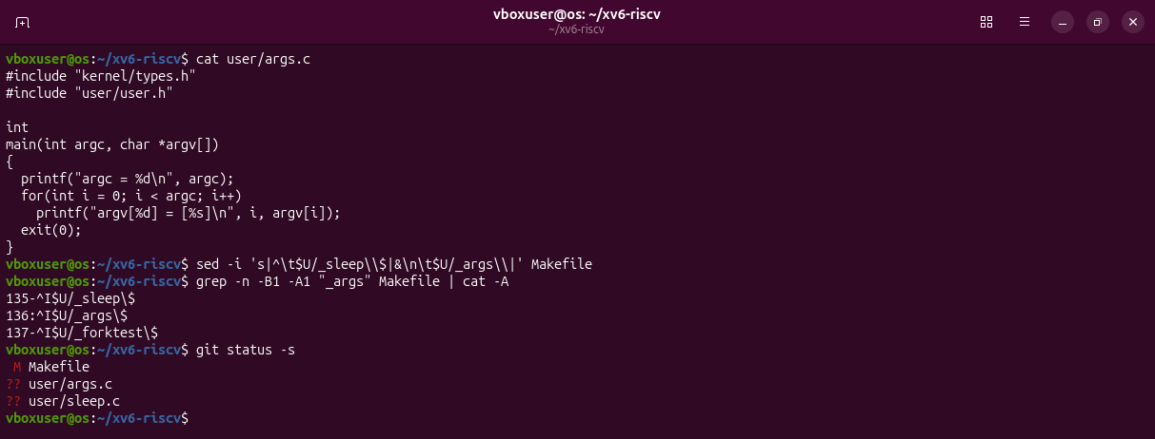
Figure 3.1 – args.c and the UPROGS line.
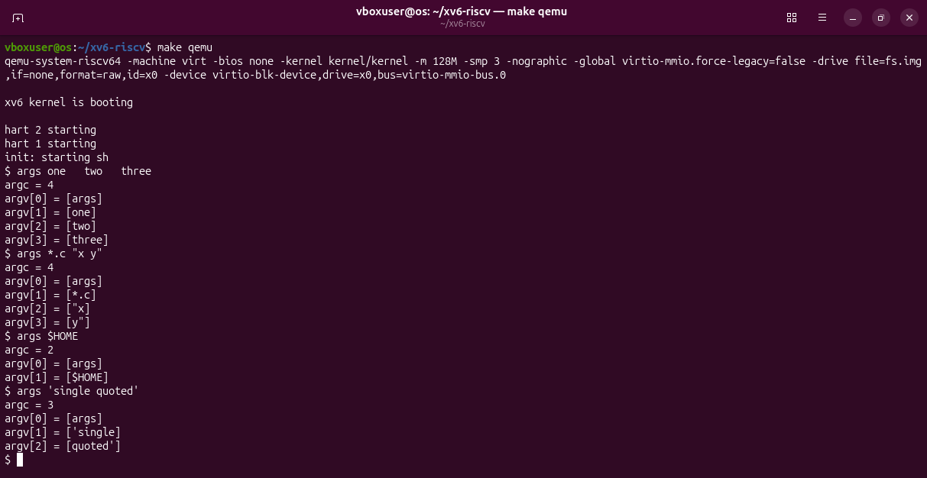
Figure 3.2 – args output in xv6.
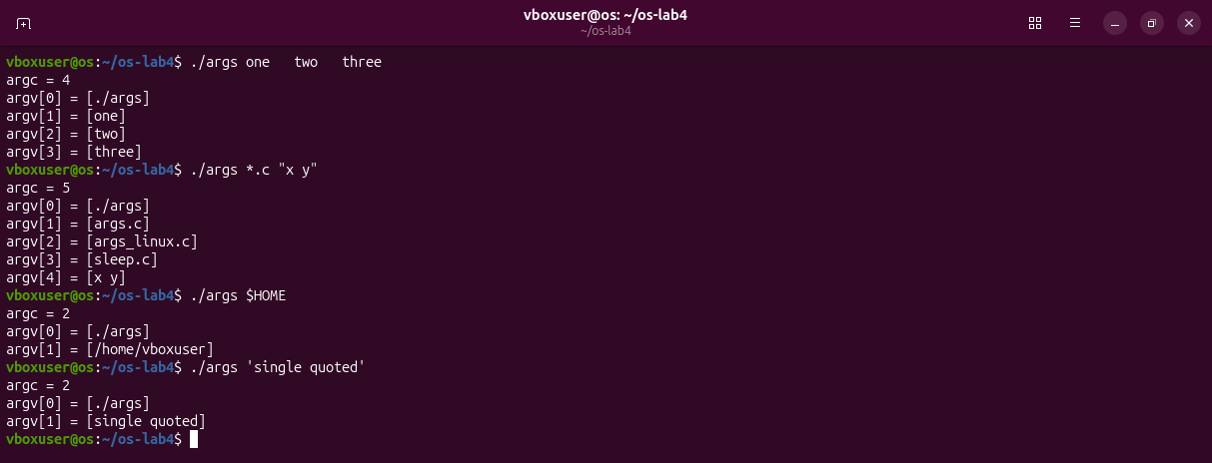
Figure 3.3 – args_linux output in bash.
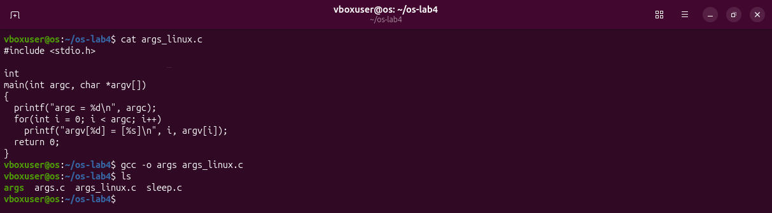
Figure 3.4 – args_linux.c compiled with gcc.
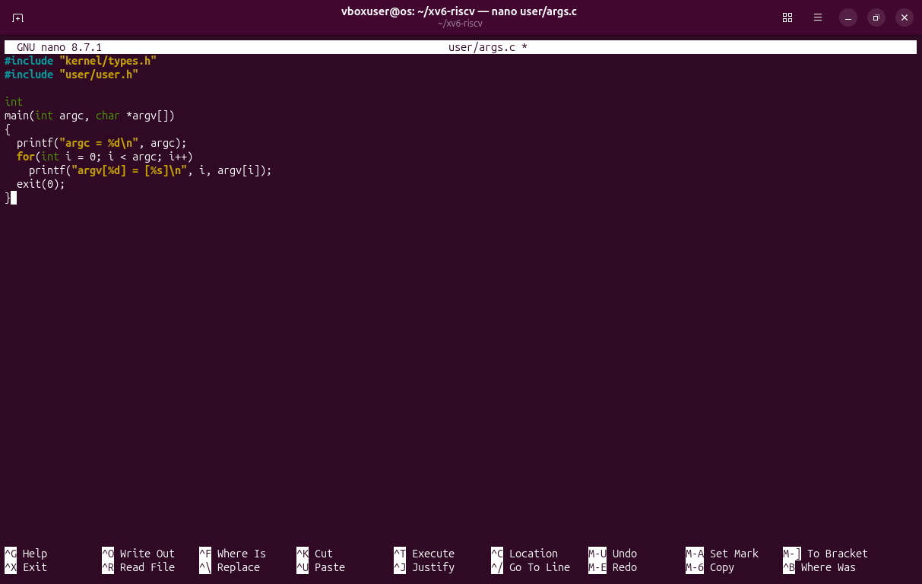
Figure 3.5 – Writing user/args.c in the editor.
Observations
(1) Outputs for args *.c "x y":
bash: argc = 5 [./args] [args.c] [args_linux.c] [sleep.c] [x y]
xv6: argc = 4 [args] [*.c] ["x] [y"]
In bash the program received four arguments after its name: three file names and x y as one argument. In xv6 it received three: the star unchanged, and the quoted text cut in two with the quotes still on it.
(2) Who does it: the shell. The program is the same in both systems and the kernel passes argv as it gets it. Bash replaced *.c and removed the quotes before starting the program; the xv6 shell did neither.
(3) The extra spaces: they disappeared in both shells. The shell cuts the line into words at any amount of white space, so the program gets only the words: argc = 4 in both.

Part 4. Read the shell
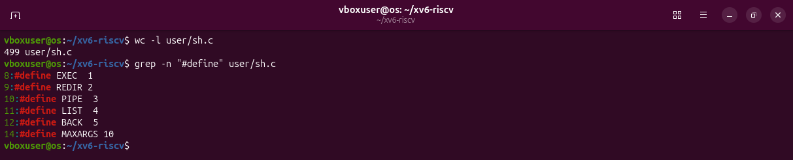
Figure 4.1 – The command kinds defined in sh.c.
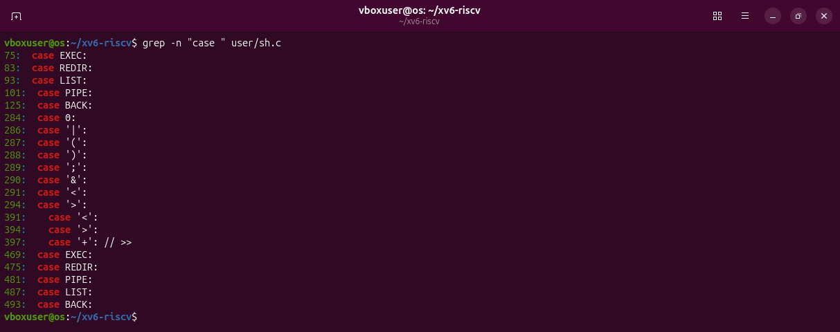
Figure 4.2 – Where each kind is run.
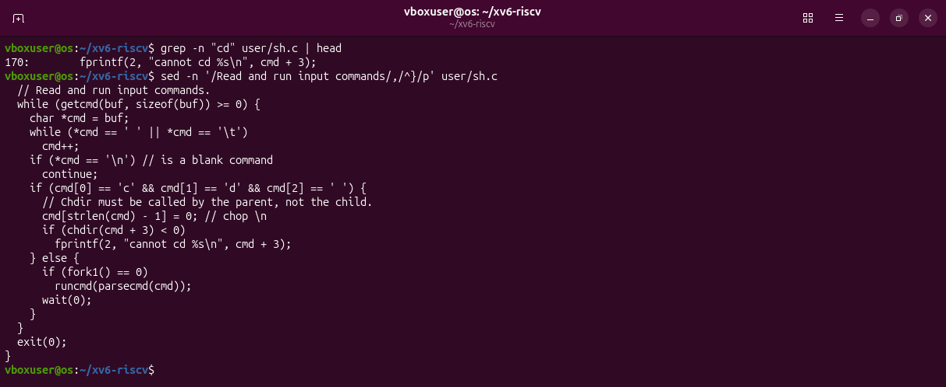
Figure 4.3 – The code that handles cd.
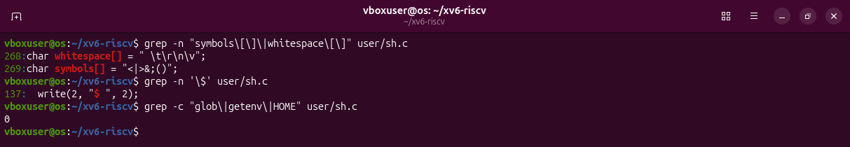
Figure 4.4 – The only special characters of the xv6 shell; no code for * or $.
Observations
(1) The five kinds: EXEC, a plain command with no special character; REDIR, produced by <, > and >>; PIPE, by |; LIST, by ;; BACK, by &. Each one is run by its case in the function runcmd (lines 75 to 125).
(2) cd: it is handled in main, at line 166, before any fork: if the line starts with cd the shell itself calls chdir. A separate program would change only its own directory and exit, and the shell would not move. The comment in the code says it: "Chdir must be called by the parent, not the child."
(3) * and $: there is no such code. The only special characters are symbols[] = "<|>&;()", the only $ in the file is the prompt, and the words glob, getenv and HOME do not appear. This explains Part 2: ls *, echo $HOME and echo "a b" reach the programs exactly as they were typed.

Deliverables and conclusions
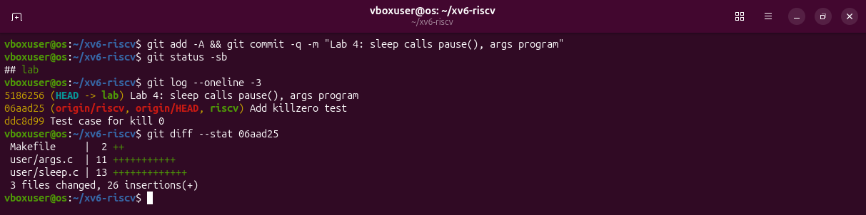
Figure 5.1 – The xv6 tree at the end of the lab: one commit on top of revision 06aad25.
A shell needs very little: read a line, cut it into words, fork, prepare the redirections and pipes, and exec. The xv6 shell does all of it in 499 lines. Everything else I am used to (globbing, variables, quotes, PATH, history, completion, job control) is added by bash, not by the kernel, and the args program proves it: the same program receives different arguments from the two shells.
Files in the folder lab4/ of the repository: this report, sleep.c, args.c, args_linux.c and the Makefile.

