Ministry of Education and Research of the Republic of Moldova
Technical University of Moldova
Faculty of Computers, Informatics and Microelectronics
Department of Software Engineering and Automatics
REPORT
on Laboratory Work No. 10
Course: Operating Systems
Topic: Add Your Own System Call: trace
Track B: build your own small OS (xv6)
Done by: st. gr. FAF-242, Eftode Andrei
Checked by: univ. assist. Reițman Patricia
Chișinău, 2026
Contents
Laboratory Work No. 10. Add Your Own System Call: trace 3
Preparation 3
Part 1. The number and the user side 4
Part 2. The kernel side 7
Part 3. Play with the mask 10
Optional: sysinfo 12
Deliverables 15
Conclusions 17

Laboratory Work No. 10. Add Your Own System Call: trace
Purpose: to change the xv6 kernel for the first time: add a system call, trace, that makes a process print every system call it makes, following its number, 23, from a user program down to a kernel function.
Environment: Ubuntu 26.04.1 LTS virtual machine, riscv64-linux-gnu-gcc 15.2.0, QEMU 10.2.1, xv6 revision 06aad25 in ~/xv6-riscv on branch lab, with my programs of Labs 4, 6 and 8.

Preparation
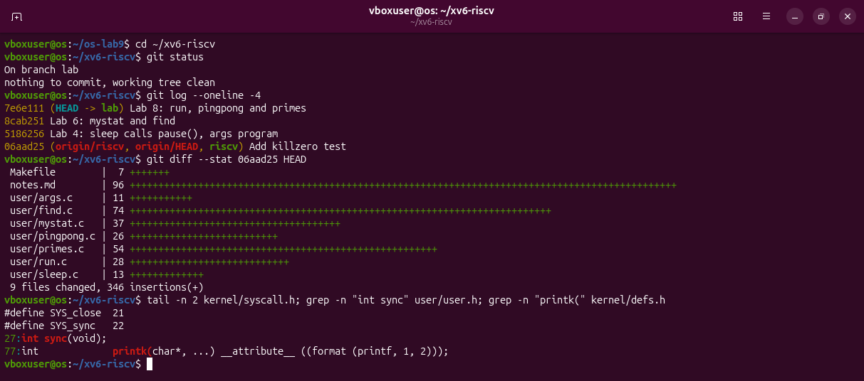
Figure 0.1 – The tree before the lab: clean, the kernel unchanged since 06aad25, SYS_sync is 22 and the kernel prints with printk, as the sheet warns.
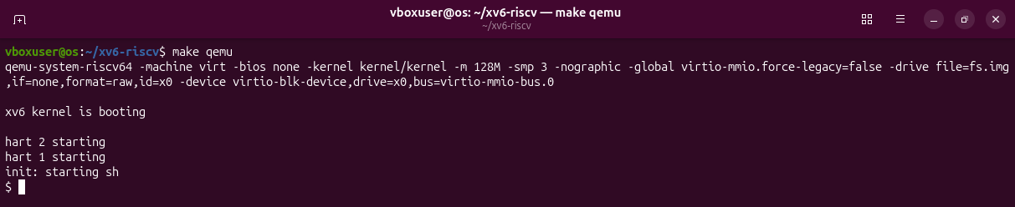
Figure 0.2 – The tree builds and boots (left with Ctrl-A X).

Part 1. The number and the user side
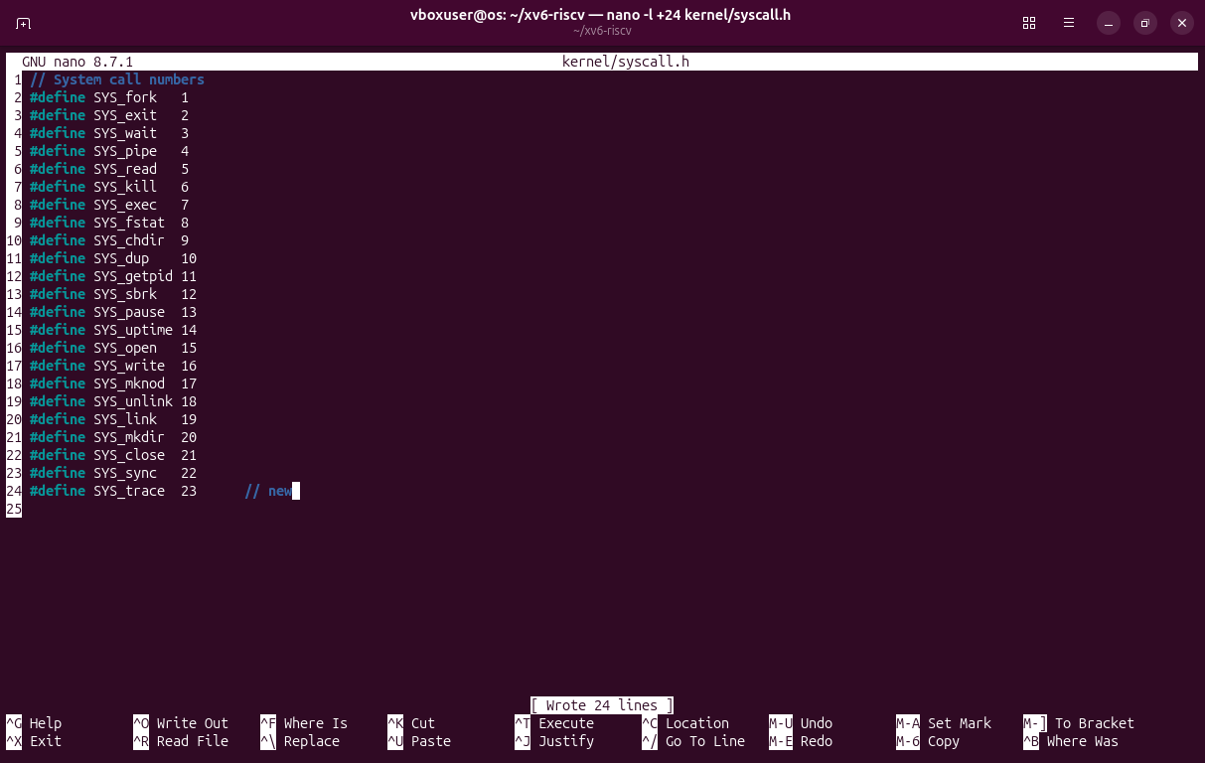
Figure 1.1 – kernel/syscall.h: SYS_trace gets the number 23.
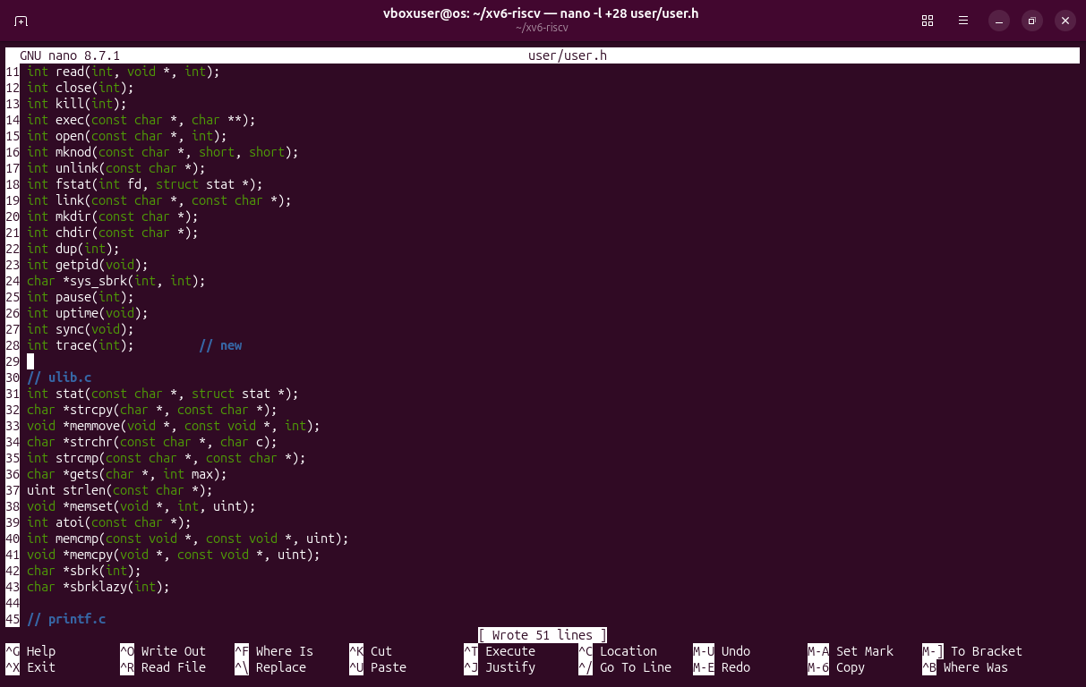
Figure 1.2 – user/user.h: the declaration int trace(int); after sync.
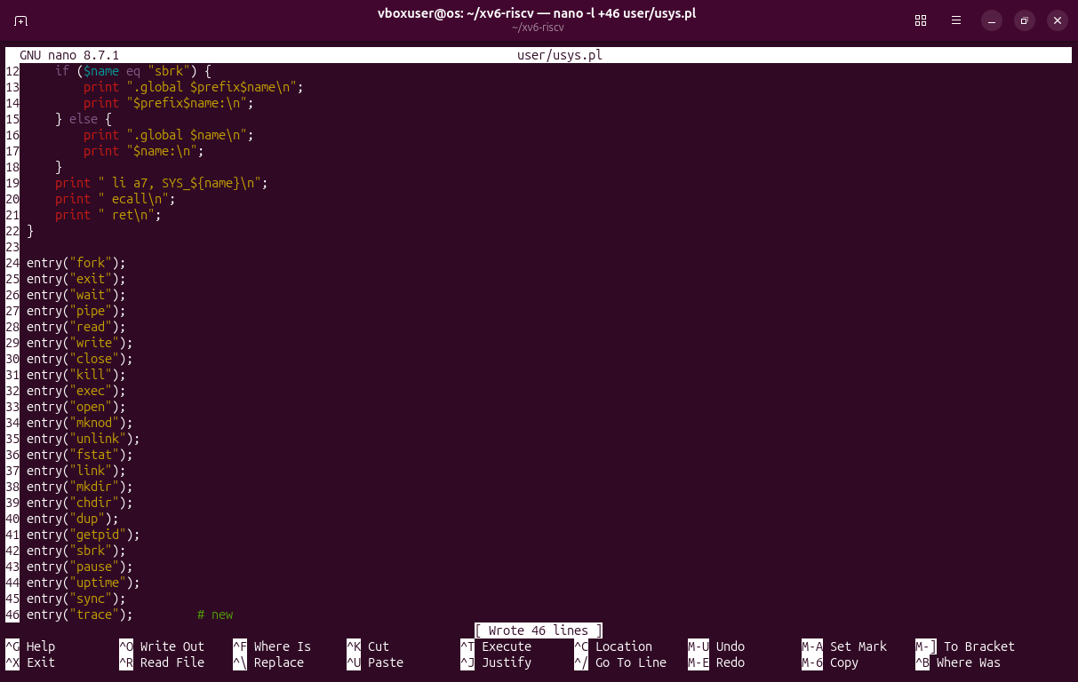
Figure 1.3 – user/usys.pl: entry("trace"); at the end.
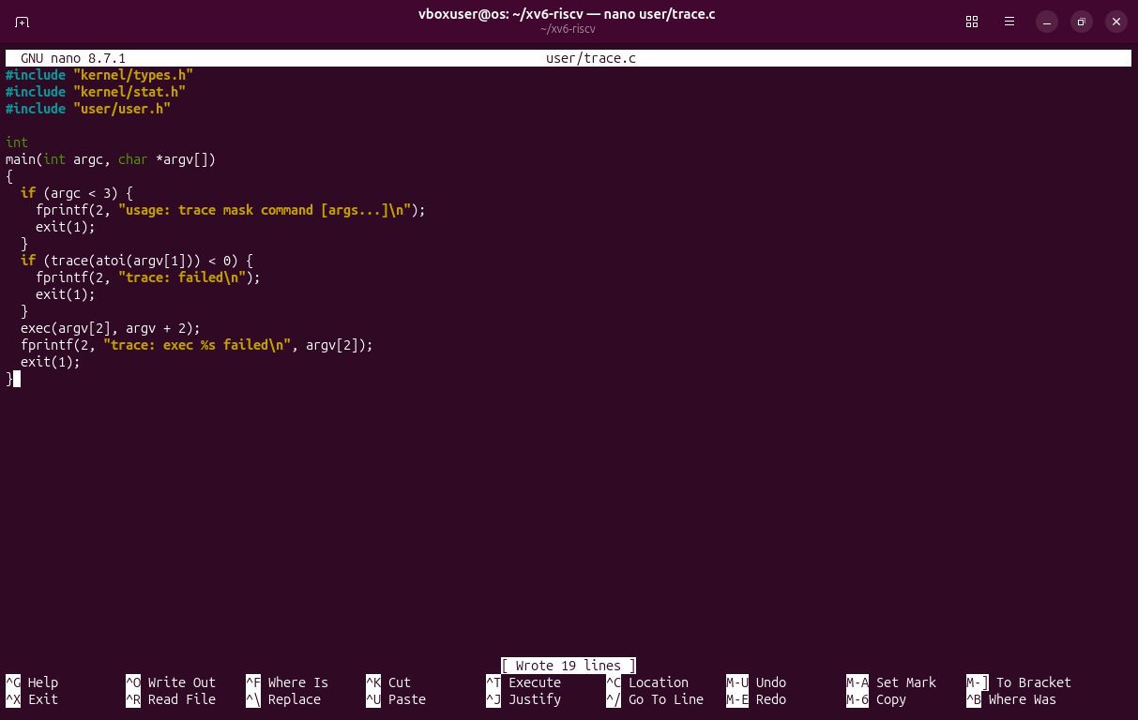
Figure 1.4 – user/trace.c, exactly as on the sheet.
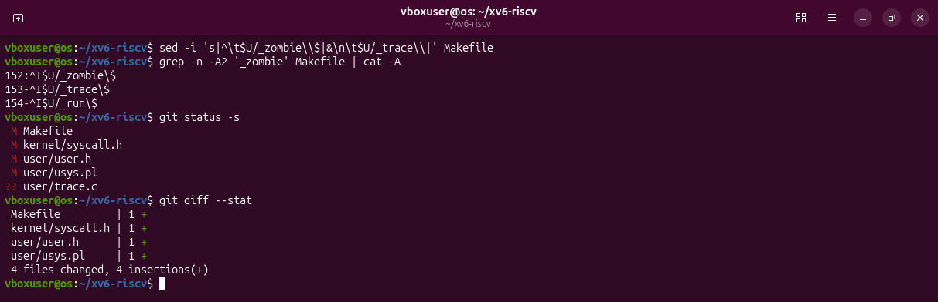
Figure 1.5 – $U/_trace\ added to UPROGS after $U/_zombie\ (^I is the TAB); the five files of Part 1.
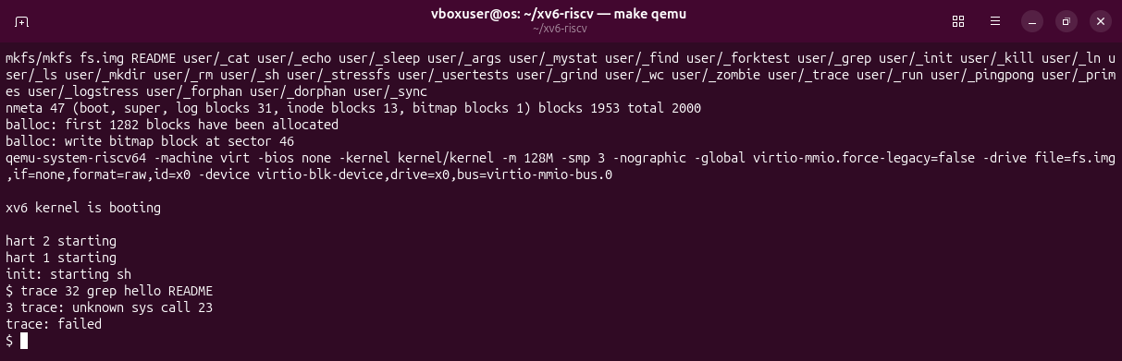
Figure 1.6 – Check 1: ecall arrives in the kernel with 23, but the kernel has no function for it yet.
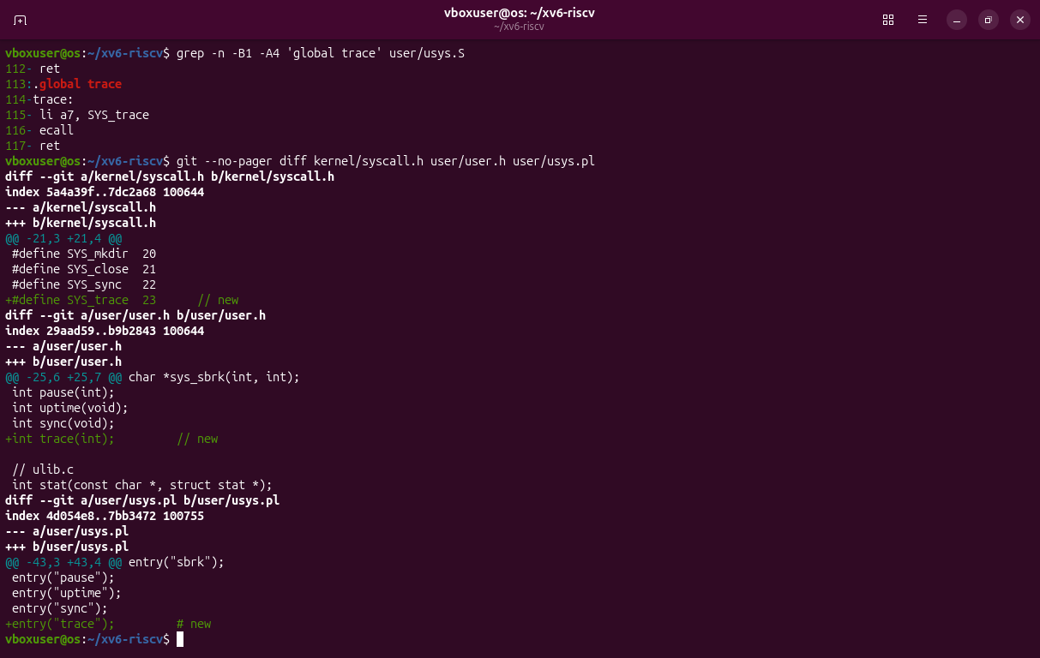
Figure 1.7 – The stub made by usys.pl in user/usys.S (li a7, SYS_trace, ecall, ret) and the three one-line changes.
"3 trace: unknown sys call 23" is printed by syscall() in kernel/syscall.c: process 3, named trace, asked for call 23. The kernel answered -1, so trace printed "trace: failed".

Part 2. The kernel side
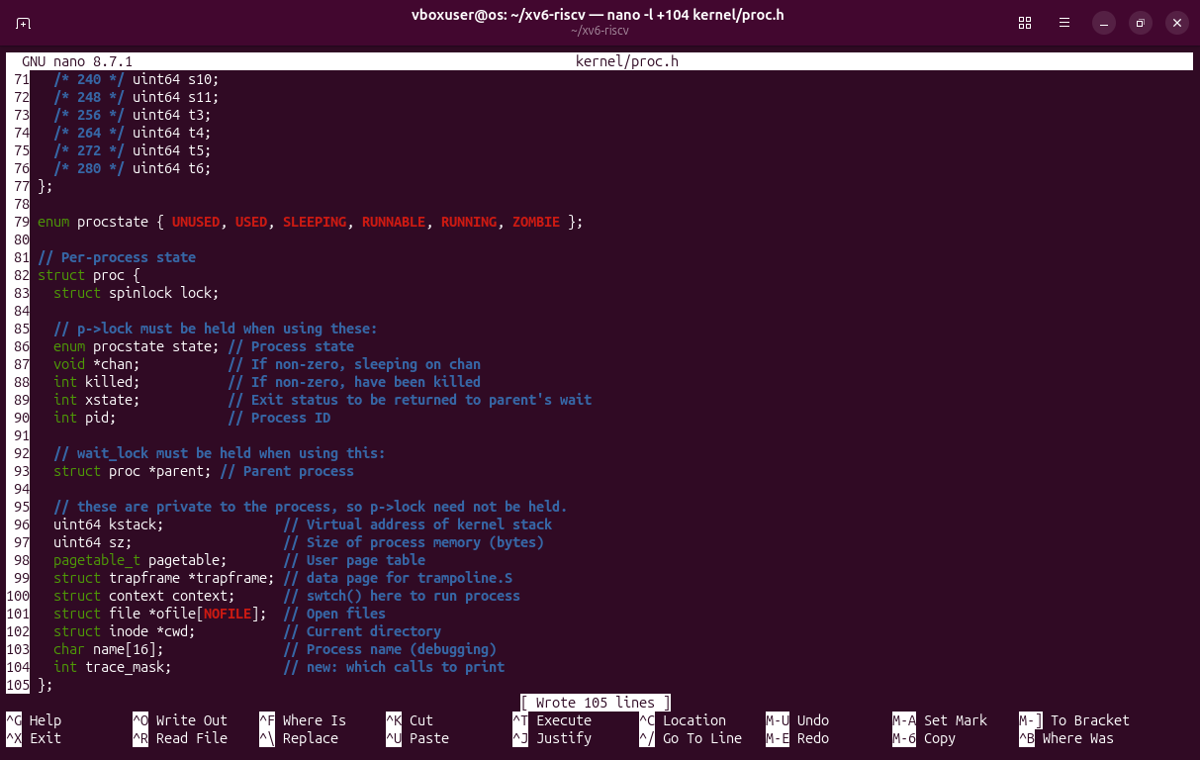
Figure 2.1 – kernel/proc.h: each process keeps its own trace_mask.
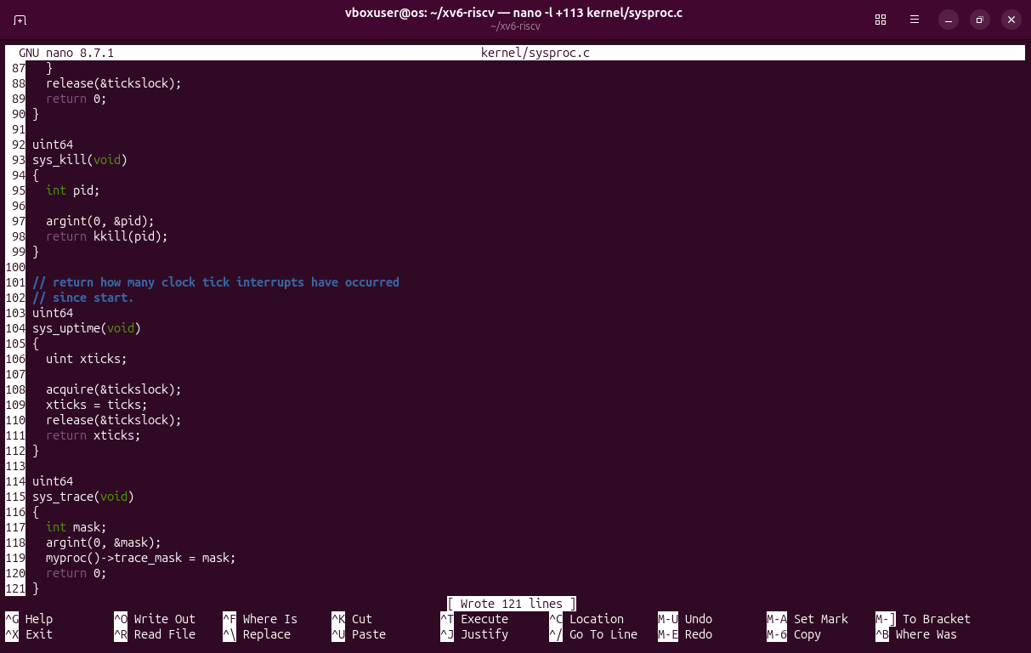
Figure 2.2 – kernel/sysproc.c: sys_trace reads argument 0 (register a0) and stores it in the process.
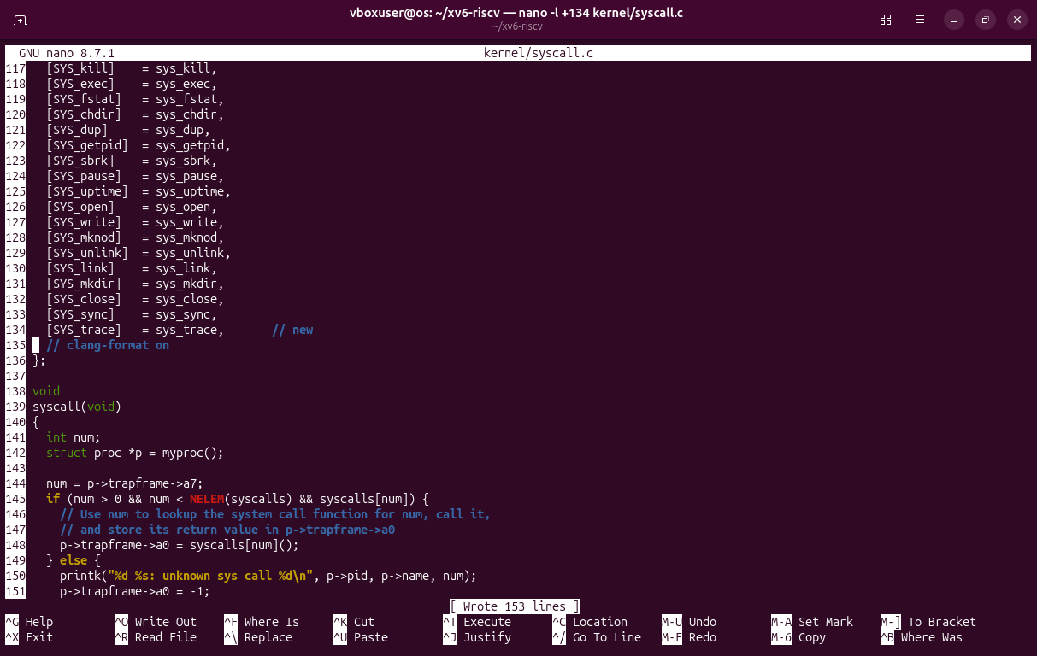
Figure 2.3 – kernel/syscall.c: sys_trace takes place 23 in the table (the extern line is at line 106).
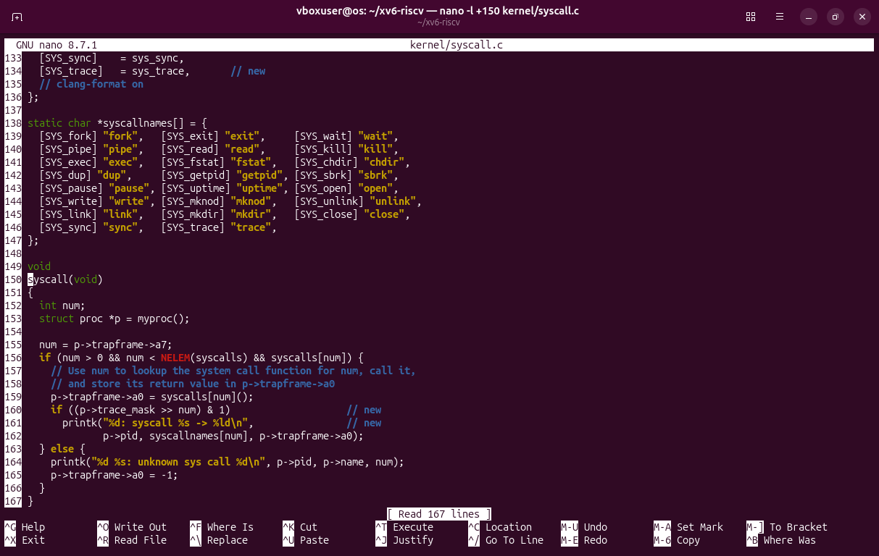
Figure 2.4 – kernel/syscall.c: the names above syscall(), and the two new lines right after the call, when a0 already holds the result.
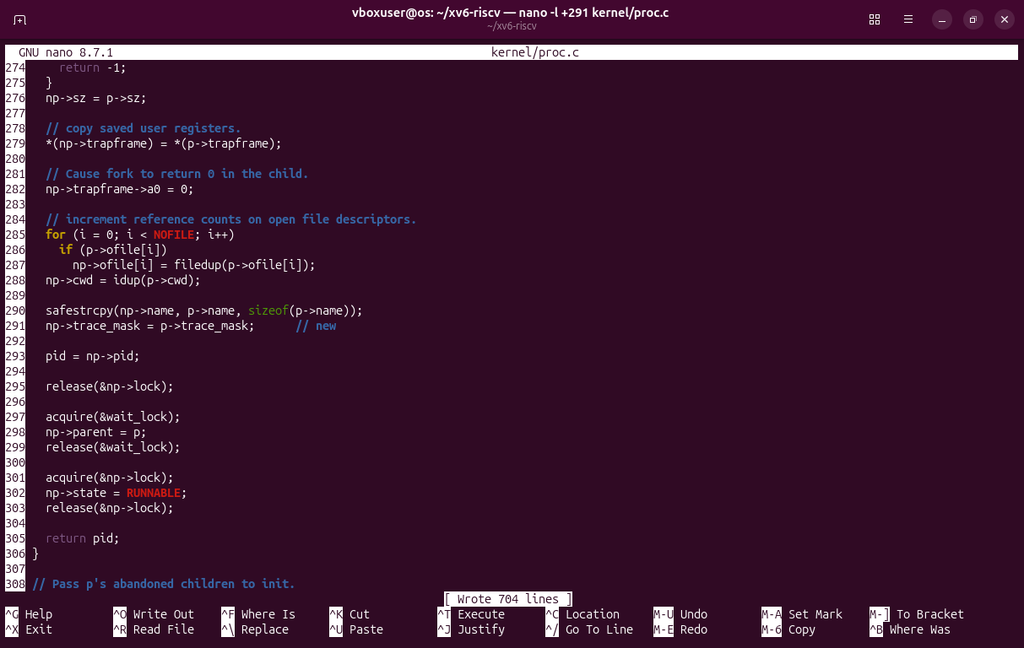
Figure 2.5 – kernel/proc.c: the child copies the mask of its parent. In this xv6 fork() is called kfork().
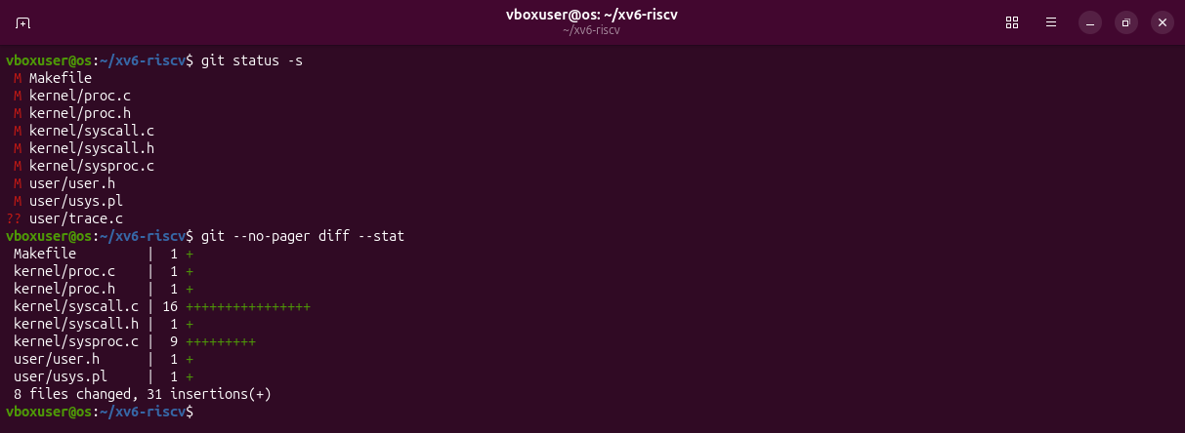
Figure 2.6 – Parts 1 and 2: 8 files changed and the new user/trace.c.
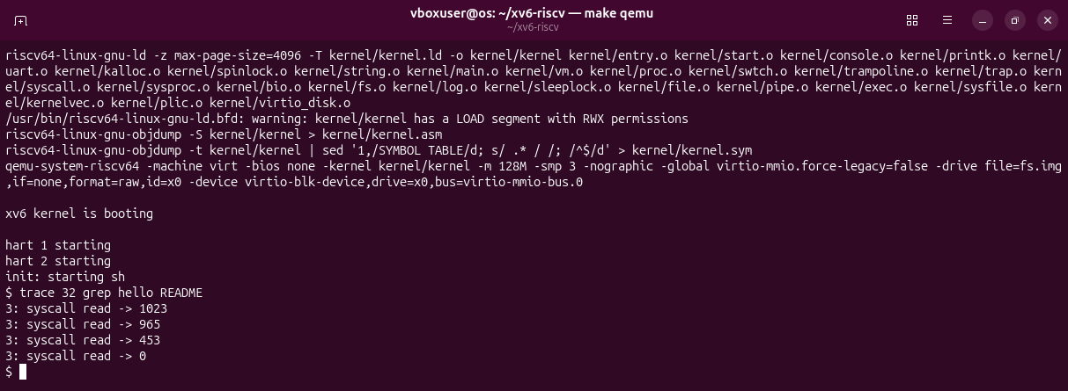
Figure 2.7 – Check 2: exactly the numbers of the sheet, 1023 + 965 + 453 = 2441 bytes, then 0 for the end of the file.

Part 3. Play with the mask
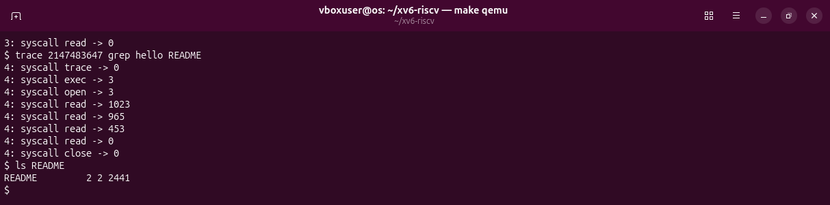
Figure 3.1 – All bits on: grep calls exec, open, read four times and close. ls confirms that README has 2441 bytes.
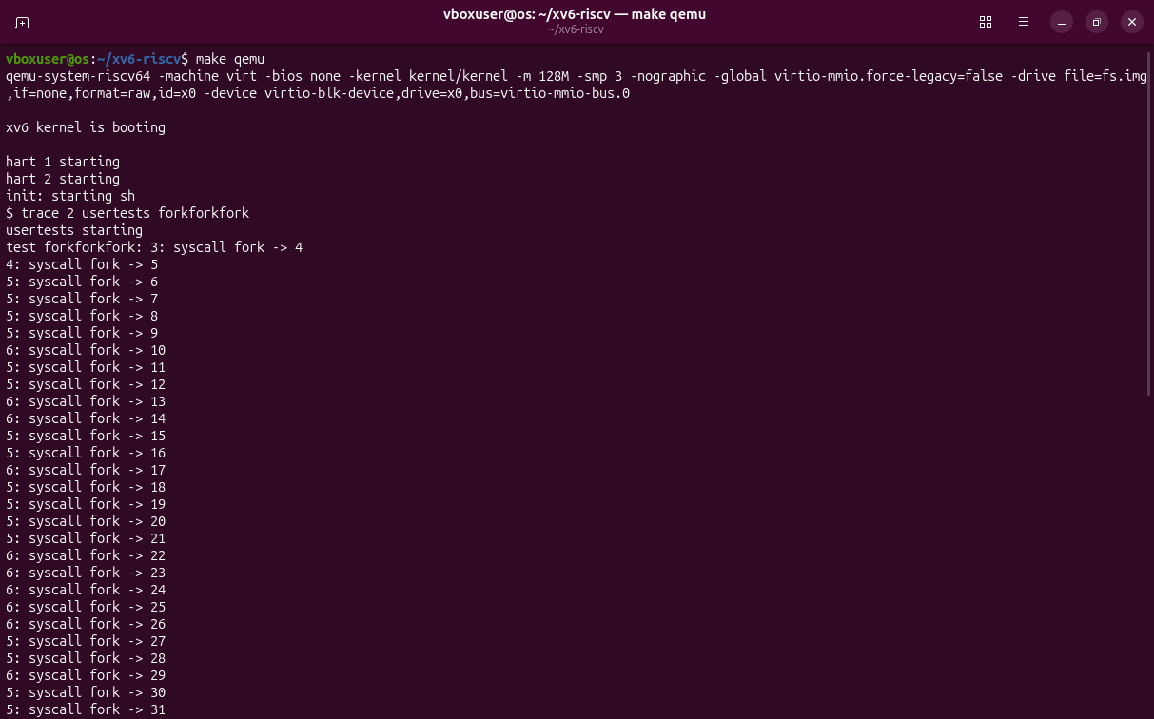
Figure 3.2 – Only fork (mask 2) in usertests forkforkfork: the beginning.
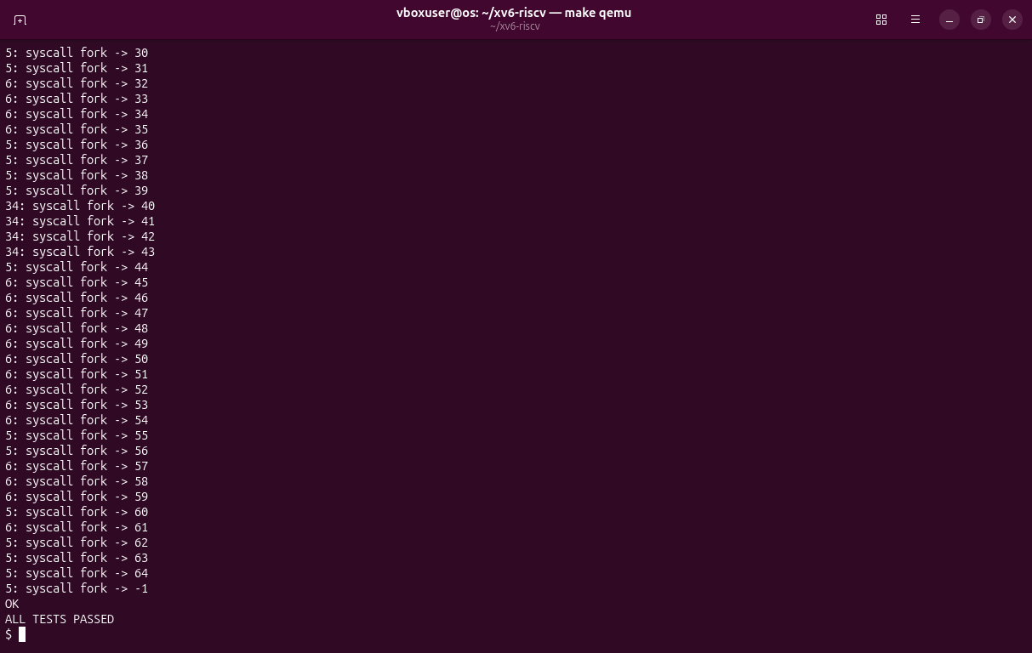
Figure 3.3 – The end: pid 64 is the last one, then fork returns -1 (the process table is full), and the test passes.
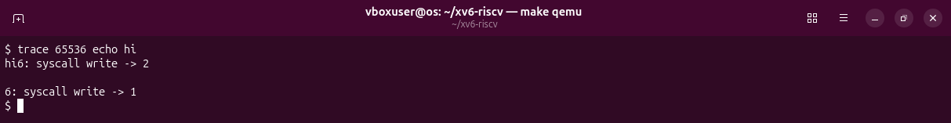
Figure 3.4 – Only write (mask 65536): the trace line lands between "hi" and the new line.
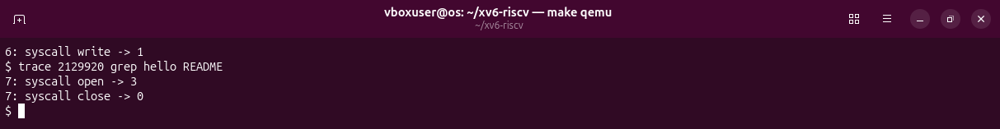
Figure 3.5 – Only open and close: mask 2^15 + 2^21 = 2129920.
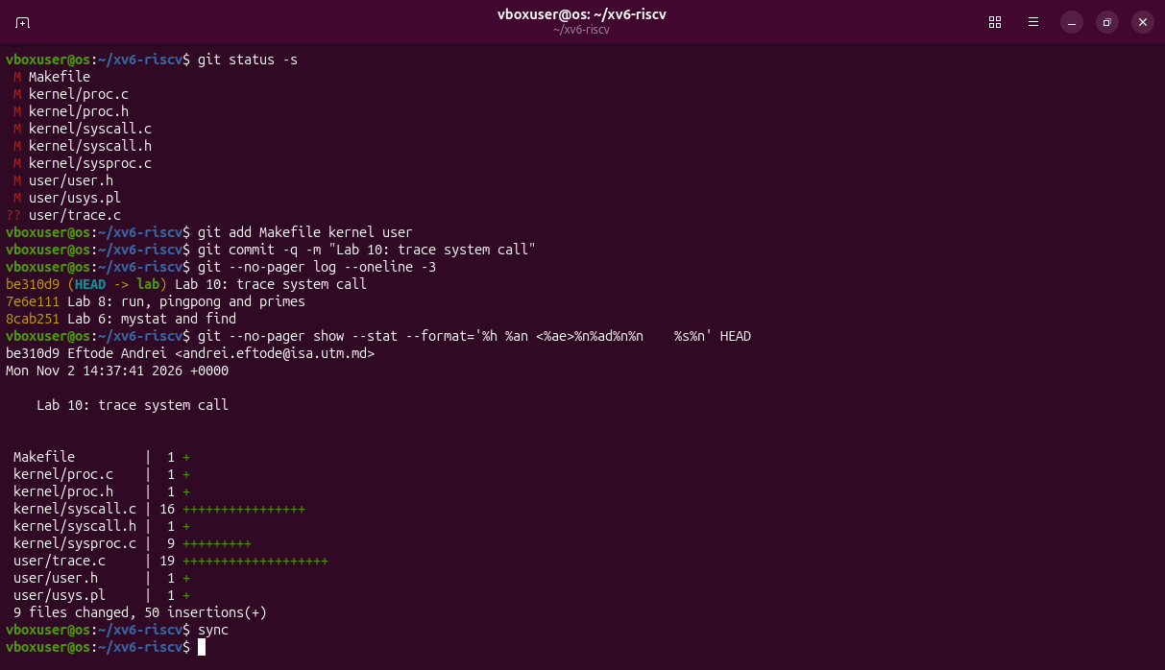
Figure 3.6 – The trace work committed on branch lab, before the long forkforkfork test.
Observations
(1) 32 = 2^5: only bit 5 is on, and 5 is SYS_read. The kernel prints a call only when (p->trace_mask >> num) & 1 is 1; the bits of open (15) and close (21) are 0. Both calls still happen (Figure 3.1).
(2) np->trace_mask = p->trace_mask; in kfork() (Part 2.5). Every child copies its parent's mask, so the forks of the children are traced too: pids 3, 4, 5, 6 and 34 print lines.
(3) echo calls write twice: once for "hi" (2 bytes) and once for "\n" (1 byte). The kernel prints its line right after each write returns, so the first trace line comes after "hi" and before the new line.
(4) 2^15 + 2^21 = 32768 + 2097152 = 2129920. With it, only open -> 3 and close -> 0 are printed (Figure 3.5).

Optional: sysinfo
Number 24 and the same recipe as trace, plus freemem() in kernel/kalloc.c and nproc() in kernel/proc.c. The kernel writes the answer into the caller's memory with copyout.
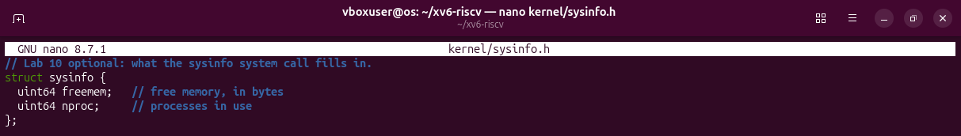
Figure 4.1 – kernel/sysinfo.h: the structure the call fills.
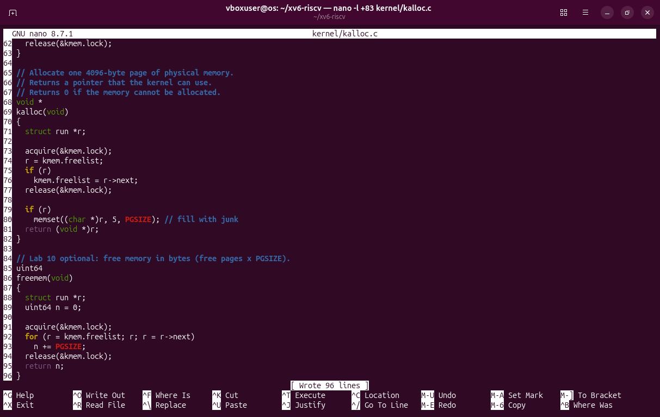
Figure 4.2 – kernel/kalloc.c: freemem() counts the pages on the free list, under the lock.
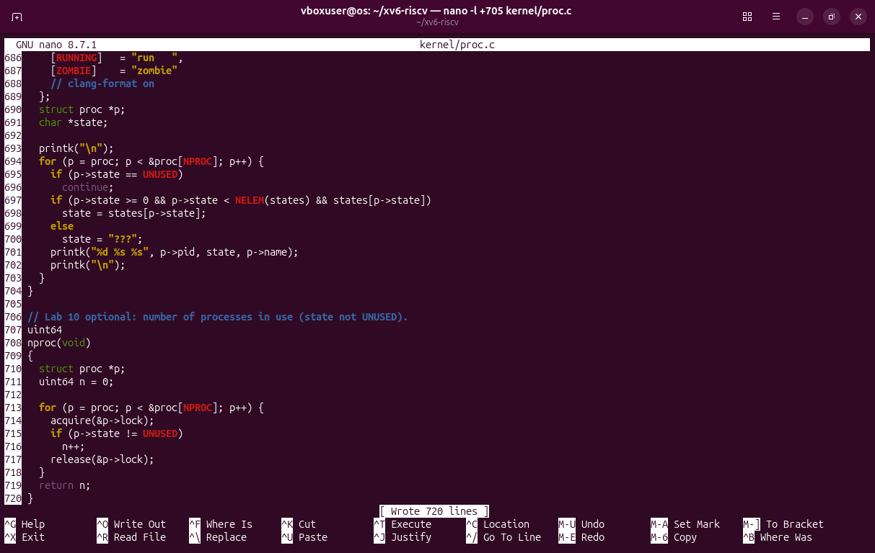
Figure 4.3 – kernel/proc.c: nproc() counts the slots of the process table that are not UNUSED.
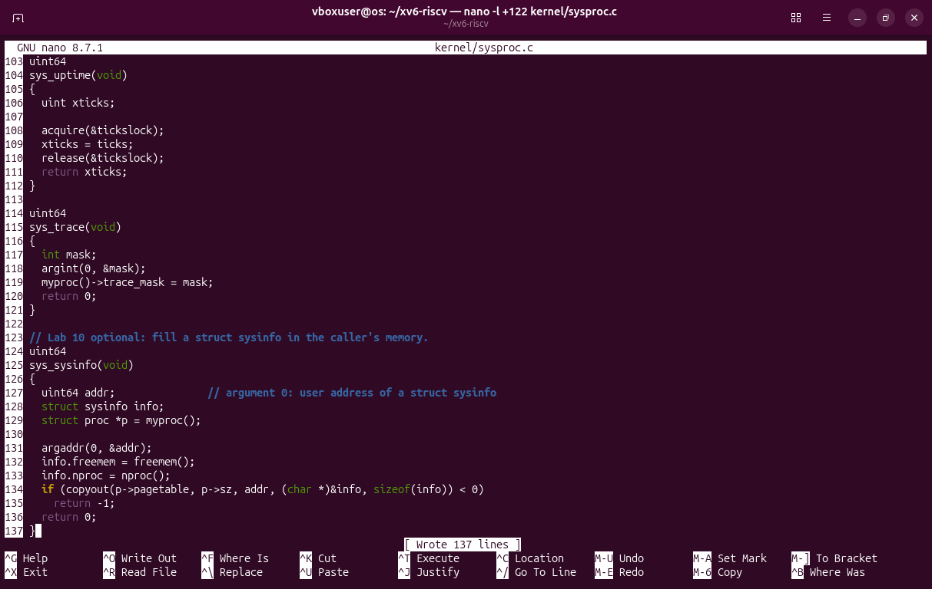
Figure 4.4 – kernel/sysproc.c: sys_sysinfo() fills the structure and copies it to the user address.
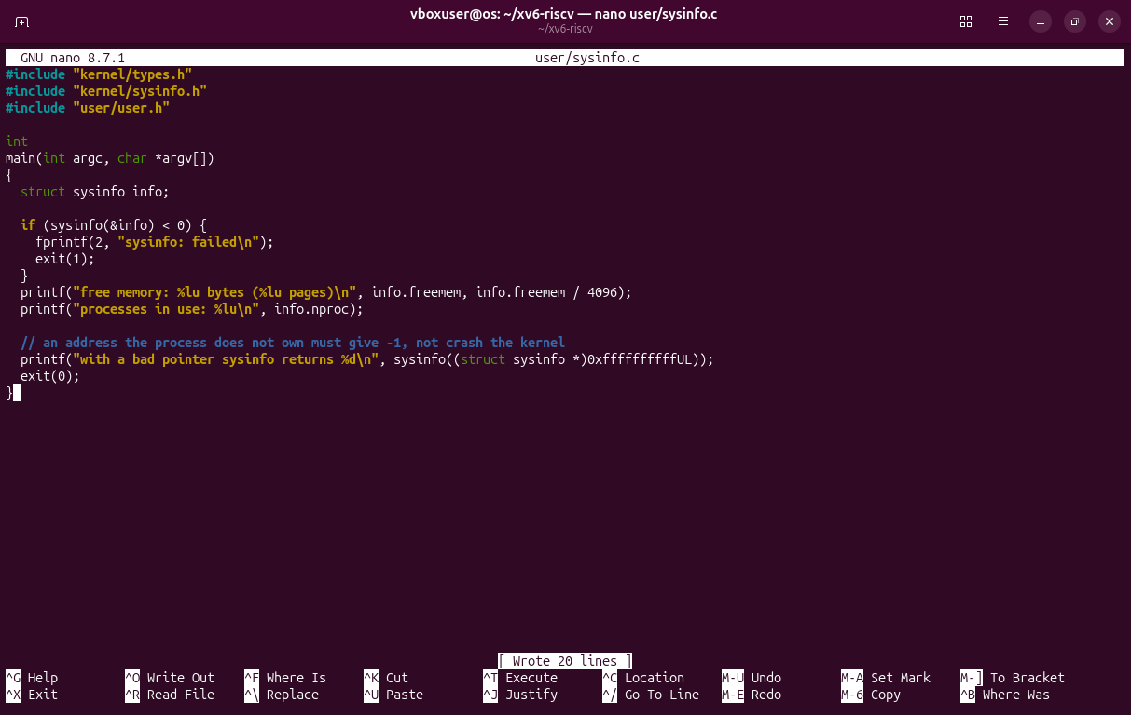
Figure 4.5 – user/sysinfo.c: prints both numbers, then calls sysinfo with a bad pointer.
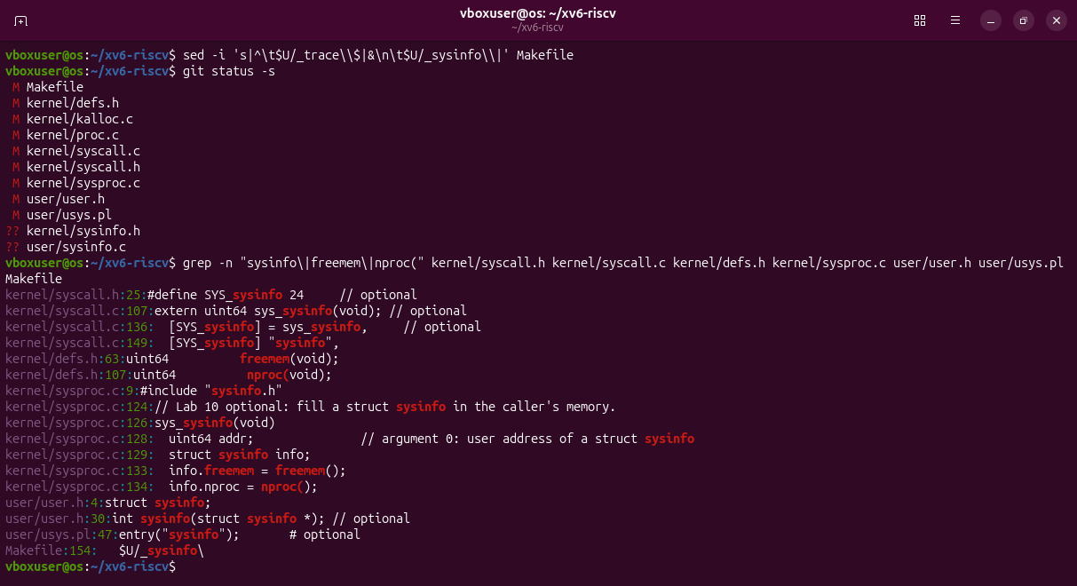
Figure 4.6 – The other lines of the recipe: number 24, extern, table, name, defs.h, user.h, usys.pl, UPROGS.
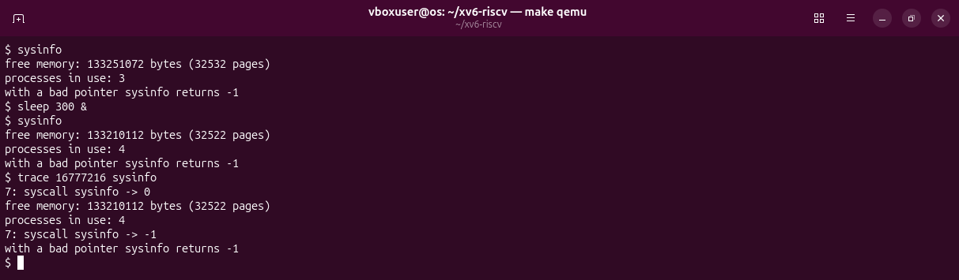
Figure 4.7 – 3 processes (init, sh, sysinfo); with a sleep in the background 4, and 10 free pages less. A bad pointer gives -1; bit 24 traces the call.

Deliverables
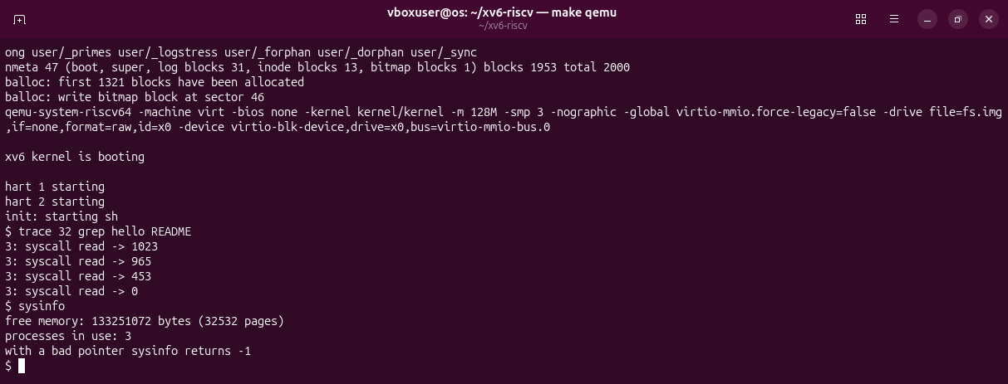
Figure 5.1 – After make clean, a full rebuild: trace and sysinfo both work.
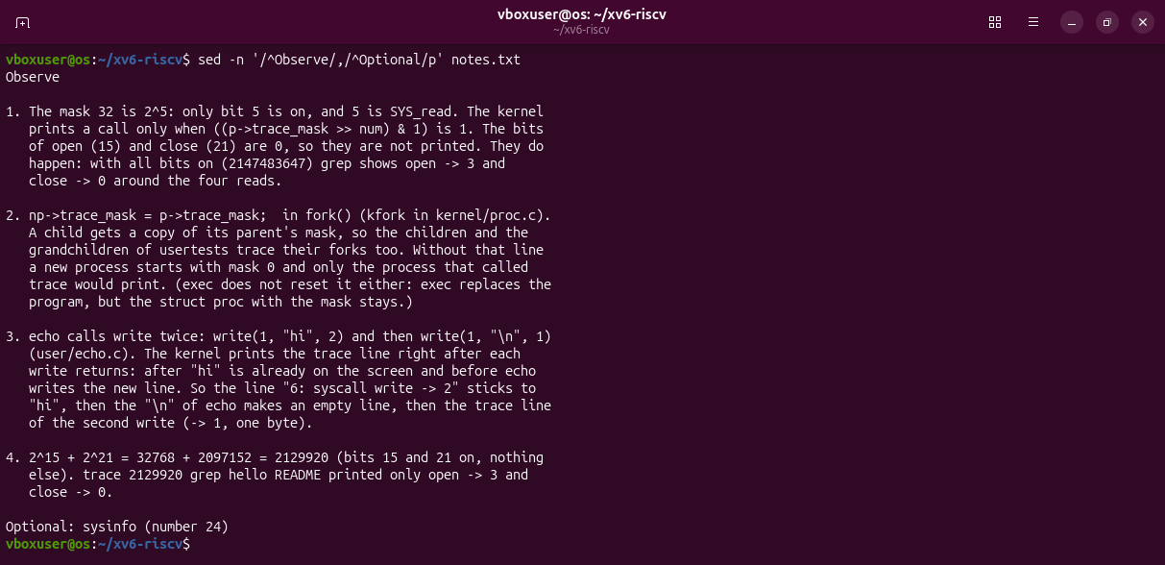
Figure 5.2 – The answers in notes.txt.
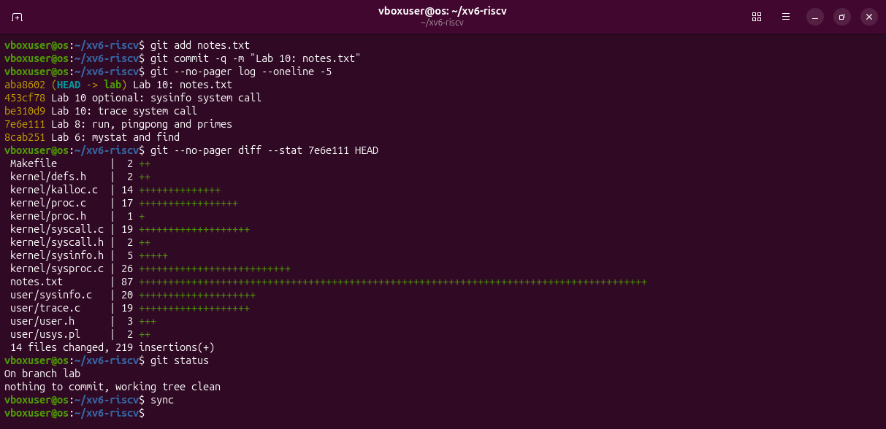
Figure 5.3 – The three Lab 10 commits on branch lab: 14 files, 219 lines added.
Files in the folder lab10/ of the repository: this report, the changed files of the xv6 tree (kernel/, user/, Makefile), lab10.patch, notes.txt and the screenshots.

Conclusions
In this laboratory work I changed the xv6 kernel for the first time: I added the system call trace and, as the optional part, sysinfo. I followed the number 23 along its whole path: the user stub puts it in register a7 and executes ecall, the kernel saves the user registers, finds sys_trace in its table of system calls, and the result returns to the program in register a0. Check 1 showed that the number reached the kernel even before the handler existed, and Check 2 printed exactly the four reads the sheet expects.
Because the mask is kept in struct proc, exec does not reset it and fork copies it, so a single command traces a whole family of processes, as forkforkfork showed. From sysinfo I learned that the kernel must never write directly to an address given by a user program; it uses copyout, which checks the address, so a bad pointer returns -1 instead of crashing the kernel. Building trace inside the kernel made clear what strace did from the outside in Lab 9.

