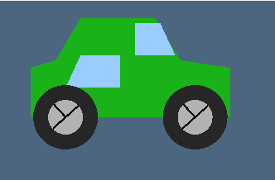
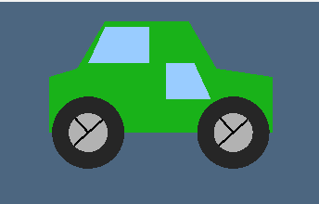
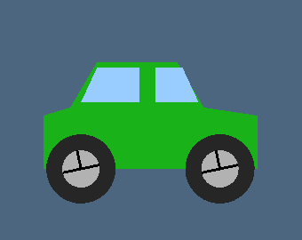
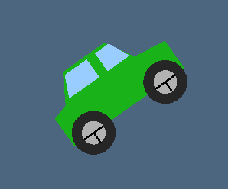
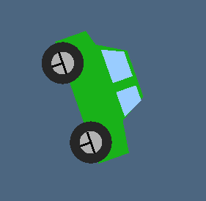
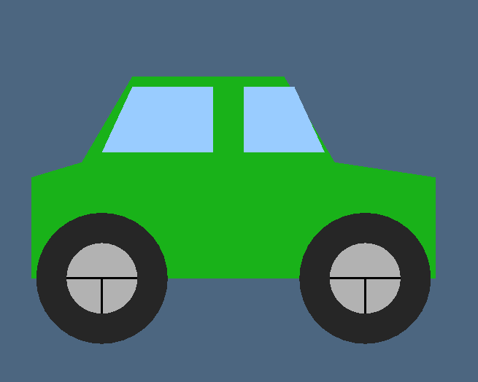
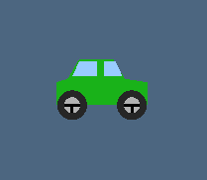
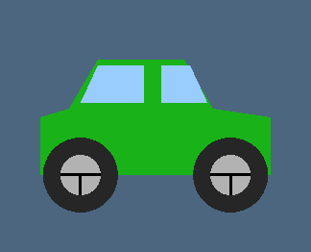
Fig 1.8: Back mirror control.
Fig 1.7: Front mirror control.
Fig 1.6: Wheel rotated.
Fig 1.5: Car rotated.
Fig 1.4: Car rotated.
Fig 1.3: Scale up car.
Fig 1.2: Scale down car.
Fig 1.1: 2D Car.

