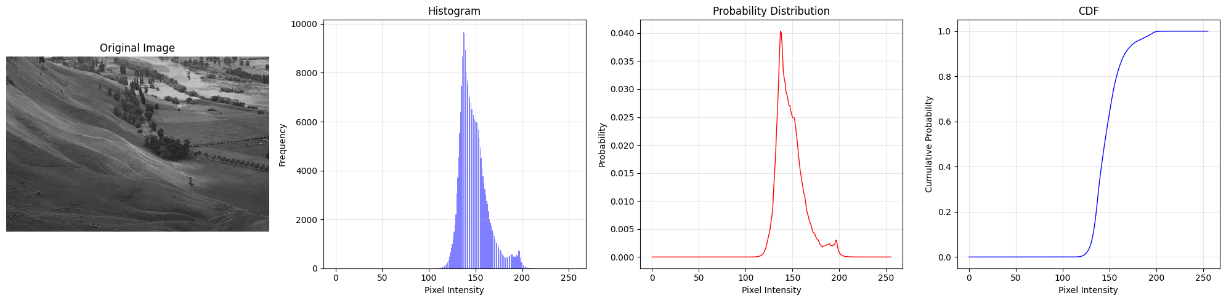
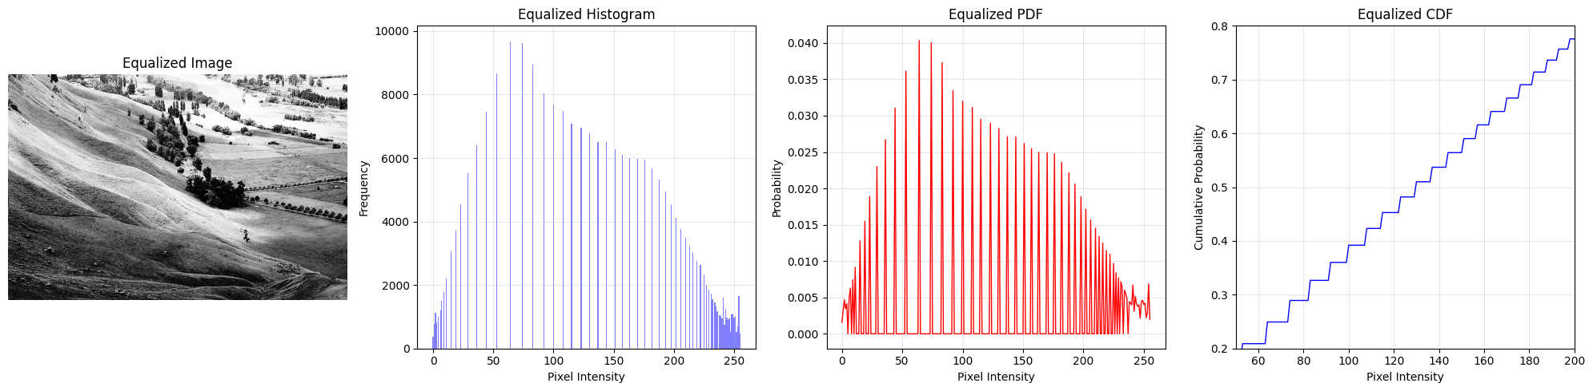
Fig 3.1: Original Image’s Data

Fig 3.2: Equalized Image’s Data

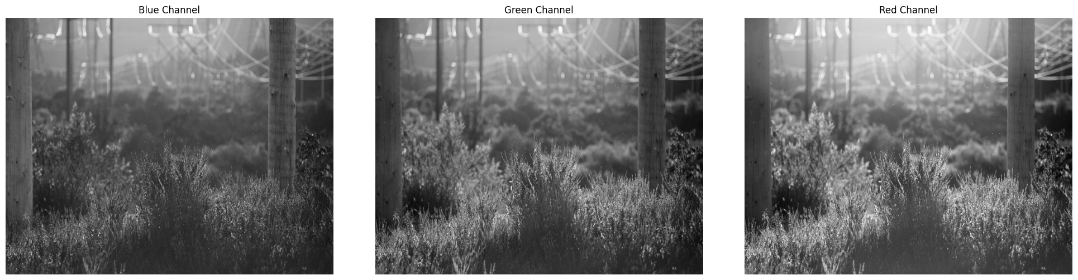
Fig 3.3: B, G, R Channel Split
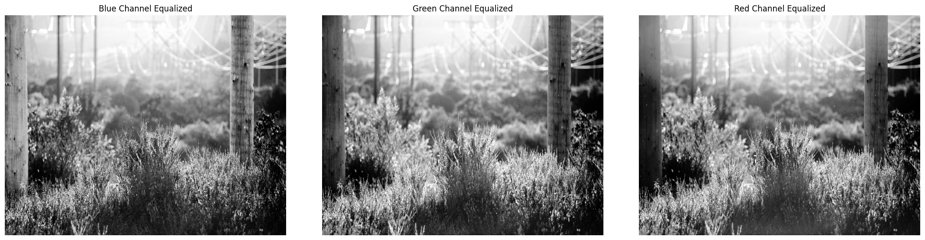
Fig 3.4: B, G, R Channel Equalized
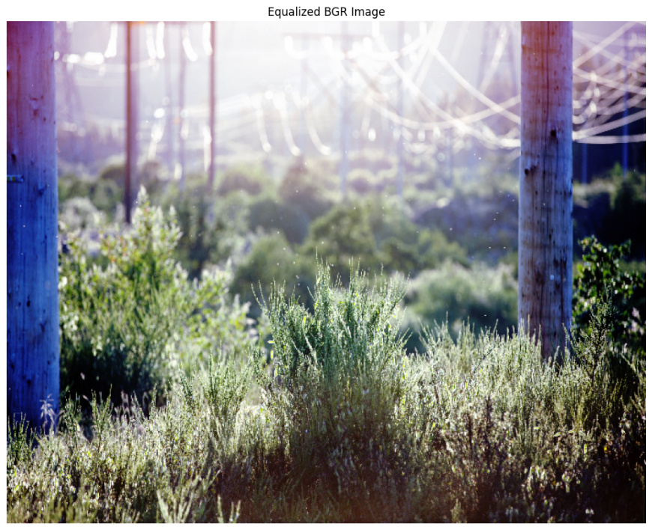

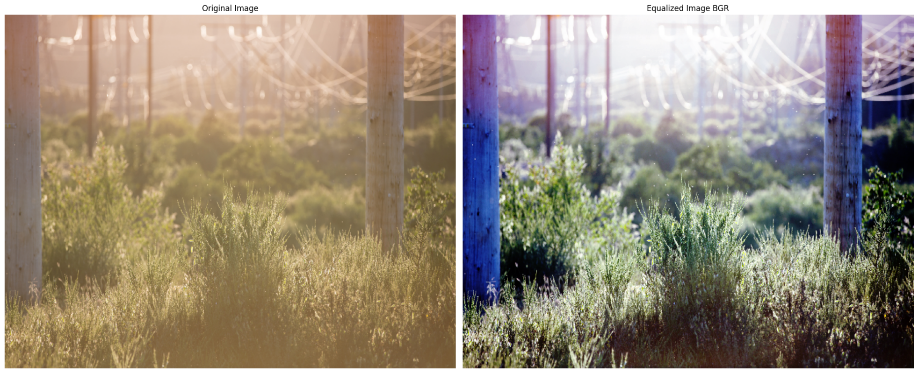
Fig 3.5: B, G, R Channel Equalized Merged

Fig 3.6: Original image vs BGR Equalized image
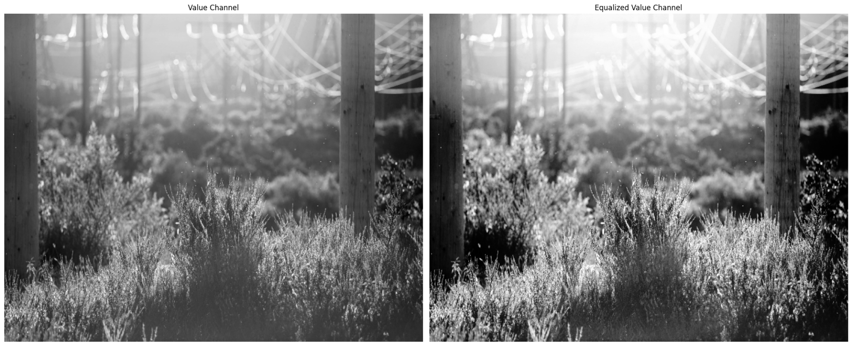
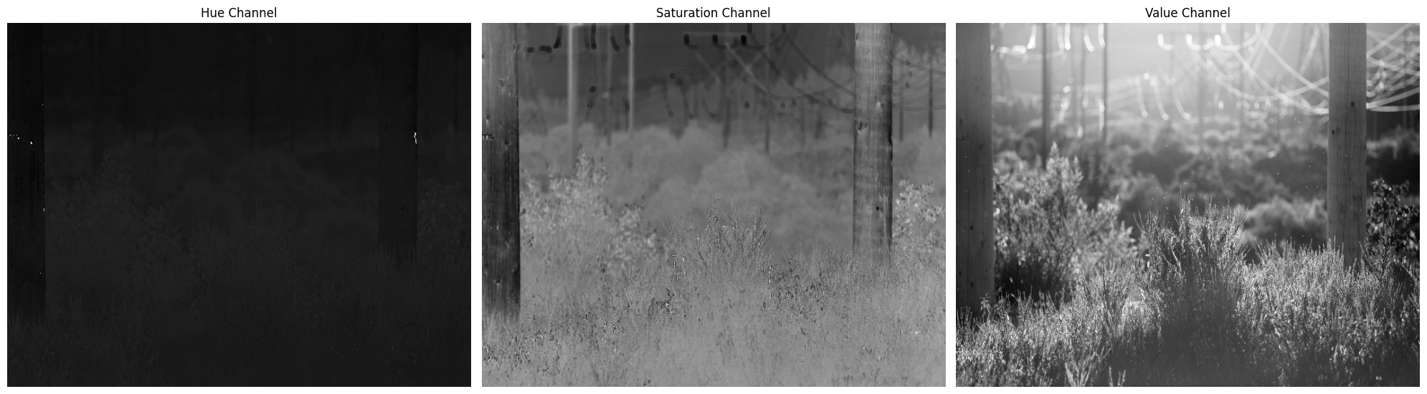
Fig 3.7: HSV Channel Split

Fig 3.8: Original Value Channel vs Equalized Value Channel
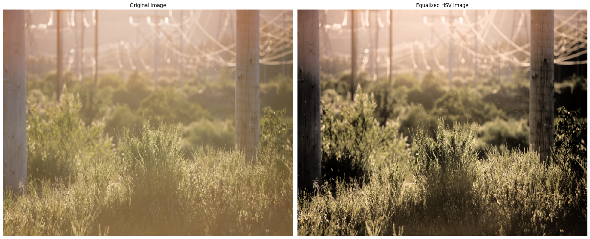
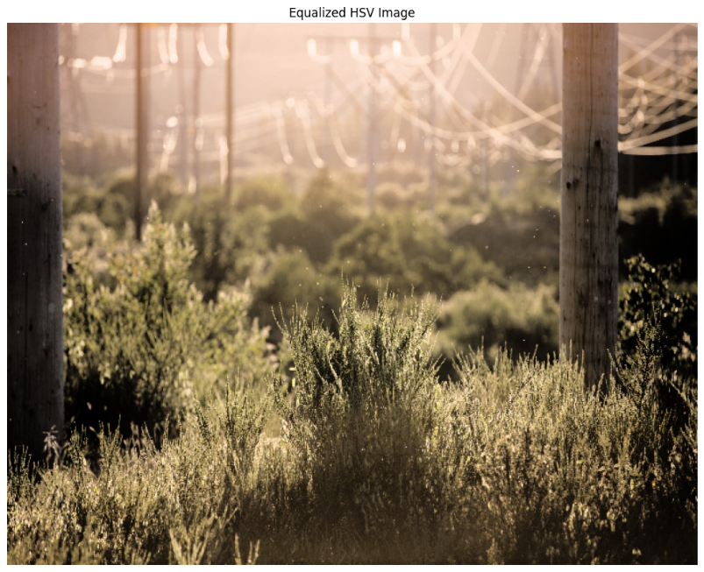

Fig 3.9: Equalized HSV image

Fig 3.10: Original image vs Equalized HSV image

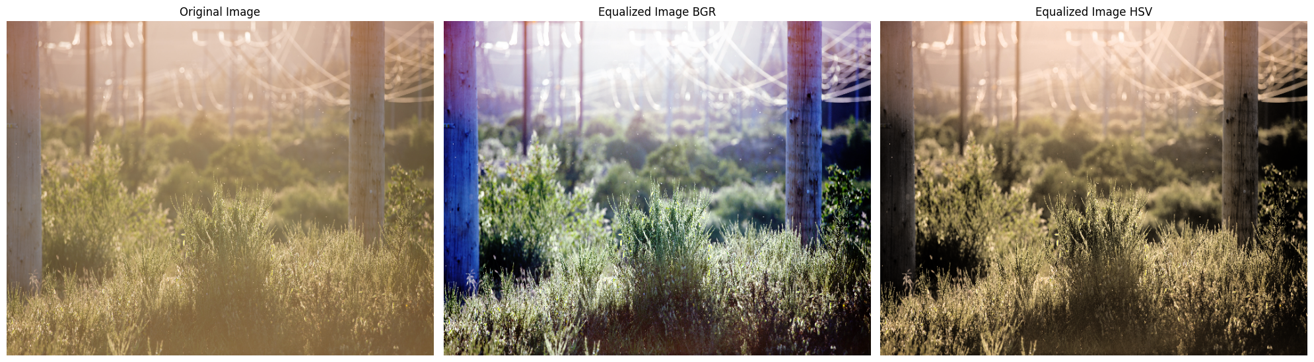

Fig 3.11: Original image vs Equalized BGR image vs Equalized HSV image

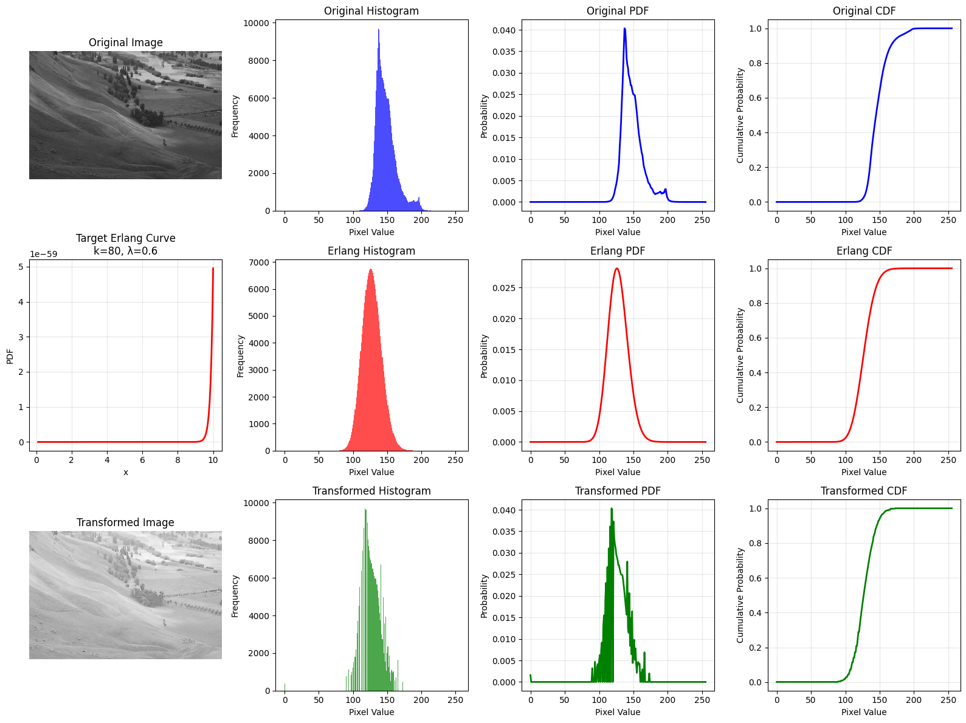
Fig 3.12: Original Image, Target(Erlang) Histogram, Transformed Image

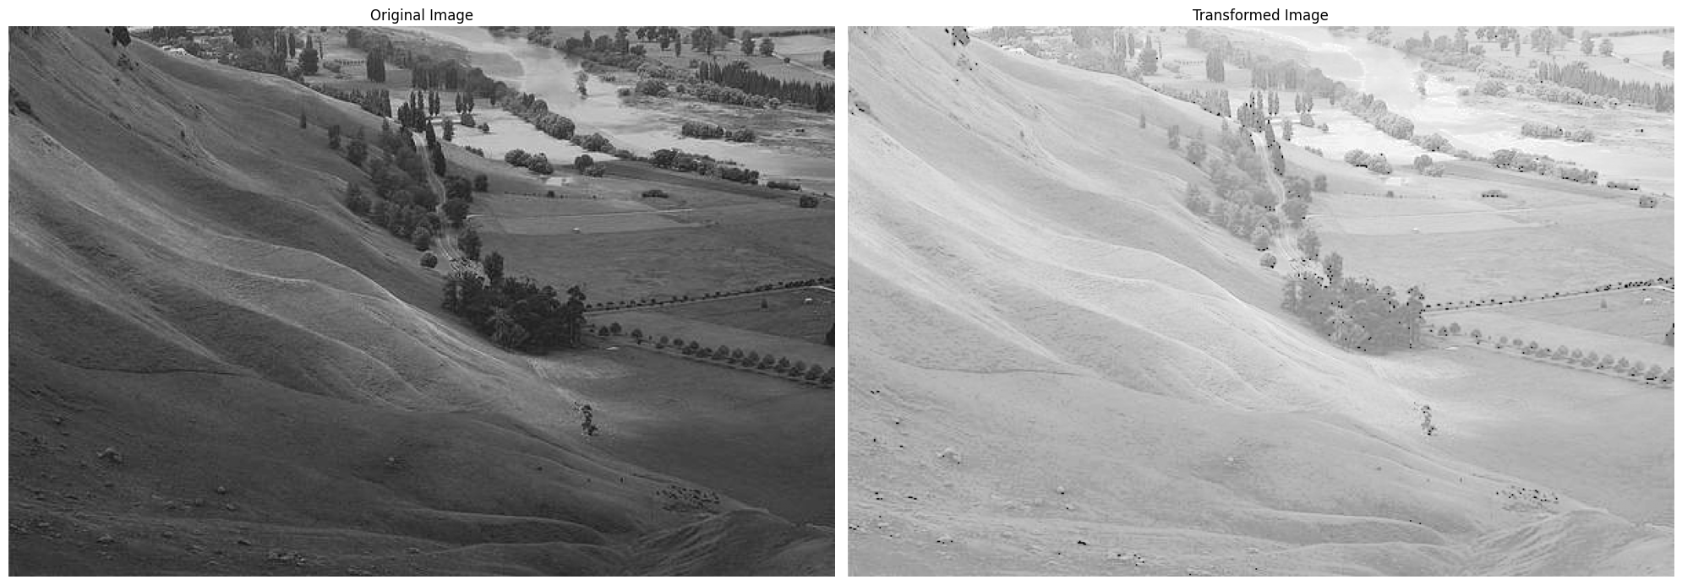
Fig 3.13: Original Image vs Target (Erlang) Histogram Image

