
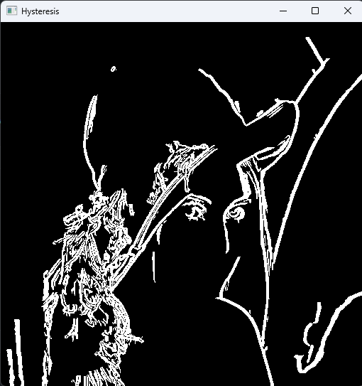

Fig 2.7: Canny Edge Detector
Fig 2.5: Double Thresholding
Fig 2.6: Hysteresis Thresholding

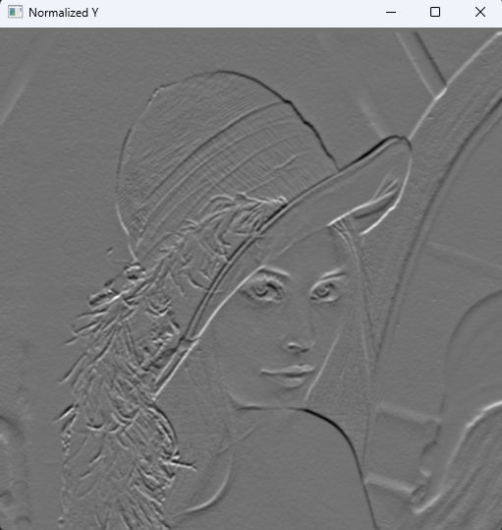
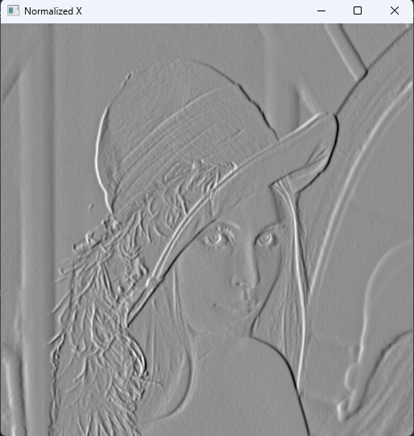

Fig 2.4: Gradient Normalized Image.
Fig 2.3: Gaussian Y Derivative kernel
Fig 2.2: Gaussian X Derivative kernel
Fig 2.1: Original Image

