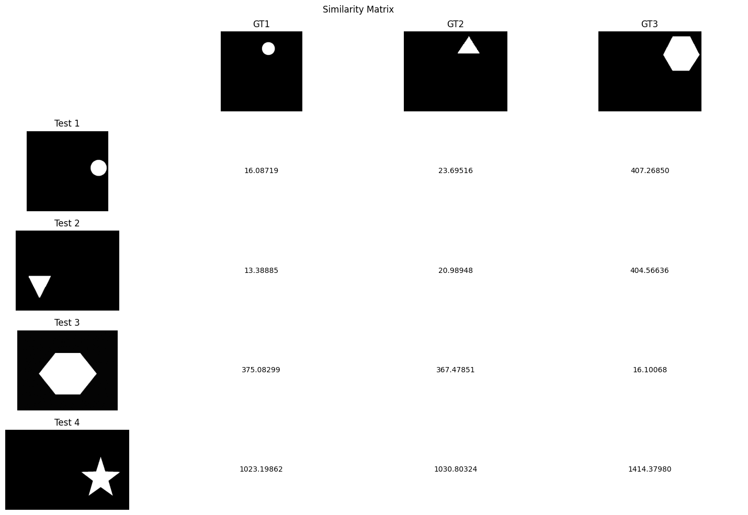

Fig 4.1: Train Image vs Test Image Similarity Matrix
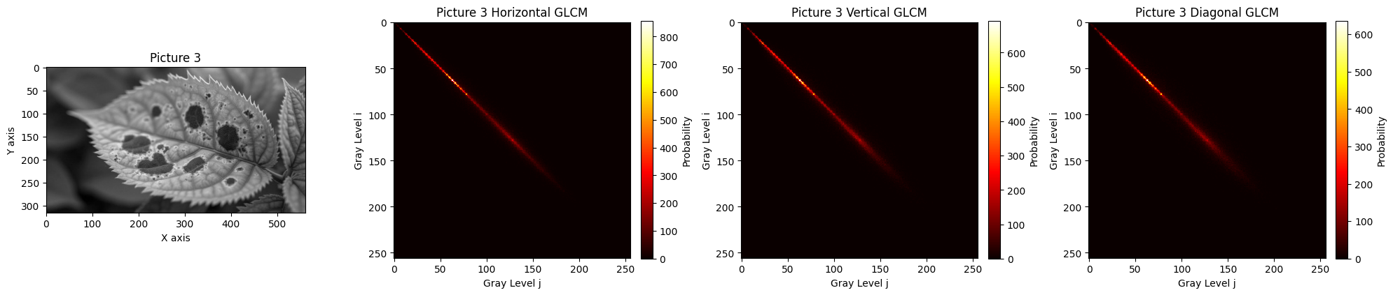
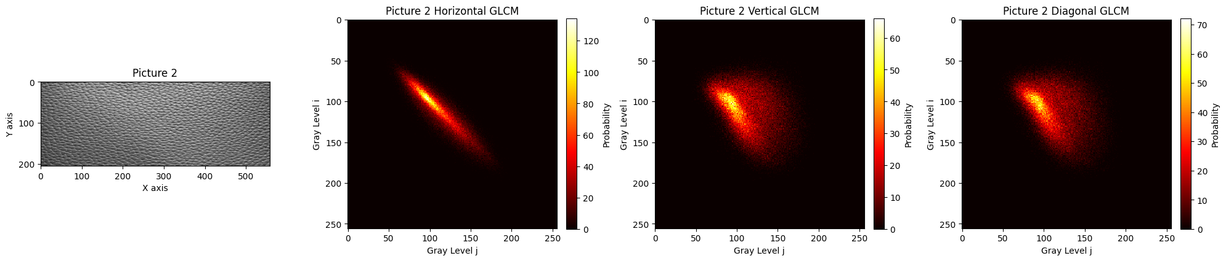
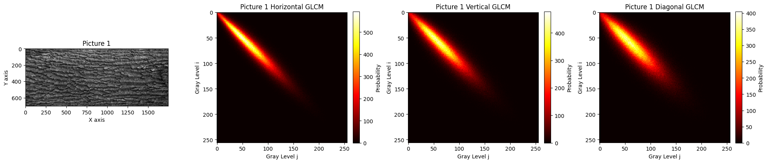

Fig 4.2: Picture 1 GLCM matrix.

Fig 4.3: Picture 2 GLCM matrix.
Fig 4.4: Picture 3 GLCM matrix.

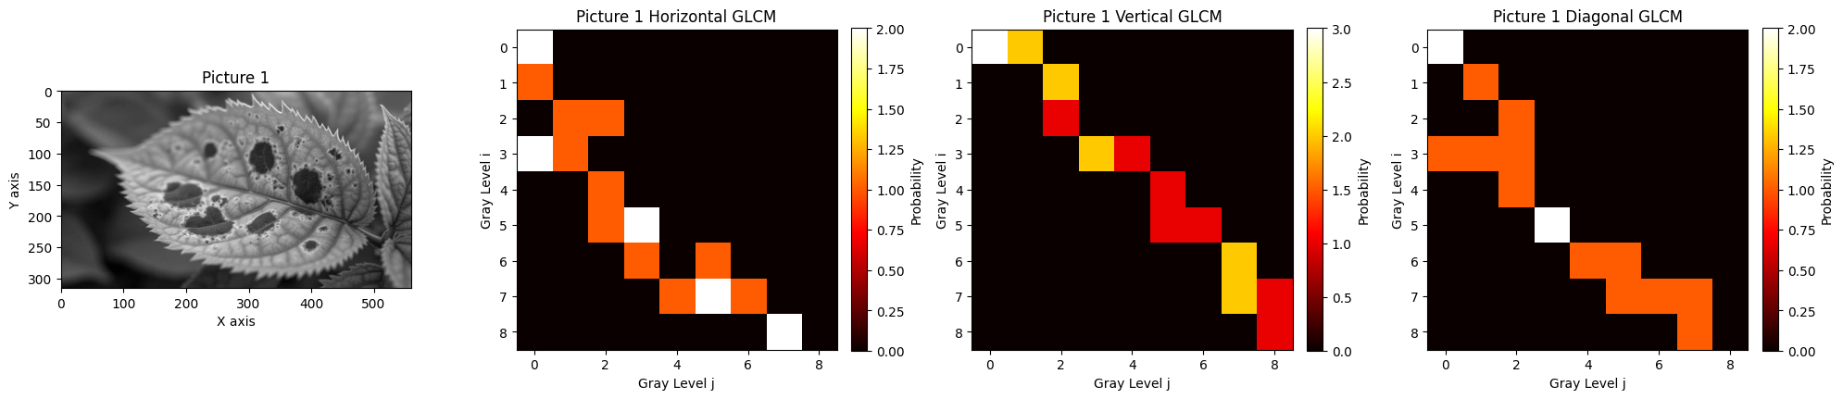

Fig 4.5: 5x5 patch GLCM matrix.

