Music Feature Lab spectral brightness control and analysis
  - ELEC5305 | Zihang Wang | SID 560746563 | 3 November 2026

Project overview
Music Feature Lab is an integrated MATLAB App for processing and analyzing existing audio. A nine-level DSP sweep increased centroid and high-frequency ratio at every step for one calibration recording. Reanalysis of 15 retained Dark, Neutral and Bright recordings did not establish a consistent three-level ordering. This report explains the theory, implementation, measurements and limits behind those findings. Its contribution is an inspectable engineering workflow and a bounded feasibility evaluation. It does not demonstrate model-internal music generation control or perceptually equal brightness steps.

Contents
1 Introduction and contribution 2
2 Literature review and theoretical context 2
3 Methodology 4
4 Implementation and verification 5
5 Results 6
6 Discussion 8
7 Limitations 10
8 Conclusion 11
9 Reproduction and references 12
AI assistance statement 12
The executed Live Script and its code-and-output PDF are supplied as a reproducible supplement. The application, audio, source and result files are included in the same submission folder.

1 Introduction and contribution
Informal requests such as making music brighter need an operational definition before they can be evaluated. A control can change a spectrum predictably while leaving unanswered whether listeners hear the intended difference. This project connects an explicit signal operation with several acoustic measurements, then uses the same analysis to examine recordings that already carry brightness labels. Keeping these questions separate makes both the positive calibration result and the negative library result interpretable.
The starting proposal concerned controllable music generation based on musical features. The delivered scope is narrower: post-generation analysis and DSP control of existing recordings, with an FM demonstration. The App does not call a generative model. It therefore evaluates an acoustic inspection and processing workflow rather than the original ambition of direct generation control. Caclin et al. [1] and Kazazis et al. [2, 3] provide perceptual context, but this project collects no listener data.
RQ1 asks whether the implemented brightness parameter produces monotonically increasing centroid and high-frequency ratio for a fixed source. RQ2 asks whether the retained library exhibits Dark < Neutral < Bright under those measurements. A separate engineering aim is to make processing, analysis, audition and export accessible through one App and one shared analysis implementation. These questions can be answered from the available files without reconstructing missing generation histories.

1.1 Personal contribution and scope
I selected the topic and ran the original audio generation. I wrote the original MATLAB implementation myself after asking AI for explanations and guidance. Experimental design was AI-assisted, and AI helped summarize and analyze the results. OpenAI Codex subsequently helped develop and integrate the revised App and shared code, run verification, organize references and draft and revise the report. These roles are disclosed so that the engineering output is not presented as entirely unaided work.
The project contribution is a unified workflow, a documented calibration and a reproducible assessment of the retained recordings. It does not introduce a new theory of timbre, establish a general result about a named generator, or claim that integrating existing methods alone proves research novelty. The retained original code and audio are the starting materials; the packaged code represents the later integrated implementation.

2 Literature review and theoretical context

2.1 Multidimensional timbre models
Caclin et al. [1] used controlled synthetic tones and listener dissimilarity judgments to study spectral and temporal contributions to timbre. Their results support the relevance of attack time, centroid and spectral fine structure; spectral flux was less salient and context dependent. They compared CLASCAL, which estimates a perceptual space with listener classes, with CONSCAL, which constrains dimensions using known acoustic variables. The latter can describe psychophysical mappings more economically, but requires defensible choices of physical dimensions.
For this project, those models motivate displaying several descriptors and their trajectories. Neither model is fitted here because no dissimilarity judgments were collected. Measuring positive spectral flux is also not equivalent to reproducing the paper's stimulus manipulation. A dashboard of acoustic features must not be interpreted as a fitted timbre space.

2.2 Ordering and perceptual distance
Kazazis et al. [2] examined ordinal judgments using synthesized stimuli with spectral features controlled as independently as possible. Listeners generally ordered appropriately spaced values, with exceptions explained in relation to stimulus conditions. The paper also identifies a problem with spectral-tilt manipulations: changing slope can simultaneously move centroid, spread and skewness. An apparent centroid effect need not isolate centroid as the listener's only cue.
This distinction motivates an ordering question for the library and simultaneous measurement of several features. The present sweep intentionally changes correlated spectral properties; it is a calibration of an implemented operation, not an experiment that isolates independent perceptual dimensions. The library's filename labels provide a proposed order to test, not listener judgments to fit.
Kazazis et al. [3] extended descriptor evaluation to interval and ratio scales using listener partition tasks and fitted psychophysical functions. Their controlled-stimulus results distinguish a physical increase from an equal perceived interval. The fitted centroid relationship was nonlinear. Their spectral-slope stimuli and units also differ from the full-band dB/Hz regression used here.
Consequently, equal increments in this App's parameter cannot be described as equal perceptual brightness steps. Published scales cannot simply be transplanted to these polyphonic recordings. A future perceptual interface would need a matching stimulus/task validation rather than a change of slider labels alone.
Table 1. Contrasting models and evidence requirements.
Approach | Strength and assumption | Implication here
Physical descriptors | Explicit, reproducible signal summaries; definition and averaging dependent | Measure the processing and the library; do not infer listener ratings
CLASCAL and CONSCAL [1] | Listener distances; flexible latent structure versus constraints on known acoustic dimensions | No fitted timbre space without perceptual data
Ordinal scaling [2] | Tests order under controlled stimulus conditions; does not establish equal intervals | Tests an acoustic order here, not a listener order
Interval and ratio scaling [3] | Fits perceptual spacing for the tested stimuli and tasks | No validated perceptually uniform slider

2.3 Synthesis and methodological rationale
These approaches address different evidence: physical descriptors measure signals; multidimensional scaling models listener distances; ordinal tasks test order; interval and ratio tasks investigate perceptual spacing. Table 1 compares their assumptions and consequences for this project. Their distinction supplies a rationale for the two experiments: first verify the signal operation with a fixed source, then examine whether existing semantic labels survive a common acoustic analysis.
The practical gap is specific to this implementation and dataset. The cited studies do not validate this FFT control, the 4 kHz ratio or the retained recordings. Accordingly, the project tests reproducible acoustic behavior before proposing any perceptual or generative claim. This is a feasibility contribution within an established field, not evidence that the field lacks interactive audio tools.

3 Methodology

3.1 Sources and comparison units
The calibration source is demo.wav, copied from the original test.wav. The library contains all 15 retained files, with five per condition and filename seeds 12315, 12325, 12335, 12345 and 12355. Table 2 gives the material properties. No new AI audio was generated during the integrated evaluation. I ran the original generation, but a complete request manifest was not retained. The available Python script records one Dark/12315 request to a local Gradio service; it cannot establish all prompts, settings, model checkpoints or successful requests.
The two experiments have different comparison units. In the sweep, the same recording is processed at b = -1, -0.75, ..., +1; these are nine deterministic settings, not nine independent subjects. In the library, each file contributes one feature summary. Filename seeds support a descriptive paired display, but do not verify controlled generation or independent sampling. Mean and sample SD use n = 5 files per condition. No p-values or population confidence intervals are reported.
Table 2. Retained audio used in the two experiments.
Experiment | Files | Duration per file | Rate | Channels
DSP calibration | 1 | 91.951 s | 44.1 kHz | 2
Retained library | 15 | 29.907 s | 48 kHz | 2

3.2 Analysis definitions
Playback, processing and WAV export retain the channels. Analysis uses their arithmetic mean. A symmetric Hamming window of nominal length 20 ms and a nominal 4 ms hop feed a next-power-of-two FFT. Table 3 records the actual sample counts and frequency-grid spacing. Zero padding refines the sampled grid; it does not establish independent frequency resolution. Short clips are padded to one frame; otherwise only complete frames are analyzed, leaving less than one hop at the end. RMS uses the complete mono recording.
Let A(k,m) be the normalized single-sided amplitude at frequency f(k) in frame m. The centroid and HF ratio are defined below. Bandwidth is the corresponding amplitude-weighted standard deviation. Reported centroid, bandwidth, HF ratio and slope are arithmetic means over active frames, rather than energy-weighted whole-recording statistics. A frame is active when its unwindowed RMS exceeds the larger of 1e-12 and 1e-6 times the maximum frame RMS. This low threshold removes near silence, not all quiet tails or noise.
The HF boundary includes bins at or above 4000 Hz. Spectral slope fits 20 log10 amplitude against frequency in Hz across the full single-sided spectrum, using a floor 240 dB below each frame's peak amplitude. Its sign and units must be retained. The centroid uses amplitude weights, whereas the default time-domain MATLAB spectralCentroid calculation uses power weights [4]. The custom implementation is not claimed to reproduce that default. Feature definitions and averaging rules therefore matter when comparing studies or software.
$$C_{m} = \frac{∑_{k}f_{k}A_{k,m}}{∑_{k}A_{k,m}} H_{m} = \frac{∑_{f(k) ≥ 4000 Hz}{A(k,m)}^{2}}{∑_{k}{A(k,m)}^{2}}$$
Table 3. Analysis sample counts and frequency grids.
Sample rate | Window L | Hop R | FFT N | Grid spacing
44,100 Hz | 882 | 176 | 1024 | 43.0664 Hz
48,000 Hz | 960 | 192 | 1024 | 46.8750 Hz

Positive spectral flux sums positive changes in consecutive amplitude spectra. The onset rule uses mean flux plus 1.5 sample SD, local maxima and at least 50 ms separation. These are descriptive event counts, not validated tempo. Pitch is disabled in the main results. The optional pitch function estimates local fundamental frequency and needs cautious interpretation for mixtures [5]. Display arrays are reduced for memory, while all analysis frames contribute to summaries.

3.3 Processing and analytical expectation
The processor multiplies each channel's whole-recording FFT by a real gain with matching values at conjugate frequencies. The folded frequency q(k) and gain G(b,k) are defined below. The nominal gain reaches 6b dB at Nyquist. After the inverse FFT, uniform scaling is applied only if a peak exceeds 1; descriptors are recomputed from that output. Uniform positive scaling cancels from normalized centroid and HF ratios. Zero b preserves an input already within range.
For a simplified static spectrum with frequency f, the gain has the form exp(kappa b f), with kappa = 6 ln(10)/(20 fN). Differentiating its amplitude-weighted centroid gives dC/db = kappa Var_b(f), which is nonnegative. This supplies an analytical expectation for a nondegenerate spectrum. The actual evaluation applies a whole-recording operator and then windowed analysis: multiplication before windowing is not equivalent to independently tilting every STFT frame. Monotonic frame-averaged results are therefore checked empirically, rather than asserted from the simplified identity.
$$q_{k} = \frac{2 min(k, N - k)}{N} G_{b}[k] = {10}^{\frac{6 b q_{k}}{20}}$$
$$\frac{dC}{db} = κ {Var}_{b}(f) ≥ 0$$
The folded-bin formula uses k = 0, ..., N - 1 and fN denotes Nyquist. The derivative applies to the simplified static-spectrum model described above.

4 Implementation and verification
The App separates four workspaces while sharing MusicAnalysis.m: Audio Workbench, Brightness Experiment, Music Library, and FM Synth and Methods. The same analysis supplies original/processed views, calibration and library tables; this prevents independent button callbacks from silently adopting different definitions. The original scripts and App are the baseline, while the delivered MLAPP contains the integrated UI, callbacks and revised processing. A backup M source is included for inspection; normal launch does not require it.
Eight numerical test groups check odd/even FFT symmetry, stereo preservation, zero-setting identity, peak scaling, known tones, silent and short clips, calibration direction, display reduction, optional pitch time coordinates and FM synthesis. Native App saving and workflow checks exercised data loading, calibration, library analysis and export. A copied package was also run with a clean MATLAB search path. These are software checks; they do not demonstrate perceptual validity or prove that historical generation requests were controlled.
The Live Script recomputes the source analysis, sweep, all library files, paired summaries and FM demonstration from WAV files. Reference CSVs are used only for tolerance comparisons. Maximum centroid differences from the retained report tables were approximately 4.55e-13 Hz for calibration and 4.55e-12 Hz for the library. These small differences establish computational agreement, not measurement accuracy at that precision. The environment was MATLAB R2026a Update 4, version 26.1.0.3312084, on Windows. Core analysis does not require optional toolboxes.

5 Results

5.1 Fixed-source calibration
RQ1 was supported for the selected source and settings. Figure 1 shows centroid and HF ratio increasing over every one of the eight adjacent steps. Centroid rose from 692.73 Hz at -1 through 729.23 Hz at zero to 774.73 Hz at +1. Relative to zero, the endpoints changed by -5.01% and +6.24%. The complete span was 82.00 Hz, or 11.84% relative to the dark endpoint. Table 4 retains all nine values and relevant secondary measures.
HF ratio rose from 0.2749% through 0.3944% to 0.5524%. The brighter endpoint exceeded the zero-setting value by 40.08%. This is a relative increase in a descriptor whose absolute value remained below 1%; it is not a 40% rating of perceived brightness. Mono RMS changed from 0.20262 to 0.20476 across the endpoints. This small change does not establish equal loudness.
The full-band slope moved in the opposite numerical direction to a simple flattening expectation: -1.4943 to -1.5498 dB/kHz. The gain operation and measured slope are different quantities, and the cause of the measured trend was not isolated. The result prevents treating every displayed feature as a mutually confirming brightness scale. Only one source was tested, so this section establishes a within-source calibration rather than performance across music styles.
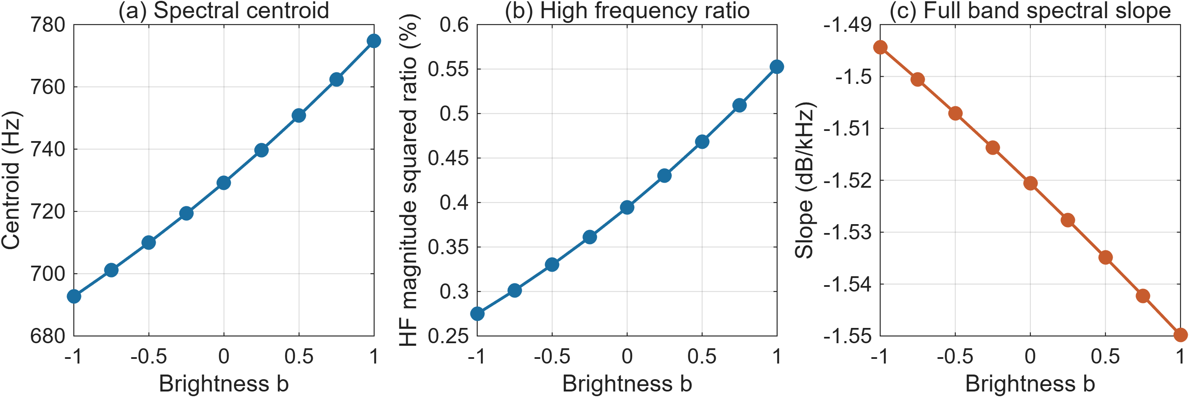
Figure 1. Nine-level calibration for the same recording. Centroid and HF ratio increase at every step; full-band slope becomes more negative. HF ratio is a percentage and slope is displayed in dB/kHz.
Table 4. Complete calibration measurements, rounded for display.
b | Centroid Hz | HF ratio % | Slope dB/kHz | Mono RMS
-1.00 | 692.73 | 0.2749 | -1.4943 | 0.20262
-0.75 | 701.10 | 0.3014 | -1.5006 | 0.20289
-0.50 | 709.96 | 0.3300 | -1.5071 | 0.20315
-0.25 | 719.33 | 0.3610 | -1.5137 | 0.20342
+0.00 | 729.23 | 0.3944 | -1.5206 | 0.20369
+0.25 | 739.70 | 0.4302 | -1.5277 | 0.20395
+0.50 | 750.75 | 0.4684 | -1.5349 | 0.20422
+0.75 | 762.42 | 0.5092 | -1.5422 | 0.20449
+1.00 | 774.73 | 0.5524 | -1.5498 | 0.20476

5.2 Retained music library
All 15 files were reanalyzed successfully. Table 5 gives condition means and sample SD for the main descriptors; complete file-level and additional-feature values are supplied as CSVs. Neutral had the largest mean centroid and HF ratio, while Bright had a slightly higher mean centroid than Dark and a lower mean HF ratio. Figure 2 shows that group averages conceal substantial variation between filename seeds.
The strict Dark < Neutral < Bright order occurred in only one of five seed groups for centroid and none for HF ratio. Table 6 gives the paired contrasts. Bright-minus-Dark centroid averaged +14.90 Hz, with three positive differences and a range from -88.72 to +81.59 Hz. The HF contrast averaged -0.4459 percentage points, with only two positive differences. These observations answer RQ2 negatively for this retained set under the specified descriptors.
The shared seed 12335 produced high values across conditions. Showing the paired values makes this visible without assuming why it happened. The project does not establish a generative mechanism from those filenames. Historical results obtained with different analysis conventions were retained for provenance and were not mixed into these tables. No listening order, causal prompt effect or statistical significance follows from the measured order counts.
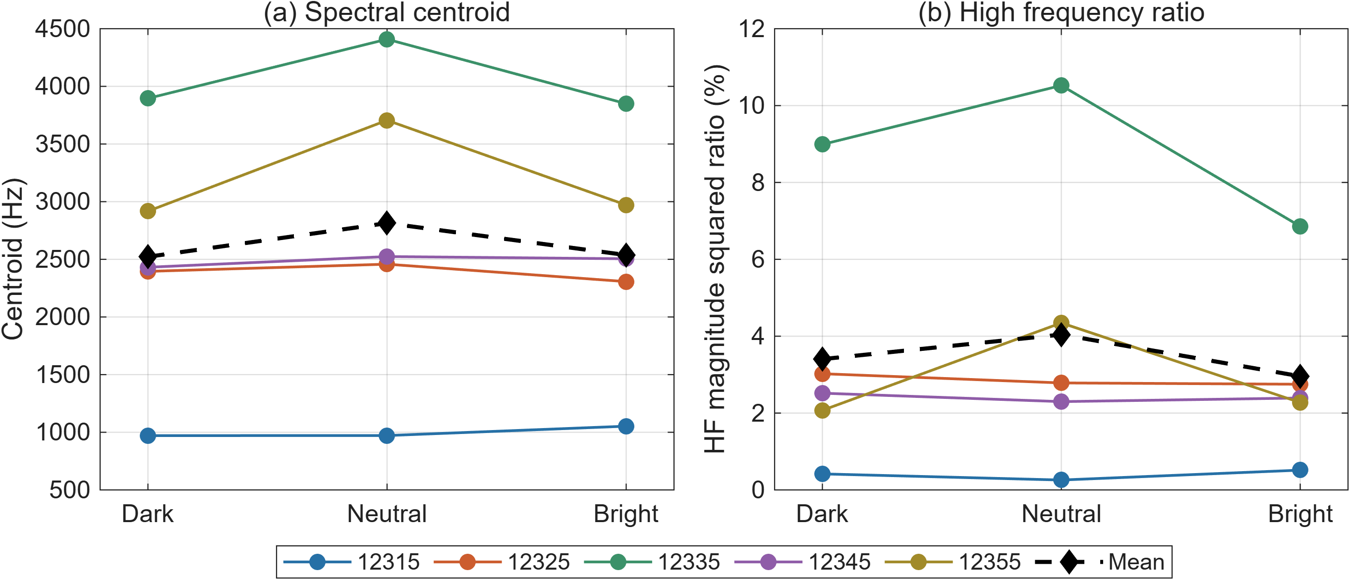
Figure 2. File-level features by filename seed and condition. Colored lines connect matching filename seeds; the dashed black line is the condition mean. The lines describe retained files, not a verified controlled-generation design.
Table 5. Mean ± sample SD for five files per condition.
Condition | Centroid Hz | HF ratio %
Dark | 2522.12 ± 1057.44 | 3.404 ± 3.272
Neutral | 2813.64 ± 1317.63 | 4.042 ± 3.906
Bright | 2537.02 ± 1020.90 | 2.958 ± 2.346

Table 6. Bright-minus-Dark contrasts paired by filename seed.
Seed | Centroid difference Hz | HF difference percentage points
12315 | +81.59 | +0.0979
12325 | -88.72 | -0.2736
12335 | -45.93 | -2.1307
12345 | +73.65 | -0.1258
12355 | +53.89 | +0.2024

5.3 Paired prompt-condition comparisons
Across five matched seeds, the Bright condition increased spectral centroid relative to Neutral in only one pair, whereas the Dark condition decreased it in all five pairs. The mean paired changes were −276.61 Hz (SD 353.39 Hz) for Bright and −291.51 Hz (SD 343.78 Hz) for Dark. However, the Dark decrease for seed 12315 was only approximately 0.52 Hz, indicating that a change in the expected direction can still be very small. High-frequency energy ratio showed the expected direction in two of five pairs for each condition.
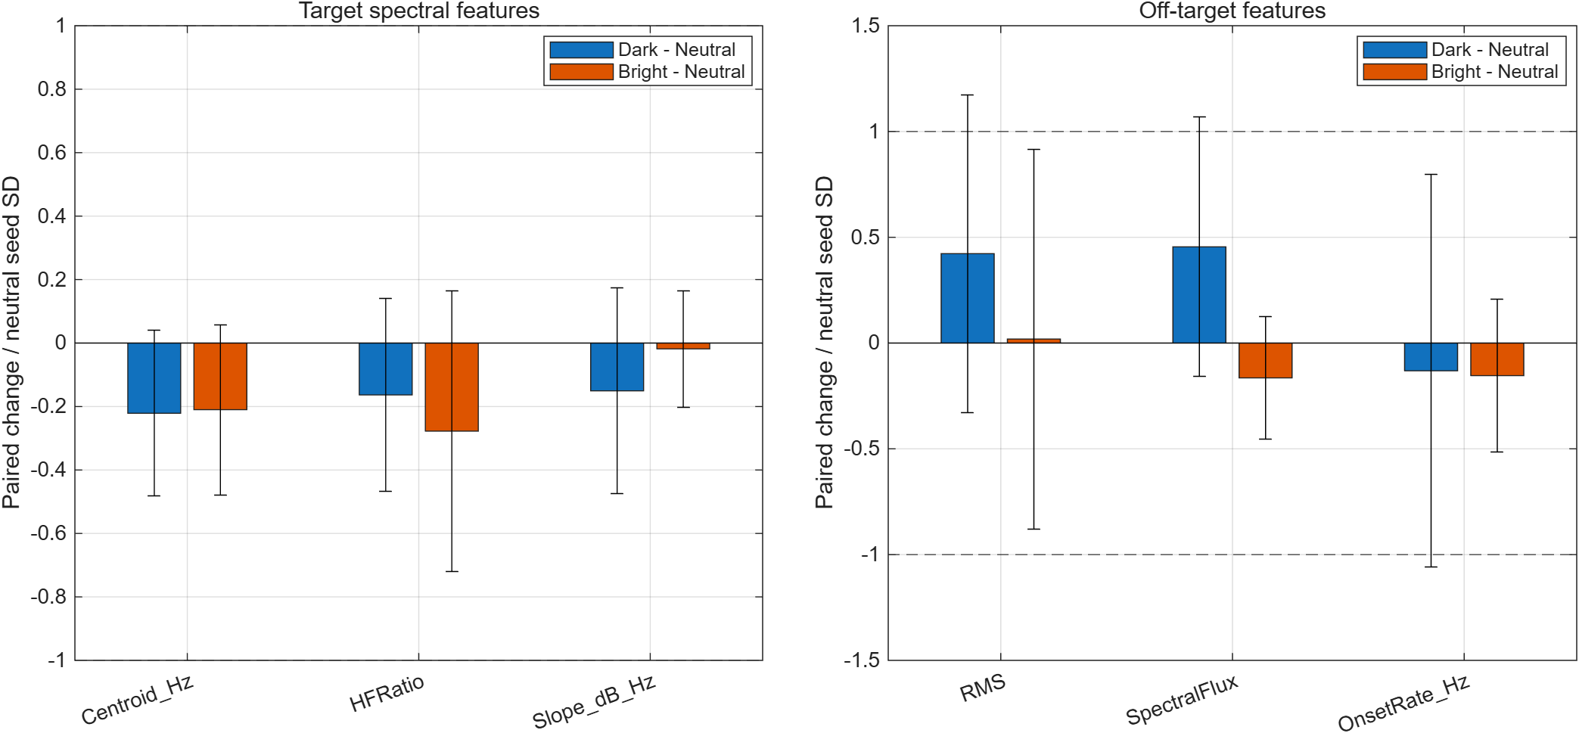
Figure 3. Mean paired changes from Neutral, normalized by the cross-seed standard deviation of Neutral recordings. Error bars indicate ±1 sample standard deviation of the paired changes. Dotted lines mark ±1 Neutral standard deviation as a descriptive reference, not a statistical significance threshold. Each comparison contains five matched seed pairs.
Changes also occurred in attributes other than the requested brightness. Relative to Neutral, the mean changes in RMS, spectral flux and onset rate were +0.00084, −0.00589 and −0.181 events/s for Bright, and +0.01871, +0.01626 and −0.154 events/s for Dark, respectively. For all three descriptors in both conditions, the standard deviation of the paired changes exceeded the magnitude of the mean change, indicating substantial variation across seeds. RMS measures signal amplitude rather than perceived loudness, while detected onset rate is not a direct measure of musical tempo.

6 Discussion

6.1 Control and perception
The calibration demonstrates a useful engineering link between an explicit parameter and two normalized descriptors. It connects the implemented operation to RQ1 and the static-spectrum expectation, while the empirical STFT analysis checks behavior after the complete processing chain. For teaching and inspection, the App makes the operation, audible output and measurements available in one place. Its usefulness is reproducibility and explanation; the measurements alone do not establish perceptual benefit.
The literature distinguishes spectral correlates from listener judgments [1-3]. Here, multiple descriptors change together, as expected for a spectral tilt. Their agreement cannot identify which cue a listener would use. The numerical order is also weaker evidence than equal perceptual spacing. No published discrimination threshold or fitted perceptual scale is applied to these recordings, so an approximately 6.24% centroid increase cannot be labeled audible or inaudible from the current data.

6.2 Unexpected spectral slope
The negative slope trend is informative because it challenges the assumption that a feature named spectral slope must track the control's gain slope. The code fits dB values across a linear frequency grid after windowing, flooring and frame averaging; the control multiplies a different, whole-recording spectrum. A broad regression also assigns many bins to weak high-frequency regions. Window leakage, relative flooring, quiet tails and frequency range are plausible influences, but none was isolated experimentally. Naming these as hypotheses avoids replacing an unexplained observation with an invented mechanism.
A diagnostic follow-up would vary one analysis choice at a time: window length, activity threshold, floor and fit band. It would compare an exact FFT-domain slope prediction against the remeasured STFT slope, then document where disagreement begins. The present paper does not report those unperformed tests. Published slope results using other stimuli and frequency scales [3] are not numerical benchmarks for the dB/Hz values here.

6.3 Library interpretation
Within this one-context, five-seed pilot, the centroid response was asymmetric: Dark reduced spectral centroid in all five matched pairs, whereas Bright increased it in only one. However, the magnitude of the Dark response varied substantially, and high-frequency energy ratio did not consistently follow the expected direction. Changes in other descriptors also varied across seeds. These results provide limited evidence of directional control and do not establish selective control of brightness. They cannot determine which musical changes caused the centroid differences, and acoustic descriptors alone do not establish perceived brightness.

7 Limitations

7.1 Measurement and comparison limits
Measurement limitations include channel cancellation in the mono average, the weighting of quiet active frames, and the choice of analysis grid and 4 kHz boundary. The 44.1 and 48 kHz analysis grids place the first included high-frequency bin at different actual frequencies, which can affect cross-source comparisons. All library recordings use the same sample rate and therefore share the same analysis grid. However, the calibration source differs from the generated library in content, duration and sample rate. Comparing absolute feature means between these experiments cannot establish DSP superiority over AI generation.
Spectral centroid and high-frequency energy ratio are related descriptors, so agreement between them would not constitute two independent confirmations. Neither descriptor alone establishes perceived brightness. Automated tests verify computational behavior rather than perceptual or generative validity.
The CSV files retain numerical precision for reproduction, while displayed values are rounded. Reproducing the same numbers does not quantify uncertainty arising from analysis choices, audio quantization or missing generation metadata. The reported sample standard deviations describe variation among retained recordings or paired changes; they are not confidence intervals for population means. Repeated execution of deterministic code is not an independent replication with new material.

7.2 Dataset and generation provenance
The library contains five matched seed triplets from one musical context, which limits generalization to other prompts, musical styles or generation systems. According to the author's recollection, only the brightness wording changed, matching seeds were manually entered, other settings remained unchanged, and no generated samples were selectively removed or edited. However, complete generation logs and the exact model version were not retained, so these controls cannot be independently verified. Matching seeds also do not guarantee identical musical content across prompts.
These limitations mean that the findings describe the retained recordings rather than demonstrating a general failure of text-based brightness control. The experiment also cannot determine which musical changes caused the observed centroid differences.

7.3 Exploratory pitch estimation
An exploratory pitch analysis was excluded from the condition comparison because its reliability was insufficient for these polyphonic recordings. A 440 Hz sinusoidal test returned a median estimate of 441 Hz, showing reasonable performance on that simple test signal. However, for seed 12315, 51.0%, 33.4% and 76.5% of finite pitch estimates for Neutral, Bright and Dark, respectively, were at or above 990 Hz, near the configured 1000 Hz upper search boundary. This accumulation raised concerns about interpreting the estimated medians. It does not establish the true pitch ordering or show that pitch remained unchanged. Pitch-related differences therefore remain unresolved.

7.4 Future validation
A stronger calibration evaluation would repeat the brightness sweep on several source recordings with different spectral balances and stereo structures, using predefined monotonicity and error measures. Sensitivity checks should distinguish changes caused by processing from those caused by analysis definitions. Any peak scaling and the resulting output RMS should also be documented.
A prospective generation experiment should retain every prompt, seed, model checkpoint, sampler, duration and other settings, changing only the intended condition within each matched set. Every planned output should be retained, or any exclusion explained. Additional musical contexts and seeds would support a broader evaluation of consistency and selectivity.
Perceptual validation would require a separate, level-matched and randomized listening task. An ordering task could examine perceived monotonicity, while an interval task could examine slider spacing. Such validation is beyond the present acoustic study. No participants, subjective ratings or proposed future outcomes are represented as completed work.

8 Conclusion
Music Feature Lab combines the previously dispersed workflows into an editable MATLAB App and a reproducible analysis package. For one calibration source, the nine-level control produced increasing centroid and HF ratio at every step, while the measured spectral slope became more negative. The 15 retained recordings did not exhibit a reliable Dark-Neutral-Bright ordering under the chosen acoustic measures. These findings meet the two stated acoustic questions with different outcomes.
The paired analysis further showed an asymmetric centroid response: Bright increased centroid relative to Neutral in only one of five matched pairs, while Dark decreased it in all five. However, effect magnitudes varied, high-frequency energy ratio did not consistently follow the expected direction, and other measured attributes also changed. The findings therefore indicate limited and inconsistent acoustic control within this sample, rather than demonstrating selective or perceptually verified brightness control.
The contribution is a documented engineering workflow and a transparent feasibility result, including a negative finding and explicit limits. Direct model control, generalized music performance and perceptually calibrated brightness remain outside the demonstrated scope. Complete generation records, additional source material and a separate listening evaluation are the next steps required to strengthen those claims.

9 Reproduction and references
Extract the complete submission folder, open its root in MATLAB and run run_project.m to launch the App. Run run_experiments.m to recompute all measurements, summaries and numerical checks. The Report folder contains the executed Experiment_Live.mlx, its code-and-output PDF and an equivalent M source. Keep the relative folder structure intact. The results folder contains calibration, file-level, condition-summary and paired-contrast CSVs, the numerical check table and JSON run/verification summaries. SHA256SUMS.csv records file integrity. No Python service or network connection is required for the delivered experiments.
The source materials are the existing local ELEC5305 project and the author's generated audio. The original proposal supplies the topic and starting aim. MusicAnalysis.m defines the measurements used here. The references below establish scientific context; AI is not treated as a primary source of acoustic theory. Department-specific citation/layout rules and assessment-specific AI permissions must be checked against the course instructions.
Project repository: https://github.com/Efwell-1106/elec5305-project-560746563
Project website: https://efwell-1106.github.io/elec5305-project-560746563/
Project video: Watch or download the project demonstration

References
[1] A. Caclin, S. McAdams, B. K. Smith, and S. Winsberg, "Acoustic correlates of timbre space dimensions: A confirmatory study using synthetic tones," The Journal of the Acoustical Society of America, vol. 118, no. 1, pp. 471-482, 2005. https://doi.org/10.1121/1.1929229
[2] S. Kazazis, P. Depalle, and S. McAdams, "Ordinal scaling of timbre-related spectral audio descriptors," The Journal of the Acoustical Society of America, vol. 149, no. 6, pp. 3785-3796, 2021. https://doi.org/10.1121/10.0005058
[3] S. Kazazis, P. Depalle, and S. McAdams, "Interval and Ratio Scaling of Spectral Audio Descriptors," Frontiers in Psychology, vol. 13, article 835401, 2022. https://doi.org/10.3389/fpsyg.2022.835401
[4] The MathWorks, Inc., "spectralCentroid," online documentation, accessed 3 November 2026. https://www.mathworks.com/help/audio/ref/spectralcentroid.html
[5] The MathWorks, Inc., "pitch," online documentation, accessed 3 November 2026. https://www.mathworks.com/help/audio/ref/pitch.html

AI assistance statement
I acknowledge the use of ChatGPT and OpenAI Codex, provided by OpenAI (https://chatgpt.com/ and https://openai.com/codex/). The exact model versions used throughout the project were not recorded. I selected the topic, ran the original audio generation, and manually wrote the original MATLAB code with AI guidance. AI assisted with experimental design, code development and debugging, integration of the revised MATLAB App, interpretation of numerical results, organization of materials and references, report drafting and revision, and language editing. AI also helped prepare the summary MATLAB Live Script. ACE-Step was used to generate the experimental audio. I am responsible for checking the accuracy of the submitted content, references and interpretation.

