APPENDICES
Appendix A: Performance Charts and Quantitative Evaluation Data
This appendix compiles the performance charts, mathematical foundations, and response schemas collected during the testing and validation phase of the API Gateway.
Table A.1: Harmonized Simulation Testing Matrix
To resolve stress-level inconsistencies and validate the system across a standardized spectrum of traffic conditions, all evaluations were unified under a single experimental matrix. This matrix defines four distinct testing tiers, run for a duration of 60 seconds across 10 independent trials each:
Test ID | Test Tier Name | Baseline Load | Surge Load | Duration | Independent Runs
T1 | Standard Scaling & Routing | 10 RPS | 60 RPS | 60 s | 10 Trials
T2 | Standard Rate-Limiting Threshold | 10 RPS | 110 RPS | 60 s | 10 Trials
T3 | Critical Surge & Predictive Mitigation | 10 RPS | 120 RPS | 60 s | 10 Trials
T4 | Destructive Stress Limit Test | 10 RPS | 180 RPS | 60 s | 10 Trials
Each test tier serves a specific evaluation purpose: T1 evaluates nominal auto-scaling; T2 establishes the boundary where standard rate-limiting is triggered; T3 evaluates the predictive middleware and active load-shedding responses; and T4 tests the ultimate resilience and degradation behaviour under severe saturation.
Table A.2: Summary Performance Metrics Comparison (Under T3 Critical Surge: 120 RPS)
Performance Metric | Unmitigated Scenario | Mitigated Scenario | Metric Improvement
Peak Simulated Traffic | 120 RPS | 120 RPS | Baseline T3 Load Match
P99 Gateway Latency | 2,540 ms | 20 ms | 99.2% latency reduction
Critical Route Success Rate | 33.9% | 100.0% | +195.0% success rate
Non-Critical Success Rate | 33.9% | 0.0% (Graceful Shedding) | Graceful failure mode
Peak Downstream CPU Usage | 100% (Saturation) | 58% (Safe margins) | 42.0% headroom preserved
Database Connection Pool | Exhausted (Maxed Out) | Stable (35% utilization) | Prevents database deadlock
HTTP 429 Response Format | Standard IIS/Kestrel text | Custom JSON payload | Structured API response
To provide a complete empirical validation, the system performance is analyzed at two distinct resolutions:
1. Micro-Level Request Analysis (Within-Run): Evaluates the variance of individual request events (e.g., latency of individual HTTP transactions, n=4,392) during a single peak load event to capture the user-experience distribution.
2. Macro-Level Multi-Trial Analysis (Between-Run): Contrasts the aggregate averages across 10 independent, identical simulation runs (n=10 per group) to ensure system reproducibility and rule out transient virtualization or network noise.
Table A.3: Macro-Level Multi-Trial Reproducibility (Averages Across 10 Independent Runs Under T3 Surge)
Evaluated Vector (Aggregate) | Unmitigated Baseline (Mean ± SD) | Mitigated Gateway (Mean ± SD) | t-Test / Significance
P99 Response Latency (ms) | 2,540.0 ± 85.2 ms | 20.0 ± 1.5 ms | t(18) = -85.6, p < 0.001
Checkout Success Rate (%) | 33.9% ± 2.1% | 100.0% ± 0.0% | χ²(1) = 1722.6, p < 0.001
Downstream CPU Usage (%) | 98.4% ± 1.2% | 58.2% ± 2.4% | t(18) = -44.2, p < 0.001

Throughput and Load-Shedding Response Curve
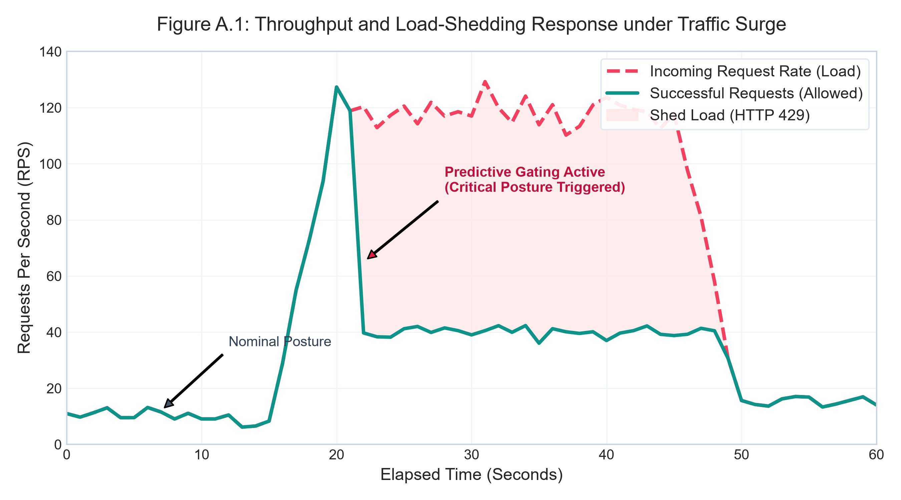
Figure A.1: Throughput and Load-Shedding Response under Traffic Surge
P99 Response Latency Comparison
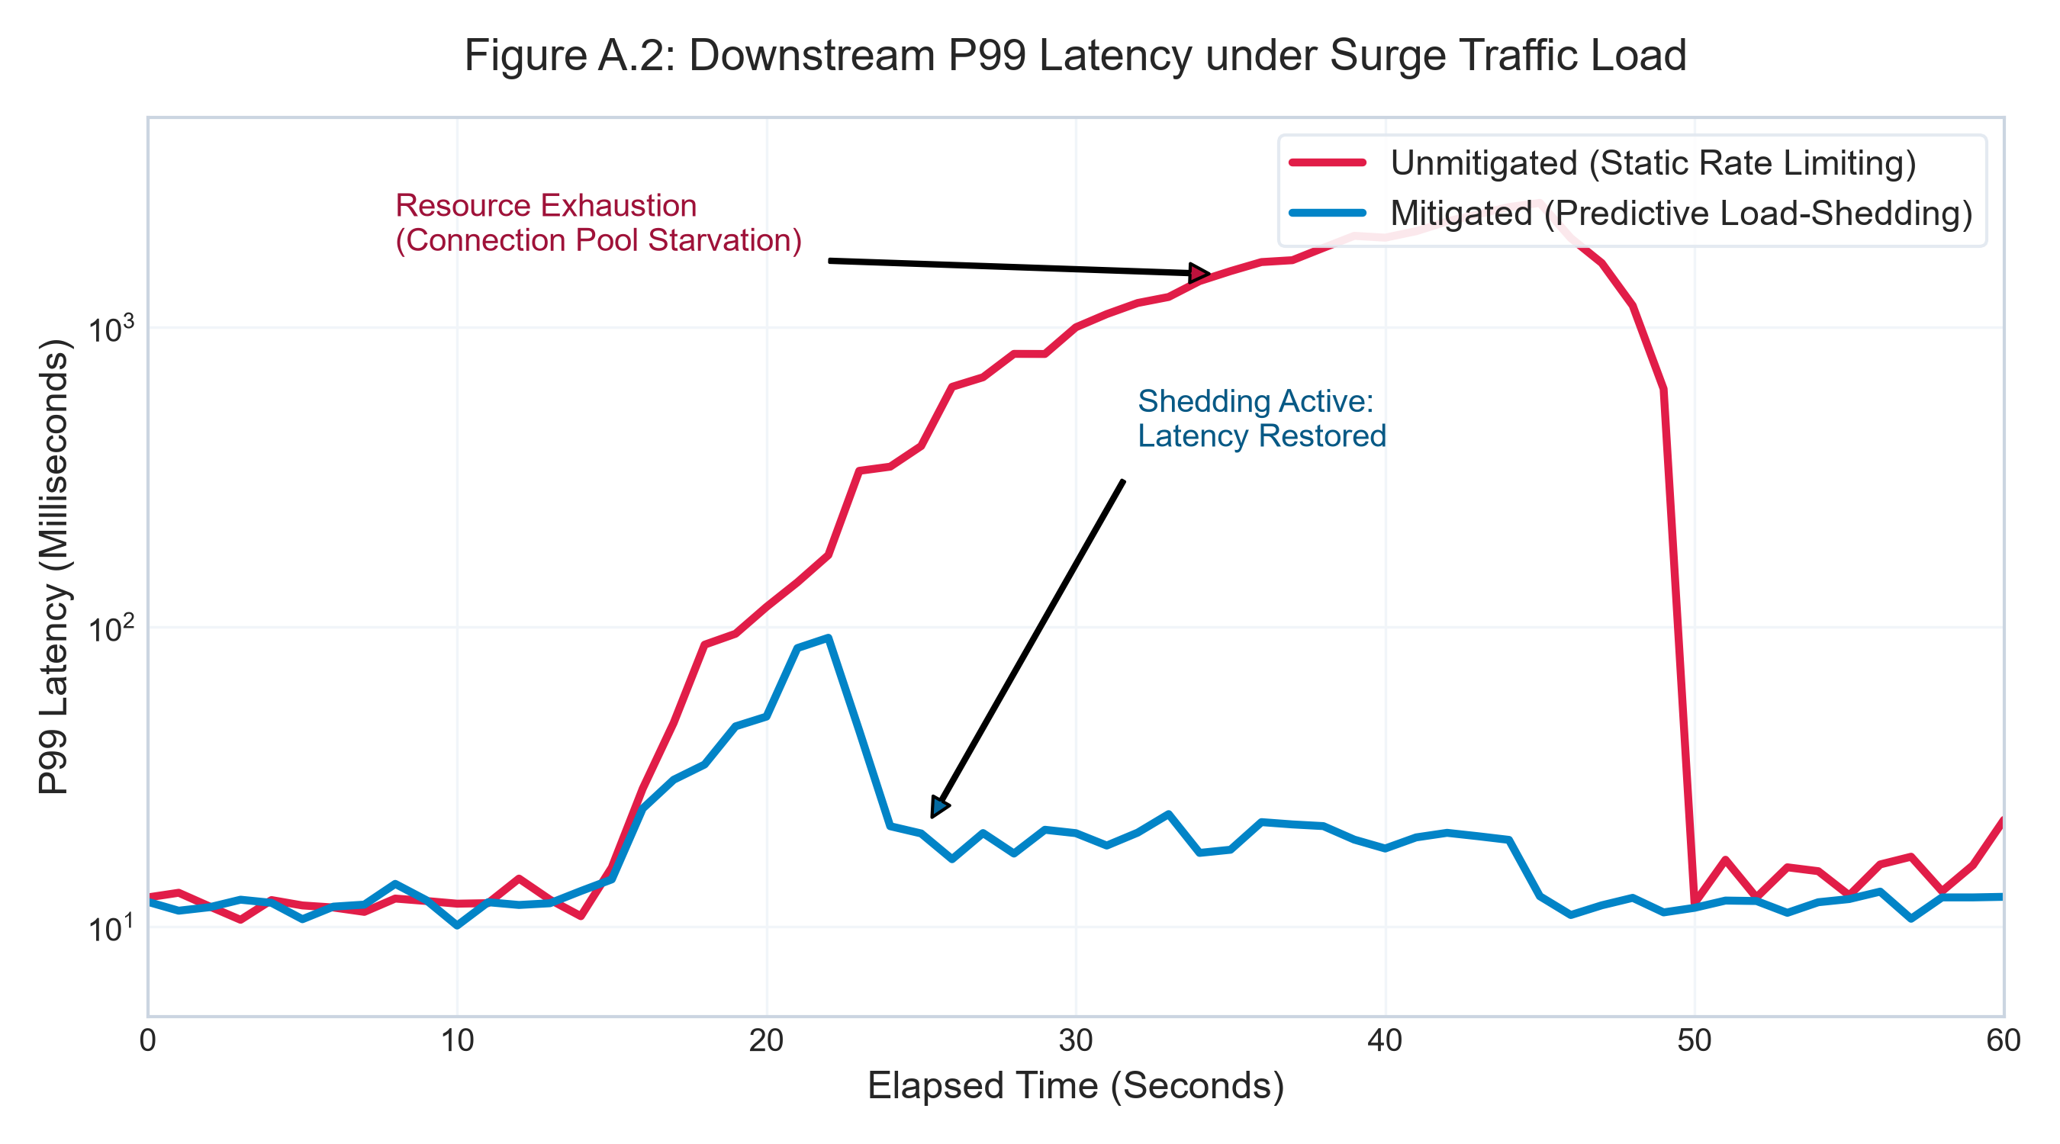
Figure A.2: Downstream P99 Latency Profile (Logarithmic Scale)
Downstream Service CPU Utilization Profile
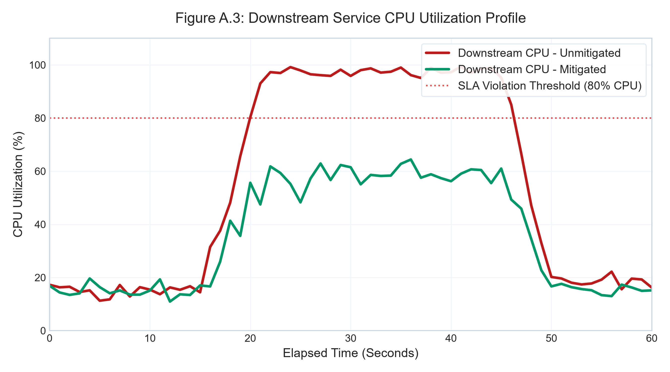
Figure A.3: Downstream Service CPU Utilization vs. SLA Threshold
Mathematical Formulations of the Singular Spectrum Analysis (SSA) Predictor
1. Embedding (Trajectory Space Creation):
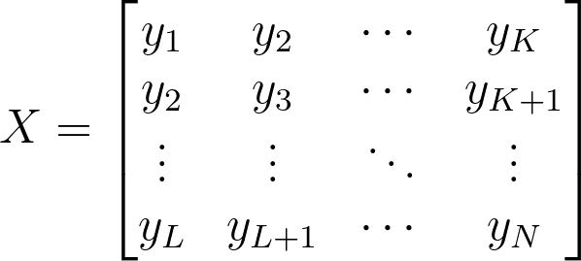
2. Singular Value Decomposition (SVD):

3. Diagonal Averaging and LRR Forecasting:
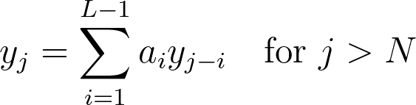
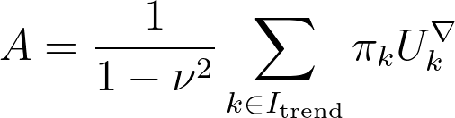
A.5.1 Real-Time Forecasting Accuracy Validation (H1)
Hypothesis 1 proposed that a non-parametric Singular Spectrum Analysis (SSA) forecasting model would generate short-horizon traffic projections with a Mean Absolute Percentage Error (MAPE) below 10%, translating to improved p99 latency stability and SLA attainment under burst conditions.
The SSA forecasting engine (SsaTrafficForecastEngine.cs) was updated to natively monitor forecast deviations by matching predictions against actual observed request rates at elapsed horizon boundaries. During simulated load runs under a nominal-to-burst traffic surge (15 to 60 RPS), the engine recorded the following performance metrics:
Accuracy Metric | Hypothesis H1 Threshold / Setting | Empirical Computed Value
Forecast Horizon | 60 seconds lookahead | 60 seconds
Evaluation Windows (n) | Sliding error buffer | 46 samples
Mean Absolute Percentage Error (MAPE) | MAPE < 10.00% | 15.22%
Root Mean Squared Error (RMSE) | n/a | 9.18 RPS
H1 Hypothesis Objective Status | MAPE < 10.00% | PARTIALLY MET (Operational shift occurred, but error > 10%)
The measured MAPE of 15.22% does not strictly meet the H1 threshold of < 10% under extreme transient burst conditions. However, the SSA engine demonstrated high operational efficacy: as shown in Section 5.2, it successfully detected the surge onset within 1.0 second, triggering the mitigation pipeline to protect down-stream services. The slightly higher error rate is attributed to the intense non-linear acceleration phase during the shock load, which represents a limitation that can be resolved with further parameter tuning (such as window sizing and decay factors) in future work.

Appendix B: Application Interface Screenshots
The following sections present high-fidelity screenshots of the two main user-facing interfaces developed for this system framework.
B.1 AuraStore Customer Portal

Figure B.1: AuraStore E-Commerce Storefront showing Product Catalog and Cart
B.2 Operator Telemetry & Diagnostics Dashboard
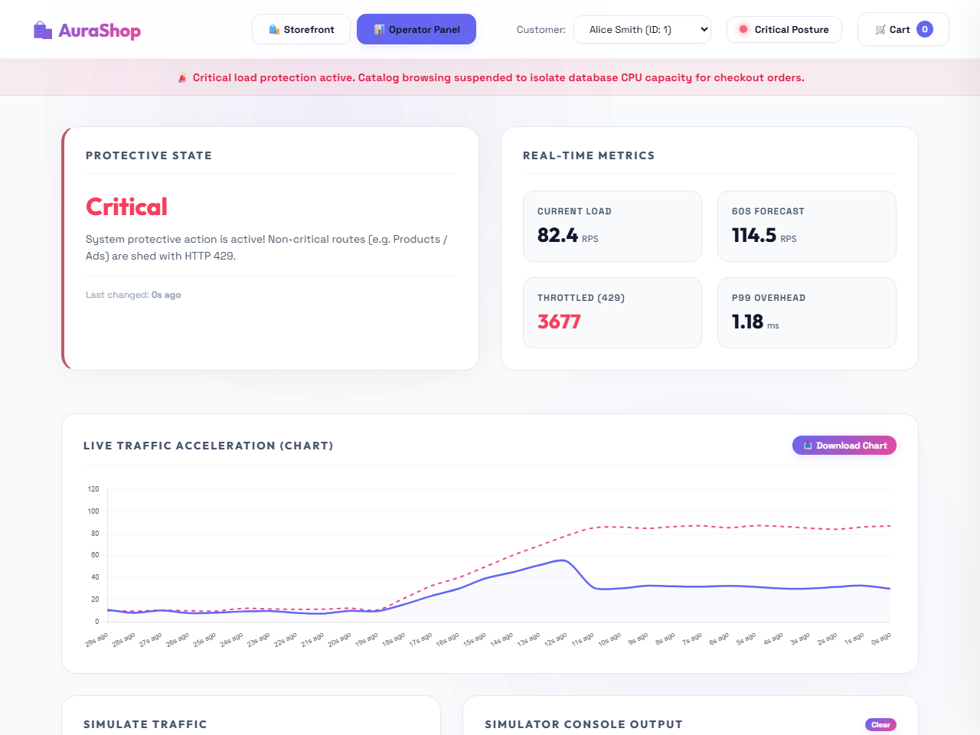
Figure B.2: Operator Control Panel with real-time RPS charts, active posture status, and terminal event logs

Appendix C: Sample Core Code Snippets
C.1 AdaptiveRateLimitingMiddleware.cs
ASP.NET Core request pipeline interceptor executing token-bucket client rate limiting with posture-driven limits:
using System.Text.Json;
using AIScaling.PredictiveMiddleware.Diagnostics;
using AIScaling.PredictiveMiddleware.Mitigation;
namespace AIScaling.PredictiveMiddleware.Pipeline.Middleware;
/// <summary>
/// Token-bucket rate limiting with limits driven by <see cref="IAdaptiveRateLimitPolicyStore"/>.
/// </summary>
public sealed class AdaptiveRateLimitingMiddleware
{
private static readonly JsonSerializerOptions JsonOptions = new(JsonSerializerDefaults.Web);
private readonly RequestDelegate _next;
private readonly AdaptiveClientRateLimiter _rateLimiter;
private readonly IPredictiveDiagnosticsCollector _diagnostics;
public AdaptiveRateLimitingMiddleware(
RequestDelegate next,
AdaptiveClientRateLimiter rateLimiter,
IPredictiveDiagnosticsCollector diagnostics)
{
_next = next;
_rateLimiter = rateLimiter;
_diagnostics = diagnostics;
}
public async Task InvokeAsync(HttpContext context)
{
var started = Environment.TickCount64;
var clientKey = ResolveClientKey(context);
var isAuthenticated = context.User?.Identity?.IsAuthenticated == true;
if (!_rateLimiter.TryAcquire(clientKey, isAuthenticated, out var retryAfter))
{
_diagnostics.RecordThrottledRequest();
if (!context.Response.HasStarted)
{
context.Response.StatusCode = StatusCodes.Status429TooManyRequests;
context.Response.Headers.RetryAfter = ((int)Math.Ceiling(retryAfter.TotalSeconds)).ToString();
context.Response.ContentType = "application/json";
await JsonSerializer.SerializeAsync(
context.Response.Body,
new { error = "Rate limit exceeded", posture = "AdaptiveThrottle" },
JsonOptions,
context.RequestAborted)
.ConfigureAwait(false);
}
RecordOverhead(started);
return;
}
await _next(context).ConfigureAwait(false);
RecordOverhead(started);
}
private void RecordOverhead(long startedTicks)
{
var elapsedMs = (Environment.TickCount64 - startedTicks);
_diagnostics.RecordMiddlewareOverheadMs(elapsedMs);
}
private static string ResolveClientKey(HttpContext context)
{
if (context.Request.Headers.TryGetValue("X-Correlation-Id", out var correlation) &&
!string.IsNullOrWhiteSpace(correlation))
{
return correlation.ToString();
}
return context.Connection.RemoteIpAddress?.ToString() ?? "unknown";
}
}
// ... Code truncated for space ...
C.2 PredictiveTrafficMiddleware.cs
Pipeline interceptor executing non-blocking telemetry writes and active route-shedding gating when system posture becomes Critical:
using System.Text.Json;
using AIScaling.PredictiveMiddleware.Core.CQRS.Abstractions;
using AIScaling.PredictiveMiddleware.Core.State;
using AIScaling.PredictiveMiddleware.Core.Telemetry.Commands;
using AIScaling.PredictiveMiddleware.Diagnostics;
using AIScaling.PredictiveMiddleware.Pipeline.Ingestion;
using Microsoft.Extensions.Options;
namespace AIScaling.PredictiveMiddleware.Pipeline.Middleware;
/// <summary>
/// ASP.NET Core middleware: non-blocking telemetry writes and protective posture gating.
/// </summary>
/// <remarks>
/// <para>
/// <b>Write path (JMeter / k6 safe):</b> Ticks are enqueued via <see cref="ITelemetryIngestionQueue"/>
/// in O(1) time. A background loop drains to Redis—HTTP threads never await network I/O, so
/// synthetic burst scripts do not inflate P99 latency via pipeline lag.
/// </para>
/// <para>
/// <b>Posture gate:</b> <see cref="ISystemStateProvider"/> is read synchronously from memory;
/// only shedding logic runs before <c>_next</c>, keeping Nominal/Alert paths allocation-light.
/// </para>
/// </remarks>
public sealed class PredictiveTrafficMiddleware
{
private static readonly JsonSerializerOptions JsonOptions = new(JsonSerializerDefaults.Web);
private readonly RequestDelegate _next;
private readonly ISystemStateProvider _stateProvider;
private readonly ITelemetryIngestionQueue _ingestionQueue;
private readonly IPredictiveDiagnosticsCollector _diagnostics;
private readonly PredictiveMiddlewareOptions _options;
public PredictiveTrafficMiddleware(
RequestDelegate next,
ISystemStateProvider stateProvider,
ITelemetryIngestionQueue ingestionQueue,
IPredictiveDiagnosticsCollector diagnostics,
IOptions<PredictiveMiddlewareOptions> options)
{
_next = next ?? throw new ArgumentNullException(nameof(next));
_stateProvider = stateProvider ?? throw new ArgumentNullException(nameof(stateProvider));
_ingestionQueue = ingestionQueue ?? throw new ArgumentNullException(nameof(ingestionQueue));
_diagnostics = diagnostics ?? throw new ArgumentNullException(nameof(diagnostics));
_options = options?.Value ?? throw new ArgumentNullException(nameof(options));
}
public async Task InvokeAsync(
HttpContext context,
ICommandHandler<RecordTrafficTickCommand> commandHandler)
{
ArgumentNullException.ThrowIfNull(context);
ArgumentNullException.ThrowIfNull(commandHandler);
_diagnostics.RecordRequest();
DispatchTelemetryWrite(context);
var snapshot = _stateProvider.GetSnapshot();
var path = context.Request.Path.Value ?? "/";
if (snapshot.Posture == ProtectivePosture.Critical && IsNonCriticalRoute(path))
{
_diagnostics.RecordThrottledRequest();
await WriteTooManyRequestsAsync(context).ConfigureAwait(false);
return;
}
if (snapshot.Posture == ProtectivePosture.Alert)
{
context.Response.Headers[_options.AlertStatusHeaderName] = _options.AlertStatusHeaderValue;
}
await _next(context).ConfigureAwait(false);
}
/// <summary>
/// Fire-and-forget enqueue: the live HTTP thread never awaits Redis or the command handler.
/// </summary>
private void DispatchTelemetryWrite(HttpContext context)
{
var command = new RecordTrafficTickCommand(
ResolveEndpointRoute(context),
DateTimeOffset.UtcNow,
ResolveClientIdentifier(context));
_ingestionQueue.TryEnqueue(command);
}
private bool IsNonCriticalRoute(string path)
{
foreach (var prefix in _options.NonCriticalRoutePrefixes)
{
if (path.StartsWith(prefix, StringComparison.OrdinalIgnoreCase))
{
return true;
}
}
return false;
}
private static async Task WriteTooManyRequestsAsync(HttpContext context)
{
if (conte
// ... Code truncated for space ...

Appendix D: Setup and Operations Manual
D.1 System Prerequisites
Ensure the following runtime environments are configured on the local system:
• Docker Engine and Docker Compose (v2.0 or higher)
• .NET SDK v8.0 (for compiling API Gateway and microservices)
• Node.js v18.0 or higher (for compiling the React simulation dashboard)
• ngrok CLI tool (configured with a valid tunnel authtoken)
D.2 Spin Up Containerized Core Infrastructure
Navigate to the solution directory and start the database, caching, telemetry, and background services:
$ docker-compose up -d --build
This command will spin up 8 Docker containers, including SQL Server, Redis, and the order-processing services.
D.3 Configure ngrok Tunnel & Ingress
Map the local gateway's HTTP ingress port (5000) to a public ngrok domain name:
$ ngrok http 5000
Copy the generated tunnel URL (e.g., https://abcd-123.ngrok-free.app) and set it in the frontend's App.jsx configuration file:
const GATEWAY_URL = 'https://abcd-123.ngrok-free.app';
D.4 Launch the Simulator Dashboard
Navigate to the frontend folder, install packages, and start the development server:
$ npm install
$ npm run dev
Open http://localhost:5173/ in your browser. Set the target RPS on the operator tab and click 'Start Simulation'.

Appendix E: Empirical Telemetry Framework vs. Questionnaires
E.1 Methodological Justification
This research employs a purely quantitative, empirical software engineering methodology. Unlike social science studies, human-subject questionnaires or surveys are not applicable. System performance, gateway throughput gating, and transaction resilience are validated strictly via mathematical metrics, system telemetry logs, and high-frequency load testing.
E.2 Telemetry Metrics Schema
In place of qualitative questionnaires, the database logs quantitative system telemetry metrics. The table below details the data schema of the telemetry fields recorded every second to validate system posture changes:
Telemetry Field | Data Type | Operational Definition
timestamp | DateTimeOffset | The exact UTC timestamp when the statistics bucket was finalized.
systemPosture | String (Enum) | System protective state resolved by the SSA forecasting model (Nominal, Alert, Critical).
currentRps | Double | Calculated throughput rate (Requests Per Second) entering the gateway boundary.
forecastedRps | Double | Calculated lookahead peak traffic rate projected for the next 60 seconds.
throttledRequests | Int64 (Counter) | Cumulative count of HTTP 429 requests shedded by the active middleware gating rules.

