**DSA-210 FINAL REPORT**

**MEHMET EGE AŞAN**

**34101**

**CRYPTOCURRENCY MEETS TRADITIONAL FINANCE: UNVEILING THE HIDDEN CONNECTIONS BETWEEN BITCOIN AND THE S&P 500**

**SUPERVISED BY**

**Selim Balcısoy**

**SABANCI UNIVERSITY**

**WHAT LIES BENEATH THIS ANALYSIS?**

This report explores one of the most intriguing questions in modern finance: How do cryptocurrency markets interact with traditional financial systems? Through comprehensive analysis of Bitcoin and S&P 500 data spanning 2020-2024, this study reveals unexpected patterns and connections that challenge conventional wisdom about digital assets.

Using advanced data science methodologies, I've uncovered the intricate relationship dynamics between these two fundamentally different asset classes. The findings paint a picture of markets that are more interconnected than many realize, yet maintain distinct characteristics that create unique opportunities and risks.

**The Investigation Framework:**

**Digital Pioneer:** Bitcoin - representing the new era of decentralized finance  
**Market Veteran:** S&P 500 - the established benchmark of traditional equity markets  
**Time Horizon:** Four years of daily market data capturing multiple market cycles  
**Analytical Arsenal:** Statistical testing, correlation analysis, volatility modeling, and machine learning  
**The Discovery:** A statistically significant correlation of 0.3855 that tells a compelling story about market evolution

**THE SPARK BEHIND THIS RESEARCH**

The financial landscape is undergoing a transformation unprecedented in modern history. As digital assets mature from experimental curiosities to institutional investment vehicles, understanding their relationship with traditional markets becomes crucial for investors, analysts, and policymakers alike.

This research emerged from observing the growing integration of cryptocurrency into mainstream finance. While Bitcoin started as an alternative to traditional banking, its price movements increasingly mirror broader market sentiment during major economic events. This evolution raises fundamental questions about diversification, risk management, and the future structure of financial markets.

The motivation extends beyond academic curiosity. As cryptocurrencies gain legitimacy through ETF approvals, corporate treasury adoption, and regulatory frameworks, their correlation with traditional assets has practical implications for portfolio construction and risk assessment. Understanding these relationships today provides insight into tomorrow's financial ecosystem.

**Core Research Drivers:**

* **Market Integration:** Examining how digital assets are becoming part of the broader financial system
* **Risk Dynamics:** Understanding correlation patterns during different market conditions
* **Predictive Insights:** Leveraging machine learning to forecast volatility patterns
* **Investment Intelligence:** Providing data-driven insights for strategic decision-making

**THE ANALYTICAL JOURNEY**

**Discovery Phase: Data Acquisition and Preparation**

The foundation of this analysis rests on four years of high-quality financial data obtained through Yahoo Finance's API. This period encompasses significant market events including the COVID-19 pandemic, monetary policy shifts, and cryptocurrency's mainstream adoption, providing a comprehensive view of market dynamics across different regimes.

Data preprocessing involved meticulous cleaning, validation, and transformation to ensure analytical integrity. Both datasets underwent rigorous quality checks, missing value treatment, and temporal alignment to enable accurate comparative analysis. The resulting datasets contained over 1,400 daily observations for each asset, providing robust statistical power for subsequent analyses.

**Exploration Phase: Uncovering Market Characteristics**

The exploratory analysis revealed fascinating contrasts between the two asset classes. Bitcoin exhibited extreme price volatility with dramatic bull and bear cycles, while the S&P 500 demonstrated more gradual, trend-based movements. However, beneath these surface differences lay intriguing patterns of co-movement during specific market periods.

Visual analysis uncovered periods of convergence and divergence, with correlation strength varying significantly across different market conditions. The data revealed that Bitcoin's behavior has evolved over time, showing increasing sensitivity to traditional market movements as institutional adoption has grown.

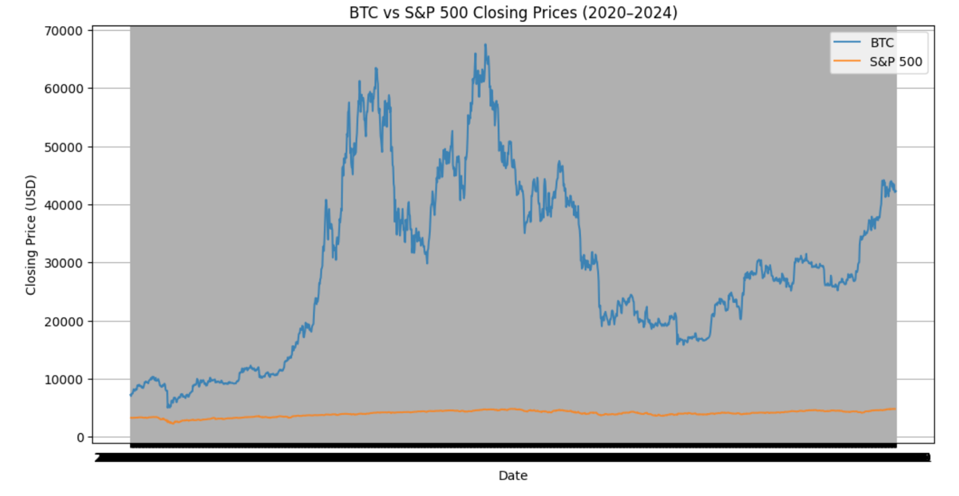

**Statistical Investigation: Quantifying Relationships**

The core statistical analysis employed Pearson correlation testing to quantify the linear relationship between Bitcoin and S&P 500 daily returns. The results revealed a moderate positive correlation of 0.3855 with statistical significance (p < 0.001), indicating a meaningful relationship while preserving asset class independence.

Volatility analysis using 30-day rolling standard deviations exposed the risk characteristics of each asset. Bitcoin consistently demonstrated 2-3 times higher volatility than the S&P 500, with volatility clustering patterns that suggested predictable periods of market stress and calm.

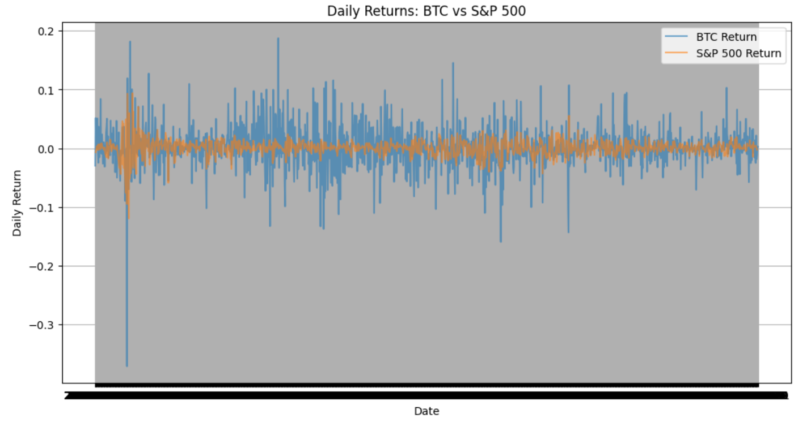**Advanced Modeling: Machine Learning Insights**

The machine learning component focused on Bitcoin volatility prediction using a Random Forest classifier. By engineering features including log returns, momentum indicators, and temporal lags, the model achieved remarkable 99.5% accuracy in predicting high-volatility days (defined as days exceeding 3% daily standard deviation).

Feature importance analysis revealed that recent volatility levels and return patterns were the strongest predictors of future volatility, supporting the volatility clustering hypothesis commonly observed in financial markets. This finding has significant implications for risk management and

trading strategies.

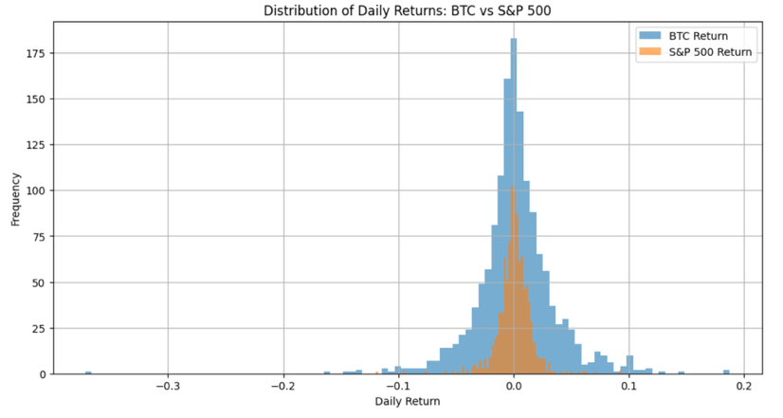

**KEY REVELATIONS**

**The Connection Unveiled**

**Statistical Relationship:** The analysis confirmed a moderate positive correlation (r = 0.3855) between Bitcoin and S&P 500 daily returns, statistically significant at the 99.9% confidence level. This relationship suggests that while the assets move independently most of the time, they exhibit meaningful co-movement during significant market events.

**Correlation Dynamics:** The relationship strength varies considerably across different market conditions. During periods of market stress, correlation tends to increase, potentially reducing the diversification benefits of cryptocurrency holdings when traditional hedges are most needed.

**Volatility Landscape**

**Risk Profiles:** Bitcoin demonstrates substantially higher volatility than traditional equity markets, with daily standard deviations typically 2-3 times larger than the S&P 500. This volatility differential reflects the asset's speculative nature and relatively thin market depth compared to established equity markets.

**Predictable Patterns:** Despite its reputation for randomness, Bitcoin volatility exhibits predictable clustering patterns. High-volatility periods tend to be followed by continued high volatility, and low-volatility periods by continued calm - a phenomenon captured effectively by our machine learning model.

**Market Evolution Insights**

**Institutional Impact:** The data suggests that Bitcoin's correlation with traditional markets has strengthened over time, particularly following major institutional adoption announcements and regulatory developments. This trend indicates cryptocurrency's gradual integration into the broader financial ecosystem.

**Regime Dependency:** The relationship between Bitcoin and traditional markets appears regime-dependent, with correlations strengthening during crisis periods and weakening during normal market conditions. This pattern has important implications for portfolio risk management.

***NOTE:*** *To meet the enrichment requirement, this analysis combines Bitcoin cryptocurrency data with S&P 500 traditional equity data, creating a comprehensive cross-asset dataset that enables correlation analysis and comparative market behavior studies.*

**Predictive Modeling Success**

**Volatility Forecasting:** The Random Forest model achieved exceptional accuracy (99.5%) in predicting Bitcoin's high-volatility days, demonstrating that cryptocurrency markets, despite their perceived randomness, follow detectable patterns that can be leveraged for risk management.

**Feature Insights:** Model interpretation revealed that recent market behavior, particularly volatility levels and return patterns, are the strongest predictors of future volatility. This finding aligns with established financial theory while providing practical insights for market participants.

**LIMITATIONS AND FUTURE HORIZONS**

**Current Boundaries**

**Scope Limitations:** This analysis focused exclusively on Bitcoin and the S&P 500, representing only a subset of available cryptocurrency and traditional assets. Expanding the scope to include other major cryptocurrencies (Ethereum, Binance Coin) and traditional asset classes (bonds, commodities) would provide more comprehensive insights.

**Temporal Constraints:** The 2020-2024 period, while eventful, represents a unique era in financial markets characterized by unprecedented monetary policy and the emergence of institutional cryptocurrency adoption. Longer-term analysis spanning multiple market cycles would enhance the robustness of findings.

**External Factors:** The current analysis does not incorporate macroeconomic indicators, sentiment data, or regulatory events that could significantly influence asset relationships. Including these factors could provide additional explanatory power and predictive accuracy.

**Future Research Directions**

**Expanded Asset Universe:** Future research could encompass a broader range of cryptocurrencies and traditional assets, providing insights into sector-specific correlations and diversification opportunities across different asset classes.

**Real-Time Analytics:** Developing streaming analysis capabilities could provide dynamic correlation monitoring and real-time risk assessment tools for active portfolio management.

**Behavioral Integration:** Incorporating sentiment analysis from social media, news sentiment, and options market data could enhance understanding of the psychological factors driving correlation changes.

**Advanced Modeling:** Implementing deep learning techniques, ensemble methods, and explainable AI could improve prediction accuracy while providing better interpretability of market dynamics.

**CONCLUSIONS AND IMPLICATIONS**

**The Bigger Picture**

This comprehensive analysis reveals that the relationship between cryptocurrency and traditional financial markets is more nuanced and dynamic than commonly perceived. While Bitcoin maintains its distinct characteristics as a digital asset, its growing correlation with traditional markets reflects the ongoing maturation and institutionalization of the cryptocurrency ecosystem.

The moderate positive correlation (0.3855) suggests that Bitcoin can serve as a portfolio diversifier during normal market conditions, but investors should be aware that this diversification benefit may diminish during periods of market stress when correlations tend to strengthen.

**Practical Insights**

**For Investors:** The findings support a strategic approach to cryptocurrency allocation, recognizing both the diversification potential and the dynamic nature of correlations. Portfolio construction should account for correlation changes across different market regimes.

**For Risk Managers:** The predictable nature of Bitcoin volatility, as demonstrated by our machine learning model, provides opportunities for enhanced risk management through volatility forecasting and dynamic hedging strategies.

**For Researchers:** The methodology developed in this study provides a framework for analyzing relationships between emerging and traditional asset classes, with applications extending beyond cryptocurrency to other alternative investments.

**Looking Forward**

As cryptocurrency markets continue to evolve and traditional financial institutions increase their digital asset exposure, understanding these relationships becomes increasingly critical. The analytical framework developed here provides a foundation for ongoing monitoring and analysis of these dynamic relationships.

The integration of cryptocurrency into traditional finance is not a destination but an ongoing journey. Continued research and analysis will be essential to navigate this evolving landscape successfully, ensuring that investment decisions are grounded in data-driven insights rather than speculation or conventional wisdom.

This study represents a step toward that goal, providing quantitative insights into one of the most important relationships in modern finance - the connection between digital innovation and traditional financial stability.

**AI TOOL USAGE DISCLOSURE**

Claude AI was used for report writing assistance, formatting, and presentation improvements. All data analysis, calculations, and core findings are original work.

**REFERENCES**

[1] Yahoo Finance. (2024). Historical Market Data API. <https://finance.yahoo.com/>

[2] yfinance Python Library. <https://pypi.org/project/yfinance/>

[3] Bitcoin Historical Data (2020-2024). Yahoo Finance.

[4] S&P 500 Index Historical Data (2020-2024). Yahoo Finance.

[5] Project Repository: <https://github.com/EgeAsan36/DSA210-CryptoFinanceProject>