T.C.
BAHÇEŞEHİR UNIVERSITY

FACULTY OF ENGINEERING AND NATURAL SCIENCES

DEPARTMENT OF COMPUTER ENGINEERING

PROJECT FINAL REPORT

SMART SAFETY SYSTEM
AN IOT BASED GAS, FLAME AND HEAT DETECTOR WITH REMOTE CONTROL

CMP3010
Course Project

Ege Gürtünca

İSTANBUL, SEPTEMBER 2026

TABLE OF CONTENTS
TABLE OF CONTENTS ii
1 OVERVIEW 1
1.1 Problem Statement and Objectives 1
1.2 Background Information 1
2 METHODOLOGY 2
2.1 Project design 2
2.2 Project components 4
3 WORK PLAN 5
3.1 Tasks and Time Line 5
3.2 Cost Proposal 6
4 REFERENCES 7
5 PHOTOS 7
6 APPENDIX 10
6.1 Arduino firmware 10
6.2 NodeMCU firmware 10
6.3 Server application 10
6.4 Database schema 11
6.5 Web page 11
6.6 Android application 11
6.7 Server tests 11

OVERVIEW

Problem Statement and Objectives
Gas leaks and house fires are still a common cause of injury and property damage. In Turkey many homes use LPG tubes for cooking and heating, so this is a real risk for a lot of families.
The problem with most detectors you can buy is simple: they only make a sound in the room where they are installed. If nobody is at home, nobody hears the buzzer. You find out that something happened when you come back, which can be hours later.
In this project I built a system that tries to fix that. It works like a normal detector when it is on its own, and it also sends its data to the internet so I can see it on my phone. I kept these two things separate on purpose. All the detection and the fan control run on the Arduino, and the Arduino never waits for the network. So if the Wi-Fi goes down or the server is offline, the detector still works. The internet part only adds reporting and a few optional commands on top.
My objectives were:
- Detect three different things: gas with an MQ-2 sensor, flame with an infrared sensor, and a fast temperature rise with a DHT11.
- React immediately on the device itself: turn on a 12 V fan through a relay, sound a buzzer, and show the state on two LEDs and a 16x2 LCD.
- Save every reading to an SD card and to a database, so I can look at what happened afterwards.
- Show live values, charts and an alarm list in an Android app and on a web page.
- Send commands back to the device: turn the fan on, silence the buzzer, and change the alarm thresholds without uploading new code.
- Notice when the system itself stops working, so a dead device is never shown as a safe device.
What I expected to finish, and what I did finish, is a working prototype on a breadboard. It is not a certified product. I did not test it against the standards that a real gas detector has to pass, and I would not tell anyone to use it instead of a proper detector.

Background Information
When I looked at what already exists, I found two groups of products.
The first group is normal detectors, the ones sold in hardware stores. Some of them are certified to standards like EN 50291 for carbon monoxide. They are cheap and they work, but they are closed boxes. You cannot read their data, you cannot connect anything to them, and the only thing they do is beep.
The second group is smart detectors like Nest Protect or Netatmo. These do send notifications to your phone, but they cost much more and they depend on the company's own cloud. If the company shuts the service down, you cannot do anything about it.
My project is somewhere between the two. It uses cheap parts, the server is mine, and it also has a fan, which neither group normally has.
About the sensors. The MQ-2 is a semiconductor sensor. Its resistance drops when there is LPG, methane, propane, hydrogen or smoke in the air. It cannot tell these gases apart, its readings drift with temperature and humidity, and it needs to be powered for 24 to 48 hours before the readings become stable. [2] The infrared flame sensor sees light in about the 760 to 1100 nm range, so it only detects a flame that is in front of it, inside a cone of roughly 60 degrees. The DHT11 measures temperature from 0 to 50 C with about 2 degrees of error, and humidity from 20 to 90 percent. [4]
Because the flame sensor only sees what is in front of it, a fire behind a sofa or a slow smouldering fire can produce no signal at all. That is why I also added heat detection based on how fast the temperature rises instead of a fixed limit. This is a standard method in fire detection. [3] A fixed limit is not very useful in a room, because a temperature that is strange in winter is normal in summer. But a rise of several degrees in one minute is strange in any season.
The benefit of this project is mostly the price. Buying every part new costs around 1350 TL, and I paid 545.59 TL of that because the lab supplied the boards and the sensors. Running it costs nothing, because every service I used has a free plan that is enough for one device. A family that would not spend money on a commercial smart detector can still get gas, flame and heat detection with a notification on the phone. And since everything is open, it can be repaired or extended later.

METHODOLOGY

Project design
The system has four parts. The Arduino Uno reads the sensors, decides if there is an alarm, and drives the relay, buzzer, LEDs and the LCD. The NodeMCU takes the readings from the Arduino over a serial connection and sends them to the internet. A Flask application on Render stores everything in a Supabase database. Finally an Android app written in Kotlin and a web page show the data to the user.
Figure 1 shows the whole system and how the data moves.

Figure 1. Overall design of the system and circuit schematic.

Readings go up once per second from the Arduino to the NodeMCU, and once every five seconds from the NodeMCU to the server as a small JSON message of about 88 bytes.
Commands go the other way, but I did not make a second connection for them. The server puts the commands inside its answer to the measurement POST, and the NodeMCU passes them to the Arduino. This way I did not need a second endpoint, a separate polling loop, or something like MQTT. The price is that a command can take up to five seconds to arrive, which is fine for a fan and a buzzer.
Commands are written as a state, not as an event. The server keeps one row with the wanted fan state, the mute flag and the thresholds, and the device gets the whole row every time. If one message is lost, the next one fixes it. If I had sent events like turn the fan on, a lost message would be lost forever.
There are three safety rules and I put all of them in the firmware, not in the app, so that a buggy app cannot break them:
- The fan runs if alarm OR button OR remote command. So a remote command can only turn the fan on, never off. You cannot switch the fan off from the phone while there is a gas alarm, and that is on purpose.
- The mute command only stops the buzzer. The fan and the LEDs keep working, and the server clears the mute by itself when the alarm ends. Otherwise one press would silence the system forever.
- The thresholds are kept in EEPROM so they survive a power cut. They are only written when a value really changes, because EEPROM can only be written about 100000 times.
I had a number of problems while building this. Table 1 shows what they were and what I did about them.

Table 1. Problems I ran into and how I solved them.
Problem | What I did
ESP8266 pins are not 5 V safe | Added a voltage divider (1 kOhm and 2 kOhm) between Arduino D9 and NodeMCU D7, which gives 3.33 V
3.3 V signal going into a 5 V input | Connected it directly. The Arduino reads anything above 0.6 x VCC = 3.0 V as HIGH, so 3.3 V is enough. A divider here would break it
Commands arrived broken or two of them stuck together | SoftwareSerial cannot send and receive at the same time. I added an XOR checksum to every command, and the Arduino throws away any line that does not match
A cut command was applied only half way | Now the Arduino checks that all eight fields are there. If one is missing the line is thrown away
The Arduino ran out of RAM (80 percent used, LCD stayed blank, EEPROM values became garbage) | Wrapped all text in the F() macro so it is stored in flash instead of RAM. This brought it down to 64 percent
When the DHT11 failed, the word nan was sent and the whole JSON became invalid, so gas and flame data was lost too | Values that are not numbers are now sent as null
A dead device looked exactly like a safe device | The server now sends how old the last reading is. If it is older than 60 seconds the app and the web page show a warning instead of NORMAL
Two thresholds could never be reached | The DHT11 only measures 0 to 50 C and 20 to 90 percent humidity, so I limited the settings to those ranges

Table 2 lists what the system is supposed to do and how I checked it.

Table 2. Specifications and how they were tested.
Specification | Target | How I tested it
Gas and flame detection speed | Under 1 second | Timestamps in the Arduino serial monitor
Local reaction to an alarm | Fan, buzzer and LED | Watched it with a lighter near the flame sensor
How often data reaches the server | Every 5 seconds | Difference between created_at values in the database
How long a command takes | 5 seconds or less | Time between pressing the button and the CMD line appearing
Thresholds survive a power cut | Yes | Unplugged the board and read the values printed at start-up
Broken commands are rejected | All of them | Tested the checksum with five different broken lines
Noticing that the device is silent | 60 seconds or less | Record age reported by the server
Free RAM on the Arduino | More than 25 percent | Compiler output after uploading

Project components
Most of the boards and sensors came from the lab stock, and I bought the rest myself. My proposal form said ESP32 for the Wi-Fi side, but I built the system with a NodeMCU ESP8266 instead, because that is the board the lab had in stock when I collected my parts. It does the same job here, and I did not end up needing anything that the ESP32 has on top of it. Table 3 shows what I used, why each part suits the job, and what else I could have used.

Table 3. Components, why I chose them and the alternatives.
Component | Why I chose it | Alternative
Arduino Uno | 5 V logic works directly with all the sensors and the relay, and there are many examples online | Nano is the same but harder to prototype with. Mega has more RAM, but after the F() fix I did not need it
NodeMCU ESP8266 | It was the board available in the lab, and it has Wi-Fi and TLS built in, which is all this project needs | ESP32 has more memory and Bluetooth, but I did not need either
MQ-2 gas sensor | Detects LPG, methane and smoke, which covers what can happen in a kitchen | MQ-5 and MQ-9 are more specific but each covers less. One MQ-2 covers more
Infrared flame sensor | Reacts to an open flame immediately | UV sensors give fewer false alarms but are much more expensive
DHT11 | Gives temperature and humidity together and is cheap | DHT22 goes up to 80 C and is more accurate. This would make the heat alarm more useful
1 channel relay module | Keeps the 12 V fan circuit separate from the logic | A MOSFET would be silent and faster but gives no isolation
Micro SD card module | Keeps a local record even if the internet is down | The EEPROM on the Arduino is far too small for logging
16x2 LCD with I2C | Shows the values locally and only uses two pins | A parallel LCD would use six pins that I needed for other things

I did not need any special lab equipment. I worked on a breadboard at home with a multimeter and a soldering iron. For software I used the Arduino IDE for both boards, Android Studio for the app, and Python with Flask for the server. Render and Supabase host the server and the database on their free plans, so the running cost is zero.

WORK PLAN

Tasks and Time Line
I did this project alone, so instead of dividing the work between people I divided it into stages. First research and design, then building and coding, and finally testing and writing this report.
Two things decided the order. The server had to have the command endpoint before I could write the firmware that uses it, and the serial link from the NodeMCU to the Arduino had to work before I could test any remote control. The second one cost me the most time. I thought the command feature was finished for quite a while, but nothing was arriving at the Arduino. In the end it turned out that I had connected the transmit pin of one board to the transmit pin of the other, so neither direction could carry anything.
The term started on 27 July 2026, and the numbers in Table 4 are the weeks counted from that date. Nothing happened in the first two weeks. The project started in week 3, when I wrote the proposal, decided what the system had to do and ordered the parts I did not have. From there I worked until week 6, and the presentation is in week 7.

Table 4. The project Gantt chart, in weeks from 27 July 2026.
TASK LIST | 1 | 2 | 3 | 4 | 5 | 6 | 7
1. Research and design
1.1 Literature search and goals |  |  | X
1.2 Design and ordering the parts |  |  | X
2. Building and coding
2.1 Wiring the sensors, Arduino code |  |  | X | X
2.2 NodeMCU code and Wi-Fi |  |  | X | X
2.3 Flask server and database |  |  | X | X
2.4 Web page |  |  |  | X | X
2.5 Android application |  |  |  |  | X | X
2.6 Command channel and integration |  |  |  | X | X | X
3. Testing and documentation
3.1 Proposal |  |  | X
3.2 Testing and fixing |  |  |  |  | X | X
3.3 Report |  |  |  |  |  | X
3.4 Presentation |  |  |  |  |  |  | X

Cost Proposal
Most of the parts came from the lab stock, so I did not pay for them. Table 5 lists everything the system uses, where each part came from, and what the parts I bought myself actually cost. The prices are the ones I paid at an online seller in September 2026. The server, the database and the notifications cost nothing, because the app asks my own server directly instead of using a push service, so I did not need a Firebase project or a Play Store account.

Table 5. Where each part came from and what I paid.
Component | Source | Cost (TL)
16x2 LCD with I2C adapter | Bought | 121.09
60x60x25 mm fan, 12 V 0.20 A | Bought | 149.51
8 x AA battery holder, the 12 V supply for the fan | Bought | 94.18
Male-male jumper wires, 40 pieces | Bought | 55.50
Male-female jumper wires, 40 pieces | Bought | 52.69
Push buttons, 10 pieces | Bought | 31.38
1 kOhm resistors, 50 pieces | Bought | 11.14
Green LEDs, 10 pieces | Bought | 10.65
Red LEDs, 10 pieces | Bought | 10.65
Heat shrink tubing, 1 m | Bought | 8.80
Arduino Uno | Lab stock | -
NodeMCU ESP8266 | Lab stock | -
MQ-2 gas sensor module | Lab stock | -
Infrared flame sensor module | Lab stock | -
DHT11 temperature and humidity sensor | Lab stock | -
1 channel relay module | Lab stock | -
Micro SD card module | Lab stock | -
220 Ohm resistors for the LEDs | Lab stock | -
Buzzer | Lab stock | -
Breadboard | Lab stock | -
Server, database and notifications | Free plans | 0
TOTAL I PAID |  | 545.59

So the project cost me 545.59 TL. That number only covers the parts I bought. Someone who had to buy the lab parts as well would pay roughly 800 TL more for the two boards, the three sensors, the relay and the SD card module at the same seller, so building this system from scratch would cost around 1350 TL. The two most expensive items I bought, the fan and the battery holder, are both there because the fan runs on 12 V and has to stay separate from the 5 V logic.

REFERENCES
- Arduino, Arduino Uno Rev3 Documentation, Available from: <https://docs.arduino.cc/hardware/uno-rev3> [3 September 2026]
- Hanwei Electronics, MQ-2 Semiconductor Sensor for Combustible Gas, Datasheet, Available from: <https://www.pololu.com/file/download/MQ2.pdf> [3 September 2026]
- National Fire Protection Association 2022, NFPA 72: National Fire Alarm and Signaling Code, chapter on heat detectors and rate of rise operation, NFPA, Quincy MA.
- Aosong Electronics, DHT11 Humidity and Temperature Sensor, Datasheet, Available from: <https://www.mouser.com/datasheet/2/758/DHT11-Technical-Data-Sheet-Translated-Version-1143054.pdf> [3 September 2026]
- Espressif Systems 2023, ESP8266EX Datasheet, version 6.9, Available from: <https://www.espressif.com/sites/default/files/documentation/0a-esp8266ex_datasheet_en.pdf> [3 September 2026]
- European Committee for Standardization 2018, EN 50291-1: Electrical apparatus for the detection of carbon monoxide in domestic premises, CEN, Brussels.

PHOTOS
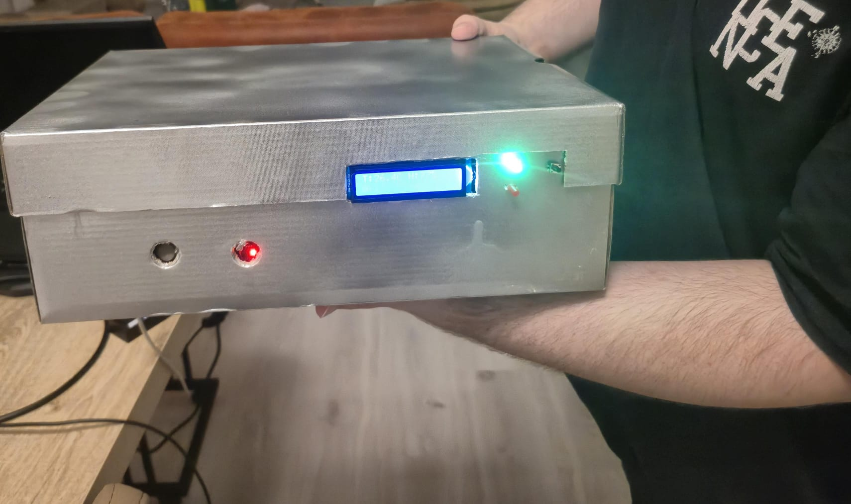
Figure 2. The finished system in its case. The LCD shows the live temperature and humidity, and the green LED means there is no alarm.
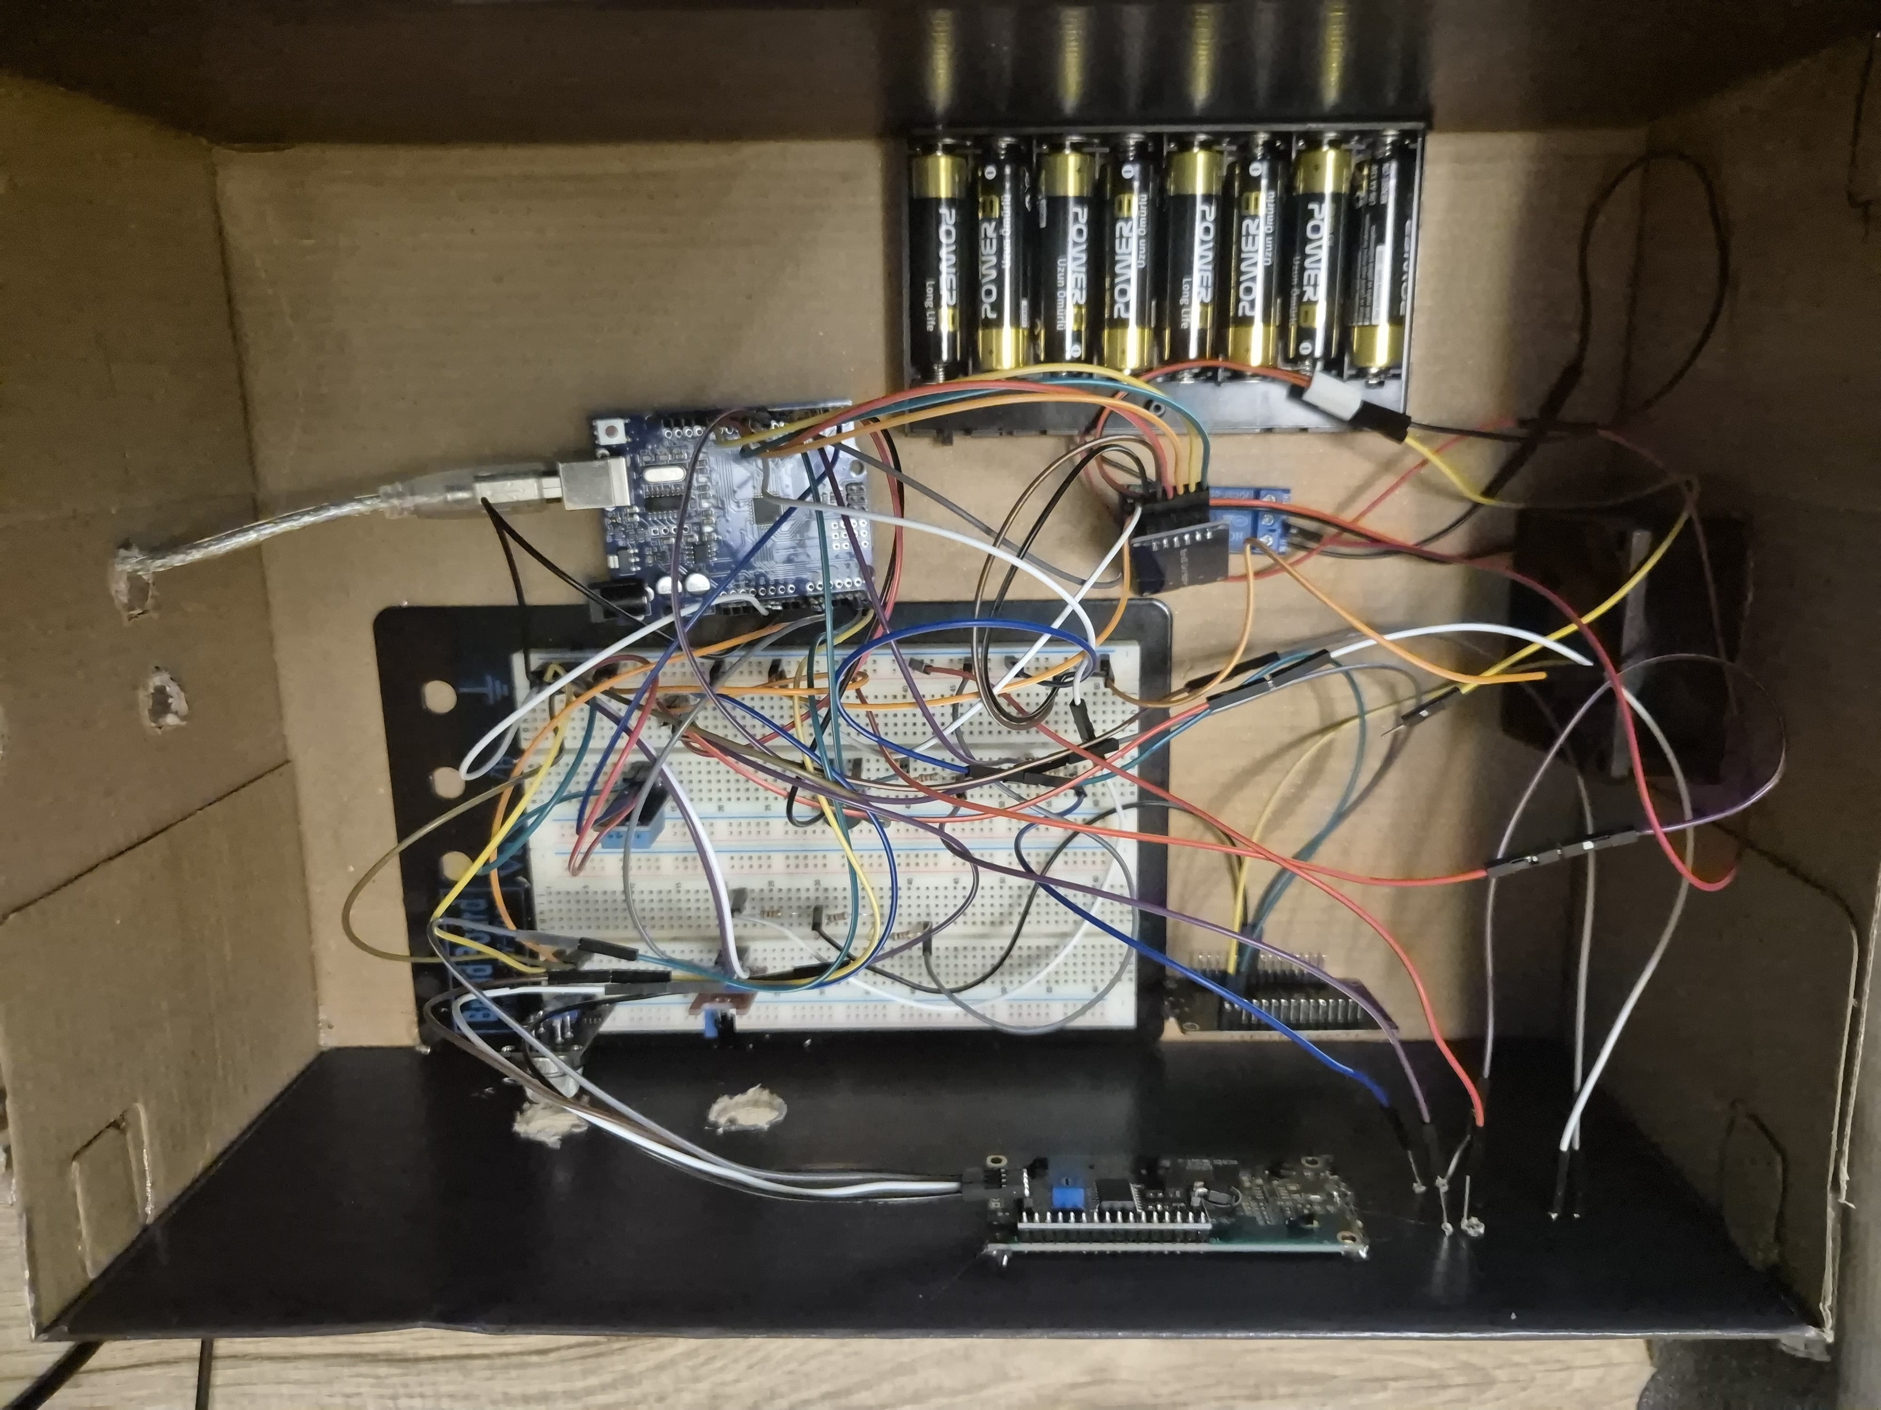
Figure 3. Inside the case: the Arduino Uno, the breadboard, the relay module, the NodeMCU and the 8 x AA battery pack.
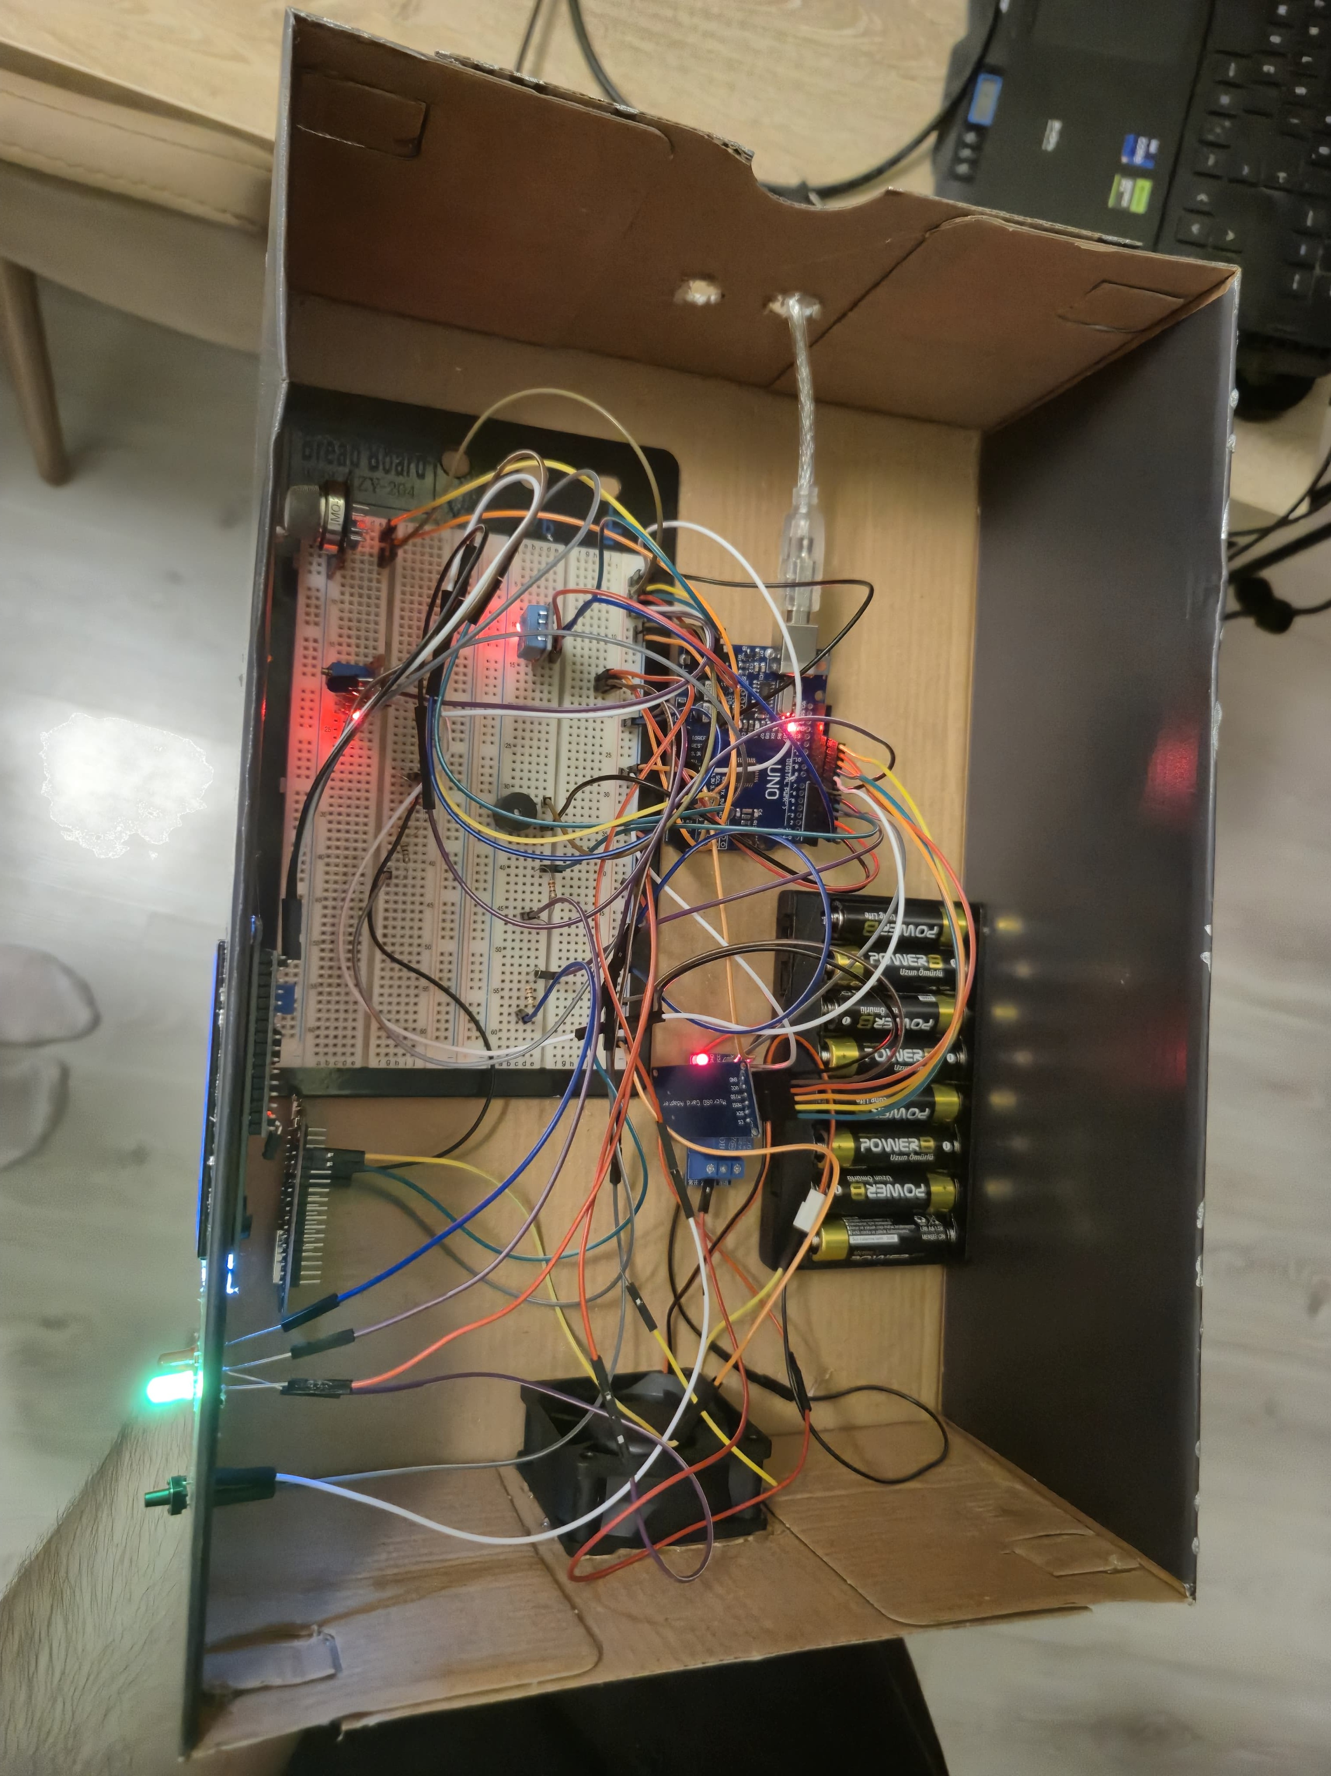
Figure 4. The system running with the case open. The MQ-2 and the flame sensor are on the breadboard and the 12 V fan is on the right.
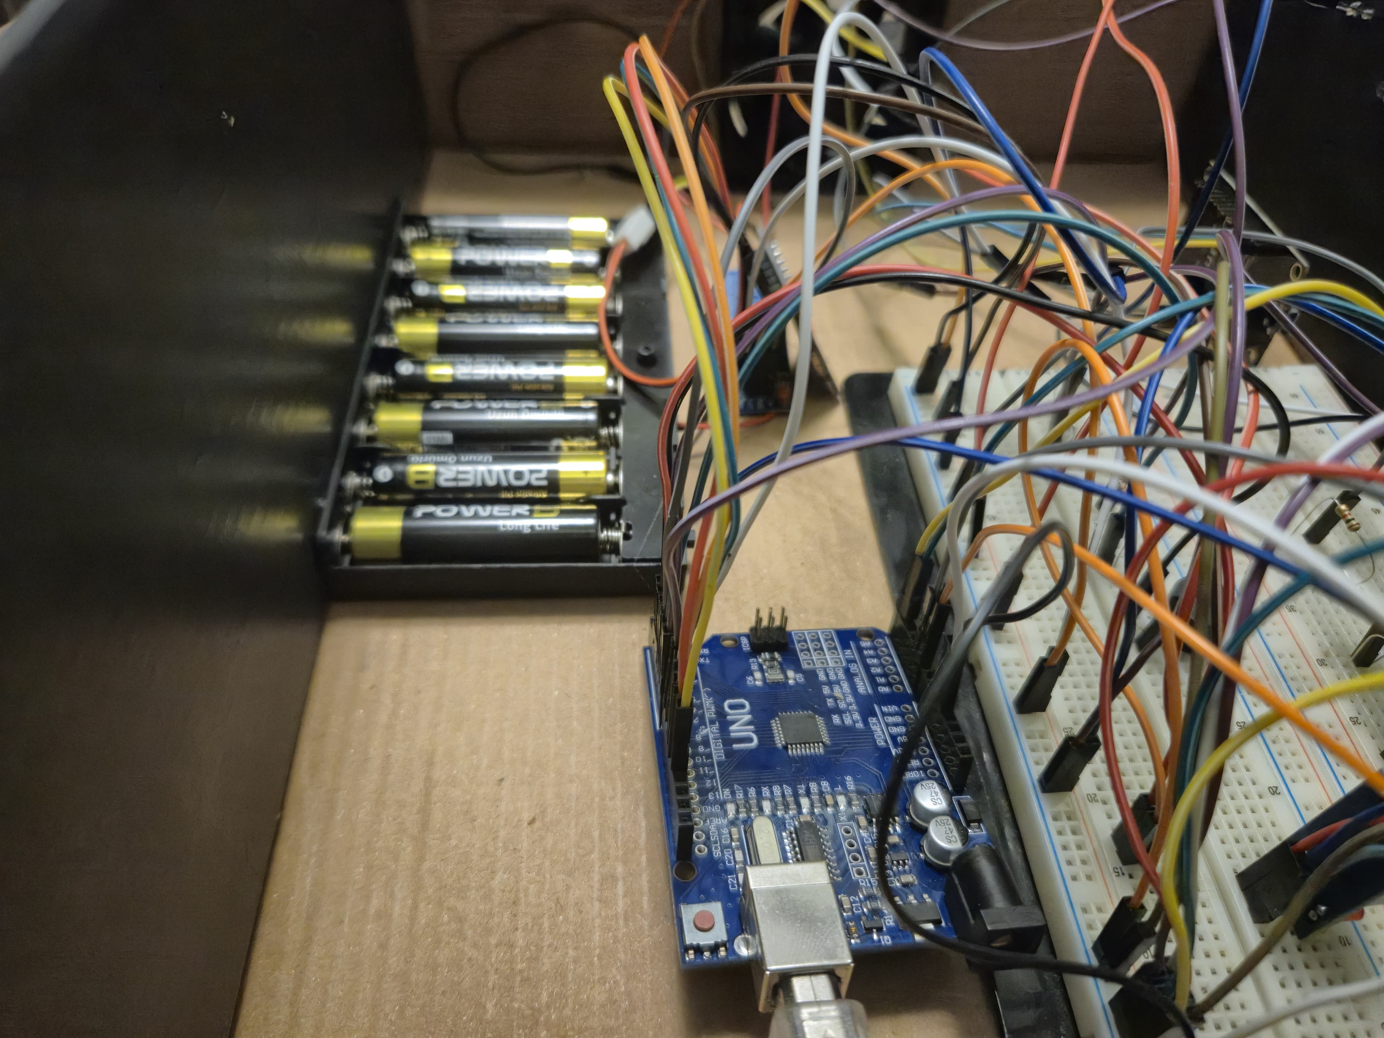
Figure 5. Close-up of the wiring between the Arduino and the breadboard, next to the battery pack that feeds the fan.

APPENDIX
This part describes the code. It is twelve files, grouped below by the part of the system they belong to. The code itself is not printed here so that the report stays short; each heading below says what its part is responsible for, and the full source is in the project repository. These parts only talk to each other through the interfaces I described in section 2.1.

Arduino firmware
This is the only part that can start an alarm or switch something on. It reads the three sensors, checks the gas, flame and heat conditions, drives the relay, buzzer, LEDs and LCD, writes a line to the SD card every two seconds, sends a measurement to the NodeMCU every second, and applies the commands that come back. The thresholds are kept in EEPROM. All the text is wrapped in the F() macro so it stays in flash. Without this the sketch fills up the 2 kB of RAM on the Uno and then the LCD stays blank and the EEPROM values get corrupted, which is exactly what happened to me. The tone() call only runs when the state changes, because that function sets up Timer2 again every time it is called and the loop runs a few thousand times per second.

NodeMCU firmware
This part only carries data, it makes no decisions. It reads the line coming from the Arduino, sends it to the server as JSON over TLS, takes the command out of the answer, and passes it back to the Arduino with a checksum at the end. Values that are not numbers, which happens when the DHT11 fails to read, are sent as null. Sending the word nan made the JSON invalid and the server rejected the whole record. The receive buffer is set to 256 bytes because the TLS handshake blocks the loop for one to three seconds and the Arduino keeps sending during that time.

Server application
The Flask app takes the measurements, saves them to Supabase, and puts the current commands in the answer to the same request. It also notices when the alarm turns on so it can send a notification, clears the mute flag when the alarm ends, serves the web page, and reports how old the last reading is so the app can tell a dead device from a safe one. Threshold values are checked against the sensor ranges before they are saved.

Database schema
This creates the commands table, which has only one row and holds the wanted state, an index on the timestamp for the history queries, and a daily job that deletes records older than seven days. The cleanup is necessary because one record every five seconds is about 17000 rows a day, which would fill the free storage in a few months.

Web page
The web page shows the live values, the controls, a chart with four lines and selectable time ranges, a second chart for the alarm and fan history, an alarm list and a history table. The access key is typed once and kept in the browser instead of being written in the page. The chart is resized after it is created, because it can be built before the page layout is finished. When that happens the container has zero width and the chart never appears.

Android application
The app is written in Kotlin with Jetpack Compose and is made of six files. MainActivity.kt draws the screen. It asks the server for the live values and the command state, holds the fan, mute and threshold controls, and draws the chart. If the server says the last reading is old, the screen stops showing NORMAL and shows a warning instead. MonitorService.kt is the part that keeps working when the app is closed. It checks the server every ten seconds and builds the alarm notification itself, so I did not need Firebase or any push service. The notification only appears when the alarm starts, not again while it continues, and losing the connection uses a separate and quieter channel, so a Wi-Fi problem at night does not wake anyone up with an alarm sound.
Api.kt has all the network code. It uses HttpURLConnection and the org.json parser that Android already has, so the app needs no networking library, and its date parser accepts the different formats the database can return. Chart.kt draws the chart on a Compose canvas instead of using a chart library. Temperature and humidity are on a 0 to 100 scale and gas and flame on 0 to 1023, because with one shared scale the temperature line is squashed at the bottom and cannot be seen, and a missing reading cuts the line instead of being guessed. Settings.kt keeps the server address and the access key on the phone, never inside the app, and BootReceiver.kt starts the monitoring again after the phone is restarted so it does not stop without me noticing.

Server tests
These tests cover the parts of the server that make decisions: thinning out the history data, finding the moment the alarm turns on, checking the threshold ranges, and refusing commands without a key. They do not connect to the database.

