

**ELE227 FUNDAMENTALS OF DIGITAL SYSTEM LABORATORY**

**PRELIMINARY WORK-3**

**Student**

**Name: Egemen Can**

**Surname: Ayduğan**

**ID: 21728036**

**1.)**

**Circuit Diagram:**

|  |
| --- |
|  |

**VHDL Implementation**

|  |  |
| --- | --- |
| entity DECODER is  Port ( A : in STD_LOGIC;  B : in STD_LOGIC;  C : in STD_LOGIC;  D : out STD_LOGIC_VECTOR (7 downto 0));  end DECODER;  architecture Behavioral of DECODER is  begin  D(0) <= (not A) and (not B) and (not C);  D(1) <= (not A) and (not B) and C;  D(2) <= (not A) and B and (not C);  D(3) <= (not A) and B and C;  D(4) <= A and (not B) and (not C);  D(5) <= A and (not B) and C;  D(6) <= A and B and (not C);  D(7) <= A and B and C;  end Behavioral; | entity FullSubstractorByDecoder is  Port ( x : in STD_LOGIC;  y : in STD_LOGIC;  z : in STD_LOGIC;  Dif : out STD_LOGIC;  Bor : out STD_LOGIC);  end FullSubstractorByDecoder;  architecture Behavioral of  FullSubstractorByDecoder is  component DECODER  Port ( A : in STD_LOGIC;  B : in STD_LOGIC;  C : in STD_LOGIC;  D : out STD_LOGIC_VECTOR (7 downto 0));  end component;  signal T : STD_LOGIC_VECTOR (7 downto 0);  begin  Dec1 : DECODER port map(x,y,z,T(7 downto 0));  Dif <= T(1) or T(2) or T(4) or T(7);  Bor <= T(1) or T(2) or T(3) or T(7);  end Behavioral; |

**RLT Schematic:**

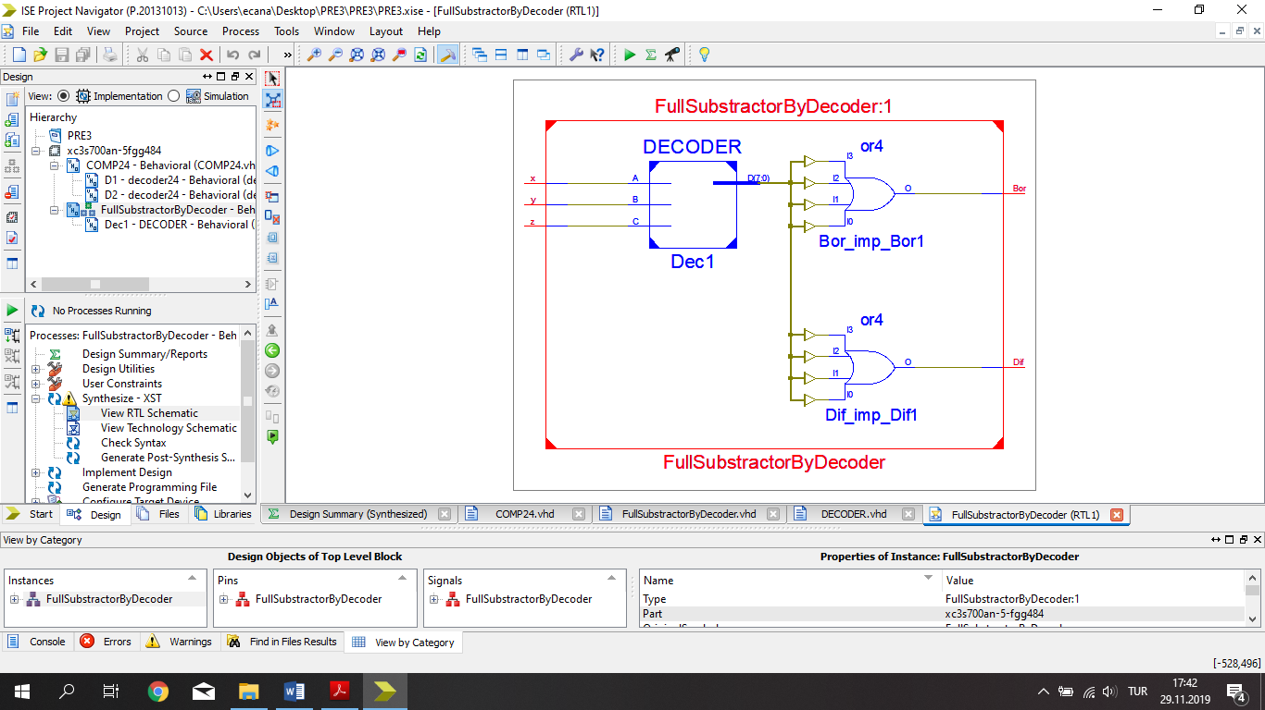

**TEST BENCH INPUT:**

stim_proc: process

begin

x <='0';

y <='0';

z <='0';

wait for 100 ns;

x <='0';

y <='0';

z <='1';

wait for 100 ns;

x <='0';

y <='1';

z <='0';

wait for 100 ns;

x <='0';

y <='1';

z <='1';

wait for 100 ns;

x <='1';

y <='0';

z <='0';

wait for 100 ns;

x <='1';

y <='0';

z <='1';

wait for 100 ns;

x <='1';

y <='1';

z <='0';

wait for 100 ns;

x <='1';

y <='1';

z <='1';

wait;

end process;

**TEST BENCH RESULTS:**

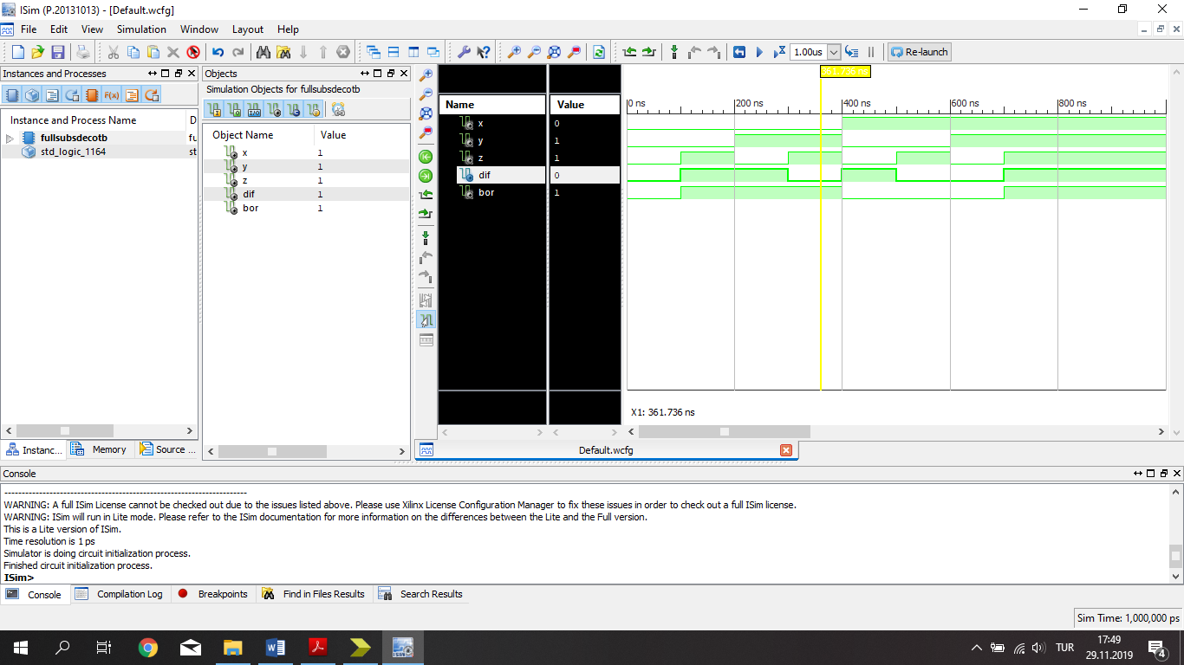

**2.)**

**Circuit Diagram:**

|  |
| --- |
|  |

**VHDL Implementation**

|  |  |
| --- | --- |
| entity FourXOneMux is  Port ( I : in STD_LOGIC_VECTOR (3 downto 0);  S : in STD_LOGIC_VECTOR (1 downto 0);  Y : out STD_LOGIC);  end FourXOneMux;  architecture Behavioral of FourXOneMux is  begin  Y <= ((not S(1)) and (not S(0)) and I(0)) or  ((not S(1)) and S(0) and I(1)) or  (S(1) and (not S(0)) and I(2)) or  (S(1) and S(0) and I(3));  end Behavioral; | entity Fonkby4x1Mux is  Port ( x : in STD_LOGIC;  y : in STD_LOGIC;  z : in STD_LOGIC;  F : out STD_LOGIC);  end Fonkby4x1Mux;  architecture Behavioral of Fonkby4x1Mux is  component FourXOneMux  Port ( I : in STD_LOGIC_VECTOR (3 downto 0);  S : in STD_LOGIC_VECTOR (1 downto 0);  Y : out STD_LOGIC);  end component;  signal T : STD_LOGIC_VECTOR (3 downto 0);  signal K : STD_LOGIC_VECTOR (1 downto 0);  begin  T(0) <= '1';  T(1) <= z;  T(2) <= '1';  T(3) <= '0';  K(0) <= y;  K(1) <= x;  M1: FourXOneMux port map (T(3 downto 0),K(1 downto 0),F);  end Behavioral; |

**RLT Schematic:**

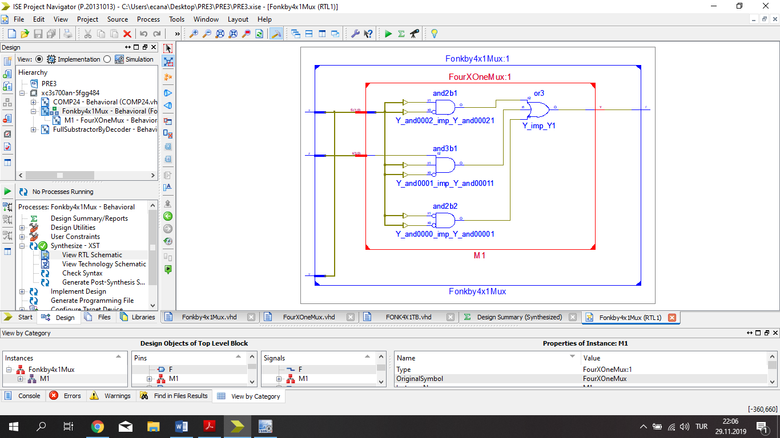

**TEST BENCH INPUT:**

stim_proc: process

begin

x<='0';

y<='0';

z<='0';

wait for 100 ns;

x<='0';

y<='0';

z<='1';

wait for 100 ns;

x<='0';

y<='1';

z<='0';

wait for 100 ns;

x<='0';

y<='1';

z<='1';

wait for 100 ns;

x<='1';

y<='0';

z<='0';

wait for 100 ns;

x<='1';

y<='0';

z<='1';

wait for 100 ns;

x<='1';

y<='1';

z<='0';

wait for 100 ns;

x<='1';

y<='1';

z<='1';

wait;

end process;

**TEST BENCH RESULTS:**

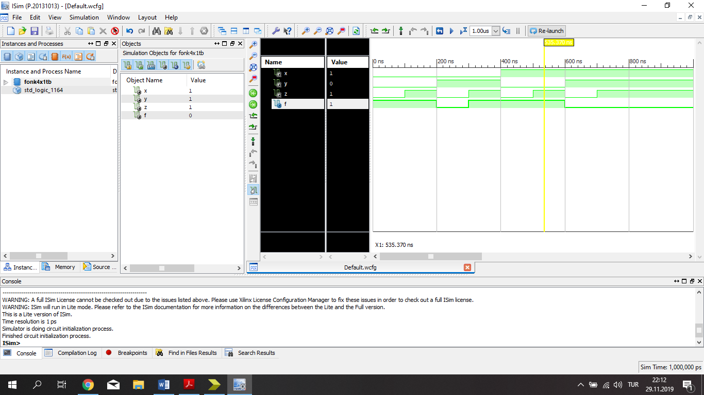

**3.)**

**Circuit Diagram:**

|  |
| --- |
|  |

**VHDL Implementation:**

|  |  |
| --- | --- |
| entity decoder24 is  Port ( A : in STD_LOGIC;  B : in STD_LOGIC;  D : out STD_LOGIC_VECTOR (3 downto 0));  end decoder24;  architecture Behavioral of decoder24 is  begin  D(0) <= (not A) and (not B);  D(1) <= (not A) and B;  D(2) <= A and (not B);  D(3) <= A and B;  end Behavioral; | entity COMP24 is  Port ( A : in STD_LOGIC_VECTOR (1 downto 0);  B : in STD_LOGIC_VECTOR (1 downto 0);  G : out STD_LOGIC;  E : out STD_LOGIC;  L : out STD_LOGIC);  end COMP24;  architecture Behavioral of COMP24 is  COMPONENT decoder24  Port ( A : in STD_LOGIC;  B : in STD_LOGIC;  D : out STD_LOGIC_VECTOR (3 downto 0));  end COMPONENT;  signal T : STD_LOGIC_VECTOR (7 downto 0);  begin  D1 : decoder24 port map(A(0),B(0),T(3 downto 0));  D2 : decoder24 port map(A(1),B(1),T(7 downto 4));  G <= T(6) or ((T(7) or T(4)) and T(2)) ;  L <= T(5) or ((T(7) or T(4)) and T(1)) ;  E <= (T(7) or T(4)) and (T(3) or T(0));  end Behavioral; |

**RLT Schematic:**

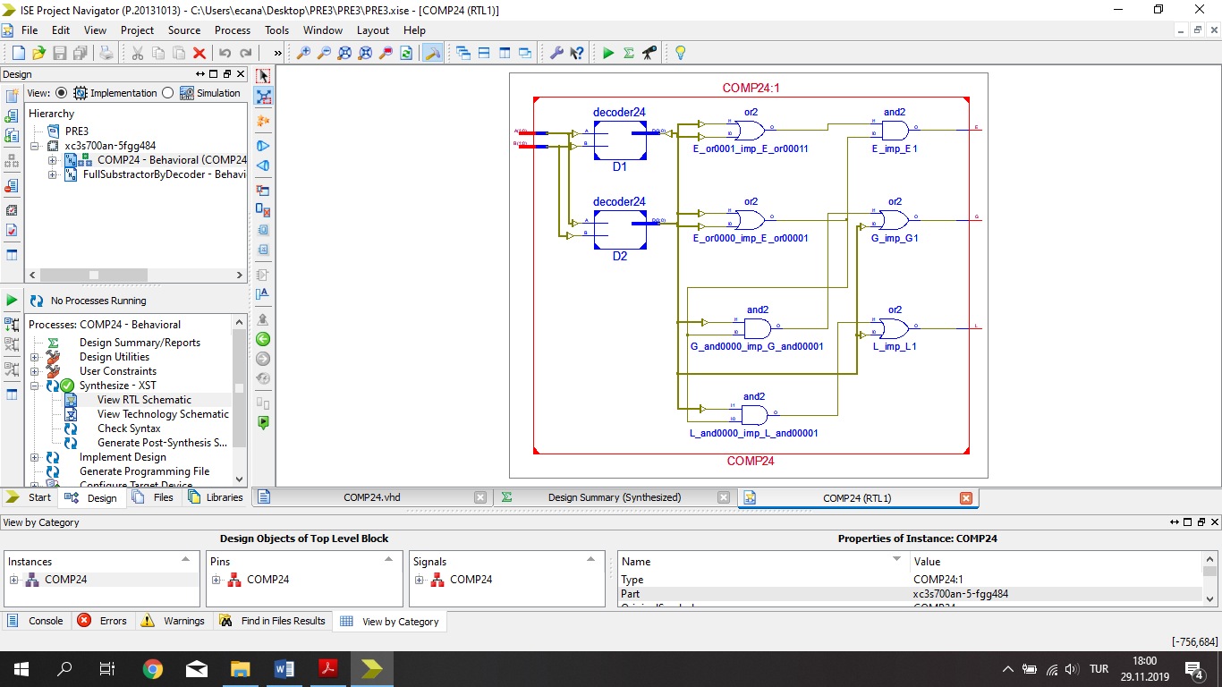

**TEST BENCH INPUT:**

stim_proc: process

begin

A <= "00";

B <= "00";

wait for 100 ns;

A <= "00";

B <= "10";

wait for 100 ns;

A <= "00";

B <= "11";

wait for 100 ns;

A <= "01";

B <= "00";

wait for 100 ns;

A <= "01";

B <= "01";

wait for 100 ns;

A <= "10";

B <= "01";

wait for 100 ns;

A <= "10";

B <= "10";

wait for 100 ns;

A <= "10";

B <= "11";

wait for 100 ns;

A <= "11";

B <= "10";

wait for 100 ns;

A <= "11";

B <= "11";

wait;

end process;

**TEST BENCH RESULTS:**

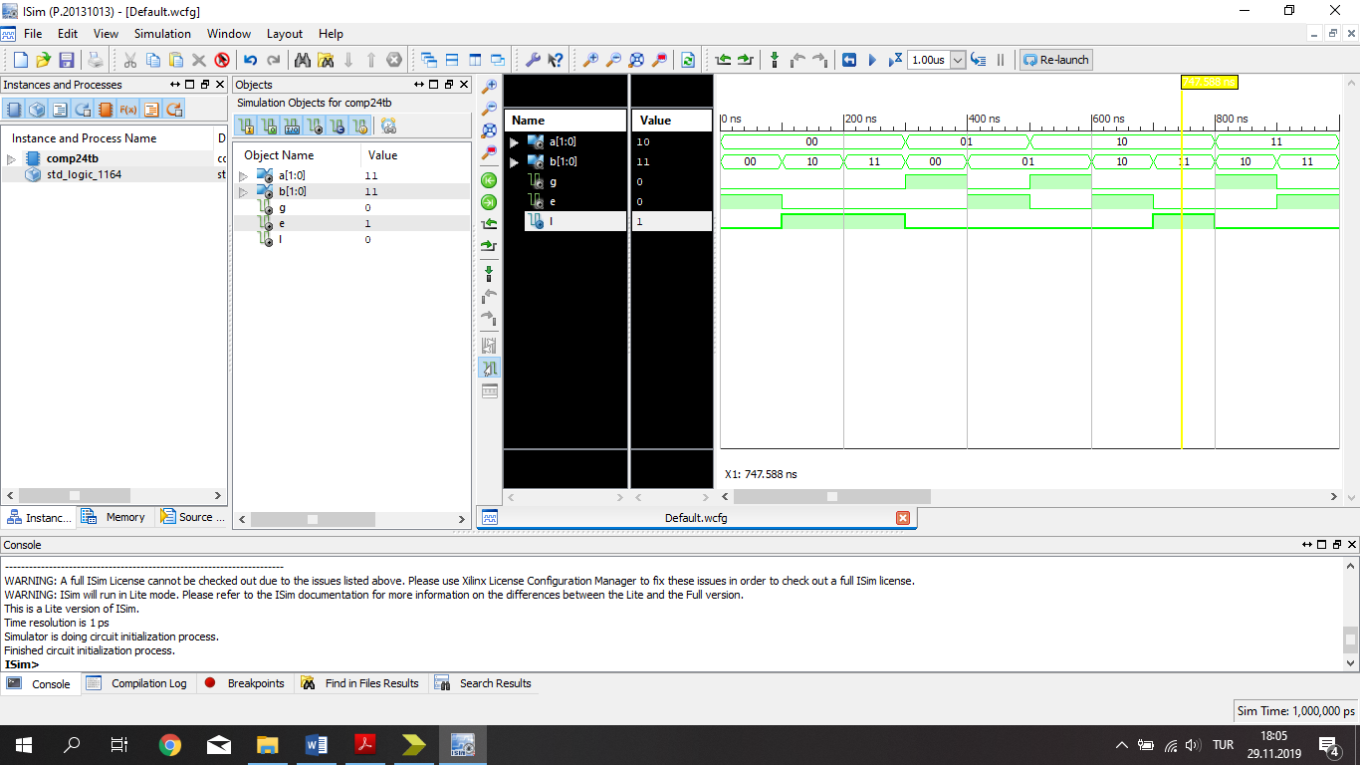

**4.)**

**Circuit Diagram:**

|  |
| --- |
|  |

**VHDL Implementation**

|  |  |
| --- | --- |
| entity ShiftAdder is  Port ( A : in STD_LOGIC_VECTOR (3 downto 0);  S : out STD_LOGIC_VECTOR (3 downto 0));  end ShiftAdder;  architecture Behavioral of ShiftAdder is  begin  S(0)<= ((not A(3)) and (not A(2)) and A(0))or ((not A(3)) and A(2) and A(1) and (not A(0)))or (A(3) and (not A(2)) and (not A(1)) and (not A(0)));    S(1)<= ((not A(3)) and (not A(2)) and A(1))or ((not A(3)) and A(1) and A(0))or  (A(3) and (not A(2)) and (not A(1)) and (not A(0)));    S(2)<= (A(3) and (not A(2)) and (not A(1)) and A(0))or ((not A(3)) and A(2) and (not A(1)) and (not A(0)));    S(3)<= ((not A(3)) and A(2) and A(0))or  ((not A(3)) and A(2) and A(1))or (A(3) and (not A(2)) and (not A(1)));  end Behavioral; | entity Converter is  Port ( A : in STD_LOGIC_VECTOR (5 downto 0);  B : out STD_LOGIC_VECTOR (6 downto 0));  end Converter;  architecture Behavioral of Converter is  component ShiftAdder  Port ( A : in STD_LOGIC_VECTOR (3 downto 0);  S : out STD_LOGIC_VECTOR (3 downto 0));  end component;  signal T : STD_LOGIC_VECTOR (9 downto 0);  signal K : STD_LOGIC_VECTOR (3 downto 0);  begin  K(3)<= '0';  K(2)<= A(5);  K(1)<= A(4);  K(0)<= A(3);  B(6)<= T(9);  T(5)<= A(2);  B(5)<= T(4);  T(0)<= A(1);  SA1 : ShiftAdder port map (K(3 downto 0),T(9 downto 6));  SA2 : ShiftAdder port map (T(8 downto 5),T(4 downto 1));  SA3 : ShiftAdder port map (T(3 downto 0),B(4 downto 1));  B(0) <= A(0);  end Behavioral; |

**RLT Schematic:**

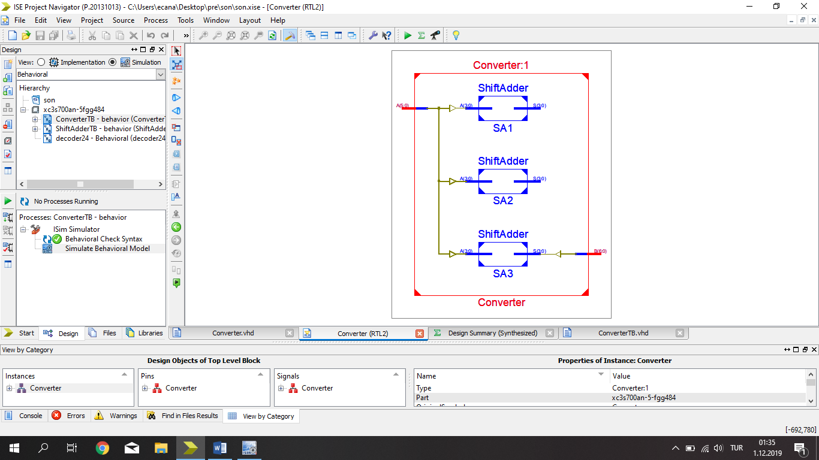

**TEST BENCH INPUT:**

stim_proc: process

begin

A <= "101010";

wait for 100 ns;

A <= "010101";

wait for 100 ns;

A <= "111111";

wait for 100 ns;

A <= "111110";

wait for 100 ns;

A <= "010110";

wait for 100 ns;

A <= "010001";

wait for 100 ns;

A <= "011011";

wait for 100 ns;

A <= "101101";

wait;

end process;

**TEST BENCH RESULTS:**

