**HACETTEPE UNIVERSITY**

**ELECTRICAL AND ELECTRONICS ENGINEERING**

**ELE227 FUNDAMENTALS OF DIGITAL SYSTEMS LABORATORY  
FALL 2019**

**Egemen Can AYDUĞAN - 21728036**

**1-A) S-R Latch Circuit Diagram**

**VHDL Implementation:**

**entity SRLatch is**

**Port ( S : in STD_LOGIC;**

**R : in STD_LOGIC;**

**Q : out STD_LOGIC;**

**Qn : out STD_LOGIC);**

**end SRLatch;**

**architecture Behavioral of SRLatch is**

**signal T : STD_LOGIC_VECTOR(1 downto 0);**

**begin**

**Q <= S nand T(1);**

**Qn <= R nand T(0);**

**T(0) <= S nand T(1);**

**T(1) <= R nand T(0);**

**end Behavioral;**

**RTL Schematic:**

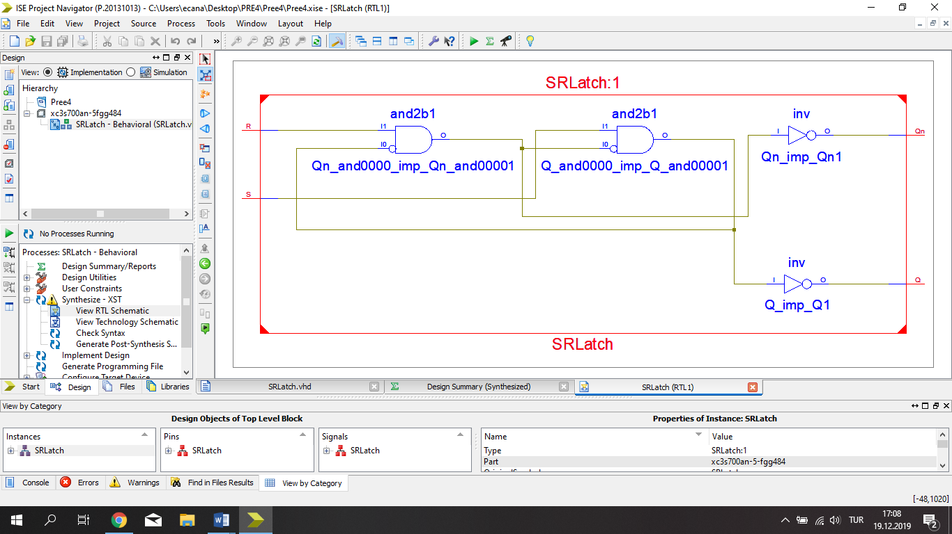

**1-B) D Latch**

**Circuit Diagram**

**VHDL Implementation:**

**entity DLatch is**

**Port ( D : in STD_LOGIC;**

**En : in STD_LOGIC;**

**Q : out STD_LOGIC;**

**Qn : out STD_LOGIC);**

**end DLatch;**

**architecture Behavioral of DLatch is**

**component SRLatch**

**Port ( S : in STD_LOGIC;**

**R : in STD_LOGIC;**

**Q : out STD_LOGIC;**

**Qn : out STD_LOGIC);**

**end component;**

**signal K : STD_LOGIC_VECTOR(1 downto 0);**

**begin**

**K(0) <= D nand En;**

**K(1) <= (not D) nand En;**

**C : SRLatch port map (K(0),K(1),Q,Qn);**

**end Behavioral;**

**RTL Schematic:**

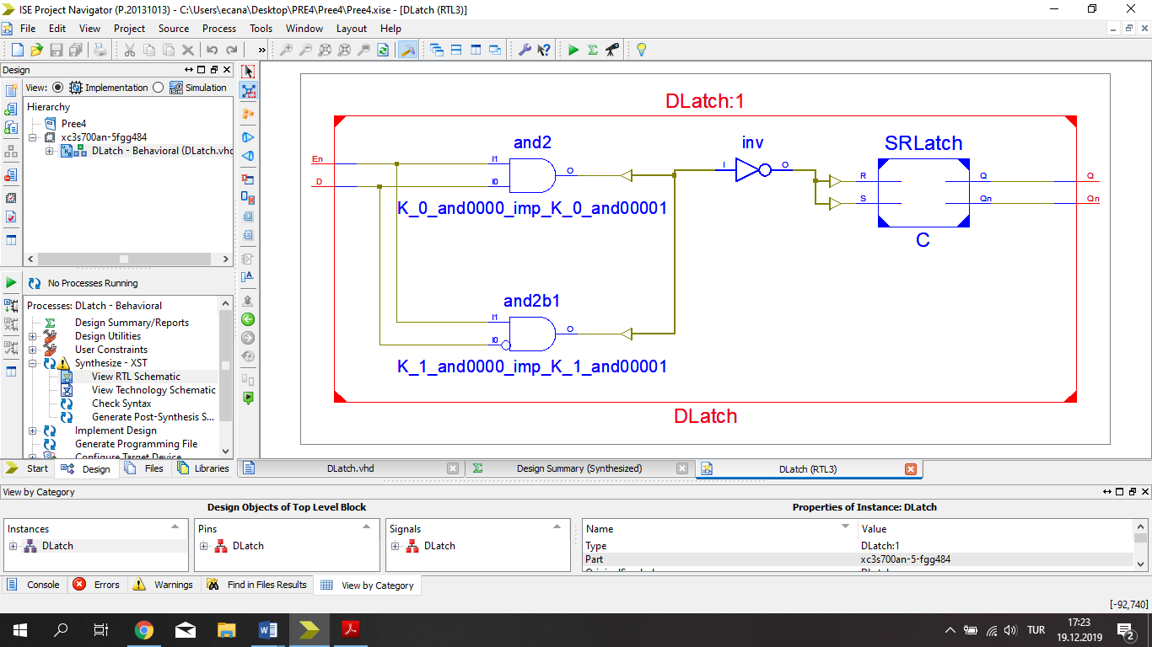

**1-C) Positive Edge D Flip-Flop**

**Circuit Diagram**

**VHDL Implementation:**

**entity DFlipFlop is**

**Port ( D : in STD_LOGIC;**

**Clk : in STD_LOGIC;**

**Q : out STD_LOGIC;**

**Qn : out STD_LOGIC);**

**end DFlipFlop;**

**architecture Behavioral of DFlipFlop is**

**component DLatch**

**Port ( D : in STD_LOGIC;**

**En : in STD_LOGIC;**

**Q : out STD_LOGIC;**

**Qn : out STD_LOGIC);**

**end component;**

**signal T : STD_LOGIC_VECTOR(1 downto 0);**

**begin**

**C1 : DLatch port map(D,Clk,T(0),T(1));**

**C2 : DLatch port map(T(0),(not Clk),Q,Qn);**

**end Behavioral;**

**RTL Schematic:**

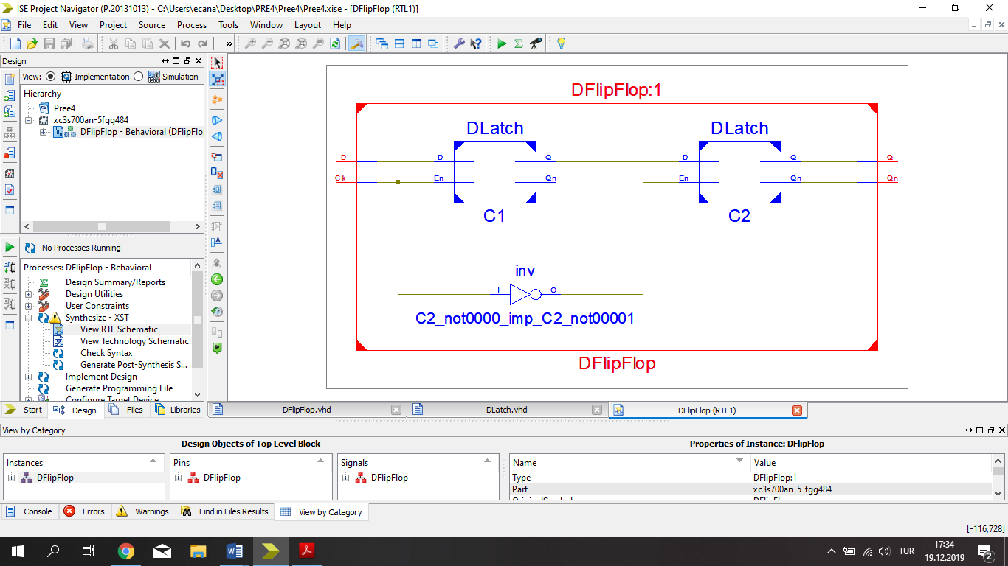

**1-D) Negative Edge T Flip-Flop**

**Circuit Diagram**

**VHDL Implementation:**

**entity NegTFlipFlop is**

**Port ( T : in STD_LOGIC;**

**Reset : in STD_LOGIC;**

**Clk : in STD_LOGIC;**

**Q : out STD_LOGIC;**

**Qn : out STD_LOGIC);**

**end NegTFlipFlop;**

**architecture Behavioral of NegTFlipFlop is**

**component JKFlipFlop**

**Port ( J : in STD_LOGIC;**

**K : in STD_LOGIC;**

**Reset : in STD_LOGIC;**

**Clk : in STD_LOGIC;**

**Q : out STD_LOGIC;**

**Qn : out STD_LOGIC);**

**end component;**

**begin**

**C : JKFlipFlop port map(T,T,Reset,(not Clk),Q,Qn);**

**end Behavioral;**

**RTL Schematic:**

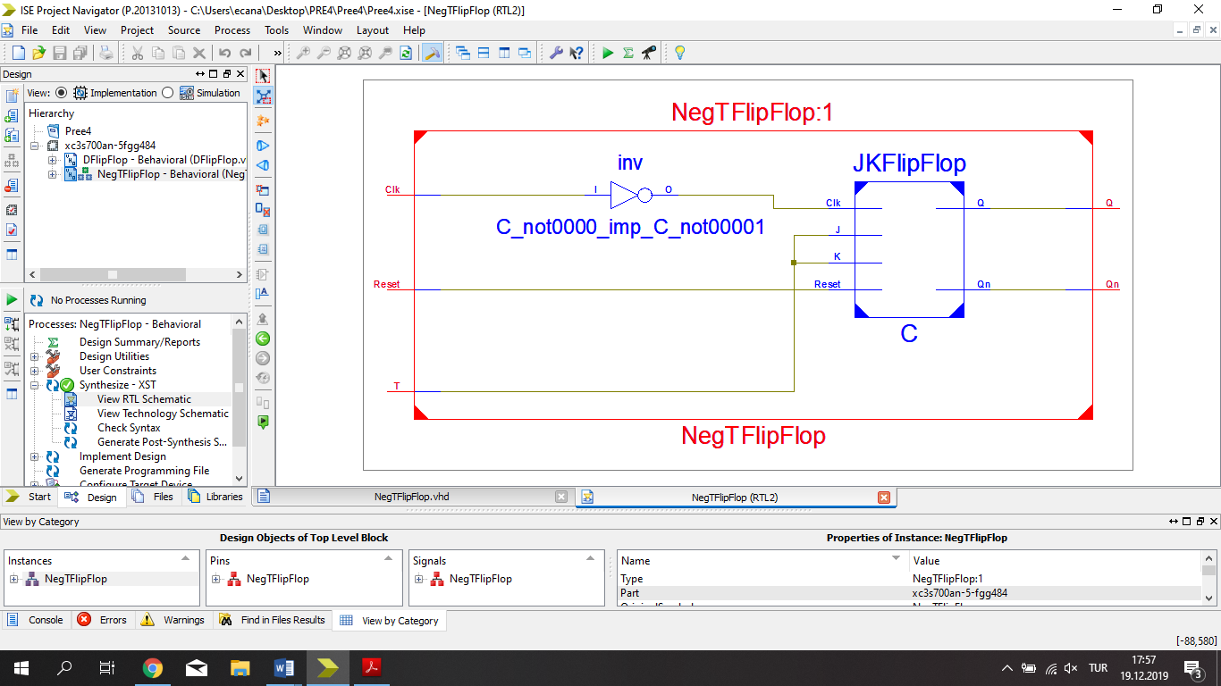

**2) Circuit Diagram**

**VHDL Implementation:**

**entity SequenceDetector is**

**Port ( X : in STD_LOGIC;**

**Reset : in STD_LOGIC;**

**Clk : in STD_LOGIC;**

**Y : out STD_LOGIC);**

**end SequenceDetector;**

**architecture Behavioral of SequenceDetector is**

**component JKFlipFlop**

**Port ( J : in STD_LOGIC;**

**K : in STD_LOGIC;**

**Reset : in STD_LOGIC;**

**Clk : in STD_LOGIC;**

**Q : out STD_LOGIC;**

**Qn : out STD_LOGIC);**

**end component;**

**signal JA,JB,JC,KA,KB,KC : STD_LOGIC;**

**signal A,B,C : STD_LOGIC;**

**begin**

**JA <= B and C and x;**

**KA <= '1';**

**JB <= (A and (not x)) or (C and (not x));**

**KB <= x or C;**

**JC <= x or B;**

**KC <= (not x) or B;**

**FF1 : JKFlipFlop port map(JA,KA,Reset,Clk,A);**

**FF2 : JKFlipFlop port map(JB,KB,Reset,Clk,B);**

**FF3 : JKFlipFlop port map(JC,KC,Reset,Clk,C);**

**Y <= A ;**

**end Behavioral;**

**RTL Schematic:**

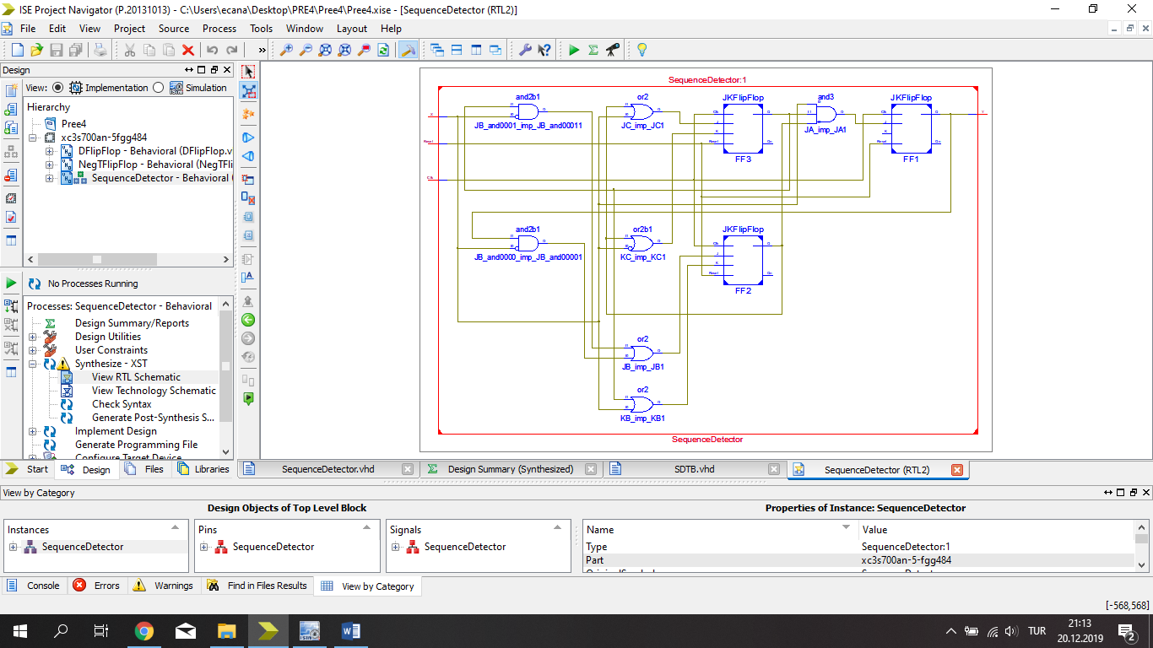

**Test Bench Input**

**constant Clk_period : time := 100 ns;**

**Clk_process :process**

**begin**

**Clk <= '1';**

**wait for Clk_period/2;**

**Clk <= '0';**

**wait for Clk_period/2;**

**end process;**

**stim_proc: process**

**begin**

**-- hold reset state for 100 ns.**

**Reset <= '1';**

**wait for 100 ns;**

**x <= '1';**

**Reset <= '0';**

**wait for 100 ns;**

**x <= '0';**

**wait for 100 ns;**

**x <= '0';**

**wait for 100 ns;**

**x <= '1';**

**wait for 100 ns;**

**x <= '0';**

**wait for 100 ns;**

**x <= '0';**

**wait for 100 ns;**

**x <= '1';**

**wait;**

**end process;**

**Test Bench Result**

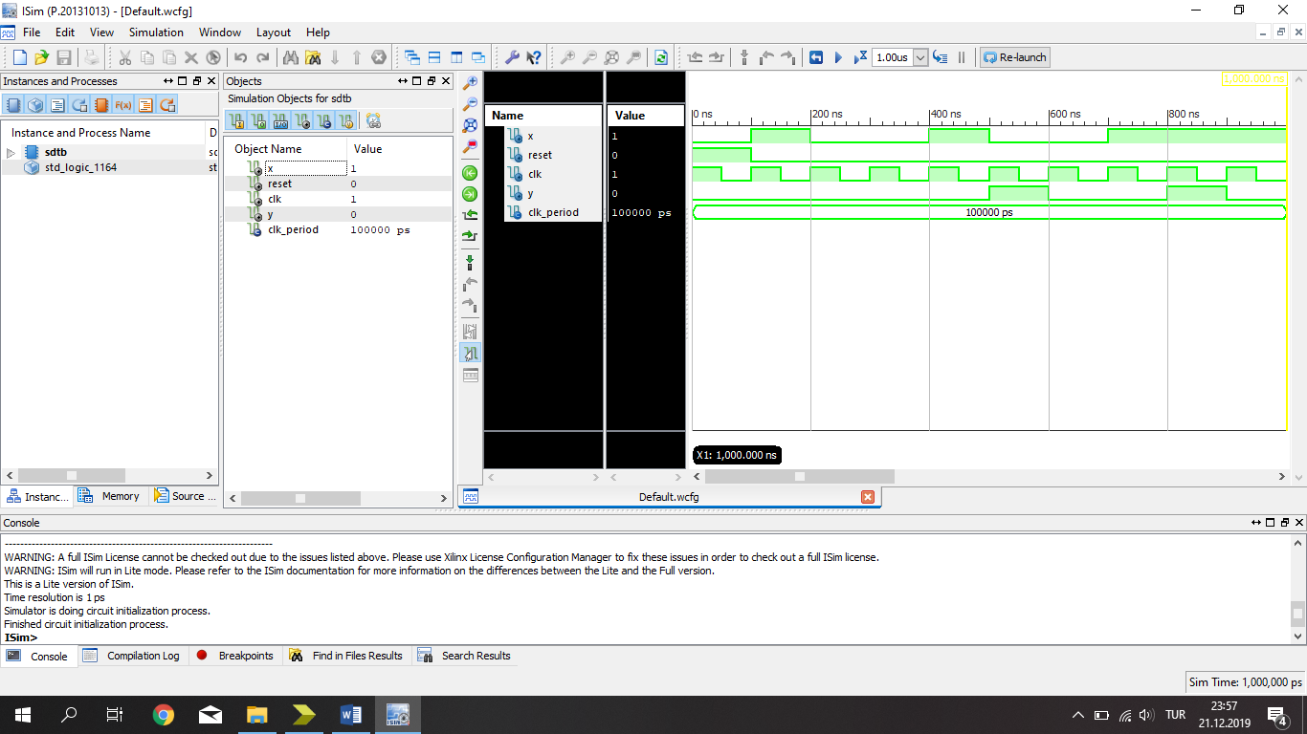

**3) Circuit Diagram**

**VHDL Implementation:**

**entity ODDParity is**

**Port ( D : in STD_LOGIC_VECTOR (11 downto 0);**

**Pin : in STD_LOGIC;**

**Reset : in STD_LOGIC;**

**Clock : in STD_LOGIC;**

**Pout : out STD_LOGIC;**

**Pche : out STD_LOGIC);**

**end ODDParity;**

**architecture Behavioral of ODDParity is**

**component TFF**

**Port ( T : in STD_LOGIC;**

**Reset : in STD_LOGIC;**

**Clock : in STD_LOGIC;**

**Q : out STD_LOGIC;**

**Qn : out STD_LOGIC);**

**end component;**

**signal T1,T2,T3 : STD_LOGIC;**

**begin**

**T1 <= D(0) xor D(1) xor D(2) xor D(3) xor**

**D(4) xor D(5) xor D(6) xor D(7) xor**

**D(8) xor D(9) xor D(10) xor D(11) ;**

**FF : TFF port map(T1,Reset,Clock,T2,T3);**

**Pout <= T2;**

**Pche <= Pin xnor T2;**

**end Behavioral;**

**RTL Schematic:**

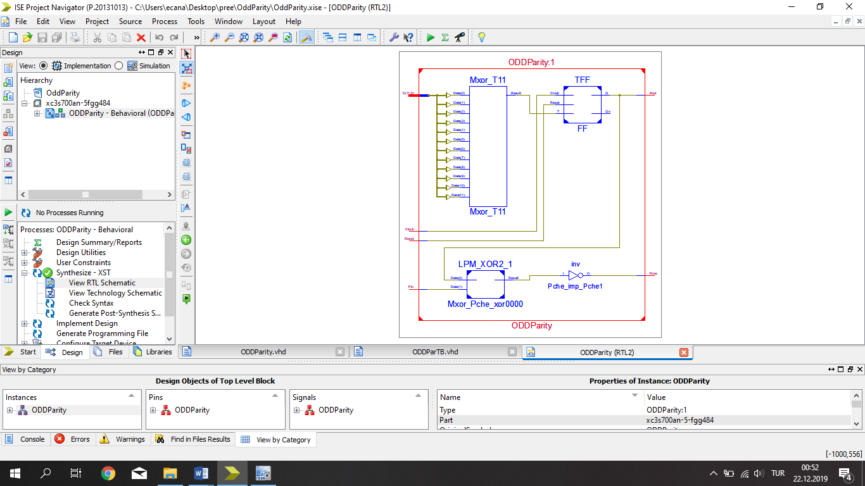

**Test Bench Input**

**constant Clock_period : time := 100 ns;**

**Clock_process :process**

**begin**

**Clock <= '1';**

**wait for Clock_period/2;**

**Clock <= '0';**

**wait for Clock_period/2;**

**end process;**

**begin**

**Reset <= '1';**

**wait for 100 ns;**

**D <= "101101010110";**

**Pin <= '1';**

**Reset <='0';**

**wait for 100 ns;**

**D <= "111100101101";**

**Pin <= '1';**

**wait for 100 ns;**

**D <= "000000001010";**

**Pin <= '0';**

**wait for 100 ns;**

**D <= "111111111111";**

**Pin <= '0';**

**wait;**

**end process;**

**Test Bench Result**

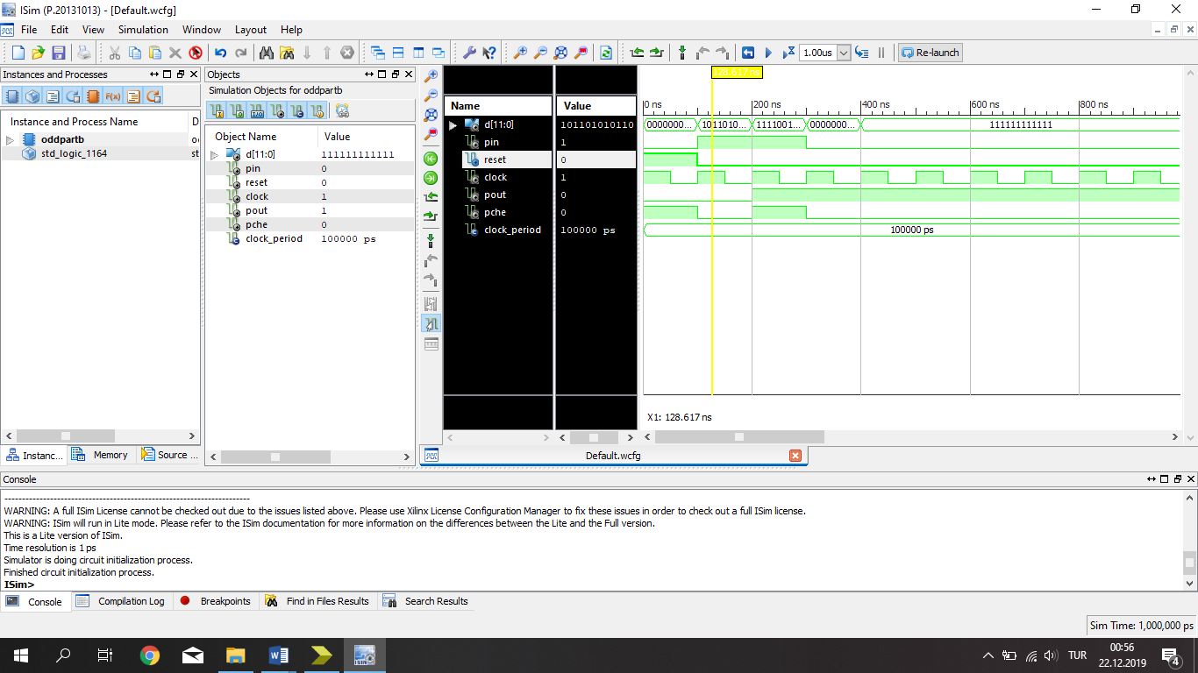

**4) Circuit Diagram**

|  |
| --- |
|  |

**VHDL Implementation:**

**entity JFF is**

**Port ( J : in STD_LOGIC;**

**K : in STD_LOGIC;**

**Reset : in STD_LOGIC;**

**Clock : in STD_LOGIC;**

**Q : out STD_LOGIC;**

**Qn : out STD_LOGIC);**

**end JFF;**

**architecture Behavioral of JFF is**

**component DFF**

**Port ( D : in STD_LOGIC;**

**Reset : in STD_LOGIC;**

**Clock : in STD_LOGIC;**

**Q : out STD_LOGIC;**

**Qn : out STD_LOGIC);**

**end component;**

**signal T1,T2,T3,T4,T5 : STD_LOGIC;**

**begin**

**T1 <= J and T5;**

**T2 <= (not K) and T4;**

**T3 <= T1 or T2;**

**FF : DFF port map (T3,Reset,Clock,T4,T5);**

**Q <= T4;**

**Qn <= T5;**

**end Behavioral;**

**RTL Schematic:**

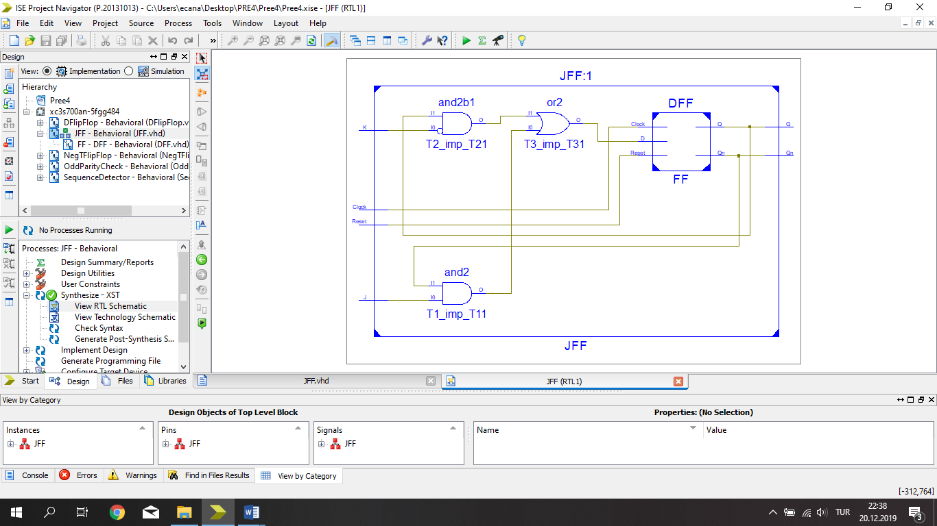

**Test Bench Input**

**constant Clock_period : time := 100 ns;**

**-- Clock process definitions**

**Clock_process :process**

**begin**

**Clock <= '0';**

**wait for Clock_period/2;**

**Clock <= '1';**

**wait for Clock_period/2;**

**end process;**

**stim_proc: process**

**begin**

**Reset <= '1';**

**wait for 100 ns;**

**J <= '0';**

**K <= '0';**

**Reset <= '0';**

**wait for 100 ns;**

**J <= '0';**

**K <= '1';**

**wait for 100 ns;**

**J <= '1';**

**K <= '0';**

**wait for 100 ns;**

**J <= '1';**

**K <= '1';**

**wait;**

**end process;**

**Test Bench Result**

