**HACETTEPE UNIVERSITY**

**ELECTRICAL AND ELECTRONICS ENGINEERING**

**ELE227 FUNDAMENTALS OF DIGITAL SYSTEMS**

**PRELIMINARY WORK 5**

**EGEMEN CAN AYDUĞAN - 21728036**

**1.A) Universal Shift Register**

**Circuit Diagram**

|  |
| --- |
|  |

**VHDL Implementation:**

entity UniversalShiftRegister is

Port ( I : in STD_LOGIC_VECTOR (3 downto 0);

S : in STD_LOGIC_VECTOR (1 downto 0);

MSB : in STD_LOGIC;

LSB : in STD_LOGIC;

Clock : in STD_LOGIC;

Reset : in STD_LOGIC;

O : out STD_LOGIC_VECTOR (3 downto 0));

end UniversalShiftRegister;

architecture Behavioral of UniversalShiftRegister is

component TFlipFlop

Port ( T : in STD_LOGIC;

Reset : in STD_LOGIC;

Clock : in STD_LOGIC;

Q : out STD_LOGIC;

Qn : out STD_LOGIC);

end component;

component MUX

Port ( I3 : in STD_LOGIC;

I2 : in STD_LOGIC;

I1 : in STD_LOGIC;

I0 : in STD_LOGIC;

S : in STD_LOGIC_VECTOR (1 downto 0);

O : out STD_LOGIC);

end component;

signal A : STD_LOGIC_VECTOR (3 downto 0);

signal L : STD_LOGIC_VECTOR (3 downto 0);

signal T : STD_LOGIC_VECTOR (3 downto 0);

begin

M3 : MUX port map(I(3),A(2),MSB,A(3),S,L(3));

M2 : MUX port map(I(2),A(1),A(3),A(2),S,L(2));

M1 : MUX port map(I(1),A(0),A(2),A(1),S,L(1));

M0 : MUX port map(I(0),LSB,A(1),A(0),S,L(0));

T(3) <= L(3) xor A(3);

T(2) <= L(2) xor A(2);

T(1) <= L(1) xor A(1);

T(0) <= L(0) xor A(0);

FF3 : TFlipFlop port map(T(3),Reset,Clock,A(3));

FF2 : TFlipFlop port map(T(2),Reset,Clock,A(2));

FF1 : TFlipFlop port map(T(1),Reset,Clock,A(1));

FF0 : TFlipFlop port map(T(0),Reset,Clock,A(0));

O(3) <= A(3);

O(2) <= A(2);

O(1) <= A(1);

O(0) <= A(0);

end Behavioral;

**RTL Schematic:**

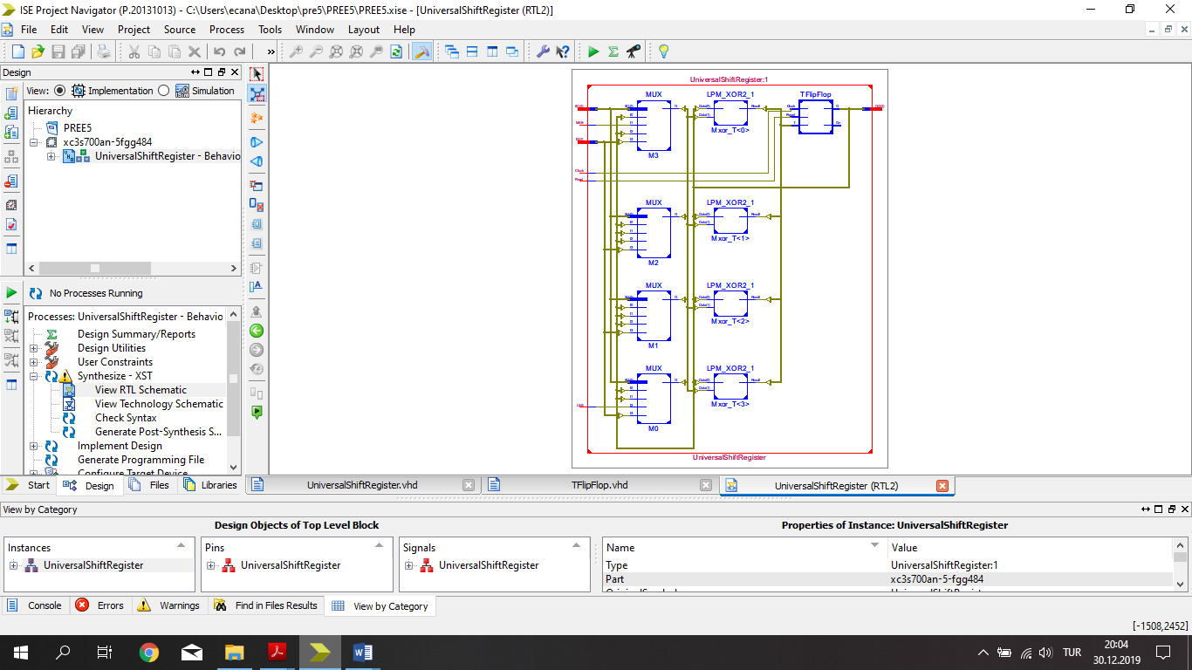

**Test Bench Input:**

signal I : std_logic_vector(3 downto 0) := (others => '0');

signal S : std_logic_vector(1 downto 0) := (others => '0');

signal MSB : std_logic := '0';

signal LSB : std_logic := '0';

signal Clock : std_logic := '0';

signal Reset : std_logic := '1';

signal O : std_logic_vector(3 downto 0);

constant Clock_period : time := 100 ns;

Clock_process :process

begin

Clock <= '0';

wait for Clock_period/2;

Clock <= '1';

wait for Clock_period/2;

end process;

stim_proc: process

begin

Reset <= '1';

wait for 100 ns;

I <= "1001";

S <= "00";

MSB <= '1';

LSB <= '0';

Reset <= '0';

wait for 100 ns;

I <= "1001";

S <= "01";

wait for 100 ns;

I <= "1001";

S <= "10";

wait for 100 ns;

I <= "1001";

S <= "11";

wait for 100 ns;

I <= "1100";

S <= "00";

wait for 100 ns;

I <= "1100";

S <= "01";

wait for 100 ns;

I <= "1100";

S <= "10";

wait for 100 ns;

I <= "1100";

S <= "11";

wait;

end process;

END;

**Test Bench Result:**

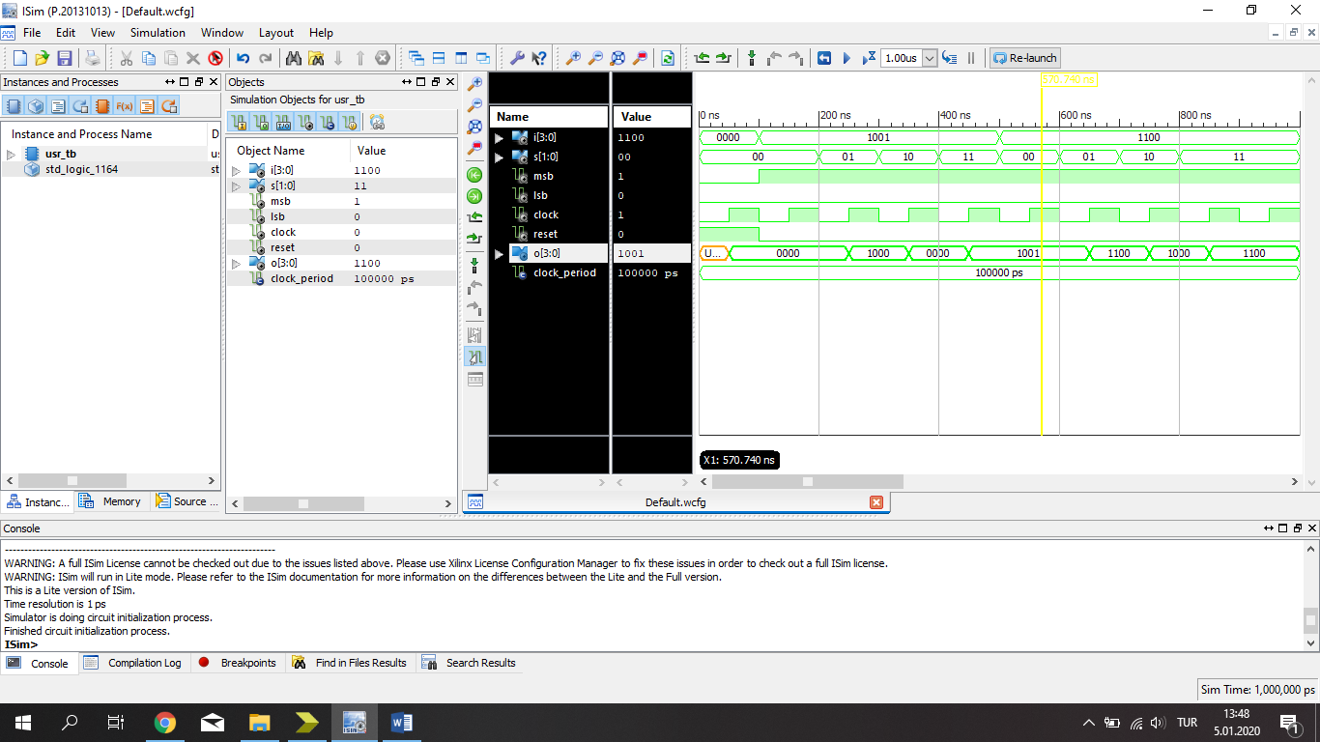

**1.B) UpDown Counter**

**Circuit Diagram**

|  |
| --- |
|  |

**VHDL Implementation:**

entity UpDownCounter is

Port ( Up : in STD_LOGIC;

Down : in STD_LOGIC;

Clock : in STD_LOGIC;

Reset : in STD_LOGIC;

O : out STD_LOGIC_VECTOR (3 downto 0));

end UpDownCounter;

architecture Behavioral of UpDownCounter is

component DFlipFlop

Port ( D : in STD_LOGIC;

Reset : in STD_LOGIC;

Clock : in STD_LOGIC;

Q : out STD_LOGIC;

Qn : out STD_LOGIC);

end component;

signal A : STD_LOGIC_VECTOR (3 downto 0);

signal B : STD_LOGIC_VECTOR (3 downto 0);

signal C : STD_LOGIC_VECTOR (6 downto 0);

signal F : STD_LOGIC_VECTOR (3 downto 0);

signal K : STD_LOGIC_VECTOR (3 downto 0);

begin

C(0) <= (not Up) and Down ;

K(0) <= Up or C(0);

F(0) <= K(0) xor A(0);

FF0 : DFlipFlop port map (F(0),Reset,Clock,A(0),B(0));

C(1) <= C(0) and B(0);

C(2) <= Up and A(0);

K(1) <= C(1) or C(2);

F(1) <= K(1) xor A(1);

FF1 : DFlipFlop port map (F(1),Reset,Clock,A(1),B(1));

C(3) <= C(1) and B(1);

C(4) <= C(2) and A(1);

K(2) <= C(3) or C(4);

F(2) <= K(2) xor A(2);

FF2 : DFlipFlop port map (F(2),Reset,Clock,A(2),B(2));

C(5) <= C(3) and B(2);

C(6) <= C(4) and A(2);

K(3) <= C(5) or C(6);

F(3) <= K(3) xor A(3);

FF3 : DFlipFlop port map (F(3),Reset,Clock,A(3),B(3));

O(0) <= A(0);

O(1) <= A(1);

O(2) <= A(2);

O(3) <= A(3);

end Behavioral;

**RTL Schematic:**

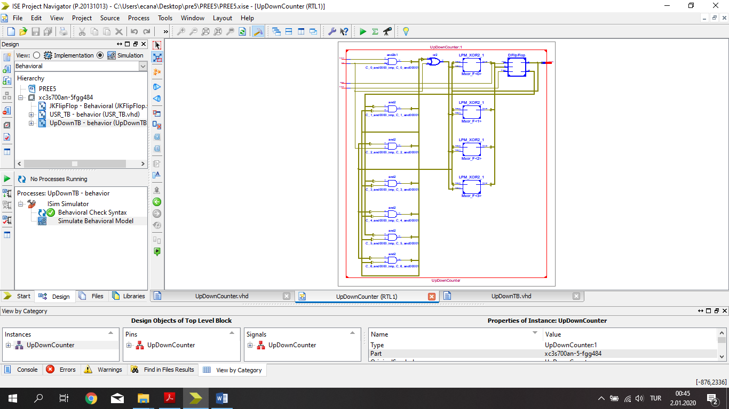

**Test Bench Input:**

signal Up : std_logic := '0';

signal Down : std_logic := '0';

signal Clock : std_logic := '0';

signal Reset : std_logic := '1';

signal O : std_logic_vector(3 downto 0);

constant Clock_period : time := 100 ns;

Clock_process :process

begin

Clock <= '0';

wait for Clock_period/2;

Clock <= '1';

wait for Clock_period/2;

end process;

stim_proc: process

begin

Reset <= '1';

wait for 100 ns;

Up <= '1';

Reset <= '0';

wait for 100 ns;

Up <= '1';

wait for 100 ns;

Up <= '1';

wait for 100 ns;

Up <= '1';

wait for 100 ns;

Up <= '0';

Down <= '1';

wait for 100 ns;

Up <= '0';

Down <= '1';

wait for 100 ns;

Up <= '0';

Down <= '1';

wait for 100 ns;

Up <= '0';

Down <= '1';

wait;

end process;

**Test Bench Result:**

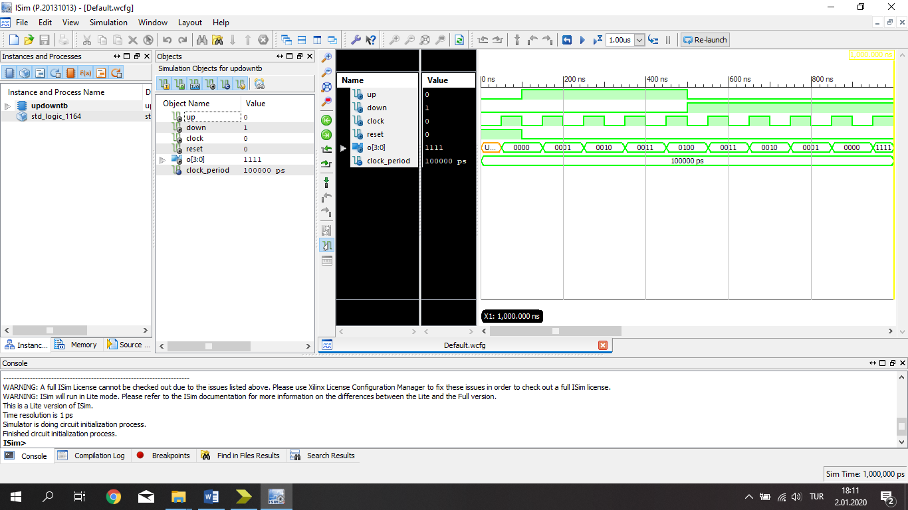

**1.C) Johnson Counter**

**Circuit Diagram**

|  |
| --- |
|  |

**VHDL Implementation**

entity JohnsonCounter is

Port ( Clock : in STD_LOGIC;

Reset : in STD_LOGIC;

O : out STD_LOGIC_VECTOR (3 downto 0));

end JohnsonCounter;

architecture Behavioral of JohnsonCounter is

component TFlipFlop

Port ( T : in STD_LOGIC;

Reset : in STD_LOGIC;

Clock : in STD_LOGIC;

Q : out STD_LOGIC;

Qn : out STD_LOGIC);

end component;

signal A : STD_LOGIC_VECTOR (3 downto 0);

signal B : STD_LOGIC_VECTOR (3 downto 0);

signal C : STD_LOGIC_VECTOR (3 downto 0);

begin

C(0) <= B(3) xor A(0);

FF0 : TFlipFlop port map(C(0),Reset,Clock,A(0),B(0));

C(1) <= A(1) xor A(0);

FF1 : TFlipFlop port map(C(1),Reset,Clock,A(1),B(1));

C(2) <= A(2) xor A(1);

FF2 : TFlipFlop port map(C(2),Reset,Clock,A(2),B(2));

C(3) <= A(3) xor A(2);

FF3 : TFlipFlop port map(C(3),Reset,Clock,A(3),B(3));

O(0) <= A(3);

O(1) <= A(2);

O(2) <= A(1);

O(3) <= A(0);

end Behavioral;

**RTL Schematic:**

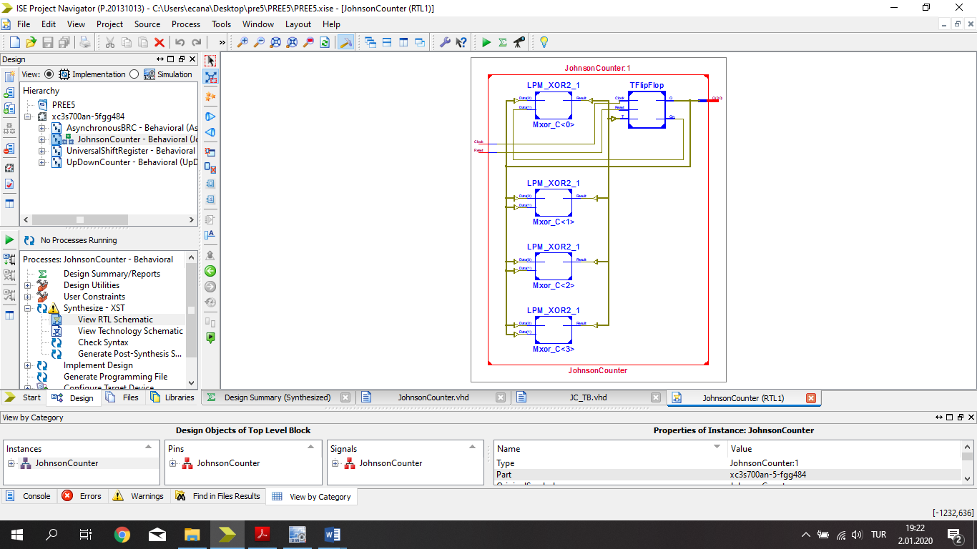

**Test Bench Input:**

signal Clock : std_logic := '0';

signal Reset : std_logic := '1';

signal O : std_logic_vector(3 downto 0);

constant Clock_period : time := 100 ns;

Clock_process :process

begin

Clock <= '0';

wait for Clock_period/2;

Clock <= '1';

wait for Clock_period/2;

end process;

stim_proc: process

begin

Reset <= '1';

wait for 100 ns;

Reset <= '0';

wait;

end process;

END;

**Test Bench Result:**

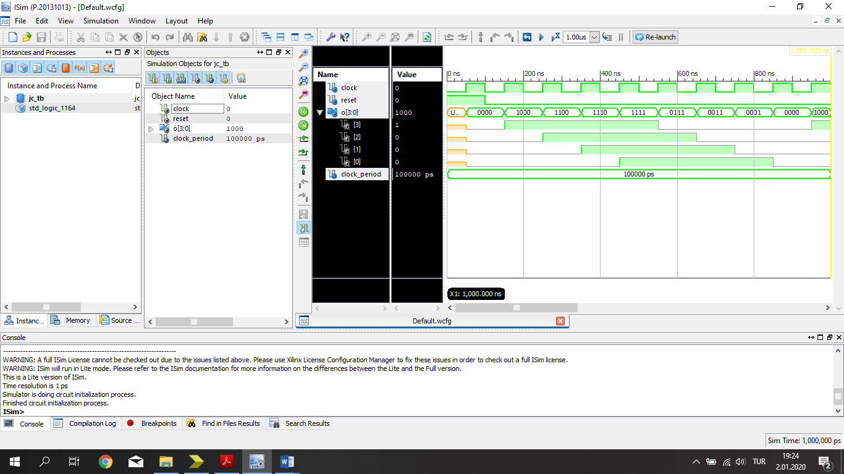

**1.D) Asynchronous Binary Ripple Counter**

**Circuit Diagram**

|  |
| --- |
|  |

**VHDL Implementation:**

entity AsynchronousBRC is

Port ( Clock : in STD_LOGIC;

Reset : in STD_LOGIC;

O : out STD_LOGIC_VECTOR (3 downto 0));

end AsynchronousBRC;

architecture Behavioral of AsynchronousBRC is

component JKFlipFlop

Port ( J : in STD_LOGIC;

K : in STD_LOGIC;

Reset : in STD_LOGIC;

Clock : in STD_LOGIC;

Q : out STD_LOGIC;

Qn : out STD_LOGIC);

end component;

signal A : STD_LOGIC_VECTOR (3 downto 0);

signal B : STD_LOGIC_VECTOR (3 downto 0);

begin

FF0 : JKFlipFlop port map (B(0),A(0),Reset,Clock,A(0),B(0));

FF1 : JKFlipFlop port map (B(1),A(1),Reset,not A(0),A(1),B(1));

FF2 : JKFlipFlop port map (B(2),A(2),Reset,not A(1),A(2),B(2));

FF3 : JKFlipFlop port map (B(3),A(3),Reset,not A(2),A(3),B(3));

O(0) <= A(0);

O(1) <= A(1);

O(2) <= A(2);

O(3) <= A(3);

end Behavioral;

**RTL Schematic:**

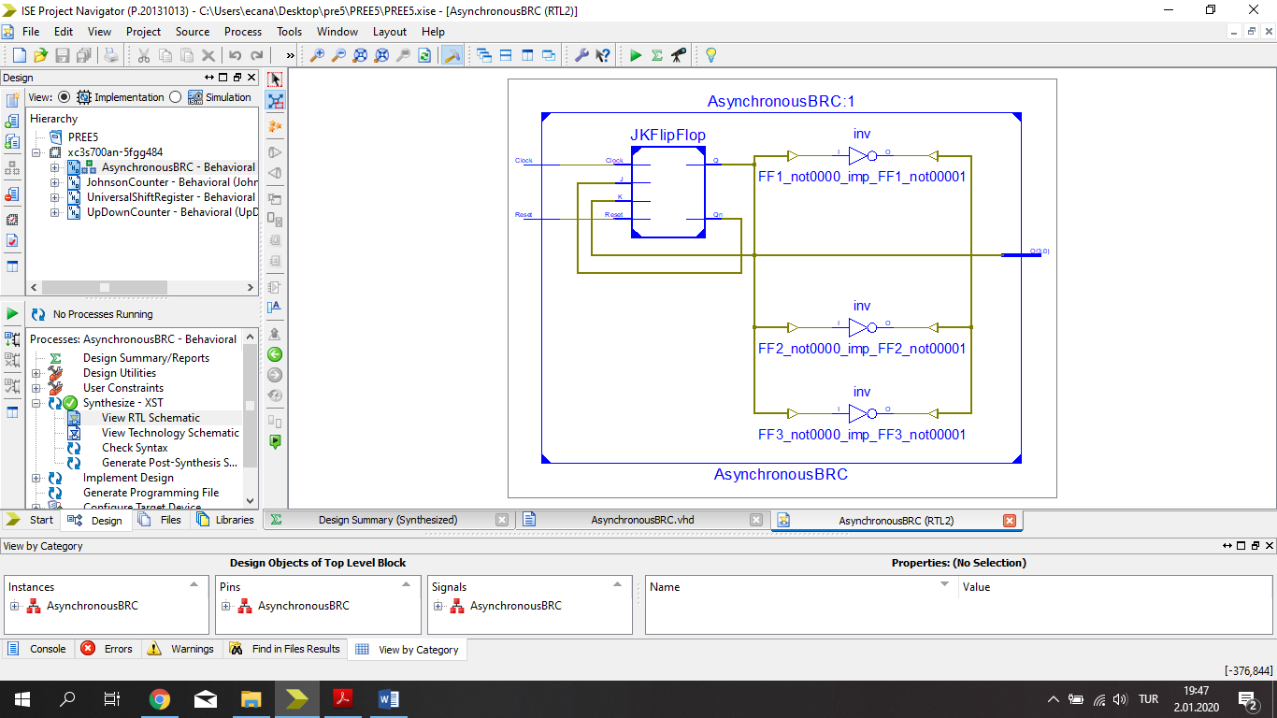

**Test Bench Input:**

signal Clock : std_logic := '0';

signal Reset : std_logic := '1';

signal O : std_logic_vector(3 downto 0);

constant Clock_period : time := 100 ns;

Clock_process :process

begin

Clock <= '0';

wait for Clock_period/2;

Clock <= '1';

wait for Clock_period/2;

end process;

stim_proc: process

begin

Reset <= '1';

wait for 100 ns;

Reset <= '0';

wait;

end process;

END;

**Test Bench Result:**

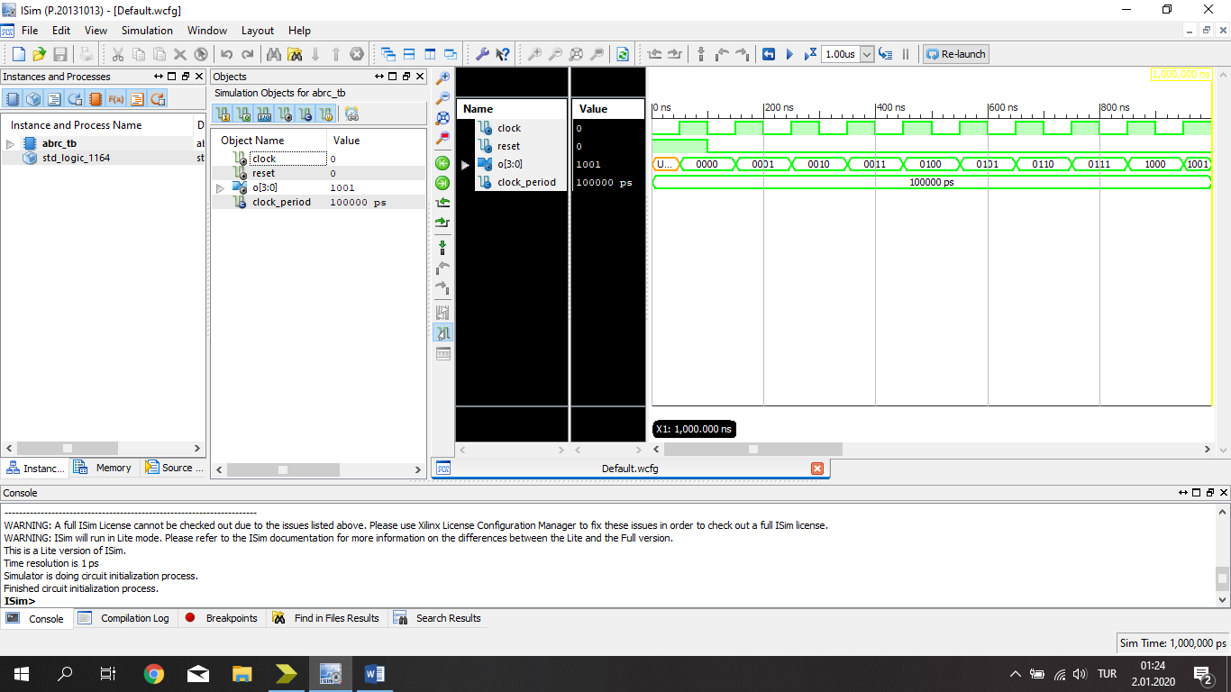

**2.) Binary Divider**

**Circuit Diagram**

|  |
| --- |
|  |

**VHDL Implementation:**

entity BinaryDivider is

Port ( A : in STD_LOGIC_VECTOR (3 downto 0);

B : in STD_LOGIC_VECTOR (3 downto 0);

SM: in STD_LOGIC;

Clock : in STD_LOGIC;

Reset : in STD_LOGIC;

Q : out STD_LOGIC_VECTOR (3 downto 0);

R : out STD_LOGIC_VECTOR (3 downto 0));

end BinaryDivider;

architecture Behavioral of BinaryDivider is

component UpDownCounter

Port ( Up : in STD_LOGIC;

Down : in STD_LOGIC;

Clock : in STD_LOGIC;

Reset : in STD_LOGIC;

O : out STD_LOGIC_VECTOR (3 downto 0));

end component;

component FourBitSubstractor

Port ( A : in STD_LOGIC_VECTOR (3 downto 0);

B : in STD_LOGIC_VECTOR (3 downto 0);

S : out STD_LOGIC_VECTOR (3 downto 0);

C : out STD_LOGIC);

end component;

component FourBitRegister

Port ( I : in STD_LOGIC_VECTOR (3 downto 0);

SE : in STD_LOGIC;

L : in STD_LOGIC_VECTOR (3 downto 0);

Clock : in STD_LOGIC;

Reset : in STD_LOGIC;

O : out STD_LOGIC_VECTOR (3 downto 0));

end component;

component FourBitComparator

Port ( a : in STD_LOGIC_VECTOR (3 downto 0);

b : in STD_LOGIC_VECTOR (3 downto 0);

g : out STD_LOGIC;

e : out STD_LOGIC;

l : out STD_LOGIC);

end component;

signal GR,EQ,LE : STD_LOGIC;

signal RA : STD_LOGIC_VECTOR (3 downto 0);

signal QAB : STD_LOGIC_VECTOR (3 downto 0);

signal Cl : STD_LOGIC ;

signal x : STD_LOGIC ;

begin

COM : FourBitComparator port map(RA,B,GR,EQ,LE);

Cl <= (not LE) and Clock ;

COUN : UpDownCounter port map('1','0',Cl,Reset,Q);

REG : FourBitRegister port map(A,SM,QAB,Clock,Reset,RA);

SUBS : FourBitSubstractor port map(RA,B,QAB,x);

R <= RA ;

end Behavioral;

**RTL Schematic:**

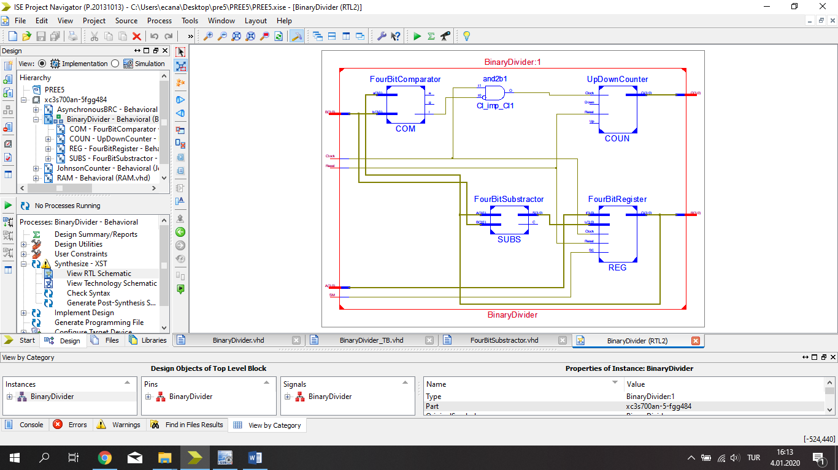

**Test Bench Input:**

|  |  |
| --- | --- |
| signal A : std_logic_vector(3 downto 0) := (others => '0');  signal B : std_logic_vector(3 downto 0) := (others => '0');  signal SM : std_logic := '0';  signal Clock : std_logic := '1';  signal Reset : std_logic := '1';    signal Q : std_logic_vector(3 downto 0);  signal R : std_logic_vector(3 downto 0);    constant Clock_period : time := 100 ns;    Clock_process :process  begin  Clock <= '0';  wait for Clock_period/2;  Clock <= '1';  wait for Clock_period/2;  end process; | stim_proc: process  begin    A <= "1001";  Reset <= '1';  SM <= '1';  wait for 100 ns;  A <= "1001";  B <= "0010";  Reset <= '0';  wait for 100 ns ;  SM <= '0';  wait;  end process;  END; |

**Test Bench Result:**

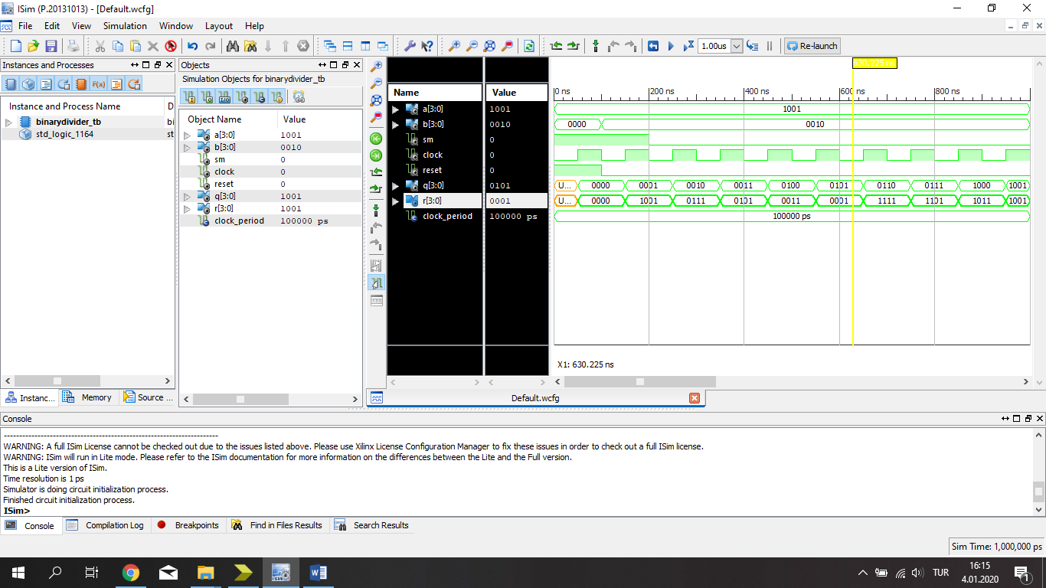

**4.A) Simple Binary Cell**

**Circuit Diagram**

|  |
| --- |
|  |

**VHDL Implementation:**

entity BinaryCell is

Port ( I : in STD_LOGIC;

S : in STD_LOGIC;

RW : in STD_LOGIC;

O : out STD_LOGIC);

end BinaryCell;

architecture Behavioral of BinaryCell is

component SRLatch

Port ( S : in STD_LOGIC;

R : in STD_LOGIC;

E : in STD_LOGIC;

Q : out STD_LOGIC;

Qn : out STD_LOGIC);

end component;

signal S1 : STD_LOGIC;

signal R1 : STD_LOGIC;

signal Q1,Qn1 : STD_LOGIC;

begin

S1 <= I and (not RW) and S ;

R1 <= (not I) and (not RW) and S ;

LA : SRLatch port map(S1,R1,S,Q1,Qn1);

O <= S and Q1 and RW ;

end Behavioral;

**RTL Schematic :**

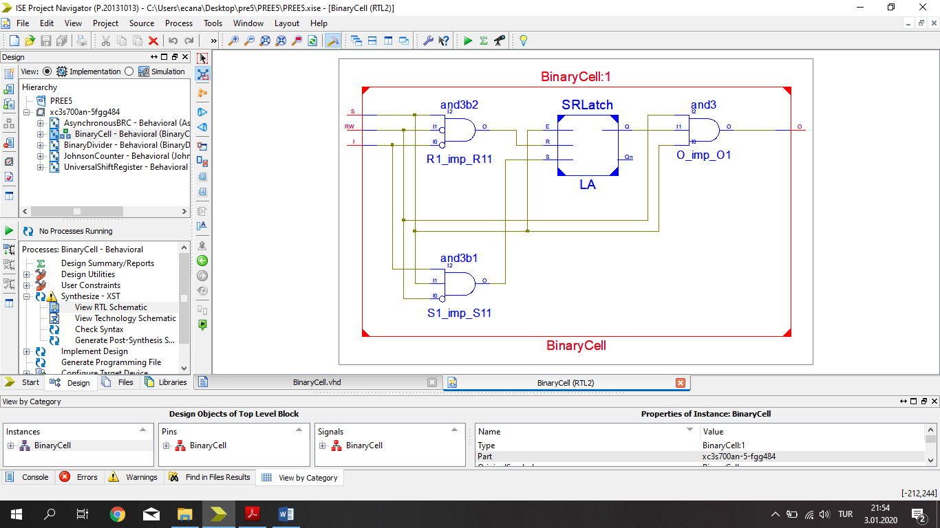

**Test Bench Input:**

|  |  |
| --- | --- |
| stim_proc: process  begin  I <= '0';  S <= '1';  RW <= '0';  wait for 100 ns;  I <= '1';  S <= '0';  RW <= '0';  wait for 100 ns;  I <= '1';  S <= '1';  RW <= '1';  wait for 100 ns;  I <= '1';  S <= '1';  RW <= '0'; | wait for 100 ns;  I <= '1';  S <= '1';  RW <= '1';  wait for 100 ns;  I <= '0';  S <= '0';  RW <= '0';  wait for 100 ns;  I <= '1';  S <= '1';  RW <= '1';  wait;  end process;  END; |

**Test Bench Result:**

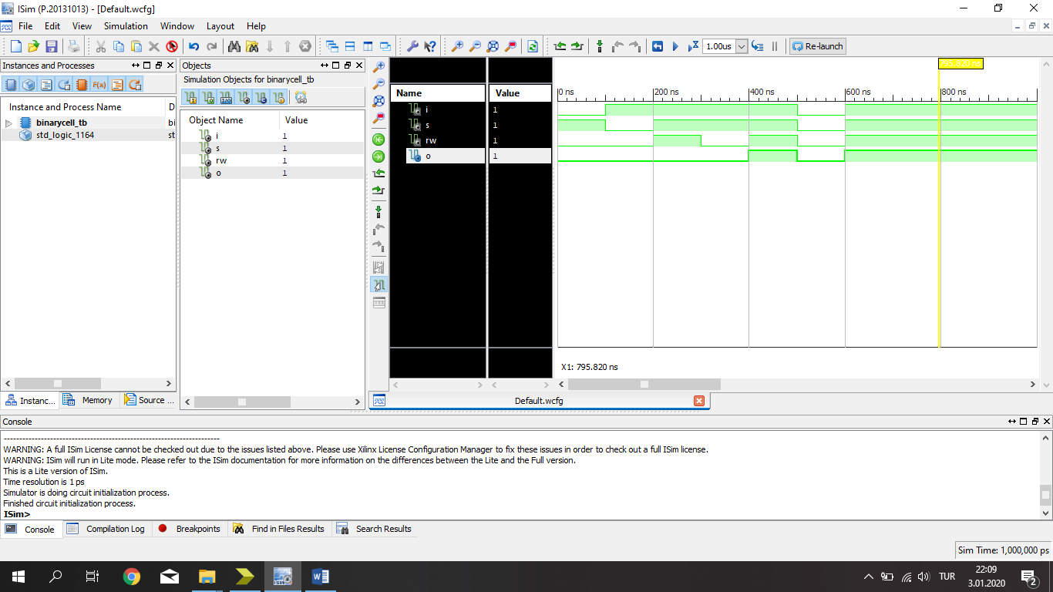

**4.B) 4X4 RAM**

**Circuit Diagram**

|  |
| --- |
|  |

**VHDL Implementation:**

|  |  |
| --- | --- |
| entity RAM is  Port ( I : in STD_LOGIC_VECTOR (3 downto 0);  AI : in STD_LOGIC_VECTOR (1 downto 0);  O : out STD_LOGIC_VECTOR (3 downto 0);  En : in STD_LOGIC;  RW : in STD_LOGIC);  end RAM;  architecture Behavioral of RAM is  component DECO  Port ( A : in STD_LOGIC;  B : in STD_LOGIC;  E : in STD_LOGIC;  D : out STD_LOGIC_VECTOR (3 downto 0));  end component;  component BinaryCell  Port ( I : in STD_LOGIC;  S : in STD_LOGIC;  RW : in STD_LOGIC;  O : out STD_LOGIC);  end component;  signal W :STD_LOGIC_VECTOR (3 downto 0);  signal T :STD_LOGIC_VECTOR (15 downto 0); | begin  DE : DECO port map(AI(1),AI(0),En,W);  BC0 : BinaryCell portmap(I(3),W(0),RW,T(0));  BC1 : BinaryCell portmap(I(2),W(0),RW,T(1));  BC2 : BinaryCell portmap(I(1),W(0),RW,T(2));  BC3 : BinaryCell portmap(I(0),W(0),RW,T(3));  BC4 : BinaryCell portmap(I(3),W(1),RW,T(4));  BC5 : BinaryCell portmap(I(2),W(1),RW,T(5));  BC6 : BinaryCell portmap(I(1),W(1),RW,T(6));  BC7 : BinaryCell portmap(I(0),W(1),RW,T(7));  BC8 : BinaryCell portmap(I(3),W(2),RW,T(8));  BC9 : BinaryCell portmap(I(2),W(2),RW,T(9));  BC10 : BinaryCell port map(I(1),W(2),RW,T(10));  BC11 : BinaryCell port map(I(0),W(2),RW,T(11));  BC12 : BinaryCell port map(I(3),W(3),RW,T(12));  BC13 : BinaryCell port map(I(2),W(3),RW,T(13));  BC14 : BinaryCell port map(I(1),W(3),RW,T(14));  BC15 : BinaryCell port map(I(0),W(3),RW,T(15));  O(3) <= T(0) or T(4) or T(8) or T(12);  O(2) <= T(1) or T(5) or T(9) or T(13);  O(1) <= T(2) or T(6) or T(10) or T(14);  O(0) <= T(3) or T(7) or T(11) or T(15);  end Behavioral; |

**RTL Schematic :**

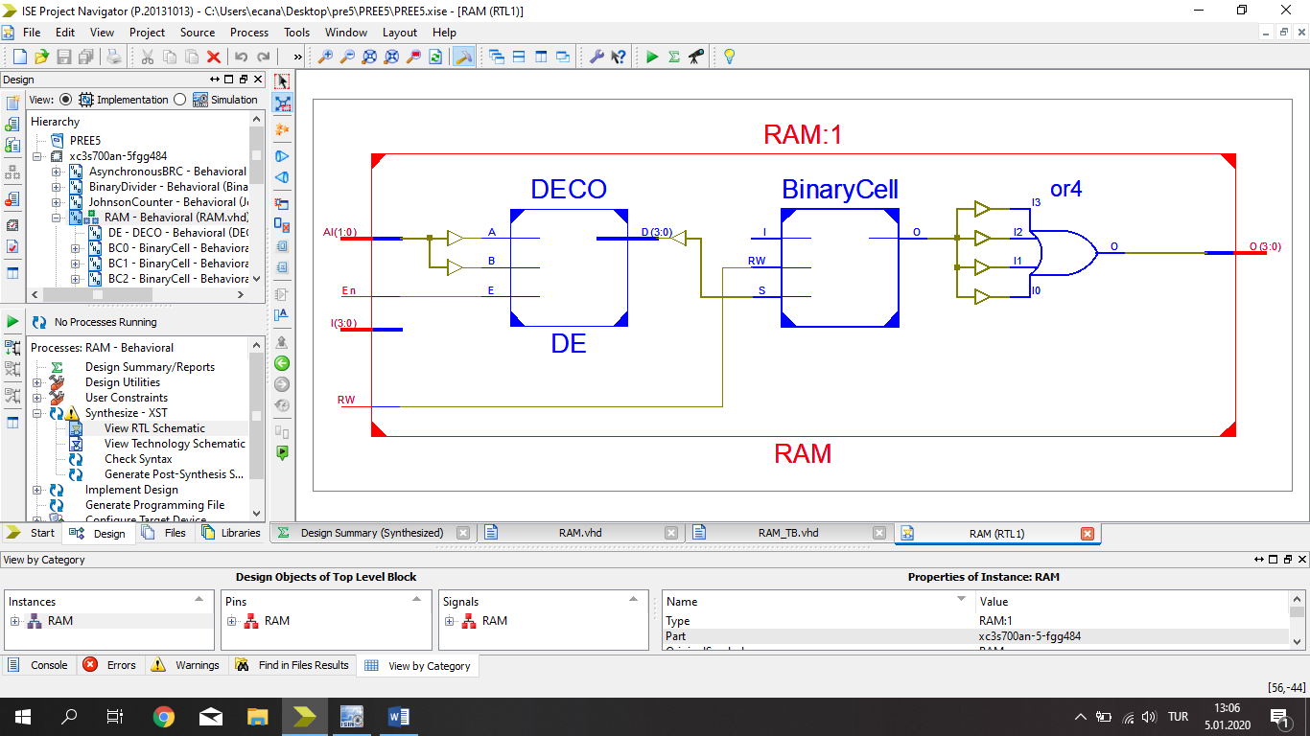

**Test Bench Input:**

|  |  |
| --- | --- |
| stim_proc: process  begin  I <="0000";  AI <= "00";  En <= '1';  RW <= '0';  wait for 100 ns;  AI <= "01";  I<="0001";  wait for 100 ns;  AI <= "10";  I<="0010";  wait for 100 ns;  AI <= "11";  I<="1001";  wait for 100 ns;  RW <= '1';  AI<= "10";  wait for 100 ns;  AI<= "00";  wait for 100 ns;  AI<= "01"; | wait for 100 ns;  AI<= "11";  wait for 100 ns;  AI<= "10";  wait for 100 ns;  AI<= "00";  wait for 100 ns;  AI<= "01";  wait for 100 ns;  AI<= "11";    wait;  end process;  END; |

**Test Bench Result:**

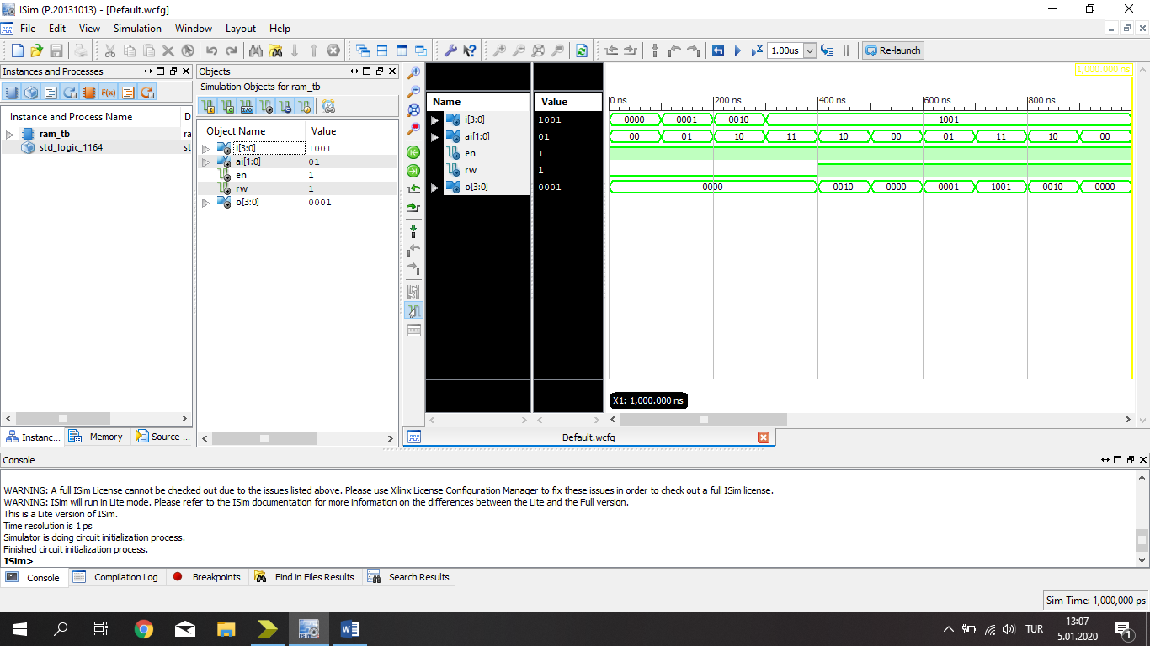

**5.) Circuit Diagram**

|  |
| --- |
|  |

**VHDL Implementation:**

|  |  |
| --- | --- |
| **entity ROM is**  **Port ( I : in STD_LOGIC_VECTOR (2 downto 0);**  **O : out STD_LOGIC_VECTOR (5 downto 0));**  **end ROM;**  **architecture Behavioral of ROM is**  **component DECODER**  **Port ( A : in STD_LOGIC;**  **B : in STD_LOGIC;**  **C : in STD_LOGIC;**  **D : out STD_LOGIC_VECTOR (7 downto 0));**  **end component;** | **signal R : STD_LOGIC_VECTOR (7 downto 0);**  **begin**  **DEC : DECODER port map(I(2),I(1),I(0),R);**  **O(0) <= R(1) or R(3) or R(5) or R(7);**  **O(1) <= '0';**  **O(2) <= R(2) or R(6);**  **O(3) <= R(3) or R(5);**  **O(4) <= R(4) or R(5) or R(7);**  **O(5) <= R(6) or R(7);**  **end Behavioral;** |

**RTL Schematic:**

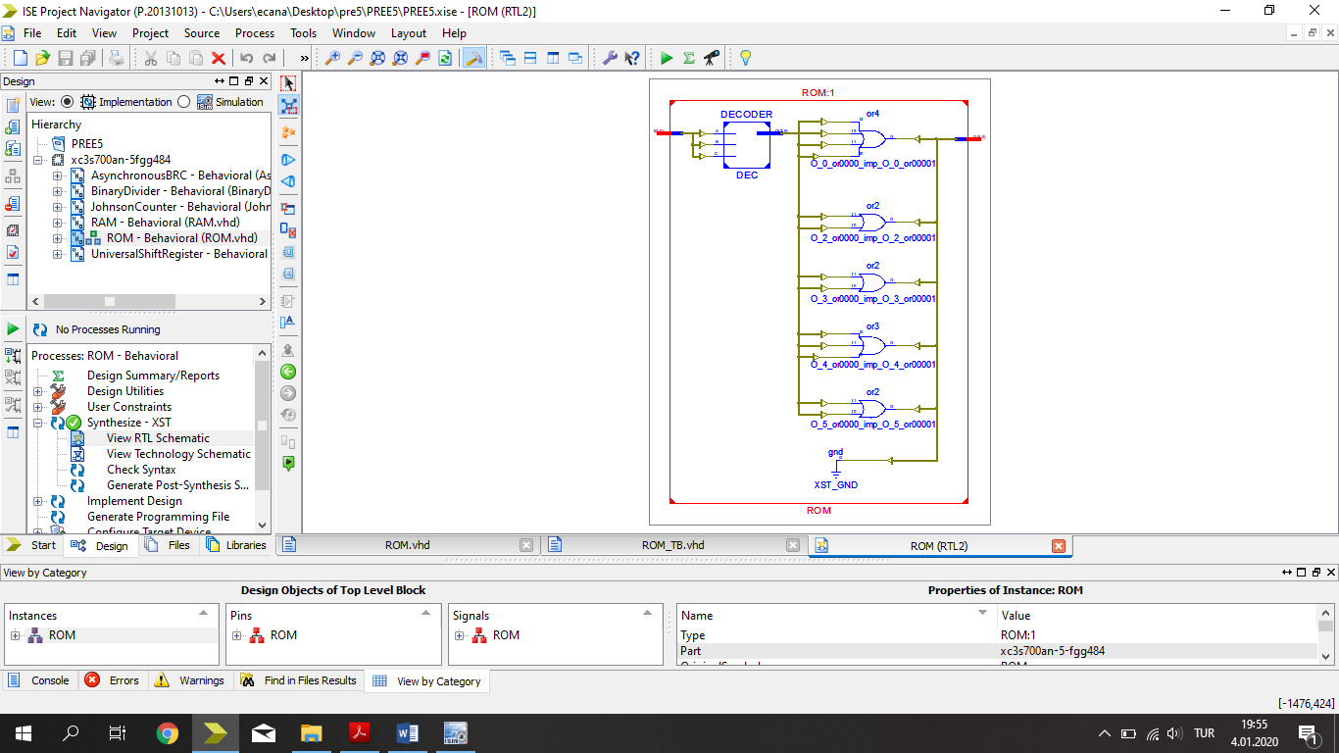

**Test Bench Inputs :**

|  |  |
| --- | --- |
| stim_proc: process  begin  I <= "000";  wait for 100 ns;  I <= "001";  wait for 100 ns;  I <= "010";  wait for 100 ns;  I <= "011";  wait for 100 ns;  I <= "100"; | wait for 100 ns;  I <= "101";  wait for 100 ns;  I <= "110";  wait for 100 ns;  I <= "111";    wait;  end process;  END; |

**Test Bench Results :**

