SE311 Software Engineering
System Health and Audit Tool
Design Patterns Report
Prepared by:
ACAR ACAY
KAYRA YEŞİLKAYA
İBRAHİM EGE KIRTIK
BAGER EKİN
Spring 2026

Table of Contents
1. Introduction
2. Design Thought Process
2.1 Problem Understanding and Scope
2.2 Pattern Selection and Rationale
2.3 Mapping Participants to Pattern Roles
2.4 Business Rules Encoded in the Model
2.5 Integration Flow (End-to-End Scenario)
2.6 Alternatives Considered and Rejected
2.7 Assumptions
3. Build and Execution
4. UML Diagrams
5. Class and Method Reference
6. Conclusion

1. Introduction
This report describes the design and implementation of a system health and audit tool we built for SE311 (Software Engineering). The program is written in Java and uses five Gang-of-Four design patterns in a single connected scenario that covers operating-system metric collection, hardware-tree inspection, a fixed health-check workflow, and pluggable audit commands.
The code is organised into five source files under src/healthaudit/: HardwareComponent.java, SystemAPI.java, SystemChecker.java, SystemTask.java, and SystemHealthFacade.java. Each file is built around exactly one pattern, and the files are connected to each other, so for example the Adapter and the Composite are both held by the Template Method, and every Command operates on the same Composite root.
All UML diagrams in Section 4 were drawn by hand and exported to PNG. We did not use any tool that generates diagrams automatically from source code.

2. Design Thought Process

2.1 Problem Understanding and Scope
The project specification (SE311_2025_2026_3_Health Audit_S.pdf) describes a tool that collects hardware and software metrics from three operating systems (Windows, Linux, macOS) and performs analyses such as security auditing and resource optimisation. The hardware is presented as a tree: a computer contains a motherboard; the motherboard contains a CPU, memory and an ISA bus; and the ISA bus contains a network interface card and a disk. Different operating systems expose the same information through completely different APIs (uname() and /proc/* on Linux, getSystemInfo and GlobalMemoryStatusEx on Windows, sysctlbyname and host_statistics64 on macOS), but the core logic must remain OS-agnostic and speak through a unified interface with getSystemData, getMemoryUsage, getProcessUsage and getDiskUsage. Regardless of the OS, every health check follows the same five steps: setup, data collection, data check, analysis and report generation. The setup step is different for a local machine than for a remote server, but the rest of the order is fixed. After the data is collected, the administrator wants to launch a variety of audit tasks (security audit, resource optimisation, and so on) from a single entry point, without scheduling each task manually.

2.2 Pattern Selection and Rationale
Our first design decision was to separate concerns by layer rather than putting everything into one big class. The hardware is hierarchical, so Composite fit naturally. The three OS APIs are incompatible but conceptually identical, so Adapter is exactly the right tool. The health-check sequence is rigid except for one varying step, which is the textbook setup for Template Method. The audit operations need to be queued and executed in bulk, so Command was the obvious choice. Finally, we wrapped the whole flow behind a Facade so that the administrator only sees one class.
Composite: We chose Composite for the hardware because the project explicitly describes a part-whole structure (Computer → Motherboard → CPU, Memory, ISABus → NICCard, Disk). With Composite, every node implements the same HardwareComponent interface, so the rest of the program can call displayInfo() on any node without checking whether it is a leaf or a container. Adding a new piece of hardware later means writing one class and registering it; nothing else in the codebase has to change.
Adapter: The PDF lists very different native calls for the three operating systems (uname / getSystemInfo / sysctlbyname, /proc/meminfo / GlobalMemoryStatusEx / host_statistics64, /proc/stat / GetProcessTimes / proc_pidinfo, statvfs / getFreeDiskSpace / getfsstat). We modelled each one as an Adaptee and wrote an Adapter that translates its calls into the unified SystemAPI vocabulary. SystemChecker speaks SystemAPI and is unaware of which OS is underneath. This is exactly what the PDF means by "OS-agnostic core".
Template Method: SystemChecker.runCheck() is declared final and calls setup, collectData, checkData, analyze and generateReport in this fixed order. The only step that varies is setup(), which is abstract: LocalMachineChecker acquires local resource handles, while RemoteServerChecker opens a socket connection. The other four steps are shared because they do the same thing regardless of where the metrics are coming from.
Command: Each audit operation is modelled as a SystemTask. SecurityAuditor scans open ports and unpatched CVEs; ResourceOptimizer flags memory-hungry processes. Both receive the Computer (the Composite root) in their constructor and operate on it during execute(). The TaskInvoker keeps a list of submitted tasks and runs them in order. This lets the administrator add tasks one by one but launch them as a batch with a single call.
Facade: SystemHealthFacade is the only public class. The administrator picks an OS and a mode, optionally registers audit tasks, then calls runFullAudit(). Inside, the facade selects the right Adapter, builds the Composite hierarchy, instantiates the Template Method subclass and dispatches the Command queue. The underlying classes still show all the pattern roles clearly; the facade just provides a clean entry point without exposing the wiring to the caller.

2.3 Mapping Participants to Pattern Roles
When mapping the project domain to pattern participants, we matched each GoF role to a concrete class in our implementation. The table below shows how each pattern participant maps to the Java source.
Pattern | GoF participants | Implementation
Composite | Component / Leaf / Composite | HardwareComponent (interface); CPU, Memory, NICCard, Disk (leaves); ISABus, Motherboard, Computer (composites)
Adapter | Target / Adapter / Adaptee | SystemAPI (target); LinuxAdapter, WindowsAdapter, MacOSAdapter; LinuxAPI, WindowsAPI, MacOSAPI as adaptees
Template Method | AbstractClass with template; ConcreteClass overrides hooks | SystemChecker.runCheck() (final); LocalMachineChecker and RemoteServerChecker override setup()
Command | Command / ConcreteCommand / Receiver / Invoker | SystemTask (interface); SecurityAuditor and ResourceOptimizer (concrete); Computer (receiver); TaskInvoker (invoker)
Facade | Facade / subsystem | SystemHealthFacade.runFullAudit() coordinates Adapter selection, Composite assembly, Template Method execution and Command dispatch
Table 1. Pattern participant mapping.

2.4 Business Rules Encoded in the Model
Hardware composition rule: every Computer must contain exactly one Motherboard, which must contain a CPU, a Memory module and an ISABus. The ISABus then holds expansion cards (NICCard, Disk). Disk and NICCard sit on the same bus level on purpose, since both are expansion-bus devices in the simulated machine. OS-routing rule: every adapter prints which native call would have been issued in production (for example, "[LinuxAPI] invoking statvfs()"), so the reader can verify that disk usage is fetched through statvfs on Linux, getFreeDiskSpace on Windows, and getfsstat on macOS. Execution-order rule: SystemChecker.runCheck() is final, so no subclass can swap the order of the five steps; only the setup step can vary. Audit-target rule: every SystemTask receives the Computer in its constructor, which guarantees that all tasks reason about the same hardware tree.

2.5 Integration Flow (End-to-End Scenario)
In our simulation, SystemHealthFacade.main() runs three scenarios end-to-end. Each scenario creates a new facade with the chosen OS and mode. The facade picks the matching Adapter, assembles the Composite tree (Computer → Motherboard → CPU + Memory + ISABus(NICCard, Disk)), constructs the right Checker subclass (Local or Remote) and creates an empty TaskInvoker. The driver then registers a SecurityAuditor and a ResourceOptimizer pointing at that scenario’s Computer, and finally calls runFullAudit(). Inside runFullAudit, the Checker walks through its five fixed steps; during collectData the four adapter methods are invoked and the resulting strings are stored on the Computer; during analyse the phase is announced, and the actual analysis is delegated to the Commands. The TaskInvoker then dispatches each registered Command in submission order. The console output shows clearly which class is talking at every step.

2.6 Alternatives Considered and Rejected
We considered putting all OS handling into one class with if/else branches on osType, but it would have made the Adapter boundary invisible and broken the "OS-agnostic core" rule from the PDF. We considered modelling each audit task as a method on Computer rather than a Command, but then we would lose the ability to queue, reorder or extend tasks without editing Computer. We also considered a Visitor for traversing the hardware tree, but Composite already lets every node display itself, and adding Visitor would have introduced a sixth pattern without solving a real problem. Finally we considered making SystemChecker non-abstract and switching on mode inside setup(), but Template Method gave us a cleaner split and let us add new checker types later without touching the parent class.

2.7 Assumptions
The project description leaves a few points open. The following assumptions were made and applied consistently throughout the design.
A1. The PDF lists "Motherboard, CPUs, Disks, Memory and Network Interfaces" as the complex object structure. The explicit hierarchy sentence in the PDF only mentions CPU, Memory, ISA bus and NIC card. We chose to place Disk as an expansion-bus device alongside NICCard, so the hierarchy stays simple while still including the disk component.
A2. The PDF only specifies three operating systems by name. We support all three with their own adapter and adaptee, and the simulation exercises each one in turn.
A3. Real native calls are not invoked. Every adaptee method prints a log line ("[LinuxAPI] invoking uname()") and returns a hard-coded but realistic string. This matches the PDF’s rule that the program "simulate/model various functions" rather than execute them.

3. Build and Execution
Compile: javac healthaudit/*.java
Run: java healthaudit.SystemHealthFacade
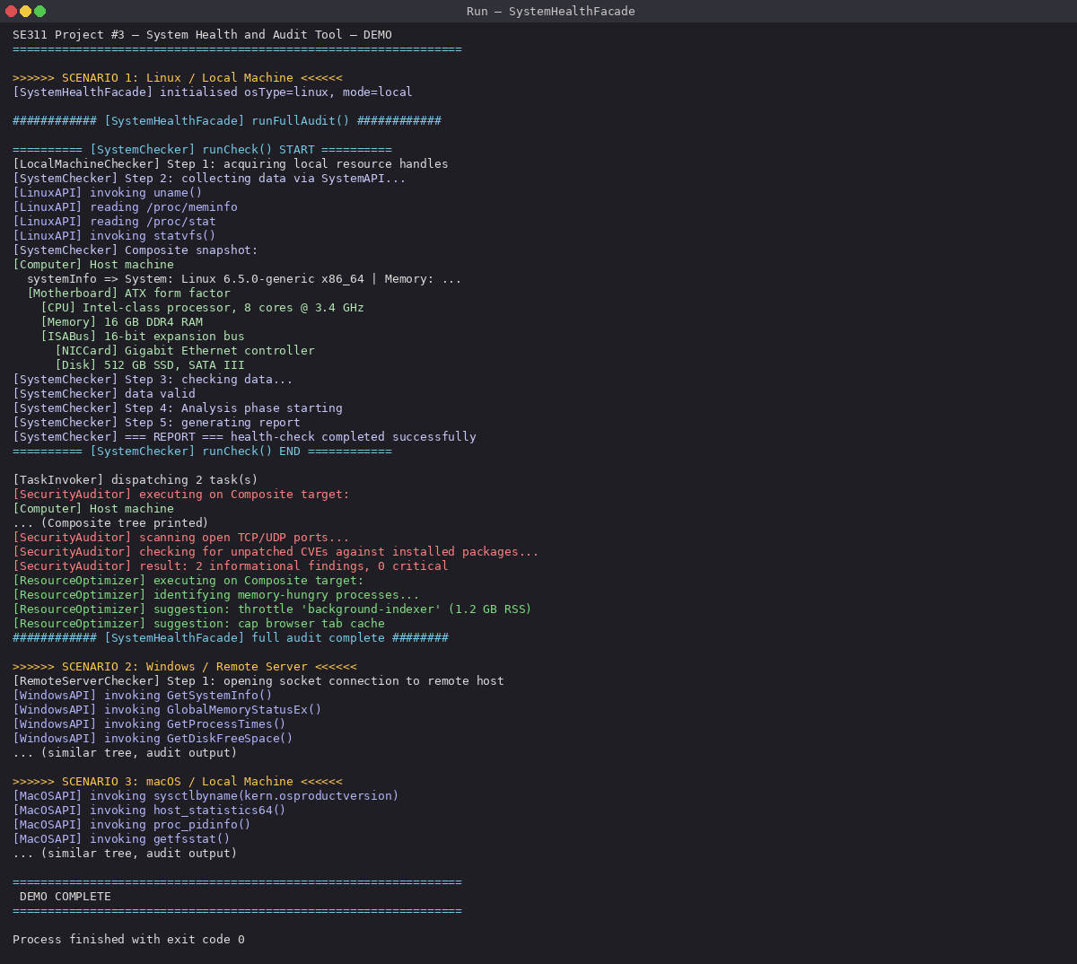
Figure 1. Console output showing the successful execution of the system health and audit simulation.
The program prints the initialised facade, the five-step health check, the composite hardware snapshot annotated with the collected system info, and then the audit tasks executing one by one with their findings. Three scenarios run in sequence (Linux / local machine, Windows / remote server, macOS / local machine) so a single run exercises every adapter and both checker variants.

4. UML Diagrams
Figures 2–6 are class diagrams for the five individual design patterns used in the project: Composite, Adapter, Template Method, Command and Facade.
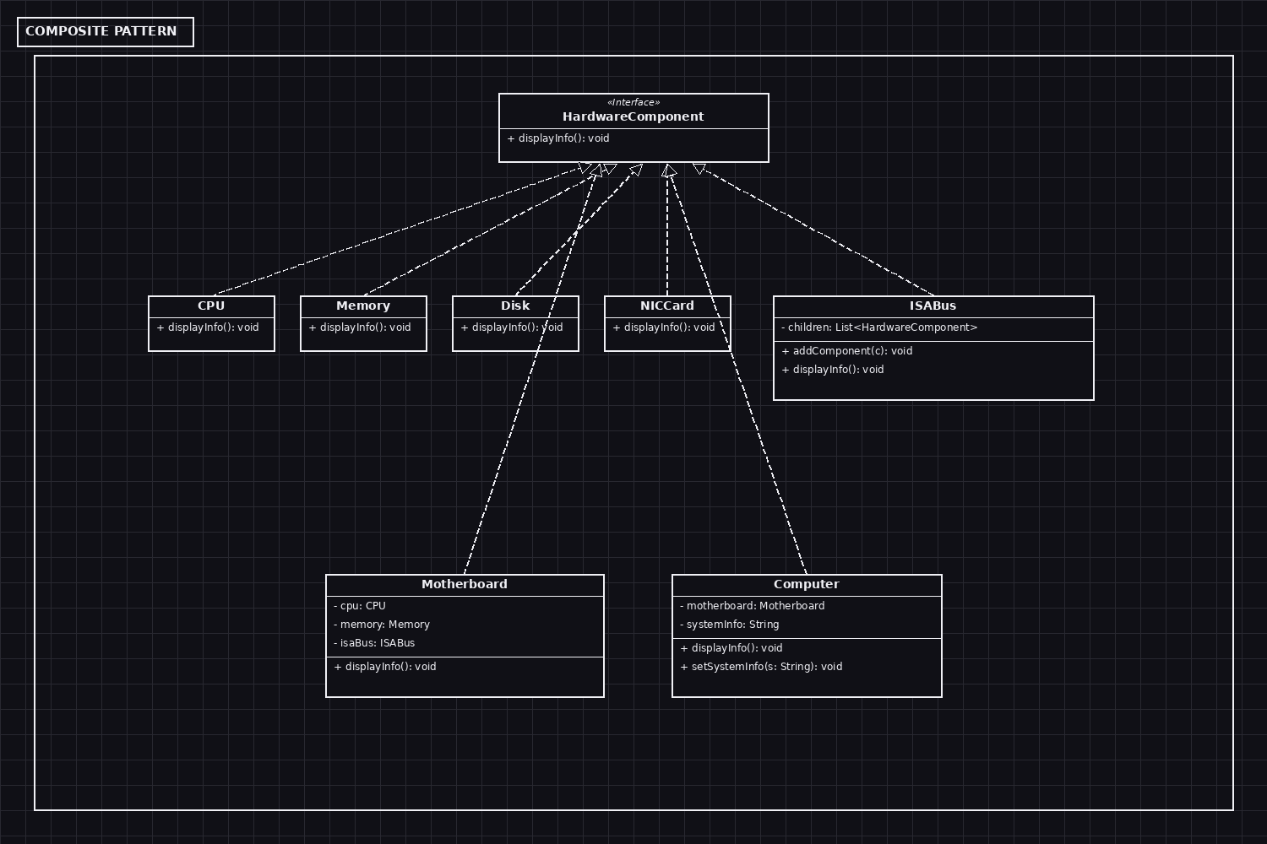
Figure 2. Composite: hardware tree with leaves and composites under one HardwareComponent interface.
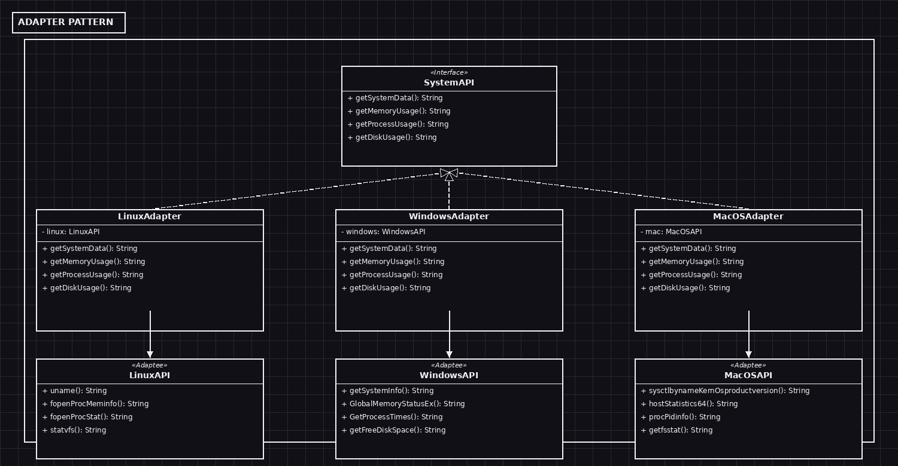
Figure 3. Adapter: three OS-specific adaptees wrapped behind the unified SystemAPI.
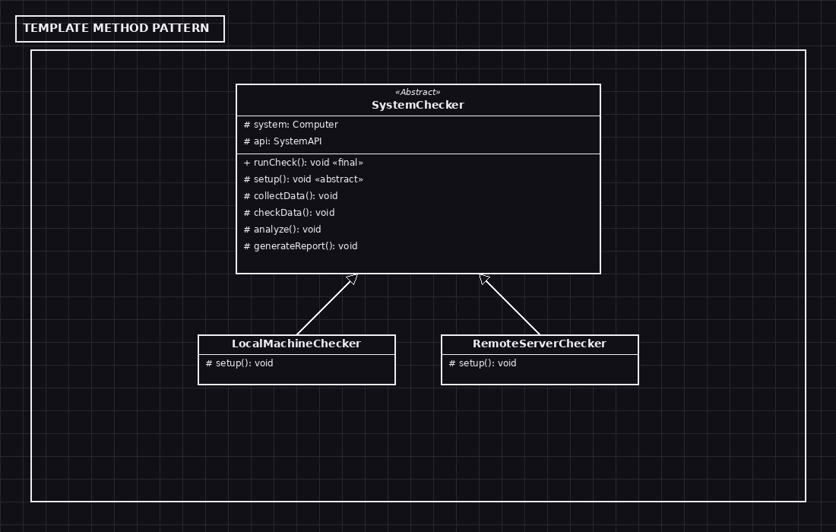
Figure 4. Template Method: SystemChecker fixes the five-step algorithm; subclasses vary only setup().
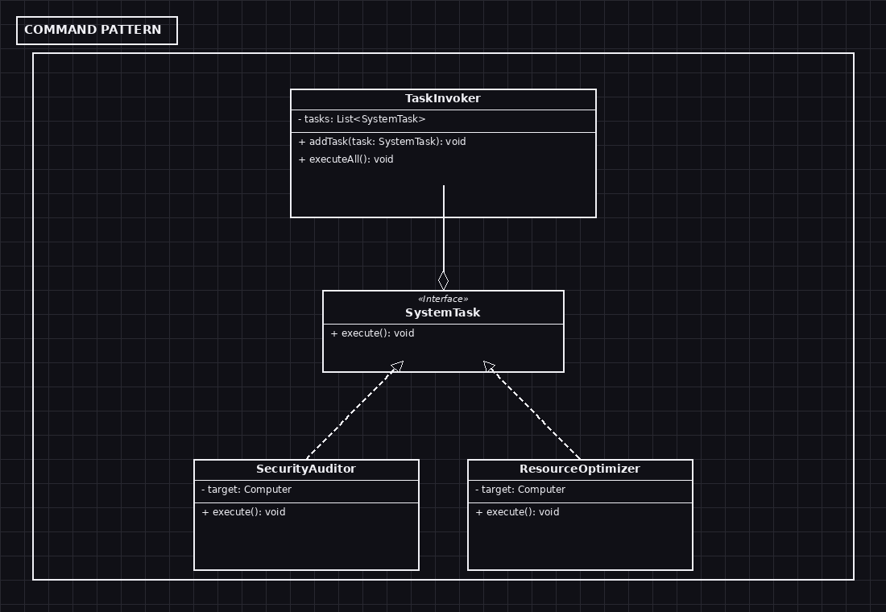
Figure 5. Command: each SystemTask wraps an audit operation; TaskInvoker dispatches the queue.
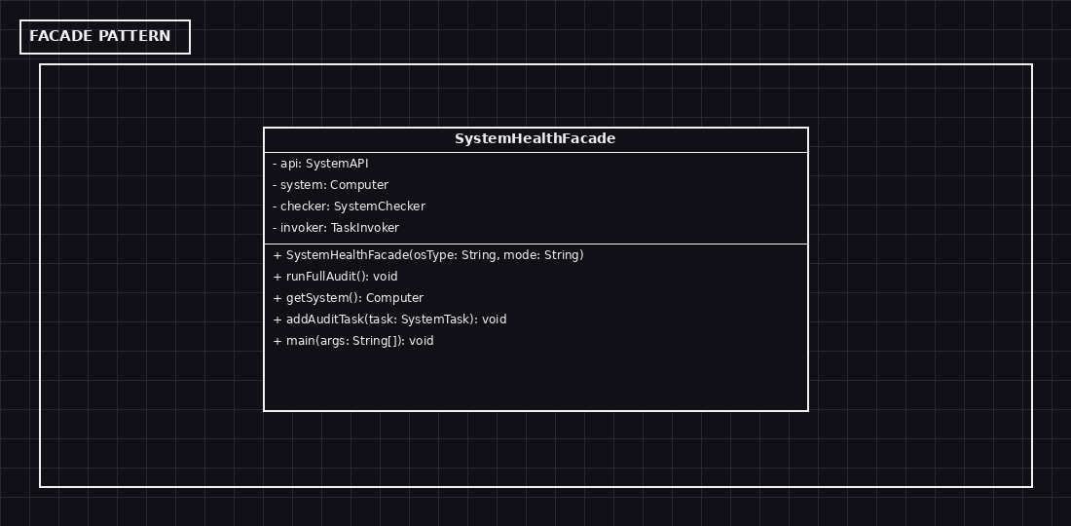
Figure 6. Facade: SystemHealthFacade hides the four subsystem patterns behind a single entry point.

5. Class and Method Reference
The following descriptions explain each type’s responsibility and the behaviour of its key methods.
HardwareComponent (interface)
Common abstraction for every node in the hardware tree. Defines the single operation that all leaves and composites must implement.
Key methods:
- displayInfo(): Prints this node, then recursively prints its children if it is a composite. Indentation is encoded directly in each leaf’s println so no parameter is needed.
CPU, Memory, NICCard, Disk (leaves)
Concrete hardware leaves. Each one prints a single human-readable line describing its role. NICCard and Disk are placed on the ISA bus; CPU and Memory sit directly on the Motherboard.
Key methods:
- displayInfo(): Prints the leaf’s description with the correct indentation level.
ISABus, Motherboard (intermediate composites)
Composite nodes that hold children. ISABus uses a List<HardwareComponent> and exposes addComponent() so the Facade can attach NICCard and Disk at construction time. Motherboard hard-codes its CPU, Memory and ISABus slots through its constructor.
Key methods:
- addComponent(c): (ISABus only) Adds an expansion card to the bus.
- displayInfo(): Prints itself, then asks every child to display itself one level deeper.
Computer (composite root)
The top-level composite. Owns a Motherboard and a systemInfo string that the Template Method writes to after collecting OS data.
Key methods:
- setSystemInfo(s): Records the combined SystemAPI output (system + memory + process + disk) on the root so the Composite snapshot can show it.
- displayInfo(): Prints the host machine header, the systemInfo line if any, then recurses into the Motherboard.
SystemAPI (interface, Adapter target)
Unified OS-agnostic vocabulary used by SystemChecker. Has exactly four methods: getSystemData, getMemoryUsage, getProcessUsage and getDiskUsage. No method here knows anything about Windows, Linux or macOS.
Key methods:
- getSystemData(), getMemoryUsage(), getProcessUsage(), getDiskUsage(): Each returns a normalised string for the corresponding metric category.
LinuxAPI / WindowsAPI / MacOSAPI (adaptees)
Simulate the raw OS-specific calls listed in the project PDF. Each method logs which native call would have been issued in production, then returns a realistic hard-coded string.
Key methods:
- Linux: uname(), fopenProcMeminfo(), fopenProcStat(), statvfs()
- Windows: getSystemInfo(), GlobalMemoryStatusEx(), GetProcessTimes(), getFreeDiskSpace()
- macOS: sysctlbynameKernOsproductversion(), hostStatistics64(), procPidinfo(), getfsstat()
LinuxAdapter / WindowsAdapter / MacOSAdapter
Adapter classes. Each holds the matching adaptee through composition and implements SystemAPI by translating every adaptee call into one of the four normalised methods with a "System:", "Memory:", "Process:" or "Disk:" prefix.
Key methods:
- getSystemData() etc.: Delegate to the adaptee and prepend the category prefix.
SystemChecker (abstract Template Method base)
Holds a SystemAPI reference and a Computer reference. Defines runCheck() as a final template method that runs the five steps in order. setup() is abstract; the other four steps have default implementations that are OS-agnostic.
Key methods:
- runCheck(): Final template method invoking setup → collectData → checkData → analyze → generateReport.
- collectData(): Calls the four SystemAPI methods, joins the results with " | ", stores them on the Computer and asks the Computer to display itself.
- checkData(): Confirms that data has been collected and prints "data valid".
- analyze(): Announces the analysis phase; the real work is done by Commands invoked by the Facade.
- generateReport(): Prints the final report header.
LocalMachineChecker / RemoteServerChecker
Concrete checkers. Each one overrides only setup() so the variation between local and remote audits is encoded in exactly one place.
Key methods:
- setup(): LocalMachineChecker prints that local resource handles are being acquired. RemoteServerChecker prints that a socket connection is being opened.
SystemTask (interface, Command)
The Command interface for any audit operation. Single method execute(). Concrete commands keep their own reference to the Composite root so the Composite ↔ Command link is explicit.
Key methods:
- execute(): Runs the audit on the target Computer and prints the findings.
SecurityAuditor / ResourceOptimizer (concrete commands)
Concrete audit operations. SecurityAuditor simulates an open-port and CVE scan; ResourceOptimizer flags memory-hungry processes and proposes mitigations.
Key methods:
- execute(): Each one walks its target Computer via displayInfo() and then prints its specific findings.
TaskInvoker
The Command invoker. Owns a List<SystemTask> and runs the queue in submission order.
Key methods:
- addTask(t): Appends a task to the queue.
- executeAll(): Dispatches the entire queue, printing a header that announces the number of tasks.
SystemHealthFacade
The only public class. Selects the right Adapter from the osType parameter, assembles the Composite tree, chooses the right Template Method subclass from the mode parameter, and owns the TaskInvoker. Exposes a tiny public API plus main().
Key methods:
- SystemHealthFacade(osType, mode): Constructor; wires up all four subsystems.
- addAuditTask(task): Delegates to TaskInvoker.addTask.
- runFullAudit(): Calls checker.runCheck() then invoker.executeAll().
- getSystem(): Returns the Composite root so commands can be attached to it.
- main(args): Demo driver that runs three scenarios: linux/local, windows/remote and macos/local.

6. Conclusion
In this project we implemented a system health and audit tool using five design patterns, each covering a different layer of the problem. Composite models the hardware tree, Adapter hides the OS-specific calls behind a single interface, Template Method fixes the order of the five health-check steps while letting subclasses vary the setup, Command encapsulates each audit operation as an independent object, and Facade ties everything together into one runnable entry point. We tried to keep the design simple and connected: every pattern references at least one other pattern (SystemChecker uses Adapter and Composite; SystemTask uses Composite; Facade orchestrates all four), so the patterns are not isolated from each other.

AI Assistance Statement
Artificial intelligence tools were used only to support the English wording, grammar, and clarity of this report. The project design, implementation decisions, UML diagrams, and final content were reviewed and prepared by the project team.

