Homework 2

CS 436/: Introduction to Machine Learning

Egemen Inal

1) Naive Bayes for Text Classification

Accuracy on the test file with Stop words is %96.44351464435147

Accuracy on the test file without Stop words is % 94.56066945606695

2) Point Estimation

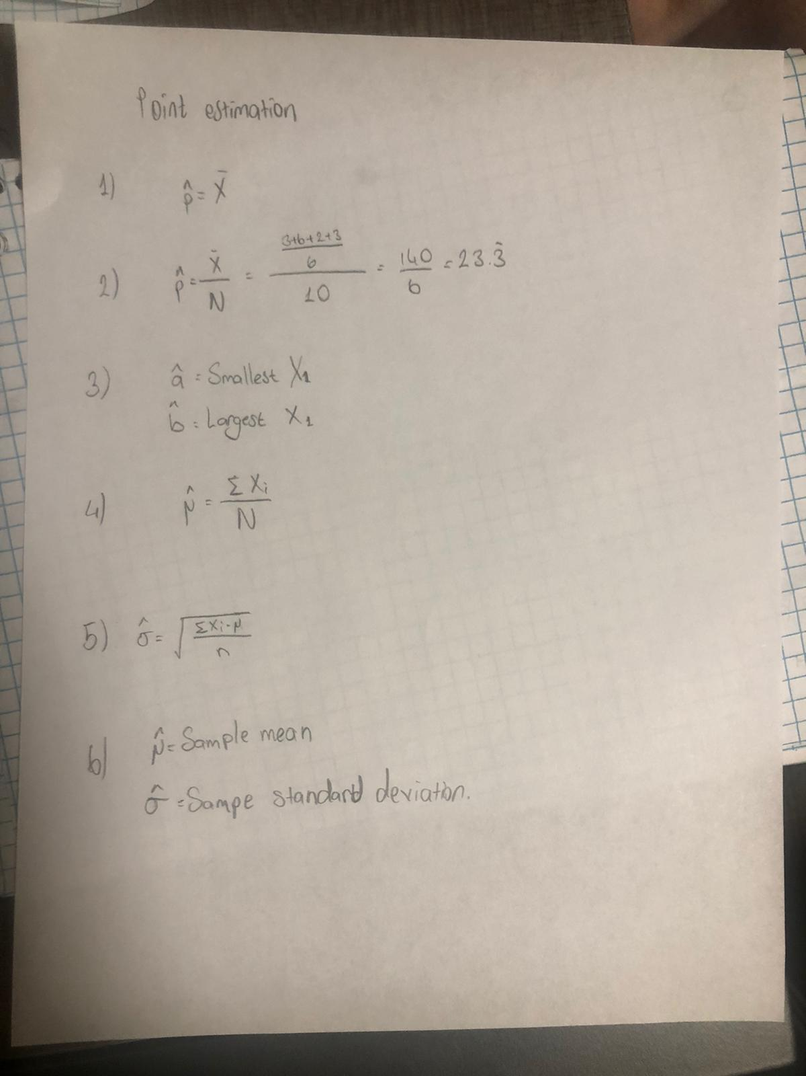

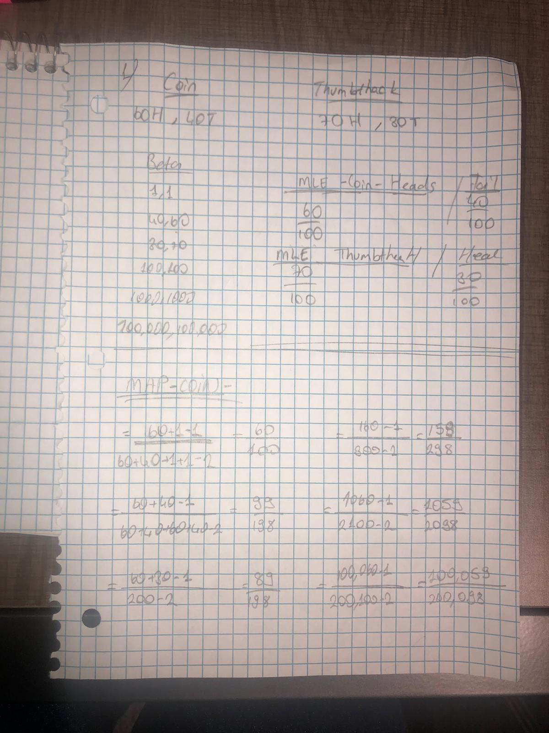

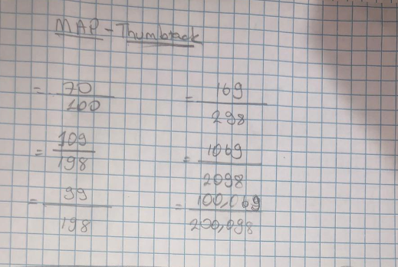

2) Prior Posterior(coin)

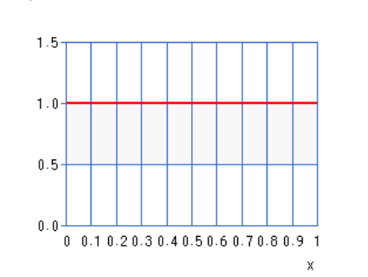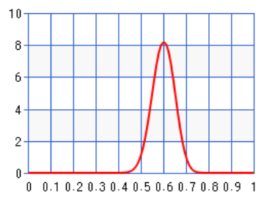

Prior is not useful and close to 0.5.

Prior Posterior (coin)

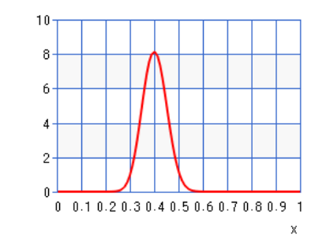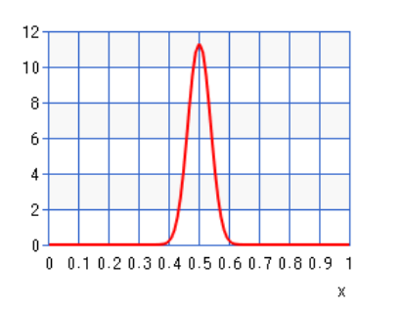

Both are at 0.5 they both contribute equally.

Prior Posterior (coin)

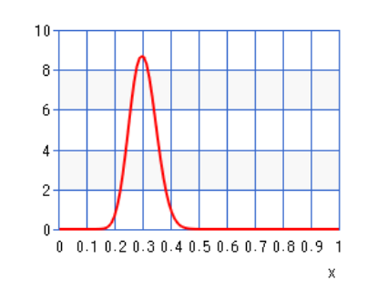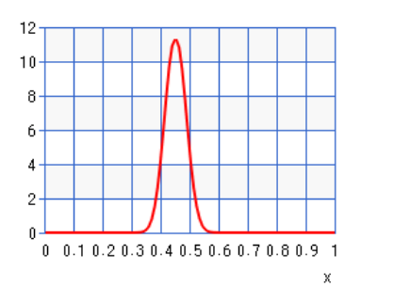

Both contribute equally and likelihood is closer to 0.5.

Prior Posterior (coin)

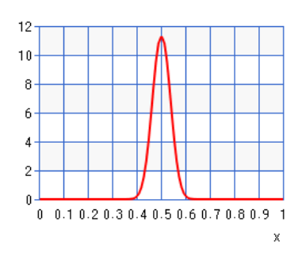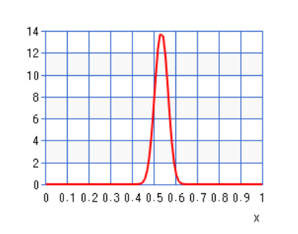

Prior contributes more, gets closer to 0.5 and gets narrower.

Prior Posterior (coin)

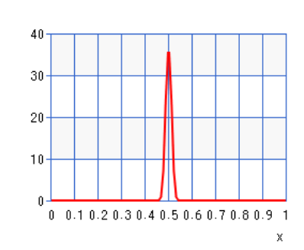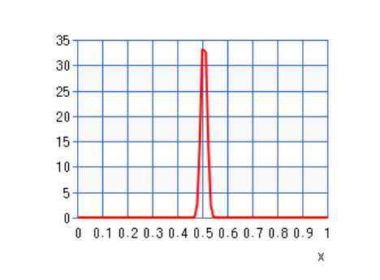

Prior contributes more, gets closer to 0.5 and gets narrower.

Prior Posterior (coin)

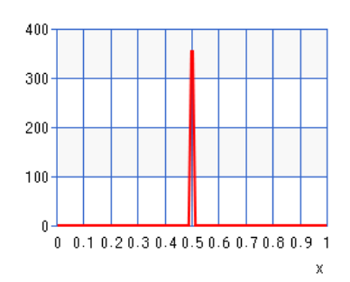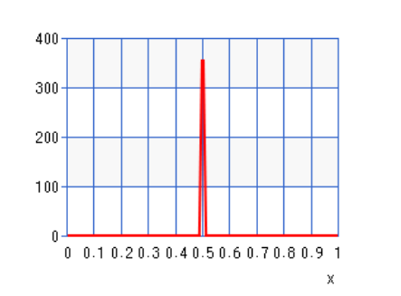

Prior contributes more, gets closer to 0.5 and gets narrower.

Prior Posterior (thumbtack)

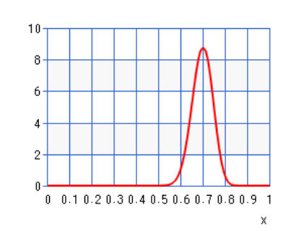

Prior is not useful and close to 0.5.

Prior Posterior (thumbtack)

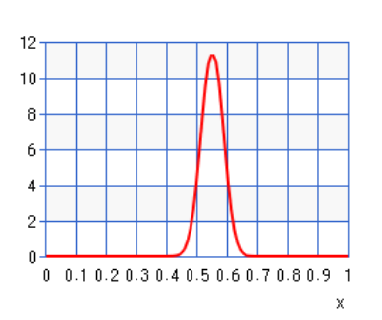

Both are at 0.5 they both contribute equally.

Prior Posterior (thumbtack)

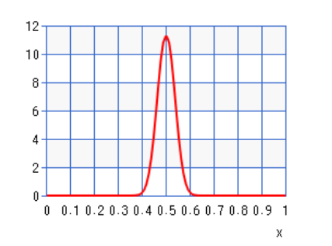

Both contribute equally and likelihood is closer to 0.5.

Prior Posterior (thumbtack)

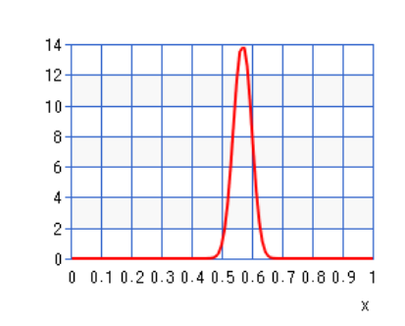

Both contribute equally and likelihood is closer to 0.5.

Prior Posterior (thumbtack)

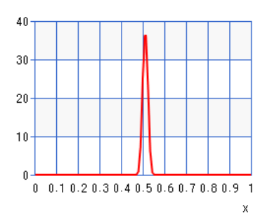

Both contribute equally and likelihood is closer to 0.5.

Prior Posterior (thumbtack)

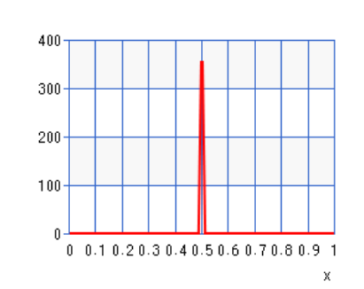

Both contribute equally and likelihood is closer to 0.5.

3)True, Data Dominates

4)True, Prior Dominates

I have done this assignment completely on my own. I have not copied it, nor have I given my solution to anyone else. I understand that if I am involved in plagiarism or cheating I will have to sign an official form that I have cheated and that this form will be stored in my official university record. I also understand that I will receive a grade of 0 for the involved assignment for my first offense and that I will receive a grade of “F” for the course for any additional offense.

Egemen Inal