DATA MINING
CS 435
Section-2

Assignment-2
Report

Egemen Inal

1)We start by importing the data set into pandas data grid. Then I named each column as ‘Attribute_0, Attribute_1, …’. Then I erased the attribute with the date after that I converted the table in to floats and when there are errors the function puts Nan’s. After that filled in the Nan’s with the mean of the attribute. Then normalized it using MinMaxScale.fit_transform(water_treatment_data).
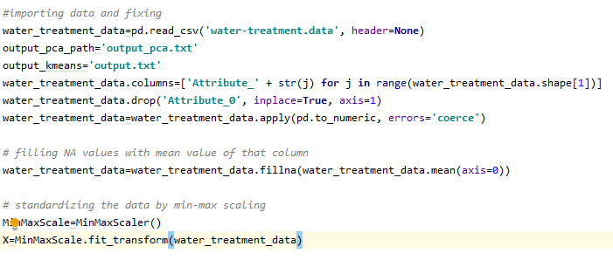
2)I used a where I calculate the change in mean Euclidian distance and if that distance is under my threshold value I break out of the code.
3) 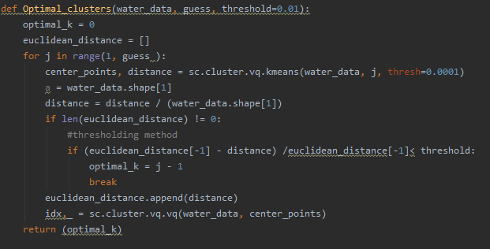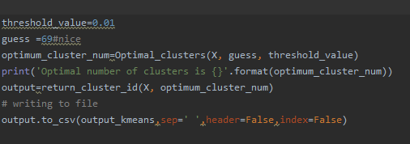
4)
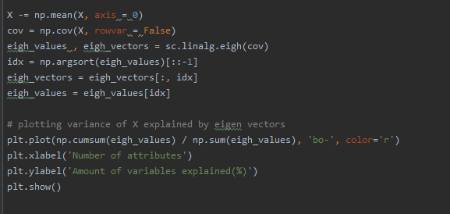
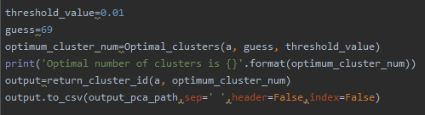

5)Applying PCA then running the k-means seems to be slightly better
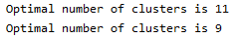
Because the number of clusters is lower. But the number of clusters change depending on where we put the starting (randomly)centroids and we can get the same number of clusters in a different seed. This tells me there is no significant difference between using K-means and using PCA then K-means

References
- Pandas for data storage
- Scipy and numpy for k-means and math functions
- Matplotlib.pyplot to plot some results

