Black & White 2

Creature Swapper + Turtle Creature

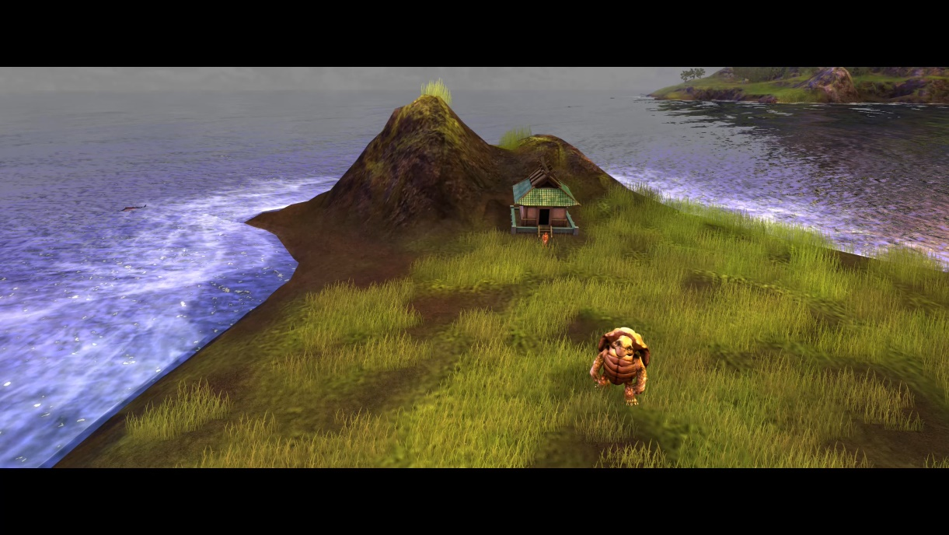

by Egerion

This Documentation is only for people who would like to modify or get insight from how to modify the game.

**Turtle Creature**

Adding Turtle creature to original game is not an easy task, this is not just like rename the turtle creature files to other existing creature names in the B&W2 like; replace cow with turtle. If you do that Turtle voice is no longer will work and it will be dumb creature. My method is directly adding turtle creature to game through modifying the game exe. Here are the creatures that exists inside the B&W2’s white.exe:

1. CREATURE_TYPE_APE
2. CREATURE_TYPE_COW
3. CREATURE_TYPE_TIGER
4. CREATURE_TYPE_WOLF
5. CREATURE_TYPE_LION
6. CREATURE_TYPE_GORILLA (locked for player, can be selected with custom script.)
7. CREATURE_TYPE_MINOTAUR (Not exists, can’t be used, only a string and linked back to APE)
8. CREATURE_TYPE_JACKAL (Not exists, can’t be used, only a string and linked back to COW)
9. CREATURE_TYPE_JAGUAR (Not exists, can’t be used, only a string and linked back to TIGER)
10. CREATURE_TYPE_LAST (backup creature, if game can’t find player creature, it gives you Lion thus, its linked back to LION)

So, we have 6 open slots inside the exe to add turtle creature and it should be the id 6 which equals to Lion creature, so I add CREATURE_TYPE_TURTLE to id 6.

**Custom Quests and CHL Files**

There is nothing much to say about it, its basic B&W2 Scripting. However, I made open version for people who want to modify or learn more about it. Its on my GitHub, you can reach it over here;

<https://github.com/Egerion/BW2-Creature-Swapper-and-Turtle-Creature>

I have also GitHub for who would like to modify or add features to my mods or simply just gain more insight about scripting or modifying the game: <https://github.com/Egerion>

For more, don’t forget to visit [https://www.bwrealm.com](https://www.bwrealm.com/)