<DATE>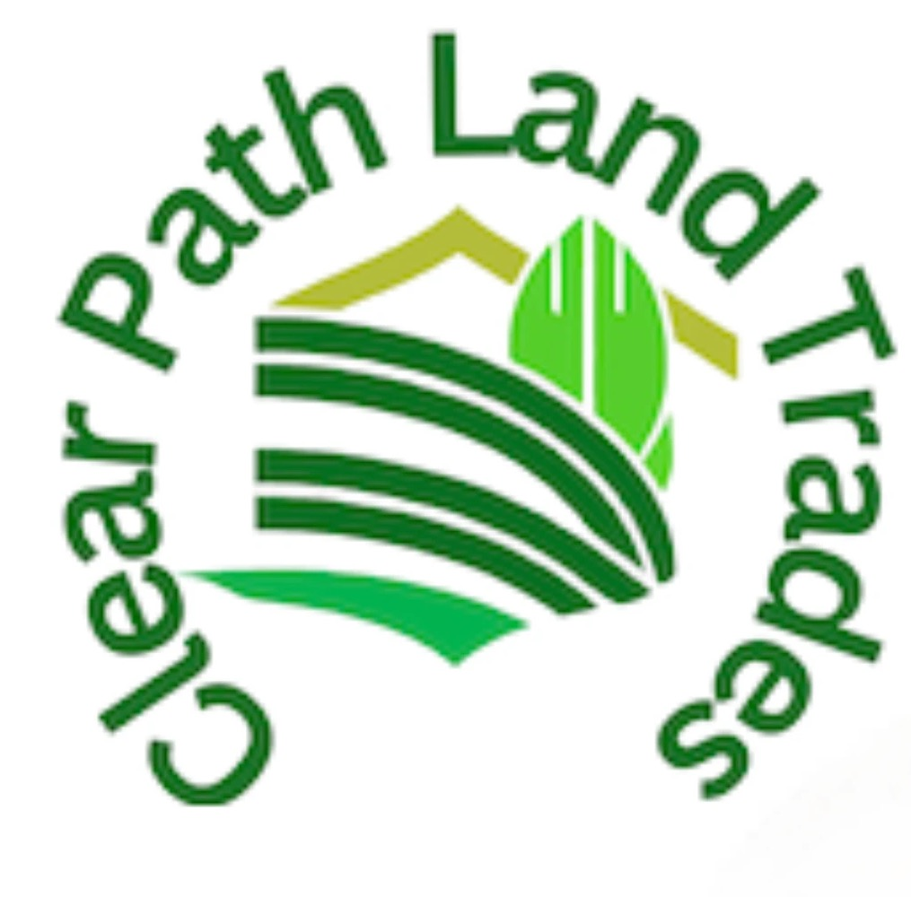

<OWNER 1 FULL NAME >

< MAILING FULL ADDRESS >

RE: Property (APN) < APN - FORMATTED >, and any others you may own.

Dear <OWNER 1 FULL NAME >,

I am writing to you because public records show you as the owner of real property located at <SITUS FULL ADDRESS>. I am very interested in purchasing this property from you.

If you are considering selling your property, I can offer you a fast, trouble-free sale, as well as a fair price and immediate cash. Of course, I will pay all of the fees.

We are a Real Estate Investment company looking to buy some raw land in your area for long term investment purposes. We have many highly satisfied customers who were glad to have cash rather than the burden of property ownership. Many of these customers had plans for their property when they initially purchased it, but with time these plans changed. Therefore, if you would like to have some money in exchange for your property, please call me. I look forward to hearing from you.

If you prefer contacting us online please visit our website, www.clearpathlandtrades.com and submit your property information through our webpage (by clicking on “sell your land”)

Sincerely,

Ethan Gerson,

Clear Path Land Trades, LLC

PS: You can reach us toll-free at 623-600-3848. Our office is open Monday to Friday from 8:00 AM to 5:00 PM Mountain Standard Time.

For faster service, please complete the “sell your land” form on our webpage, www.clearpathlandtrades.com