**Near Space Cube-Satellites**

Student Guide V 1.0

*March 4, 2020*

# PREFACE

This student guide is meant to be an open source resource for all to use. This guide was started as part of Yiyang Wang’s senior project “ASTRAIOS” on Near Space Cube-Satellites. The information in this guide will cover from beginning to end the process of designing, programming, and launching a Cube-Satellite. I hope that future students will find this as a helpful guide/resource to refer to.  
  
Ad Astra,  
  
Yiyang (Ian) Wang

**DISCLAIMER:**

**FOLLOWING THIS GUIDE WILL DEMONSTRATE THE USE OF HAND AND POWER TOOLS, PLEASE ABIDE BY ALL SAFETY PRECAUTIONS BEFORE USING EQUIPMENT. THE STUDENT/USER SHOULD BE RESPONSIBLE TO FOLLOW ALL SAFETY GUIDELINES, LOCAL LAWS, AND ENSURING SAFETY OF THEMSELVES AND OTHERS.**

# CONTENTS

1. PREFACE

# OVERVIEW

In the following guide, you will find a complete guide on how to design, build, program, and prepare for your near space cube satellite. Before we begin, let’s discuss what exactly a near space cube satellite is:  
  
A near space cube satellite are miniature satellites used in low earth orbit to track a variety of data and information about earth and our near space environment. This is achieved through the implementation of sensor arrays, sensitive onboard equipment, and cameras. CubeSats can be deployed using weather balloons, rockets, and from space. Characteristically, they are cubical in shape and weigh less than 3 lbs. per unit.

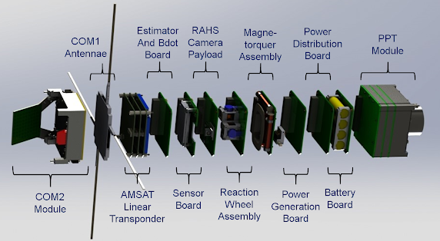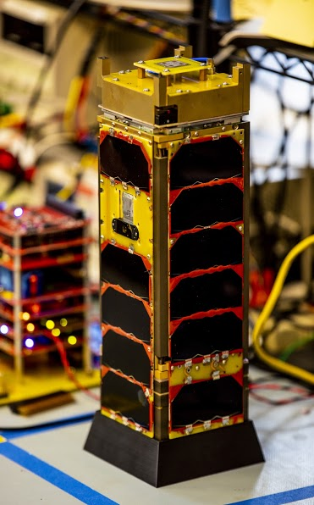

Figure b. Teardown of HUSKT SAT-1

Figure . University of Washington HUSKY SAT-1