Please make a website that fetches the content as a RSS from https://flipboard.com/@raimoseero/feed-nii8kd0sz?rss
The content is then showed, more or less, in this manner:
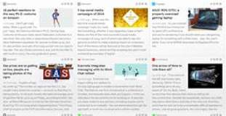
If the site is opened via mobile then the content is showed in this manner:
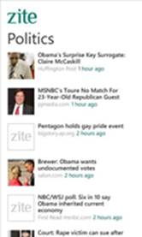
The user may click an article. This action opens a pop-up window that displays a content of an article fetched via mercury API (https://mercury.postlight.com/ ).

