Technical report AI vaccination project

Egil A.J.Fischer

2023-04-05

## Objectives and research questions

The objective of this study is to quantify the risk difference of humans being infected during an outbreak of avian influenza in a (partially) vaccinated herd versus non-vaccinated herds.

## Model description

We use a two-type stochastic SIRD-model. The population is divided into two type 1 and 2 which are birds with a low or high HAR titre. Differences between these two types of birds are infectivity and/or susceptibility and mortality. We assume equal infectious periods. Birds can loose the high titre status with a specific rate at which they become type 1 (low titre). Background mortality is equal for both types, but type 1 (low titre birds) are assumed to die at recovery, while type 2 (high titre birds) are assumed to survive. Human infection is affected by the amount of virus shedded. The dose-response relationship is assumed to be equal to the between-bird transmission and thus proportionate to the transmission rates between-birds. The force of infection of an infected flock towards a human is thus:

$$FOI_{chickentohuman}=α\frac{β_{11}Y_{1}+β_{22}Y_{2}}{N}$$

With $β_{i}i$ being the transmission rate from type $i$ to animals of the same type and $α$ a scaling factor for susceptibility if humans to this strain. The probability of a human being infected at a certain time $t$ is thus:

$$P_{infection}\left(t\right)=1-e^{\int_{0}^{t}{-α\frac{β_{11}Y_{1}\left(τ\right)+β_{22}Y_{2}\left(τ\right)}{N}dτ}}$$

To obtain the number of infectious birds we use a simulation of the stochastic model. From this model we define the course of outbreaks and the moment of detection based on the number of dead birds in a given interval.

To obtain the distribution of relative risk of vaccinated versus unvaccinated flocks we simulate both situations and report the distribution of infection probabilities until the detection time of each outbreak.

## Parameter values

Parameter values are based on Germeraad et al. 2023 \url(<https://edepot.wur.nl/584306>).

## [1] "Population size N0:"

## [1] 50000

## [1] "transmission coefficients"

## [,1] [,2]  
## [1,] 3.73 0.058  
## [2,] 3.73 0.058

## [1] "infectious periods"

## [1] 1.47 1.47

## [1] "Probability of dying"

## [1] 0.95 0.00

## [1] "Waning of immunity (transfer type i to j)"

## [,1] [,2]  
## [1,] 0.000 0  
## [2,] 0.038 0

## Probability of a major outbreak

Similar to the probability of a minor outbreak in a single type outbreak the probability of a minor outbreak in a two type model can be determined assuming a branching process in which $q_{j}$ is the probability of a branch starting with type $j$ going extinct is given by the probability of this individual recovering or dying before it produces a new branch + the probability of new branches going extinct: $q_{1}=\frac{γ_{1}+μ+β_{11}\frac{N_{1}}{N_{1}+N_{2}}q_{1}^{2}+β_{12}\frac{N_{2}}{N_{1}+N_{2}}q_{1}q_{2}}{γ_{1}+μ+β_{11}\frac{N_{1}}{N_{1}+N_{2}}+β_{12}\frac{N_{2}}{N_{1}+N_{2}}}$ $q_{2}=\frac{γ_{2}+μ+β_{21}\frac{N_{1}}{N_{1}+N_{2}}q_{1}q_{2}+β_{22}\frac{N_{2}}{N_{1}+N_{2}}q_{2}^{2}}{γ_{2}+μ+β_{21}\frac{N_{1}}{N_{1}+N_{2}}+β_{22}\frac{N_{2}}{N_{1}+N_{2}}}$

## Loading required package: rootSolve

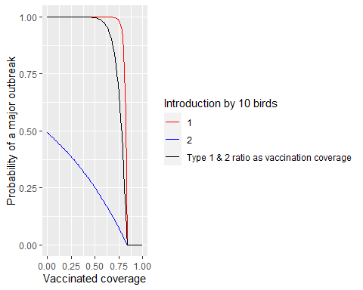

## Outbreak simulations

Simulations were produced for broilers (round of 42 days) and layers (rounds of 17 months approx 500 days); For layers we consider introduction at the beginning of round and half way, such that different vaccination levels occur. Outbreaks are simulated in one of the following scenarios:

| scenario | bird | roundlength | populationsize | initial.infected | proportion.hightitre |
| --- | --- | --- | --- | --- | --- |
| 1 | broiler | 42 | 75000 | 10 | 9e-01 |
| 2 | layer | 500 | 45000 | 10 | 9e-01 |
| 3 | layer | 250 | 45000 | 10 | 7e-05 |

For each scenario the model was run 10 times.

## Warning: Removed 2437 rows containing missing values (`geom_step()`).

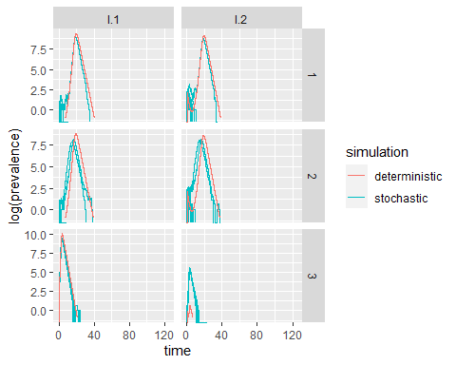

In scenario’s 1 and 2 the outbreak will cause many minor outbreaks (as expected from the calculation of this probability) for scenario 3 the outbreak will cause only major outbreaks.