NDV_Paper

Egil Fischer

23-3-2020

## Data

Samples are deemed positive if:

Chicks are positive if one or both (CLO and ON) samples are positive.

Result: No inconsistent ELISA and CT-positive samples

Only CLO is not possible and inconsistent with ELISA

# Material and methods

## Visualization of descriptive data

* Survival plot
* Epidemic curves (number of infectious animals divided by the total) were produced.
* Histogram of infectious period

## Statistical analyses

The infectious period $T_{inf}$: Parametric survival analyses assuming Normal distribution

The transmission parameter $β$: Generalized linear model with a complementary loglog-link function:

glm(cbind(C, S-C) ~ 1,offset = log(I/N), family = binomial(link = "cloglog"), data = data.set, na.action = na.omit)

The basic reproduction number ${\text{R}}_{0}=β⋅T_{inf}$ The confidence interval is calculated by $\text{log}(R)=\text{log}(β)+\text{log}(T_{inf})±Z_{0.05}⋅(\text{log}(SE(β))+\text{log}(SE(T_{inf}))$

Assumes independence between the transmission parameter and the infectious period.

# Results

## Survival curve

survivalplot

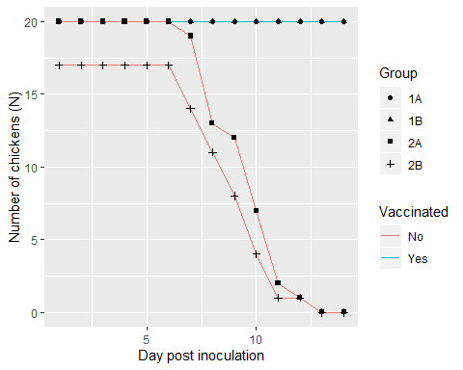

Infection curves

## Epidemic curve SIR and one or both positive

epicurveplot

## Warning: Removed 4 rows containing missing values (geom_path).

## Warning: Removed 4 rows containing missing values (geom_point).

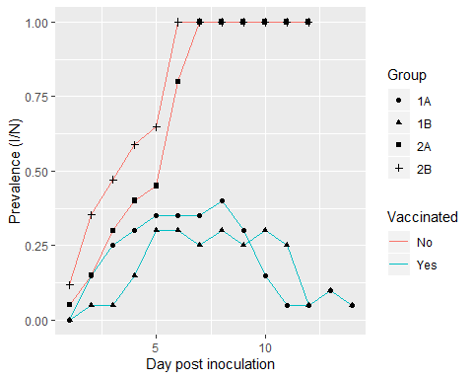

## $T_{inf}$ at least one (CLO or ON) positive sample

hist.one

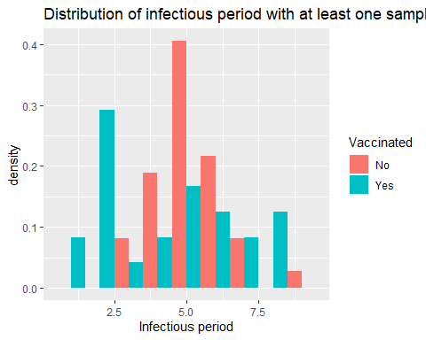

## $T_{inf}$ at least one (CLO or ON) positive sample

hist.one.chal

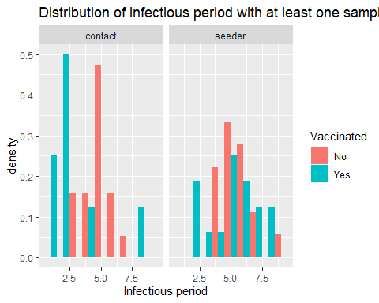

## Infectious period

mean.beta.inf.R[, c(1,5,6,7)]

## Vaccinated infper llinfper ulinfper  
## 1 No 4.789474 4.154680 5.424267  
## 2 Yes 3.380799 1.477503 5.284095

p =

signif(pvalueInf,2)

## [1] 0.03

$β$

## 

mean.beta.inf.R[, c(1,2,3,4)]

## Vaccinated beta llbeta ulbeta  
## 1 No 0.7123108 0.43678638 1.086711  
## 2 Yes 0.3205199 0.09646276 0.972477

p-value:

signif(pvalueBeta,2)

## [1] 0.023

$R$

## 

mean.beta.inf.R[, c(1,11,12,13)]

## Vaccinated R llR ulR  
## 1 No 3.411594 1.29263601 4.198793  
## 2 Yes 1.083613 0.04568178 1.647043

# Conclusion and discussion

## Conclusion

Based on the assumption of one of both samples required to be positive, we find that the transmission parameter $β$ is lower, and the mean infectious period $T_{inf}$ in the contact birds is lower, which results in a reproduction number $R$ which is smaller, but is not lower than the threshold $R≤1$.

# Additional assessment

## Compare CT value

For those that were defined positive

signif(summary(lm(valueP ~ ci + Sample + Vaccinated, data= melt.ct.data))$coefficients,2)

## Estimate Std. Error t value Pr(>|t|)  
## (Intercept) 26.00 0.49 52.0 8.1e-124  
## ciseeder -1.90 0.53 -3.7 3.0e-04  
## SampleON swab -0.56 0.55 -1.0 3.1e-01  
## VaccinatedYes 8.40 0.59 14.0 3.7e-33

summary(lm(valueP ~ ci, data= melt.ct.data[melt.ct.data$Vaccinated=="Yes"& melt.ct.data$Sample=="ON swab",]))

##   
## Call:  
## lm(formula = valueP ~ ci, data = melt.ct.data[melt.ct.data$Vaccinated ==   
## "Yes" & melt.ct.data$Sample == "ON swab", ])  
##   
## Residuals:  
## Min 1Q Median 3Q Max   
## -5.5151 -1.8651 0.9407 2.1549 4.6607   
##   
## Coefficients:  
## Estimate Std. Error t value Pr(>|t|)   
## (Intercept) 30.869 0.720 42.87 <2e-16 ***  
## ciseeder 1.476 0.829 1.78 0.0806 .   
## ---  
## Signif. codes: 0 '***' 0.001 '**' 0.01 '*' 0.05 '.' 0.1 ' ' 1  
##   
## Residual standard error: 2.694 on 55 degrees of freedom  
## (503 observations deleted due to missingness)  
## Multiple R-squared: 0.05449, Adjusted R-squared: 0.03729   
## F-statistic: 3.169 on 1 and 55 DF, p-value: 0.08055

summary(lm(valueP ~ ci, data= melt.ct.data[melt.ct.data$Vaccinated=="No"& melt.ct.data$Sample=="ON swab",]))

##   
## Call:  
## lm(formula = valueP ~ ci, data = melt.ct.data[melt.ct.data$Vaccinated ==   
## "No" & melt.ct.data$Sample == "ON swab", ])  
##   
## Residuals:  
## Min 1Q Median 3Q Max   
## -7.4628 -2.4659 -0.5778 2.4695 10.1472   
##   
## Coefficients:  
## Estimate Std. Error t value Pr(>|t|)   
## (Intercept) 25.833 0.589 43.862 < 2e-16 ***  
## ciseeder -3.649 0.917 -3.979 0.000154 ***  
## ---  
## Signif. codes: 0 '***' 0.001 '**' 0.01 '*' 0.05 '.' 0.1 ' ' 1  
##   
## Residual standard error: 4.038 on 78 degrees of freedom  
## (438 observations deleted due to missingness)  
## Multiple R-squared: 0.1688, Adjusted R-squared: 0.1581   
## F-statistic: 15.84 on 1 and 78 DF, p-value: 0.0001537

## Seeder acted as contact

Two seeder bird #817 and #818 in unvaccinated were positive slower. These were transfered to the contact group.

## INfectious period

#  
mean.beta.inf.R[, c(1,5,6,7)]

## Vaccinated infper llinfper ulinfper  
## 1 No 4.789474 4.154680 5.424267  
## 2 Yes 3.380799 1.477503 5.284095

pvalueInf

## [1] 0.02951464

## Transmision parameter

mean.beta.inf.R[, c(1,2,3,4)]

## Vaccinated beta llbeta ulbeta  
## 1 No 0.7123108 0.43678638 1.086711  
## 2 Yes 0.3205199 0.09646276 0.972477

pvalueBeta

## [1] 0.02274817

## Reproduction number

mean.beta.inf.R[, c(1,11,12,13)]

## Vaccinated R llR ulR  
## 1 No 3.411594 1.29263601 4.198793  
## 2 Yes 1.083613 0.04568178 1.647043

## Information on versions

sessionInfo()

## R version 3.6.0 (2019-04-26)  
## Platform: x86_64-w64-mingw32/x64 (64-bit)  
## Running under: Windows 10 x64 (build 17763)  
##   
## Matrix products: default  
##   
## locale:  
## [1] LC_COLLATE=Dutch_Netherlands.1252 LC_CTYPE=Dutch_Netherlands.1252   
## [3] LC_MONETARY=Dutch_Netherlands.1252 LC_NUMERIC=C   
## [5] LC_TIME=Dutch_Netherlands.1252   
##   
## attached base packages:  
## [1] stats graphics grDevices utils datasets methods base   
##   
## other attached packages:  
## [1] survival_3.1-8 lme4_1.1-21 Matrix_1.2-18 ggplot2_3.2.1 openxlsx_4.1.4  
##   
## loaded via a namespace (and not attached):  
## [1] zip_2.0.4 Rcpp_1.0.3 plyr_1.8.5 highr_0.8   
## [5] nloptr_1.2.1 pillar_1.4.3 compiler_3.6.0 tools_3.6.0   
## [9] boot_1.3-24 digest_0.6.23 nlme_3.1-143 evaluate_0.14   
## [13] lifecycle_0.1.0 tibble_2.1.3 gtable_0.3.0 lattice_0.20-38   
## [17] pkgconfig_2.0.3 rlang_0.4.4 yaml_2.2.1 xfun_0.12   
## [21] withr_2.1.2 stringr_1.4.0 dplyr_0.8.4 knitr_1.27   
## [25] grid_3.6.0 tidyselect_1.0.0 glue_1.3.1 R6_2.4.1   
## [29] rmarkdown_2.1 minqa_1.2.4 reshape2_1.4.3 farver_2.0.3   
## [33] purrr_0.3.3 magrittr_1.5 MASS_7.3-51.5 splines_3.6.0   
## [37] scales_1.1.0 htmltools_0.4.0 assertthat_0.2.1 colorspace_1.4-1  
## [41] labeling_0.3 stringi_1.4.4 lazyeval_0.2.2 munsell_0.5.0   
## [45] crayon_1.3.4