IBV Transmission study to determine the transmission of pathogenic IBV (Challenge) among vaccinated Commercial Broilers compared to that of unvaccinated birds

Egil A.J.Fischer

23 augustus, 2022

Source required code-files including loading the data

# Document structure

* Visualization and summarizing data
* Final size method
* Estimation of $R$ in vaccinated and unvaccinated birds using final size estimation

reference: (Velthuis et al. 2007)

## Input data

The following assumptions are made to determine the status of a bird (susceptible, infectious or recovered):

* At least two Ct-value < 36 during the entire experiment (a single CT-value < 36 is considered false positive)
* Between the first and last Ct-value <36 a bird is considered infectious (even if CT-values > 36)
* After the last positive sample a bird is considered recovered
* Susceptible birds is those never been positive.
* Inoculated birds are considered not to be susceptible even if they have no positive samples.

In the figure below the time interval from negative to postive and positive to negative is indicated.

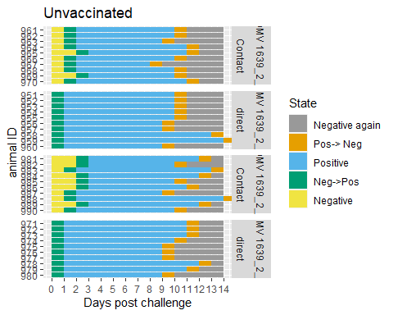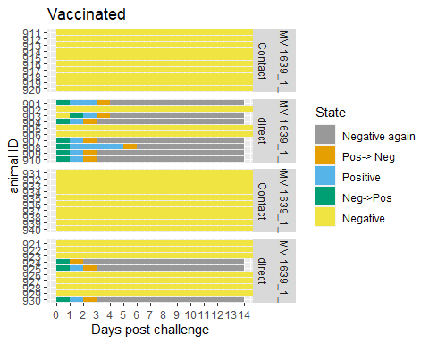

In the unvaccinated groups we see a quick transmission of the infection within a few day post exposure. In three days all contact animals are infected. In the vaccinated groups non of the contact animals are infected, and only a proportion of the challenged birds. For the vaccinated birds the estimation of a transmission rate $β$ is not possible. For both vaccinated and unvaccinated birds estimation of $R$ using the final size method (see below) is possible for the respectively upper and lower confidence boundary, and testing whether it differs from 1. The infectious period of the unvaccinated birds seems to be similar in challenged and unchallenged birds. These will be estimated as well.

# Final size method

The final size are the number of animals that were infected during the entire duration of an outbreak (or experiment). For small numbers the exact distribution can be determined numerically for a known value of $R$. This can be used to determine the most likely value of $R$ and its boundaries given an observed final size. In case of no or all contact animals being infected the most likely value is respectively 0 or $∞$ and only the upper- and lower boundary of the confidence interval can be given.

## `summarise()` has grouped output by 'Group'. You can override using the  
## `.groups` argument.

Input values for the final size calculations. fs = susceptibles infected at end of experiment, iS = contact birds beginning of experiment, iI = challenged birds that excreed during experiment, iR = challenged birds that do not excrete

| Group | Vaccinated | fs | iS | iI | iR | n |
| --- | --- | --- | --- | --- | --- | --- |
| DMV 1639_1_1 | Yes | 0 | 10 | 7 | 7 | 20 |
| DMV 1639_1_2 | Yes | 0 | 10 | 3 | 3 | 20 |
| DMV 1639_2_1 | No | 10 | 10 | 10 | 20 | 20 |
| DMV 1639_2_2 | No | 10 | 10 | 10 | 20 | 20 |

## $R$ with final size estimation

Estimate of $R$ based on the final size. Estimate = best value, 95%-LL= lower limit,95%-UL = upper limit, pval.above1 = probability $R$ is above 1

| Vaccinated | Estimate | 95%-LL | 95%-UL | pval.above1 |
| --- | --- | --- | --- | --- |
| Yes | 0 | 0.00 | 0.73 | 0.02 |
| No | Inf | 4.11 | Inf | 1.00 |

# Estimate beta

Transmission coefficient unvaccinated birds

|  | est.beta | 2.5%-CI | 97.5%-CI |
| --- | --- | --- | --- |
|  | 0.58 | 0.37 | 0.9 |

# Estimate the infectious period

ggplot(inf.per.data)+geom_histogram(aes(infT),binwidth = 1)+facet_grid(Challenge~Group)

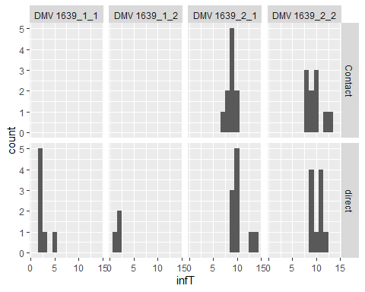

Average infectious periods for each group

| Challenge | Vaccinated | replication | mean | sd | df | 2.5%-CI | 97.5%-CI |
| --- | --- | --- | --- | --- | --- | --- | --- |
| direct | Yes | 1 | 2.57 | 1.13 | 6 | 1.52 | 3.62 |
| direct | Yes | 2 | 1.67 | 0.58 | 2 | 0.23 | 3.10 |
| Contact | No | 1 | 8.80 | 0.92 | 9 | 8.14 | 9.46 |
| direct | No | 1 | 10.40 | 1.71 | 9 | 9.17 | 11.63 |
| Contact | No | 2 | 9.70 | 1.70 | 9 | 8.48 | 10.92 |
| direct | No | 2 | 10.20 | 1.14 | 9 | 9.39 | 11.01 |

From the histograms and table it is already evident that the vaccination affects the infectious period. There seems to be no difference between challenged and contact infected birds.

fit.inft <- lm(infT ~ Vaccinated+Challenge, data = inf.per.data)  
drop1(fit.inft)

## Single term deletions  
##   
## Model:  
## infT ~ Vaccinated + Challenge  
## Df Sum of Sq RSS AIC  
## <none> 86.05 33.145  
## Vaccinated 1 426.67 512.72 120.385  
## Challenge 1 11.03 97.07 37.173

Conclusion there is not difference between the model with and without challenge (difference in AIC less than 2). Still we choose for the most parsimonious model without challenge.

Average infectious periods per treatment

| Vaccinated | mean | sd | df | 2.5%-CI | 97.5%-CI |
| --- | --- | --- | --- | --- | --- |
| No | 9.78 | 1.49 | 39 | 9.32 | 10.23 |
| Yes | 2.30 | 1.06 | 9 | 1.29 | 3.31 |

# R value of unvaccinated calculated from $β$ and $Tinf$

Reproduction number of unvaccinated animals

| R.est | 2.5%-CI | 97.5%-CI |
| --- | --- | --- |
| 5.71 | 3.56 | 9.15 |

# Summary

* Vaccination will reduce the R value from a value larger than 1 to below 1. The best estimate for vaccinated groups is $R=0$ with upper limit 0.32. For unvaccinated the $R$ estimated from final size is $∞$ with lower limit of 2.06.
* In the unvaccinated group some variation in transmission times was observed. The transmission coefficient $β$ and the infectious period could be estimated from which a more precise R value could be calculated:
  + $β$ is

beta.est

## est.beta 2.5%-CI 97.5%-CI  
## 0.584 0.37 0.9

* $Tinf$ is

av.infT.vaccinated.adjusted[1,c(2,5,6)]

## # A tibble: 1 x 3  
## mean `2.5%-CI` `97.5%-CI`  
## <dbl> <dbl> <dbl>  
## 1 9.78 9.32 10.2

* $R_{0}$ is

Rests

## R.est 2.5%-CI 97.5%-CI  
## 1 5.708109 3.561607 9.148263

(small difference with beta*Tinf because of rounding. )

# Reference

Velthuis, A. G. J., Bouma, A., Katsma, W. E. A., Nodelijk, G., & De Jong, M. C. M. (2007). Design and analysis of small-scale transmission experiments with animals. Epidemiology and Infection, 135(2), 202–217. <https://doi.org/10.1017/S095026880600673X>