IBV Transmission study to determine the transmission of pathogenic IBV (Challenge) among vaccinated Commercial Broilers compared to that of unvaccinated birds

Egil A.J.Fischer

18 augustus, 2022

Source required code-files including loading the data

## Warning: package 'reshape2' was built under R version 4.1.3

##   
## Attaching package: 'reshape2'

## The following object is masked from 'package:tidyr':  
##   
## smiths

## [1] "Analysis run at Thu Aug 18 08:31:45 2022"

# Document structure

* Visualization and summarizing data
* Final size method
* Estimation of $R$ in vaccinated and unvaccinated birds using final size estimation

reference: (Velthuis et al. 2007)

## visualize data

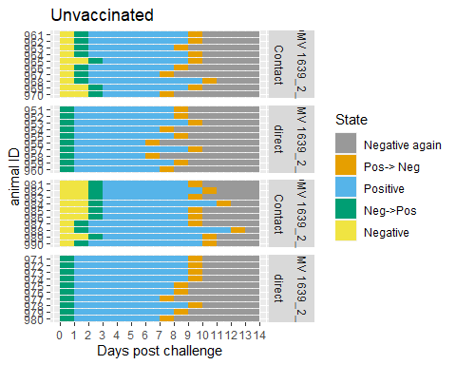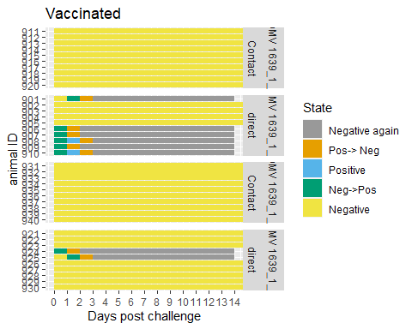

In the unvaccinated groups we see a quick transmission of the infection within a few day post exposure. In three days all contact animals are infected. In the vaccinated groups non of the contact animals are infected, and only a proportion of the challenged birds. For the vaccinated birds the estimation of a transmission rate $β$ is not possible. For both vaccinated and unvaccinated birds estimation of $R$ using the final size method (see below) is possible for the respectively upper and lower confidence boundary, and testing whether it differs from 1. The infectious period of the unvaccinated birds seems to be similar in challenged and unchallenged birds. These will be estimated as well.

# Final size method

The final size are the number of animals that were infected during the entire duration of an outbreak (or experiment). For small numbers the exact distribution can be determined numerically for a known value of $R$. This can be used to determine the most likely value of $R$ and its boundaries given an observed final size. In case of no or all contact animals being infected the most likely value is respectively 0 or $inf$ and only the upper- and lower boundary of the confidence interval can be given.

## `summarise()` has grouped output by 'Group'. You can override using the  
## `.groups` argument.

Input values for the final size calculations. fs = susceptibles infected at end of experiment, iS = contact birds beginning of experiment, iI = challenged birds that excreed during experiment, iR = challenged birds that do not excrete

| Group | Vaccinated | fs | iS | iI | iR | n |
| --- | --- | --- | --- | --- | --- | --- |
| DMV 1639_1_1 | Yes | 0 | 10 | 10 | 0 | 20 |
| DMV 1639_1_2 | Yes | 0 | 10 | 10 | 0 | 20 |
| DMV 1639_2_1 | No | 10 | 10 | 10 | 0 | 20 |
| DMV 1639_2_2 | No | 10 | 10 | 10 | 0 | 20 |

## $R$ with final size estimation

Estimate of $R$ based on the final size. Estimate = best value, 95%-LL= lower limit,95%-UL = upper limit, pval.above1 = probability $R$ is above 1

| Vaccinated | Estimate | 95%-LL | 95%-UL | pval.above1 |
| --- | --- | --- | --- | --- |
| Yes | 0 | 0.00 | 0.32 | 0 |
| No | Inf | 2.06 | Inf | 1 |

## $R$ with final size estimation: Non excreting challenged are S

Estimate of $R$ based on the final size. Estimate = best value, 95%-LL= lower limit,95%-UL = upper limit, pval.above1 = probability $R$ is above 1

| Vaccinated | Estimate | 95%-LL | 95%-UL | pval.above1 |
| --- | --- | --- | --- | --- |
| Yes | 0 | 0.00 | 0.32 | 0 |
| No | Inf | 2.06 | Inf | 1 |

# Estimate beta

## all animals

glmdat <- sir.data.nona[[1]]%>%filter(S>0&I>0)  
fit <- glm(cbind(C,S-C)~Vaccinated,offset =-log(I/N),family = binomial(link = "cloglog"),data = glmdat)

## Warning: glm.fit: fitted probabilities numerically 0 or 1 occurred

summary(fit)

##   
## Call:  
## glm(formula = cbind(C, S - C) ~ Vaccinated, family = binomial(link = "cloglog"),   
## data = glmdat, offset = -log(I/N))  
##   
## Deviance Residuals:   
## Min 1Q Median 3Q Max   
## -2.52359 -0.00016 -0.00008 0.56875 2.70578   
##   
## Coefficients:  
## Estimate Std. Error z value Pr(>|z|)   
## (Intercept) -0.5379 0.2382 -2.259 0.0239 *  
## VaccinatedYes -22.8944 3301.8349 -0.007 0.9945   
## ---  
## Signif. codes: 0 '***' 0.001 '**' 0.01 '*' 0.05 '.' 0.1 ' ' 1  
##   
## (Dispersion parameter for binomial family taken to be 1)  
##   
## Null deviance: 1417.312 on 7 degrees of freedom  
## Residual deviance: 17.891 on 6 degrees of freedom  
## AIC: 27.176  
##   
## Number of Fisher Scoring iterations: 18

signif(exp(cumsum(fit$coefficients)),3)

## (Intercept) VaccinatedYes   
## 5.84e-01 6.66e-11

## only estimate for unvaccinated aniamals

fit <- glm(cbind(C,S-C)~1,offset =-log(I/N),family = binomial(link = "cloglog"),data = glmdat[glmdat$Vaccinated == "No",])  
summary(fit)

##   
## Call:  
## glm(formula = cbind(C, S - C) ~ 1, family = binomial(link = "cloglog"),   
## data = glmdat[glmdat$Vaccinated == "No", ], offset = -log(I/N))  
##   
## Deviance Residuals:   
## 1 2 5 6   
## 0.07553 -2.52360 2.04841 2.70577   
##   
## Coefficients:  
## Estimate Std. Error z value Pr(>|z|)   
## (Intercept) -0.5379 0.2382 -2.259 0.0239 *  
## ---  
## Signif. codes: 0 '***' 0.001 '**' 0.01 '*' 0.05 '.' 0.1 ' ' 1  
##   
## (Dispersion parameter for binomial family taken to be 1)  
##   
## Null deviance: 17.891 on 3 degrees of freedom  
## Residual deviance: 17.891 on 3 degrees of freedom  
## AIC: 25.176  
##   
## Number of Fisher Scoring iterations: 5

signif(exp(cumsum(fit$coefficients)),3)

## (Intercept)   
## 0.584

# Estimate the infectious period

ggplot(inf.per.data)+geom_histogram(aes(infT),binwidth = 1)+facet_grid(Challenge~Group)

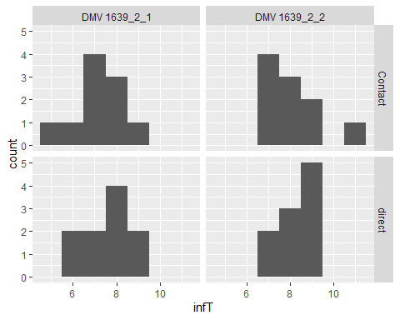

anova <- lm(infT ~ Group + Challenge, data = inf.per.data)  
drop1(anova)

## Single term deletions  
##   
## Model:  
## infT ~ Group + Challenge  
## Df Sum of Sq RSS AIC  
## <none> 43.1 8.9857  
## Group 1 6.4 49.5 12.5237  
## Challenge 1 0.9 44.0 7.8124

kable(cbind(av.infT.group),  
 caption = c("Average infectious periods"),  
 digits = 2)

Average infectious periods

| Group | mean | sd |
| --- | --- | --- |
| DMV 1639_2_1 | 7.4 | 1.10 |
| DMV 1639_2_2 | 8.2 | 1.06 |

#Conclusions

Vaccination will reduce the R value from a value larger than below 1 and

# Reference

Velthuis, A. G. J., Bouma, A., Katsma, W. E. A., Nodelijk, G., & De Jong, M. C. M. (2007). Design and analysis of small-scale transmission experiments with animals. Epidemiology and Infection, 135(2), 202–217. <https://doi.org/10.1017/S095026880600673X>