HEALTH CENTER MANAGEMENT SYSTEM
QSHMS
System Analysis & Design Document
Prepared by: Health Center Project Team
Date: 18 March 2026 | Updated: April 2026

1. Stakeholder Analysis
The QSHMS serves as a central platform connecting four main groups of stakeholders, each with distinct roles and interests in the system's functionality and performance.

Stakeholder | Role / Interest in QSHMS
Operational Stakeholders
Doctor | Views patient records, adds diagnoses & prescriptions, manages appointments
Receptionist | Registers new patients, schedules appointments, manages patient information
Nurse | Assists doctors, updates patient vitals and care notes in the system
System Administrator | Manages users, generates reports, maintains system data and integrity
Internal Stakeholders
IT Staff | Maintain, deploy, and troubleshoot the technical infrastructure of QSHMS
HR Manager | Manages staff profiles, schedules, and employment records
Accountant | Monitors billing, payments, and financial data generated by the system
Lab Technician | Accesses lab orders tied to patient records and uploads test results
External Stakeholders
Patient | Primary beneficiary — books appointments, registers, views medical records
Insurance Company | Receives claim data and billing information from the system
Pharmacy | Receives and processes prescriptions generated by doctors in the system
Referral Hospital | Receives patient referral documentation and medical history exports
External Laboratory | Receives test requests and sends back results integrated into records
Executive Stakeholders
Healthcare Center Director | Overall system success, efficiency, and patient satisfaction
Medical Director | Clinical quality, adherence to medical standards, doctor performance
IT Manager / CTO | Technology choices, system security, scalability and maintenance
Ministry of Health | Regulatory compliance, public health data reporting
Finance Manager | Budget, system cost management, financial reporting outputs

2. Use Case Summary
The following table summarizes the key use cases identified for QSHMS, mapping each use case to its actors, process flow, and system postconditions.

UC ID | Use Case | Actor(s) | Flow Summary | Postcondition
UC-01 | Register New Patient | Receptionist | Receptionist selects Register Patient, fills in the patient form, and submits. The system validates data, saves patient info, and generates a unique Patient ID. | Patient information stored; unique Patient ID generated.
UC-02 | Search Patient | Receptionist | Receptionist enters patient name or ID and clicks Search. The system queries the database, retrieves matching records, and displays patient details. | Patient record displayed to receptionist.
UC-03 | Schedule Appointment | Receptionist | Receptionist selects patient, doctor, date, and time. The system shows available doctors and slots, then confirms and saves the appointment. | Appointment record saved; time slot reserved.
UC-04 | Add Diagnosis | Doctor | Doctor opens patient record, enters diagnosis notes, and saves. System records and updates the medical record with the new diagnosis. | Diagnosis saved; patient medical record updated.
UC-05 | Secure Login | Doctor, Receptionist, Admin | User enters username and password and clicks Login. The system validates credentials and redirects to the role-specific dashboard. | User authenticated and granted system access.

3. Functional Requirements
Functional requirements define the specific behaviors and functions that the QSHMS must perform. Each requirement is mapped to a system module, the responsible actor(s), and a priority level (High / Medium / Low).

FR ID | Module | Functional Requirement | Actor(s) | Priority
FR-01 | User Authentication | The system shall allow users (Doctor, Receptionist, Admin) to log in using a username and password. | Doctor, Receptionist, Admin | High
FR-02 | User Authentication | The system shall validate credentials and redirect users to their role-based dashboard upon successful login. | Doctor, Receptionist, Admin | High
FR-03 | User Authentication | The system shall display an error message when invalid credentials are entered. | Doctor, Receptionist, Admin | High
FR-04 | Patient Registration | The system shall provide a patient registration form for entering personal information. | Receptionist | High
FR-05 | Patient Registration | The system shall validate all patient data before saving (e.g., phone number format, required fields). | Receptionist | High
FR-06 | Patient Registration | The system shall generate a unique Patient ID upon successful registration. | Receptionist, System | High
FR-07 | Patient Registration | The system shall display an error when mandatory patient fields are missing or incorrectly formatted. | Receptionist | Medium
FR-08 | Patient Search | The system shall allow the receptionist to search patients by name or patient ID. | Receptionist | High
FR-09 | Patient Search | The system shall display a list of matching patient records from the database. | Receptionist | High
FR-10 | Patient Search | The system shall notify the receptionist if no patient record is found. | Receptionist | Medium
FR-11 | Appointment Scheduling | The system shall allow the receptionist to select a patient, doctor, date, and time for an appointment. | Receptionist | High
FR-12 | Appointment Scheduling | The system shall display available doctors and open time slots for scheduling. | Receptionist, System | High
FR-13 | Appointment Scheduling | The system shall save the appointment and prevent double-booking of time slots. | System | High
FR-14 | Appointment Scheduling | The system shall notify the receptionist if the selected time slot is unavailable. | Receptionist | Medium
FR-15 | Medical Records | The system shall allow doctors to open and view a patient's existing medical record. | Doctor | High
FR-16 | Medical Records | The system shall allow doctors to enter and save a diagnosis for a patient. | Doctor | High
FR-17 | Medical Records | The system shall automatically update the patient's medical record after a diagnosis is saved. | Doctor, System | High
FR-18 | Medical Records | The system shall display an error if a patient record is not found during diagnosis entry. | Doctor | Medium
FR-19 | Prescription | The system shall allow doctors to create and link prescriptions to a patient diagnosis. | Doctor | High
FR-20 | Prescription | The system shall allow prescriptions to be exported or sent to a linked pharmacy. | Doctor, System | Medium
FR-21 | Doctor Schedule | The system shall display the availability and schedule of all registered doctors. | Receptionist, Doctor | High
FR-22 | User Management | The system administrator shall be able to create, edit, and deactivate user accounts. | Admin | High
FR-23 | User Management | The system shall assign role-based access rights to each user (Doctor, Receptionist, Admin). | Admin, System | High
FR-24 | Reporting | The system shall allow administrators to generate reports on appointments, patients, and diagnoses. | Admin | Medium
FR-25 | Lab Integration | The system shall allow lab technicians to upload test results linked to patient records. | Lab Technician | Medium

4. Non-Functional Requirements (NFR)
Non-functional requirements define the quality attributes, constraints, and standards that the QSHMS must conform to. These requirements govern how the system performs its functions rather than what functions it performs. They are categorized by quality dimension and include performance, security, availability, scalability, usability, reliability, maintainability, and compliance.

NFR ID | Category | Non-Functional Requirement | Stakeholder | Priority
NFR-01 | Performance | The system shall load any page or dashboard within 3 seconds under normal operating conditions (up to 100 concurrent users). | All Users | High
NFR-02 | Performance | The system shall process patient search queries and return results within 2 seconds. | Receptionist | High
NFR-03 | Performance | The system shall support at least 200 simultaneous active user sessions without degradation in response time. | System | High
NFR-04 | Security | All user passwords shall be stored as hashed values using a minimum of bcrypt (work factor ≥ 12) or equivalent algorithm. | System, Admin | High
NFR-05 | Security | All data transmitted between the client and server shall be encrypted using TLS 1.2 or higher (HTTPS). | System, IT Staff | High
NFR-06 | Security | The system shall enforce role-based access control (RBAC) ensuring users can only access data and functions permitted for their role. | System, Admin | High
NFR-07 | Security | The system shall lock a user account after 5 consecutive failed login attempts and require admin intervention to unlock. | System, Admin | High
NFR-08 | Security | The system shall maintain a complete audit trail log of all access, modifications, and deletions to patient records. | System | High
NFR-09 | Availability | The system shall achieve a minimum uptime of 99.5% during operational hours (06:00–22:00 daily). | IT Staff | High
NFR-10 | Availability | Scheduled maintenance windows shall not exceed 4 hours per month and must be performed outside peak hours. | IT Manager | Medium
NFR-11 | Scalability | The system architecture shall support horizontal scaling to accommodate a 300% increase in user load without redesign. | IT Manager / CTO | Medium
NFR-12 | Scalability | The database shall support storage of up to 1 million patient records with consistent query performance. | System | Medium
NFR-13 | Usability | The system shall provide an intuitive interface where a newly trained receptionist can complete patient registration within 5 minutes. | Receptionist | High
NFR-14 | Usability | All key actions shall be accessible within 3 clicks from the role-based dashboard. | All Users | Medium
NFR-15 | Usability | The system shall support keyboard navigation and comply with WCAG 2.1 Level AA accessibility standards. | All Users | Medium
NFR-16 | Reliability | The system shall implement automatic daily database backups retained for a minimum of 30 days. | IT Staff | High
NFR-17 | Reliability | In case of a system failure, recovery time objective (RTO) shall be ≤ 4 hours and recovery point objective (RPO) ≤ 24 hours. | IT Staff | High
NFR-18 | Maintainability | The system codebase shall follow modular design principles to allow individual module updates without affecting other modules. | IT Staff | Medium
NFR-19 | Maintainability | System error logs shall be automatically generated and accessible via the admin panel for troubleshooting. | Admin, IT Staff | Medium
NFR-20 | Compliance | The system shall comply with applicable national health data protection regulations and patient privacy laws. | Admin, Ministry of Health | High
NFR-21 | Compliance | All medical records and transactions shall be timestamped and non-editable after submission to ensure data integrity. | System | High
NFR-22 | Compatibility | The system shall be accessible via modern web browsers (Chrome, Firefox, Edge, Safari) on both desktop and mobile devices. | All Users | High
NFR-23 | Compatibility | The system shall integrate with external lab systems and pharmacy APIs using standardized HL7/REST interface protocols. | Lab Technician, Pharmacy | Medium
NFR-24 | Localization | The system shall support display in at least two languages (English and Arabic) with a user-selectable language toggle. | All Users | Low
NFR-25 | Interoperability | The system shall provide a secure API endpoint for data exchange with external hospitals and insurance companies using JSON/XML formats. | Insurance Company, Referral Hospital | Medium

4.1 NFR Category Summary
The 25 non-functional requirements above are distributed across 11 quality categories:
- Performance (NFR-01 to NFR-03): System must remain responsive under concurrent load.
- Security (NFR-04 to NFR-08): Data must be protected at rest and in transit with strict access control.
- Availability (NFR-09 to NFR-10): System must remain operational during working hours.
- Scalability (NFR-11 to NFR-12): System architecture must accommodate future growth.
- Usability (NFR-13 to NFR-15): Interface must be intuitive and accessible to all roles.
- Reliability (NFR-16 to NFR-17): Data must be recoverable in case of failure.
- Maintainability (NFR-18 to NFR-19): System must be easy to update and monitor.
- Compliance (NFR-20 to NFR-21): System must adhere to health data regulations.
- Compatibility (NFR-22 to NFR-23): System must work across browsers and integrate with external systems.
- Localization (NFR-24): System must support multilingual interfaces.
- Interoperability (NFR-25): System must exchange data with external health entities.

5. Business Process Modeling (BPM)
Business Process Modeling identifies the structured sequence of activities performed within QSHMS to achieve defined business outcomes. Each process is described by its trigger event, step-by-step activities, and expected result.

ID | Process Name | Trigger | Process Steps | Outcome
BP-01 | Patient Registration Process | New patient arrives at health center | 1. Receptionist logs into system  2. Selects Register Patient  3. Enters patient personal info  4. System validates data  5. System saves record  6. System assigns Patient ID  7. Registration confirmed to receptionist | Patient record created with unique ID
BP-02 | Appointment Scheduling Process | Patient requests appointment | 1. Receptionist searches patient record  2. Selects patient  3. Views available doctors  4. Views available time slots  5. Selects doctor, date, and time  6. System saves appointment  7. Confirmation displayed | Appointment booked and stored in system
BP-03 | Medical Consultation Process | Patient arrives for scheduled appointment | 1. Doctor logs into system  2. Opens patient record  3. Reviews patient history  4. Conducts consultation  5. Enters diagnosis notes  6. Creates prescription (if needed)  7. Saves record | Diagnosis recorded; prescription created
BP-04 | Lab Test Process | Doctor orders lab tests | 1. Doctor adds lab request to patient record  2. System sends order to lab  3. Lab technician receives request  4. Lab technician processes test  5. Results uploaded to system  6. Doctor reviews results  7. Results linked to patient record | Test results stored in patient record
BP-05 | User Login & Authentication Process | User accesses system login page | 1. User opens system  2. Enters username and password  3. Clicks Login  4. System validates credentials  5. System identifies user role  6. Redirects to role-based dashboard | User authenticated and granted access

5.1 Key Business Process Descriptions
BP-01: Patient Registration — This process begins when a new patient arrives and ends when a unique Patient ID is generated and stored. The receptionist initiates the process via the registration form, and the system handles validation and ID assignment automatically.
BP-02: Appointment Scheduling — Triggered by a patient request, this process involves matching a patient to an available doctor and time slot. The system prevents double-booking by checking real-time slot availability before confirming.
BP-03: Medical Consultation — The core clinical process initiated when a patient attends their appointment. The doctor records diagnosis notes and optionally creates prescriptions. All data is persisted to the patient's medical record.
BP-04: Lab Test Process — Initiated by a doctor's order, this process spans from test request through result delivery. The system coordinates between the doctor, lab technician, and patient record to ensure results are captured and linked correctly.

5.2 BPMN Diagram
The Business Process Model and Notation (BPMN) diagram below illustrates the complete flow of all core QSHMS processes across swimlanes representing each actor. Start events (green circles), tasks (blue rectangles), gateways (yellow diamonds), and end events (red circles) are used per BPMN 2.0 notation.
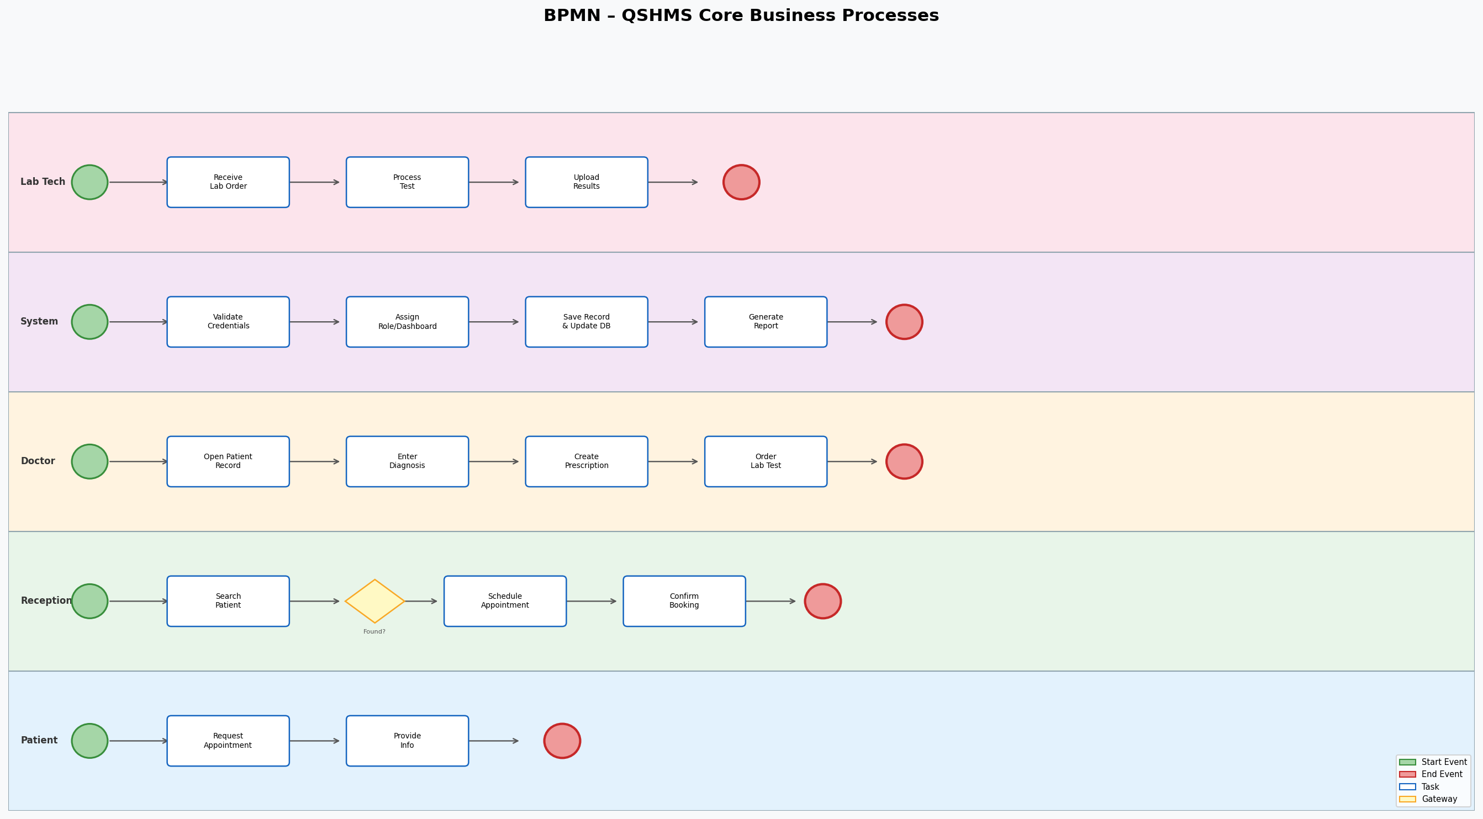

6. Business Process Mapping
Business Process Mapping provides a cross-reference of each business process with its actor, associated use case, data inputs and outputs, supporting system module, and exception conditions. This mapping ensures traceability between business needs and system functionality.

Business Process | Actor | Use Case | Input | System Used | Output | Exception
Patient Registration | Receptionist | Register New Patient | Patient Registration Form | Patient DB | Patient Record + Patient ID | Missing info / Invalid phone
Patient Search | Receptionist | Search Patient | Patient Name / ID | Patient DB | Patient details displayed | Patient not found
Appointment Scheduling | Receptionist | Schedule Appointment | Patient ID, Doctor selection, Date/Time | Appointments DB, Doctor Schedule | Confirmed appointment record | Slot unavailable
Medical Consultation | Doctor | Add Diagnosis | Patient ID, Diagnosis notes | Medical Records DB | Updated patient record with diagnosis | Patient record not found
Prescription Creation | Doctor | Create Prescription | Diagnosis ID, Medication details | Prescription DB | Prescription linked to patient | Drug interaction warning
Lab Test Request | Doctor / Lab Tech | Request Lab Test | Patient ID, Test type | Lab Orders DB | Test results uploaded to patient record | Lab system unavailable
User Login | Doctor / Receptionist / Admin | Secure Login | Username & Password | User Credentials DB | Role-based dashboard access | Invalid credentials
User Management | Administrator | Manage Users | Staff details, role assignment | User Management DB | User account created / modified | Duplicate username

7. Data Flow Diagramming (DFD)
Data Flow Diagrams model how data moves through the QSHMS. The diagram and table below describe each process with its external entities (sources/sinks), data inputs, internal processing module, data outputs, and the corresponding data stores (databases).

7.1 DFD Context Level (Level 0) — System Overview
At the context level, QSHMS receives data from external entities such as Receptionists, Doctors, and Administrators, processes it through internal modules, and stores outputs in the relevant databases. Outputs include patient records, appointments, diagnoses, prescriptions, and reports.

7.2 Data Flow Diagram (Visual)
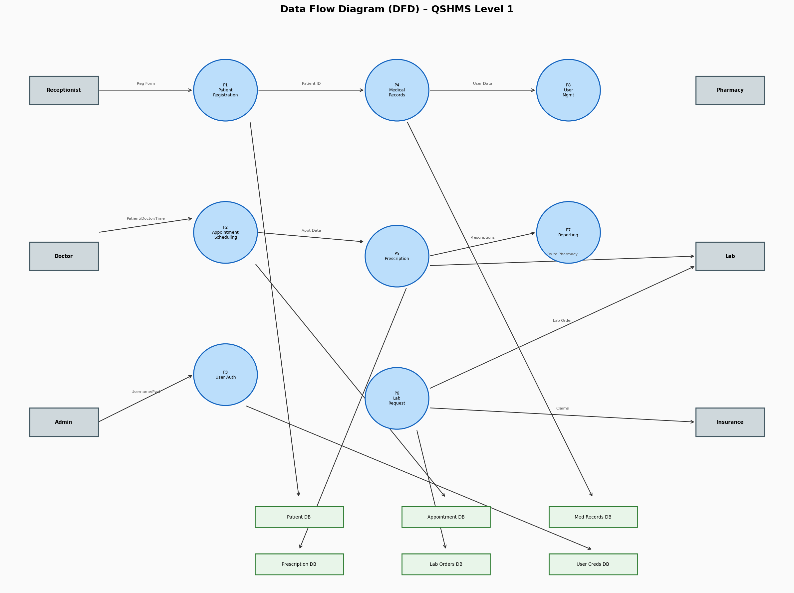

7.3 Level 1 DFD — Process Decomposition
Process Name | External Entity | Data Input | Processing Module | Data Output | Data Store
Patient Registration | Receptionist | Registration Form Data (Name, DOB, Phone, Address) | Patient Registration Module | Patient Record, Patient ID | Patient Database
Patient Search | Receptionist | Search Query (Name or ID) | Patient Search Module | Patient Record Details | Patient Database
Appointment Scheduling | Receptionist | Patient ID, Doctor ID, Date, Time | Appointment Module | Appointment Confirmation | Appointment Database, Doctor Schedule
Add Diagnosis | Doctor | Diagnosis Notes, Patient ID | Medical Records Module | Updated Medical Record | Medical Records Database
Create Prescription | Doctor | Diagnosis ID, Medication Info | Prescription Module | Prescription Document | Prescription Database
Lab Test Request | Doctor | Patient ID, Test Type | Lab Request Module | Lab Order; Test Results | Lab Orders Database
User Authentication | Doctor / Receptionist / Admin | Username, Password | Authentication Module | Session Token, Dashboard Access | User Credentials Database
User Management | Administrator | User Profile, Role Assignment | User Management Module | Updated User Account | User Database
Report Generation | Administrator | Report Parameters (Date Range, Type) | Reporting Module | Summary Report (PDF/Table) | All System Databases

7.4 Data Stores Summary
Data Store | Description
Patient Database | Stores all patient personal information, registration dates, and unique Patient IDs.
Appointment Database | Stores appointment records including patient, doctor, date, time, and status.
Medical Records Database | Contains all diagnosis records, treatment plans, and consultation notes per patient.
Prescription Database | Stores all prescriptions linked to diagnoses, including medication details and durations.
Lab Orders Database | Records lab test requests and stores results uploaded by lab technicians.
User Credentials Database | Manages usernames, hashed passwords, roles, and account status for all system users.
User Database | Stores staff profiles including contact details, roles, and system access rights.

8. Entity-Relationship Diagram (ERD)
The Entity-Relationship model defines the data entities within QSHMS, their attributes, primary keys, and the relationships between them. This model forms the basis for the system's database design.

8.1 ERD Visual Diagram
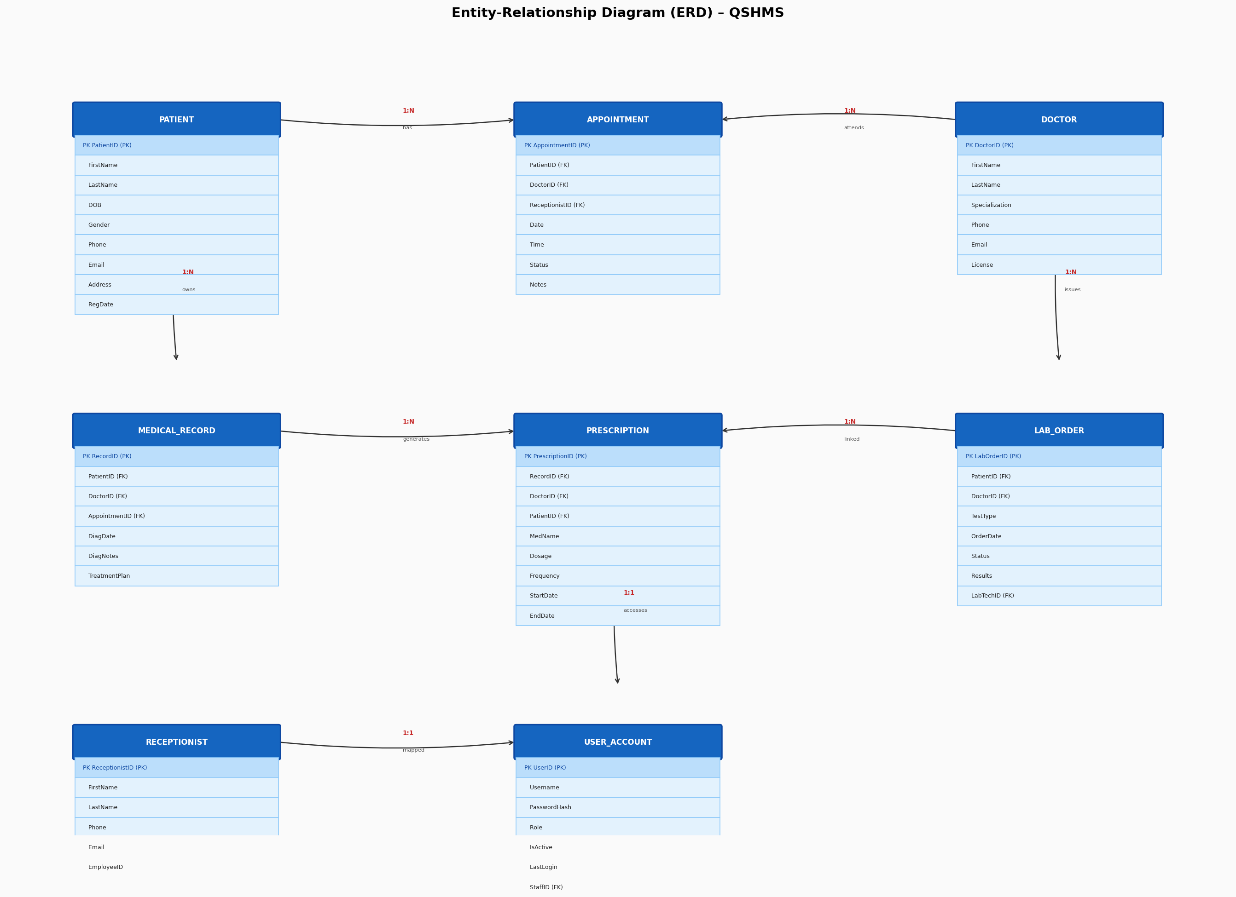

8.2 Entities and Attributes
Entity | Primary Key | Attributes
PATIENT | PatientID (PK) | FirstName, LastName, DateOfBirth, Gender, Phone, Email, Address, RegistrationDate
DOCTOR | DoctorID (PK) | FirstName, LastName, Specialization, Phone, Email, LicenseNumber
RECEPTIONIST | ReceptionistID (PK) | FirstName, LastName, Phone, Email, EmployeeID
APPOINTMENT | AppointmentID (PK) | PatientID (FK), DoctorID (FK), ReceptionistID (FK), AppointmentDate, AppointmentTime, Status, Notes
MEDICAL_RECORD | RecordID (PK) | PatientID (FK), DoctorID (FK), AppointmentID (FK), DiagnosisDate, DiagnosisNotes, TreatmentPlan
PRESCRIPTION | PrescriptionID (PK) | RecordID (FK), DoctorID (FK), PatientID (FK), MedicationName, Dosage, Frequency, StartDate, EndDate
LAB_ORDER | LabOrderID (PK) | PatientID (FK), DoctorID (FK), TestType, OrderDate, Status, Results, LabTechnicianID (FK)
USER_ACCOUNT | UserID (PK) | Username, PasswordHash, Role (Doctor/Receptionist/Admin), IsActive, LastLogin, StaffID (FK)

8.3 Relationships Between Entities
Entity A | Entity B | Cardinality | Description
PATIENT | APPOINTMENT | One-to-Many | A patient can have many appointments
DOCTOR | APPOINTMENT | One-to-Many | A doctor can have many appointments
RECEPTIONIST | APPOINTMENT | One-to-Many | A receptionist books many appointments
PATIENT | MEDICAL_RECORD | One-to-Many | A patient can have many medical records
DOCTOR | MEDICAL_RECORD | One-to-Many | A doctor creates many medical records
MEDICAL_RECORD | PRESCRIPTION | One-to-Many | A medical record can generate many prescriptions
PATIENT | LAB_ORDER | One-to-Many | A patient can have many lab orders
DOCTOR | LAB_ORDER | One-to-Many | A doctor can issue many lab orders
USER_ACCOUNT | DOCTOR / RECEPTIONIST / ADMIN | One-to-One | Each user account maps to one staff member

8.4 ER Model Notes
- Primary Keys (PK): Each entity has a unique identifier auto-generated by the system (e.g., PatientID, AppointmentID).
- Foreign Keys (FK): Relationships between entities are enforced through foreign keys ensuring referential integrity (e.g., Appointment.PatientID references Patient.PatientID).
- Cardinality: Most relationships follow a One-to-Many (1:N) pattern, meaning one patient can have many appointments, and one doctor can issue many prescriptions.
- User Account linkage: Every staff member (Doctor, Receptionist, Admin) has exactly one corresponding User Account record, enforcing role-based access control.

9. The Brown Cow Model
The Brown Cow Model provides a four-quadrant view that separates WHAT the system does from HOW it does it, and NOW (current state) from FUTURE (proposed system). This framework bridges business analysis and system design by clearly distinguishing current manual processes from the planned automated solution.

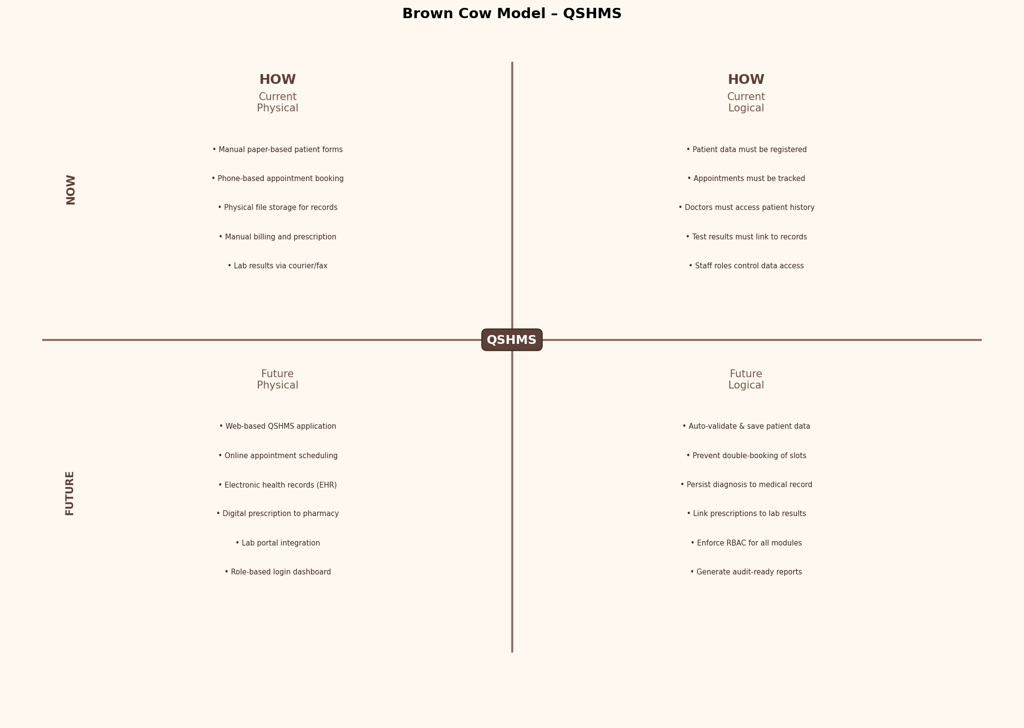

9.1 Quadrant Descriptions

Current Physical (How Now)
Describes the current manual, physical implementation of health center processes:
- Manual paper-based patient registration forms filled by receptionists
- Telephone-based appointment booking with handwritten scheduling books
- Physical file storage for patient medical records and histories
- Manual billing, invoicing, and prescription writing by doctors
- Lab results delivered by courier, fax, or telephone communication

Current Logical (What Now)
Describes the essential business rules and information flows that currently exist, independent of how they are implemented:
- Patient data must be captured and uniquely identified at registration
- Appointments must be tracked and assigned to specific doctors and time slots
- Doctors must access complete patient history before consultation
- Test results must be linked to the correct patient record
- Staff roles must control which data and functions they can access

Future Physical (How Future — QSHMS)
Describes the planned technical implementation of the QSHMS system:
- Web-based QSHMS application accessible via modern browsers
- Online appointment scheduling with real-time availability checking
- Electronic Health Records (EHR) stored in a centralized database
- Digital prescriptions transmitted directly to linked pharmacies
- Lab portal integration allowing electronic test orders and result uploads
- Role-based login dashboard providing tailored views per user type

Future Logical (What Future)
Describes the essential business rules and processes the future QSHMS will enforce:
- System shall auto-validate and save patient data with unique ID generation
- System shall prevent double-booking of doctor appointment slots
- System shall persist diagnosis information directly to medical records
- System shall link prescriptions and lab results to patient records automatically
- System shall enforce RBAC permissions across all system modules
- System shall generate audit-ready reports for administration and compliance

10. Database Schema Drawing
The database schema defines the physical structure of the QSHMS relational database. It maps each entity to a database table with column names, data types, and key constraints. Primary Keys (PK) uniquely identify each record; Foreign Keys (FK) establish referential integrity between related tables.

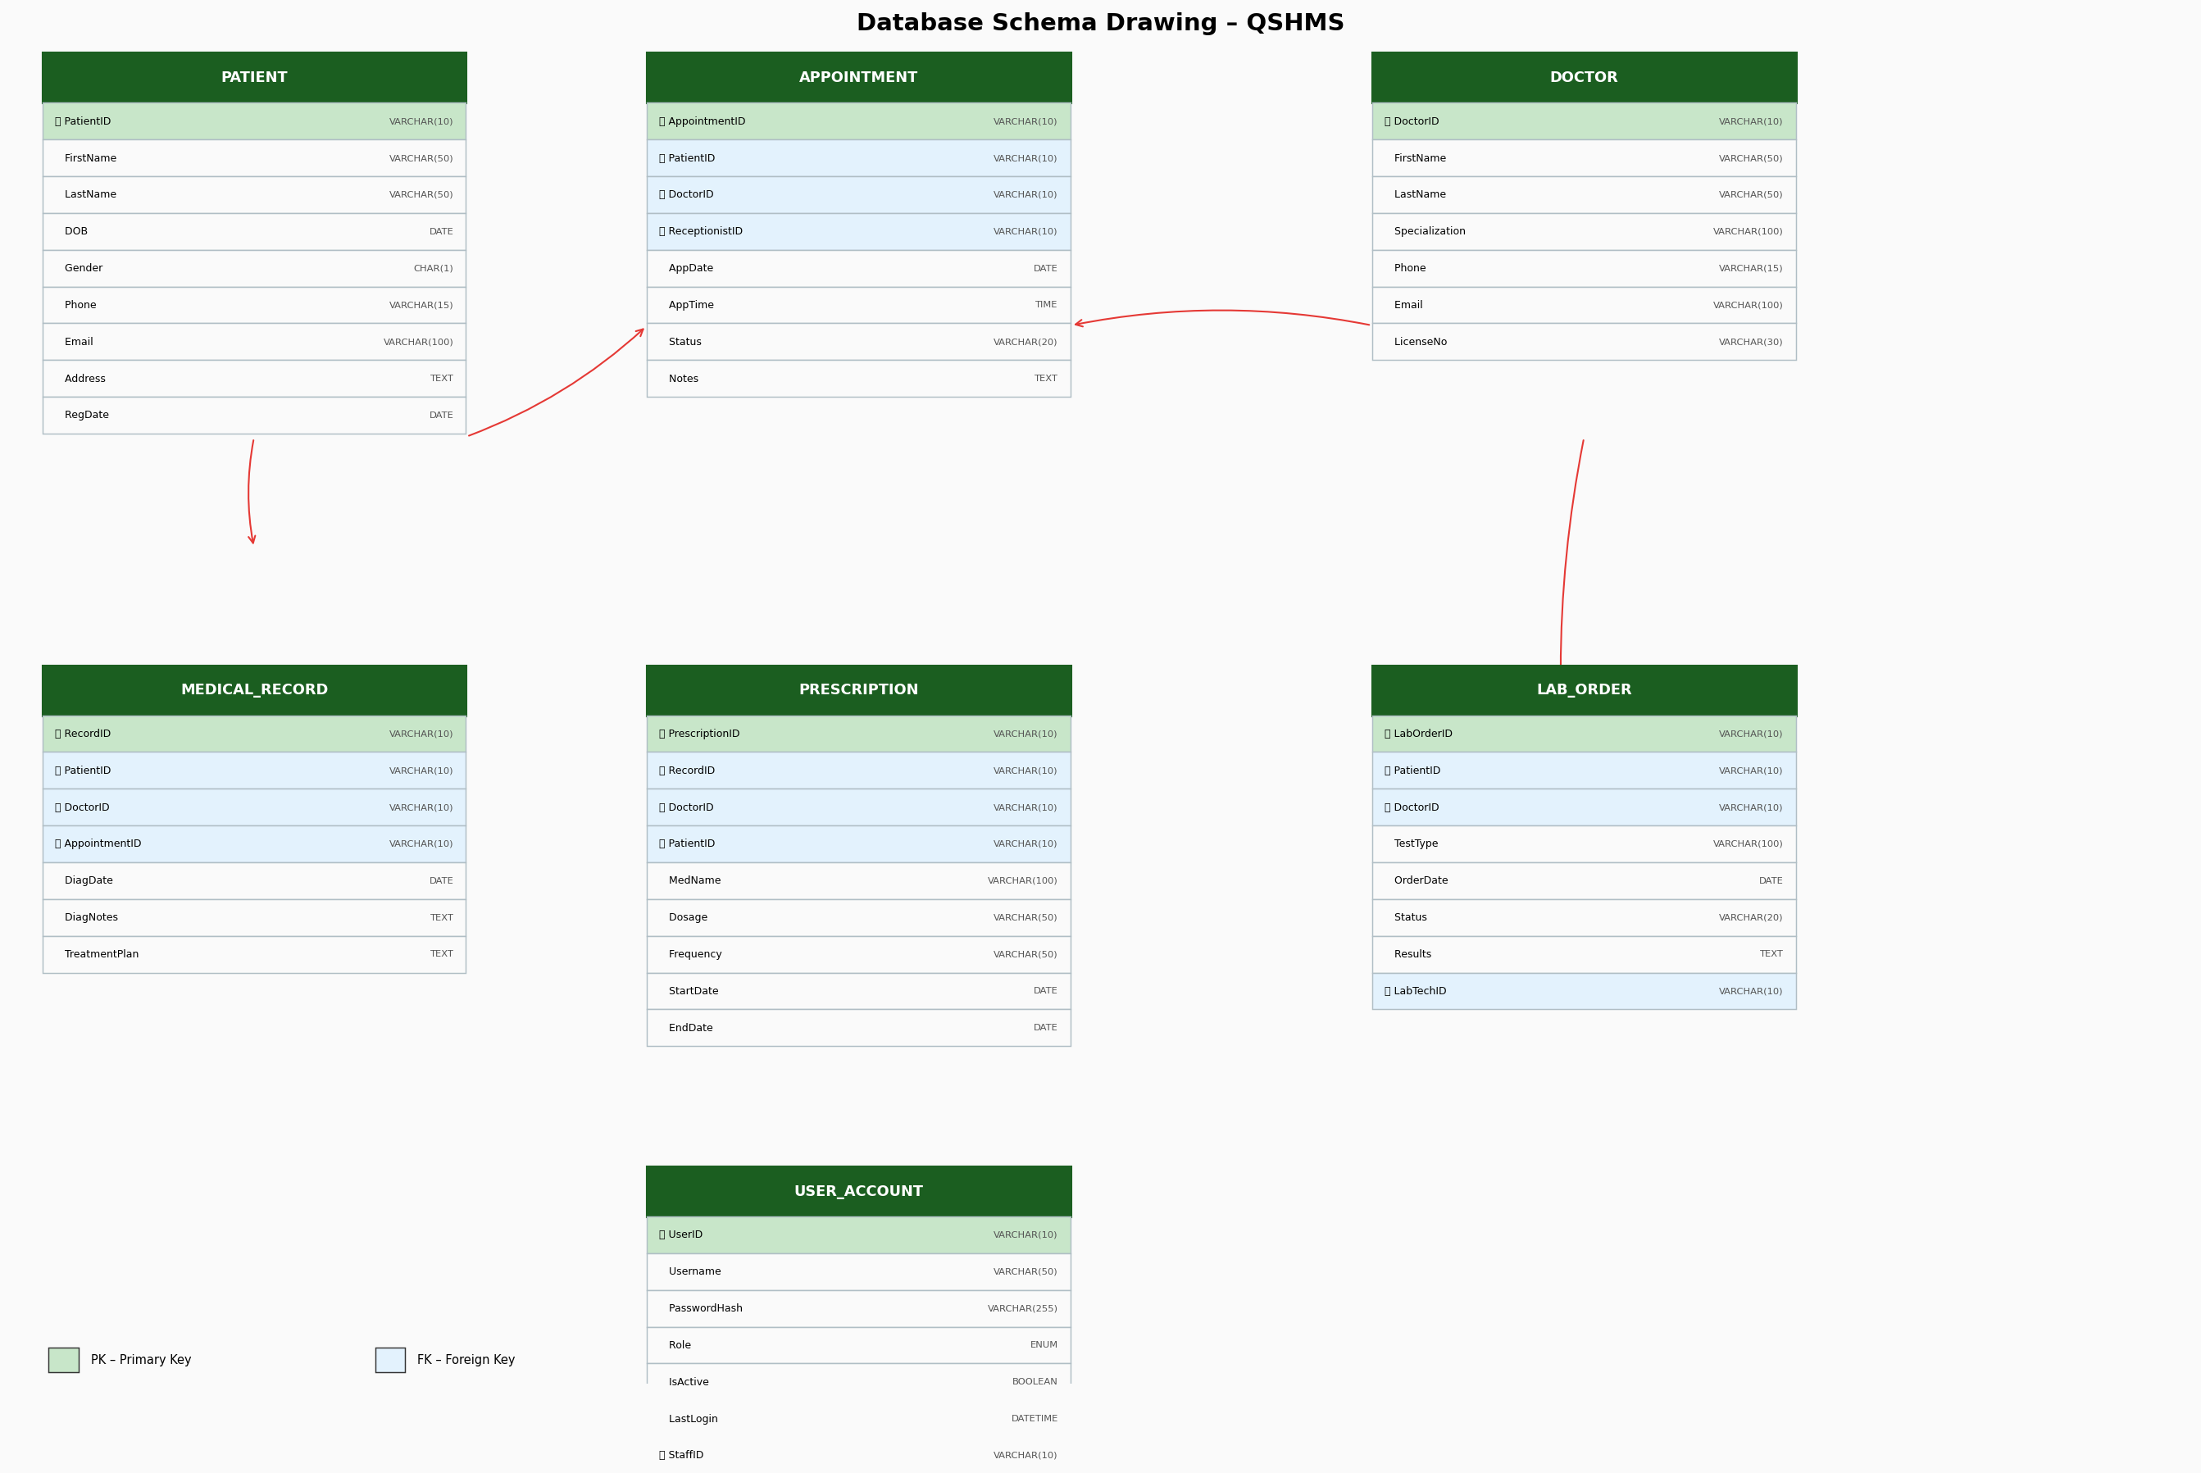

10.1 Schema Design Principles
- Normalization: All tables are normalized to at least Third Normal Form (3NF) to eliminate data redundancy.
- Referential Integrity: All FK constraints are enforced at the database level to prevent orphaned records.
- Data Types: VARCHAR is used for variable-length strings; DATE and DATETIME for temporal values; BOOLEAN for binary flags; ENUM for controlled value sets.
- Indexes: Primary keys are automatically indexed; frequently queried FK columns (PatientID, DoctorID) carry secondary indexes for performance.
- Audit Columns: Critical tables include CreatedAt and UpdatedAt timestamp columns (not shown for brevity) for audit trail compliance (NFR-08, NFR-21).

11. UML Class Diagram
The UML Class Diagram illustrates the object-oriented design of the QSHMS system. Each class corresponds to a domain entity, exposing its attributes (data) and methods (behaviours). Associations between classes model the relationships established in the ER model, while methods represent the system operations identified in the functional requirements.

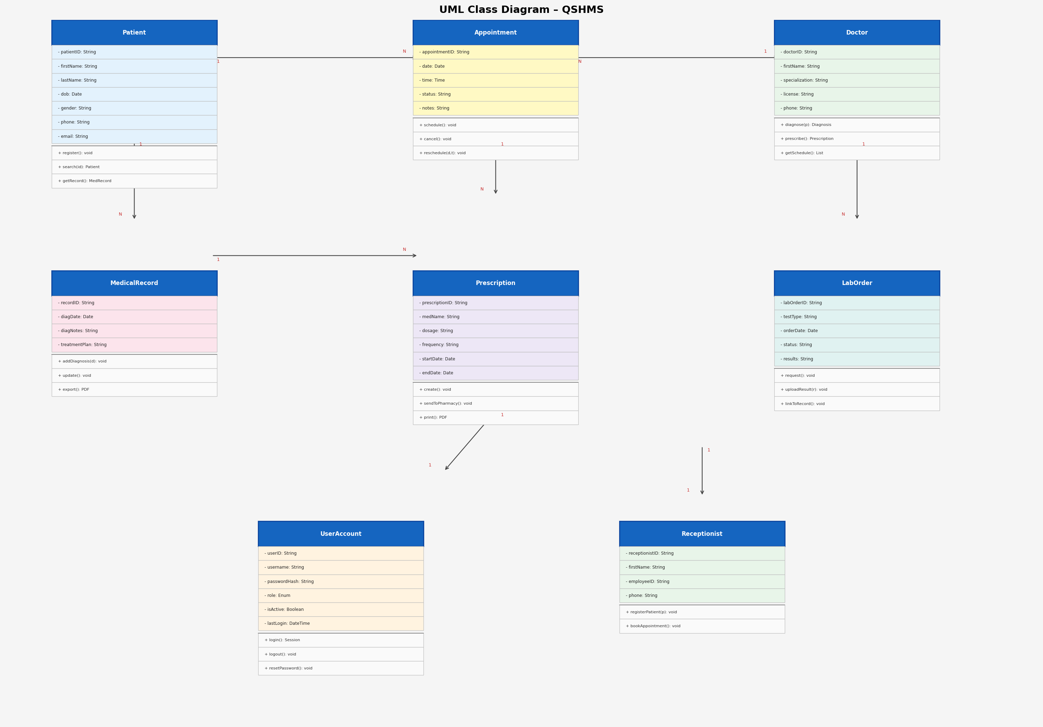

11.1 Class Descriptions

Patient Class
Represents registered patients. Key methods include register() for new patient onboarding, search() for patient lookup, and getRecord() for retrieving the full medical history.

Doctor Class
Represents medical professionals. Exposes diagnose(), prescribe(), and getSchedule() to support clinical workflows.

Receptionist Class
Front-desk staff who manage patient registration and appointment booking via registerPatient() and bookAppointment().

Appointment Class
Central scheduling entity. Contains schedule(), cancel(), and reschedule() methods to manage booking lifecycle.

MedicalRecord Class
Stores clinical encounter data. addDiagnosis() and update() write consultation outcomes; export() generates PDF summaries.

Prescription Class
Linked to medical records and patients. create() generates the prescription; sendToPharmacy() transmits it electronically.

LabOrder Class
Manages lab test workflow from request() through uploadResult() to linkToRecord(), ensuring traceability.

UserAccount Class
Controls system access via login(), logout(), and resetPassword() methods, enforcing RBAC as specified in FR-23 and NFR-06.

11.2 Key Class Associations
Class A | Class B | Multiplicity | Description
Patient | Appointment | 1..* | A patient can have one or more appointments
Doctor | Appointment | 1..* | A doctor attends one or more appointments
Appointment | MedicalRecord | 1..1 | Each appointment generates one medical record
MedicalRecord | Prescription | 1..* | A medical record can produce multiple prescriptions
Doctor | LabOrder | 1..* | A doctor can issue multiple lab orders
UserAccount | Doctor/Receptionist | 1..1 | One-to-one mapping enforces unique system identity

End of QSHMS System Analysis & Design Document

